Supplementary Results

Alexander J. Shackman^{1,2,3}
Jason F. Smith*¹
Ryan D. Orth¹
Christina L. G. Savage¹
Paige R. Didier¹
Julie M. McCarthy^{4,5}
Melanie E. Bennett⁶
Jack J. Blanchard*¹

Department of ¹Psychology, ²Neuroscience and Cognitive Science Program, and ³Maryland Neuroimaging Center, University of Maryland, College Park, MD 20742, USA. ⁴Division of Psychotic Disorders, McLean Hospital, Belmont, MA 02478 USA. ⁵Department of Psychiatry, Harvard Medical School, Boston, MA 02115 USA. ⁶Department of Psychiatry, University of Maryland School of Medicine, Baltimore, MD 21201, USA.

* contributed equally

Please address manuscript correspondence to
Dr. Jack J. Blanchard (jblancha@umd.edu)

Supplementary Figure S1. The human striatum. The ventral striatum (yellow) includes the nucleus accumbens and olfactory tubercle¹. The accumbens can, in turn, be chemoarchitectonically divided into two major divisions, the shell and core, with the shell marked by stronger expression of mu and kappa opioid receptors and D1 and D3 dopamine receptors, and weaker expression of D2 dopamine receptors^{2, 3}. Mechanistic work in rodents indicates that both divisions are critically involved in dopamine-mediated appetitive motivation (‘wanting’ reward), whereas only the medial shell is involved in opioid/cannabinoid-mediated hedonic pleasure (‘liking’ reward)^{4, 5}. Whether humans share the same functional architecture remains unclear (e.g., Ref. ⁶). The figure was created with reference to the Allen Brain Institute (ABI) and Mai atlases^{7, 8}. Portions of the artwork were adapted with permission from Ref. ⁸. Abbreviations—GP, globus pallidus; NACc, nucleus accumbens core; NACs, nucleus accumbens shell; OT, olfactory tubercle.

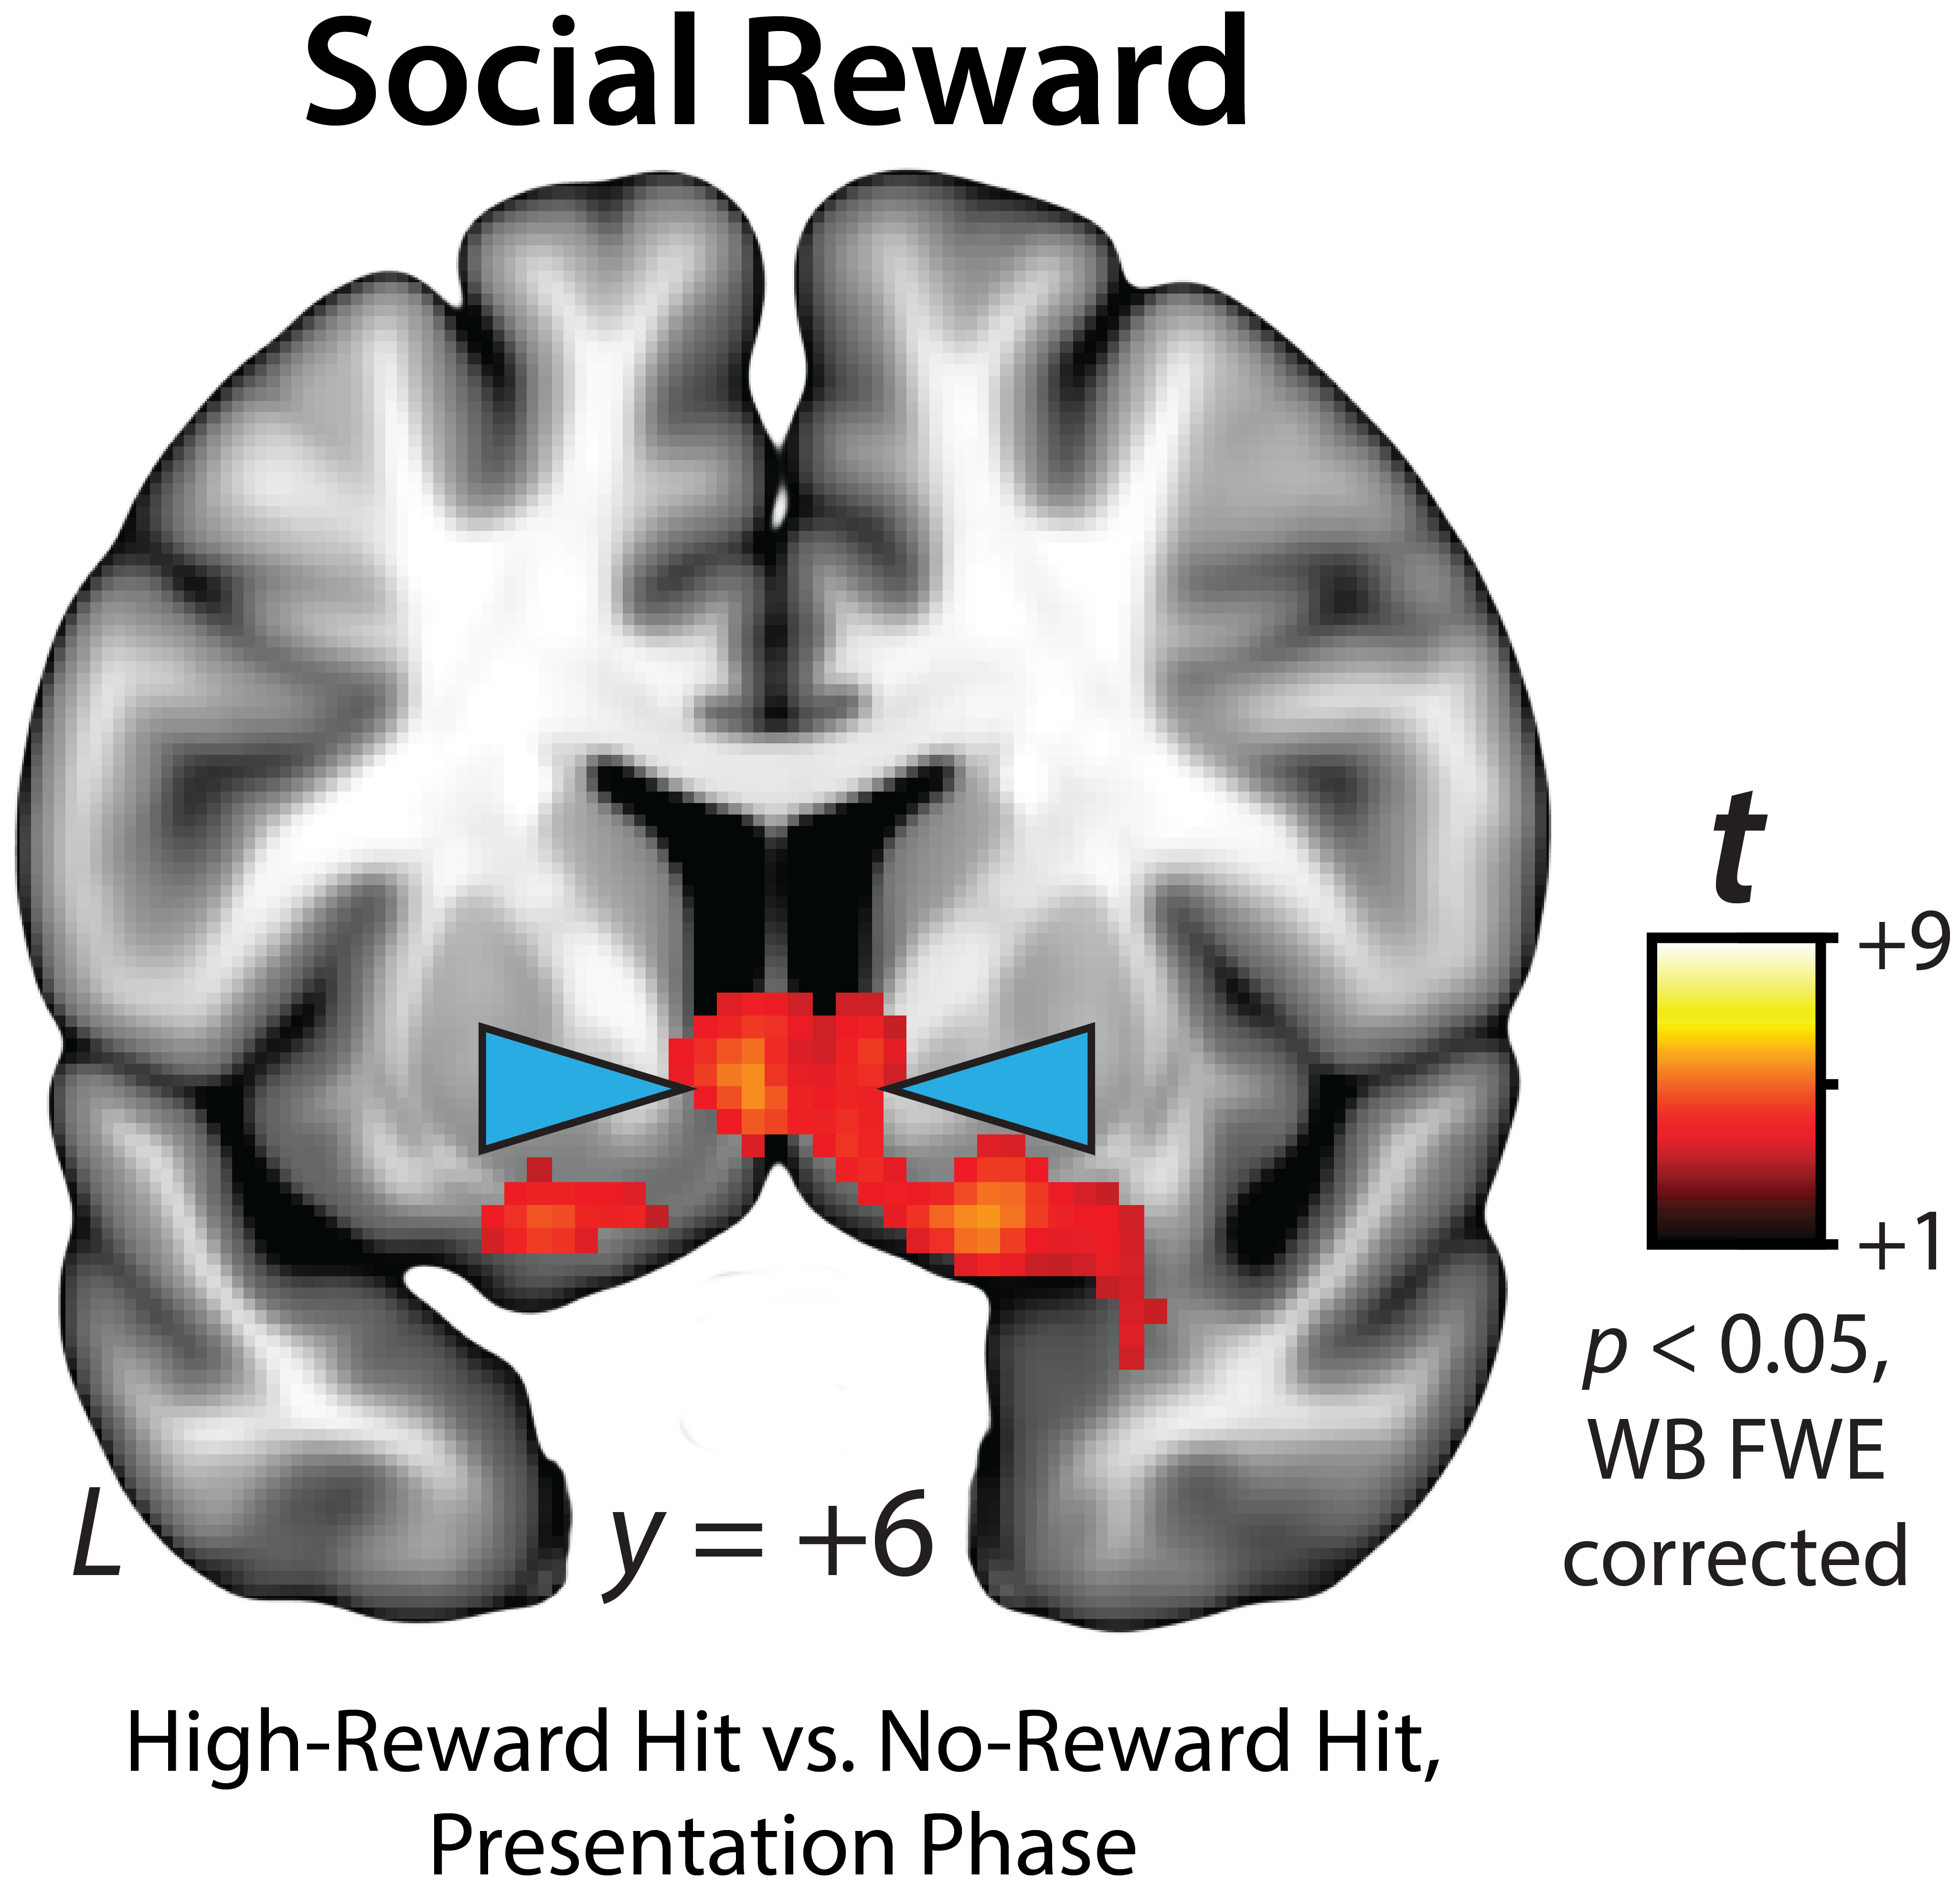

Supplementary Figure S2. The presentation of social reward robustly engages the ventral striatum. Figure depicts regions showing significantly greater activation during High- compared to No-Reward hit trials for the outcome phase of the SID paradigm (p<0.05, whole-brain FWE corrected). Blue arrows indicate the ventral striatum. Abbreviations—FWE, familywise error; L, left hemisphere; WB, whole-brain.

Supplementary Table S1. Descriptive Statistics for Symptoms and Social Function.
Scale (Instrument) | M (SD) | Range
Motivation and Pleasure (CAINS) | 11.51 (6.74) | 1 – 34
Expression (CAINS) | 5.48 (3.57) | 0 – 14
Positive Symptoms (BPRS) | 12.52 (6.00) | 8 – 31
Depression/Anxiety (BPRS) | 7.65 (4.05) | 4 – 19
Agitation (BPRS) | 7.51 (2.25) | 6 – 19
Interpersonal Relationships (SLOF) | 27.05 (6.27) | 11 – 35
Note. N=69. Abbreviations—BPRS, Brief Psychiatric Rating Scale; CAINS, Clinical Assessment Interview for Negative Symptoms; SLOF, Specific Levels of Functioning.

Supplementary Table S2. Descriptive statistics for clusters and local extrema showing greater activation in the SID paradigm for High-Reward compared to No-Reward hit trials (p<0.05, whole-brain FWE corrected).
 |  | mm³ | t | x | y | z
Cluster 1 |  | 60480
 | R Lateral Occipital Cortex, inferior division |  | 17.14 | 46 | -68 | 2
 | R Occipital Pole |  | 13.21 | 16 | -92 | 6
 | R Occipital Fusiform Gyrus |  | 12.81 | 30 | -76 | -12
 | R Temporal Occipital Fusiform Cortex |  | 10.2 | 46 | -50 | -16
 | R Inferior Temporal Gyrus, temporooccipital part |  | 8.68 | 48 | -58 | -14
 | R Lateral Occipital Cortex, superior division |  | 8.04 | 28 | -84 | 22
 | R Temporal Fusiform Cortex, posterior division |  | 6.55 | 38 | -38 | -22
Cluster 2 |  | 31168
 | L Lateral Occipital Cortex, inferior division |  | 13.18 | -44 | -70 | 4
 | L Temporal Occipital Fusiform Cortex |  | 7.68 | -40 | -56 | -14
 | L Temporal Fusiform Cortex, posterior division |  | 6.22 | -40 | -36 | -24
 | L Occipital Pole |  | 5.29 | -24 | -94 | -8
 | L Occipital Fusiform Gyrus |  | 5.21 | -32 | -80 | -14
 | L Lateral Occipital Cortex, superior division |  | 4.75 | -42 | -88 | 12
Cluster 3 |  | 12368
 | L Paracingulate Gyrus |  | 6.33 | -2 | 46 | 4
 | L Cingulate Gyrus, anterior division |  | 5.7 | -6 | 36 | 20
 | L Frontal Pole |  | 3.56 | -4 | 62 | 6
 | R Cingulate Gyrus, anterior division |  | 6.83 | 6 | 30 | 14
 | R Paracingulate Gyrus |  | 6.3 | 4 | 46 | 10
 | R Frontal Medial Cortex |  | 3.64 | 0 | 50 | -8
Cluster 4 |  | 8792
 | L Frontal Orbital Cortex |  | 4.78 | -26 | 14 | -20
 | L Left Thalamus |  | 4.52 | -6 | -2 | 4
 | L Insular Cortex |  | 4.15 | -32 | 16 | -10
 | R Ventral Striatum |  | 7.56 | 8 | 14 | -6
 | R Ventral Striatum |  | 7.05 | 10 | 14 | -8
 | R Insular Cortex |  | 5.02 | 36 | 20 | -8
 | R Right Caudate |  | 3.49 | 6 | 12 | 6
Cluster 5 |  | 3136
 | L Brain-Stem |  | 4.45 | -6 | -36 | -6
 | R Brain-Stem |  | 5.38 | 6 | -36 | -8
 | R Right Thalamus |  | 5.33 | 10 | -30 | -2
Cluster 6 |  | 1888
 | R Superior Parietal Lobule |  | 5.39 | 26 | -52 | 52
 | R Lateral Occipital Cortex, superior division |  | 3.96 | 22 | -62 | 46
Cluster 7 |  | 1280
 | R Heschls Gyrus (includes H1 and H2) |  | 4.43 | 46 | -20 | 8
 | R Planum Temporale |  | 4.25 | 62 | -16 | 4
Cluster 8 |  | 792
 | L Lateral Occipital Cortex, superior division |  | 4.38 | -30 | -72 | 22

Supplementary Table S3. Descriptive statistics for clusters and local extrema showing greater activation in the SID paradigm for No-Reward compared to High-Reward hit trials (p<0.05, whole-brain FWE corrected).
 |  | mm³ | t | x | y | z
No Clusters

Supplementary Table S4. Descriptive statistics for clusters and local extrema showing greater activation in the MID paradigm for High-Reward compared to No-Reward hit trials (p<0.05, whole-brain FWE corrected).
 |  | mm³ | t | x | y | z
Cluster 1 |  | 99568
 | L Lateral Occipital Cortex, inferior division |  | 9.36 | -48 | -78 | -10
 | L Occipital Fusiform Gyrus |  | 6.19 | -36 | -70 | -18
 | L Occipital Pole |  | 5.77 | -38 | -90 | 8
 | L Lateral Occipital Cortex, superior division |  | 5.72 | -40 | -88 | 10
 | L Intracalcarine Cortex |  | 4.92 | -12 | -82 | 8
 | L Lingual Gyrus |  | 4.69 | -4 | -72 | 4
 | L Middle Temporal Gyrus, temporooccipital part |  | 3.87 | -56 | -58 | 8
 | L Inferior Temporal Gyrus, temporooccipital part |  | 3.81 | -48 | -62 | -20
 | R Lateral Occipital Cortex, inferior division |  | 9.32 | 44 | -80 | -8
 | R Occipital Pole |  | 6.85 | 12 | -90 | 2
 | R Inferior Temporal Gyrus, temporooccipital part |  | 6.35 | 56 | -60 | -10
 | R Middle Temporal Gyrus, temporooccipital part |  | 6.24 | 58 | -54 | -8
 | R Occipital Fusiform Gyrus |  | 5.76 | 30 | -70 | -18
 | R Lateral Occipital Cortex, superior division |  | 5.22 | 40 | -80 | 12
 | R Intracalcarine Cortex |  | 5.11 | 6 | -74 | 6
 | R Lingual Gyrus |  | 4.53 | 12 | -62 | 2
 | R Brain-Stem |  | 3.91 | 12 | -44 | -40
Cluster 2 |  | 61112
 | L Frontal Orbital Cortex |  | 5.98 | -28 | 22 | -10
 | L Insular Cortex |  | 5.49 | -38 | 14 | -6
 | L Frontal Operculum Cortex |  | 5.11 | -34 | 20 | 10
 | L Brain-Stem |  | 4.62 | -4 | -34 | -26
 | L Thalamus |  | 3.55 | -6 | -26 | 12
 | R Frontal Orbital Cortex |  | 7.67 | 32 | 30 | -2
 | R Middle Frontal Gyrus |  | 7.39 | 44 | 6 | 36
 | R Thalamus |  | 6.57 | 2 | -12 | 12
 | R Precentral Gyrus |  | 6.48 | 42 | 8 | 26
 | R Brain-Stem |  | 5.81 | 4 | -32 | -18
 | R Inferior Frontal Gyrus, pars opercularis |  | 5.1 | 50 | 8 | 16
 | R Caudate |  | 4.57 | 14 | -6 | 18
 | R Insular Cortex |  | 4.38 | 38 | 6 | -4
 | R Putamen |  | 4.2 | 30 | -12 | -10
 | R Amygdala |  | 4.07 | 26 | 0 | -12
 | R Superior Frontal Gyrus |  | 3.91 | 24 | 8 | 66
 | R Pallidum |  | 3.76 | 24 | -8 | -6
 | R Ventral Striatum |  | 8.78 | 12 | 14 | -10
 | L Ventral Striatum |  | 7.81 | -10 | 14 | -10
 | L Ventral Striatum |  | 8.32 | -6 | 16 | -4
 | R Ventral Striatum |  | 9.23 | 8 | 14 | -2
Cluster 3 |  | 35000
 | L Cingulate Gyrus, anterior division |  | 7.14 | -2 | 34 | 20
 | L Paracingulate Gyrus |  | 6.96 | -2 | 38 | 28
 | L Cingulate Gyrus, posterior division |  | 4.84 | -8 | -22 | 42
 | L Juxtapositional Lobule Cortex (formerly Supplementary Motor Cortex) |  | 4.31 | -2 | 6 | 58
 | R Paracingulate Gyrus |  | 7.04 | 2 | 36 | 26
 | R Cingulate Gyrus, anterior division |  | 6.96 | 0 | 46 | 4
 | R Cingulate Gyrus, posterior division |  | 5.12 | 0 | -32 | 26
Cluster 4 |  | 23992
 | R Superior Parietal Lobule |  | 7.56 | 32 | -48 | 48
 | R Supramarginal Gyrus, posterior division |  | 7.16 | 48 | -38 | 54
 | R Lateral Occipital Cortex, superior division |  | 6.36 | 26 | -68 | 38
 | R Supramarginal Gyrus, anterior division |  | 5.08 | 56 | -26 | 44
 | R Precuneus Cortex |  | 4.16 | 16 | -66 | 38
Cluster 5 |  | 8592
 | L Precentral Gyrus |  | 6.89 | -54 | 0 | 48
 | L Superior Frontal Gyrus |  | 4.62 | -22 | 0 | 54
 | L Inferior Frontal Gyrus, pars opercularis |  | 4.34 | -56 | 10 | 16
Cluster 6 |  | 6096
 | L Lateral Occipital Cortex, superior division |  | 5.5 | -28 | -66 | 30
 | L Superior Parietal Lobule |  | 4.57 | -28 | -52 | 48
 | L Precuneus Cortex |  | 4.33 | -6 | -78 | 54
Cluster 7 |  | 1176
 | L Supramarginal Gyrus, posterior division |  | 4.97 | -56 | -42 | 22

Supplementary Table S5. Descriptive statistics for clusters and local extrema showing greater activation in the MID paradigm for No-Reward compared to High-Reward hit trials (p<0.05, whole-brain FWE corrected).
 |  | mm³ | t | x | y | z
Cluster 1 |  | 5784
 | R Planum Temporale |  | 6.02 | 56 | -26 | 10
 | R Heschls Gyrus (includes H1 and H2) |  | 5.87 | 38 | -22 | 12
 | R Insular Cortex |  | 5.05 | 38 | -16 | 16
 | R Central Opercular Cortex |  | 3.94 | 56 | -8 | 8
 | R Postcentral Gyrus |  | 3.89 | 66 | -6 | 28
Cluster 2 |  | 1840
 | L Central Opercular Cortex |  | 5.62 | -36 | -20 | 20
 | L Heschls Gyrus (includes H1 and H2) |  | 4.97 | -36 | -28 | 14
Cluster 3 |  | 1048
 | R Occipital Pole |  | 4.51 | 22 | -96 | 4
Cluster 4 |  | 904
 | R Precentral Gyrus |  | 4.78 | 4 | -28 | 66

Supplementary Table S6. Descriptive statistics for clusters and local extrema showing greater activation in the SID paradigm for the presentation of High-Reward compared to No-Reward incentives (p<0.05, whole-brain FWE corrected).
 |  | mm³ | t | x | y | z
Cluster 1 |  | 82944
 | R Lateral Occipital Cortex, inferior division |  | 17.92 | 48 | -70 | 0
 | R Occipital Pole |  | 12.8 | 16 | -92 | 4
 | R Temporal Occipital Fusiform Cortex |  | 11.61 | 44 | -50 | -20
 | R Inferior Temporal Gyrus, temporooccipital part |  | 10.49 | 48 | -60 | -14
 | R Occipital Fusiform Gyrus |  | 10.47 | 22 | -86 | -10
 | R Lateral Occipital Cortex, superior division |  | 8.9 | 30 | -84 | 26
 | R Planum Temporale |  | 6.27 | 62 | -12 | 4
 | R Supramarginal Gyrus, posterior division |  | 5.01 | 66 | -42 | 14
 | R Heschls Gyrus (includes H1 and H2) |  | 4.58 | 50 | -18 | 6
 | R Superior Temporal Gyrus, anterior division |  | 3.67 | 64 | 0 | -8
Cluster 2 |  | 38008
 | L Lateral Occipital Cortex, inferior division |  | 13.02 | -48 | -72 | 4
 | L Temporal Occipital Fusiform Cortex |  | 8.03 | -42 | -54 | -22
 | L Occipital Pole |  | 7.86 | -24 | -96 | 0
 | L Occipital Fusiform Gyrus |  | 5.01 | -34 | -80 | -18
 | L Lateral Occipital Cortex, superior division |  | 4.89 | -40 | -88 | 12
 | L Supramarginal Gyrus, posterior division |  | 4.19 | -56 | -50 | 14
 | L Inferior Temporal Gyrus, temporooccipital part |  | 3.94 | -60 | -46 | -16
Cluster 3 |  | 19456
 | R Amygdala |  | 5.83 | 28 | 2 | -14
 | R Amygdala |  | 5.25 | 24 | -6 | -12
 | R Amygdala |  | 5.09 | 16 | -6 | -14
 | R Amygdala/ R Parahippocampal Gyrus, anterior division |  | 4.71 | 26 | 0 | -30
 | R Amygdala |  | 3.55 | 22 | -4 | -26
 | L Amygdala |  | 5.76 | -14 | -6 | -18
 | L Amygdala |  | 4.78 | -28 | -8 | -14
 | L Amygdala |  | 4.67 | -22 | 0 | -26
 | L Frontal Orbital Cortex |  | 6.23 | -26 | 14 | -20
 | L Insular Cortex |  | 4.84 | -30 | 14 | -10
 | L Parahippocampal Gyrus, anterior division |  | 4.25 | -16 | -6 | -26
 | L Hippocampus |  | 4.14 | -32 | -8 | -22
 | L Thalamus |  | 3.85 | -16 | -34 | -2
 | L Putamen |  | 3.46 | -20 | 14 | 2
 | R Thalamus |  | 5.97 | 12 | -32 | 0
 | R Hippocampus |  | 5.16 | 20 | -30 | -6
 | R Temporal Pole |  | 3.54 | 30 | 6 | -24
 | R Putamen |  | 3.39 | 32 | -12 | -2
 | R Ventral Striatum |  | 5.49 | 10 | 10 | -12
 | R Ventral Striatum |  | 5.99 | 6 | 12 | -6
 | R Ventral Striatum |  | 7.56 | 8 | 14 | -6
 | R Ventral Striatum |  | 5.89 | 8 | 16 | -6
Cluster 4 |  | 15744
 | L Paracingulate Gyrus |  | 5.34 | -2 | 34 | -10
 | L Cingulate Gyrus, anterior division |  | 5.23 | -6 | 32 | -4
 | L Caudate |  | 4.16 | -10 | 10 | 16
 | L Frontal Pole |  | 4.05 | -2 | 58 | -6
 | R Cingulate Gyrus, anterior division |  | 6.51 | 0 | 46 | 4
 | R Frontal Pole |  | 5.37 | 0 | 62 | 6
 | R Subcallosal Cortex |  | 5.06 | 2 | 28 | -20
 | R Frontal Medial Cortex |  | 4.49 | 2 | 52 | -8
 | R Paracingulate Gyrus |  | 4.05 | 8 | 46 | 18
Cluster 5 |  | 3224
 | L Frontal Pole |  | 5.3 | -12 | 46 | 50
 | L Superior Frontal Gyrus |  | 4.81 | -18 | 38 | 46
Cluster 6 |  | 1600
 | L Cingulate Gyrus, posterior division |  | 3.85 | -4 | -46 | 32
 | R Cingulate Gyrus, posterior division |  | 4.09 | 0 | -30 | 32
Cluster 7 |  | 1368
 | R Superior Parietal Lobule |  | 5.41 | 30 | -50 | 54

Supplementary Table S7. Descriptive statistics for clusters and local extrema showing greater activation in the SID paradigm for the presentation of No-Reward compared to High-Reward incentives (p<0.05, whole-brain FWE corrected).
 |  | mm³ | t | x | y | z
Cluster 1 |  | 3568
 | R Frontal Pole |  | 5.1 | 30 | 40 | 28
Cluster 2 |  | 2888
 | L Juxtapositional Lobule Cortex (formerly Supplementary Motor Cortex) |  | 4.99 | -2 | -10 | 54
 | R Juxtapositional Lobule Cortex (formerly Supplementary Motor Cortex) |  | 4.72 | 8 | 4 | 54
Cluster 3 |  | 2016
 | L Precentral Gyrus |  | 4.61 | -26 | -14 | 70
Cluster 4 |  | 1584
 | R Postcentral Gyrus |  | 4.48 | 54 | -16 | 40
 | R Supramarginal Gyrus, anterior division |  | 4.4 | 62 | -30 | 38
Cluster 5 |  | 1304
 | R Superior Frontal Gyrus |  | 5.01 | 26 | 2 | 60
Cluster 6 |  | 1040
 | L Postcentral Gyrus |  | 4.59 | -40 | -28 | 62
Cluster 7 |  | 904
 | R Cingulate Gyrus, posterior division |  | 5.18 | 12 | -24 | 40
Cluster 8 |  | 704
 | L Postcentral Gyrus |  | 4.74 | -58 | -16 | 50

SUPPLEMENTARY REFERENCES
1. Heimer L. A new anatomical framework for neuropsychiatric disorders and drug abuse. Am J Psychiatry 2003; 160: 1726-1739.

2. Voorn P, Brady LS, Berendse HW, Richfield EK. Densitometrical analysis of opioid receptor ligand binding in the human striatum--I. Distribution of mu opioid receptor defines shell and core of the ventral striatum. Neuroscience 1996; 75(3): 777-792.

3. Fox AS, Chang LJ, Gorgolewski KJ, Yarkoni T. Bridging psychology and genetics using large-scale spatial analysis of neuroimaging and neurogenetic data. bioRxiv 2014: 012310.

4. Berridge KC, Kringelbach ML. Pleasure systems in the brain. Neuron 2015; 86: 646-664.

5. Morales I, Berridge KC. 'Liking' and 'wanting' in eating and food reward: Brain mechanisms and clinical implications. Physiol Behav 2020; 227: 113152.

6. Buchel C, Miedl S, Sprenger C. Hedonic processing in humans is mediated by an opioidergic mechanism in a mesocorticolimbic system. Elife 2018; 7.

7. Ding SL, Royall JJ, Sunkin SM, Ng L, Facer BA, Lesnar P et al. Comprehensive cellular-resolution atlas of the adult human brain. J Comp Neurol 2016; 524: 3127-3481.

8. Mai JK, Majtanik M, Paxinos G. Atlas of the human brain. 4th edn. Academic Press: San Diego, CA, 2015.

