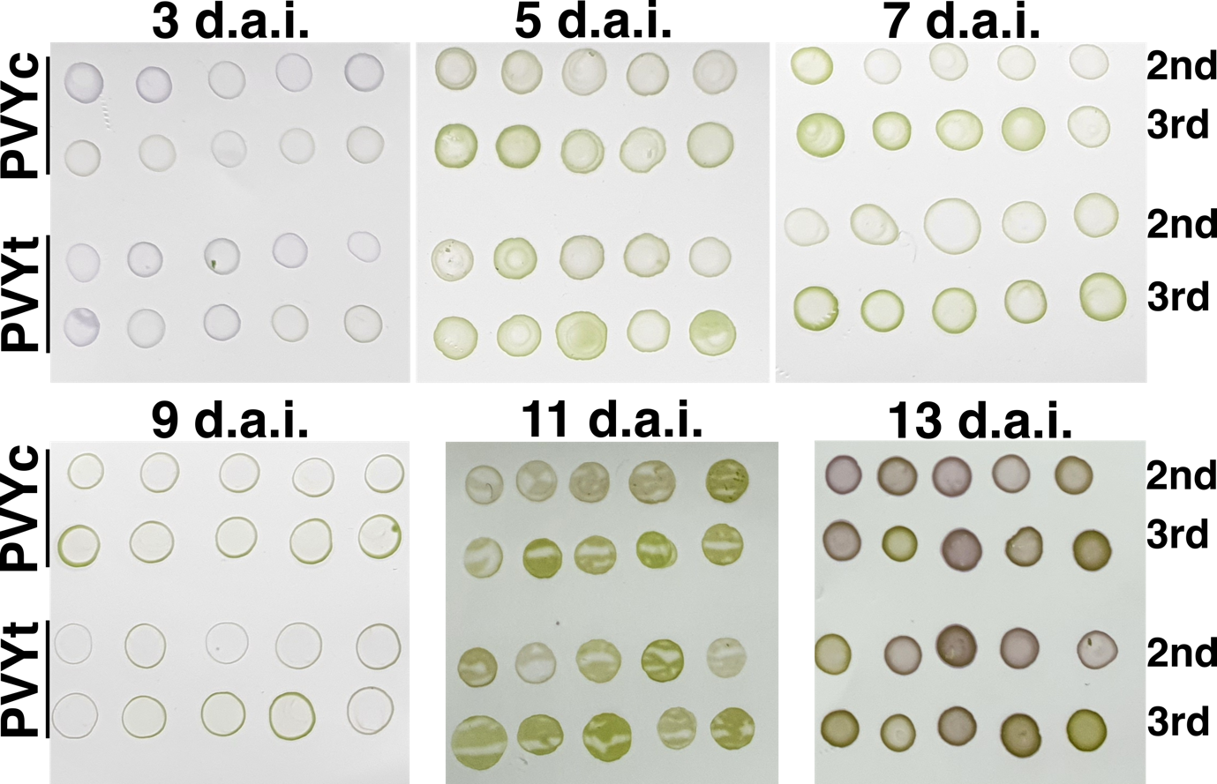
Sup. Fig 1. dot-ELISA of pepper plants with 3, 5, 7, 9, 11 and 13 days after inoculation (d.a.i.) using two isolates, PVYc and PVYt, and two different leaves, the second (2nd) and the third (3rd) leaf from the top. The purple color development represents a positive reaction.

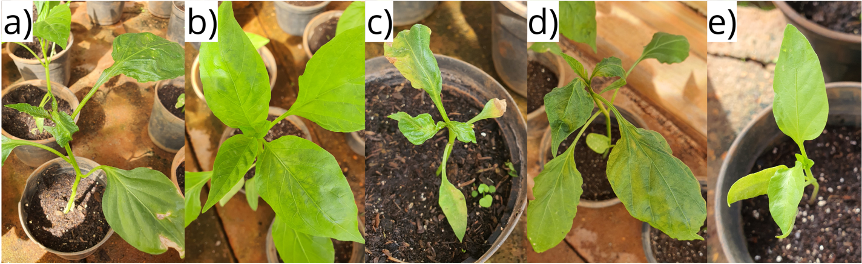
Sup Fig 2. Symptoms observed in sweet pepper cultivars mechanically inoculated with PVYc: (a) foliar deformation and interveinal chlorosis in Camaro, (b) interveinal and veinal chlorosis in Dahra RX, (c) foliar deformation, stunting and necrotic spots in Ikeda, (d) foliar deformation, interveinal and veinal chlorosis in Raquel, and (e) stunting in Taurus.

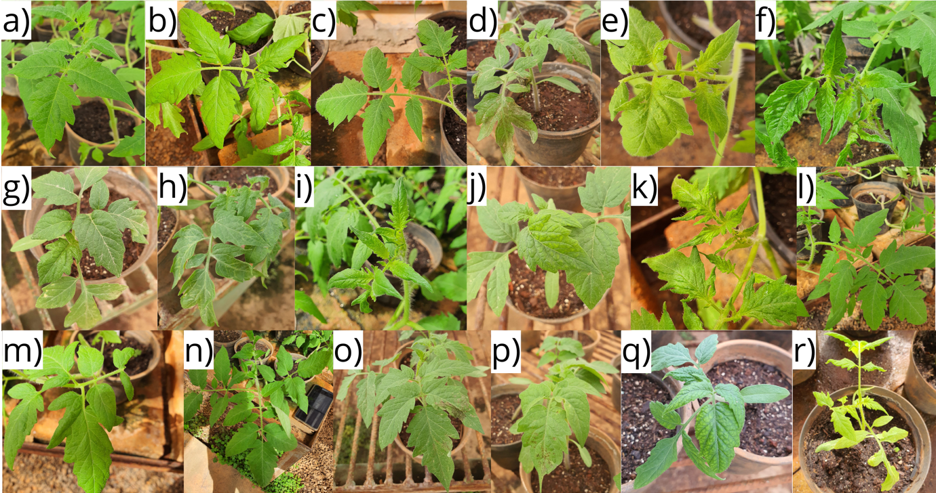
Sup Fig 3. Symptoms observed in tomato cultivars mechanically inoculated with PVYt: (a) interveinal chlorosis in Ângela Hiper, (b) foliar deformation in BRS Sena, (c) veinal chlorosis in Candieiro, (d) necrotic spots in Dominador, (e) chlorotic spots in Durino, (f) foliar deformation in Grazianni, (g) veinal chlorosis in Itaipava, (h) chlorotic spots in Matinella, (i) chlorosis in Milão, (j) internerval chlorosis in Monza, (k) foliar deformation in Parma, (l) interveinal chlorosis in Protheus, (m) interveinal chlorosis in Santa Clara, (n) veinal chlorosis in Santyno, (o) local necrosis in Serato, (p) local necrosis in Tyson, (q) interveinal chlorosis in Vento and (r) chlorosis in Viradoro. Only cultivars with symptoms are shown in the figure.

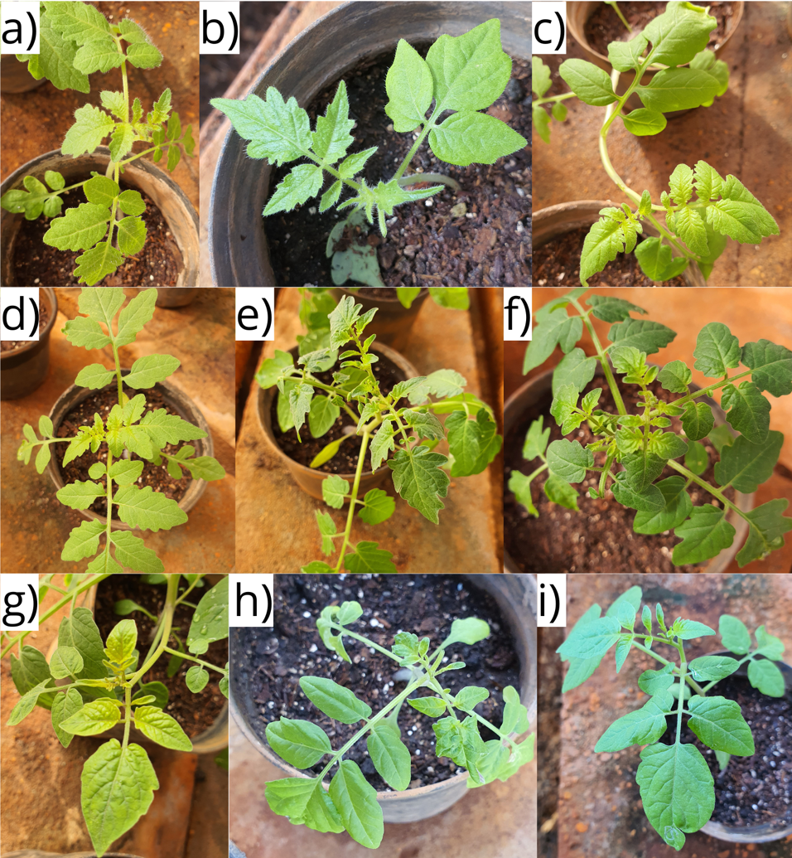
Sup Fig 4. Symptoms observed in wild tomato cultivars mechanically inoculated with PVYt: (a) chlorosis in PI127826, (b) chlorosis in PI134418, (c) chlorosis in PI128659, (d) chlorosis in PI270435, (e) veinal chlorosis in IAC 237, (f) chlorosis in LA1584, (g) chlorosis in LA722, (h) chlorosis and leafroll in PI126925 and (i) chlorosis in PI126931. Only cultivars with symptoms are shown in the figure.

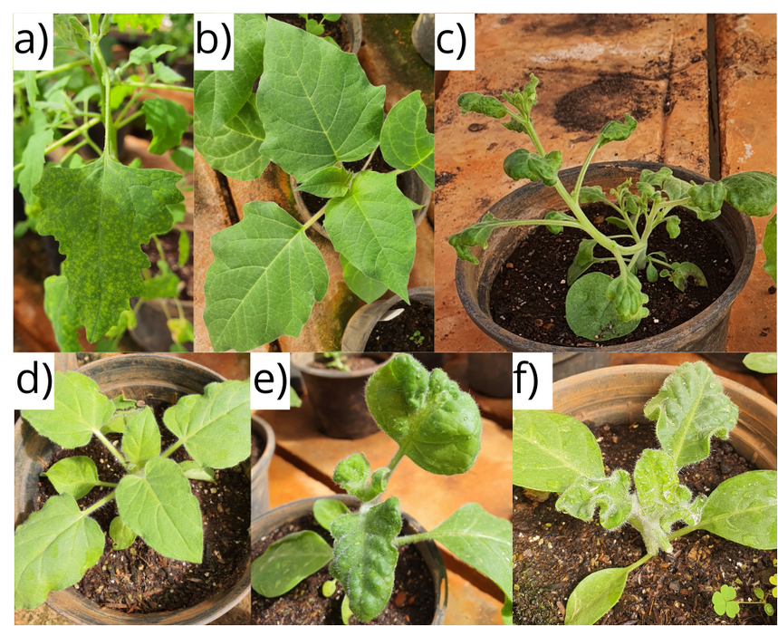
Sup Fig 5. Symptoms observed in indicator plants mechanically inoculated with PVYc, -p and -t: (a) chlorotic spots in C. quinoa (PVYt), (b) veinal chlorosis in D. metel (PVYp), (c) foliar deformation in N. benthamiana (PVYt), (d) veinal chlorosis in N. glutinosa (PVYp), (e) foliar deformation in N. rustica (PVYt) and (f) blistering and foliar deformation in N. sylvestris (PVYt).

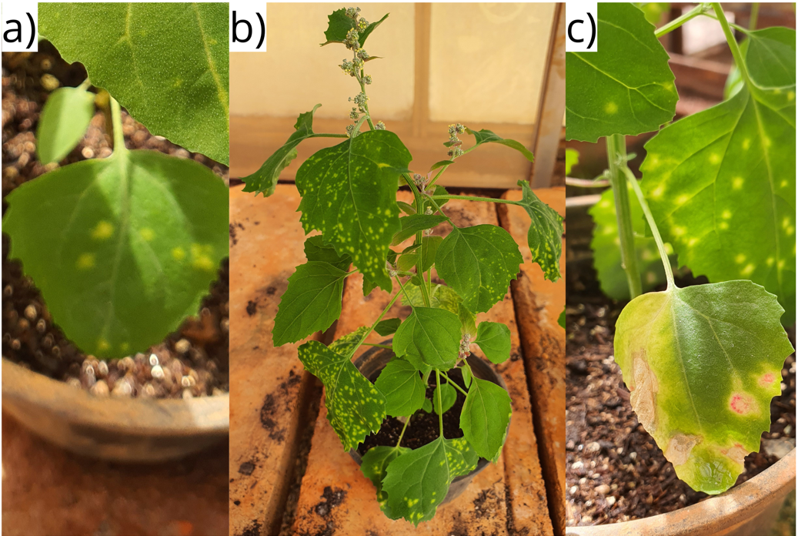
Sup Fig 6. Evolution of symptoms in C. amaranticolor infected with PVYt, showing (a) the first chlorotic spots on the inoculated leaves, (b) followed by a systemic infection with chlorotic spots in young leaves and (c) the generation of a red halo in the old lesions.

