Atlas of tandem kinase proteins across the plant kingdom
Reveguk T.^{1,2}, Fatiukha A.^{1,2,3}, Potapenko E.^{1,2}, Reveguk I.⁴, Sela H.¹, Klymiuk V.^{1,2,3}, Li Y. ^{1,2,5}, Pozniak C.³, Wicker T.⁶, Coaker G.L.^{7*}, Fahima T.^{1,2*}

¹Institute of Evolution, University of Haifa, Mt. Carmel, Haifa 3498838, Israel.
²The Department of Evolutionary and Environmental Biology, University of Haifa, Mt. Carmel, Haifa 3498838, Israel.
³Crop Development Centre and Department of Plant Sciences, University of
Saskatchewan, 51 Campus Drive, Saskatoon, SK S7N 5A8, Canada.
⁴Laboratory of the Structural Biology of the Cell (BIOC), École Polytechnique, Palaiseau 91120, Paris, France
⁵ Triticeae Research Institute, Sichuan Agricultural University, Chengdu 611130, Sichuan, China
⁶Department of Plant and Microbial Biology, University of Zurich, Zurich, Switzerland.
⁷Department of Plant Pathology, University of California, One Shields Avenue, Davis, CA 95616, USA.

*Corresponding authors: Tzion Fahima tfahima@evo.haifa.ac.il, and Gitta L Coaker glcoaker@ucdavis.edu.
Keywords: plant immunity, plant defense response, tandem kinase protein family, plant resistance proteins

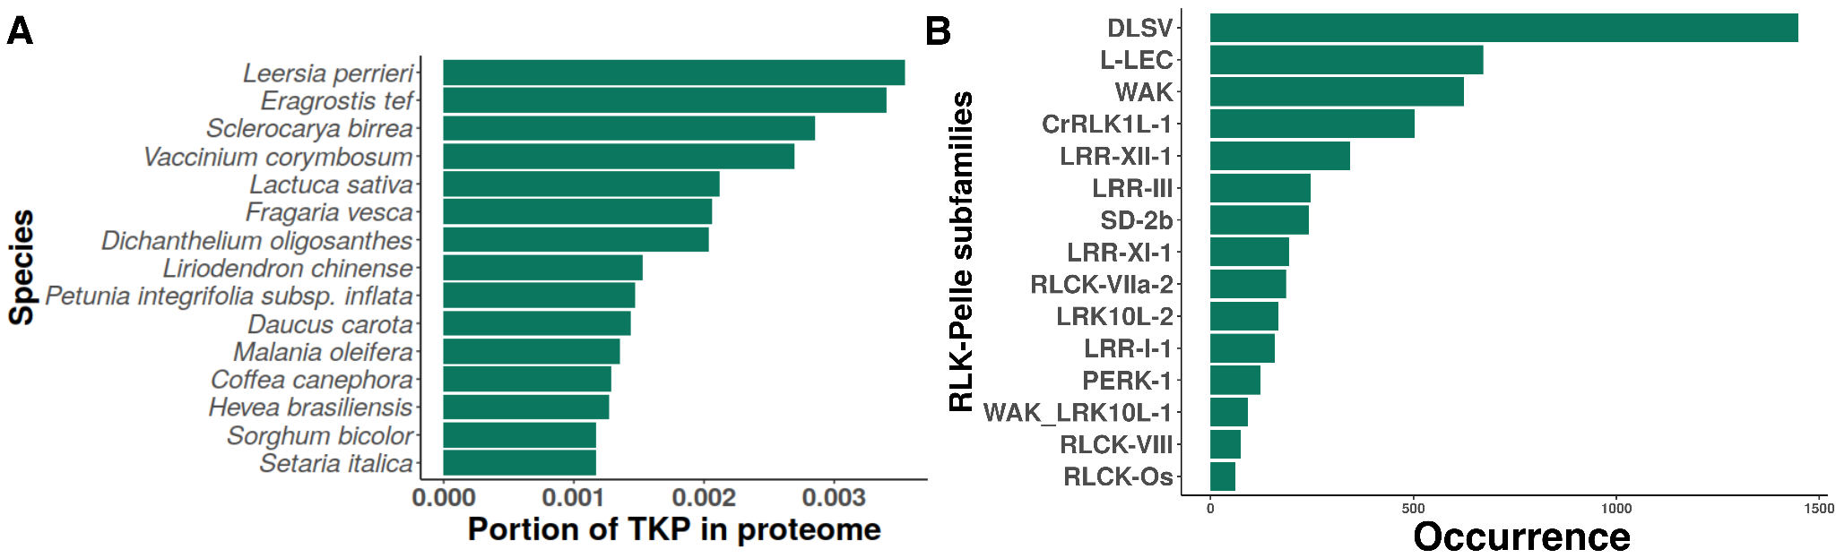

Supplementary figure S1. Domain diversity and proportion of TKPs identified from predicted proteomes. (A) The proportion of TKPs compared to the total proteome size. (B) TKPs containing 2-5 kinase domains and their family membership.
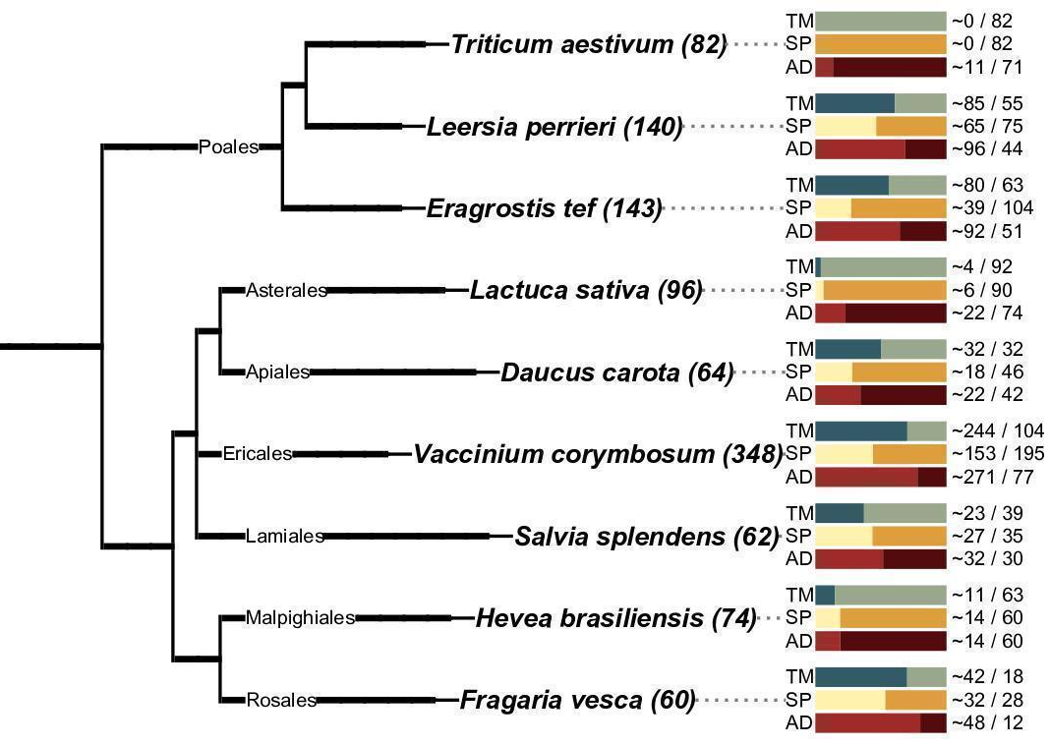
Supplementary figure S2. A tree with the nine species having the most abundant number of TKPs. Bars demonstrate the presence/absence of a transmembrane region (TM), a signal peptide (SP), and at least one additional (non-kinase) domain (AD). The tree represents taxonomy, created using the ete toolkit v3.1.2, showcasing total TKP counts as a bar chart ¹. This tree illustrates qualitative branching patterns, excluding distance information.

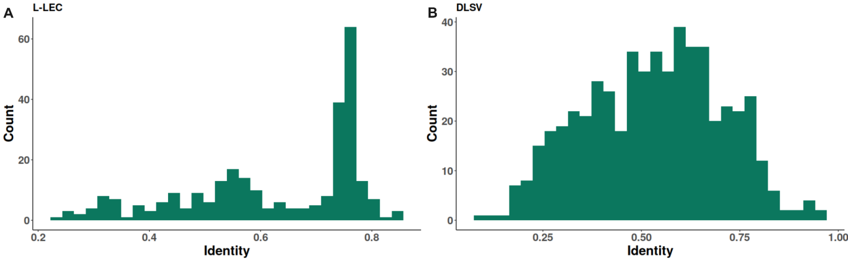
Supplementary figure S3. Distance histogram calculated on domain sequences with matching family annotations (A) for TKPs with two domains from the RLK Pelle LEC family and (B) for TKPs with two domains from RLK Pelle DLSV family. Pairwise distances were calculated for sequences from two subfamilies by dist.alignment function from seqinr (version 4.2-16) R package.

Supplementary table S1. The architecture of functional tandem kinase proteins.
Source | Gene | Protein | Kinase I | Kinase II | IDs | Pathogen | Reference
Hordeum vulgare | Rpg1 | RPG1 | pseudokinase  RLK-Pelle LRR-VIIIb | kinase  RLK-Pelle LRR-VIIIb | HMA | Pgt | ²
Triticum dicoccoides | Yr15 | WTK1 | kinase  RLK-Pelle WAK | pseudokinase  RLK-Pelle RLCK_8 | - | Pst | ³
T. monococcum | Sr60 | WTK2 | kinase  RLK-Pelle LRR-VIIIb | kinase  RLK-Pelle WAK | - | Pgt | ^{4,5}
T. aestivum | Pm24 | WTK3 | kinase  RLK-Pelle LRR-VIIIb | pseudokinase  RLK-Pelle LRR-VIIIb | - | Bgt | ⁶
Aegilops tauschii | WTK4 | WTK4 | pseudokinase  RLK-Pelle LRR-VIIIb | kinase  RLK-Pelle LRR-VIIIb | - | Bgt | ⁷
Ae. tauschii | Rwt4 | RWT4 | kinase  RLK-Pelle LRR-VIIIb | pseudokinase  RLK-Pelle LRR-VIIIb | - | Po | ⁸
Ae. sharonensis | Sr62 | WTK5 | kinase  RLK-Pelle LRR-VIIIb | pseudokinase  RLK-Pelle LRR-VIIIb | - | Pgt | ⁹
Ae. umbellulata | Lr9 | WTK6-vWA | kinase  RLK-Pelle LRR-VIIIb | pseudokinase  RLK-Pelle LRR-VIIIb | vWA | Pt | ¹⁰
Ae. searsii | Pm57 | WTK6b-vWA | kinase  RLK-Pelle LRR-VIIIb | pseudokinase  RLK-Pelle LRR-VIIIb | vWA | Bgt | ¹¹
T. dicoccoides | Pm36 | WTK7-TM | pseudokinase  RLK-Pelle LRR-VIIIb | pseudokinase  RLK-Pelle LRR-VIIIb | - | Bgt | ¹²
Note: WAK, wall-associated kinase; RLCK_8, receptor-like cytoplasmic kinase; LRR_8B, cysteine-rich receptor-like kinase. RLK-Pelle LRR-VIIIb is blong to DLSV. IDs, Integrated Domain; vWA, von Willebrand factor A and Vwaint domains; HMA, heavy-metal-associated domain Pgt, Puccinia graminis f. sp. tritici; Pt, Puccinia triticina. tritici; Bgt, Blumeria graminis f. sp. tritici; Po, Pyricularia oryzae;
Supplementary table S2. Comparison of the kinase domains from TKPs. The protein kinases were classified into 10 groups and 77 families.
Group | Subfamily | Number
PKA-PKG-PKC (AGC) | AGC_MAST | 2
PKA-PKG-PKC (AGC) | AGC_RSK-2 | 4
PKA-PKG-PKC (AGC) | AGC-Pl | 3
calcium- and calmodulin-regulated kinase (CAMK) | CAMK_AMPK | 4
calcium- and calmodulin-regulated kinase (CAMK) | CAMK_CAMKL-CHK1 | 19
calcium- and calmodulin-regulated kinase (CAMK) | CAMK_CDPK | 21
calcium- and calmodulin-regulated kinase (CAMK) | CAMK_OST1L | 10
cyclin-dependent kinases, mitogen-activated protein kinases, glycogen synthase kinases and cyclin-dependent like kinases (CMGC) | CMGC_CDK-CRK7-CDK9 | 9
 | CMGC_CDK-Pl | 7
 | CMGC_CDKL-Os | 14
 | CMGC_CK2 | 2
 | CMGC_CLK | 2
 | CMGC_DYRK-PRP4 | 4
 | CMGC_GSK | 12
 | CMGC_MAPK | 22
 | CMGC_RCK | 4
 | CMGC_SRPK | 2
sterility (STE) | STE_STE11 | 50
sterility (STE) | STE_STE20-Fray | 2
sterility (STE) | STE_STE20-Pl | 2
sterility (STE) | STE_STE7 | 13
tyrosine kinase-like kinases (TKL) | TKL_CTR1-DRK-2 | 4
tyrosine kinase-like kinases (TKL) | TKL-Pl-4 | 3
tyrosine kinase-like kinases (TKL) | TKL-Pl-5 | 4
tyrosine kinase-like kinases (TKL) | TKL-Pl-6 | 8
tyrosine kinase-like kinases (TKL) | TKL-Pl-7 | 2
receptor-like kinase (RLK) | RLK-Pelle_CR4L | 28
receptor-like kinase (RLK) | RLK-Pelle_CrRLK1L-1 | 462
receptor-like kinase (RLK) | RLK-Pelle_DLSV | 1354
receptor-like kinase (RLK) | RLK-Pelle_Extensin | 18
receptor-like kinase (RLK) | RLK-Pelle_L-LEC | 626
receptor-like kinase (RLK) | RLK-Pelle_LRK10L-2 | 150
receptor-like kinase (RLK) | RLK-Pelle_LRR-I-1 | 132
receptor-like kinase (RLK) | RLK-Pelle_LRR-II | 35
receptor-like kinase (RLK) | RLK-Pelle_LRR-III | 240
receptor-like kinase (RLK) | RLK-Pelle_LRR-IV | 2
receptor-like kinase (RLK) | RLK-Pelle_LRR-IX | 10
receptor-like kinase (RLK) | RLK-Pelle_LRR-V | 6
receptor-like kinase (RLK) | RLK-Pelle_LRR-VI-2 | 5
receptor-like kinase (RLK) | RLK-Pelle_LRR-VII-1 | 5
receptor-like kinase (RLK) | RLK-Pelle_LRR-VIII-1 | 35
receptor-like kinase (RLK) | RLK-Pelle_LRR-Xa | 12
receptor-like kinase (RLK) | RLK-Pelle_LRR-Xb-1 | 10
receptor-like kinase (RLK) | RLK-Pelle_LRR-XI-1 | 182
receptor-like kinase (RLK) | RLK-Pelle_LRR-XI-2 | 2
receptor-like kinase (RLK) | RLK-Pelle_LRR-XII-1 | 322
receptor-like kinase (RLK) | RLK-Pelle_LRR-XIIIa | 2
receptor-like kinase (RLK) | RLK-Pelle_LRR-XIV | 9
receptor-like kinase (RLK) | RLK-Pelle_LRR-XV | 2
receptor-like kinase (RLK) | RLK-Pelle_LysM | 32
receptor-like kinase (RLK) | RLK-Pelle_PERK-1 | 112
receptor-like kinase (RLK) | RLK-Pelle_PERK-2 | 16
receptor-like kinase (RLK) | RLK-Pelle_RKF3 | 11
receptor-like kinase (RLK) | RLK-Pelle_RLCK-II | 1
receptor-like kinase (RLK) | RLK-Pelle_RLCK-IV | 2
receptor-like kinase (RLK) | RLK-Pelle_RLCK-IXb | 35
receptor-like kinase (RLK) | RLK-Pelle_RLCK-Os | 55
receptor-like kinase (RLK) | RLK-Pelle_RLCK-V | 12
receptor-like kinase (RLK) | RLK-Pelle_RLCK-VI | 9
receptor-like kinase (RLK) | RLK-Pelle_RLCK-VIIa-1 | 20
receptor-like kinase (RLK) | RLK-Pelle_RLCK-VIIa-2 | 184
receptor-like kinase (RLK) | RLK-Pelle_RLCK-VIII | 64
receptor-like kinase (RLK) | RLK-Pelle_RLCK-X | 2
receptor-like kinase (RLK) | RLK-Pelle_RLCK-XII-1 | 2
receptor-like kinase (RLK) | RLK-Pelle_RLCK-XII-2 | 25
receptor-like kinase (RLK) | RLK-Pelle_RLCK-XV | 5
receptor-like kinase (RLK) | RLK-Pelle_RLCK-XVII | 2
receptor-like kinase (RLK) | RLK-Pelle_SD-2b | 228
receptor-like kinase (RLK) | RLK-Pelle_Singleton | 2
receptor-like kinase (RLK) | RLK-Pelle_URK-2 | 1
receptor-like kinase (RLK) | RLK-Pelle_WAK | 565
receptor-like kinase (RLK) | RLK-Pelle_WAK_LRK10L-1 | 90
with no lysine kinase (WNK) | WNK_NRBP | 2
novel Arabidopsis protein kinases (NAK) | NAK | 6
plant-specific (Group-Pl) | Group-Pl-3 | 3
plant-specific (Group-Pl) | Group-Pl-4 | 1

Supplementary table S3. Overview of identified tandem kinases across 104 plant species: counts and specific characteristics.
Species | Count of TKP | Count of TKP with integrated domain | Count of TKP with transmembrane domain | Count of TKP with signal peptide
Actinidia chinensis | 13 | 6 | 3 | 2
Aquilegia coerulea | 8 | 1 | 0 | 0
Ananas comosus | 9 | 7 | 8 | 6
Arachis hypogaea | 30 | 13 | 11 | 9
Arabidopsis lyrata | 3 | 2 | 2 | 1
Antirrhinum majus | 36 | 10 | 7 | 7
Asparagus officinalis | 7 | 3 | 4 | 1
Aegilops tauschii | 30 | 4 | 1 | 0
Arabidopsis thaliana | 1 | 0 | 0 | 0
Amborella trichopoda | 9 | 8 | 8 | 5
Bombax ceiba | 8 | 6 | 6 | 4
Brachypodium distachyon | 40 | 18 | 14 | 12
Dorcoceras hygrometricum | 8 | 7 | 3 | 6
Brassica napus | 10 | 3 | 3 | 3
Brassica rapa | 3 | 2 | 2 | 1
Beta vulgaris | 11 | 5 | 7 | 4
Camptotheca acuminata | 12 | 7 | 8 | 6
Cenchrus americanus | 9 | 2 | 1 | 1
Capsicum annuum | 10 | 8 | 3 | 2
Cajanus cajan | 21 | 7 | 6 | 6
Coffea canephora | 33 | 22 | 20 | 9
Citrus clementina | 14 | 12 | 12 | 6
Theobroma cacao | 17 | 16 | 14 | 11
Cephalotus follicularis | 11 | 6 | 5 | 4
Cinnamomum micranthum f. kanehirae | 23 | 15 | 15 | 10
Citrullus lanatus | 2 | 2 | 2 | 0
Cucumis melo | 10 | 8 | 7 | 6
Cucurbita moschata | 17 | 13 | 12 | 7
Carica papaya | 5 | 5 | 5 | 1
Catharanthus roseus | 18 | 13 | 13 | 8
Cucumis sativus | 2 | 0 | 0 | 0
Camellia sinensis | 40 | 19 | 15 | 7
Daucus carota | 64 | 22 | 32 | 19
Dianthus caryophyllus | 31 | 24 | 0 | 5
Dimocarpus longan | 27 | 21 | 21 | 12
Dichanthelium oligosanthes | 54 | 40 | 36 | 18
Dioscorea cayenensis subsp. rotundata | 10 | 9 | 10 | 3
Eucalyptus grandis | 29 | 16 | 15 | 10
Elaeis guineensis | 6 | 5 | 5 | 4
Eutrema salsugineum | 2 | 1 | 1 | 1
Eragrostis tef | 143 | 92 | 80 | 39
Fragaria vesca | 59 | 47 | 41 | 31
Gossypium arboreum | 10 | 8 | 7 | 6
Genlisea aurea | 1 | 0 | 0 | 0
Glycine max | 11 | 3 | 3 | 4
Hevea brasiliensis | 74 | 14 | 11 | 9
Handroanthus impetiginosus | 32 | 4 | 3 | 4
Hordeum vulgare | 9 | 1 | 0 | 0
Ipomoea trifida | 36 | 21 | 21 | 13
Juglans regia | 7 | 5 | 4 | 4
Liriodendron chinense | 54 | 38 | 36 | 14
Lotus japonicus | 1 | 0 | 0 | 0
Lolium perenne | 19 | 6 | 1 | 1
Leersia perrieri | 138 | 95 | 84 | 53
Lablab purpureus | 23 | 16 | 16 | 7
Lactuca sativa | 96 | 22 | 4 | 1
Linum usitatissimum | 10 | 7 | 7 | 5
Musa acuminata | 18 | 16 | 15 | 12
Macleaya cordata | 18 | 16 | 16 | 11
Malus domestica | 9 | 6 | 3 | 3
Erythranthe guttata | 28 | 21 | 10 | 15
Macadamia integrifolia | 16 | 13 | 13 | 5
Morus notabilis | 10 | 8 | 9 | 3
Moringa oleifera | 25 | 16 | 13 | 9
Medicago truncatula | 14 | 9 | 6 | 5
Nicotiana benthamiana | 1 | 0 | 0 | 0
Nelumbo nucifera | 15 | 13 | 10 | 9
Olea europaea | 18 | 8 | 3 | 5
Oryza sativa | 46 | 9 | 8 | 5
Oropetium thomaeum | 3 | 2 | 2 | 1
Phoenix dactylifera | 8 | 6 | 7 | 4
Prunus domestica | 29 | 16 | 14 | 6
Phyllostachys edulis | 19 | 11 | 10 | 3
Phalaenopsis equestris | 9 | 7 | 7 | 4
Punica granatum | 14 | 8 | 4 | 4
Petunia integrifolia subsp. inflata | 54 | 45 | 40 | 33
Panicum miliaceum | 17 | 5 | 4 | 1
Panax notoginseng | 4 | 1 | 1 | 0
Populus trichocarpa | 19 | 9 | 9 | 8
Rhizophora apiculata | 13 | 9 | 10 | 4
Rosa chinensis | 11 | 6 | 5 | 3
Rhodiola crenulata | 7 | 2 | 2 | 1
Saccharum saccharum | 1 | 1 | 0 | 0
Sorghum bicolor | 46 | 11 | 10 | 5
Sclerocarya birrea | 54 | 39 | 36 | 18
Secale cereale | 23 | 4 | 1 | 1
Sesamum indicum | 38 | 11 | 7 | 10
Setaria italica | 42 | 15 | 14 | 9
Solanum lycopersicum | 11 | 10 | 9 | 8
Spirodela polyrhiza | 2 | 0 | 0 | 0
Salvia splendens | 62 | 32 | 23 | 27
Solanum tuberosum | 19 | 18 | 15 | 13
Triticum aestivum | 82 | 11 | 0 | 0
Tarenaya hassleriana | 3 | 1 | 1 | 1
Triticum urartu | 15 | 2 | 1 | 0
Utricularia gibba | 2 | 1 | 0 | 0
Vaccinium corymbosum | 346 | 271 | 243 | 156
Vigna radiata | 13 | 3 | 3 | 4
Vitis vinifera | 21 | 20 | 13 | 13
Zoysia japonica | 5 | 1 | 0 | 0
Ziziphus jujuba | 11 | 8 | 7 | 5
Zostera marina | 2 | 1 | 0 | 1
Zea mays | 26 | 0 | 0 | 0
Zostera muelleri | 11 | 7 | 8 | 6

Supplementary table S4. Plant species included in the analysis.
Clade | Count of species | Species names | Reference
Magnoliidae | 7 | Amborella trichopoda | 10.1126/science.1241089
Magnoliidae | 7 | Aquilegia coerulea | 10.7554/eLife.36426
Magnoliidae | 7 | Cinnamomum micranthum f. kanehirae | 10.1038/s41477-018-0337-0
Magnoliidae | 7 | Liriodendron chinense | 10.1038/s41477-018-0323-6
Magnoliidae | 7 | Macadamia integrifolia | 10.1186/s12864-016-3272-3
Magnoliidae | 7 | Macleaya cordata | 10.1016/j.molp.2017.05.007
Magnoliidae | 7 | Nelumbo nucifera | 10.1186/gb-2013-14-5-r41
Monocotyledoneae | 30 | Aegilops tauschii | 10.1038/s41477-017-0067-8
Monocotyledoneae | 30 | Ananas comosus | 10.1038/ng.3435
Monocotyledoneae | 30 | Asparagus officinalis | 10.1038/s41467-017-01064-8
Monocotyledoneae | 30 | Brachypodium distachyon | 10.1038/nature08747
Monocotyledoneae | 30 | Cenchrus americanus | 10.1038/nbt.3943
Monocotyledoneae | 30 | Dichanthelium oligosanthes | 10.1186/s13059-016-1080-3
Monocotyledoneae | 30 | Dioscorea cayenensis subsp. rotundata | 10.1186/s12915-017-0419-x
Monocotyledoneae | 30 | Elaeis guineensis | 10.1093/dnares/dsw036
Monocotyledoneae | 30 | Eragrostis tef | 10.1186/1471-2164-15-581
Monocotyledoneae | 30 | Hordeum vulgare | 10.1038/nature22043
Monocotyledoneae | 30 | Leersia perrieri | 10.1038/s41588-018-0040-0
Monocotyledoneae | 30 | Lolium perenne | 10.1111/tpj.13037
Monocotyledoneae | 30 | Musa acuminata | 10.1038/nature11241
Monocotyledoneae | 30 | Oropetium thomaeum | 10.1038/nature15714
Monocotyledoneae | 30 | Oryza sativa | 10.1186/1939-8433-6-4
Monocotyledoneae | 30 | Panicum miliaceum | 10.1038/s41467-019-08409-5
Monocotyledoneae | 30 | Phalaenopsis equestris | 10.1038/ng.3149
Monocotyledoneae | 30 | Phoenix dactylifera | 10.1038/ncomms3274
Monocotyledoneae | 30 | Phyllostachys edulis | 10.1093/gigascience/giy115
Monocotyledoneae | 30 | Saccharum spp. | 10.1038/s41467-018-05051-5
Monocotyledoneae | 30 | Secale cereale | 10.1038/s41588-021-00807-0
Monocotyledoneae | 30 | Setaria italica | 10.1038/nbt.2195
Monocotyledoneae | 30 | Spirodela polyrhiza | 10.1038/ncomms4311
Monocotyledoneae | 30 | Sorghum bicolor | 10.1038/s41467-018-07271-1
Monocotyledoneae | 30 | Triticum aestivum | 10.1126/science.aar7191
Monocotyledoneae | 30 | Triticum urartu | 10.1038/s41586-018-0108-0
Monocotyledoneae | 30 | Zea mays | 10.1038/s41588-018-0158-0
Monocotyledoneae | 30 | Zostera marina | 10.1038/nature16548
Monocotyledoneae | 30 | Zostera muelleri | 10.1104/pp.16.00868
Monocotyledoneae | 30 | Zoysia japonica | 10.1093/dnares/dsw006
Eudicotyledoneae | 67 | Actinidia chinensis | 10.1186/s12864-018-4656-3
Eudicotyledoneae | 67 | Antirrhinum majus | 10.1038/s41477-018-0349-9
Eudicotyledoneae | 67 | Arabidopsis lyrata | 10.1038/ng.807
Eudicotyledoneae | 67 | Arabidopsis thaliana | 10.1038/35048692
Eudicotyledoneae | 67 | Arachis hypogaea | 10.1038/s41588-019-0405-z
Eudicotyledoneae | 67 | Beta vulgaris | 10.1038/nature12817
Eudicotyledoneae | 67 | Bombax ceiba | 10.1093/gigascience/giy051
Eudicotyledoneae | 67 | Brassica napus | 10.1126/science.1253435
Eudicotyledoneae | 67 | Brassica rapa | 10.1038/s41477-018-0289-4
Eudicotyledoneae | 67 | Cajanus cajan | 10.1038/nbt.2022
Eudicotyledoneae | 67 | Camellia sinensis | 10.1073/pnas.1719622115
Eudicotyledoneae | 67 | Camptotheca acuminata | 10.1093/gigascience/gix065
Eudicotyledoneae | 67 | Capsicum annuum | 10.1038/ng.2877
Eudicotyledoneae | 67 | Carica papaya | 10.1038/nature06856
Eudicotyledoneae | 67 | Catharanthus roseus | 10.1111/tpj.12827
Eudicotyledoneae | 67 | Cephalotus follicularis | 10.1038/s41559-016-0059
Eudicotyledoneae | 67 | Citrullus lanatus | 10.1038/ng.2470
Eudicotyledoneae | 67 | Citrus clementina | 10.1038/nbt.2906
Eudicotyledoneae | 67 | Coffea canephora | 10.1126/science.1255274
Eudicotyledoneae | 67 | Cucumis melo | 10.1073/pnas.1205415109
Eudicotyledoneae | 67 | Cucumis sativus | 10.1371/journal.pone.0022728
Eudicotyledoneae | 67 | Cucurbita moschata | 10.1016/j.molp.2017.09.003
Eudicotyledoneae | 67 | Daucus carota | 10.1007/s00438-018-1428-3
Eudicotyledoneae | 67 | Dianthus caryophyllus | 10.1093/dnares/dst053
Eudicotyledoneae | 67 | Dimocarpus longan | 10.1093/gigascience/gix023
Eudicotyledoneae | 67 | Dorcoceras hygrometricum | 10.1073/pnas.1505811112
Eudicotyledoneae | 67 | Erythranthe guttata | 10.1073/pnas.1319032110
Eudicotyledoneae | 67 | Eucalyptus grandis | 10.1038/nature13308
Eudicotyledoneae | 67 | Eutrema salsugineum | 10.3389/fpls.2013.00046
Eudicotyledoneae | 67 | Fragaria vesca | 10.1038/ng.740
Eudicotyledoneae | 67 | Genlisea aurea | 10.1186/1471-2164-14-476
Eudicotyledoneae | 67 | Glycine max | 10.1038/nature08670
Eudicotyledoneae | 67 | Gossypium arboreum | 10.1038/ng.2987
Eudicotyledoneae | 67 | Handroanthus impetiginosus | 10.1093/gigascience/gix125
Eudicotyledoneae | 67 | Hevea brasiliensis | 10.1038/nplants.2016.73
Eudicotyledoneae | 67 | Ipomoea trifida | 10.1186/s12870-019-1708-z
Eudicotyledoneae | 67 | Juglans regia | 10.1111/tpj.13207
Eudicotyledoneae | 67 | Lablab purpureus | 10.1093/gigascience/giy152
Eudicotyledoneae | 67 | Lactuca sativa | 10.1038/ncomms14953
Eudicotyledoneae | 67 | Linum usitatissimum | 10.1111/j.1365-313X.2012.05093.x
Eudicotyledoneae | 67 | Lotus japonicus | 10.1093/dnares/dsn008
Eudicotyledoneae | 67 | Malus domestica | 10.1038/s41467-019-09518-x
Eudicotyledoneae | 67 | Medicago truncatula | 10.1038/nature10625
Eudicotyledoneae | 67 | Moringa oleifera | 10.1093/gigascience/giy152
Eudicotyledoneae | 67 | Morus notabilis | 10.1038/ncomms3445
Eudicotyledoneae | 67 | Nicotiana benthamiana | 10.1094/MPMI-06-12-0148-TA
Eudicotyledoneae | 67 | Olea europaea | 10.1186/s13742-016-0134-5
Eudicotyledoneae | 67 | Panax notoginseng | 10.1016/j.molp.2017.02.010
Eudicotyledoneae | 67 | Petunia integrifolia subsp. inflata | 10.1038/nplants.2016.74
Eudicotyledoneae | 67 | Populus trichocarpa | 10.1126/science.1128691
Eudicotyledoneae | 67 | Prunus domestica | 10.1038/s41438-020-00438-2
Eudicotyledoneae | 67 | Punica granatum | 10.1111/pbi.12875
Eudicotyledoneae | 67 | Rhizophora apiculata | 10.1093/nsr/nwx065
Eudicotyledoneae | 67 | Rhodiola crenulata | 10.1093/gigascience/gix033
Eudicotyledoneae | 67 | Rosa chinensis | 10.1038/s41477-018-0166-1
Eudicotyledoneae | 67 | Salvia splendens | 10.1093/gigascience/giy068
Eudicotyledoneae | 67 | Sclerocarya birrea | 10.1093/gigascience/giy152
Eudicotyledoneae | 67 | Sesamum indicum | 10.1186/gb-2014-15-2-r39
Eudicotyledoneae | 67 | Solanum lycopersicum | 10.1038/nature11119
Eudicotyledoneae | 67 | Solanum tuberosum | 10.1038/nature10158
Eudicotyledoneae | 67 | Tarenaya hassleriana | 10.1105/tpc.113.113480
Eudicotyledoneae | 67 | Theobroma cacao | 10.1038/ng.736
Eudicotyledoneae | 67 | Utricularia gibba | 10.1038/nature12132
Eudicotyledoneae | 67 | Vaccinium corymbosum | 10.1093/gigascience/giz012
Eudicotyledoneae | 67 | Vigna radiata | 10.1038/ncomms6443
Eudicotyledoneae | 67 | Vitis vinifera | 10.1038/nature06148
Eudicotyledoneae | 67 | Ziziphus jujuba | 10.1038/ncomms6315

1. Huerta-Cepas, J., Serra, F. & Bork, P. ETE 3: Reconstruction, Analysis, and Visualization of Phylogenomic Data. Mol. Biol. Evol. 33, 1635–1638 (2016).
2. Brueggeman, R. et al. The barley stem rust-resistance gene Rpg1 is a novel disease-resistance gene with homology to receptor kinases. Proc. Natl. Acad. Sci. 99, 9328–9333 (2002).
3. Klymiuk, V. et al. Cloning of the wheat Yr15 resistance gene sheds light on the plant tandem kinase-pseudokinase family. Nat. Commun. 9, 3735 (2018).
4. Chen, S. et al. Mapping and characterization of wheat stem rust resistance genes SrTm5 and Sr60 from Triticum monococcum. Theor. Appl. Genet. 131, 625–635 (2018).
5. Chen, S. et al. Wheat gene Sr60 encodes a protein with two putative kinase domains that confers resistance to stem rust. New Phytol. 225, 948–959 (2020).
6. Lu, P. et al. A rare gain of function mutation in a wheat tandem kinase confers resistance to powdery mildew. Nat. Commun. 11, 680 (2020).
7. Gaurav, K. et al. Evolution of the Bread Wheat D-Subgenome and Enriching It with Diversity from Aegilops Tauschii. http://biorxiv.org/lookup/doi/10.1101/2021.01.31.428788 (2021) doi:10.1101/2021.01.31.428788.
8. Arora, S. et al. A Wheat Kinase and Immune Receptor Form the Host-Specificity Barrier against the Blast Fungus. http://biorxiv.org/lookup/doi/10.1101/2022.01.27.477927 (2022) doi:10.1101/2022.01.27.477927.
9. Yu, G. et al. Aegilops sharonensis genome-assisted identification of stem rust resistance gene Sr62. Nat. Commun. 13, 1607 (2022).
10. Wang, Y. et al. An unusual tandem kinase fusion protein confers leaf rust resistance in wheat. Nat. Genet. 55, 914–920 (2023).
11. Liu, W. et al. Pm57 from Aegilops searsii encodes a novel tandem kinase protein conferring powdery mildew resistance in bread wheat. Preprint at https://doi.org/10.21203/rs.3.rs-2844708/v1 (2023).
12. Li, M. et al. A membrane associated tandem kinase from wild emmer wheat confers broad-spectrum resistance to powdery mildew. Nat. Commun. 15, 3124 (2024).

