Supplementary Figures
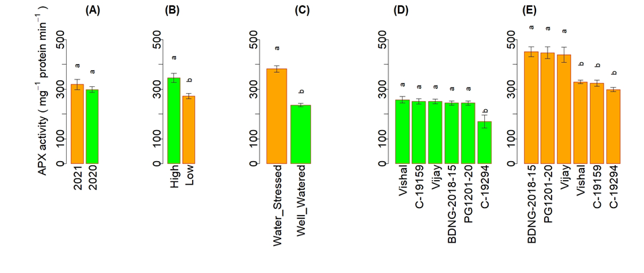
Supplementary Figure 1. Effect of crop season (A) year effect, (B) tissue ascorbic acid (AsA) content, and (C) soil water regime (treatment effect) on ascorbate peroxidase (APX) activity (ascorbate oxidized mg^{–1} protein minute^{–1} (nmol)) of selected AsA-rich and AsA-poor chickpea genotypes. Genotype effects on APX activity (ascorbate oxidized mg^{–1} protein minute^{–1} (nmol)) (D) without stress (well-watered) and (E) with stress (water-stressed). Different letters above bars within a figure indicate significant differences among mean values as computed by Duncan’s multiple range test at a 95% confidence interval.

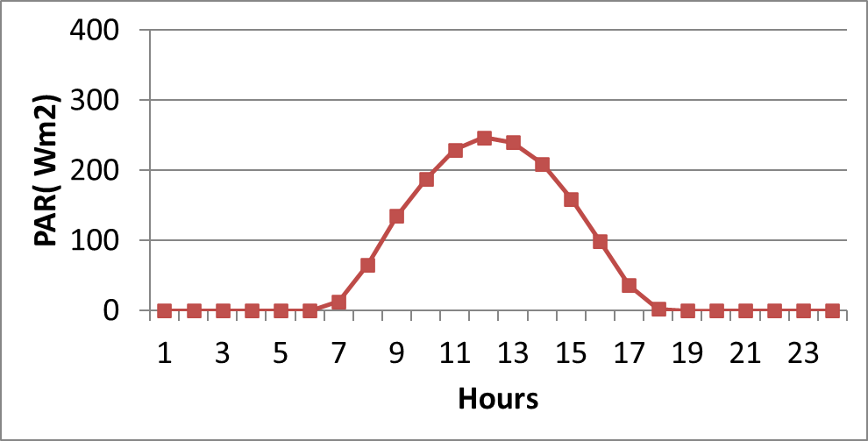
Supplementary Figure 2. Photosynthetically active radiation (W m^{–2}) during leaf sampling for AsA estimation in the last 10 days of October 2020 in the NIASM screenhouse.

Supplementary Tables
Sr No. | Code | Decode | Pedigree | Source
1 | Phule Digvijay | Phule Digvijay | Phule G 91028 x Bheema | MPKV, Rahuri
2 | JG-16 | JG 16 (SAKI 9516) | ICCC 42 x ICCCV -10 | Sehore, Akola & ICRISAT, Hyderabad
3 | PDKV Kanchan | PDKV Kanchan | SAKI 9516 x FG 716 | PDKV, Akola
4 | Phule Vishwas | Phule Vishwas | B-110 x N-31 | MPKV, Rahuri
5 | PG 1107-5 | PG 1107-5 | Phule G 0302-7-3 x ICCV 10107 | MPKV, Rahuri
6 | BDNG-2018-13 | BDNG-2018-13 | BDN 9-3 x BCP 60 | ARS, Badnapur
7 | PG-1221-6 | PG-1221-6 | ICCV 10107 x WR 315 | MPKV, Rahuri
8 | BDNG-2018-16 | BDNG-2018-16 | BCP 60 x Vishal | ARS, Badnapur
9 | PG-1221-1 | PG-1221-1 | ICCV 10107 x WR 315 | MPKV, Rahuri
10 | PG-1216-14 | PG-1216-14 | GJG 0907 x ICCV 92944 | MPKV, Rahuri
11 | Phule Vikram | Phule Vikram | ICCV 10 x ICCL 87322 | MPKV, Rahuri
12 | PG-1816-67 | PG-1816-67 | JAKI 9218 x ICCV 11601 | MPKV, Rahuri
13 | BDNG-2018-15 | BDNG-2018-15 | Vijay x BCP 60 | ARS, Badnapur
14 | Phule Vikrant | Phule Vikrant | Digvijay x WCG 2000-2 | MPKV, Rahuri
15 | PG-1331-4 | PG-1331-4 | ICCV 96854 x Kripa | MPKV, Rahuri
16 | Jaki-9218 | Jaki-9218 | (ICCC 37 x GW 5/7) x ICCV 10 | PDKV, Akola
17 | BDNG-2020-8 | BDNG-2020-8 | BDN 9-3 x ICC 14077 | ARS, Badnapur
18 | BDNG-2018-8 | BDNG-2018-8 | Digvijay x BCP 60 | ARS, Badnapur
19 | BDNG-9-3 | BDNG-9-3 | Selection from local germplasm | ARS, Badnapur
20 | C-1906 | H12-62 | (HC 5 x H00-256) x ICCV 4958 | CCS HAU, Hisar
21 | PG-181608 | PG-181608 | JG 130/ ICCV 11601 | MPKV, Rahuri
22 | PG-1216-10-17 | PG-1216-10-17 | GJG 0907 x ICCV 92944 | MPKV, Rahuri
23 | PG-181117 | PG-181117 | ICCV 96029/ICC 16644/JG 11 | MPKV, Rahuri
24 | BDNG-2017-23 | BDNG-2017-23 | BCG 54-2 x ICC 113 | ARS, Badnapur
25 | PG-181674 | PG-181674 | Genesis 836/GG2/ICC 4958 TM/ JG11 | MPKV, Rahuri
26 | BDNG-797 | Akash | Annegiri x ICCV 6 | ARS, Badnapur
27 | PG-181609 | PG-181609 | ICCV 97105 / ICCV 11601 | MPKV, Rahuri
28 | PG-16115 | PG-16115 | JG 11 x ICC 4958 | MPKV, Rahuri
29 | BDNG-2017 | BDNG-2017 | BCG 54-2 x ICC 113 | ARS, Badnapur
30 | PG-1201-20 | PG-1201-20 | Phule G 96006 x Phule G 07102 | MPKV, Rahuri
31 | C-19480 | CSJ 515 | FG 712 x CSJ 146 | RARI, Durgapura
32 | C-19483 | RSG 888 (Anubhav) | RSG 44 x E 100 ym | RARI, Durgapura
33 | C-19486 | NC 2 | (Pusa 362 x ICC 14649) * Pusa 362 | IARI, New Delhi
34 | C-19492 | BGM 10220 | JAKI 9218 ///JAKI 9218*ICC 4958-09 | IARI, New Delhi
35 | C-19494 | IPC (L4-14) | (DCP92-3 x ICC 4958)* 3DCP92-3 | IIPR, Kanpur
36 | C-19487 | BGM 10218 | (RSG 888 x (RSG 888 x (RSG 888 x ICC 4958)-4 | IARI, New Delhi
37 | C-19482 | IPC (L4-25) | (DCP92-3 x ICC 4958)* 3DCP92-3 | IIPR, Kanpur
38 | C-19493 | IPC (L22-33-2) | (DCP92-3 x ICC 4958)* 3DCP92-3 | IIPR, Kanpur
39 | C-19496 | NBeG 506 | (JG 11 x ICC 4958) x 3*JG 11-35) | RARS, Nandyal
40 | C-19491 | NC 3 | (JG 11 x ICC 14649) * JG 11 | IARI, New Delhi
41 | C-19495 | JG 16 (SAKI 9516) | ICCC 4 x ICCV 10 | Sehore, Akola & ICRISAT, Hyderabad
42 | C-19484 | JG 11 | (Phule G 5 x Narsingpur bold) x (ICCC 37 x ICC 860265- BPB 29 P-BP) | Jabalpur, Sehore& ICRISAT, Hyderabad
43 | C-19490 | Pusa 362 (BG 362) | BG 303 X P 179 | IARI, New Delhi
44 | C-19489 | DCP 92-3 | Selection from local germplasm | IIPR, Kanpur
45 | C-19481 | BG 4005 | Pusa 362 x (Pusa 362 x (Pusa 362 x ICC 4958)-6 | IARI, New Delhi
46 | C-19202 | IPCD 2016-44 | IPC 2008-57 x WR 315 | IIPR, Dharwad
47 | C-19188 | BAUG 106 | JG 11 x ICC 4958 | Ranchi
48 | C-19155 | NBeG 698 | ICCV 03112 x JAKI 9218 | RARS, Nandyal
49 | C-19190 | ADBG487 | ICC4958 TM X JAKI9218 | Adilabad
50 | C-19193 | RVSSG-79 | JG 11 x JSC 52 | RVSKVV, AICRP, RAK, Sehore
51 | C-19209 | RKG 19-1 | JAKI 9218 x ICCV 00108 | ARS, Kota
52 | C-19170 | DC 18-1104 | Genesis 836/JAKI 9218 | Dholi
53 | C-19172 | BUC-1 | Genesis 836 x JAKI 9218 | Banda
54 | C-19159 | GCP-101 | GCP 2 x ICCV2 | JAU, Junagadh
55 | C-19186 | BG 4010 | JG 11/BG 1098 | IARI, New Delhi
56 | C-19187 | PG 227 | M 35 (selection from MAGIC cross involving 8 parents) | GBPAUT, Pantnagar
57 | C-19171 | H12-22 | HC1 x (HC1 x ICCV 96030) | CCS HAU, Hisar
58 | C-19180 | BDNG 2017-44 | Digvijay x ICC 4533 | ARS, Badnapur
59 | C-19199 | JG 2019-155-118 | ICCV 05530 x ICCV 88510 | JNKVV, Jabalpur
60 | C-18189 | GNG 2477 | CNG 1581 x ICC 1251 | ARS, Sriganganagar
61 | C-19185 | BDNG 2017-49 | BDNG 804 x BDNG 797 | ARS, Badnapur
62 | C-19153 | Phule G 171105 | (ICCC 4958 x ICCV 97105) x (ICCV 10 x ICCV 00108) | MPKV, Rahuri
63 | C-19163 | RLBG-6 | JG 14/ICCV 96836 | Jhansi
64 | C-19183 | BG 4011 | F1[F1(ICCC4958 x ICCV) x F1 (Pusa 372 x Pusa 256)] x F1 (Pusa 547 x JAKI 9218) | IARI, New Delhi
65 | C-19176 | IPC 2016-107 | IPC 2009-50 x IPC 2007-88 | IIPR, Kanpur
66 | C-19179 | H13-36 | PDG84-16 x HO4-31 | CCS HAU, Hisar
67 | C-19294 | H15-03 | H96-51 x C235 | CCS HAU, Hisar
68 | C-19291 | GNG2461 | (KWR108 X GNG 1861) X (Pant G 186 X GNG 1958) | ARS, Sriganganagar
69 | C-19315 | GL17004 | PBG 5 x GNG 469 | PAU, Ludhiana
70 | C-19320 | H16-12 | H04-31 x GNG 663 | CCS HAU, Hisar
71 | C-19326 | IPCB 2016-222 | GNG 1581 x IPC 2 004-52 | IIPR, Bhopal
72 | C-19313 | RVSSG-83 | JAKI 9218 x JSC 35 | RVSKVV, AICRP, RAK, Sehore
73 | C-19301 | GNG2479 | CNG 1881 x ICC 12951 | ARS, Sriganganagar
74 | C-19296 | IPC 2016-69 | BG 303 x P 179 | IIPR, Kanpur
75 | C-19307 | GL17033 | ICC 14810 x PBG 1 | PAU, Ludhiana
76 | C-19305 | JG 16 (SAKI 9516) | ICCC 42 x ICCV -10 | Sehore, Akola & ICRISAT, Hyderabad
77 | C-19316 | RSGD-926 | RSG 973 x RSG 143-1 | RARI, Durgapura
78 | C-19300 | GCP 101 | GCP 2 x ICCV2 | JAU, Junagadh
79 | C-19318 | Vijay | P 1270 x Annigeri | MPKV, Rahuri
80 | C-19290 | RKG 19-6 | JG 2000-87 x JG 2000-14-14 | ARS, Kota
81 | C-19309 | DBGC-4 | BGD 103 XTL-II 109 | CER, Patna
82 | C-19295 | BDNG 2017-28 | BDN 9-3 x ICC 4958 | ARS, Badnapur
83 | C-19312 | CJG 1712 | ICCV 03112 x JG 130 | JAU, Junagadh
84 | C-19306 | BG 4015 | BGD 111 / JG 11 | IARI, New Delhi
85 | C-19299 | RVSSG-82 | JG11 x ICC4958 | RVSKVV, AICRP, RAK, Sehore
86 | C-19304 | NBeG 1632 | Genesis 836 x JG 11 | RARS, Nandyal
87 | C-19325 | BG 4014 | ICC x 030026/ WR 315 | IARI, New Delhi
88 | C-19308 | RSGD-1068 | JG-11 x RSG 973 | RARI, Durgapura
89 | C-19310 | RKG 19-5 | JG 11 x ICC 4958 | ARS, Kota
90 | C-19293 | Phule G 1107-5 | Phule G 0302-7-3 x ICCV 10107 | MPKV, Rahuri
91 | C-19319 | Phule G 1201-20 | Phule G 96006 x Phule G 07102 | MPKV, Rahuri
92 | C-19323 | BDNG 2017-21 | BCP 26 x Vishal | ARS, Badnapur
93 | C-19317 | IPC 2015-267 | DCP 92-3 x IPCK 2002-29 | IIPR, Kanpur
94 | C-19298 | CJG 1721 | JG 11 x ICC 4958 | JAU, Junagadh
95 | C-19321 | NBeG 857 | ICC 12419 X JG 11 | RARS, Nandyal
96 | PG-1012-15 | PG-1012-15 | Phule G 0748 x ICCV 09112 | MPKV, Rahuri
97 | PG-0914-6-17 | PG-0914-6-17 | Phule G 0403-7 x AKG 70 | MPKV, Rahuri
98 | PG-171104 | PG-171104 | (ICC 4958 x ICCV 10) x (ICCV 93952 x ICCV 93954) | MPKV, Rahuri
99 | PG-1131-9 | PG-1131-9 | [(Phule G 0403-7 x PBC 101) x Phule G 0403-7] x PBC 101 | MPKV, Rahuri
100 | PG-1010-14 | PG-1010-14 | [(Phule G 0403-7 x PBC 101) x Phule G 0403-7] x PBC 101 | MPKV, Rahuri
101 | PG-1231-10 | PG-1231-10 | (PDG-90-2E x WR-315) x Phule G-2007-10) | MPKV, Rahuri
102 | PG-15109 | PG-15109 | ICCV 93952 x ICCV 94954 | MPKV, Rahuri
103 | PG-1226-14 | PG-1226-14 | JG-25 x Vijay | MPKV, Rahuri
104 | PG-1331-31-4 | PG-1331-31-4 | ICCV 96854 x Kripa | MPKV, Rahuri
105 | Vishal | Vishal | K-850 x ICCL-80074 | MPKV, Rahuri
106 | Vijay | Vijay | P-1270 x Annigeri | MPKV, Rahuri
Supplementary Table 1. Chickpea genotypes screened for ascorbic acid (AsA) at 30±1% field capacity.

 | Genotypes | Leaf AsA (µg g^{–1} FW) | Seed AsA (µg g^{–1} FW)
1 | BDNG-2018-15 | 367.12 | 132.99
2 | PG-1201-20 | 361.25 | 133.57
3 | C-19315 | 357.34 | 126.98
4 | C-19186 | 349.51 | 131.50
5 | Vikrant | 323.37 | 124.50
6 | BDNG-2017 | 312.71 | 66.33
7 | PG-1012-15 | 309.50 | 69.22
8 | C-19190 | 309.01 | 109.32
9 | C-19291 | 308.79 | 66.51
10 | JG-16 | 306.84 | 69.08
11 | C-194-90 | 305.95 | 94.76
12 | C-19308 | 305.59 | 64.96
13 | PG-1231-5-10 | 304.35 | 71.28
14 | C-19319 | 303.64 | 84.04
15 | C-194-93 | 302.96 | 99.47
16 | C-19484 | 301.68 | 72.63
17 | BDNG-2018-16 | 301.15 | 86.20
18 | C-19320 | 301.15 | 97.81
19 | C-19301 | 300.61 | 88.47
20 | C-19305 | 299.55 | 84.27
21 | C-19313 | 299.55 | 75.41
22 | PG-1331-31-4 | 299.37 | 101.55
23 | PG-181609 | 299.19 | 102.35
24 | C-19171 | 298.84 | 96.02
25 | C-19293 | 298.66 | 104.82
26 | C-19491 | 297.23 | 85.86
27 | C-19183 | 296.70 | 103.86
28 | BDNG-2018-13 | 296.35 | 121.60
29 | C-19296 | 295.99 | 106.96
30 | C-19202 | 295.81 | 67.57
31 | PG-181117 | 295.81 | 85.42
32 | C-19155 | 295.28 | 103.58
33 | C-19-4-83 | 294.31 | 95.34
34 | C-18189 | 294.21 | 106.43
35 | BDNG-2017-23 | 294.21 | 104.07
36 | BDNG-2018-8 | 292.97 | 111.66
37 | C-19170 | 292.81 | 102.06
38 | PG-16115 | 292.26 | 71.48
39 | BDNG-2020-8 | 292.08 | 88.38
40 | C-19179 | 292.08 | 85.73
41 | C-19496 | 290.83 | 89.81
42 | C-19321 | 289.94 | 58.64
43 | PG-171104 | 289.06 | 73.63
44 | C-19188 | 288.80 | 97.97
45 | C-19326 | 288.70 | 104.65
46 | C-19486 | 288.52 | 104.40
47 | C-19209 | 288.44 | 83.89
48 | C-19482 | 288.34 | 89.52
49 | C-19185 | 288.17 | 90.72
50 | C-19487 | 287.99 | 75.75
51 | Jaki-9218 | 287.81 | 97.56
52 | C-19187 | 287.63 | 104.48
53 | C-19323 | 287.10 | 96.28
54 | C-19163 | 286.57 | 104.55
55 | BDNG-797 | 286.57 | 122.54
56 | C-19176 | 286.39 | 80.97
57 | C-19199 | 286.39 | 95.40
58 | C-19180 | 285.85 | 90.56
59 | C-19492 | 285.68 | 97.15
60 | PG-1010-14 | 285.14 | 88.63
61 | BDNG-9-3 | 284.79 | 90.15
62 | PG-1216-10-17 | 283.19 | 115.02
63 | PG-181674 | 282.83 | 92.46
64 | PG-1221-6 | 282.65 | 103.31
65 | PG-1331-4 | 281.59 | 116.10
66 | C-19325 | 280.34 | 56.99
67 | C-19494 | 279.10 | 103.58
68 | C-19153 | 277.85 | 102.95
69 | C-19172 | 277.50 | 91.41
70 | PDKV Kanchan | 277.32 | 120.44
71 | C-19317 | 275.36 | 95.85
72 | Digvijay | 274.12 | 107.78
73 | PG-1216-14 | 273.23 | 95.35
74 | C-19310 | 272.87 | 64.02
75 | PG-181608 | 272.70 | 83.31
76 | PG-1510-9 | 272.52 | 60.63
77 | C-19193 | 272.16 | 85.37
78 | C-19298 | 271.63 | 64.22
79 | C-1906 | 271.63 | 96.09
80 | C-19495 | 270.92 | 59.83
81 | PG-1221-1 | 270.74 | 103.42
82 | C-19316 | 270.21 | 81.14
83 | C-19481 | 270.03 | 98.47
84 | Vishwas | 269.14 | 121.38
85 | Vikram | 267.36 | 85.54
86 | PG-1131-31-9 | 267.18 | 77.46
87 | C-19307 | 267.01 | 72.35
88 | PG 1107-5 | 265.58 | 85.26
89 | C-19318 | 265.58 | 67.33
90 | PG-0914-6-17 | 264.87 | 61.67
91 | C-19306 | 263.81 | 84.83
92 | PG-1816-67 | 262.74 | 115.69
93 | C-19299 | 262.74 | 112.97
94 | C-19312 | 260.43 | 66.79
95 | C-19290 | 260.07 | 68.12
96 | C-19304 | 254.74 | 106.30
97 | C-19309 | 251.71 | 72.52
98 | C-19480 | 233.65 | 94.85
99 | C-19295 | 218.11 | 69.23
100 | PG-1226-3314 | 208.33 | 48.08
101 | C-19489 | 194.28 | 114.41
102 | C-19300 | 188.77 | 50.20
103 | C-19294 | 186.28 | 46.31
104 | C-19159 | 179.87 | 47.79
Supplementary Table 2. Ascorbic acid (AsA) content in fresh leaves (µg g^{–1} FW) at 30±1% field capacity and in seeds (µg g^{–1} FW) of diverse chickpea genotypes.
Hours | Photosynthetically active radiation (W m^{–2}) | Standard error
0 | 0.00 | 0.00
1 | 0.00 | 0.00
2 | 0.00 | 0.00
3 | 0.00 | 0.00
4 | 0.00 | 0.00
5 | 0.00 | 0.00
6 | 12.63 | 0.13
7 | 65.45 | 0.30
8 | 135.05 | 0.20
9 | 187.71 | 0.31
10 | 229.49 | 0.32
11 | 246.59 | 0.15
12 | 239.88 | 0.14
13 | 209.09 | 0.17
14 | 159.12 | 0.21
15 | 98.39 | 0.23
16 | 35.85 | 0.21
17 | 2.37 | 0.08
18 | 0.00 | 0.00
19 | 0.00 | 0.00
20 | 0.00 | 0.00
21 | 0.00 | 0.00
22 | 0.00 | 0.00
23 | 0.00 | 0.00
Supplementary Table 3. Photosynthetically active radiation (W m^{–2}) during leaf sampling for AsA estimation in the last 10 days of October 2020 in the NIASM screenhouse.

