SUPPLEMENTARY INFORMATION
Table of Contents
1. DISCOVERY STUDY 2
1.1 METHODS 2
1.1.1 Participants, general protocol and exclusions 2
1.1.2 Task differences between discovery study and main study 2
1.1.3 Computational models 3
1.1.4 Mixed effects models 3
1.2 RESULTS 3
1.2.1 Credible feedback promotes greater learning 3
1.2.2 Substantial deviations from Bayesian Learning 5
1.2.3 The effect of non-credible feedback and learning 5
1.2.4 Exaggerated learning for fully credible feedback 5
1.2.5 Individuals show a positivity bias in learning, particularly for sources of limited credibility. 7
1.2.6 True feedback elicits greater learning 8
2. ADDITIONAL SUPPLEMENTARY FIGURES 10
3. SUPPLEMENTARY STATISTICS 14
3.1. Mixed-effects model results 14
3.1.1 Main study 14
3.1.2 Discovery study 23
3.2. Additional analyses of model parameters main study 30
3.2.1 Main study 30
3.2.2. Discovery study 31
3.3 Parameter recovery 33
4. SUPPLEMENTARY BAYESIAN DERIVATIONS 36
4.1. Derivation of posterior update for Bayesian model 36
References 36

1. DISCOVERY STUDY

1.1 METHODS
The methods in our discovery study were similar to the ones in our main study. Here we specify only the methodological differences between the two studies.

1.1.1 Participants, general protocol and exclusions
We recruited 111 participants (mean age 36.23± 11.26, 50 female) from the Prolific participant pool (www.prolific.co) who performed the task in the Gorilla platform ¹. All participants were fluent English speakers with normal or corrected-to-normal vision and a Prolific approval rate of 95% or higher. The UCL Research Ethics Committee approved the study (Project ID 6649/004), and all participants provided informed consent before the experiment.
The participants took on average 60 minutes to complete the experiment. They received a fixed compensation of 6 GBP and variable compensation between 0 and 2 GBP based on their performance on the disinformation task.
Based on the same exclusion criteria from the main task, 7 participants were excluded, while 104 participants were kept for the analyses.

1.1.2 Task differences between discovery study and main study
In the discovery study participants also completed a traditional version of the two-armed bandit task. The task was like the one in the main study, but each block featured a single bandit pair. Participants completed 6 blocks in total (of 16 trials each), 3 before the disinformation task and 3 right after.
The disinformation task in the discovery study worked as the one in the main study, but with a three main differences. Firstly, it included 4 feedback agents, with credibilities of 50%, 70%, 85% and 100%, represented by 1, 2, 3, and 4 stars, respectively (Fig. S1a). Each experimental block consisted of a single bandit pair, presented over 16 trials (with 4 trials for each feedback agent). Participants completed a total of 15 blocks: in 5 of them the bandits had 25% and 75% probability; while in the remaining 10 blocks, the two bandits within a pair were equally rewarding, with a reward probability randomly sampled between 60 and 80%.
At the end of the experiment, a subset of participants (n=79) completed eight standard self-report questionnaires: 1) the Obsessional Compulsive Inventory - Revised (OCI-R)², assessing symptoms of obsessive-compulsive disorder (OCD); 2) The Revised Green et al. Paranoid Thoughts Scale (R-GPTS) ³, measuring paranoid ideations; 3) the DOG scale⁴, evaluating dogmatism; 4) the autism-spectrum quotient (AQ)⁵, assessing symptoms of autism spectrum disorder; 5)the Adult ADHD Self-Report Scale (ASRS)⁶, for attention-deficit/hyperactivity disorder; 6) the GAD-7 scale⁷ for generalized anxiety disorder; 7) the self-rating depression scale (SDS)⁸; and 8) and the Barratt Impulsiveness scale (BIS) for impulsivity⁹.

1.1.3 Computational models

RL MODELS
The RL models in the discovery task were analogous to the ones in the main task but included extra free CA parameters to accommodate the use of 4 (instead of 3) feedback agents.
Table 1: summary of free parameters for each of the CA models.
Model | Free CA parameter
Null | $$CA$$
Credibility-CA | $$CA_{0.5},CA_{0.7},CA_{0.85},CA_{1}$$
Credibility-Valence-CA | $$CA_{0.5}+,CA_{0.7}+,CA_{0.85}+CA_{1}+$$  $$CA_{0.5}-,CA_{0.7}-,CA_{0.85}-,CA_{1}-$$
constant feedback-valence bias CA | $$VB$$  $$CA_{0.5}-,CA_{0.7}-,CA_{0.85}-,CA_{1}-$$
Truth-CA | $$CA_{0.5}^{true},CA_{0.7}^{true}, CA_{0.85}^{true}, CA_{1}^{true}$$  $$CA_{0.5}^{lie},CA_{0.75}^{lie},CA_{0.85}^{lie}$$

BAYESIAN MODELS
The Bayesian models in the discovery study worked like the one in the main study. In the free-credibility Bayesian model, we fixed the 4-star agent credibility to 1 but estimated the credibility of the three lying agents as free parameters.

1.1.4 Mixed effects models
The mixed-effects models in our discovery study used the same regressors as in our main study, replacing (AGENT_{2-star} + AGENT_{3-star}) with (AGENT_{2-star} + AGENT_{3-star} + AGENT_{4-star}) to account for the fact that the task featured four (instead of three agents). Moreover, when regressing the CA parameters from truth-CA model on agent-credibility and feedback truthfulness, we replaced the regressor CREDIBILITY with regressors indicating the presence/absence of the 2-star and 3-star agents (AGENT_{2-star} + AGENT_{3-star}).

1.2 RESULTS

1.2.1 Credible feedback promotes greater learning
To test whether participants modulated their learning based on feedback credibility, we regressed in a binomial mixed-effects model, choice-repetition, on feedback-valence (negative or positive) and the agent-credibility (1,2,3 or 4-star) from the last trial (Fig. S2a) (see SI 1.1.3 for full model description). Consistent with findings in the main task, we found that feedback valence exerted a positive effect on choice-repetition (b=1.02, F(1,2462)=617.38, p<0.001), and it interacted with agent-credibility (F(3,2462)=196.61, p<0.001), such that, the feedback effect was larger for more credible agents (4-star vs. 3-star: b=1.21, F(1,2462)=137.71; 4-star vs. 2-star: b=0.47, F(1,2462)=322.88; 4-star vs. 1-star: b= 2.55, t(2462)=22.91; 3-star vs. 2-star: =2.03, F(1,2462)=40.54; 3-star vs. 1-star: b=1.24, t(2462)=11.25; and 2-star vs. 1-star: b=0.52, t(2462)=4.74, all p’s<0.001). Additionally, we found a positive feedback-effect for the 4-star agent (b=2.46, F(1,2462)= 911.81, p<0.001), a smaller feedback-effect for the 3-star agent (b=1.15, F(1,2462)=206.19, p<0.001), and an even smaller feedback-effect for the 2-star agent (b=2.03, F(1,2462)=40.54, p<0.001). Such increased learning as a function of feedback credibility was predicted by simulations based on the instructed-credibility Bayesian, free-credibility Bayesian and credibility-CA models, but not by the null-CA model (Fig. S2b).
We next examined how the Maximum Likelihood (ML) CA parameters from the credibility-CA model differed as a function of feedback credibility (Fig. S2c). We regressed, using a mixed effects model (Methods and SI 1.1.4), the CA parameters on their associated agent, showing that CA differed across the agents (F(3,412)=98.77, p<0.001), increasing as a function of agent-credibility (4-star vs. 3-star: b=0.49, F(1,412)=99.94; 4-star vs. 2-star: b=0.89, F(1,412)=330.15; 4-star vs. 1-star: b= 1.4, Ft(412)=28.5 ; 3-star vs. 2-star: b=0.4, F(1,412)=66.8; 3-star vs. 1-star: b=0.91, t(412)=18.5; and 2-star vs. 1-star: b=0.51, t(412)=10.33, all p’s<0.001).
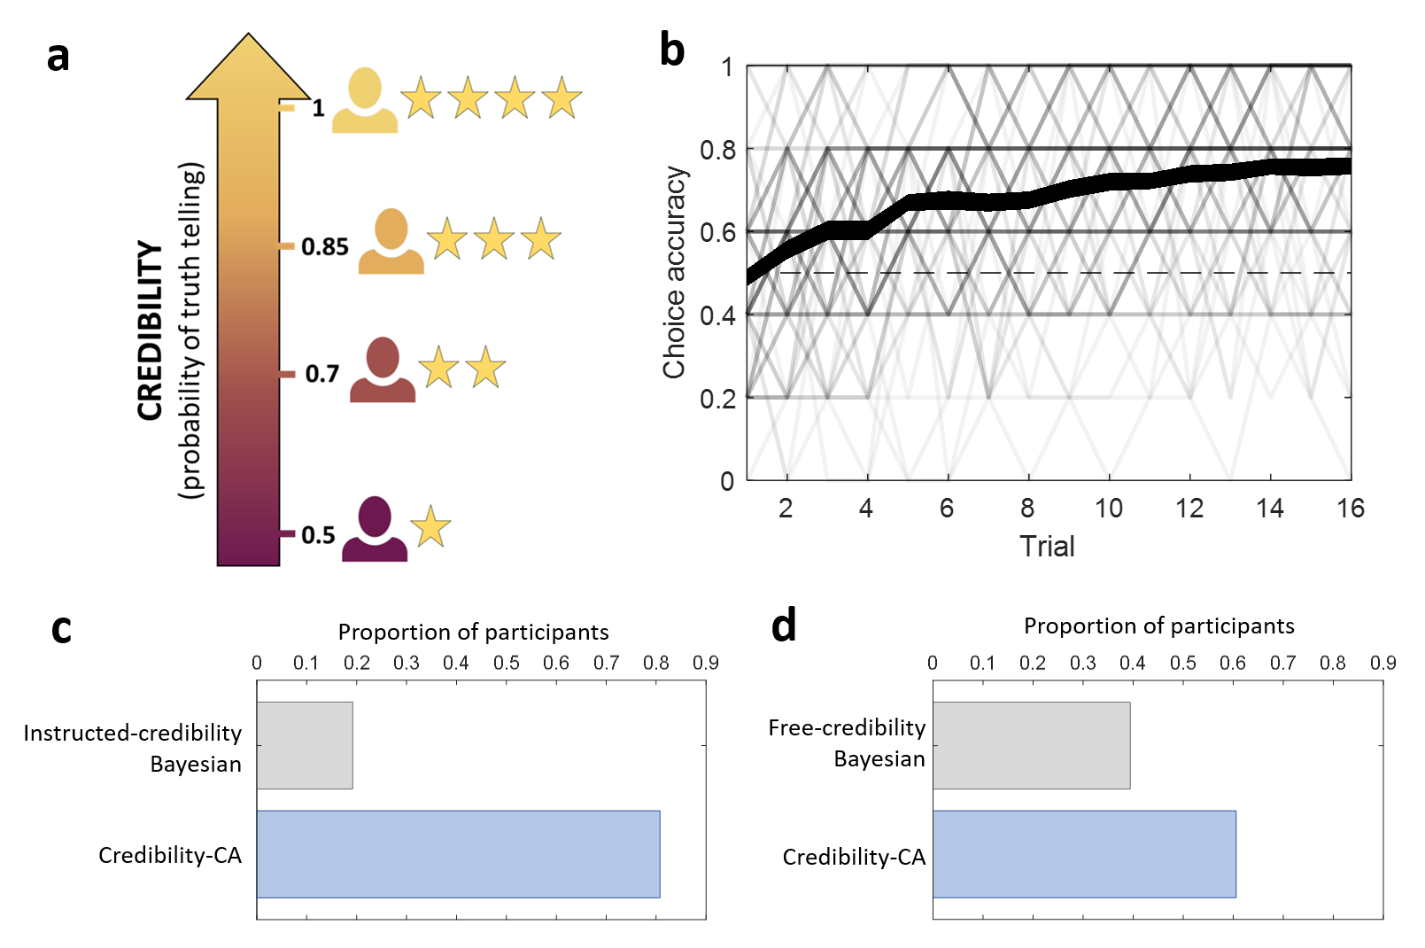
SI Figure 1: Task design, performance and model selection in discovery study. a, During the task participants received feedback from 4 feedback agents, varying in their credibility (i.e., truth-telling probability). The credibility of the agents was represented using a star-based system: the 4-star agent always reported the truth (and never lied), whereas the 3-star agent reported the truth on 85% of the trials (lying on the remaining 15%), the 2-star agent reported the truth on 70% of the trials (lying on the remaining 30%), and the 1-star agent reported the truth half of the time (lying on the other half). Participants were explicitly instructed and quizzed about the credibility of each agent prior to the task. b, Learning curve. Average choice accuracy as a function of trial number (within a bandit-pair). Thin lines: individual participants; thick line: group mean with thickness representing the group standard error of the mean for each trial. c,d, Model selection between the credibility-CA model and the two variants of Bayesian models. Most participants were best fitted by the credibility-CA model, compared to the instructed-credibility Bayesian (c) or free-credibility Bayesian (d) models.

1.2.2 Substantial deviations from Bayesian Learning
Model comparisons between each of the Bayesian models and the credibility-CA revealed that the credibility-CA model provided a superior fit for 80.8% of participants (sign test; z=6.17, p<0.001) when compared to the instructed-credibility Bayesian model (Fig. S1c), and for 60.6% (z=2.06, p= 0.03) when compared with the free-credibility Bayesian model (Fig. S1d). In line with the main study, this suggests most of the participants deviated from normative learning.
The Bayesian-CA parameters revealed that both the instructed-credibility and free-credibility Bayesian models predicted increased Bayesian-CA parameters as a function of agent credibility (Fig. S2c; See SI 3.1.2.2). We next test whether the different deviations from normative Bayesian learning that we described in the main study are still present in the discovery study.

1.2.3 The effect of non-credible feedback and learning
In the main study, we found evidence supporting the idea that participants update their beliefs based on random feedback (a positive feedback effect for the 1-star agent on choice-repetition and a positive CA parameter). However, corresponding analyses for the discovery task revealed neither a feedback-effect on choice-repetition (mixed effects model, b=-0.09, t(2462)=-1.21, p=0.22; Fig. S2a), nor positive credit-assignment (b=-0.13, t(412)=-1.07, p=0.28; Fig. S2c) for the 1-star agent. Moreover, based on the free-credibility Bayesian model, we found no evidence ML-estimated credibility for the 1-star agent differed from 0.5 (Wilcoxon signed-rank test, median=-0.02, z=-0.29, p=0.76; Fig. S2d). Importantly, we show below that feedback from this agent was not fully ignored as it still elicited a positivity bias. Incidentally, using the free-credibility Bayesian model we found the ML-estimated credibility increased as a function of instructed agent-credibility (Wilcoxon signed-rank test; 3-star vs 2-star, median=0.13, z=6.75; 3-star vs 1-star, median=0.28, z=7.45; 2-star vs 1-star, median=0.10 z=4.54; all p’s<0.001), and was lower than the instructed credibility for the 2-star (median=-0.06 z=4.90, p<0.001) and 3-star agents (median=-0.27, z=-4.49, p<0.001). In line with the main study, this finding suggests that participants tend to underestimate the credibility of agents with intermediate levels of credibility.

1.2.4 Exaggerated learning for fully credible feedback
Consistent with the main study, both Bayesian models predicted an attenuated credit-assignment for the fully credible agent (Wilcoxon signed-rank test; instructed-credibility Bayesian model: median difference=0.67 z=6.70; free-credibility Bayesian model: median difference=0.26, z=4.28, all p’s<0.001). We did not analyse the effects of the credibility context on learning, since this task affords no instances where the credibility context featured a separate bandit pair (because our discovery task featured a single bandit-pair per block).

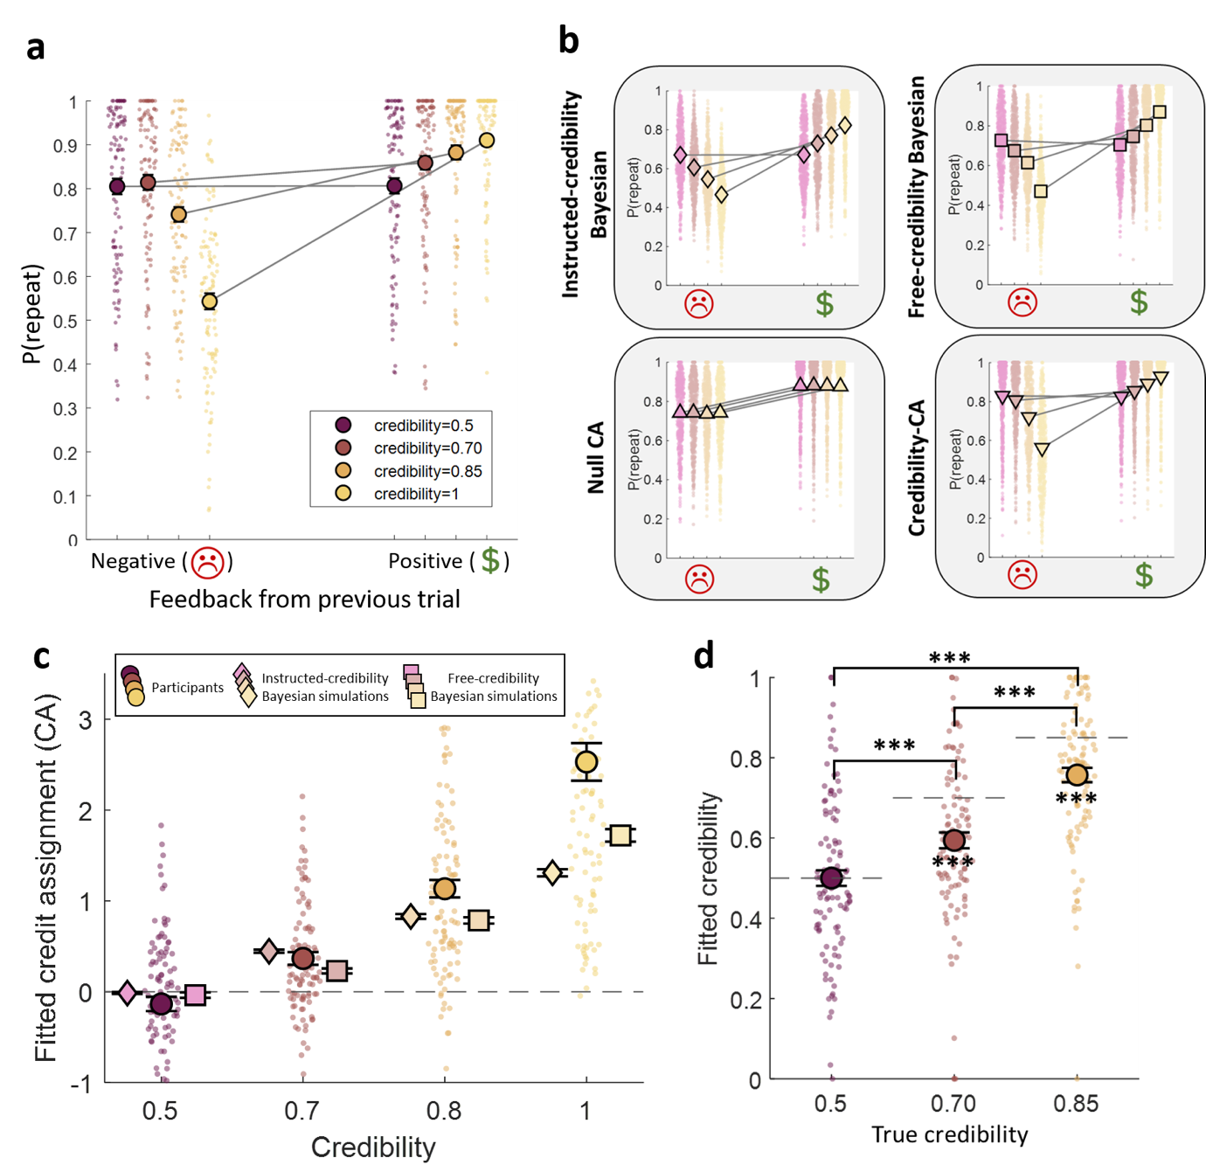
SI Figure 2: Learning adaptations to credibility in discovery study. a, Probability of repeating a choice as a function of feedback-valence and agent-credibility on the previous trial with the same bandit pair. As in the main study, the effect of feedback-valence on repetition increases as feedback credibility increases, indicating that more credible feedback has a greater effect on behavior. b, Same analysis as in panel a, but for synthetic data obtained by simulating the main models. Simulations were computed using the ML parameters of participants for each model. c, ML credit assignment parameters for the credibility-CA model. Consistent with the main study, participants show a CA increase as a function of agent-credibility, as predicted by cross-fitting parameters from instructed-credibility Bayesian and free-credibility Bayesian model simulations. However, we find no evidence for a positive CA for the 1-star agent. d, ML credibility parameters for a free-credibility Bayesian model attributing credibility 1 to the 4-star agent but estimating credibility for the three lying agents as free parameters. Small dots represent results for individual participants/simulations, big circles represent the group mean (a,b,d) or median (c) of participants’ behavior. Results of the synthetic model simulations are represented by diamonds (instructed-credibility Bayesian model), squares (free-credibility Bayesian model), upward-pointing triangles (null-CA model) and downward-pointing triangles (credibility-CA model). Error bars show the standard error of the mean. (*) p<.05, (**) p<0.01,(***) p<.001.

1.2.5 Individuals show a positivity bias in learning, particularly for sources of limited credibility.
Next, we turned to test whether, in the discovery study, participants showed greater learning from positive (instead of negative) feedback. We regressed in a mixed-effects model the ML parameters from the credibility-valence-CA model (Fig. S3a) on their associated agent-credibility and valence (see SI Discovery study methods). As in the main study, this revealed an overall positivity bias in credit-assignment (b=0.94, F(1,824)=42.60, p<0.001). Furthermore, participants assigned negative credit based on negative feedback from the 1-star agent (b=-0.51, F(1,824)=3.89, p=0.049), and positive credit based on positive feedback from the same agent (b=0.42, F(1,824)=5.74, p=0.017). Critically, this suggests that in agreement with conclusions from the main task, participants do not ignore random feedback. Instead, at the group level, both negative and positive feedback from the 1-star agent led to a value increase of the selected bandit. Participants selectively assigned positive credit to positive feedback from the 2-star agent (b=1.25, F(1,824)=16.34, p<0.001), with no evidence for CA based on negative feedback (b=-0.34, F(1,824)=2.53, p=0.11). For the 3-star and 4-star agents, credit-assignment was positive for both positive (3-star: b=2.28, F(1,824)=71.28; 4-star: b=2.91, F(1,824)=183.22; p<0.001) and negative (3-star: b=0.86, F(1,824)=37.77; 4-star: b=2.60, F(1,824)=146.55; p<0.001) feedback.
In line with the main task, free-credibility Bayesian-CA parameters revealed a negativity bias (b=-0.71, F(1,824)=49.8, p<0.001; Fig. S3a), and lower absolute valence bias indices than the ones from participants for all credibility levels (Fig. S3b) [Wilcoxon signed-rank test, 50% credibility (median difference=1.43, z=3.99, p<0.001), 70% credibility (median difference=1.70, z=5.44, p<0.001), 85% credibility (median difference=1.59, z=4.78, p<0.001) and 100% credibility (median difference=1.06, z=3.06, p=0.002)]. Results supporting the same conclusions were observed for instructed-credibility Bayesian-CA parameters (See SI 3.1.2.3 and 3.2.2.2). These results confirm that the detected positivity bias represent a departure from normative Bayesian learning.
In the main study, we found no group-level evidence positivity-bias was modulated by agent-credibility in absolute terms. However, in the discovery study, the mixed effects regressing the credibility-valence-CA model parameters (Fig. S3a-b) revealed a significant interaction effect between feedback valence and credibility on CA (F(3,824)=3.28 p=0.02), such that the valence effect for the 2-star agent was larger than the one for the 4-star gent (b=1.29, F(1, 824)=9.84, p=0.002), with no significant valence effect difference between other agent pairs (see SI Supplementary statistics 4.3 Table 30). Moreover, while the valence effect for the lying agents was significantly positive (1-star: b=0.94, t(824)=3.24, p<0.001; 2-star: b=1.60, F(1, 824)=30.21, p=0.001; 3-star: b=0.94, F(1, 824)=10.63, p=0.001), we found no evidence for a positivity bias for the 4-star agent (b=0.31, F(1, 824)=1.12, p=0.29). In contrast, we found no evidence for an interaction between feedback valence and credibility based on free-credibility Bayesian-CA (Fig. S3b; F(3,824)=0.11 p=0.95) and instructed-credibility Bayesian-CA (F(3,824)=0.25 p=0.85) parameters. These results suggest that participants show a heightened positivity bias (measured in absolute terms) in response to low-credibility feedback.
The positivity bias measured relative to the overall extent of learning (i.e., the rVBI) was significantly positive for low-credibility feedback [Wilcoxon signed-rank test, 50% credibility (median=0.57, z=4.43), 70% credibility (median =1.00, z=5.62), and 85% credibility (median=0.31, z=4.12); all p’s<0.001] (Fig. S3c). However, we found no evidence for positive rVBI for the fully credible agent (Wilcoxon signed-rank test, median=-0.02, z=0.53, p=0.59). Moreover, in line with the main study, we found that the rVBI varied depending on the credibility of feedback (Friedman test, χ2(3) = 49.6, p<0.001), such that the rVBI for 4-star agent was lower than the one for any of the low-credibility agents [Wilcoxon signed-rank test, 50% credibility (median difference=0.31, z=4.19), 70% credibility (median difference=0.62, z=5.60), and 85% credibility (median difference=0.25, z=4.13); all p’s<0.001]. The rVBI for 70% credibility agent was higher than the one for the 85% credibility agent (Wilcoxon signed-rank test, median difference=0, z=2.58, p=0.01). Feedback with 50% credibility yielded similar rVBI values to feedback with and 70% (Wilcoxon signed rank tests, median difference= 0, z = 1.49, p = 0.13) or 85% credibility (median difference=0, z = 0.81, p = 0.41). Notably, the rVBI based on free-credibility Bayesian-CA (Fig. S3c) and instructed-credibility Bayesian-CA parameters was significantly below 0 for all credibility levels and did not differ significantly across agents (See SI 3.2.2.3). These results support the same conclusion from the main study, suggesting that positivity bias, relative to the overall extent of CA, is higher for lying, compared to fully-credible, agents.

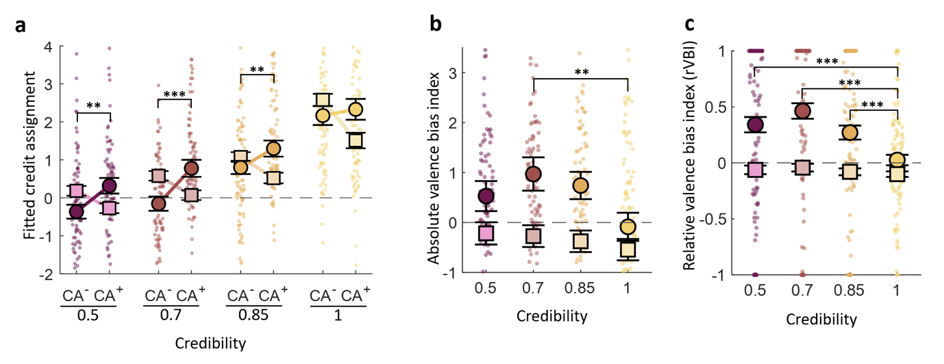
SI Figure 3: Positivity bias as a function of agent-credibility in the discovery study. a, Maximum likelihood parameters from the credibility-valence-CA model. CA+ and CA- are free parameters representing credit assignments for positive and negative feedback respectively (for each credibility level). The data revealed a positivity bias (CA+ > CA-) for feedback of low-credibility, but not for fully credible feedback. b, Absolute valence bias index (defined as CA⁺-CA⁻) based on the ML parameters from the credibility-valence CA model. Positive values indicate a positivity bias, while negative values represent a negativity bias. c, Relative valence bias index (rVBI, defined as (CA⁺-CA⁻)/(|CA⁺|+|CA⁻|)) based on the ML parameters from the credibility-valence CA model. Positive values indicate a positivity bias, while negative values represent a negativity bias. Small dots represent fitted parameters for individual participants and big circles represent the group median (a,b) or mean (c) (both of participants’ behavior), while squares are the median or mean of the fitted parameters of the free-credibility Bayesian model simulations. Error bars show the standard error of the mean. (**) p<.01, (***) p<.001 for ML fits of participants behavior.

1.2.6 True feedback elicits greater learning
We next assessed whether participants infer whether the feedback they received on each trial was true or false and adjust their credit assignment based on this inference. Participants can, in principle, use their posterior truthfulness beliefs to discriminate true from false feedback (1-star agent: mean difference=0.10, t(103)=20.91; 2-star agent: mean difference=0.09, t(103)=18.94; 3-star agent: mean difference=0.057, t(103)=11.68; all p’s<0.001) (Fig. S4a and Fig. S9b).
We again used the “Truth-CA” model to obtain estimates for the average levels of credit assignment for true and false-feedback trials for each agent. We regressed, in a mixed effects model, the ML parameters for the non-credible agents on agent-credibility (1,2, or 3-star) and truthfulness of their associated feedback (see SI 1.1.4). In line with the main study, we found a main effect of truthfulness (b=0.22 F(1,618)=4.87, p=0.028; Fig. S4b) showing participants assigned higher credit based on true compared to false feedback. However, in contrast with the main results, this effect was qualified by an interaction between the effect of truthfulness and agent-credibility (F(2,618)=4.21 p=0.015), such that the truth effect for the 3-star agent was selectively positive (1-star: b=-0.05, t(618)=-0.31, p=0.76; 2-star: b=0.10 F(1,618)=0.30 p=0.59; 3-star: b=0.64 F(1,618)=12.90 p<0.001). Moreover, the truthfulness effect for the 3-star agent was larger than the one for the 2-star (b=0.54 F(1,618)=4.64 p=0.032) and the 1-star agents (b=0.69, t(618)=2.76, p=0.006). Strikingly, model-simulations (Methods) showed both the main truthfulness effect and the effect for the 85%-credibility agent are predicted by none of the other models (Fig. S4c and S4d) (See SI 3.1.2.4). As in the main study, these results suggest that participants infer whether feedback is true or not, and subsequently modulate credit-assignment (albeit, here there is evidence for this process only for the 3-star agent).

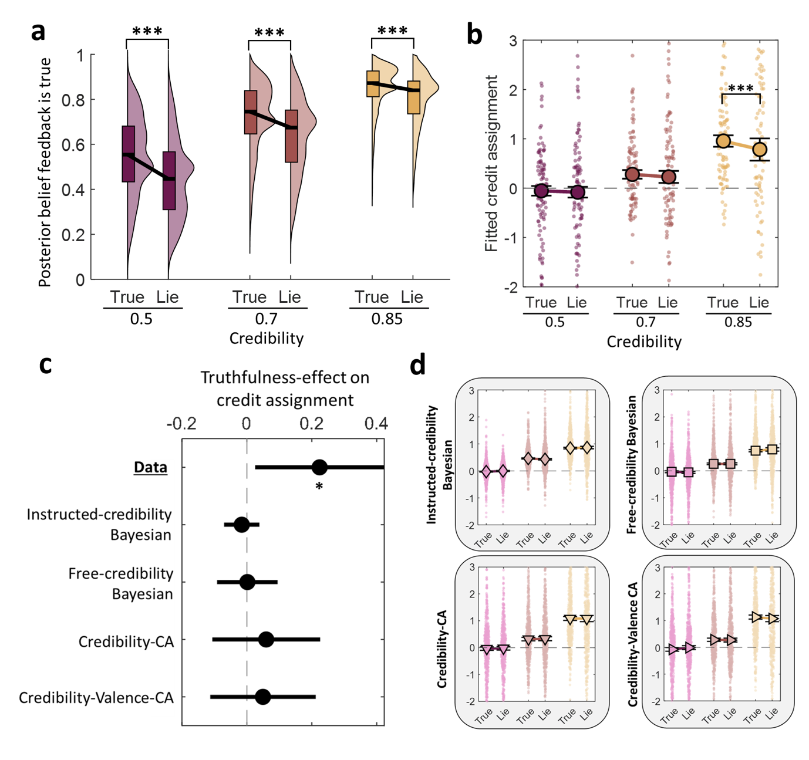
SI Figure 4: Credit assignment is higher on true-feedback trials in the discovery study. a, Distribution of posterior belief probability that feedback is true calculated separately for each agent (1,2 or 3 star) and objective feedback-truthfulness (true or lie). These probabilities were computed based on trial-sequences and feedback participants experienced, revealing that belief probabilities that feedback is true are higher in truth compared to lie trials. For illustration, plotted distributions pool trials across participants. The black line within each box represents the median, upper and lower bounds represent the third and first quartile respectively. The width of each half-violin plot corresponds to the frequency of each posterior belief value among all trials for a given condition. b, ML parameters for the “Truth-CA” model. Credit assignment parameters (y-axes) are shown as a function of agent-credibility and feedback-truthfulness (x-axes). The data revealed higher Credit assignment was higher for true compared to false feedback (CA^{true}>CA^{lie}) for the agent of 85% credibility. Small dots represent fitted parameters for individual participants, big circles represent the group median, and error bars show the standard error of the mean. c, Effect of feedback-truthfulness on CA for the 85%-credibility agent calculated for participants and for synthetic simulations of the alternative models. Effects were estimated by regressing ML CA parameters of the 1-star, 2-star and 3-star agents and on the truthfulness of their associated feedback. Lines represent 95% confidence intervals around the estimated effect coefficient. d, ML parameters based on synthetic simulations of the alternative models. Simulations were computed using the ML parameters of participants for each model. None of these models predicted higher credit assignment for true compared to false feedback overall, or for the 85%-credibility agent specifically. Small dots represent fitted parameters for individual simulations, diamonds represent the median value, and error bars show the standard error of the mean. (*) p<.05 and (***) p<.001

2. ADDITIONAL SUPPLEMENTARY FIGURES
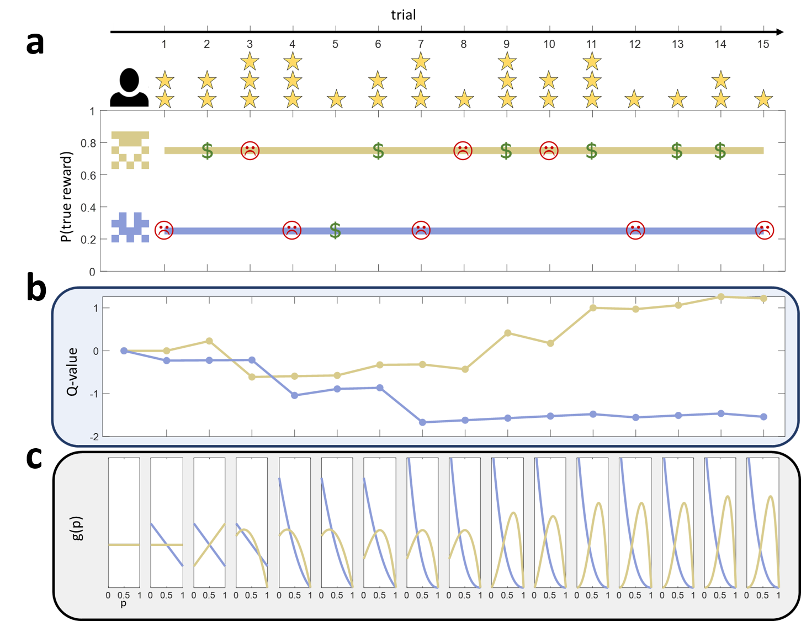
SI Figure 5: Illustration of computational models over 15 trials with an example bandit-pair. a, Example block with a bandit pair. The top bandit provided true rewards 75% of the time, while the bottom bandit did so 25% of the time. The agent providing feedback on each trial is represented above the plot, while the feedback is depicted in the horizontal line of the bandit selected for that trial. Dollar signs represent positive feedback, while sad emojis represent negative feedback. b, Values of the two bandits computed based on credibility-CA model. The values are represented as a point estimates (i.e., Q-values). On each trial, the Q-value of the selected bandit is updated based on the feedback valence and credibility. Values correspond to ends of trials following credit-assignment. c, Posterior beliefs about the true reward probabilities of the bandits, computed using the instructed-credibility Bayesian model. The x-axis in each subplot represents the probability of a true reward (p), while the y-axis represents the density distribution of such true reward probability (g(p)). On each trial, the density distribution g(p) of the selected bandit is updated based on the feedback valence and credibility. Both b and c were generated with the mean ML parameters from participants fitted with the CA-credibility and instructed-credibility Bayesian models respectively.

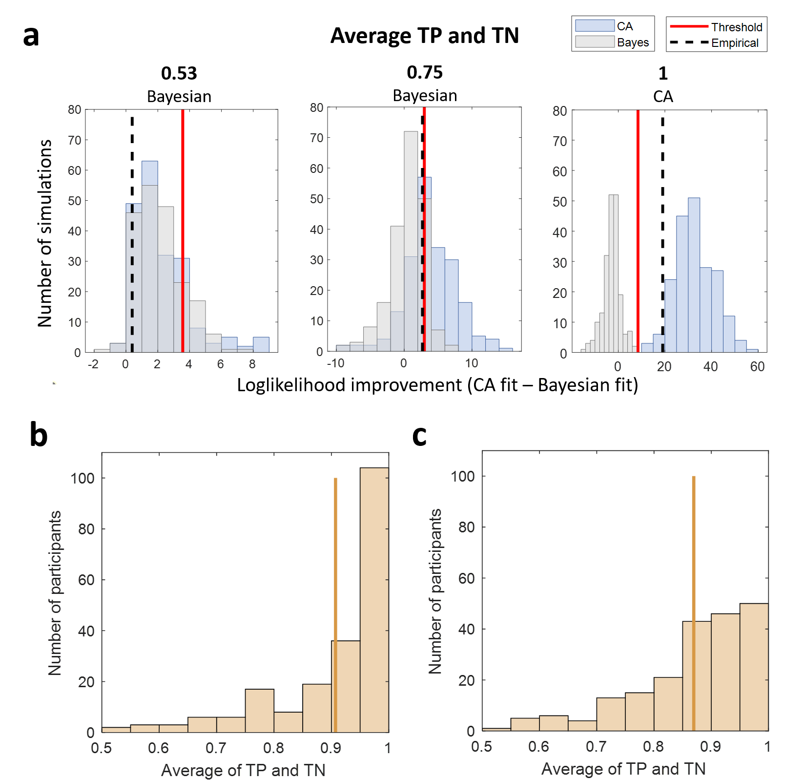
SI Figure 6: Model comparison between Bayesian models and credibility-CA model for main study. a, Histograms of log-likelihood improvements for three example participants. For each participant, we generated 201 simulations based on their ML parameters for each model variant (i.e., the Bayesian model and the CA model). We fitted each dataset with the two models and calculated the log-likelihood difference between the two fits for each dataset (CA fit – Bayesian fit), resulting in two log-likelihood difference distributions: one for the dataset based on Bayesian simulations (grey) and another for the dataset based on CA simulations (blue). A greater value along the x-axis indicates that a dataset was better fitted with the CA model compared to the Bayesian model. We determined a log-likelihood difference threshold that leads to the best model classification (i.e., maximizing the average of true positives and true negatives), represented by a red line in the plots. Finally, we fitted the empirical data of each participant with the two model variants, calculating an empirical log-likelihood difference, represented as a black dashed line in the plots. The three example plots correspond to participants with different model classification accuracy (i.e., proportion of true positives and true negatives) and different model classifications, both stated above each subplot. b, Distribution of model classification accuracy for the model comparison between the instructed-credibility Bayesian and credibility-CA models. A greater average of TP and TN represents a better discrimination between the models. c, Distribution of model classification accuracy for the model comparison between the free-credibility Bayesian and credibility-CA models. Vertical orange lines represent the mean classification accuracy for each model comparison.

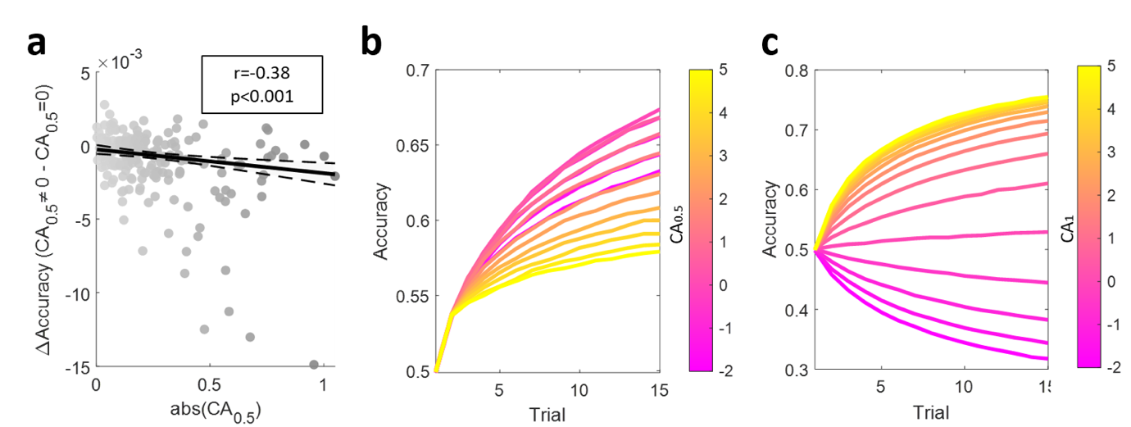
SI Figure 7: Effects of CA for the 1-star and 3-star agents on accuracy. a, Scatter plot between the absolute CA parameter for the 1-star agent in the main task (x-axes) and the predicted drop in accuracy due to CA based on random feedback (y-axes). For each participant, we generated 5000 synthetic simulations based on their ML parameters from the credibility-CA model, and another 5000 simulations using the same ML parameters but ablating CA for the 1-star agent by fixing it to 0. The difference in mean accuracy between the two datasets represents the estimated drop in accuracy for each participant due to learning from random feedback. The negative Pearson’s correlation illustrates that accuracy drop increases as a function of (absolute) credit assignment based on random feedback. Circles represent the datapoints of individual participants, lines represent the prediction from linear regression on the data with shaded areas representing the 99% confidence interval. b, Mean learning curves for different 1-star CA parameter values. We generated synthetic simulations based on the credibility-CA model ML parameters from participants but fixing the 1-star CA to different values between -2 and 5. We generated 100 synthetic simulations per participant for each 1-star CA value and averaged across participants. As (absolute) CA attributed to random feedback diverges from 0 (with all other parameters held invariant), accuracy decreases. c, For comparison with b we show the mean learning curves for different 3-star CA values, calculated in the same way but fixing the 3-star CA to different values. Here, accuracy increases with the CA attributed to fully credible.

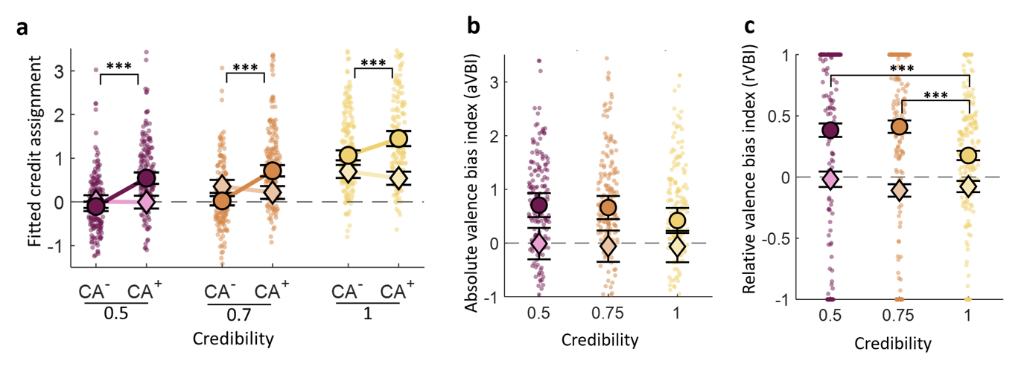
SI Figure 8: Positivity bias as a function of agent-credibility compared with instructed-credibility Bayesian-CA parameters in the main study. a, ML parameters from the credibility-valence-CA model. CA+ and CA- are free parameters representing credit assignments for positive and negative feedback respectively (for each credibility level). Empirical-CA parameters revealed a positivity bias (CA+ > CA-) for all credibility levels, while instructed-credibility Bayesian-CA parameters revealed a negativity bias. b, Absolute valence bias index (defined as CA⁺-CA⁻) based on the ML parameters from the credibility-valence CA model. Positive values indicate a positivity bias, while negative values represent a negativity bias. c, Relative valence bias index (rVBI, defined as (CA⁺-CA⁻)/(|CA⁺|+|CA⁻|)) based on the ML parameters from the credibility-valence CA model. Positive values indicate a positivity bias, while negative values represent a negativity bias. Small dots represent fitted parameters for individual participants and big circles represent the group median (a,b) or mean (c) (both of participants’ behaviour), while diamonds are the median or mean of the fitted parameters of the instructed-credibility Bayesian model simulations. Error bars show the standard error of the mean. (***) p<.001 for ML fits of participants behaviour.
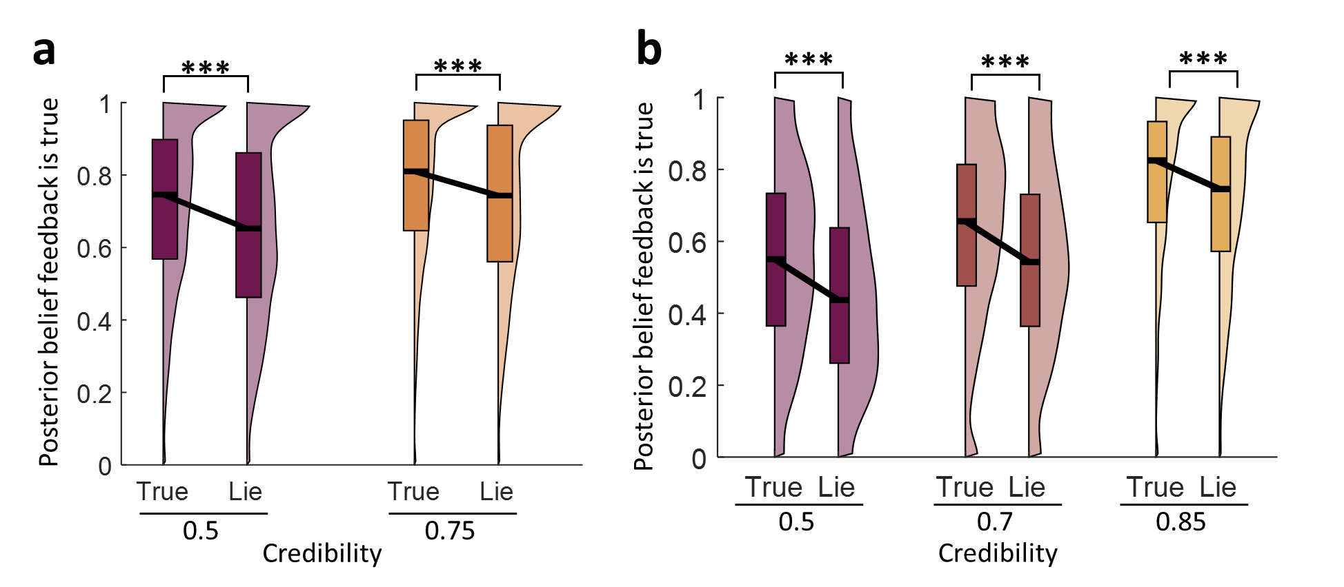SI Figure 9: Posterior-truthfulness belief as a function of objective feedback truthfulness based on distorted credibilities from free-credibility Bayesian model fits. a, Main study distributions of posterior truthfulness belief probability that feedback is true calculated separately for each agent (1 or 2 star) and objective feedback-truthfulness (true or lie). These probabilities are based on the ML credibilities from the free-credibility Bayesian model fits for each participant. The probabilities are computed based on trial-sequences and feedback participants experienced, revealing that belief probabilities that feedback is true are higher in truth compared to lie trials, even if participants attribute distorted feedback-credibilities. For illustration, plotted distributions pool trials across participants. The black line within each box represents the median, upper and lower bounds represent the third and first quartile respectively. The width of each half-violin plot corresponds to the frequency of each posterior belief value among all trials for a given condition. b, Same as in a, but for discovery study.

3. SUPPLEMENTARY STATISTICS

3.1. Mixed-effects model results

3.1.1 Main study

3.1.1.1 Choice repetition and feedback credibility
In this section we provide full result tables for mixed effects models used in the sections “Credible feedback promotes greater learning” and “Non-credible feedback elicits learning”; and figures 3a and 3b. The Wilkinson’s notation of the model is:
$$REPEAT \sim FEEDBACK*BETTER*(AGENT_{2-star}+AGENT_{3-star})+\left(1 | participant\right)$$

Table 2: Mixed-effects binomial regression model regressing choice-repetition on feedback-valence, agent-credibility and better/worse choice from previous trial featuring the same bandit pair. Based on participants’ data. Feedback effect increased as a function of agent-credibility (3-star vs. 2-star: b= 0.91, F(1,2436)=351.17; 3-star vs. 1-star: b=1.15, t(2436)=24.02; and 2-star vs. 1-star: b=0.24, t(2436)=5.34, all p’s<0.001). Feedback valence exerted a positive effect for the 1-star agent (b=0.25, t(2436)=8.05, p<0.001).
PARTICIPANTS DATA
Name | Estimate | SE | tStat | DF | pValue | Lower | Upper
(Intercept) | 0.99 | 0.04 | 25.27 | 2436 | <0.001 | 0.92 | 1.07
FEEDBACK | 0.25 | 0.03 | 8.05 | 2436 | <0.001 | 0.19 | 0.31
BETTER | 0.58 | 0.03 | 18.41 | 2436 | <0.001 | 0.51 | 0.64
AGENT(2-STAR) | 0.01 | 0.02 | 0.48 | 2436 | 0.62 | -0.03 | 0.05
AGENT(3-STAR) | -0.13 | 0.02 | -5.43 | 2436 | <0.001 | -0.18 | -0.08
FEEDBACK:BETTER | -0.02 | 0.06 | -0.25 | 2436 | 0.8 | -0.14 | 0.11
FEEDBACK:AGENT(2-STAR) | 0.24 | 0.04 | 5.34 | 2436 | <0.001 | 0.15 | 0.33
BETTER:AGENT(2-STAR) | -0.07 | 0.04 | -1.63 | 2436 | 0.1 | -0.16 | 0.01
FEEDBACK:AGENT(3-STAR) | 1.16 | 0.05 | 24.02 | 2436 | <0.001 | 1.06 | 1.25
BETTER:AGENT(3-STAR) | -0.13 | 0.05 | -2.73 | 2436 | <0.001 | -0.23 | -0.04
FEEDBACK:BETTER:AGENT(2-STAR) | 0.07 | 0.09 | 0.82 | 2436 | 0.42 | -0.1 | 0.25
FEEDBACK:BETTER:AGENT(3-STAR) | 0.07 | 0.1 | 0.71 | 2436 | 0.48 | -0.12 | 0.26
Any interaction between FEEDBACK and AGENT: F(2,2436)=307.11, p<0.001
FEEDBACK:AGENT(3-STAR) vs FEEDBACK:AGENT(2-STAR): b= 0.91, F(1,2436)=351.17, p<0.001

Table 3: Mixed-effects binomial regression model regressing choice-repetition on feedback-valence, agent-credibility and better/worse choice from previous trial featuring the same bandit pair. Based on instructed-credibility Bayesian model simulations. Feedback effect increased as a function of agent-credibility (3-star vs. 2-star: b=0.47, F(1,2436)=581.93; 3-star vs. 1-star: b=0.86, t(2436)=44.52; and 2-star vs. 1-star: b=0.39, t(2436)=21.22, all p’s<0.001). Feedback valence did not exert a positive effect for the 1-star agent (b=-0.01, t(2436)=-0.41, p=0.68).
INSTRUCTED-CREDIBILITY BAYESIAN MODEL
Name | Estimate | SE | tStat | DF | pValue | Lower | Upper
(Intercept) | 0.33 | 0.02 | 15.06 | 2436 | <0.001 | 0.28 | 0.37
FEEDBACK | -0.01 | 0.01 | -0.41 | 2436 | 0.68 | -0.03 | 0.02
BETTER | 0.84 | 0.01 | 65.92 | 2436 | <0.001 | 0.81 | 0.86
AGENT(2-STAR) | -0.03 | 0.01 | -3.45 | 2436 | <0.001 | -0.05 | -0.01
AGENT(3-STAR) | -0.07 | 0.01 | -6.9 | 2436 | <0.001 | -0.09 | -0.05
FEEDBACK:BETTER | 0.03 | 0.03 | 1.27 | 2436 | 0.2 | -0.02 | 0.08
FEEDBACK:AGENT(2-STAR) | 0.39 | 0.02 | 21.22 | 2436 | <0.001 | 0.35 | 0.42
BETTER:AGENT(2-STAR) | -0.02 | 0.02 | -0.98 | 2436 | 0.33 | -0.05 | 0.02
FEEDBACK:AGENT(3-STAR) | 0.86 | 0.02 | 44.52 | 2436 | <0.001 | 0.82 | 0.9
BETTER:AGENT(3-STAR) | -0.13 | 0.02 | -6.75 | 2436 | <0.001 | -0.17 | -0.09
FEEDBACK:BETTER:AGENT(2-STAR) | -0.07 | 0.04 | -1.94 | 2436 | 0.052 | -0.14 | 0.0007
FEEDBACK:BETTER:AGENT(3-STAR) | 0.004 | 0.04 | 0.1 | 2436 | 0.92 | -0.07 | 0.08
Any interaction between FEEDBACK and AGENT: F(2,2436)=991.54, p<0.001
FEEDBACK:AGENT(3-STAR) vs FEEDBACK:AGENT(2-STAR): b=0.47, F(1,2436)=581.93, p<0.001

Table 4: Mixed-effects binomial regression model regressing choice-repetition on feedback-valence, agent-credibility and better/worse choice from previous trial featuring the same bandit pair. Based on Free-credibility Bayesian model simulations. Feedback effect increased as a function of agent-credibility (3-star vs. 2-star: b=0.70, F(1,2436)=1268.1; 3-star vs. 1-star: b=0.85, t(2436)=43.63; and 2-star vs. 1-star: b=0.15, t(2436)=7.99, all p’s<0.001). Feedback valence exerted a positive effect for the 1-star agent (b=0.12, t(2436)=9.48, p=0.68).
FREE-CREDIBILITY BAYESIAN MODEL
Name | Estimate | SE | tStat | DF | pValue | Lower | Upper
(Intercept) | 0.37 | 0.02 | 16.87 | 2436 | <0.001 | 0.33 | 0.41
FEEDBACK | 0.12 | 0.01 | 9.48 | 2436 | <0.001 | 0.1 | 0.15
BETTER | 0.83 | 0.01 | 64.91 | 2436 | <0.001 | 0.8 | 0.85
AGENT(2-STAR) | 0 | 0.01 | -0.07 | 2436 | 0.95 | -0.02 | 0.02
AGENT(3-STAR) | -0.03 | 0.01 | -3.08 | 2436 | 0.002 | -0.05 | -0.01
FEEDBACK:BETTER | -0.02 | 0.03 | -0.85 | 2436 | 0.39 | -0.07 | 0.03
FEEDBACK:AGENT(2-STAR) | 0.15 | 0.02 | 7.99 | 2436 | <0.001 | 0.11 | 0.18
BETTER:AGENT(2-STAR) | -0.02 | 0.02 | -0.82 | 2436 | 0.41 | -0.05 | 0.02
FEEDBACK:AGENT(3-STAR) | 0.85 | 0.02 | 43.63 | 2436 | <0.001 | 0.81 | 0.89
BETTER:AGENT(3-STAR) | -0.15 | 0.02 | -7.87 | 2436 | <0.001 | -0.19 | -0.12
FEEDBACK:BETTER:AGENT(2-STAR) | 0 | 0.04 | -0.08 | 2436 | 0.93 | -0.07 | 0.07
FEEDBACK:BETTER:AGENT(3-STAR) | -0.04 | 0.04 | -1.07 | 2436 | 0.28 | -0.12 | 0.03
Any interaction between FEEDBACK and AGENT: F(2,2436)=1041.3, p<0.001
FEEDBACK:AGENT(3-STAR) vs FEEDBACK:AGENT(2-STAR): b=0.70, F(1,2436)=1268.1, p<0.001

Table 5: Mixed-effects binomial regression model regressing choice-repetition on feedback-valence, agent-credibility and better/worse choice from previous trial featuring the same bandit pair. Based on null-CA model simulations. The feedback effect did not interact with agent-credibility (F(2,2436)=0.11, p=0.89).
NULL-CA MODEL
Name | Estimate | SE | tStat | DF | pValue | Lower | Upper
(Intercept) | 0.86 | 0.03 | 25.46 | 2436 | <0.001 | 0.79 | 0.92
FEEDBACK | 0.69 | 0.01 | 51.25 | 2436 | <0.001 | 0.66 | 0.72
BETTER | 0.37 | 0.01 | 27.54 | 2436 | <0.001 | 0.35 | 0.4
AGENT(2-STAR) | -0.01 | 0.01 | -0.87 | 2436 | 0.38 | -0.03 | 0.01
AGENT(3-STAR) | 0.01 | 0.01 | 1.2 | 2436 | 0.23 | -0.01 | 0.03
FEEDBACK:BETTER | -0.01 | 0.03 | -0.49 | 2436 | 0.62 | -0.07 | 0.04
FEEDBACK:AGENT(2-STAR) | 0.004 | 0.02 | -0.2 | 2436 | 0.84 | -0.04 | 0.03
BETTER:AGENT(2-STAR) | -0.07 | 0.02 | -3.86 | 2436 | <0.001 | -0.11 | -0.04
FEEDBACK:AGENT(3-STAR) | 0.006 | 0.02 | 0.29 | 2436 | 0.77 | -0.03 | 0.05
BETTER:AGENT(3-STAR) | -0.08 | 0.02 | -3.81 | 2436 | <0.001 | -0.12 | -0.04
FEEDBACK:BETTER:AGENT(2-STAR) | -0.02 | 0.04 | -0.53 | 2436 | 0.6 | -0.1 | 0.06
FEEDBACK:BETTER:AGENT(3-STAR) | -0.03 | 0.04 | -0.66 | 2436 | 0.51 | -0.11 | 0.05
Any interaction between FEEDBACK and AGENT: F(2,2436)=0.11, p=0.89
FEEDBACK:AGENT(3-STAR) vs FEEDBACK:AGENT(2-STAR): b=0.002, F(1,2436)=0.22, p=0.64

Table 6: Mixed-effects binomial regression model regressing choice-repetition on feedback-valence, agent-credibility and better/worse choice from previous trial featuring the same bandit pair. Based on credibility-CA model simulations. Feedback effect increased as a function of agent-credibility (3-star vs. 2-star: b=0.96, F(1,2436)=2009.5.1; 3-star vs. 1-star: b=1.15, t(2436)=54.5; and 2-star vs. 1-star: b=0.19, t(2436)=9.79, all p’s<0.001). Feedback valence exerted a positive effect for the 1-star agent (b=0.25, t(2436)=18.31, p<0.001).
CREDIBILITY-CA MODEL
Name | Estimate | SE | tStat | DF | pValue | Lower | Upper
(Intercept) | 0.9 | 0.03 | 26.07 | 2436 | <0.001 | 0.84 | 0.97
FEEDBACK | 0.25 | 0.01 | 18.31 | 2436 | <0.001 | 0.22 | 0.28
BETTER | 0.49 | 0.01 | 35.89 | 2436 | <0.001 | 0.46 | 0.51
AGENT(2-STAR) | -0.01 | 0.01 | -0.52 | 2436 | 0.6 | -0.02 | 0.01
AGENT(3-STAR) | -0.1 | 0.01 | -9.62 | 2436 | p<0.001 | -0.12 | -0.08
FEEDBACK:BETTER | 0.03 | 0.03 | 1.08 | 2436 | 0.28 | -0.02 | 0.08
FEEDBACK:AGENT(2-STAR) | 0.19 | 0.02 | 9.79 | 2436 | <0.001 | 0.15 | 0.23
BETTER:AGENT(2-STAR) | -0.03 | 0.02 | -1.79 | 2436 | 0.07 | -0.07 | 0
FEEDBACK:AGENT(3-STAR) | 1.15 | 0.02 | 54.5 | 2436 | <0.001 | 1.11 | 1.19
BETTER:AGENT(3-STAR) | -0.1 | 0.02 | -4.85 | 2436 | <0.001 | -0.14 | -0.06
FEEDBACK:BETTER:AGENT(2-STAR) | -0.01 | 0.04 | -0.2 | 2436 | 0.84 | -0.08 | 0.07
FEEDBACK:BETTER:AGENT(3-STAR) | -0.07 | 0.04 | -1.65 | 2436 | 0.1 | -0.15 | 0.01
Any interaction between FEEDBACK and AGENT: F(2,2436)=1618.8, p<0.001
FEEDBACK:AGENT(3-STAR) vs FEEDBACK:AGENT(2-STAR): b=0.96, F(1,2436)=2009.5, p<0.001

3.1.1.2 CA and feedback credibility
In this section we provide full result tables for mixed effects models used in the sections “Credible feedback promotes greater learning”, “Most participants deviate from Bayesian Learning” and “Non- credible feedback elicits learning”; and figure 3c. The Wilkinson’s notation of the model is:
$$CA \sim AGENT_{2-star}+AGENT_{3-star}+(1|participant)$$

Table 7: Mixed-effects linear regression model regressing CA on agent-credibility, based on credibility-CA fits of participants’ data. CA increased as a function of agent-credibility (3-star vs. 2-star: b= 1.02, F(1,609)=253.73; 3-star vs. 1-star: b=1.24, t(609)=19.31; and 2-star vs. 1-star: b=0.22, t(609)=3.38, all p’s<0.001). We found a positive CA for the 1-star agent (b=0.23, t(609)=4.54, p<0.001).
PARTICIPANTS DATA
Name | Estimate | SE | tStat | DF | pValue | Lower | Upper
(Intercept) | 0.23 | 0.05 | 4.54 | 609 | <0.001 | 0.13 | 0.33
AGENT(2-STAR) | 0.22 | 0.06 | 3.38 | 609 | <0.001 | 0.09 | 0.34
AGENT(3-STAR) | 1.24 | 0.06 | 19.31 | 609 | <0.001 | 1.12 | 1.37
Any effect of AGENT: F(2,609)=212.65, p<0.001
AGENT(3-STAR) vs AGENT(2-STAR): b= 1.02, F(1,609)=253.73, p<0.001

Table 8: Mixed-effects linear regression model regressing CA on agent-credibility, based on credibility-CA fits of instructed-credibility Bayesian model simulations. CA increased as a function of agent-credibility (3-star vs. 2-star: b= 0.33, F(1,609)=233.17; 3-star vs. 1-star: b=0.61, t(609)=28.55; and 2-star vs. 1-star: b=0.28, t(609)=13.28, all p’s<0.001). There was no evidence that CA for the 1-star agent differed from 0 (b=-0.01, t(609)=-0.31, p=0.76).
INSTRUCTED-CREDIBILITY BAYESIAN SIMULATIONS
Name | Estimate | SE | tStat | DF | pValue | Lower | Upper
(Intercept) | -0.01 | 0.02 | -0.64 | 609 | 0.54 | -0.06 | 0.03
AGENT(2-STAR) | 0.30 | 0.02 | 11.22 | 609 | <0.001 | 0.24 | 0.35
AGENT(3-STAR) | 0.60 | 0.02 | 22.93 | 609 | <0.001 | 0.55 | 0.66
Any effect of AGENT: F(2,609)=262.96, p<0.001
AGENT(3-STAR) vs AGENT(2-STAR): b=0.30, F(1,609)=136.94, p<0.001

Table 9: Mixed-effects linear regression model regressing CA on agent-credibility, based on credibility-CA fits of free-credibility Bayesian model simulations. CA increased as a function of agent-credibility (3-star vs. 2-star: b= 0.5, F(1,609)=272.63; 3-star vs. 1-star: b=0.61, t(609)=20.05; and 2-star vs. 1-star: b=0.11, t(609)=3.54, all p’s<0.001). We detected a positive CA for the 1-star agent (b=0.08, t(609)=3.32, p<0.001).
FREE-CREDIBILITY BAYESIAN SIMULATIONS
Name | Estimate | SE | tStat | DF | pValue | Lower | Upper
(Intercept) | 0.08 | 0.02 | 3.01 | 609 | 0.002 | 0.03 | 0.13
AGENT(2-STAR) | 0.11 | 0.03 | 3.26 | 609 | 0.001 | 0.05 | 0.18
AGENT(3-STAR) | 0.61 | 0.03 | 20.05 | 609 | <0.001 | 0.54 | 0.67
Any effect of AGENT: F(2,609)=172.43, p<0.001
AGENT(3-STAR) vs AGENT(2-STAR): b=0.5, F(1,609)=201.64, p<0.001

3.1.1.3 CA, feedback valence and feedback credibility
In this section we provide full result tables for mixed effects models used in the sections “Individuals show a positivity bias in learning” and “Positivity bias increases for sources of limited credibility”; and figure 5a and 5b. The Wilkinson’s notation of the model is:
$$CA \sim VALENCE*(AGENT_{2-star}+AGENT_{3-star})+(1|participant)$$

Table 10: Mixed-effects linear regression model regressing CA on feedback-valence and agent-credibility, based on credibility-valence-CA fits of participants’ data. We found an overall positive valence effect(b=0.64, F(1,1218)=37.39, p<0.001), with no interactions with agent credibility (F(2,1218)=0.12, p=0.88).

PARTICIPANTS DATA
Name | Estimate | SE | tStat | DF | pValue | Lower | Upper
(Intercept) | 0.29 | 0.09 | 3.19 | 1218 | 0.001 | 0.11 | 0.47
VALENCE | 0.65 | 0.18 | 3.56 | 1218 | <0.001 | 0.29 | 1
AGENT(2-STAR) | 0.21 | 0.13 | 1.61 | 1218 | 0.11 | -0.05 | 0.46
AGENT(3-STAR) | 1.25 | 0.13 | 9.76 | 1218 | <0.001 | 1 | 1.5
VALENCE:AGENT(2-STAR) | 0.05 | 0.26 | 0.21 | 1218 | 0.83 | -0.45 | 0.56
VALENCE:AGENT(3-STAR) | -0.07 | 0.26 | -0.29 | 1218 | 0.77 | -0.58 | 0.43
Average valence effect: b=0.64, F(1,1218)=37.39, p<0.001
Any interaction: F(2,1218)=0.12, p=0.88
Effect of negative feedback 1-star: b=-0.03, F(1,1218)=0.07, p=0.79
Effect of positive feedback 1-star: b=0.61, F(1,1218)=22.81, p<0.001
Effect of negative feedback 2-star: b=0.14, F(1,1218)=1.28, p=0.25
Effect of positive feedback 2-star: b=0.85, F(1,1218)=43.5, p<0.001
Effect of negative feedback 3-star: b=1.25, F(1,1218)=95.7, p=<0.001
Effect of positive feedback 3-star: b=1.83, F(1,1218)=203.1, p<0.001

Table 11: Mixed-effects linear regression model regressing CA on feedback-valence and agent-credibility, based on credibility-valence-CA fits of instructed-credibility Bayesian model simulations. We found an overall negative valence effect (b=-0.54, F(1,1218)=101.87, p<0.001), with no interactions with agent credibility (F(2,1218)=0.02, p=0.98).
INSTRUCTED-CREDIBILITY BAYESIAN SIMULATIONS
Name | Estimate | SE | tStat | DF | pValue | Lower | Upper
(Intercept) | 0 | 0.05 | -0.06 | 1218 | 0.95 | -0.09 | 0.09
VALENCE | -0.5 | 0.09 | -5.38 | 1218 | <0.001 | -0.68 | -0.32
AGENT(2-STAR) | 0.29 | 0.07 | 4.41 | 1218 | <0.001 | 0.16 | 0.41
AGENT(3-STAR) | 0.62 | 0.07 | 9.54 | 1218 | <0.001 | 0.49 | 0.75
VALENCE:AGENT(2-STAR) | -0.04 | 0.13 | -0.34 | 1218 | 0.73 | -0.3 | 0.21
VALENCE:AGENT(3-STAR) | -0.08 | 0.13 | -0.6 | 1218 | 0.54 | -0.33 | 0.18
Average valence effect: b=-0.54, F(1,1218)=101.87, p<0.001
Any interaction: F(2,1218)=0.02, p=0.98
Effect of negative feedback 1-star: b=0.25, F(1,1218)=14.17, p<0.001
Effect of positive feedback 1-star: b=-0.25, F(1,1218)=14.78, p<0.001
Effect of negative feedback 2-star: b=0.55, F(1,1218)=72.47, p<0.001
Effect of positive feedback 2-star: b=0.014, F(1,1218)=0.04, p=0.83
Effect of negative feedback 3-star: b=0.91, F(1,1218)=193.45, p<0.001
Effect of positive feedback 3-star: b=0.33, F(1,1218)=25.91, p<0.001

Table 12: Mixed-effects linear regression model regressing CA on feedback-valence and agent-credibility, based on credibility-valence-CA fits of free-credibility Bayesian model simulations. We found an overall negative valence effect (b=-0.54, F(1,1218)=98.91, p<0.001), with no interactions with agent credibility (F(2,1218)=0.06, p=0.94).
FREE-CREDIBILITY BAYESIAN SIMULATIONS
Name | Estimate | SE | tStat | DF | pValue | Lower | Upper
(Intercept) | 0.08 | 0.05 | 1.72 | 1218 | 0.09 | -0.01 | 0.17
VALENCE | -0.51 | 0.09 | -5.39 | 1218 | <0.001 | -0.7 | -0.33
AGENT(2-STAR) | 0.1 | 0.07 | 1.56 | 1218 | 0.12 | -0.03 | 0.24
AGENT(3-STAR) | 0.62 | 0.07 | 9.31 | 1218 | <0.001 | 0.49 | 0.76
VALENCE:AGENT(2-STAR) | -0.02 | 0.13 | -0.18 | 1218 | 0.85 | -0.29 | 0.24
VALENCE:AGENT(3-STAR) | -0.07 | 0.13 | -0.56 | 1218 | 0.58 | -0.34 | 0.19
Average valence effect: b=-0.54, F(1,1218)=98.91, p<0.001
Any interaction: F(2,1218)=0.06, p=0.94
Effect of negative feedback 1-star: b=0.34, F(1,1218)=25.29, p<0.001
Effect of positive feedback 1-star: b=-0.17, F(1,1218)=6.74, p=0.010
Effect of negative feedback 2-star: b=0.45, F(1,1218)=45.91, p<0.001
Effect of positive feedback 2-star: b=-0.08, F(1,1218)=1.48, p=0.22
Effect of negative feedback 3-star: b=1.00, F(1,1218)=221.82, p<0.001
Effect of positive feedback 3-star: b=0.41, F(1,1218)=37.84, p<0.001

3.1.1.4 CA and true feedback
In this section we provide full result tables for mixed effects models used in the section “True feedback elicits greater learning”; and figure 6b, 6c and 6d. The Wilkinson’s notation of the model is:

$$CA \sim CREDIBILITY*TRUTH+\left(1 | participant\right)$$

Table 13: Mixed-effects linear regression model regressing CA on whether the agent was telling the truth and agent-credibility, based on truth-CA fits of participants’ data. We found an overall positive effect of truth (b=0.08, t(812)=2.23, p=0.026), with no interactions with agent credibility (b=-0.03, t(812)=-0.43, p=0.67).
PARTICIPANTS DATA
Name | Estimate | SE | tStat | DF | pValue | Lower | Upper
(Intercept) | 0.33 | 0.03 | 13.14 | 812 | <0.001 | 0.28 | 0.38
TRUTH | 0.08 | 0.04 | 2.23 | 812 | 0.026 | 0.01 | 0.16
CREDIBILITY | 0.2 | 0.04 | 5.3 | 812 | <0.001 | 0.12 | 0.27
TRUTH:CREDIBILITY | -0.03 | 0.07 | -0.43 | 812 | 0.67 | -0.18 | 0.11

Table 14: Mixed-effects linear regression model regressing CA on whether the agent was telling the truth and agent-credibility, based on truth-CA fits of instructed-credibility Bayesian model simulations. We found no evidence for an effect of truth (b=0.01, t(812)=0.63, p=0.52), with no interactions with agent credibility (b=-0.02, t(812)=-0.53, p=0.6).
INSTRUCTED-CREDIBILITY BAYESIAN SIMULATIONS
Name | Estimate | SE | tStat | DF | pValue | Lower | Upper
(Intercept) | 0.14 | 0.01 | 15.5 | 812 | <0.001 | 0.12 | 0.15
TRUTH | 0.010 | 0.02 | 0.63 | 812 | 0.52 | -0.02 | 0.04
CREDIBILITY | 0.29 | 0.02 | 18.98 | 812 | <0.001 | 0.26 | 0.32
TRUTH:CREDIBILITY | -0.02 | 0.03 | -0.53 | 812 | 0.6 | -0.08 | 0.04

Table 15: Mixed-effects linear regression model regressing CA on whether the agent was telling the truth and agent-credibility, based on truth-CA fits of free-credibility Bayesian model simulations. We found no evidence for an effect of truth (b=0.002, t(812)=0.14, p=0.89), with no interactions with agent credibility (b=-0.02, t(812)=-0.61, p=0.54).
FREE-CREDIBILITY BAYESIAN SIMULATIONS
Name | Estimate | SE | tStat | DF | pValue | Lower | Upper
(Intercept) | 0.13 | 0.01 | 9.44 | 812 | <0.001 | 0.11 | 0.16
TRUTH | 0.002 | 0.02 | 0.14 | 812 | 0.89 | -0.03 | 0.04
CREDIBILITY | 0.11 | 0.02 | 6.12 | 812 | <0.001 | 0.07 | 0.14
TRUTH:CREDIBILITY | -0.02 | 0.04 | -0.61 | 812 | 0.54 | -0.09 | 0.05

Table 16: Mixed-effects linear regression model regressing CA on whether the agent was telling the truth and agent-credibility, based on truth-CA fits of credibility-CA model simulations. We found no evidence for an effect of truth (b=-0.001, t(812)=-0.04, p=0.97), with no interactions with agent credibility (b=0.01, t(812)=0.08, p=0.93).
CREDIBILITY-CA SIMULATIONS
Name | Estimate | SE | tStat | DF | pValue | Lower | Upper
(Intercept) | 0.37 | 0.03 | 12.64 | 812 | <0.001 | 0.32 | 0.43
TRUTH | -0.001 | 0.03 | -0.04 | 812 | 0.97 | -0.06 | 0.06
CREDIBILITY | 0.23 | 0.03 | 7.69 | 812 | <0.001 | 0.17 | 0.29
TRUTH:CREDIBILITY | 0.01 | 0.06 | 0.08 | 812 | 0.93 | -0.11 | 0.12

Table 17: Mixed-effects linear regression model regressing CA on whether the agent was telling the truth and agent-credibility, based on truth-CA fits of credibility-valence-CA model simulations. We found no evidence for an effect of truth (b=0.005, t(812)=0.14, p=0.89), with no interactions with agent credibility (b=0.05, t(812)=0.85, p=0.4).
CREDIBILITY-VALENCE-CA SIMULATIONS
Name | Estimate | SE | tStat | DF | pValue | Lower | Upper
(Intercept) | 0.37 | 0.03 | 12.02 | 812 | <0.001 | 0.31 | 0.43
TRUTH | 0.005 | 0.03 | 0.14 | 812 | 0.89 | -0.06 | 0.07
CREDIBILITY | 0.24 | 0.03 | 7.41 | 812 | <0.001 | 0.18 | 0.3
TRUTH:CREDIBILITY | 0.05 | 0.06 | 0.85 | 812 | 0.4 | -0.07 | 0.18

3.1.2 Discovery study

3.1.2.1 Choice repetition and feedback credibility
In this section we provide full result tables for mixed effects models used in the SI Discovery study sections “Credible feedback promotes greater learning” and “Learning for non-credible feedback”; and SI figure 2a. The Wilkinson’s notation of the model is:
$$REPEAT \sim FEEDBACK*BETTER*(AGENT_{2-star}+AGENT_{3-star}+AGENT_{4-star})+\left(1 | participant\right)$$

Table 18: Mixed-effects binomial regression model regressing choice-repetition on feedback-valence, agent-credibility and better/worse choice from previous trial featuring the same bandit pair. Based on participants’ data. Feedback effect increased as a function of agent-credibility, and we found no significant feedback valence effect for the 1-star agent.
PARTICIPANTS’ DATA
Name | Estimate | SE | tStat | DF | pValue | Lower | Upper
(Intercept) | 1.87 | 0.09 | 19.89 | 2462 | <0.001 | 1.68 | 2.05
FEEDBACK | -0.09 | 0.08 | -1.21 | 2462 | 0.22 | -0.24 | 0.06
BETTER | 0.82 | 0.13 | 6.11 | 2462 | <0.001 | 0.56 | 1.09
AGENT(2-STAR) | 0.19 | 0.05 | 3.44 | 2462 | <0.001 | 0.08 | 0.3
AGENT(3-STAR) | 0.05 | 0.05 | 0.88 | 2462 | 0.37 | -0.06 | 0.16
AGENT(4-STAR) | -0.39 | 0.06 | -7.07 | 2462 | <0.001 | -0.5 | -0.28
FEEDBACK:BETTER | -0.67 | 0.27 | -2.51 | 2462 | 0.012 | -1.2 | -0.15
FEEDBACK:AGENT(2-STAR) | 0.52 | 0.11 | 4.74 | 2462 | <0.001 | 0.31 | 0.74
BETTER:AGENT(2-STAR) | -0.01 | 0.2 | -0.04 | 2462 | 0.97 | -0.39 | 0.38
FEEDBACK:AGENT(3-STAR) | 1.24 | 0.11 | 11.25 | 2462 | <0.001 | 1.03 | 1.46
BETTER:AGENT(3-STAR) | -0.27 | 0.2 | -1.41 | 2462 | 0.16 | -0.66 | 0.11
FEEDBACK:AGENT(4-STAR) | 2.55 | 0.11 | 22.91 | 2462 | <0.001 | 2.33 | 2.77
BETTER:AGENT(4-STAR) | -0.5 | 0.2 | -2.56 | 2462 | 0.01 | -0.88 | -0.12
FEEDBACK:BETTER:AGENT(2-STAR) | 0.71 | 0.39 | 1.8 | 2462 | 0.071 | -0.06 | 1.48
FEEDBACK:BETTER:AGENT(3-STAR) | 0.44 | 0.39 | 1.11 | 2462 | 0.27 | -0.33 | 1.2
FEEDBACK:BETTER:AGENT(4-STAR) | 0.24 | 0.39 | 0.62 | 2462 | 0.53 | -0.52 | 1.01
Overall feedback effect: b=1.02, F(1,2462)=617.38, p<0.001
Feedback effect for AGENT(4-STAR): b=2.46, F(1,2462)= 911.81, p<0.001
Feedback effect for AGENT(3-STAR): b=1.15, F(1,2462)=206.19, p<0.001
Feedback effect for AGENT(2-STAR): b=0.43, F(1,2462)=28.84, p<0.001
Any interaction: F(3,2462)=196.61, p<0.001
FEEDBACK:AGENT(4-STAR) vs FEEDBACK:AGENT(2-STAR): b=0.47, F(1,2462)=322.88, p<0.001
FEEDBACK:AGENT(4-STAR) vs FEEDBACK:AGENT(3-STAR): b=1.21, F(1,2462)=137.71, p<0.001
FEEDBACK:AGENT(3-STAR) vs FEEDBACK:AGENT(2-STAR): b=2.03, F(1,2462)=40.54, p<0.001

3.1.2.2 CA and feedback credibility
In this section we provide full result tables for mixed effects models used in the SI Discovery study sections “Credible feedback promotes greater learning”, “Most participants deviate from Bayesian Learning” and “Non- credible feedback elicits learning”; and SI figure 2c. The Wilkinson’s notation of the model is:
$$CA \sim AGENT_{2-star}+AGENT_{3-star}+AGENT_{4-star}+(1|participant)$$

Table 19: Mixed-effects linear regression model regressing CA on agent-credibility, based on credibility-CA fits of participants’ data. CA increased as a function of agent-credibility. We found no evidence for significant CA for the 1-star agent.
PARTICIPANTS’ DATA
Name | Estimate | SE | tStat | DF | pValue | Lower | Upper
(Intercept) | -0.13 | 0.13 | -1.07 | 412 | 0.28 | -0.38 | 0.11
AGENT(2-STAR) | 0.5 | 0.17 | 3.03 | 412 | 0.003 | 0.18 | 0.83
AGENT(3-STAR) | 1.27 | 0.17 | 7.68 | 412 | <0.001 | 0.94 | 1.59
AGENT(4-STAR) | 2.67 | 0.17 | 16.13 | 412 | <0.002 | 2.34 | 2.99
AGENT(3-STAR) vs AGENT(2-STAR): b=0.77, F(1,412)=21.58, p<0.001
AGENT(4-STAR) vs AGENT(3-STAR): b=1.4, F(1,412)=71.40, p<0.001
AGENT(4-STAR) vs AGENT(2-STAR): b=2.17, F(1,412)=171.49, p<0.001

Table 20: Mixed-effects linear regression model regressing CA on agent-credibility, based on credibility-CA fits of instructed-credibility Bayesian model simulations. CA increased as a function of agent-credibility. Instructed-credibility Bayesian simulations do net predict significant CA for the 1-star agent.
INSTRUCTED-CREDIBILITY BAYESIAN SIMULATIONS
Name | Estimate | SE | tStat | DF | pValue | Lower | Upper
(Intercept) | -0.02 | 0.05 | -0.33 | 412 | 0.74 | -0.11 | 0.08
AGENT(2-STAR) | 0.51 | 0.05 | 10.33 | 412 | <0.001 | 0.41 | 0.61
AGENT(3-STAR) | 0.91 | 0.05 | 18.5 | 412 | <0.001 | 0.81 | 1.01
AGENT(4-STAR) | 1.4 | 0.05 | 28.5 | 412 | <0.001 | 1.31 | 1.5
Any difference across agents: F(3,412)=98.77, p<0.001
AGENT(3-STAR) vs AGENT(2-STAR): b=0.4, F(1,412)=66.8, p<0.001
AGENT(4-STAR) vs AGENT(3-STAR): b=0.49, F(1,412)=99.94, p<0.001
AGENT(4-STAR) vs AGENT(2-STAR): b=0.89, F(1,412)=330.15, p<0.001

Table 21: Mixed-effects linear regression model regressing CA on agent-credibility, based on credibility-CA fits of free-credibility Bayesian model simulations. CA increased as a function of agent-credibility. Free-credibility Bayesian simulations do net predict significant CA for the 1-star agent.
FREE-CREDIBILITY BAYESIAN SIMULATIONS
Name | Estimate | SE | tStat | DF | pValue | Lower | Upper
(Intercept) | -0.1 | 0.09 | -1.12 | 412 | 0.26 | -0.27 | 0.07
AGENT(2-STAR) | 0.41 | 0.11 | 3.68 | 412 | <0.001 | 0.19 | 0.63
AGENT(3-STAR) | 0.95 | 0.11 | 8.48 | 412 | <0.001 | 0.73 | 1.17
AGENT(4-STAR) | 2.09 | 0.11 | 18.64 | 412 | <0.002 | 1.87 | 2.31
AGENT(3-STAR) vs AGENT(2-STAR): b=0.54, F(1,412)=22.97, p<0.001
AGENT(4-STAR) vs AGENT(3-STAR): b=1.14, F(1,412)=103.24, p<0.001
AGENT(4-STAR) vs AGENT(2-STAR): b=1.68, F(1,412)=223.60, p<0.001

3.1.2.3 CA, feedback valence and feedback credibility
In this section we provide full result tables for mixed effects models used in the SI Discovery study sections “Individuals show a positivity bias in learning” and “Positivity bias increases for sources of limited credibility”; and SI figure 3a and 3b. The Wilkinson’s notation of the model is:
$$CA \sim VALENCE*(AGENT_{2-star}+AGENT_{3-star}+AGENT_{4-star})+(1|participant)$$

Table 22: Mixed-effects linear regression model regressing CA on feedback-valence and agent-credibility, based on credibility-valence-CA fits of participants’ data. We found an overall positive valence effect, which interacted with agent credibility, such that the valence effect was two 2-star agent than for the 4-star agent. Moreover, we found a positive valence effect for the 1-star, 2-star and 3-star agents, but not for the 4-star agent. Finally, the negative feedback from 1-star agent had a significant negative effect on CA, while positive feedback from the same agent had a significant positive effect.
PARTICIPANTS’ DATA
Name | Estimate | SE | tStat | DF | pValue | Lower | Upper
(Intercept) | -0.05 | 0.16 | -0.29 | 824 | 0.77 | -0.36 | 0.27
VALENCE | 0.94 | 0.29 | 3.24 | 824 | 0.001 | 0.37 | 1.51
AGENT(2-STAR) | 0.5 | 0.21 | 2.44 | 824 | 0.015 | 0.1 | 0.9
AGENT(3-STAR) | 1.39 | 0.21 | 6.76 | 824 | <0.001 | 0.99 | 1.79
AGENT(4-STAR) | 2.8 | 0.21 | 13.66 | 824 | <0.001 | 2.4 | 3.21
VALENCE:AGENT(2-STAR) | 0.66 | 0.41 | 1.6 | 824 | 0.11 | -0.15 | 1.46
VALENCE:AGENT(3-STAR) | 0.01 | 0.41 | 0.02 | 824 | 0.99 | -0.8 | 0.81
VALENCE:AGENT(4-STAR) | -0.63 | 0.41 | -1.54 | 824 | 0.12 | -1.44 | 0.17
Average valence effect: b=0.94, F(1,824)=42.60, p<0.001
Effect of negative feedback 1-star: b=-0.51, F(1,824)=3.89, p=0.049
Effect of positive feedback 1-star: b=0.42, F(1,824)=5.74, p=0.017
Effect of negative feedback 2-star: b=-0.34, F(1,824)=2.53, p=0.11
Effect of positive feedback 2-star: b=1.25, F(1,824)=16.34, p<0.001
Effect of negative feedback 3-star: b=0.86, F(1,824)=37.77, p<0.001
Effect of positive feedback 3-star: b=2.28, F(1,824)=71.28, p<0.001
Effect of negative feedback 4-star: b=2.60, F(1,824)=146.55, p<0.001
Effect of positive feedback 4-star: b=2.91, F(1,824)=183.22, p<0.001
Any interaction: F(3,824)=3.28 p=0.02
Valence effect AGENT(2-STAR): b=1.60, F(1, 824)=30.21, p<0.001
Valence effect AGENT(3-STAR): b=0.94, F(1, 824)=10.63, p=0.001
Valence effect AGENT(4-STAR): b=0.31, F(1, 824)=1.12, p=0.29
Valence effect AGENT(2-STAR) vs AGENT(3-STAR): b=0.65, F(1, 824)=2.50, p=0.11
Valence effect AGENT(2-STAR) vs AGENT(4-STAR): b=1.29, F(1, 824)=9.84, p=0.002
Valence effect AGENT(3-STAR) vs AGENT(4-STAR): b=0.64, F(1, 824)=2.42, p=0.12

Table 23: Mixed-effects linear regression model regressing CA on feedback-valence and agent-credibility, based on credibility-valence-CA fits of instructed-credibility Bayesian model simulations. We found an overall negative valence effect, with no interactions with agent credibility.
INSTRUCTED-CREDIBILITY BAYESIAN SIMULATIONS
Name | Estimate | SE | tStat | DF | pValue | Lower | Upper
(Intercept) | -0.01 | 0.08 | -0.13 | 824 | 0.89 | -0.18 | 0.15
VALENCE | -0.41 | 0.16 | -2.53 | 824 | 0.012 | -0.72 | -0.09
AGENT(2-STAR) | 0.54 | 0.11 | 4.79 | 824 | <0.001 | 0.32 | 0.77
AGENT(3-STAR) | 0.98 | 0.11 | 8.59 | 824 | <0.001 | 0.75 | 1.2
AGENT(4-STAR) | 1.53 | 0.11 | 13.41 | 824 | <0.001 | 1.3 | 1.75
VALENCE:AGENT(2-STAR) | -0.02 | 0.23 | -0.11 | 824 | 0.91 | -0.47 | 0.42
VALENCE:AGENT(3-STAR) | -0.11 | 0.23 | -0.5 | 824 | 0.61 | -0.56 | 0.33
VALENCE:AGENT(4-STAR) | -0.18 | 0.23 | -0.77 | 824 | 0.44 | -0.62 | 0.27
Average valence effect: b=-0.49, F(1,824)=36.47, p<0.001
Any interaction: F(3,824)=0.25 p=0.85

Table 24: Mixed-effects linear regression model regressing CA on feedback-valence and agent-credibility, based on credibility-valence-CA fits of free-credibility Bayesian model simulations. We found an overall negative valence effect, with no interactions with agent credibility.
FREE-CREDIBILITY BAYESIAN SIMULATIONS
Name | Estimate | SE | tStat | DF | pValue | Lower | Upper
(Intercept) | -0.1 | 0.1 | -0.99 | 824 | 0.32 | -0.31 | 0.1
VALENCE | -0.68 | 0.2 | -3.37 | 824 | <0.001 | -1.07 | -0.28
AGENT(2-STAR) | 0.44 | 0.14 | 3.1 | 824 | 0.002 | 0.16 | 0.72
AGENT(3-STAR) | 1.03 | 0.14 | 7.27 | 824 | <0.001 | 0.75 | 1.31
AGENT(4-STAR) | 2.28 | 0.14 | 16.13 | 824 | <0.001 | 2.01 | 2.56
VALENCE:AGENT(2-STAR) | 0.05 | 0.28 | 0.17 | 824 | 0.86 | -0.51 | 0.6
VALENCE:AGENT(3-STAR) | -0.07 | 0.28 | -0.25 | 824 | 0.8 | -0.63 | 0.48
VALENCE:AGENT(4-STAR) | -0.1 | 0.28 | -0.36 | 824 | 0.72 | -0.66 | 0.45
Average valence effect: b=-0.71, F(1,824)=49.8, p<0.001
Any interaction: F(3,824)=0.11 p=0.95

3.1.2.4 CA and true feedback
In this section we provide full result tables for mixed effects models used in the SI Discovery study section “True feedback elicits greater learning”; and SI figure 4b, 4c and 4d. The Wilkinson’s notation of the model is:

$$CA \sim TRUTH* \left(AGENT_{2-star}+AGENT_{3-star}+AGENT_{4-star}\right)+\left(1 | participant\right)$$

Table 25: Mixed-effects linear regression model regressing CA on whether the agent was telling the truth and agent-credibility, based on truth-CA fits of participants’ data. We found an overall positive effect of truth, which interacted with agent credibility, such that the truth effect for the 3-star agent was larger than the one for the 2-star or 1-star agents. Moreover, only the 3-star agent presented a significant truth effect.
PARTICIPANTS’ DATA
Name | Estimate | SE | tStat | DF | pValue | Lower | Upper
(Intercept) | -0.13 | 0.1 | -1.27 | 618 | 0.2 | -0.32 | 0.07
TRUTH | -0.05 | 0.18 | -0.31 | 618 | 0.76 | -0.4 | 0.29
AGENT(2-STAR) | 0.48 | 0.12 | 3.89 | 618 | <0.001 | 0.24 | 0.73
AGENT(3-STAR) | 1.04 | 0.12 | 8.34 | 618 | <0.001 | 0.79 | 1.28
TRUTH:AGENT(2-STAR) | 0.15 | 0.25 | 0.61 | 618 | 0.54 | -0.34 | 0.64
TRUTH:AGENT(3-STAR) | 0.69 | 0.25 | 2.76 | 618 | 0.006 | 0.2 | 1.17
Any interaction: F(2,618)=4.21 p=0.015
Truth effect for AGENT(2-STAR): b=0.10 F(1,618)=0.30 p=0.59
Truth effect for AGENT(3-STAR): b=0.64 F(1,618)=12.90 p<0.001
Truth effect for AGENT(3-STAR) vs AGENT(2-STAR): b=0.54 F(1,618)=4.64 p=0.032
Average truth effect: b=0.22 F(1,618)=4.87, p=0.028

Table 26: Mixed-effects linear regression model regressing CA on whether the agent was telling the truth and agent-credibility, based on truth-CA fits of instructed-credibility Bayesian model simulations. We found no evidence for an effect of truth, with no interactions with agent credibility.
INSTRUCTED-CREDIBILITY BAYESIAN SIMULATIONS
Name | Estimate | SE | tStat | DF | pValue | Lower | Upper
(Intercept) | -0.02 | 0.04 | -0.58 | 618 | 0.56 | -0.09 | 0.05
TRUTH | 0 | 0.05 | -0.03 | 618 | 0.97 | -0.1 | 0.09
AGENT(2-STAR) | 0.54 | 0.03 | 15.86 | 618 | <0.001 | 0.47 | 0.6
AGENT(3-STAR) | 1 | 0.03 | 29.46 | 618 | <0.001 | 0.93 | 1.07
TRUTH:AGENT(2-STAR) | 0.04 | 0.07 | 0.62 | 618 | 0.054 | -0.09 | 0.17
TRUTH:AGENT(3-STAR) | -0.08 | 0.07 | -1.24 | 618 | 0.21 | -0.22 | 0.05
Any interaction: F(2,618)=1.80, p=0.17
Truth effect for AGENT(2-STAR): b=0.04 F(1,618)=0.71 p=0.40
Truth effect for AGENT(3-STAR): b=-0.08 F(1,618)=3.21 p=0.074
Average truth effect: b=-0.02 F(1,618)=0.32, p=0.57

Table 27: Mixed-effects linear regression model regressing CA on whether the agent was telling the truth and agent-credibility, based on truth-CA fits of free-credibility Bayesian model simulations. We found no evidence for an effect of truth, with no interactions with agent credibility.
FREE-CREDIBILITY BAYESIAN SIMULATIONS
Name | Estimate | SE | tStat | DF | pValue | Lower | Upper
(Intercept) | -0.11 | 0.06 | -1.96 | 618 | 0.05 | -0.22 | 0
TRUTH | 0.04 | 0.08 | 0.54 | 618 | 0.59 | -0.12 | 0.21
AGENT(2-STAR) | 0.45 | 0.06 | 7.7 | 618 | <0.001 | 0.33 | 0.56
AGENT(3-STAR) | 1.05 | 0.06 | 17.95 | 618 | <0.001 | 0.93 | 1.16
TRUTH:AGENT(2-STAR) | -0.02 | 0.12 | -0.19 | 618 | 0.85 | -0.25 | 0.21
TRUTH:AGENT(3-STAR) | -0.11 | 0.12 | -0.91 | 618 | 0.36 | -0.33 | 0.12
Any interaction: F(2,618)=0.46, p=0.63
Truth effect for AGENT(2-STAR): b=0.02 F(1,618)=0.07 p=0.79
Truth effect for AGENT(3-STAR): b=-0.07 F(1,618)=0.56 p=0.45
Average truth effect: b=0.002 F(1,618)=0.001, p=0.97

Table 28: Mixed-effects linear regression model regressing CA on whether the agent was telling the truth and agent-credibility, based on truth-CA fits of credibility-CA model simulations. We found no evidence for an effect of truth, with no interactions with agent credibility.
CREDIBILITY-CA SIMULATIONS
Name | Estimate | SE | tStat | DF | pValue | Lower | Upper
(Intercept) | -0.14 | 0.1 | -1.35 | 618 | 0.18 | -0.35 | 0.06
TRUTH | 0.02 | 0.15 | 0.14 | 618 | 0.89 | -0.27 | 0.31
AGENT(2-STAR) | 0.65 | 0.1 | 6.23 | 618 | <0.001 | 0.44 | 0.85
AGENT(3-STAR) | 1.57 | 0.1 | 15.12 | 618 | <0.001 | 1.37 | 1.77
TRUTH:AGENT(2-STAR) | 0.1 | 0.21 | 0.5 | 618 | 0.62 | -0.3 | 0.51
TRUTH:AGENT(3-STAR) | 0.01 | 0.21 | 0.06 | 618 | 0.95 | -0.4 | 0.42
Any interaction: F(2,618)=0.15, p=0.86
Truth effect for AGENT(2-STAR): b=0.12 F(1,618)=0.72 p=0.40
Truth effect for AGENT(3-STAR): b=0.03 F(1,618)=0.05 p=0.82
Average truth effect: b=0.06 F(1,618)=0.49, p=0.48

Table 29: Mixed-effects linear regression model regressing CA on whether the agent was telling the truth and agent-credibility, based on truth-CA fits of credibility-valence-CA model simulations. We found no evidence for an effect of truth, with no interactions with agent credibility.
CREDIBILITY-VALENCE-CA SIMULATIONS
Name | Estimate | SE | tStat | DF | pValue | Lower | Upper
(Intercept) | -0.12 | 0.11 | -1.08 | 618 | 0.28 | -0.33 | 0.09
TRUTH | -0.09 | 0.14 | -0.65 | 618 | 0.52 | -0.38 | 0.19
AGENT(2-STAR) | 0.56 | 0.1 | 5.49 | 618 | <0.001 | 0.36 | 0.76
AGENT(3-STAR) | 1.51 | 0.1 | 14.85 | 618 | <0.001 | 1.31 | 1.71
TRUTH:AGENT(2-STAR) | 0.11 | 0.2 | 0.54 | 618 | 0.59 | -0.29 | 0.51
TRUTH:AGENT(3-STAR) | 0.32 | 0.2 | 1.57 | 618 | 0.12 | -0.08 | 0.72
Any interaction: F(2,618)=1.28, p=0.28
Truth effect for AGENT(2-STAR): b=0.12 F(1,618)=0.01 p=0.91
Truth effect for AGENT(3-STAR): b=0.03 F(1,618)=2.47 p=0.12
Average truth effect: b=0.05 F(1,618)=0.36, p=0.55

3.2. Additional analyses of model parameters main study

3.2.1 Main study

3.2.1.1 Comparison of empirical-aVBI and instructed-credibility Bayesian-aVBI
In this section we provide full result tables for the sections “Individuals show a positivity bias in learning” and “Positivity bias increases for sources of limited credibility”; and figure 5a and 5b. For each individual and credibility level we calculated the absolute Valence Bias Index (aVBI), defined as the difference between the Credit Assignment for positive (CA+) and negative feedback (CA-).
Table 30: Statistics summarizing Wilcoxon test results comparing aVBI from participants with the one from instructed-credibility Bayesian simulations. Participants showed a greater aVBI than predicted by the instructed-credibility Bayesian model, for all levels of credibility.
Name | Median difference | z | pValue
50% credibility | 1.34 | 5.20 | <0.001
75% credibility | 1.34 | 5.94 | <0.001
100% credibility | 1.10 | 5.87 | <0.001

Table 31: Statistics summarizing Wilcoxon test results comparing aVBI from participants with the one from free-credibility Bayesian simulations. Participants showed a greater aVBI than predicted by the free-credibility Bayesian model, for all levels of credibility.
Name | Median difference | z | pValue
50% credibility | 1.02 | 5.95 | <0.001
75% credibility | 1.21 | 6.13 | <0.001
100% credibility | 1.21 | 5.36 | <0.001

3.2.1.2 rVBI for Bayesian models
In this section we provide full result tables for the section “Positivity bias increases for sources of limited credibility”; and figure 5c.
Table 32: Statistics summarizing Wilcoxon test results on the rVBI from instructed-credibility Bayesian simulations. The instructed-credibility Bayesian model predicted a negative rVBI for all credibility levels, with no difference across different credibility-levels.
INSTRUCTED-CREDIBILITY BAYESIAN SIMULATIONS
Name | Median difference | z | pValue
50% credibility | -0.04 | -2.37 | 0.017
75% credibility | -0.09 | -3.99 | <0.001
100% credibility | -0.12 | -6.09 | <0.001
Friedman test, χ2(2) = 0.53, p=0.77

Table 33: Statistics summarizing Wilcoxon test results on the rVBI from free-credibility Bayesian simulations. The free-credibility Bayesian model predicted a negative rVBI for all credibility levels, with no difference across different credibility-levels.
FREE-CREDIBILITY BAYESIAN SIMULATIONS
Name | Median difference | z | pValue
50% credibility | -0.13 | -3.48 | <0.001
75% credibility | -0.08 | -3.95 | <0.001
100% credibility | -0.11 | -5.11 | <0.001
Friedman test, χ2(2) = 0.5, p=0.78

3.2.2. Discovery study

3.2.2.1 Comparison of empirical-aVBI and Bayesian-aVBI
In this section we provide full result tables for the SI Discovery study sections “Individuals show a positivity bias in learning” and “Positivity bias increases for sources of limited credibility”; and SI figure 3a and 3b.
Table 34: Statistics summarizing Wilcoxon test results comparing aVBI from participants with the one from instructed-credibility Bayesian simulations. Participants showed a greater aVBI than predicted by the instructed-credibility Bayesian model, for all levels of credibility.
INSTRUCTED-CREDIBILITY BAYESIAN SIMULATIONS
Name | Median difference | Z | pValue
50% credibility | 1.04 | 3.63 | <0.001
70% credibility | 1.58 | 5.27 | <0.001
85% credibility | 1.49 | 4.70 | <0.001
100% credibility | 0.93 | 2.82 | 0.005

Table 35: Statistics summarizing Wilcoxon test results comparing aVBI from participants with the one from free-credibility Bayesian simulations. Participants showed a greater aVBI than predicted by the free-credibility Bayesian model, for all levels of credibility.
INSTRUCTED-CREDIBILITY BAYESIAN SIMULATIONS
Name | Median difference | Z | pValue
50% credibility | 1.43 | 3.99 | <0.001
70% credibility | 1.70 | 5.44 | <0.001
85% credibility | 1.59 | 4.78 | <0.001
100% credibility | 1.06 | 3.06 | 0.002

3.2.2.2 rVBI for Bayesian models
In this section we provide full result tables for the SI Discovery study section “Positivity bias increases for sources of limited credibility”; and SI figure 3c.
Table 36: Statistics summarizing Wilcoxon test results on the rVBI from instructed-credibility Bayesian simulations. The instructed-credibility Bayesian model did not predicted a positive rVBI for any credibility levels, with no difference across different credibility-levels.
INSTRUCTED-CREDIBILITY BAYESIAN SIMULATIONS
Name | Median difference | z | pValue
50% credibility | -0.05 | -1.64 | 0.10
70% credibility | -0.02 | -1.18 | 0.23
85% credibility | -0.10 | -3.26 | 0.001
100% credibility | -0.06 | -3.56 | <0.001
Friedman test, χ2(2) = 3.08, p=0.38

Table 37: Statistics summarizing Wilcoxon test results on the rVBI from free-credibility Bayesian simulations. The instructed-credibility Bayesian model did not predict a positive rVBI for any credibility levels, with no difference across different credibility-levels.
FREE-CREDIBILITY BAYESIAN SIMULATIONS
Name | Median difference | z | pValue
50% credibility | -0.11 | -1.78 | 0.08
70% credibility | -0.05 | -1.34 | 0.18
85% credibility | -0.09 | -2.43 | 0.015
100% credibility | -0.12 | -3.74 | <0.001
Friedman test, χ2(2) = 5.49, p=0.14

3.3 Parameter recovery
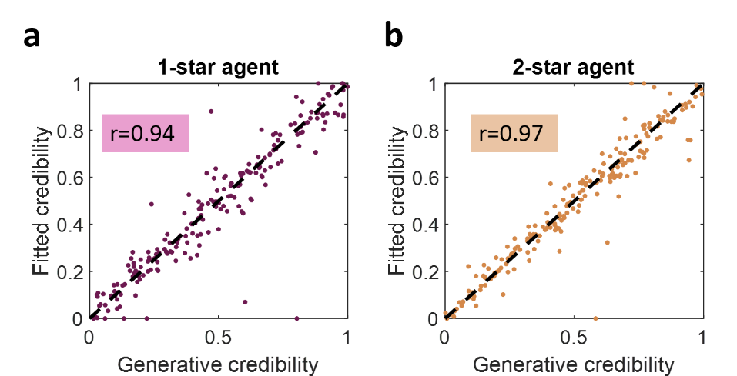
SI Figure 10: Parameter recovery for parameters of interest from free-credibility Bayesian model. a, Recovery for the credibility parameter of the 1-star agent. b, Recovery for the credibility parameter of the 2-star agent. Recoverability is represented by scatter plots between the generative credibility parameters used to create the synthetic datasets (x-axis) and the corresponding credibility parameters fitted from those datasets (y-axis). Circles represent the datapoints of individual simulations, the denoted metric “r” corresponds to the Spearman correlation between the generative and fitted parameters.
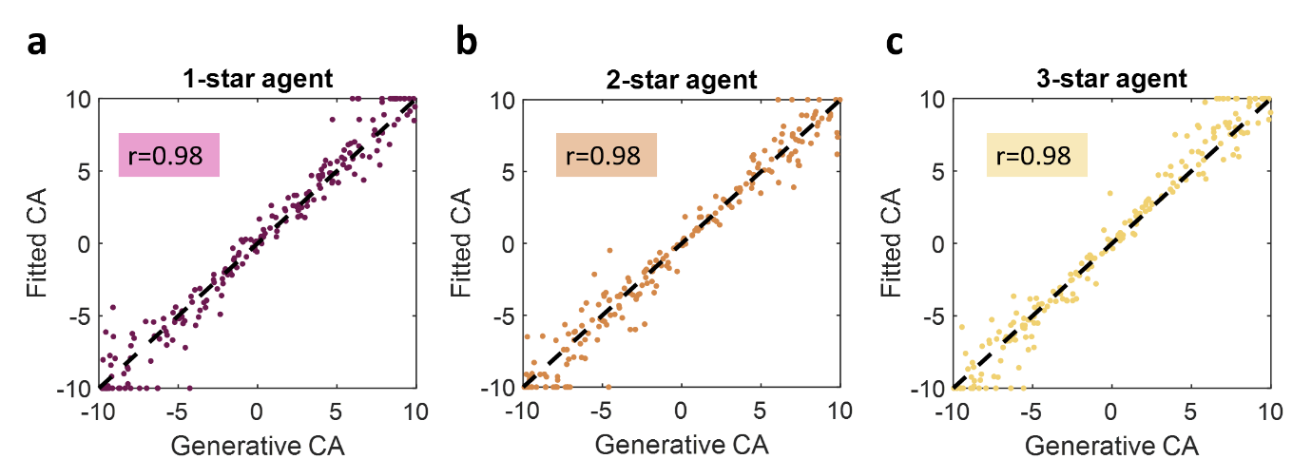 SI Figure 11: Parameter recovery for parameters of interest from credibility-CA model. Recovery for the CA parameter of the 1-star agent (a), 2-star agent (b), and 3-star agent (c). Recoverability is represented by scatter plots between the generative CA parameters used to create the synthetic datasets (x-axis) and the corresponding CA parameters fitted from those datasets (y-axis). Circles represent the datapoints of individual simulations, the denoted metric “r” corresponds to the Spearman correlation between the generative and fitted parameters.

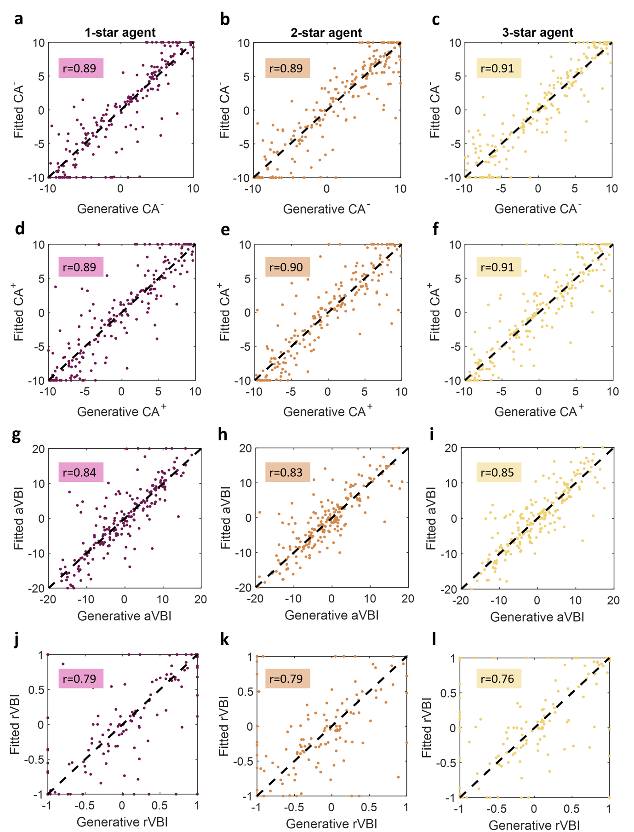
SI Figure 12: Parameter recovery for parameters and metrics of interest from credibility-valence-CA model. Recovery for the CA⁻ and CA⁺ parameters (top two rows) and their associated absolute valence bias (aVBI) and relative valence bias (rVBI) (bottom two rows) for the 1-star agent (a, d, g, j), 2-star agent (b, e, h, k), and 3-star agent (c, f, i, l). Recoverability is represented by scatter plots between the generative parameters/metrics used to create the synthetic datasets (x-axis) and the corresponding parameters/metrics fitted from those datasets (y-axis). Circles represent the datapoints of individual simulations, the denoted metric “r” corresponds to the Spearman correlation between the generative and fitted parameters.

4. SUPPLEMENTARY BAYESIAN DERIVATIONS

4.1. Derivation of posterior update for Bayesian model
In the Bayesian models, the beliefs about each bandit were represented by density distribution g(p) over the probability p a bandit will provide a true reward. In a given trial n, after reward-feedback was provided, the distribution for the chosen bandit was updated based on Bayes rule considering the agent’s feedback in the current trial (f_{n}), its associated credibility (C_{n}), and the history of the bandit prior to trial n (H_{1,2,…n-1}). This update was calculated as (note proportionality omits terms that are independent of p and $r_{n}$ denotes the true, latent, choice outcome on trial n):
$$g\left(p | H_{1,2,…n}\right)=g\left(p | f_{n}, C_{n}, H_{1,2,…n-1}\right)∝Prob\left(f_{n} | p,C_{n},H_{1,2,…n-1}\right)g\left(p | C_{n},H_{1,2,…n-1}\right)=g\left(p | H_{1,2,…n-1}\right)\sum_{r_{n}=0}^{1}{Prob\left(r_{n},f_{n} | p,C_{n},H_{1,2,…n-1}\right)=}g\left(p | H_{1,2,…n-1}\right)\sum_{r_{n}=0}^{1}{Prob\left(f_{n} | r_{n},p,C_{n},H_{1,2,…n-1}\right)Prob\left(r_{n} | p,C_{n},H_{1,2,…n-1}\right)=g\left(p | H_{1,2,…n-1}\right)\sum_{r_{n}=0}^{1}{Prob\left(f_{n} | r_{n},C_{n}\right)Prob\left(r_{n} | p\right)=}g\left(p | H_{1,2,…n-1}\right)[}\left(C_{n}*1_{f=1}+\left(1-C_{n}\right)*1_{f=0}\right)p+\left(C_{n}*1_{f=0}+\left(1-C_{n}\right)*1_{f=1}\right)\left(1-p\right)=g\left(p | H_{1,2,…n-1}\right)\left[\left(C_{n}p+\left(1-C_{n}\right)\left(1-p\right)\right)1_{f=1}+\left(C_{n}\left(1-p\right)+\left(1-C_{n}\right)p\right)1_{f=0}\right]$$
This was followed with normalisation to compensate for the proportionality in the derivation above
$$g(p│H_{1,2,…n})←\frac{g(p│H_{1,2,…n})}{\int_{0}^{1}{g(p│H_{1,2,…n})dp}}$$
For the forgone trial n bandit we have $g\left(p | H_{1,2,…n}\right)=g\left(p | H_{1,2,…n-1}\right)$.

References
1. Anwyl-Irvine, A. L., Massonnié, J., Flitton, A., Kirkham, N. & Evershed, J. K. Gorilla in our midst: An online behavioral experiment builder. Behav. Res. Methods 52, 388–407 (2020).
2. Foa, E. B. et al. The Obsessive-Compulsive Inventory: Development and validation of a short version. Psychol. Assess. 14, 485–496 (2002).
3. Freeman, D. et al. The revised Green et al., Paranoid Thoughts Scale (R-GPTS): psychometric properties, severity ranges, and clinical cut-offs. Psychol. Med. 51, 244–253.
4. Altemeyer, B. Dogmatic behavior among students: testing a new measure of dogmatism. J. Soc. Psychol. 142, 713–721 (2002).
5. Baron-Cohen, S., Wheelwright, S., Skinner, R., Martin, J. & Clubley, E. The autism-spectrum quotient (AQ): evidence from Asperger syndrome/high-functioning autism, males and females, scientists and mathematicians. J. Autism Dev. Disord. 31, 5–17 (2001).
6. Kessler, R. C. et al. The World Health Organization Adult ADHD Self-Report Scale (ASRS): a short screening scale for use in the general population. Psychol. Med. 35, 245–256 (2005).
7. Spitzer, R. L., Kroenke, K., Williams, J. B. W. & Löwe, B. A brief measure for assessing generalized anxiety disorder: the GAD-7. Arch. Intern. Med. 166, 1092–1097 (2006).
8. Zung, W. W. A SELF-RATING DEPRESSION SCALE. Arch. Gen. Psychiatry 12, 63–70 (1965).
9. Stanford, M. S. et al. Fifty years of the Barratt Impulsiveness Scale: An update and review. Personal. Individ. Differ. 47, 385–395 (2009).

