Extended Data 1: Mode Isolation and Harmonic Suppression in Balanced THz Frequency Multiplier
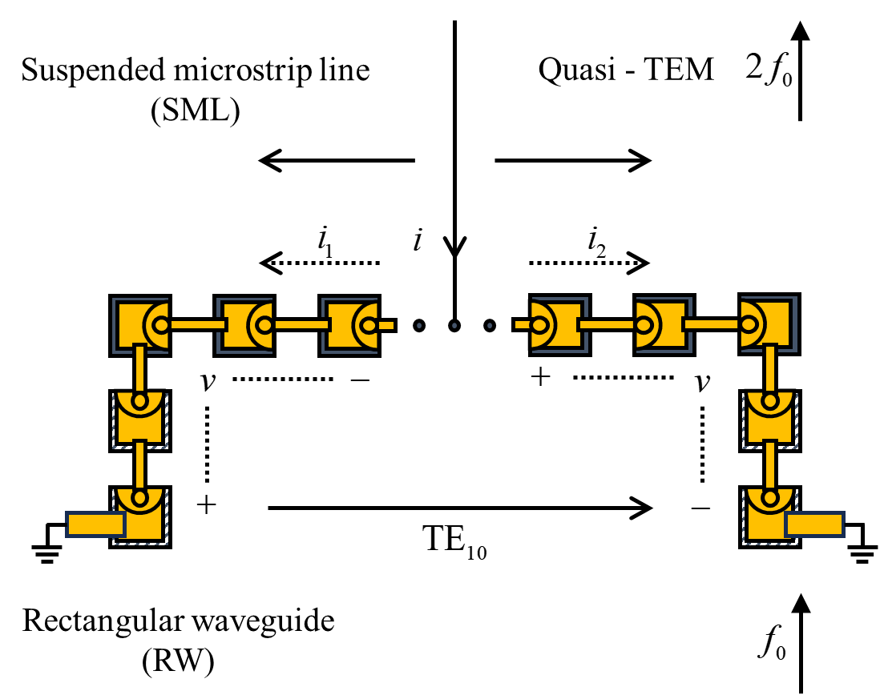
Extended Data Fig.1. Schematic diagram illustrating the operating principle of a balanced frequency doubler based on an artificial microstructure Schottky diode series array.
Solid-state THz frequency doublers typically utilize the classical Erickson structure⁴¹ as the most common circuit topology. In this structure, reverse-connected diodes are laterally placed within the input waveguide. The solder pads on both sides are connected to the waveguide walls, and the central solder pad is led out through a suspended microstrip line. The generated second harmonic passes through the matching circuit on the suspended microstrip and transitions to the waveguide at the output end, ultimately transmitted to the output waveguide.
Since the dominant mode transmitted through the input waveguide is the TE10 mode, and the output suspended microstrip line supports the quasi-TEM mode, these two modes are orthogonal to each other. Therefore, a natural mode isolation is formed between the input and output, eliminating the need for filters to prevent input signal leakage into the suspended microstrip. This not only eliminates the losses introduced by filters but also simplifies the design of the frequency multiplier.
On the other hand, the balanced configuration of the diodes ensures that the power levels of all odd-order harmonics in the input signal are strongly suppressed, and only even-order harmonics are output on the suspended microstrip. This enhances the purity of the output spectrum. The level balance and symmetry of this circuit rely more on the superior accuracy of the MMIC chip photolithography manufacturing than on the precision of manually assembling multiple devices, especially at higher frequencies. This significantly reduces waveguide losses resulting from the use of unnecessary waveguide power combiner structures.
The operating principle of a balanced frequency doubler can be analyzed straightforwardly, assuming that the diodes on both sides are symmetric and satisfy the same nonlinear equation. In this case, the current through the diode branches on both sides can be expanded into a Taylor series and represented as Equation (A) and Equation (B) respectively:
(A) The expansion of current through the diode branch on the first side:
(A)
(B) The expansion of current through the diode branch on the second side:
(B)
Here, and represent the currents through the diode branches on the first and second sides, respectively, while represents the voltage applied to the diode pair.
It is important to note that this analysis is based on the expansion of the nonlinear characteristics of the diode branches and assumes their symmetry. The design and adjustment of this balanced frequency doubler rely on precise current and voltage balance, as well as accurate modeling and control of the nonlinear characteristics, to achieve efficient frequency doubling performance.
The total current on the suspended microstrip line is the sum of the currents in the two side branches and can be written as Equation (C):
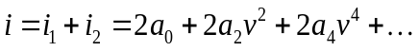 (C)
From Equation (C), it can be seen that all odd-order harmonics are suppressed in its output current spectrum, leaving only even-order harmonics. Assuming the input signal 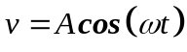, the output current is represented by Equation (D):
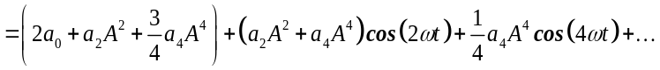 (D)
In the equation, the DC component proportion is the largest, and the even-order harmonic components gradually decrease, indicating lower efficiency for higher-order harmonics. By establishing an appropriate matching network, the second harmonic component can be selected to the maximum extent. Combined with the selective frequency characteristic of the waveguide, higher-order harmonic components can be interrupted, thus obtaining a purer THz wave.

Extended Data 2: The preparation process of the chip
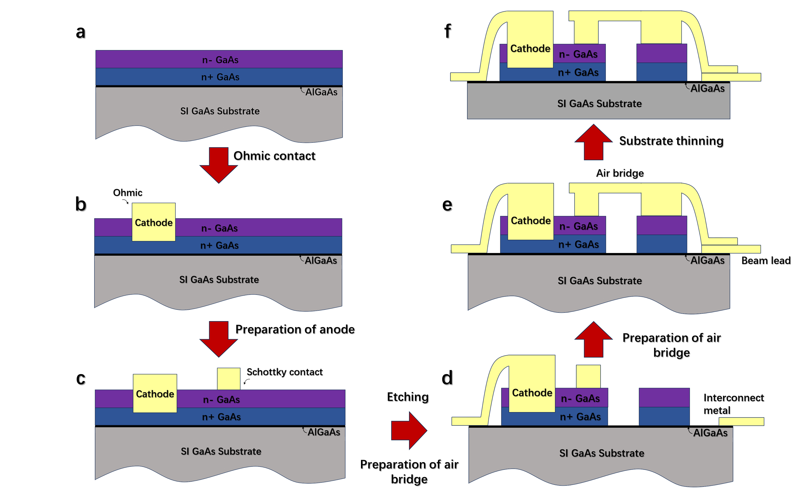
Extended Data Fig.2. Substrate device fabrication process steps. a, Mesa definition; b, Ohmic definition. c, Schottky definition; d, Mesa etching and air-bridged Schottky deposition. e, Bridge metal definition. f, Backside thinning and device separation.
Extended Data 2 gives steps on the core substrate device fabrication process.
Compared with the traditional "flip-chip" method of assembling planar Schottky diodes on the circuit microstrip, the monolithic integration technology can greatly improve the performance of terahertz solid-state devices by growing diodes on the circuit substrate directly instead of manual assembly through the semiconductor process. The diodes are grown or lutted on a semi-insulating substrate, on which the beam leads are generated to provide a grounding potential for the diodes and support the entire circuit substrate. This helps to realize unique diode arrangement structures, as conventional diodes are molded in one piece and modifying operations cannot be made. For example, in this paper, we propose artificial microstructures for multi-anode SBDs, which need to be accomplished under an advanced monolithic integration process. The process steps used to fabricate the chips are described below.
The structure of the GaAs monolithic Schottky diode is similar to the planar Schottky diode. The GaAs substrate serves as the bottom layer and the doping layers are grown on the base of the GaAs substrate. The high doping buffer layer (n +GaAs) is located between the epitaxial layer and the substrate, which prevents the impurities in the substrate from diffusing into the epitaxial layer, thus ensuring the electrical performance of the device. At the same time, the layer forms an ohmic contact with the pad metal, and the high doping concentration ensures a small ohmic resistance. The doping concentration of the layer is usually at the order of 10¹⁸ cm⁻³. The epitaxial layer (n-GaAs) and the anode metal form the Schottky contact, and the doping concentration is usually 1~2 orders of magnitude lower than that of the n+GaAs, which is 5×10¹⁶ cm⁻³ ~5×10¹⁷ cm⁻³. In steps c,d, a selective dry etch is used to define the device table, which stops at the AlGaAs etch stop layer. In steps e,f, the GaAs substrate is thinned to the desired thickness by grinding, polishing and wet etching.
Processing of the chip is accomplished by the monolithic preparation process described above. An array of sixteen diodes, eight on each arm, in a balanced configuration was used. The diodes are doped using an epitaxial layer of 2 × 10¹⁷ cm⁻³ and a diode anode size of 4um radius is employed. Our diode model calculations predict a zero-bias junction capacitance of 85 fF and a series resistance of 2 for these devices. The frequency doubler is optimized for an input pump power of around 0.5/1W.

Extended Data 3: Influence of Three-Dimensional Field Coupling on Transmission Characteristics
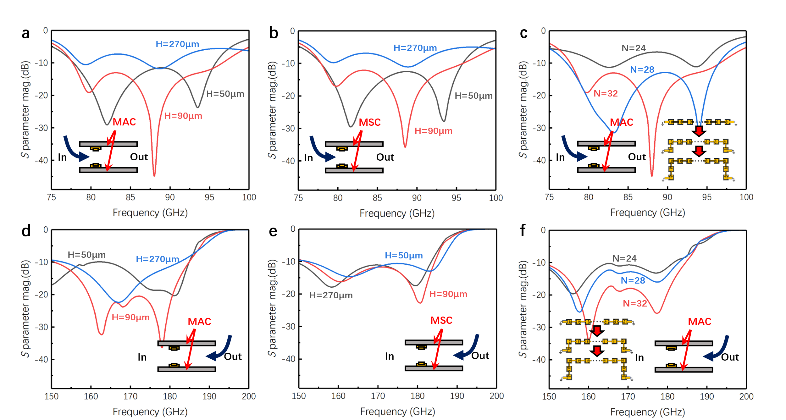
Extended Data 3. Influence of three-dimensional field coupling on transmission characteristics.
Extended Data 3 presents simulation results concerning the three-dimensional field coupling and its impact on transmission characteristics. Specifically, the study examines the influence of altering two coupling parameters on the input and output transmission characteristics of the device. Figs a and b highlight similarities in the trend of input coupling efficiency with frequency for both the dual-layer MSC and the dual-layer MAC when adjusting the interlayer spacing.
A reduction in interlayer spacing from a larger value of 270μm to 50μm results in an initial increase and subsequent decrease in coupling efficiency, showing a peak point. Larger interlayer spacing leads to greater deviation from the waveguide center, naturally decreasing coupling efficiency. However, reducing it to 50μm is constrained due to limitations in chip dimensions.
Figs c and d demonstrate that in the conventional approach, increasing the number of anodes in a single-chip to 14 anodes leads to lower input and output coupling efficiency, resulting in energy waste. By vertically increasing the number of anodes in the xoy plane to form a C-shaped array, input and output coupling efficiency can be enhanced.
For the dual-layer MSC, altering the interlayer spacing has minimal effect on transmission characteristics due to symmetrically distributed fields suppressing near-field coupling, allowing the chips to operate independently without mutual interference. Conversely, for the dual-layer MAC, the optimal interaction point varies with longitudinal interlayer spacing, achieving maximum resonance interaction when reducing it from 270μm to 90μm.
Considering the spatial transverse coupling distance, it has a relatively small impact on input coupling efficiency due to inherent mode isolation in transmission. However, under near-field decoupling and near-field coupling states, the spatial transverse coupling distance affects output coupling efficiency. Optimizing this distance identifies regions of optimal coupling, where the minimum size is determined by chip thickness. By accounting for optimal coupling regions for both input and output, near-field coupling between chips can achieve higher output coupling efficiency compared to near-field decoupling.
Furthermore, as the transverse coupling distance decreases, the electric field between interchip diodes increases, strengthening coupling between Meta chips, leading to the highest coupling efficiency in the optimal coupling region. However, continued decrease in distance results in reduced coupling efficiency as the transverse electric field between interchip diodes decreases.
Extended Data 4 | Experimental Setup 1:
a
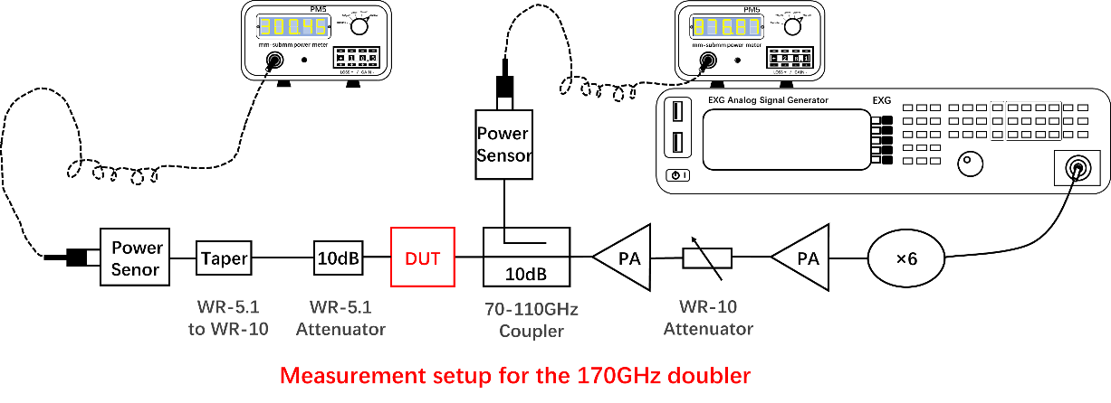
b
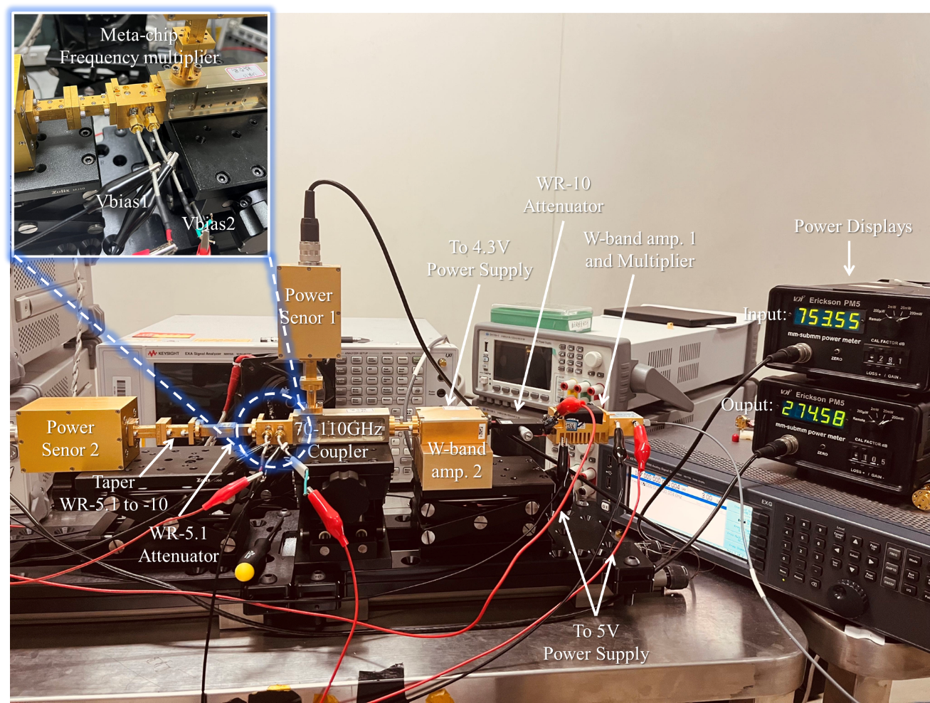
Extended Data 4. Setup of the power experiment testing platform.
We constructed a testing platform to test and validate the excellent performance metrics of the dual-layer Meta chip. Fig. a shows the schematic diagram of the testing platform, and Fig. b presents the actual setup.
The testing platform consists of a W-band driver amplifier and a millimeter-wave sixfold frequency multiplier, providing a preceding driving signal of 10-20 dBm from right to left. A WR-10 variable attenuator was used to adjust the power of the preceding driving source, controlling the input power. A power combining power amplifier was used to provide a high-power signal, with a maximum output power of up to 30 dBm. A 70-110 GHz directional coupler connects the straight waveguide and power probe to the VDI PM5, monitoring the input power.
The input port of the device under test (DUT) was connected to the preceding solid-state devices in series. The DUT employed parallel and independent bias-controlled diodes. The output port of the DUT was connected sequentially to a 10dB fixed attenuator for WR-5.1, a waveguide adapter from WR-5.1 to WR-10, and the probe of VDI PM5. The attenuator serves to protect the instrument and probe, as the detected power may occasionally exceed the rated power. The waveguide adapter and probe are used to convert and measure the output power.
In the experiment, we used power monitor 1 to observe the input power and power monitor 2 to read the output power. Through this method, we were able to test and verify the performance of the device. During the testing process, we conducted high-power tests on the device, starting from a smaller input power and gradually increasing it until the output power exceeded 300mW. This process validated the actual performance of the device.

Extended Data Table 1 | Comparison between THz Frequency Multipliers based on Meta-device Concept and Traditional Devices:
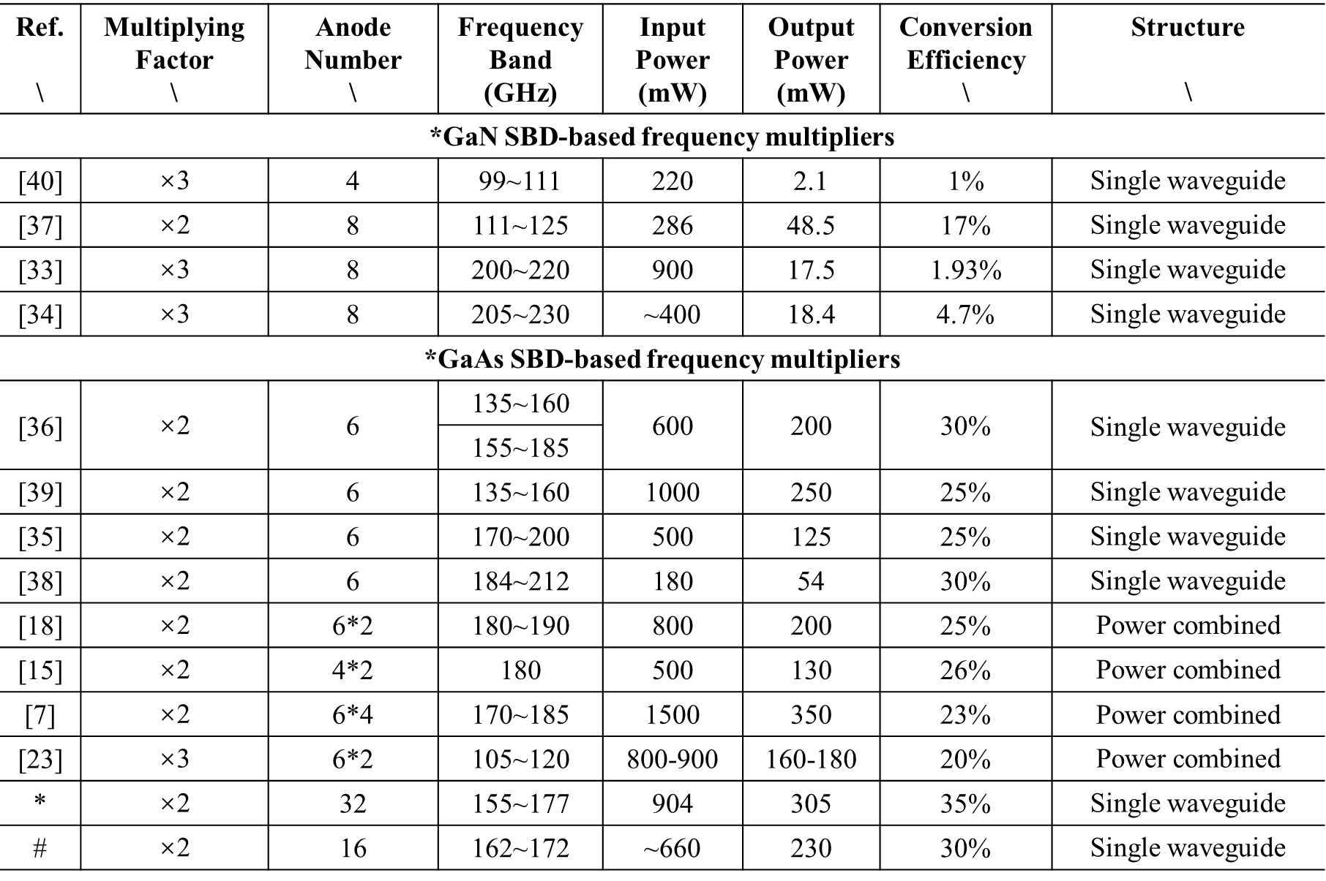
The technical specifications for THz frequency multipliers^{7,15,18,23,25,33–40}. Classic THz frequency multipliers often utilize two semiconductor materials, GaN and GaAs, to achieve higher power. However, the less heat-resistant GaN material is typically operated at very low duty cycles to achieve greater pulse power capacity. Nevertheless, for practical applications, continuous wave (CW) THz takes precedence, and power combining techniques can further extend the power capacity. However, for practical applications, CW THz is dominant, and power combining techniques can further extend the power capacity. Taking the WR-5.1 waveguide standard as an example, # represents the Meta single-layer frequency multiplier structure, and * represents the Meta double-layer frequency multiplier structure, both of which are capable of competing with, or even outperforming, the power combining approach.

