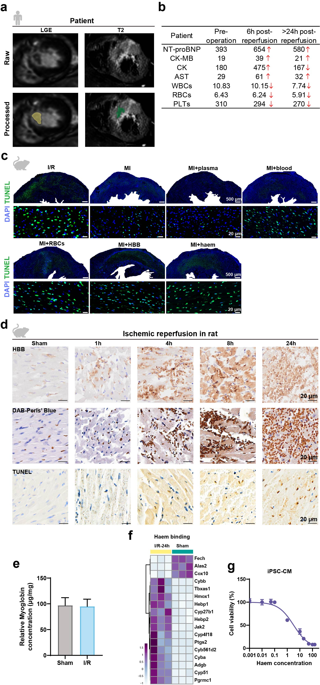
Extended Data Fig.1| Contribution of IMH to cardiac injury post I/R. a, Patient LGE and T2 CMR images at 1 day post-reperfusion. Yellow: infarct, IMH: green. b, Changes of serum NT-proBNP, CK-MB, CK and AST levels and WBCs, RBCs and PLTs numbers over time in the patient after I/R surgery. c, TUNEL staining in rat LV of Sham, I/R, MI rats, and MI rats received intramyocardial injections of autogenous blood, erythrocytes, plasma, HBB or haem. d, Influence of reperfusion time (0 h, 1 h, 4 h, 8 h, 23 h) on intramyocardial iron deposition and cardiac cell death. Immunohistochemical staining of HBB; DAB-enhanced Perl’s blue for ferric iron level in tissue; TUNEL for cell death. e, Rat myoglobin concentration in infarcted myocardium in Sham and I/R-24h groups. f, Heatmap showing differentially expressed genes in LV tissue of Sham and I/R-24h groups, under the “haem binding” term. g, Viability of iPSC-CMs cultured with haem of gradient concentrations. LGE: late gadolinium enhancement; CMR: Cardiac magnetic resonance imaging; NT-proBNP: N-terminal pro-brain natriuretic peptide; WBC: white blood cell count; RBC: red blood cell; PLT: platelet.
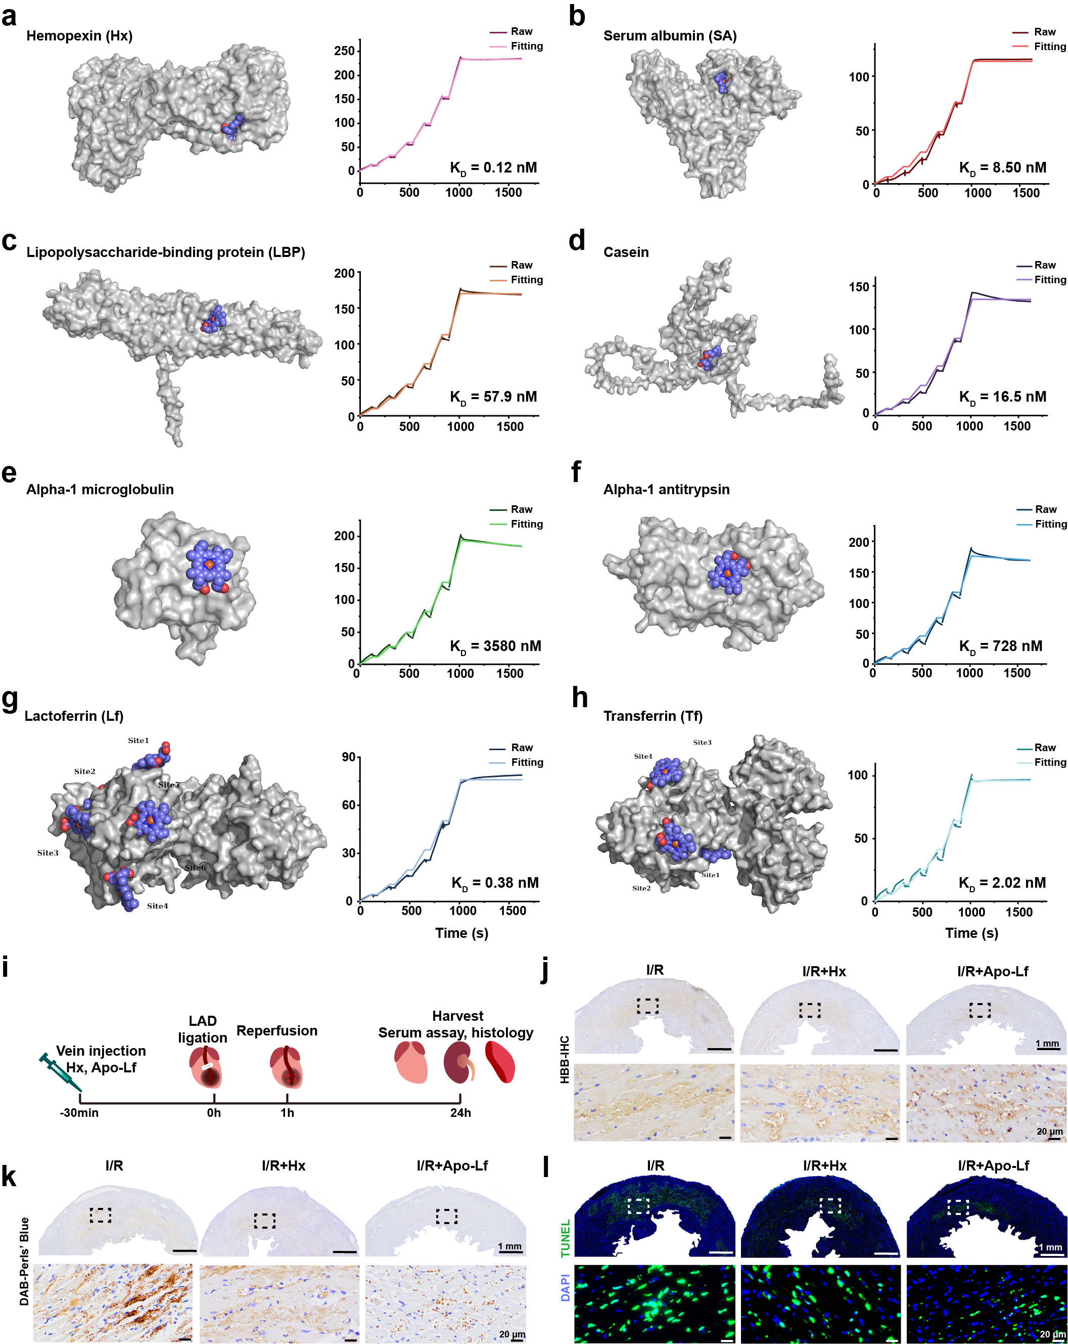
Extended Data Fig.2| Comparison of haem binding affinities and cardiac protection effects between Apo-Lf molecules and other haem-binding protein molecules. a-h, Surface plasmon resonance (SPR) detections of haem binding proteins with haem (haem = 168.07, 240.1, 343, 490, 700, 1000 (nM) flowing over a CM5 protein-immobilized sensor-chip at 25°C) and molecular docking of haem binding proteins with haem. a, Hemopexin (Hx). b, Serum albumin. c, Lipopolysaccharide-binding protein. d, Casein. e, Alpha 1-Microglobulin. f, Alpha-1-Antitrypsin. g, Lactoferrin (Lf). h, Transferrin (Tf). i, Scheme of the animal study for evaluation of the cardiac protection against IMH and I/R injury with intravenous injection of Apo-Lf or Hx solution. j, Immunohistochemical staining of HBB, locating of IMH injury sites in LV of rats from groups including Sham, I/R and I/R pre-treated with Hx and Apo-Lf (4 mg/kg). k, DAB-enhanced Perl’s blue showing ferric iron deposition in the myocardium. l, TUNEL fluorescent staining reveals cell death in the corresponding three groups.

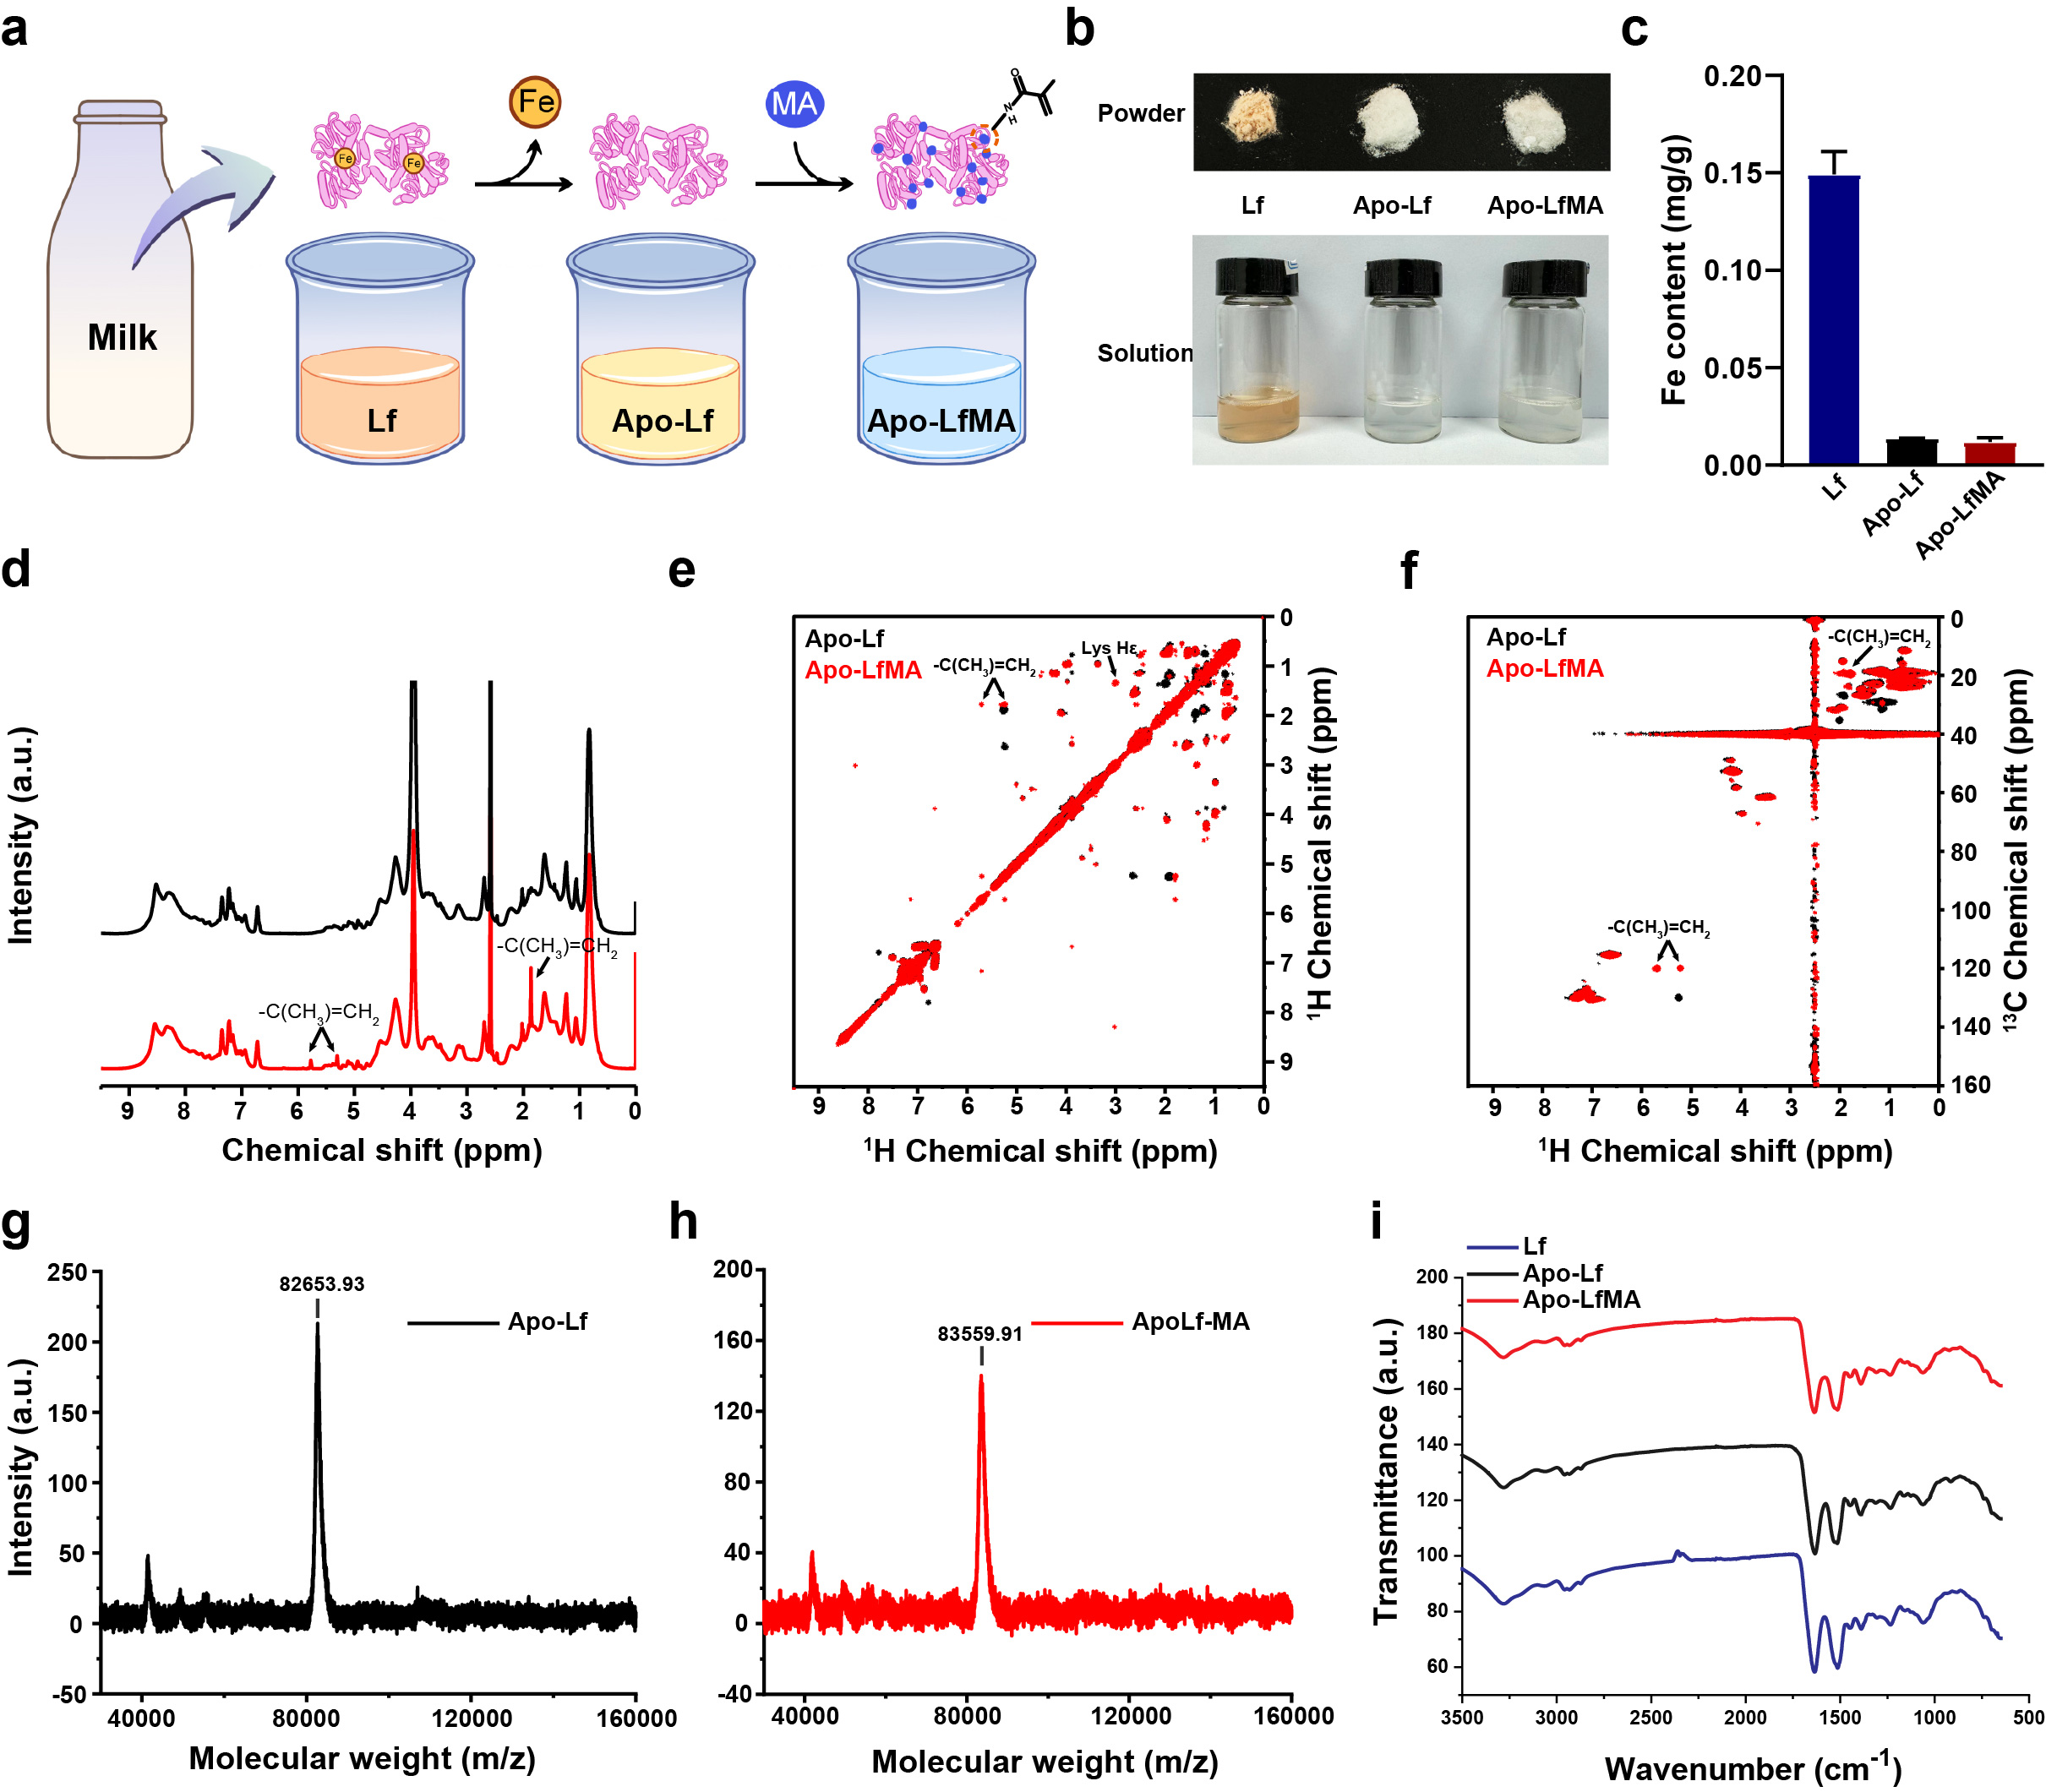
Extended Data Fig.3 | Synthesis of Apo-Lf and Apo-LfMA. a, Schematic illustration of the iron depletion and methacrylation process b, Powder and solution forms of Lf, Apo-Lf and Apo-LfMA. c, Fe content in Lf, Apo-Lf and Apo-LfMA. d-f, ¹H NMR spectra, ¹H-¹H HSQC, and ¹H-¹³C HSQC of Apo-Lf and Apo-LfMA. g,h, Maldi-TOF mass spectra of Apo-Lf and Apo-LfMA. i, FTIR spectra of Lf, Apo-Lf and Apo-LfMA. FTIR: fourier transform infrared spectrometer; NMR: nuclear magnetic resonance; HSQC: heteronuclear singular quantum correlation.

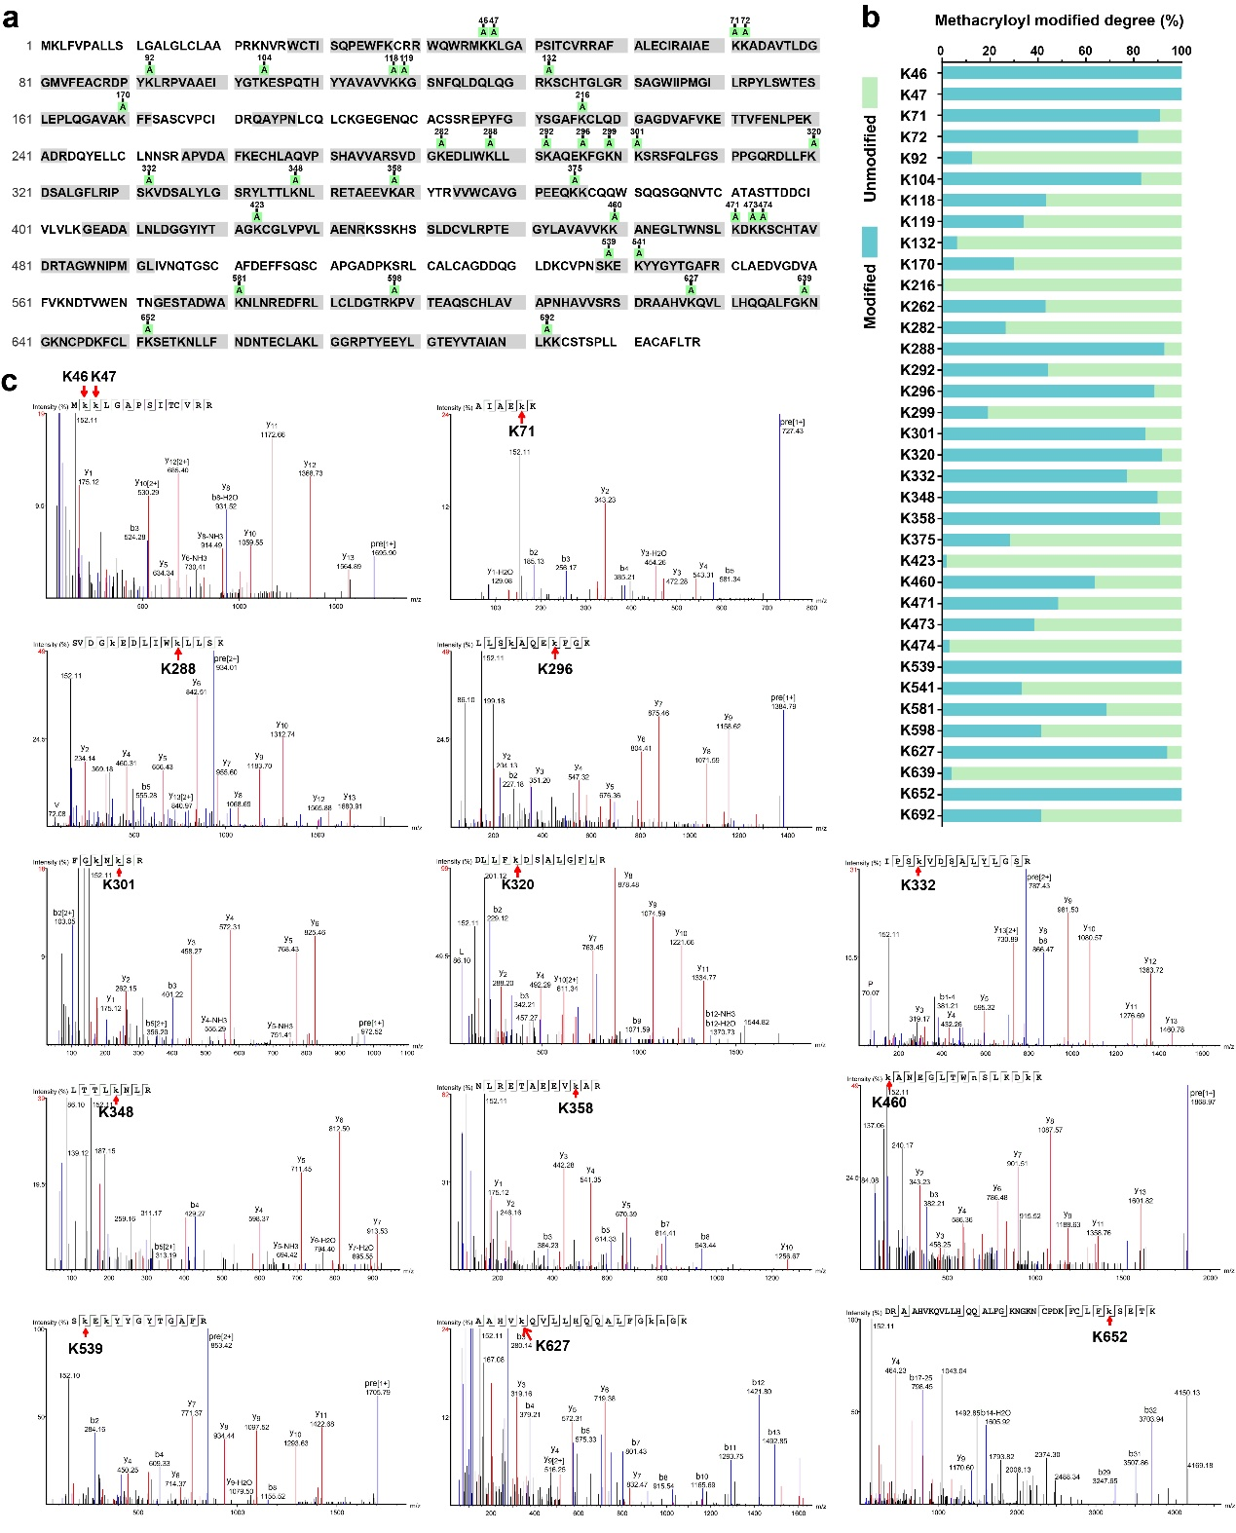
Extended Data Fig.4 | Quantification of double bonds in Apo-LfMA using HPLC-MS spectra. a, Protein sequence coverage of Apo-LfMA were shadowed with gray color. The green “A” indicates the presence of a methacryloyl modification. b, Degree of methacryloyl modification (%) on lysine at different sites of Apo-Lf. c, The spectra of fragments locating the top 14 lysines with highest degree of methacryloyl modification. HPLC-MS: high performance liquid chromatography mass.

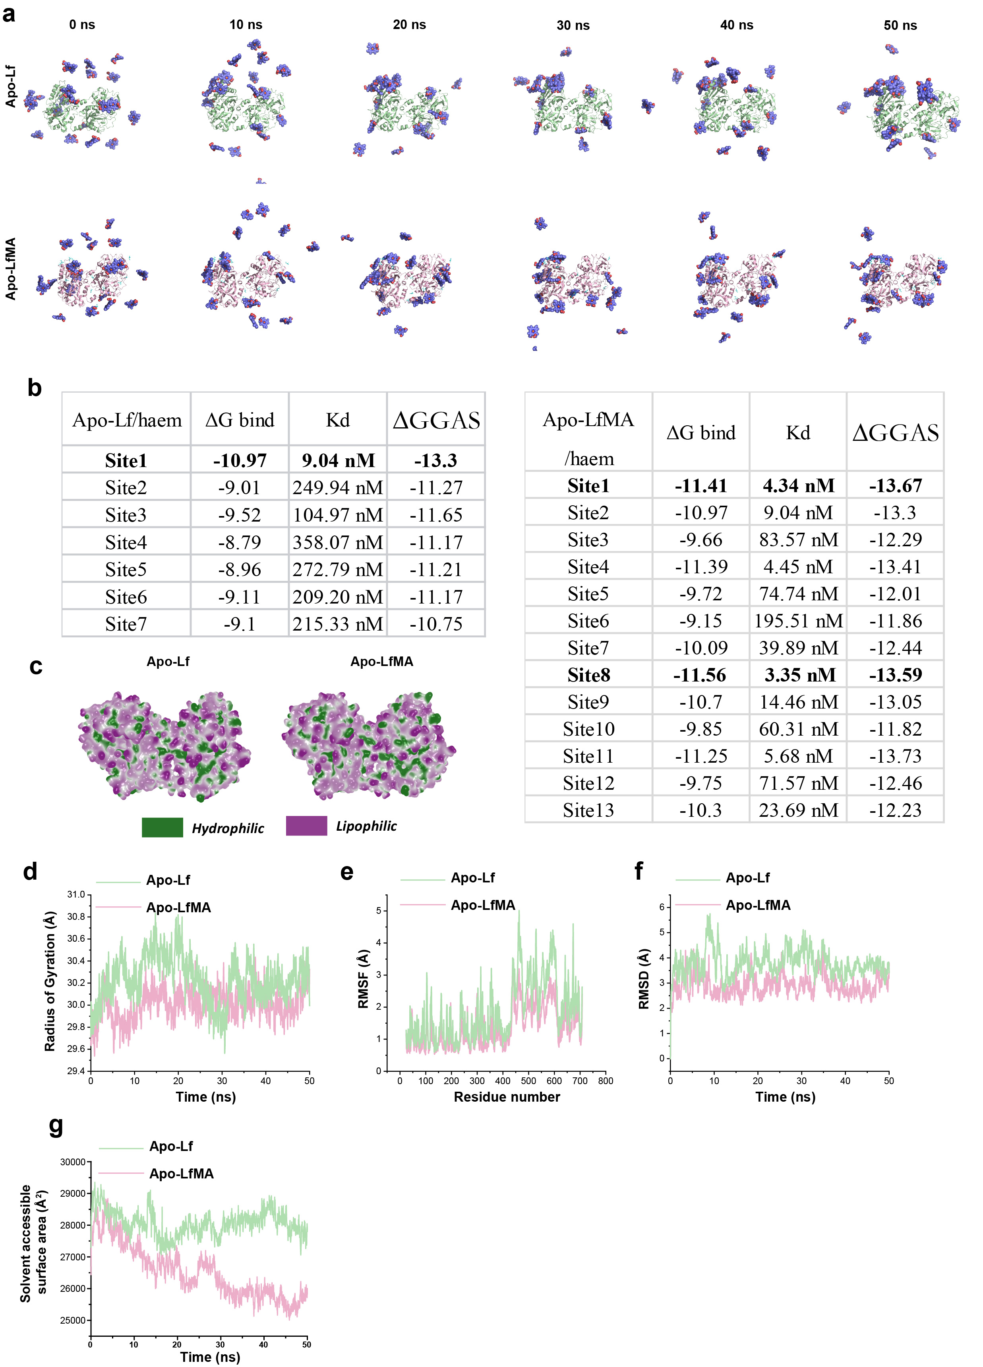
Extended Data Fig.5 | Exploration of surface property of Apo-Lf and Apo-LfMA and MD simulation of Apo-Lf and Apo-LfMA interaction with haem. a MD simulation of Apo-Lf/haem and Apo-LfMA/haem interaction in 50 ns. b, Affinity parameters of the 7 haem-binding sites in Apo-Lf and 13 haem binding sites in Apo-LfMA, including protein-haem binding free energy (ΔG bind), equilibrium dissociation constant (Kd) and molecular mechanics term (energy in the gas phase) (∆GGAS). c, Surface hydrophobics showed differences between Apo-Lf and Apo-LfMA. d-g, The change trajectory of radius of gyration, RMSF, RMSD and SASA of Apo-Lf and Apo-LfMA in haem interaction process as determined by 50 ns MD simulations, revealing the compactness of protein structure. RMSD: root mean square deviation; RMSF: root mean square fluctuation; SASA: solvent accessible surface area.
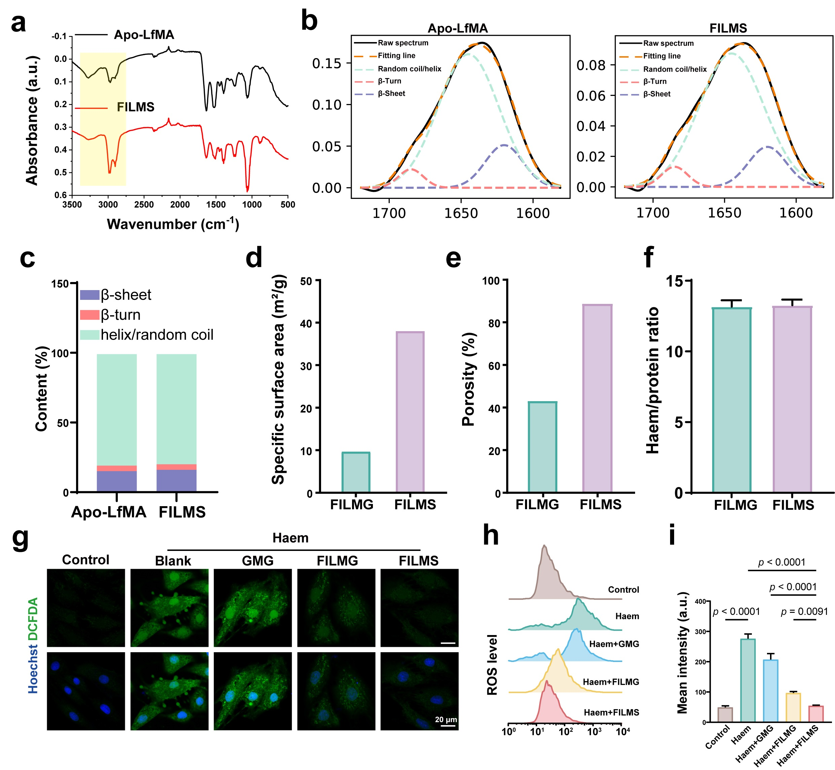
Extended Data Fig.6 | The characteristics of FILMG and FILMS and their functions in inhibiting haem-induced ferroptosis of H9C2. a,b, FTIR spectra of Apo-LfMA and FILMS. c, Quantitative analysis of secondary structures present in Apo-LfMA and FILMS. . d,e, Specific surface area and porosity of FILMG and FILMS obtained from mercury pressure curves. f, Saturated haem-binding numbers of FILMG and FILMS, detected by extracting bound haem. g-i, Representative fluorescent images of DCFDA (green) and DAPI (blue), flow cytometric histogram of DCFDA and the mean intensity of flow cytometric histogram of H9C2 treated with haem for 24 h in the presence of GMG, FILMG or FILMS (n=3). Control: H9C2 with no treatment; Blank: H9C2 with haem treatment; SEM=scanning electron microscope; EDX=energy dispersive X-Ray spectroscopy; DCFDA=2',7'-dichlorofluorescein diacetate.
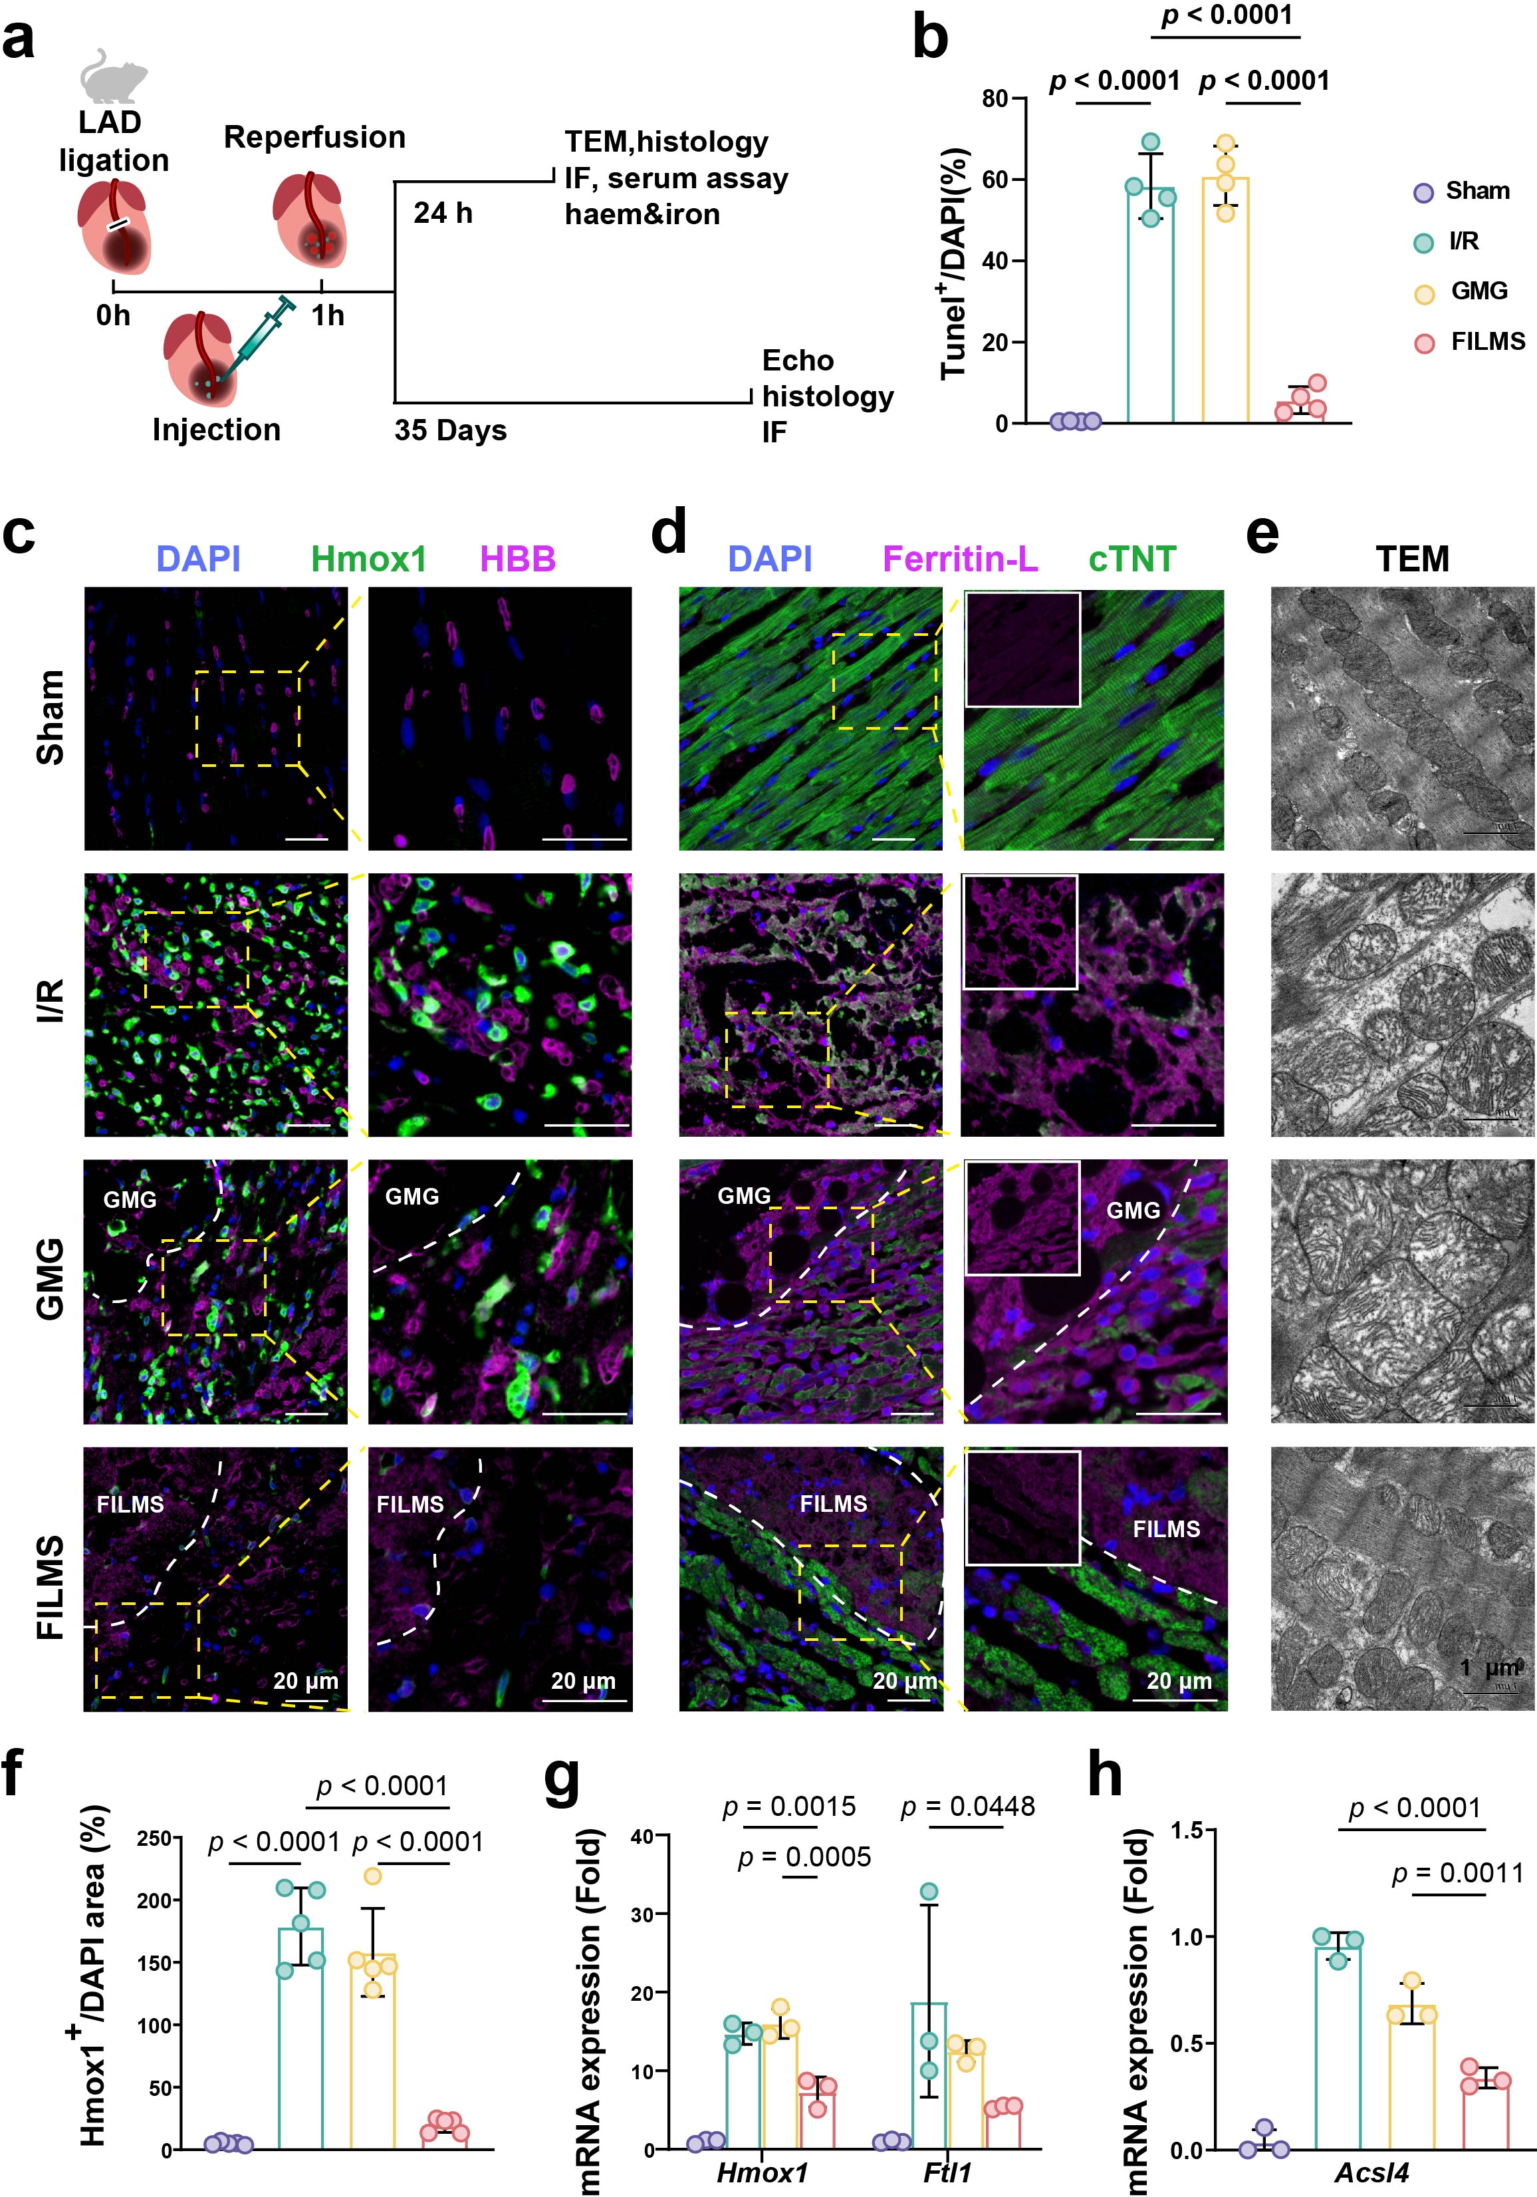
Extended Data Fig. 7 | Additional data of FILMS protecting against IMH-induced ferroptosis in myocardium via haem clearance. a, Schematic illustration of rat I/R model and experimental design to evaluate the anti-ferroptotic and cardiac-protective effects of FILMS, with GMG as control material. b, The ratio between TUNEL and DAPI of samples in Fig. 4d, including Sham rats and I/R rats with saline, GMG or FILMS treatment (n=4). c, Immunofluorescent staining of HBB and Hmox1 in myocardium of rats subjected to I/R injury treated with GMG or FILMS. d, Ferritin-L and cTNT staining in the heart slice of I/R rats with GMG or FILMS treatment. e, TEM images of mitochondria in cardiomyocytes of Sham rats and I/R rats treated with saline, GMG or FILMS. f, The semi-quantitative measurement of Hmox1 area versus DAPI area in myocardium of rats subjected to I/R injury in different groups (n=5). g,h, Hmox1, Ftl and Acsl4 mRNA levels in Sham rats and I/R rats received saline, GMG or FILMS treatment (n=3).
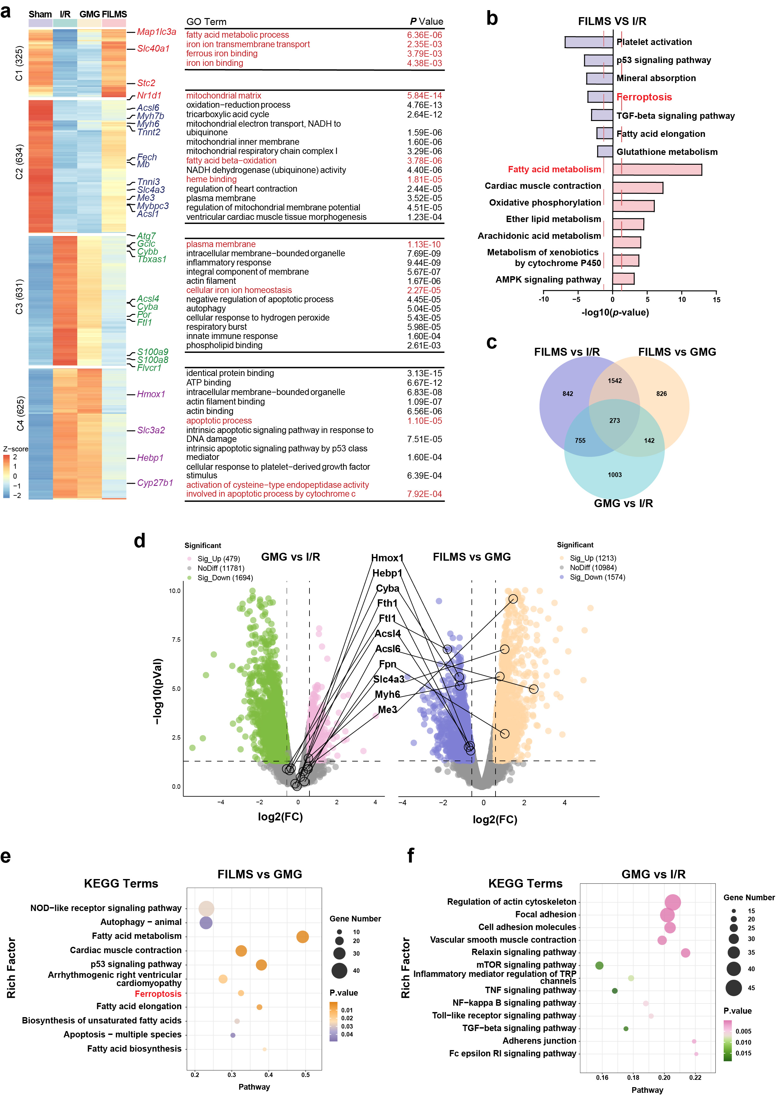
Extended Data Fig.8 | Transcriptomic study of rat myocardium. a, Heatmap of Cluster 1-4 (C1, C2, C3 and C4) genes expressed in the 4 groups. GO enrichment of Cluster 1-4 genes and the p value of each GO term. b, A total of 22,580 genes were identified, and 3420 differentially expressed genes among the three groups were identified (fold changes ≥ 1.5 and p values < 0.05). Venn diagram for the differentially expressed genes detected in myocardium after I/R surgery with saline, GMG or FILMS treatment. c, KEGG pathway analysis of differentially expressed genes between I/R group and I/R rats treated with FILMS group. d, Volcano plots of genes related to ferroptosis, haem binding and cardiac function between I/R treated with GMG and I/R groups or between I/R treated with FILMS and I/R treated with GMG groups (p value by Wald test in DESeq2). e, KEGG pathway analysis of differentially expressed genes between I/R treated with GMG and I/R groups. f, KEGG pathway analysis of differentially expressed genes between I/R treated with FILMS and I/R treated with GMG.
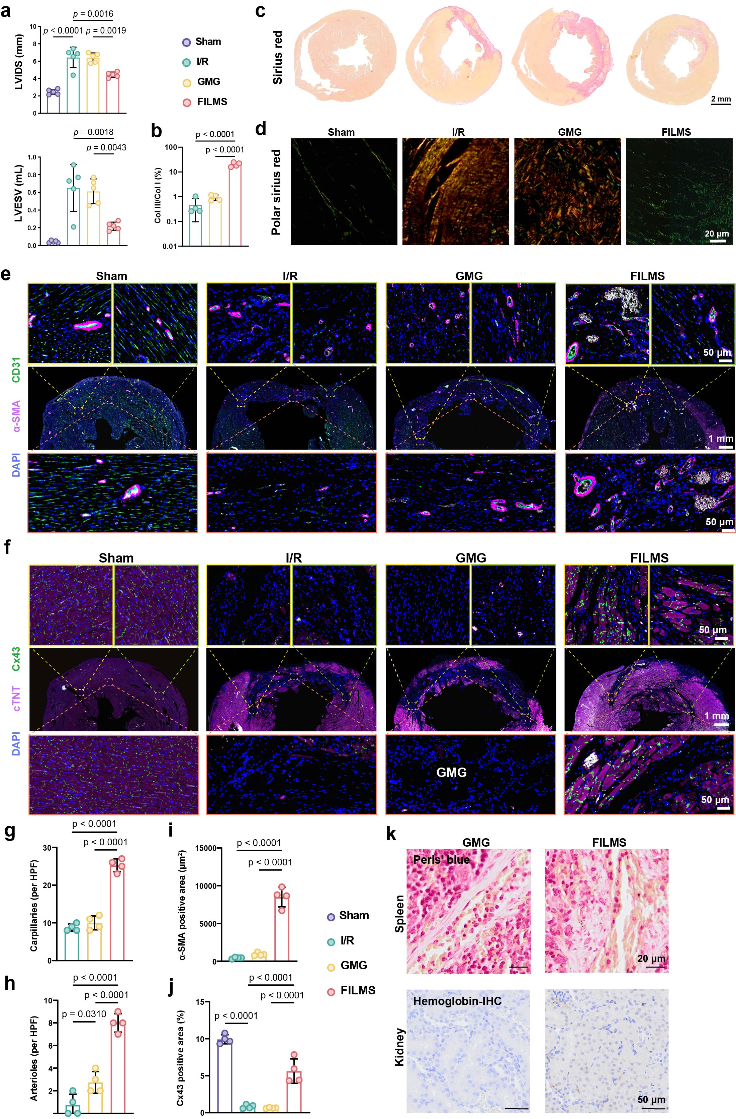
Extended Data Fig. 9 | Additional evaluation of safety and efficacy of FILMS implantation. a, A prognostic evaluation containing echocardiograms (LVESV and LVIDS) of rats subjected to Sham surgery or I/R injury treated with saline, GMG or FILMS in 5-week post-surgery (n=4). b-d and the quantitative data, optical images and polarized light images of Sirius red of rats subjected to Sham surgery or I/R injury treated with saline, GMG or FILMS in 5-week post-surgery (n=4). Representative images of immunofluorescent staining of (e) α-SMA (pink), CD31 (green), and DAPI (blue) for blood vessels, and (f) cTNT (pink), Cx43 (green), and DAPI (blue) for remaining CMs at day 35 in the border zones and infarct areas of rats subjected to Sham surgery or I/R injury treated with saline, GMG or FILMS (n=4). g-i, Quantitative analysis of the densities of capillaries and arteries and α-SMA positive area in all groups based on immunofluorescent staining in (e), (n=4). j, Quantitative analysis of Cx43 positive area in all groups based on immunofluorescent staining in (f), (n=4). k, The safety of GMG or FILMS implantation was evaluated in I/R rats treated with GMG or FILMS, via Perl’s blue showing iron deposition in spleen and HBB levels in kidney. LVESV: left ventricular end-systolic volume; LVIDS: left ventricular internal dimension in systole; α-SMA: α-smooth muscle actin; cTNT: cardiac troponin I; Cx43: connexin 43.

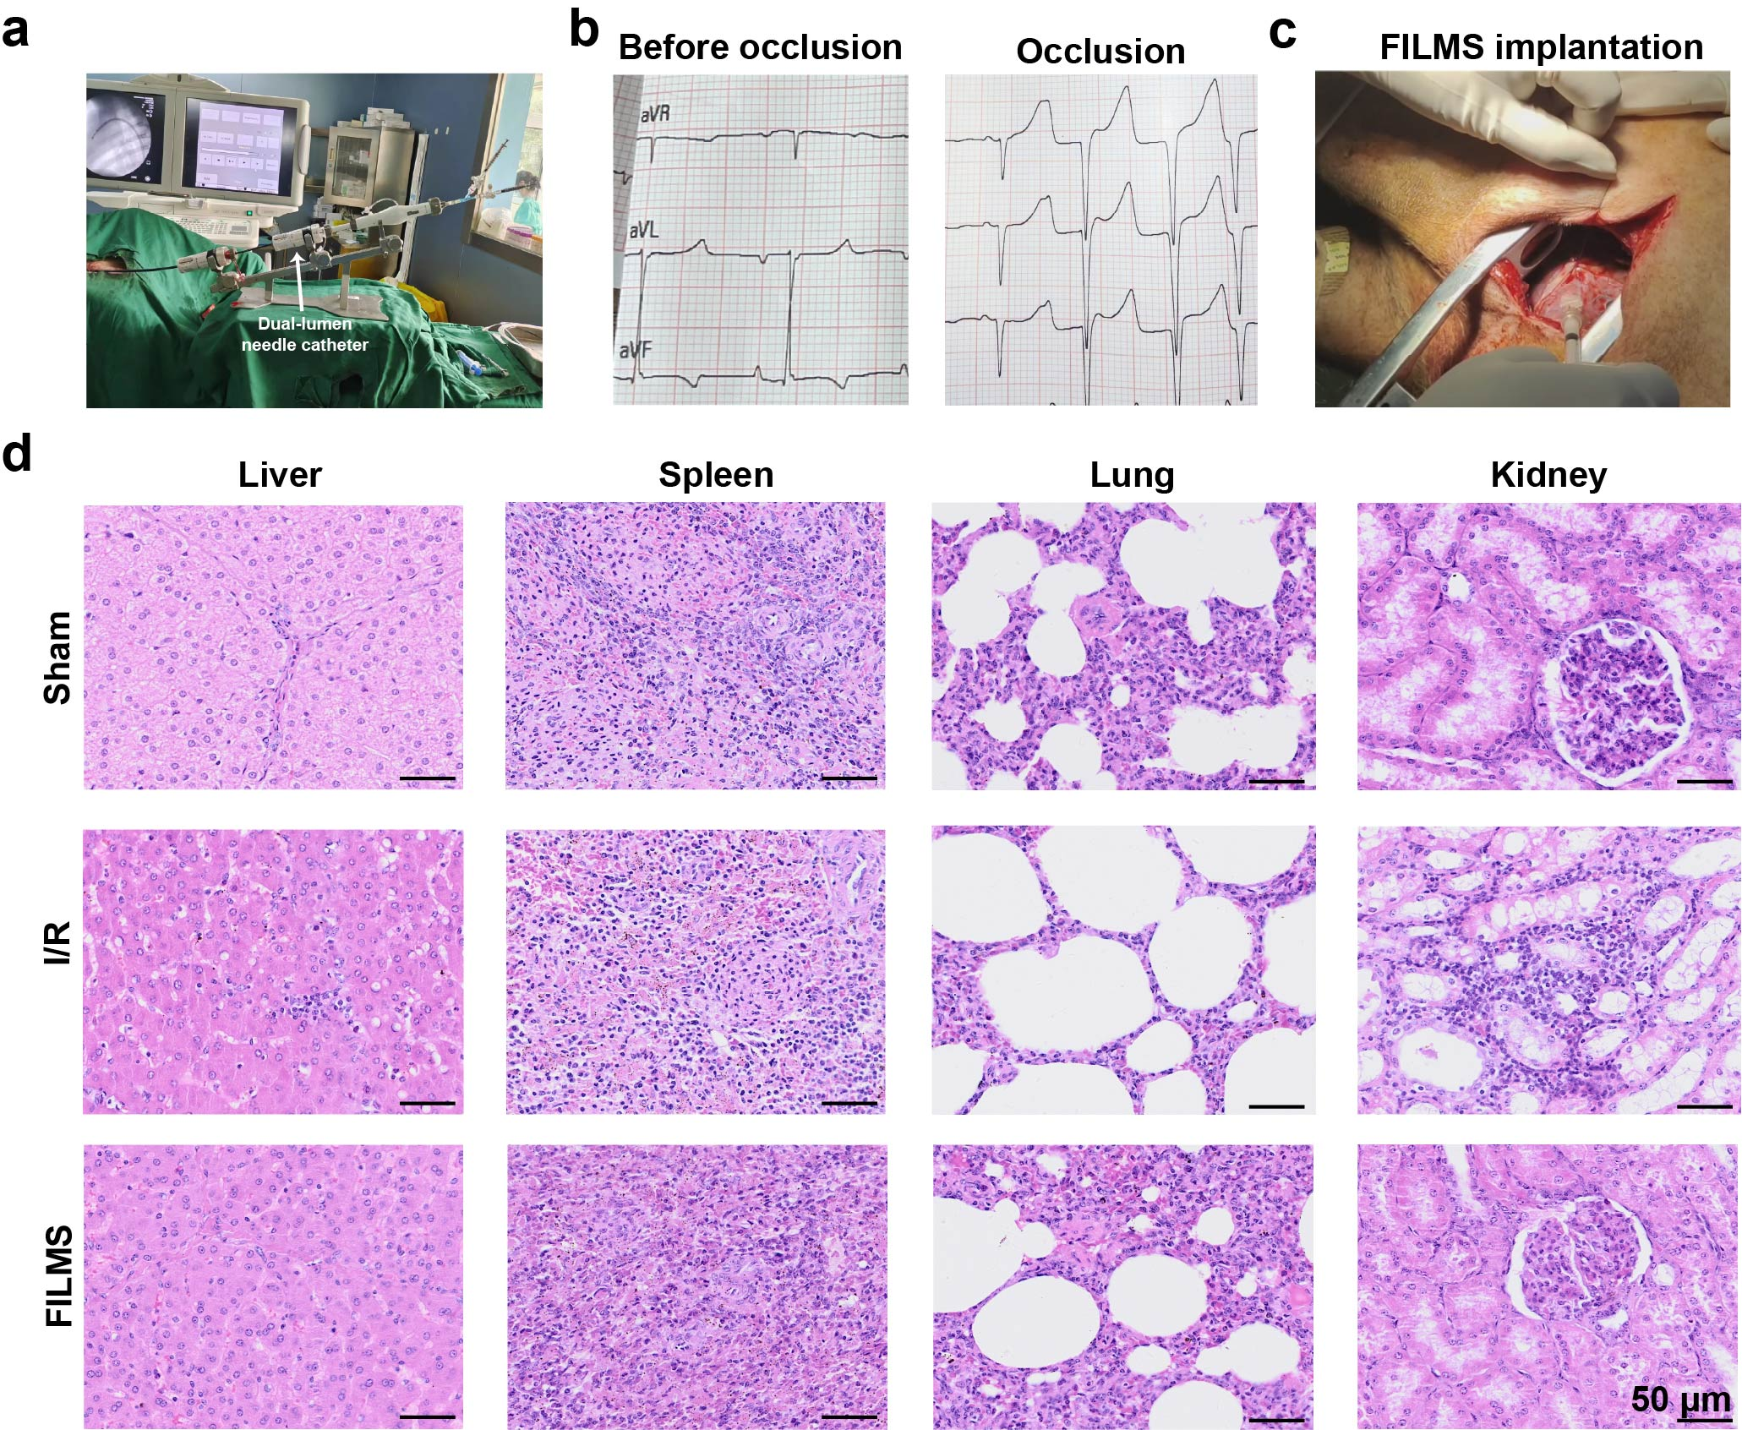
Extended Data Fig.10 | Additional information of minimally invasive FILMS implantation in porcine models. a, a dual-lumen needle catheter device²³ went through the femoral artery of a Chinese giant white pig under the guidance of DSA to deliver FILMS to LV myocardium. b, Typical electrocardiograms of Bamma minipigs before and after occlusion in left anterior or descending branch are also shown. c, FILMS were homogeneously injected into the infarcted myocardium of Bamma minipigs after I/R. d, H&E staining of histological sections from liver, spleen, lungs, and kidneys of minipigs subjected to Sham surgery or I/R injury treated with saline or FILMS (n= 3).

