TableS1. The number of SNPs at each threshold.
PGS | P Threshold | Num_SNP
WR_Arithmetic | 0.4799 | 64207
WR_ Reasoning | 0.16425 | 37345
WR_ Visuospatial | 0.0001 | 112
PA_Arithmetic | 0.4196 | 59812
PA_ Reasoning | 0.4766 | 63281
PA_ Visuospatial | 0.00015 | 113
NWR_Arithmetic | 0.0147 | 6264
NWR_ Reasoning | 0.2989 | 51242
NWR_ Visuospatial | 0.0236 | 9238
NREP_Arithmetic | 0.3851 | 55031
NREP_ Reasoning | 0.3856 | 55061
NREP_ Visuospatial | 0.0133 | 4967
Note: WR = Word reading, PA = Phonological awareness, NWR = Nonword reading, NREP = Nonword repetition.

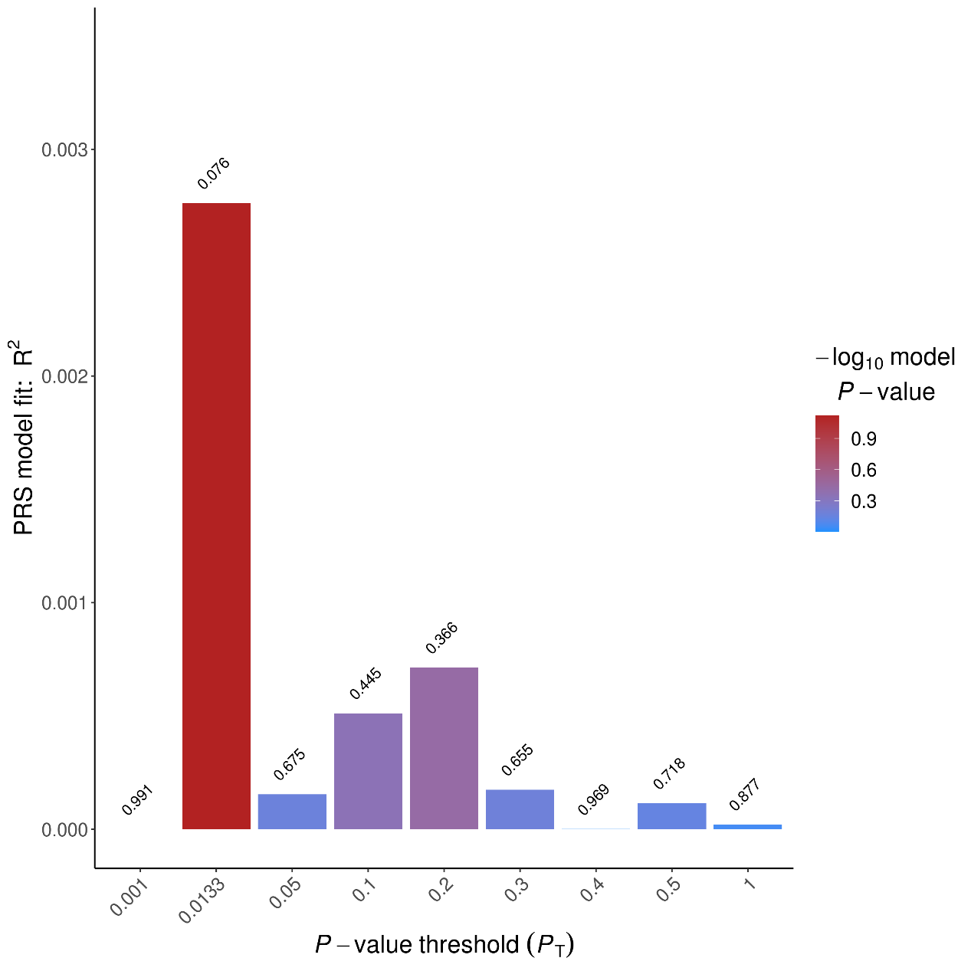
Figure S1 p-value threshold of NREP_VIS PGS
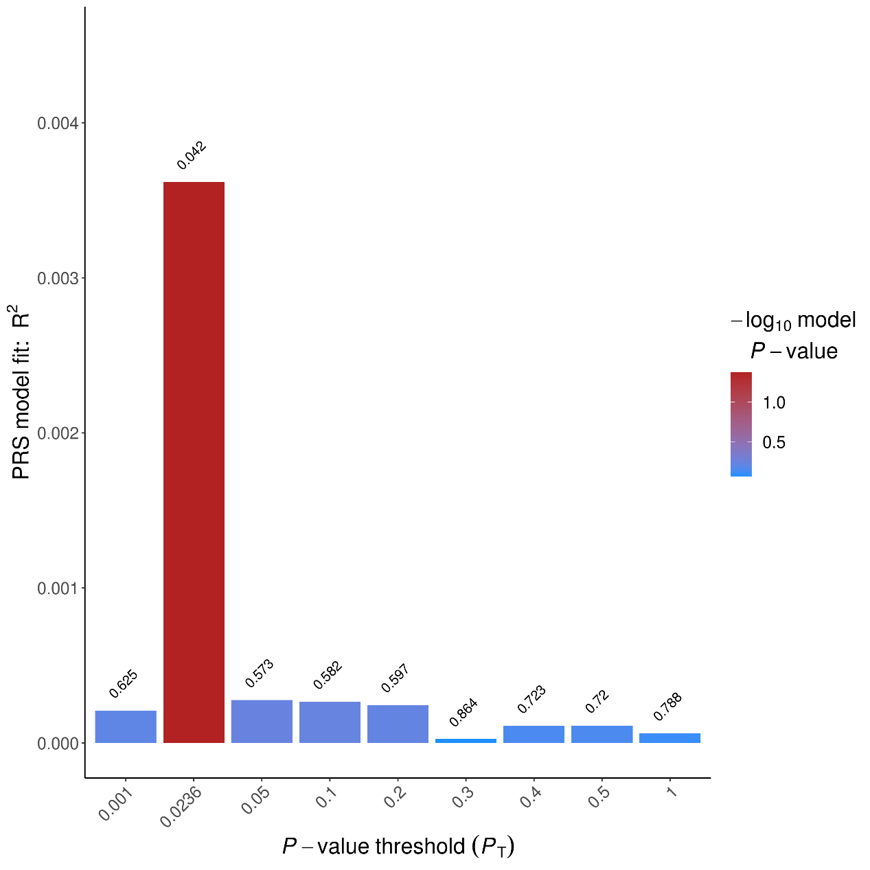
Figure S2 p-value threshold of NREP_ Visuospatial PGS
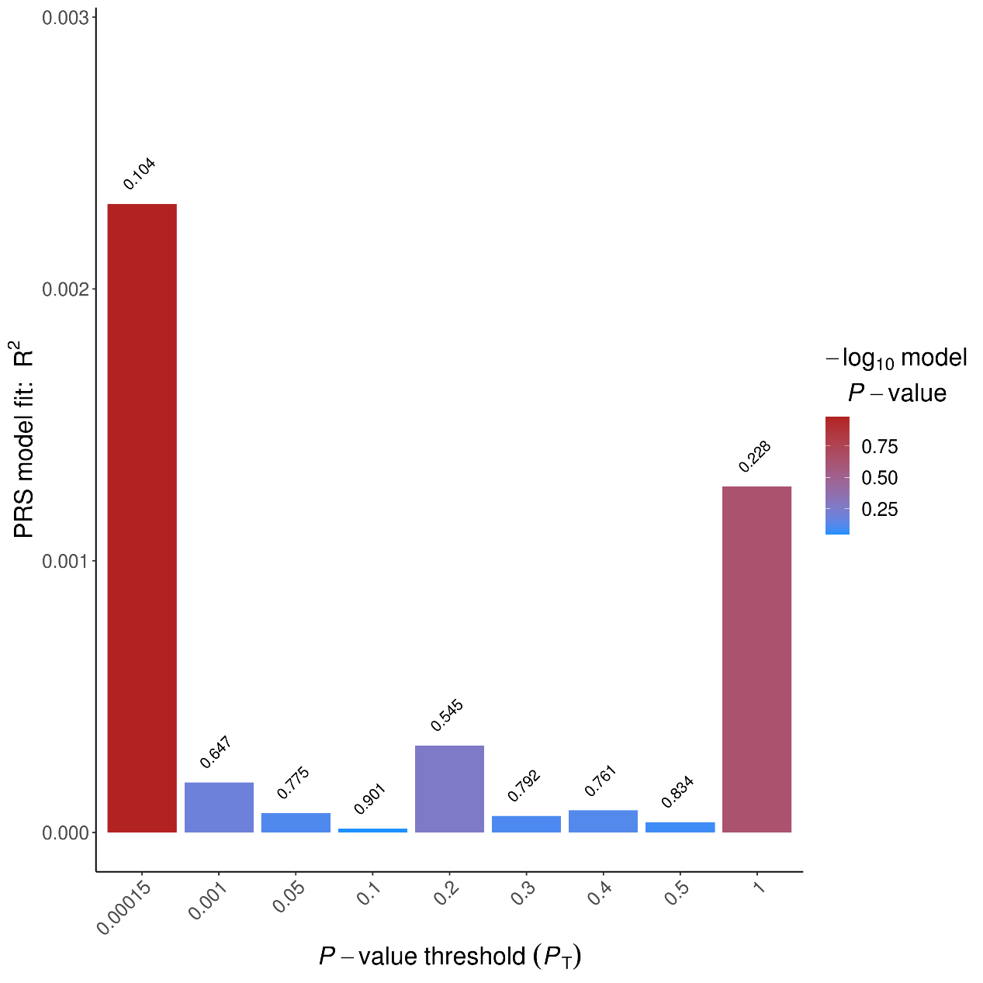
Figure S3 p-value threshold of PA_ Visuospatial PGS
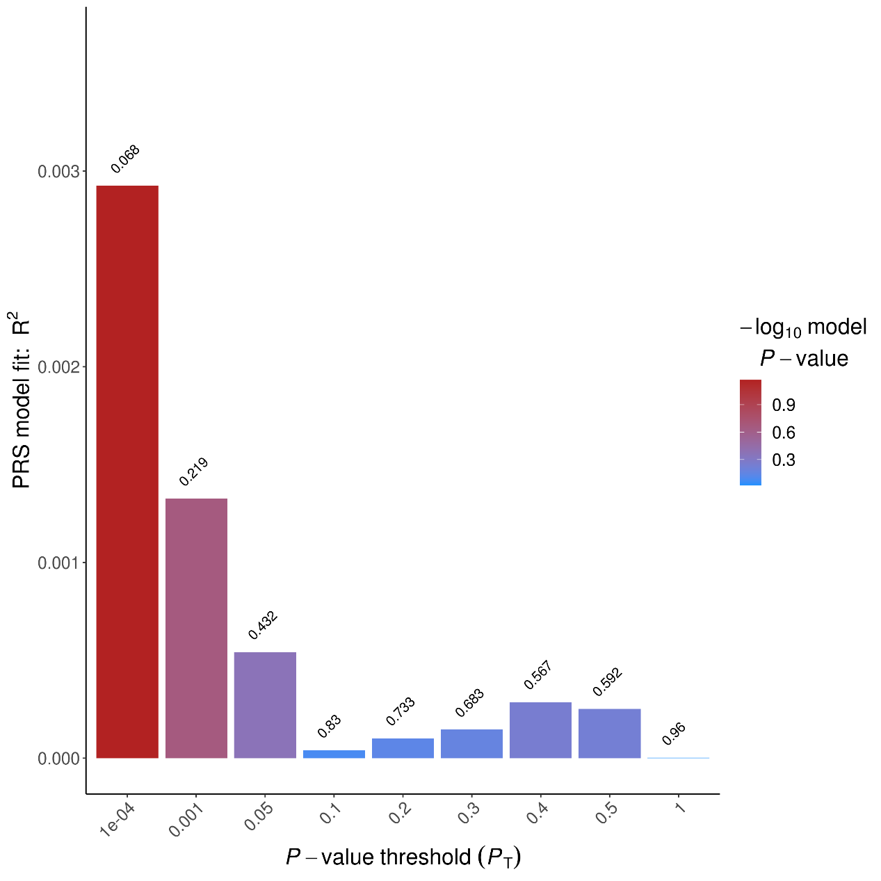
Figure S4 p-value threshold of WR_ Visuospatial PGS
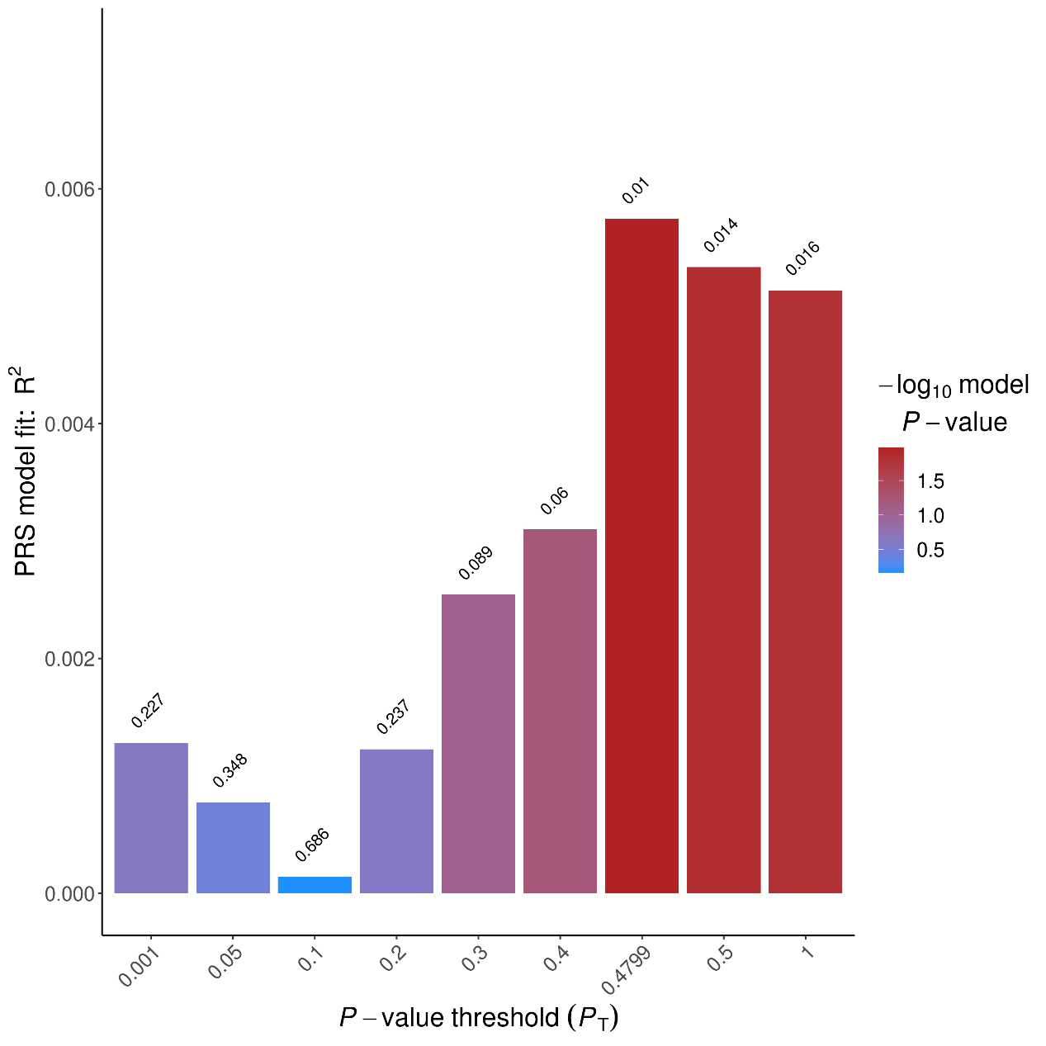
Figure S5 p-value threshold of WR_ Arithmetic PGS
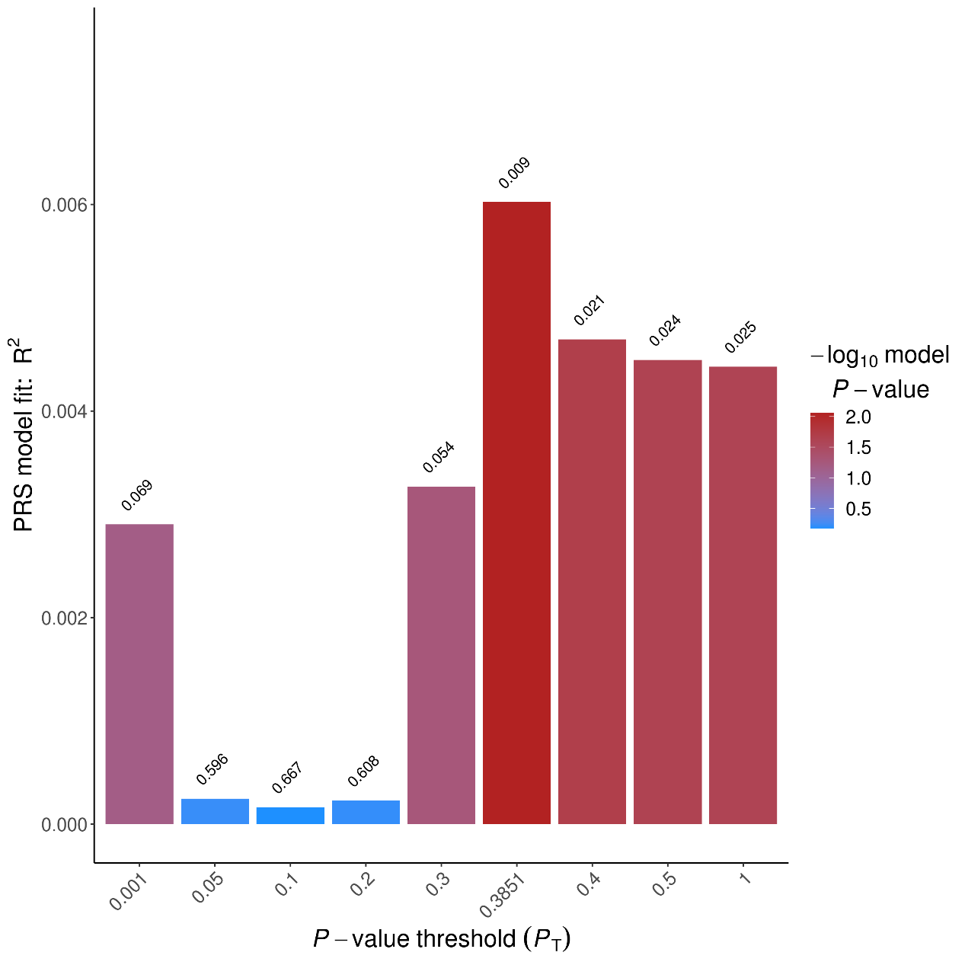
Figure S6 p-value threshold of NREP_ Arithmetic PGS
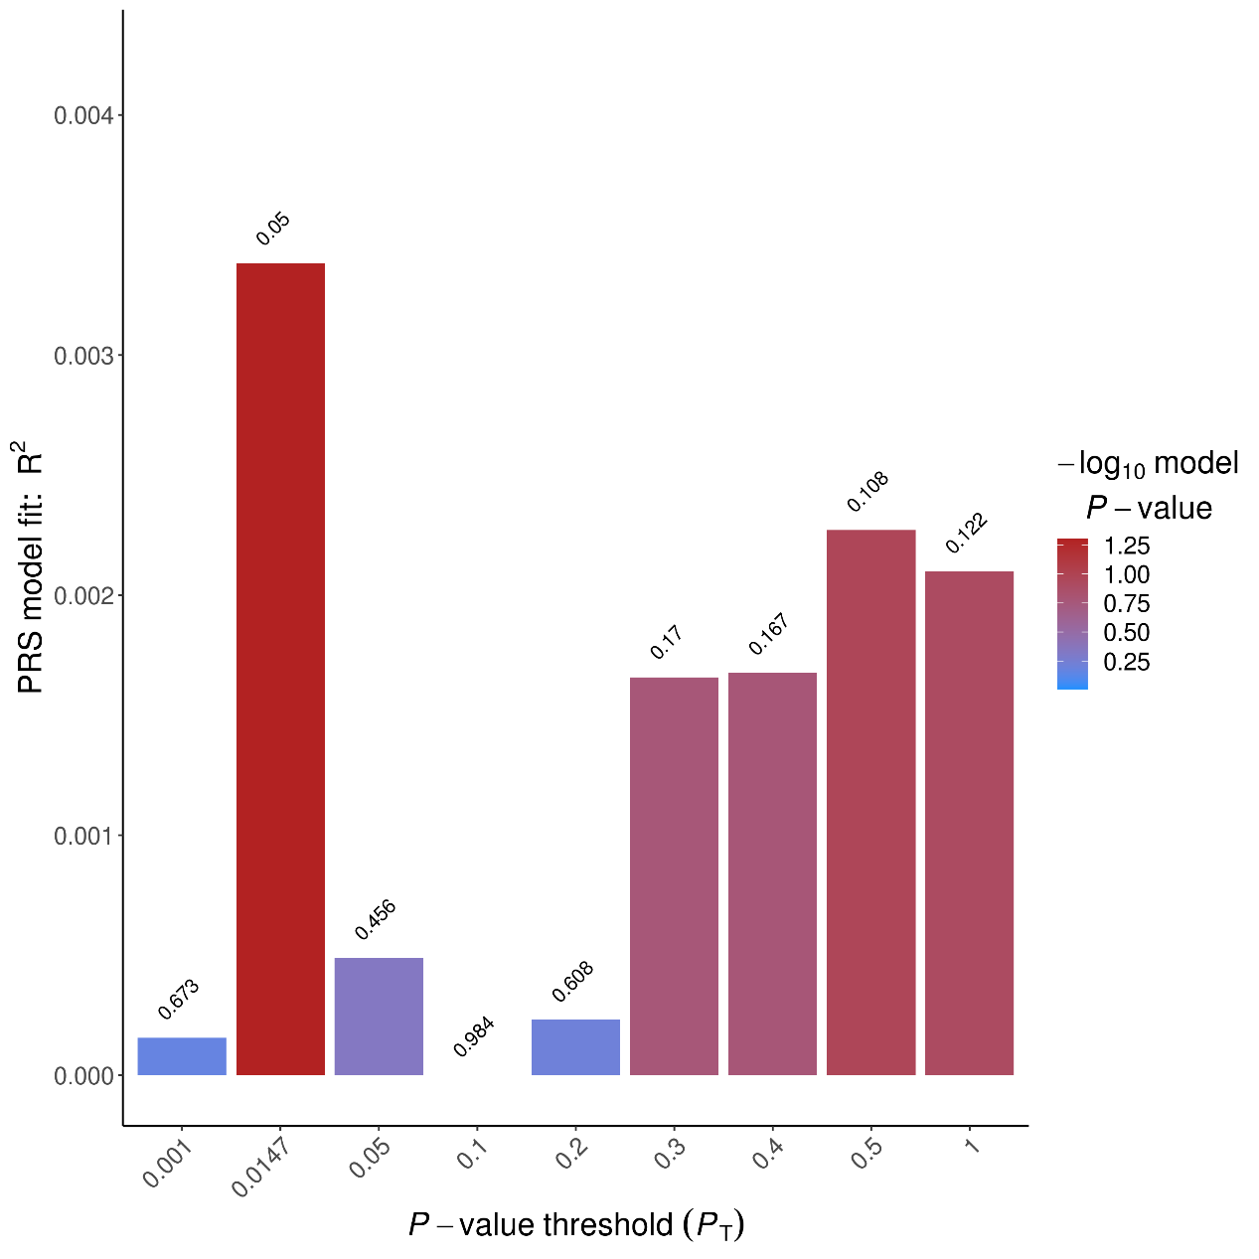
Figure S7 p-value threshold of NWR_ Arithmetic PGS
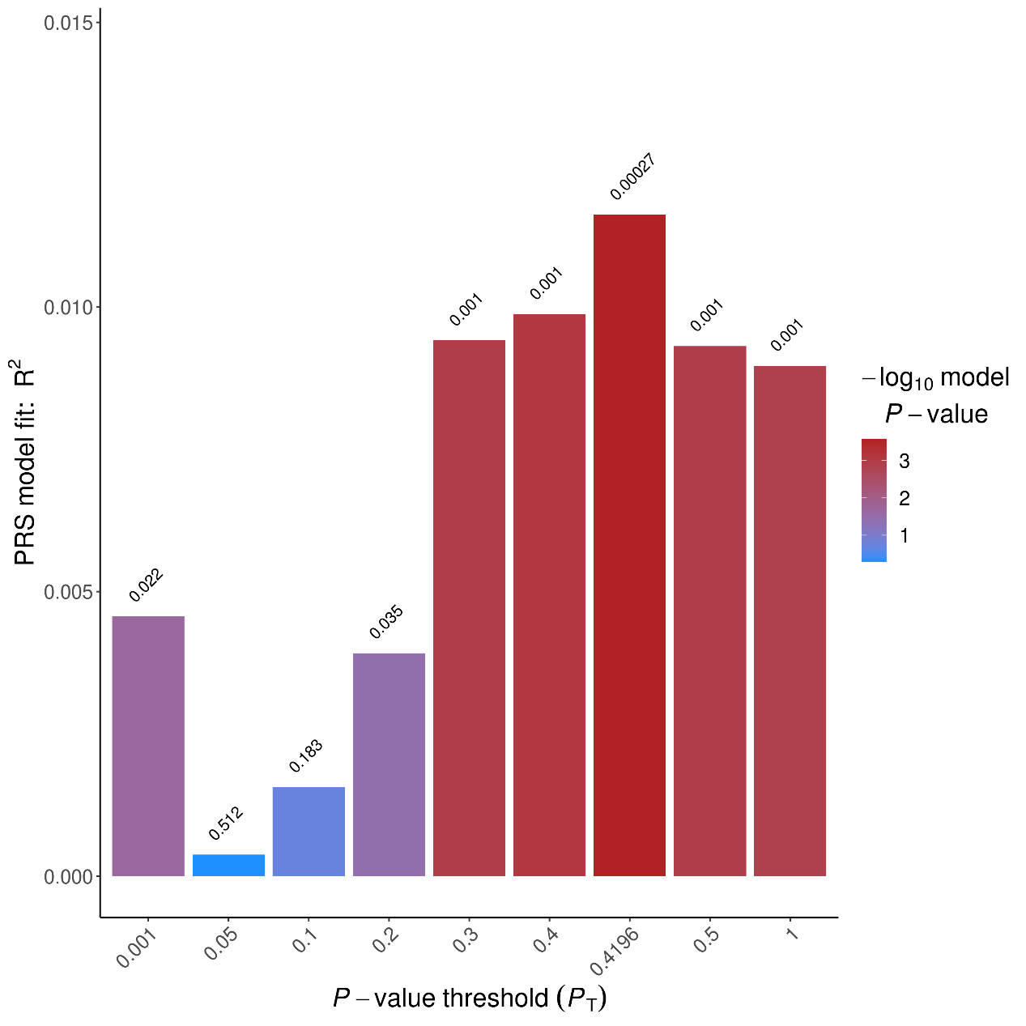
Figure S8 p-value threshold of PA_ Arithmetic PGS
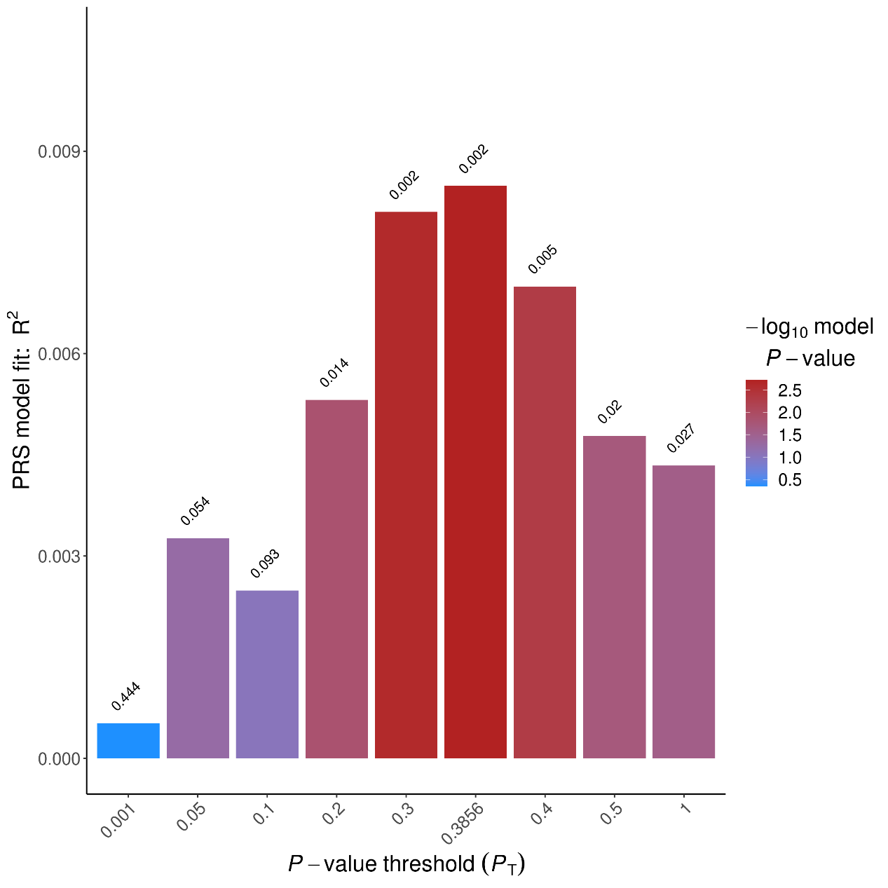
Figure S9 p-value threshold of NREP_ Reasoning PGS
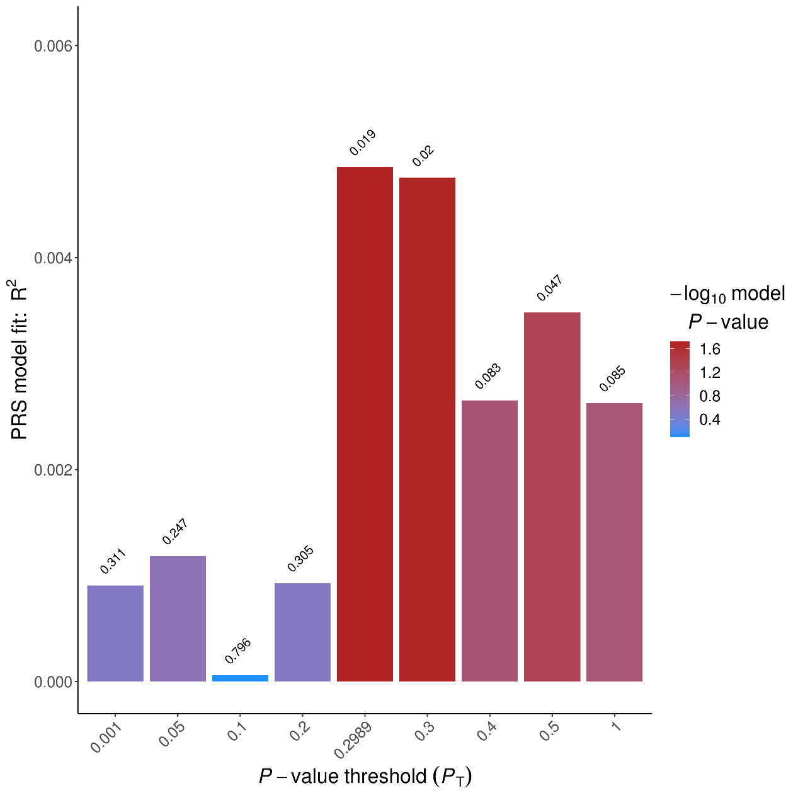
Figure S10 p-value threshold of NWR_ Reasoning PGS
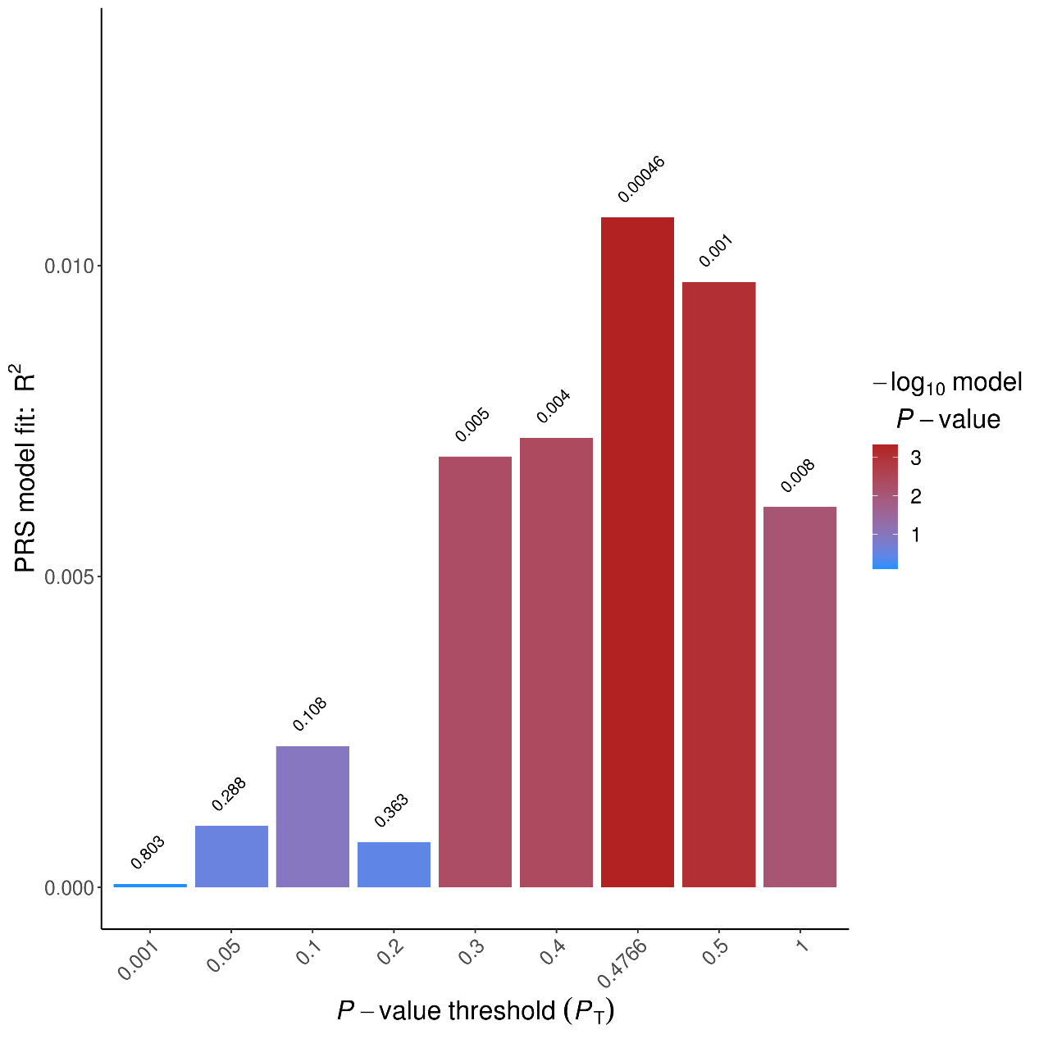
Figure S11 p-value threshold of PA_ Reasoning PGS
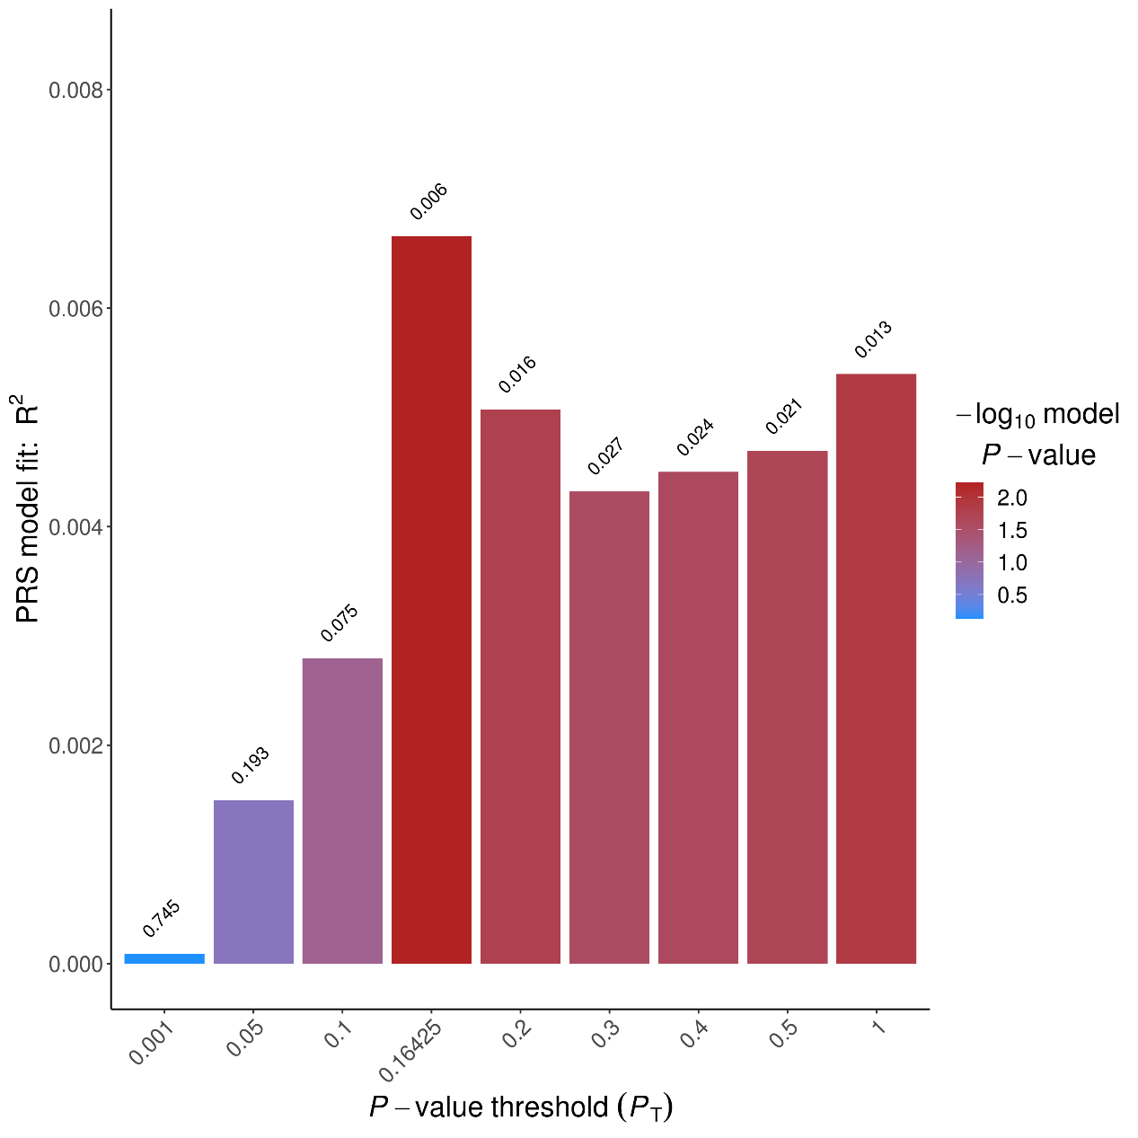
Figure S12 p-value threshold of WR_ Reasoning PGS

