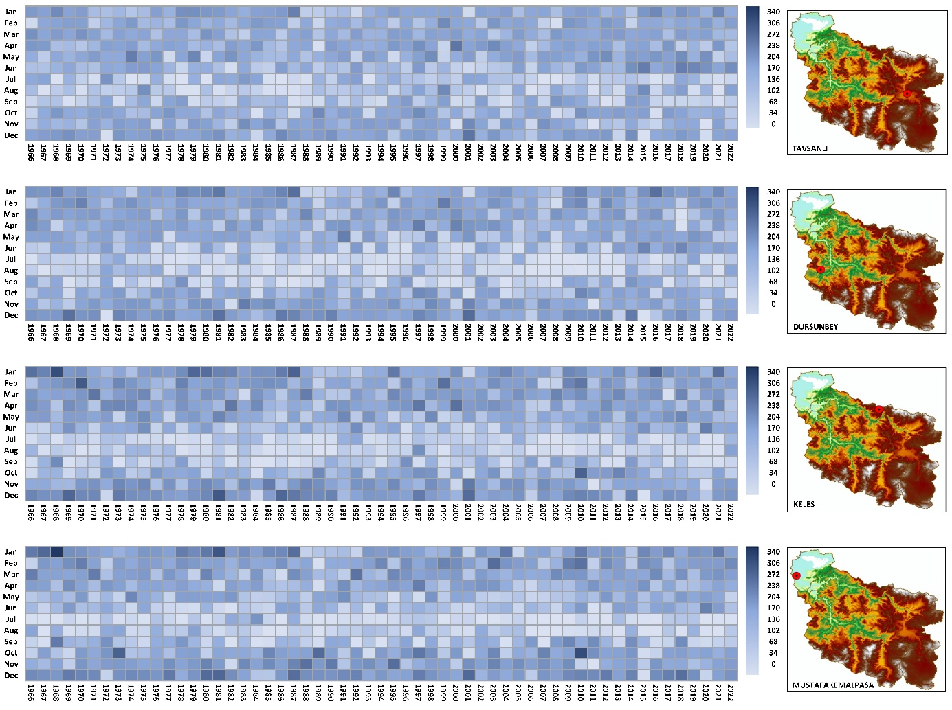Figure S1. Cumulative Monthly Precipitations between 1966 and 2022 (mm)
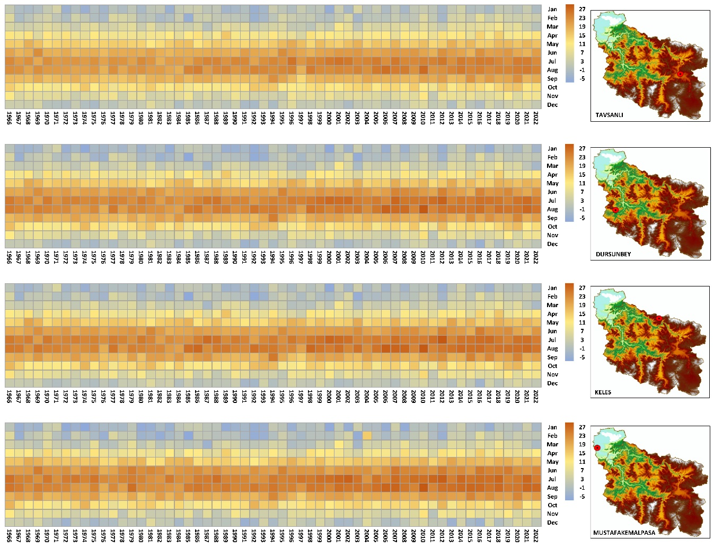Figure S2. Average Monthly Temperatures between 1966 and 2022 (°C)

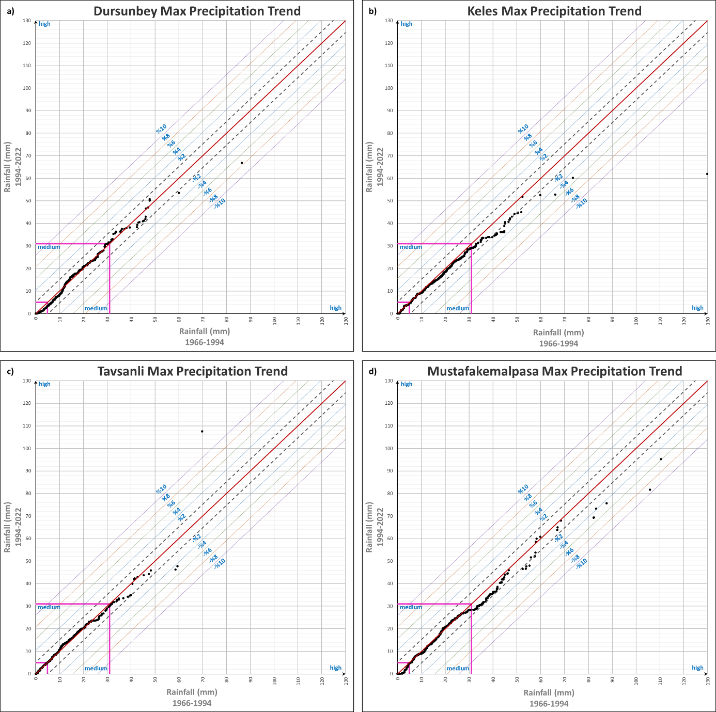Figure S3. ITA manners of max precipitation data of 4 stations

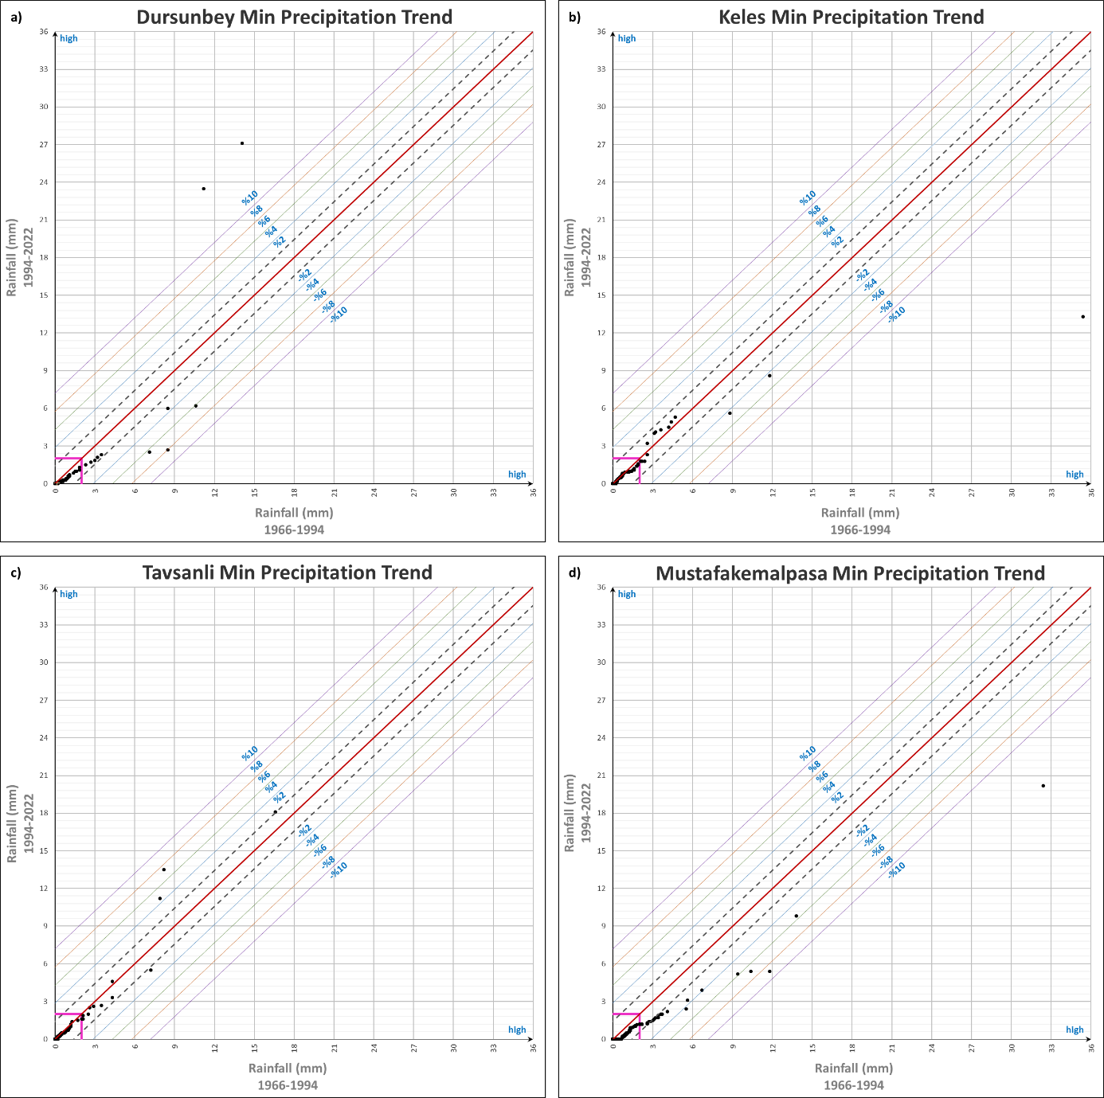
Figure S4. ITA manners of min precipitation data of 4 stations

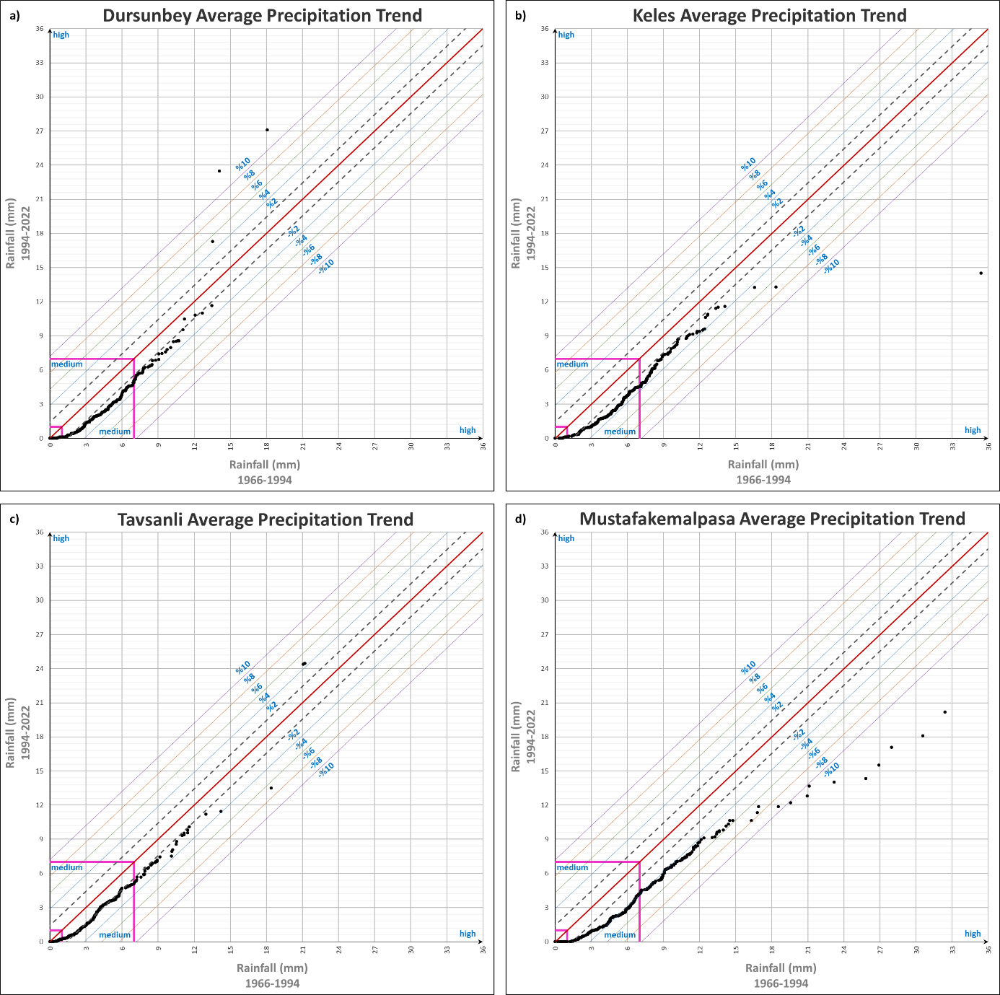
Figure S5. ITA manners of avg precipitation data of 4 stations

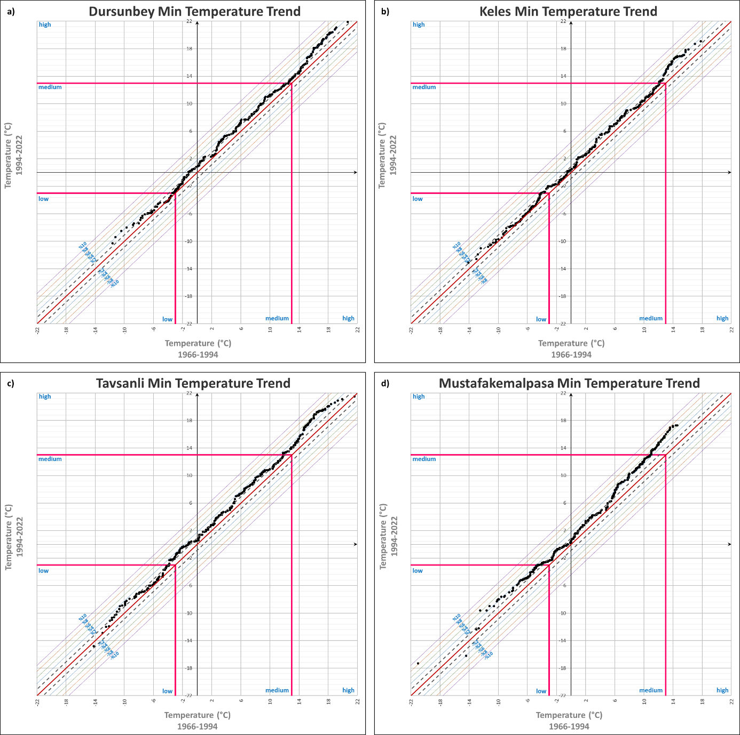
Figure S6. ITA manners of min temperature data of 4 stations

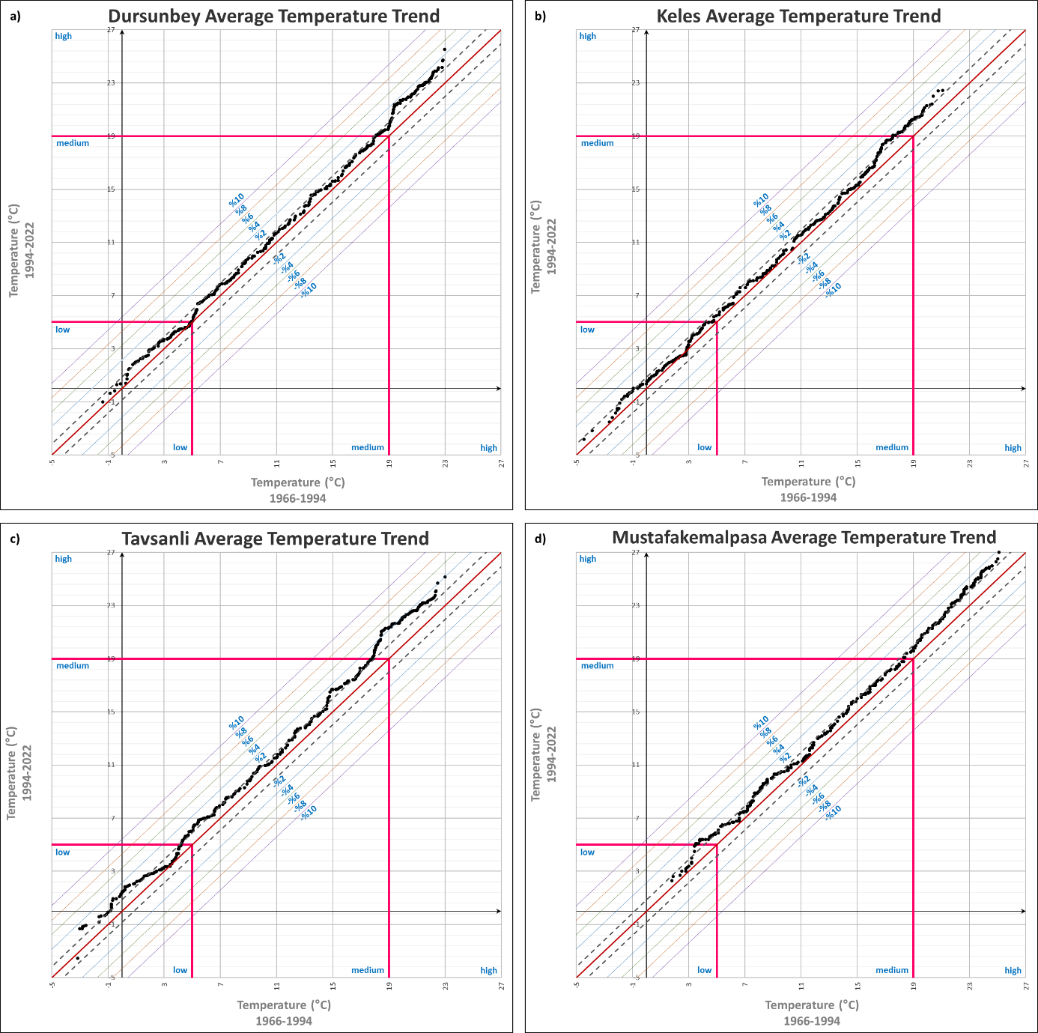
Figure S7. ITA manners of avg temperature data of 4 stations

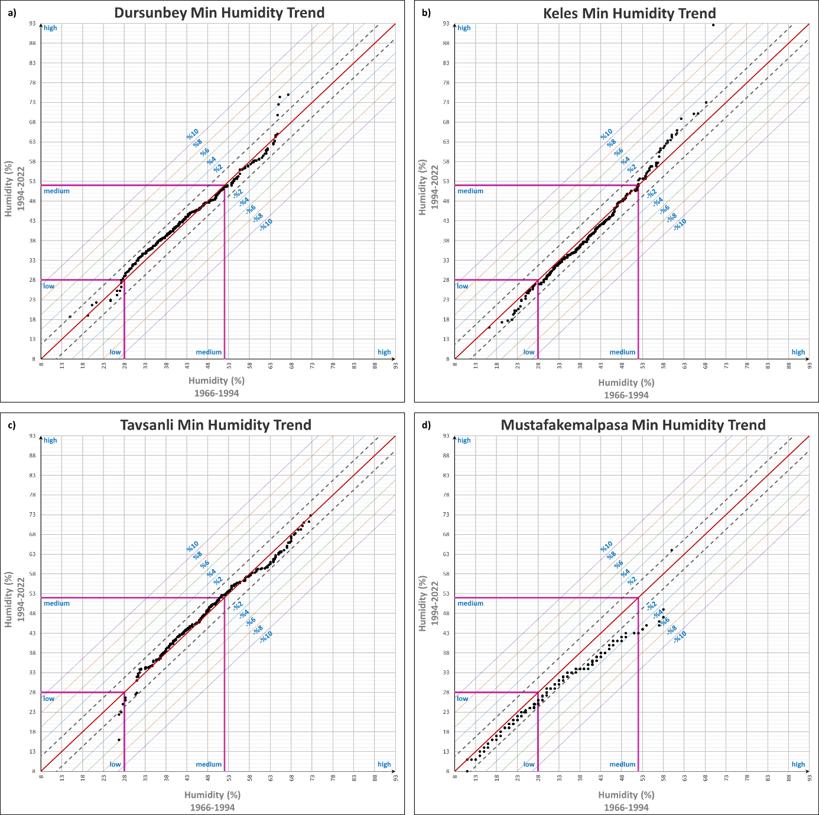
Figure S8. ITA manners of min humidity data of 4 stations

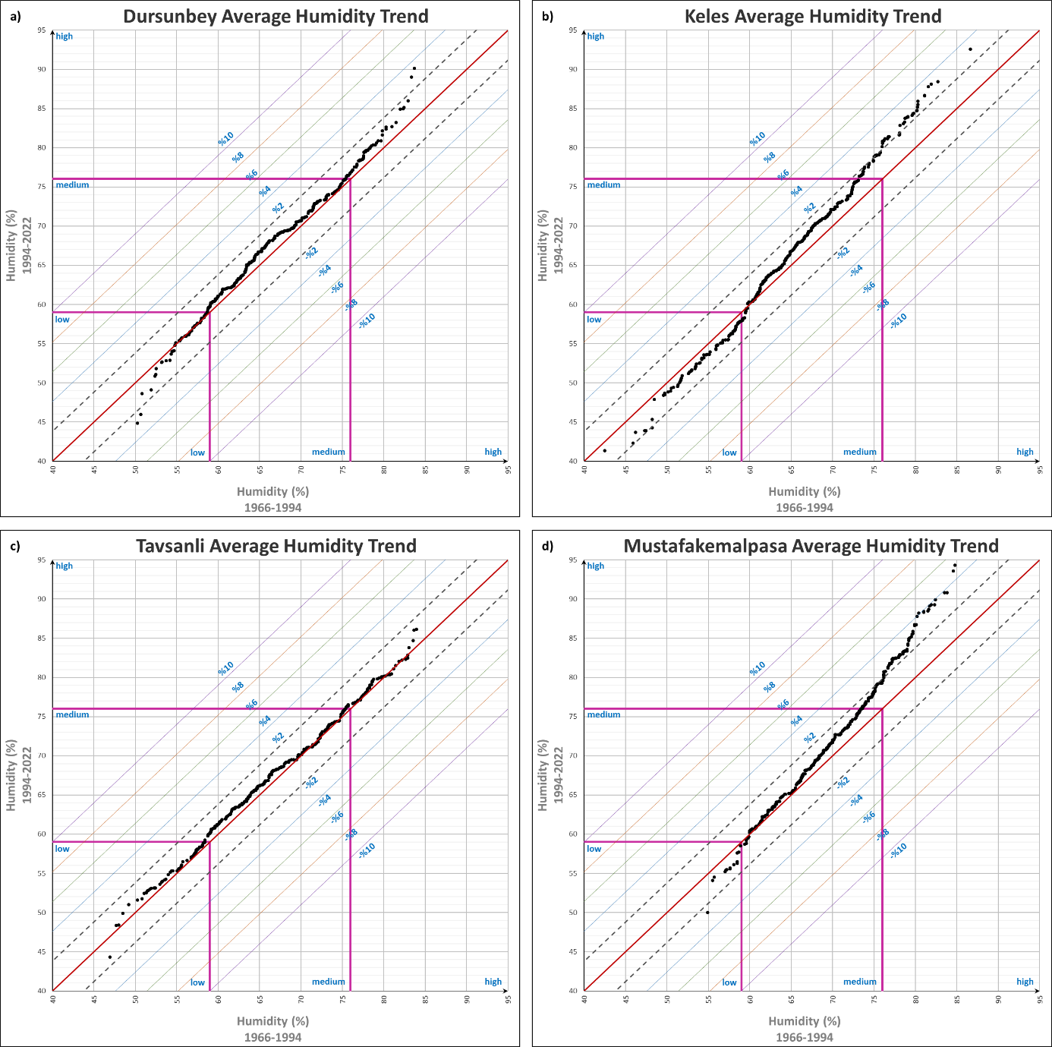
Figure S9. ITA manners of avg humidity data of 4 stations

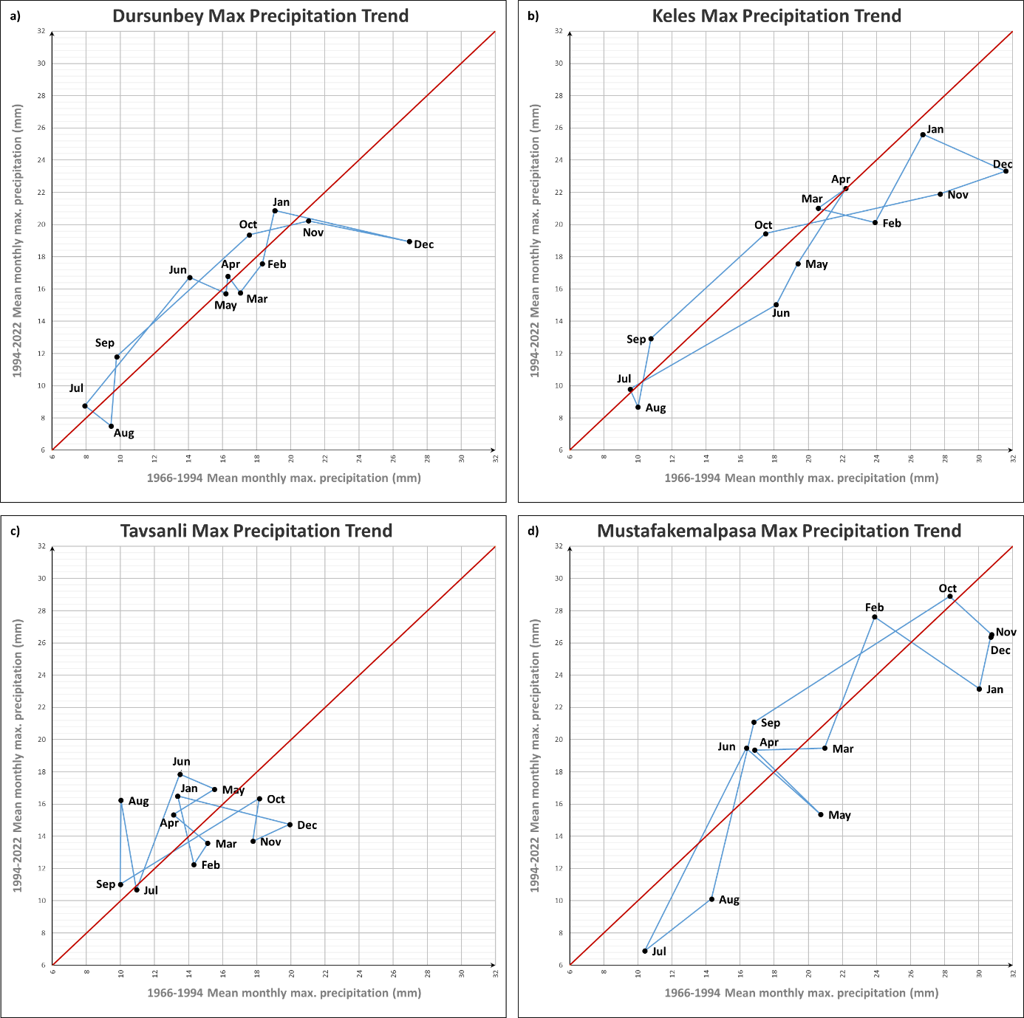
Figure S10. IPTA manners of max precipitation data of 4 stations

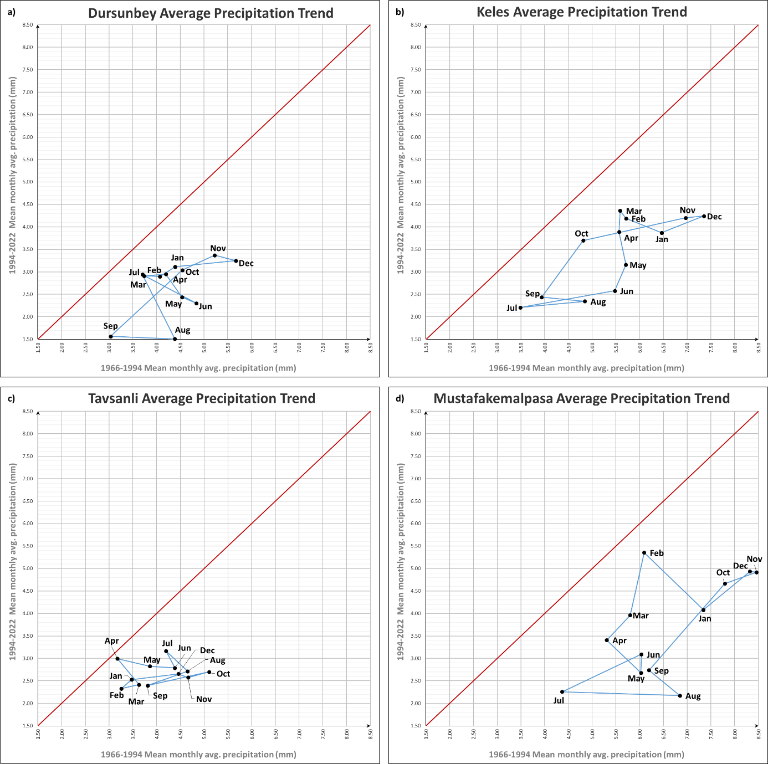
Figure S11. IPTA manners of avg precipitation data of 4 stations

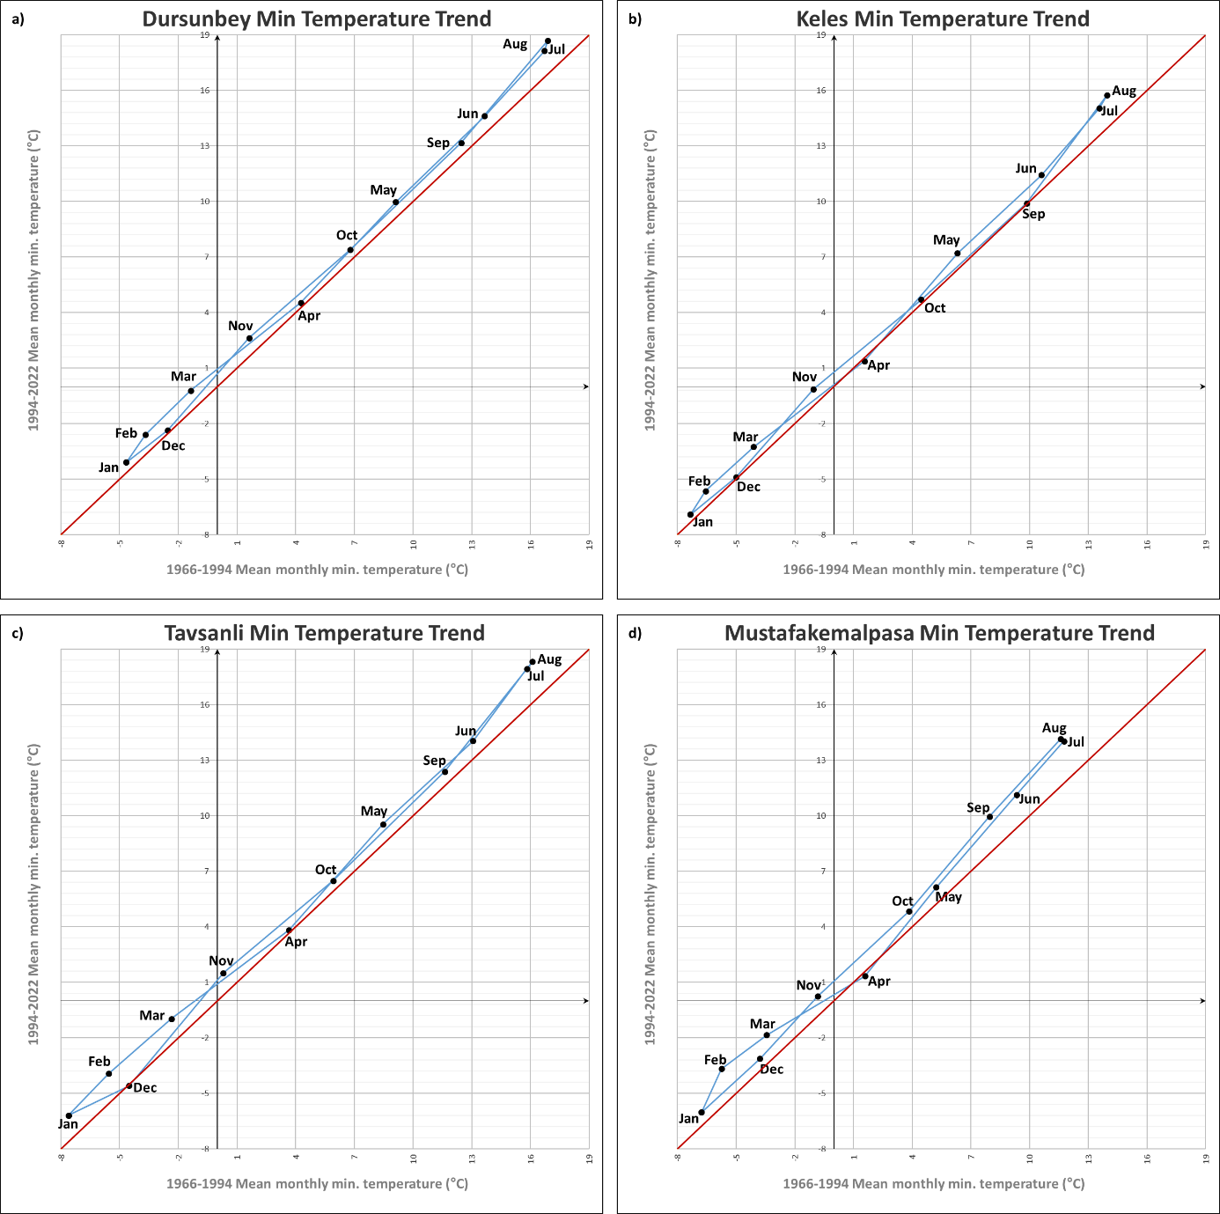
Figure S12. IPTA manners of min temperature data of 4 stations

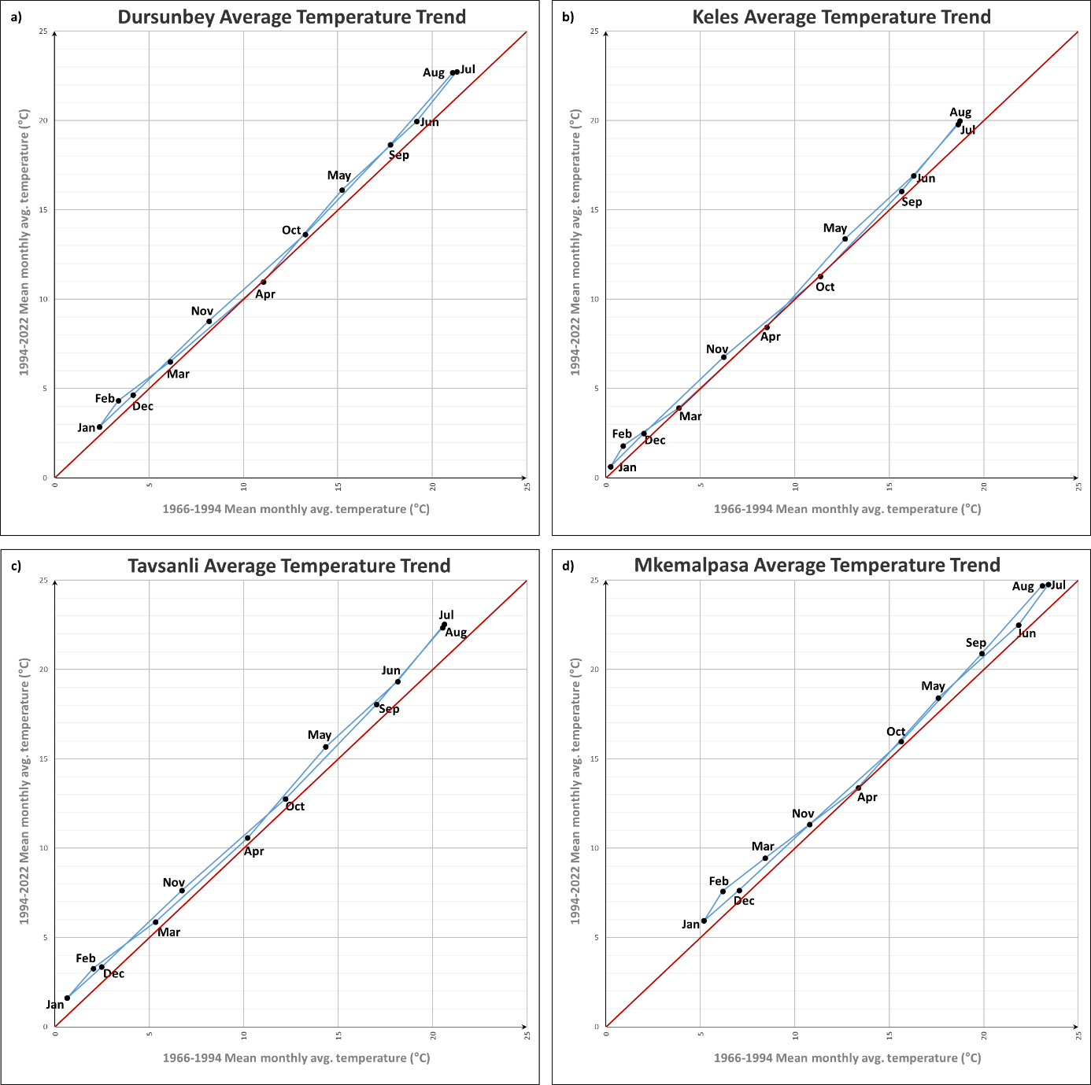
Figure S13. IPTA manners of avg temperature data of 4 stations

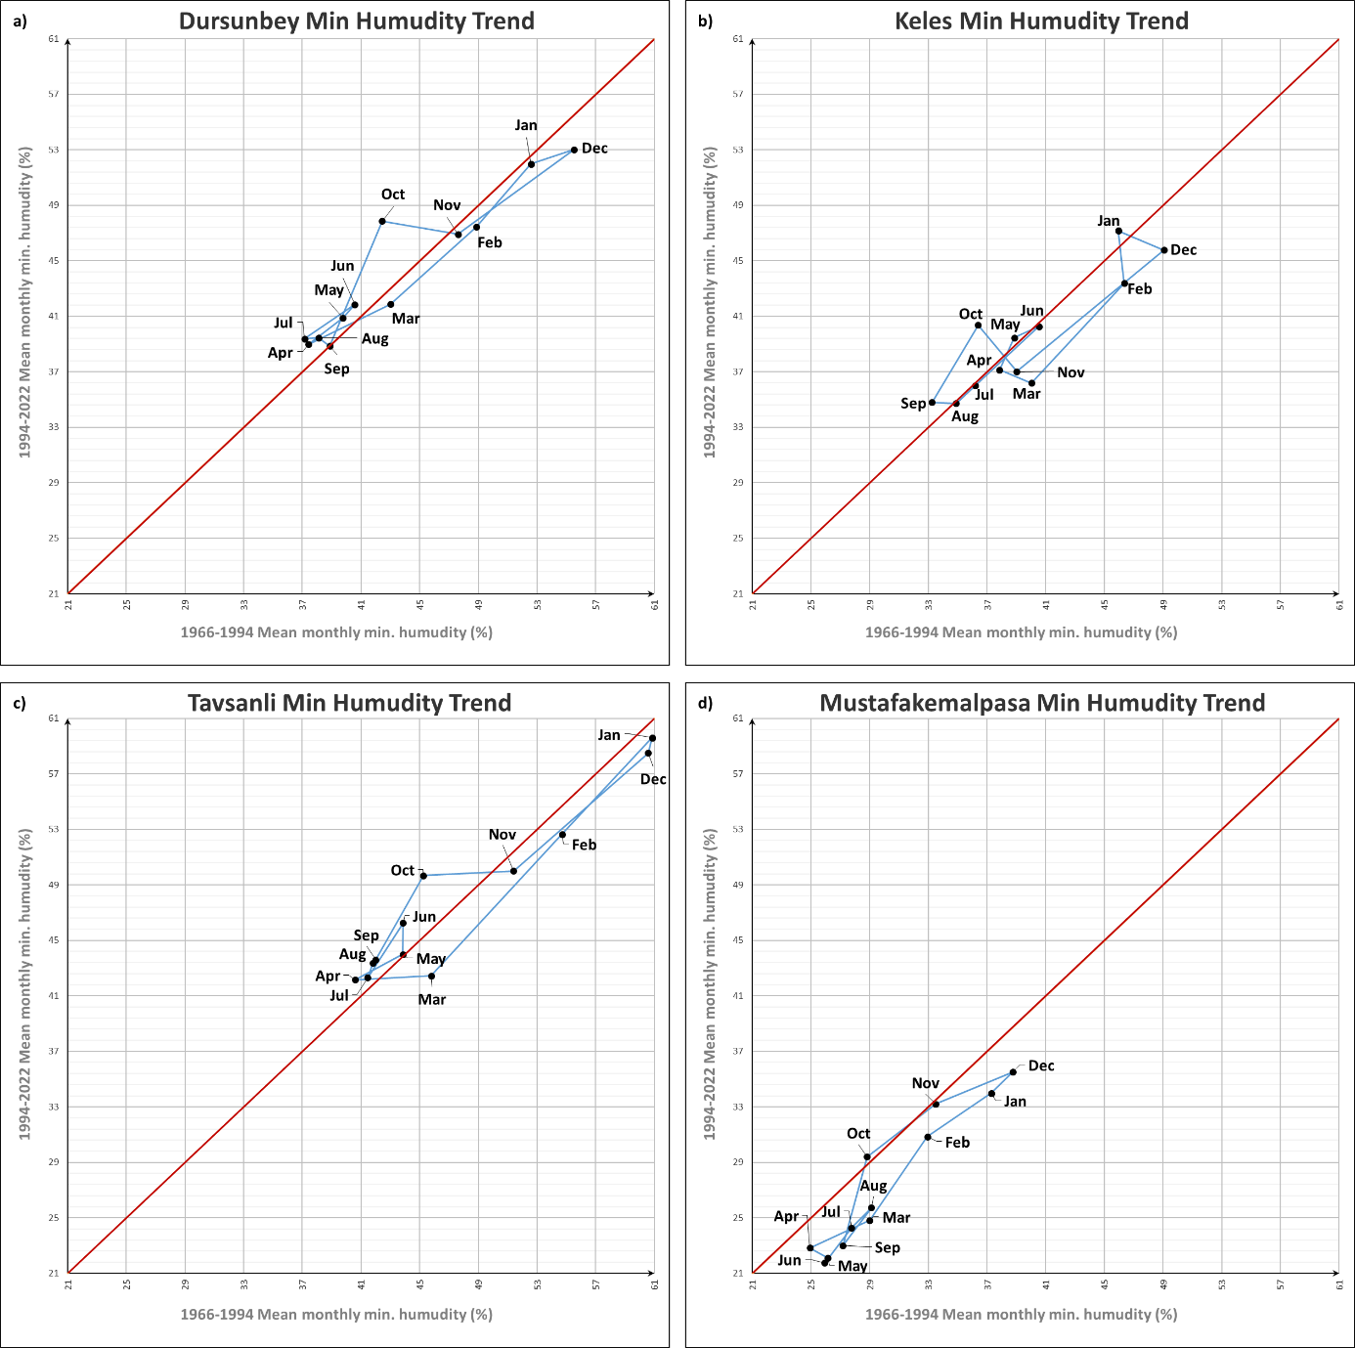
Figure S14. IPTA manners of min humidity data of 4 stations

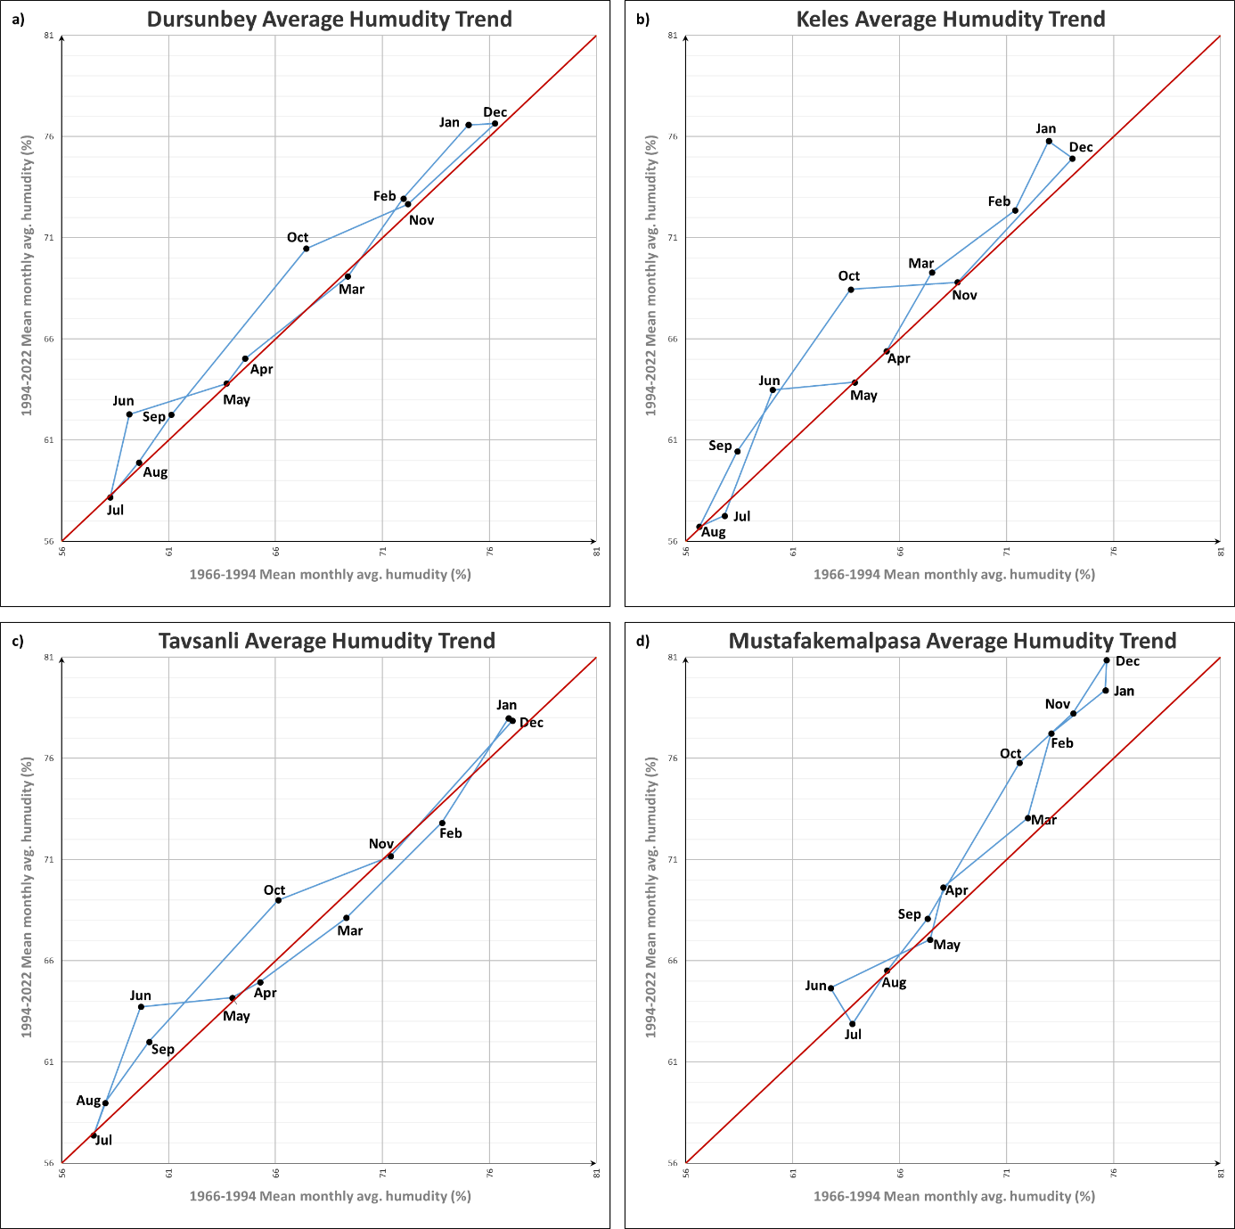
Figure S15. IPTA manners of avg humidity data of 4 stations
Table S1. Cluster class intervals
Cluster Class | Data
High | $$\overline{m}+σ<x$$
Medium | $$\overline{m}- σ<x< \overline{m}+ σ$$
Low | $$x< \overline{m}- σ$$
$\overline{m}$: mean of the data series, σ: Standard deviation of the data series, x: Data

Table S2. IPTA monthly aritmetic mean values graph in Figure S10 and general evaluation of arithmetic mean of monthly max precipitation analysis results for each station
Maximum Precipitation Data |  | Months
 |  | Jan | Feb | Mar | Apr | May | Jun | Jul | Aug | Sep | Oct | Nov | Dec
Dursunbey Station | 1st half (mm) | 19,06 | 18,34 | 17,04 | 16,31 | 16,20 | 14,07 | 7,92 | 9,46 | 9,79 | 17,57 | 21,05 | 26,96
 | 2nd half (mm | 20,88 | 17,58 | 15,77 | 16,80 | 15,72 | 16,73 | 8,76 | 7,51 | 11,81 | 19,37 | 20,23 | 18,95
Evaluation
Keles Station | 1st half (mm) | 26,72 | 23,92 | 20,58 | 22,20 | 19,38 | 18,11 | 9,55 | 10,01 | 10,77 | 17,48 | 27,73 | 31,58
 | 2nd half (mm | 25,60 | 20,13 | 21,02 | 22,24 | 17,59 | 15,03 | 9,80 | 8,68 | 12,93 | 19,44 | 21,90 | 23,32
Evaluation
Tavsanli Station | 1st half (mm) | 13,35 | 14,30 | 15,11 | 13,10 | 15,52 | 13,48 | 10,93 | 10,02 | 9,99 | 18,14 | 17,76 | 19,93
 | 2nd half (mm | 16,50 | 12,26 | 13,58 | 15,35 | 16,92 | 17,85 | 10,68 | 16,23 | 11,02 | 16,35 | 13,70 | 14,74
Evaluation
MKemalpasa Station | 1st half (mm) | 30,03 | 23,89 | 20,95 | 16,86 | 20,73 | 16,36 | 10,40 | 14,32 | 16,81 | 28,30 | 30,76 | 30,70
 | 2nd half (mm | 23,16 | 27,61 | 19,47 | 19,36 | 15,36 | 19,48 | 6,90 | 10,12 | 21,09 | 28,90 | 26,51 | 26,37
Evaluation

Table S3. IPTA monthly aritmetic mean values graph in Figure S11 and general evaluation of arithmetic mean of monthly avg precipitation analysis results for each station
Average Precipitation Data |  | Months
 |  | Jan | Feb | Mar | Apr | May | Jun | Jul | Aug | Sep | Oct | Nov | Dec
Dursunbey Station | 1st half (mm) | 4,39 | 4,07 | 3,74 | 4,20 | 4,54 | 4,84 | 3,70 | 4,39 | 3,03 | 4,54 | 5,22 | 5,67
 | 2nd half (mm | 3,11 | 2,90 | 2,91 | 2,95 | 2,44 | 2,30 | 2,94 | 1,51 | 1,57 | 3,04 | 3,37 | 3,25
Evaluation
Keles Station | 1st half (mm) | 6,46 | 5,71 | 5,59 | 5,57 | 5,71 | 5,48 | 3,49 | 4,85 | 3,94 | 4,81 | 6,97 | 7,35
 | 2nd half (mm | 3,87 | 4,19 | 4,36 | 3,89 | 3,16 | 2,58 | 2,21 | 2,35 | 2,44 | 3,70 | 4,20 | 4,24
Evaluation
Tavsanli Station | 1st half (mm) | 3,47 | 3,26 | 3,63 | 3,17 | 3,86 | 4,38 | 4,20 | 4,65 | 3,81 | 5,10 | 4,66 | 4,46
 | 2nd half (mm | 2,53 | 2,33 | 2,42 | 2,99 | 2,83 | 2,79 | 3,16 | 2,71 | 2,39 | 2,70 | 2,58 | 2,66
Evaluation
MKemalpasa Station | 1st half (mm) | 7,34 | 6,10 | 5,80 | 5,31 | 6,03 | 6,04 | 4,37 | 6,85 | 6,20 | 7,79 | 8,46 | 8,32
 | 2nd half (mm | 4,08 | 5,35 | 3,96 | 3,41 | 2,68 | 3,09 | 2,26 | 2,17 | 2,74 | 4,66 | 4,92 | 4,94
Evaluation

Table S4. IPTA monthly aritmetic mean values graph in Figure S12 and general evaluation of arithmetic mean of monthly min temperature analysis results for each station
Minimum Temperature Data |  | Months
 |  | Jan | Feb | Mar | Apr | May | Jun | Jul | Aug | Sep | Oct | Nov | Dec
Dursunbey Station | 1st half (mm) | -4,67 | -3,67 | -1,36 | 4,26 | 9,11 | 13,66 | 16,71 | 16,88 | 12,46 | 6,79 | 1,63 | -2,54
 | 2nd half (mm | -4,08 | -2,58 | -0,21 | 4,53 | 9,97 | 14,63 | 18,15 | 18,69 | 13,17 | 7,41 | 2,63 | -2,35
Evaluation
Keles Station | 1st half (mm) | -7,34 | -6,56 | -4,10 | 1,56 | 6,31 | 10,60 | 13,57 | 13,96 | 9,86 | 4,46 | -1,05 | -5,01
 | 2nd half (mm | -6,90 | -5,64 | -3,26 | 1,39 | 7,21 | 11,43 | 15,06 | 15,75 | 9,91 | 4,71 | -0,13 | -4,89
Evaluation
Tavsanli Station | 1st half (mm) | -7,61 | -5,56 | -2,35 | 3,66 | 8,46 | 13,06 | 15,81 | 16,10 | 11,62 | 5,92 | 0,30 | -4,51
 | 2nd half (mm | -6,19 | -3,93 | -0,98 | 3,83 | 9,54 | 14,04 | 17,94 | 18,33 | 12,39 | 6,49 | 1,51 | -4,58
Evaluation
MKemalpasa Station | 1st half (mm) | -6,77 | -5,75 | -3,44 | 1,59 | 5,22 | 9,33 | 11,76 | 11,58 | 7,96 | 3,84 | -0,83 | -3,78
 | 2nd half (mm | -6,02 | -3,67 | -1,84 | 1,34 | 6,14 | 11,13 | 14,03 | 14,15 | 9,96 | 4,85 | 0,25 | -3,12
Evaluation

Table S5. IPTA monthly arithmetic mean values graph in Figure S13 and general evaluation of arithmetic mean of monthly avg temperature analysis results for each station
Average Temperature Data |  | Months
 |  | Jan | Feb | Mar | Apr | May | Jun | Jul | Aug | Sep | Oct | Nov | Dec
Dursunbey Station | 1st half (mm) | 2,37 | 3,38 | 6,12 | 11,05 | 15,22 | 19,17 | 21,29 | 21,07 | 17,79 | 13,27 | 8,18 | 4,16
 | 2nd half (mm | 2,86 | 4,33 | 6,51 | 10,99 | 16,11 | 19,96 | 22,75 | 22,68 | 18,67 | 13,64 | 8,79 | 4,66
Evaluation
Keles Station | 1st half (mm) | 0,25 | 0,90 | 3,86 | 8,51 | 12,65 | 16,28 | 18,64 | 18,73 | 15,63 | 11,34 | 6,22 | 1,99
 | 2nd half (mm | 0,64 | 1,80 | 3,92 | 8,45 | 13,38 | 16,92 | 19,78 | 19,97 | 16,05 | 11,28 | 6,77 | 2,48
Evaluation
Tavsanli Station | 1st half (mm) | 0,65 | 2,03 | 5,33 | 10,20 | 14,34 | 18,14 | 20,63 | 20,52 | 17,04 | 12,21 | 6,71 | 2,47
 | 2nd half (mm | 1,62 | 3,28 | 5,89 | 10,58 | 15,68 | 19,34 | 22,55 | 22,35 | 18,06 | 12,76 | 7,64 | 3,35
Evaluation
MKemalpasa Station | 1st half (mm) | 5,18 | 6,17 | 8,41 | 13,36 | 17,60 | 21,84 | 23,42 | 23,09 | 19,89 | 15,61 | 10,77 | 7,04
 | 2nd half (mm | 5,95 | 7,60 | 9,44 | 13,39 | 18,42 | 22,50 | 24,78 | 24,70 | 20,89 | 15,97 | 11,33 | 7,65
Evaluation

Table S6. IPTA monthly arithmetic mean values graph in Figure S14 and general evaluation of arithmetic mean of monthly min humidity analysis results for each station
Minimum Humidity Data |  | Months
 |  | Jan | Feb | Mar | Apr | May | Jun | Jul | Aug | Sep | Oct | Nov | Dec
Dursunbey Station | 1st half (mm) | 52,59 | 48,86 | 43,01 | 37,41 | 39,77 | 40,57 | 37,16 | 38,11 | 38,88 | 42,45 | 47,61 | 55,53
 | 2nd half (mm | 51,98 | 47,43 | 41,87 | 38,97 | 40,89 | 41,85 | 39,38 | 39,47 | 38,85 | 47,87 | 46,91 | 53,02
Evaluation
Keles Station | 1st half (mm) | 45,94 | 46,36 | 40,03 | 37,84 | 38,85 | 40,54 | 36,21 | 34,89 | 33,24 | 36,39 | 39,03 | 49,06
 | 2nd half (mm | 47,18 | 43,39 | 36,19 | 37,13 | 39,46 | 40,27 | 36,02 | 34,73 | 34,80 | 40,37 | 37,02 | 45,78
Evaluation
Tavsanli Station | 1st half (mm) | 60,86 | 54,71 | 45,79 | 40,59 | 43,84 | 43,88 | 41,45 | 41,83 | 42,00 | 45,26 | 51,41 | 60,58
 | 2nd half (mm | 59,62 | 52,65 | 42,46 | 42,16 | 44,00 | 46,26 | 42,31 | 43,38 | 43,61 | 49,68 | 50,01 | 58,51
Evaluation
MKemalpasa Station | 1st half (mm) | 37,28 | 32,93 | 29,00 | 24,93 | 26,14 | 25,93 | 27,75 | 29,11 | 27,17 | 28,82 | 33,50 | 38,75
 | 2nd half (mm | 33,99 | 30,85 | 24,83 | 22,84 | 22,12 | 21,75 | 24,28 | 25,73 | 23,01 | 29,41 | 33,21 | 35,52
Evaluation

Table S7. IPTA monthly arithmetic mean values graph in Figure S15 and general evaluation of arithmetic mean of monthly avg humidity analysis results for each station
Average Humidity Data |  | Months
 |  | Jan | Feb | Mar | Apr | May | Jun | Jul | Aug | Sep | Oct | Nov | Dec
Dursunbey Station | 1st half (mm) | 75,02 | 71,97 | 69,38 | 64,57 | 63,71 | 59,17 | 58,27 | 59,61 | 61,13 | 67,44 | 72,19 | 76,25
 | 2nd half (mm | 76,59 | 72,94 | 69,10 | 65,04 | 63,81 | 62,29 | 58,18 | 59,90 | 62,26 | 70,47 | 72,67 | 76,65
Evaluation
Keles Station | 1st half (mm) | 72,96 | 71,39 | 67,50 | 65,38 | 63,89 | 60,06 | 57,82 | 56,63 | 58,40 | 63,71 | 68,70 | 74,07
 | 2nd half (mm | 75,79 | 72,35 | 69,29 | 65,41 | 63,86 | 63,49 | 57,27 | 56,73 | 60,45 | 68,45 | 68,80 | 74,93
Evaluation
Tavsanli Station | 1st half (mm) | 76,88 | 73,77 | 69,31 | 65,28 | 63,98 | 59,70 | 57,49 | 58,03 | 60,08 | 66,12 | 71,37 | 77,08
 | 2nd half (mm | 77,98 | 72,83 | 68,12 | 64,95 | 64,18 | 63,73 | 57,39 | 58,98 | 62,00 | 68,99 | 71,17 | 77,87
Evaluation
MKemalpasa Station | 1st half (mm) | 75,61 | 73,08 | 71,99 | 68,04 | 67,43 | 62,77 | 63,79 | 65,41 | 67,30 | 71,60 | 74,11 | 75,68
 | 2nd half (mm | 79,37 | 77,23 | 73,06 | 69,64 | 67,05 | 64,66 | 62,89 | 65,52 | 68,08 | 75,79 | 78,24 | 80,85
Evaluation

