Exploring of TNF-α concentration and treating time
CCK-8 kit was used to analyze mature oligodendrocyte toxicity at different TNF-α concentrations and stimulation times. Mature oligodendrocytes were plated in 96-well plate at 1×10⁴ cells per well. Based on previous studies [1,2], TNF-α was administered at final concentrations of 5ng/mL, 10ng/mL, 20ng/mL, and 50ng/mL. Each concentration was tested for 4h, 10h, 18h, 24h, and 48h of treatment. The control wells were treated with PBS, and corresponding blank wells (wells with medium but no cells) were set up. After incubating for an appropriate time, 10μL of CCK-8 solution was added to all wells and incubated at 37◦C for 4h. The absorbance at 450 nm was measured. The inhibition rate of the drug on the cells was calculated using the formula: Inhibition rate % = [(Control - Blank) - (Test - Blank)] / (Control - Blank) × 100%.
Mature oligodendrocytes treated with TNF-α at 50ng/mL for 18h, 20ng/mL for 48h, and 50ng/mL for 48h, resulting in a significantly higher inhibition rate (Supplement Fig. 1A). Subsequently, we measured the GAPDH protein levels in mature oligodendrocytes under different TNF-α concentrations and stimulation durations, revealing that the lowest GAPDH protein content occurred at 50ng/mL TNF-α after 18h of stimulation (Supplement Fig. 1B). Based on these results, we chose to stimulate mature oligodendrocytes with 50ng/mL TNF-α for 18h to establish a cellular model of TNF-α-induced damage in mature oligodendrocytes.
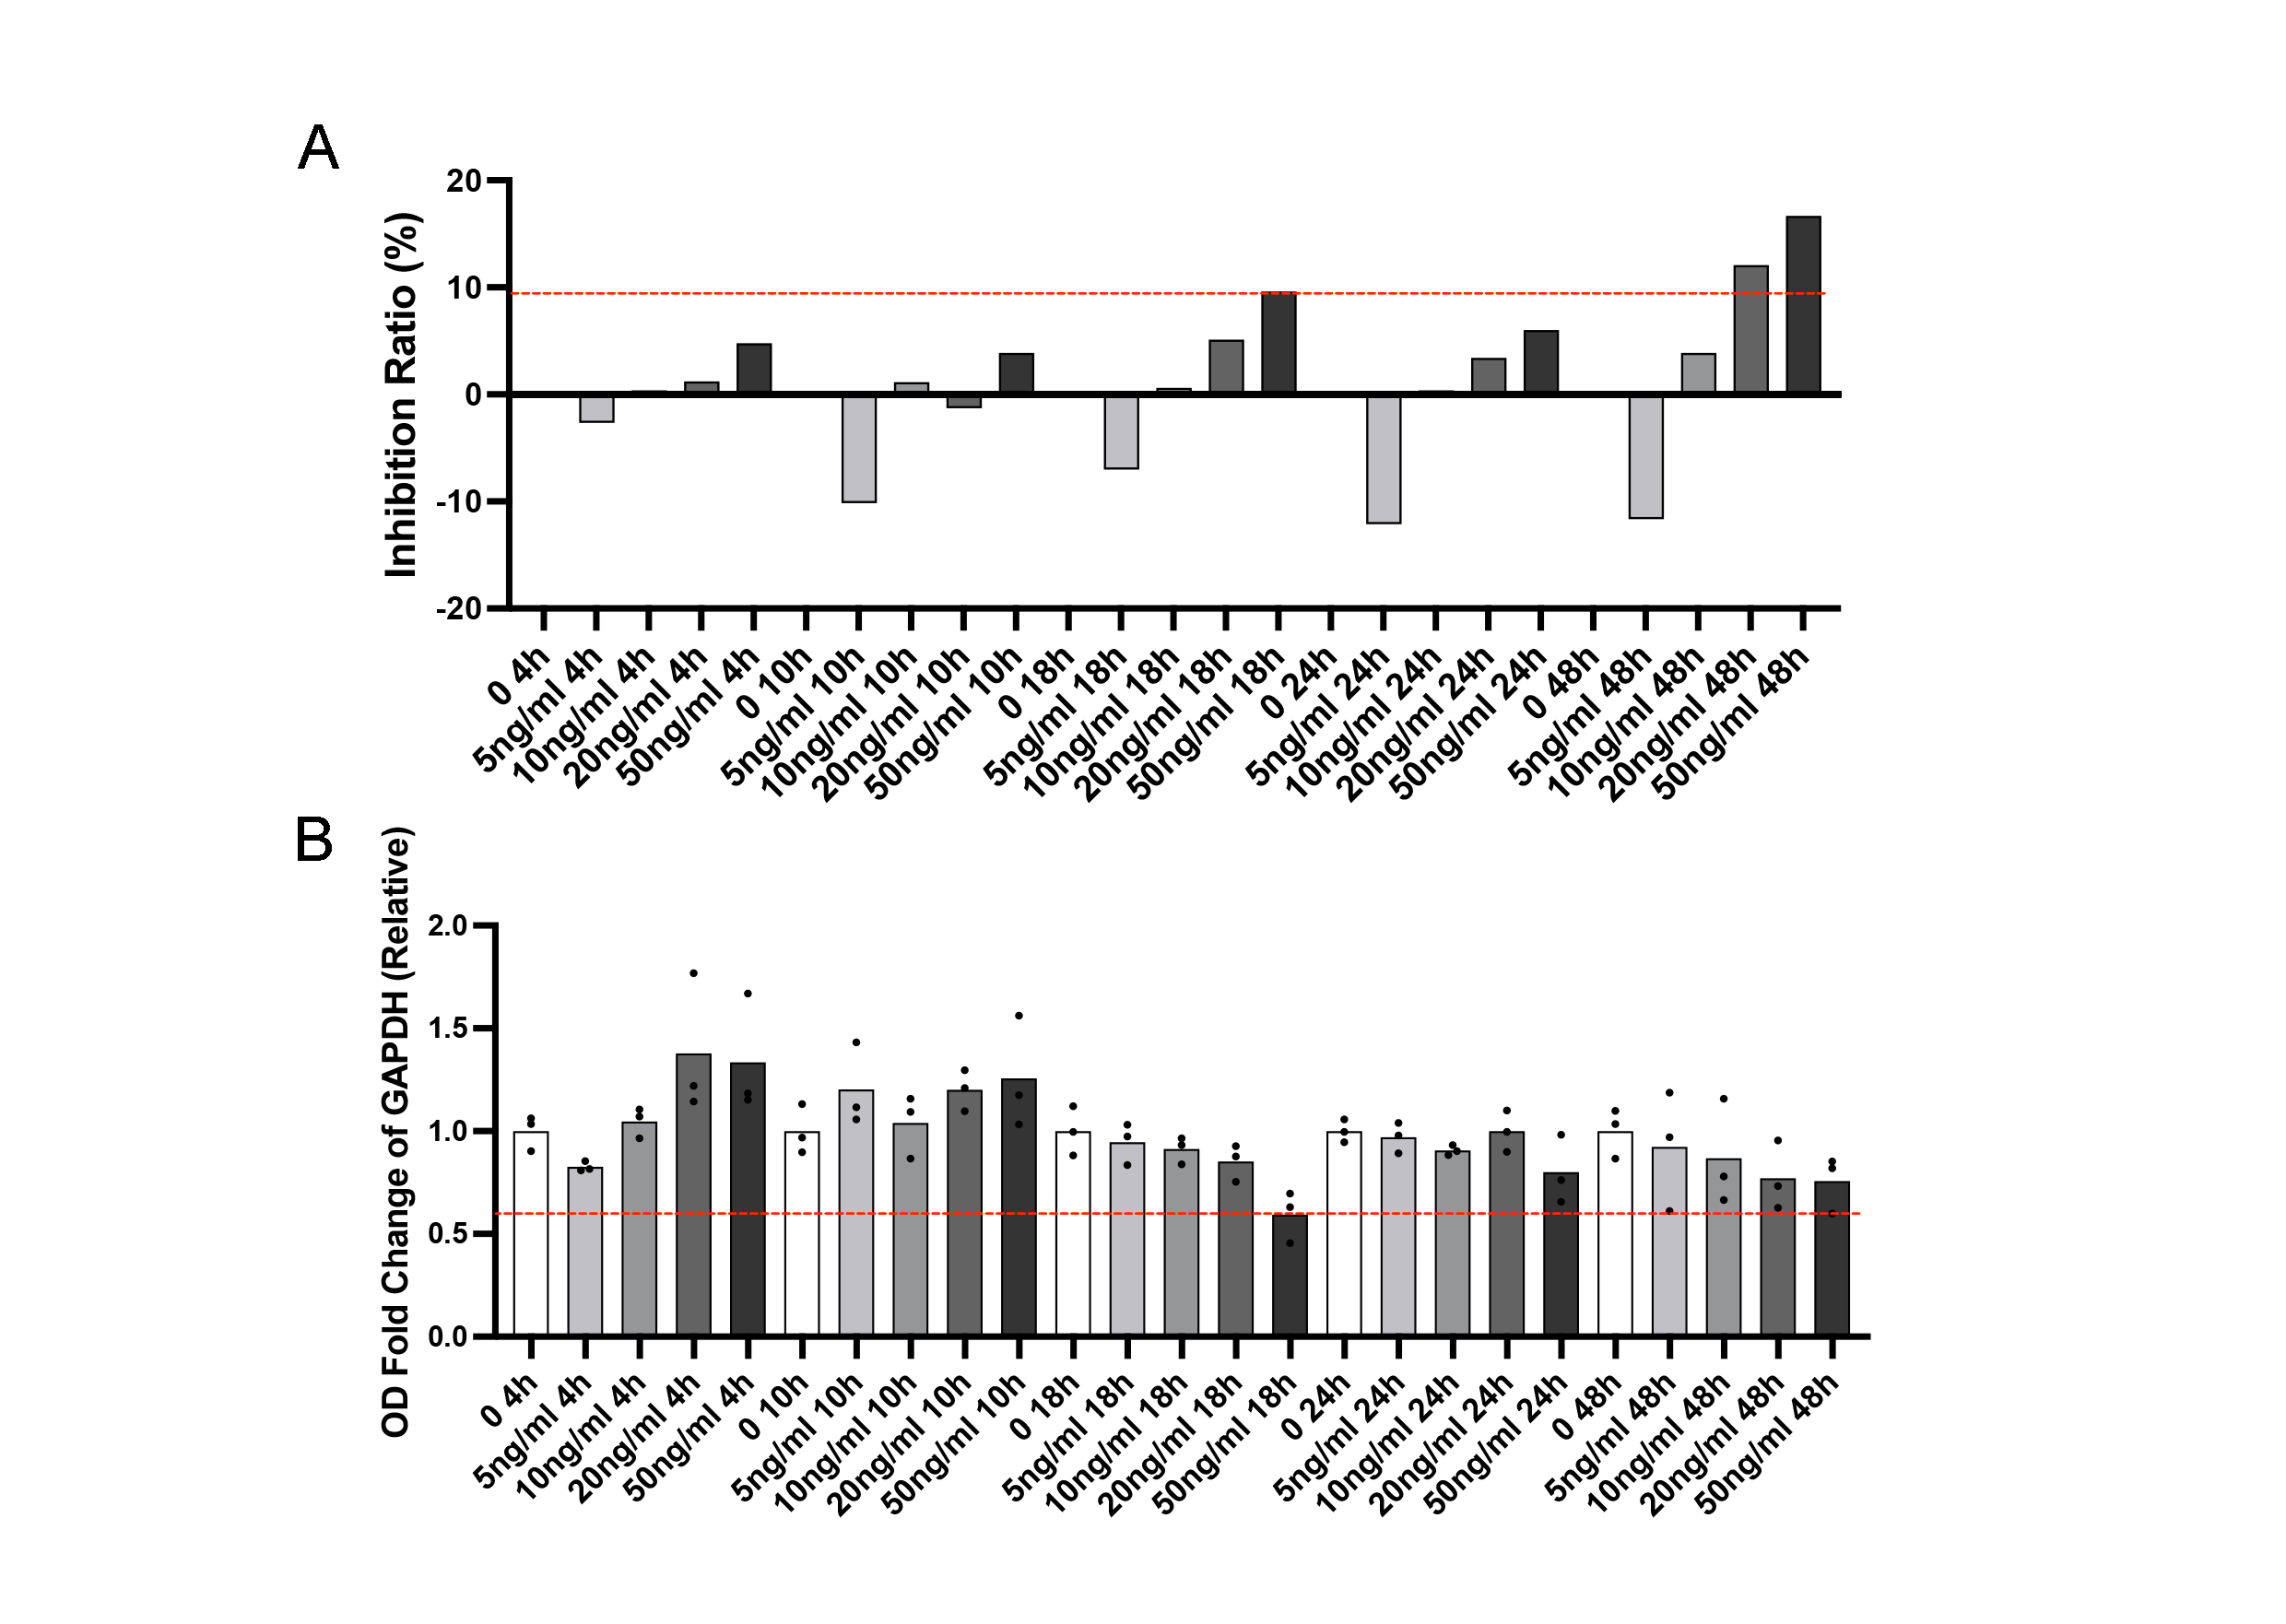
Supplementary figure 1. Establishment the model for TNF-α-induced damage in mature oligodendrocyte. A. CCK-8 assesses the inhibition rate of mature oligodendrocyte under different concentrations and stimulation times. N=2. B. Relative levels of GAPDH protein in mature oligodendrocyte under different concentrations and stimulation times. N=3.

References
1. La Rosa G, Sozio C, Pipicelli L, Raia M, Palmiero A, Santillo M, et al. Antioxidant, Anti-Inflammatory and Pro-Differentiative Effects of Chlorogenic Acid on M03-13 Human Oligodendrocyte-like Cells. Int J Mol Sci. 2023;24:16731.
2. Paintlia MK, Paintlia AS, Singh AK, Singh I. Synergistic activity of interleukin-17 and tumor necrosis factor-α enhances oxidative stress-mediated oligodendrocyte apoptosis. J Neurochem. 2011;116:508–21.

