Dear Editor-in-Chief,
Thank you for technical checking our submission.

Due to material constraints, we did not perform full membrane incubation of antibodies. The original images taken by the exposure machine of Figure 9 and Figure 11 are listed below. We are sorry that we could not find the original image of Figure 6.
We are sorry for bringing trouble to your work by our problems.

Prof. Tianlong Wang

Figure 9
The original images of GAPDH. Lane 3 to lane 6 were selected to demonstrate in manuscript.
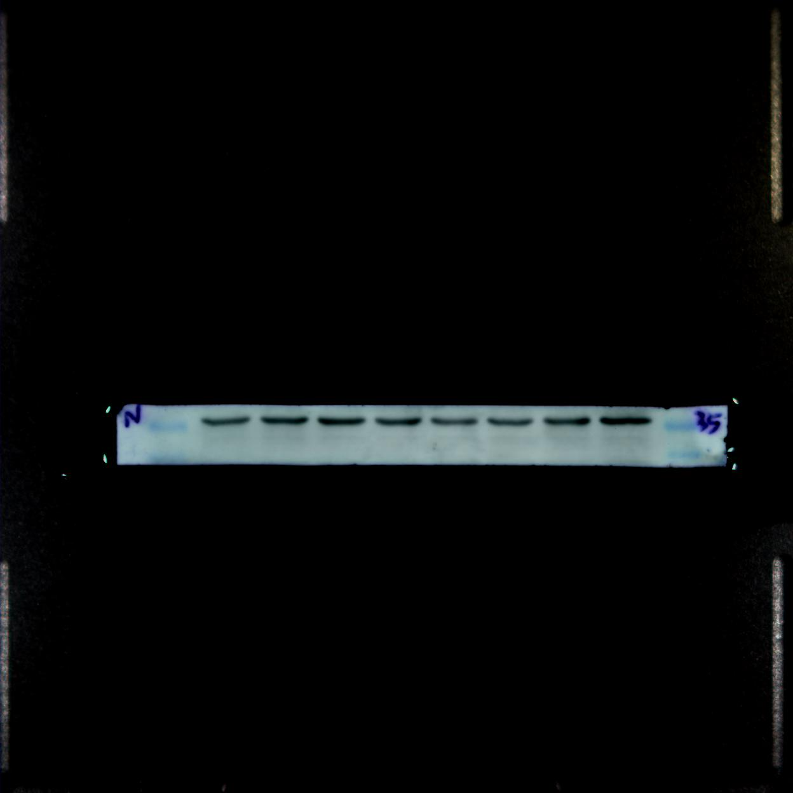
The original images of β-actin. Lane 3 to lane 6 were selected to demonstrate in manuscript.
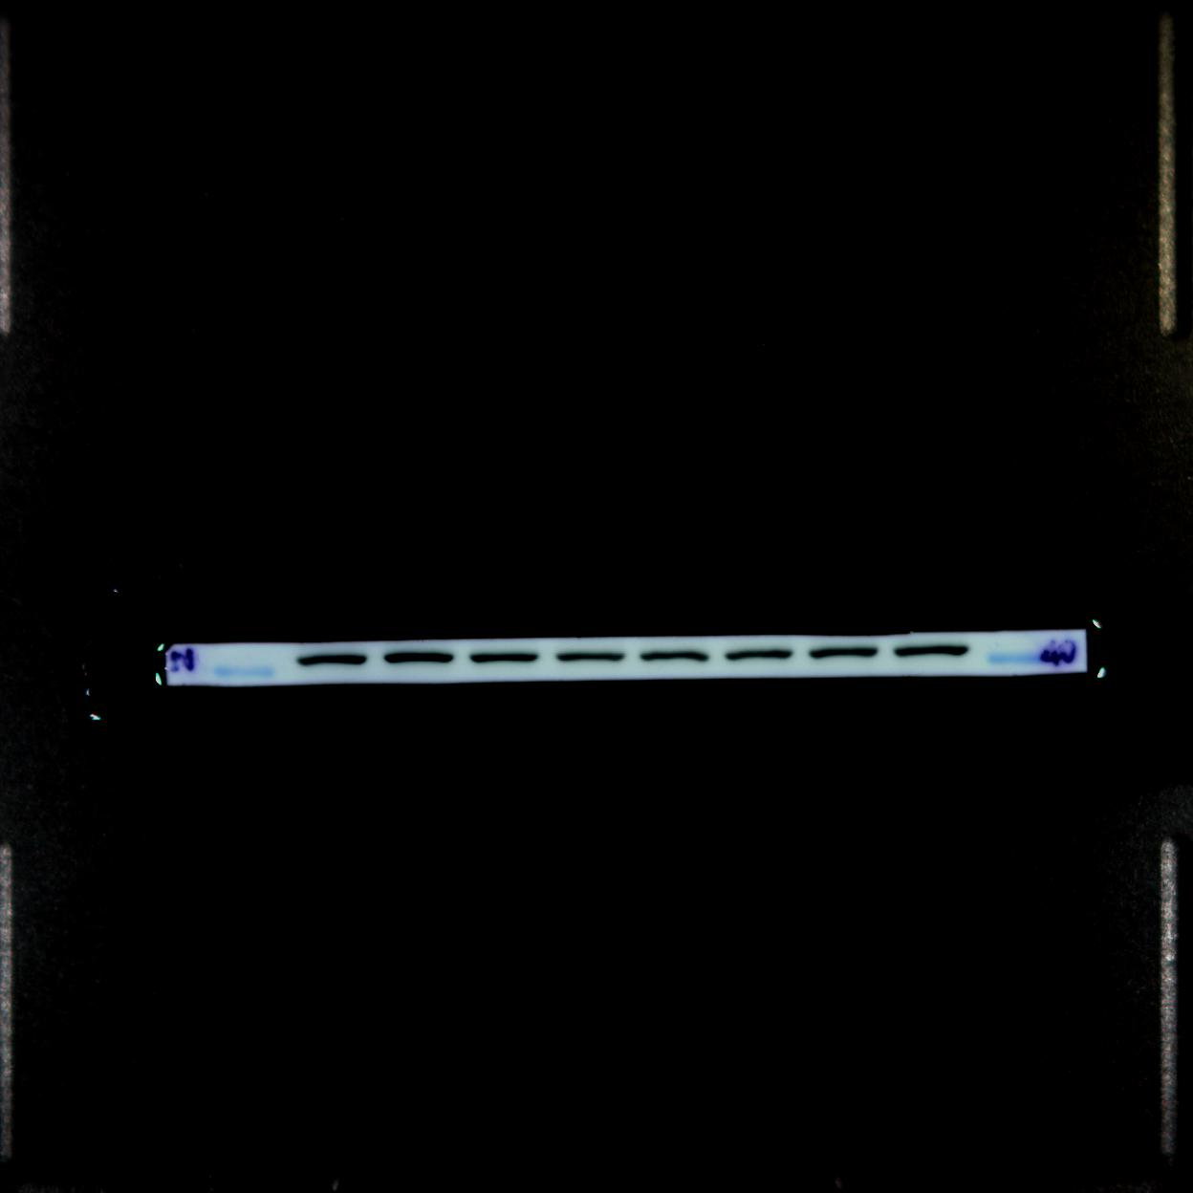
Figure 11
The original images of MBP. Lane 9 to lane 12 were selected to demonstrate in manuscript.
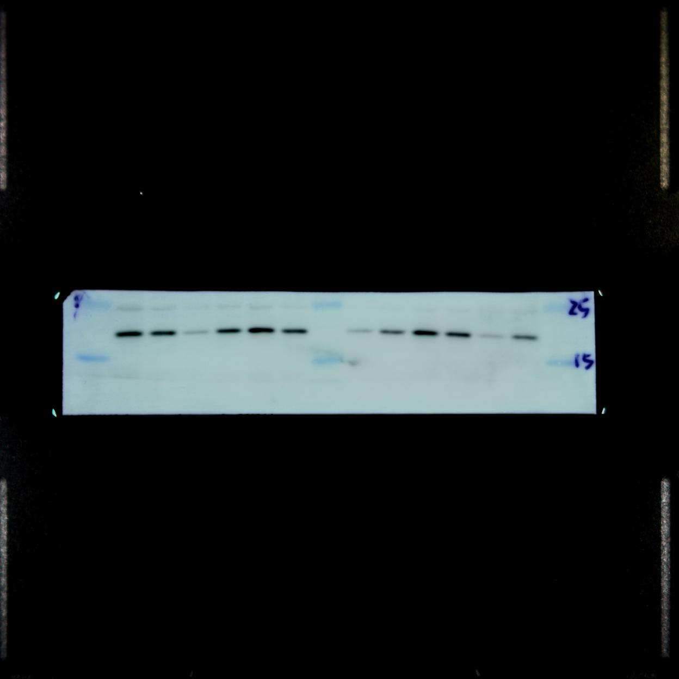
The original images of β-tublin. Lane 3 to lane 6 were selected to demonstrate in manuscript.
