Supplemental Figures

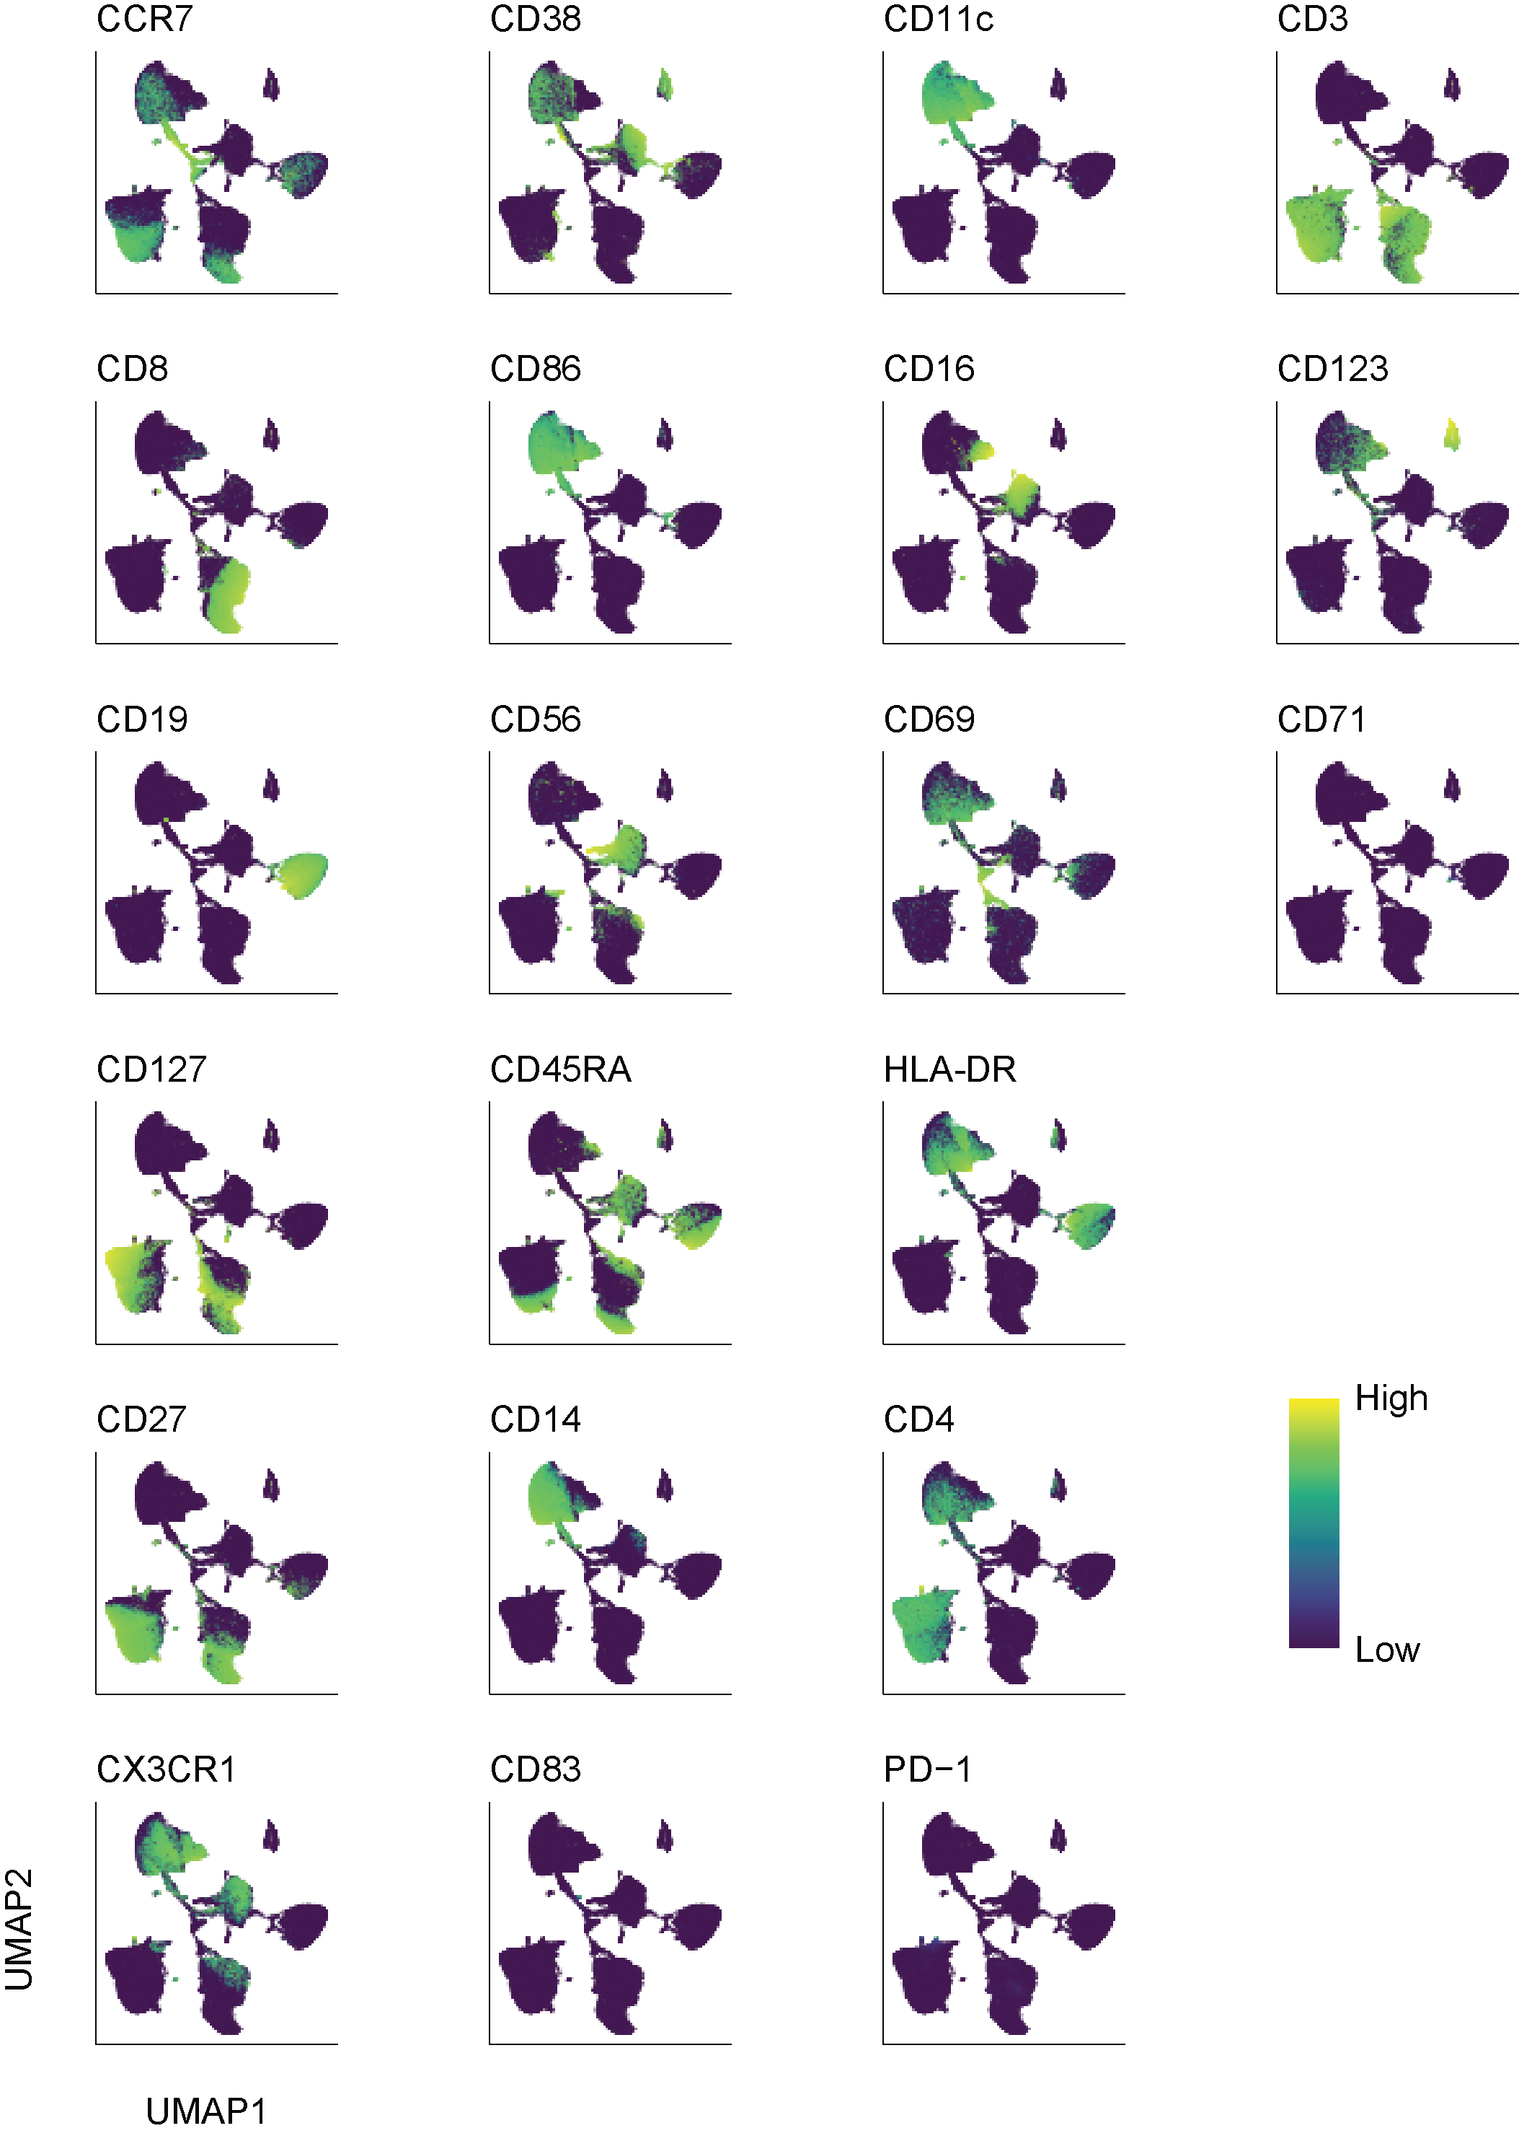
Supplemental Figure 1. Expression of immune cell lineage markers measured via flow cytometry. UMAP representation of individual immune cell lineage markers among PBMCs.
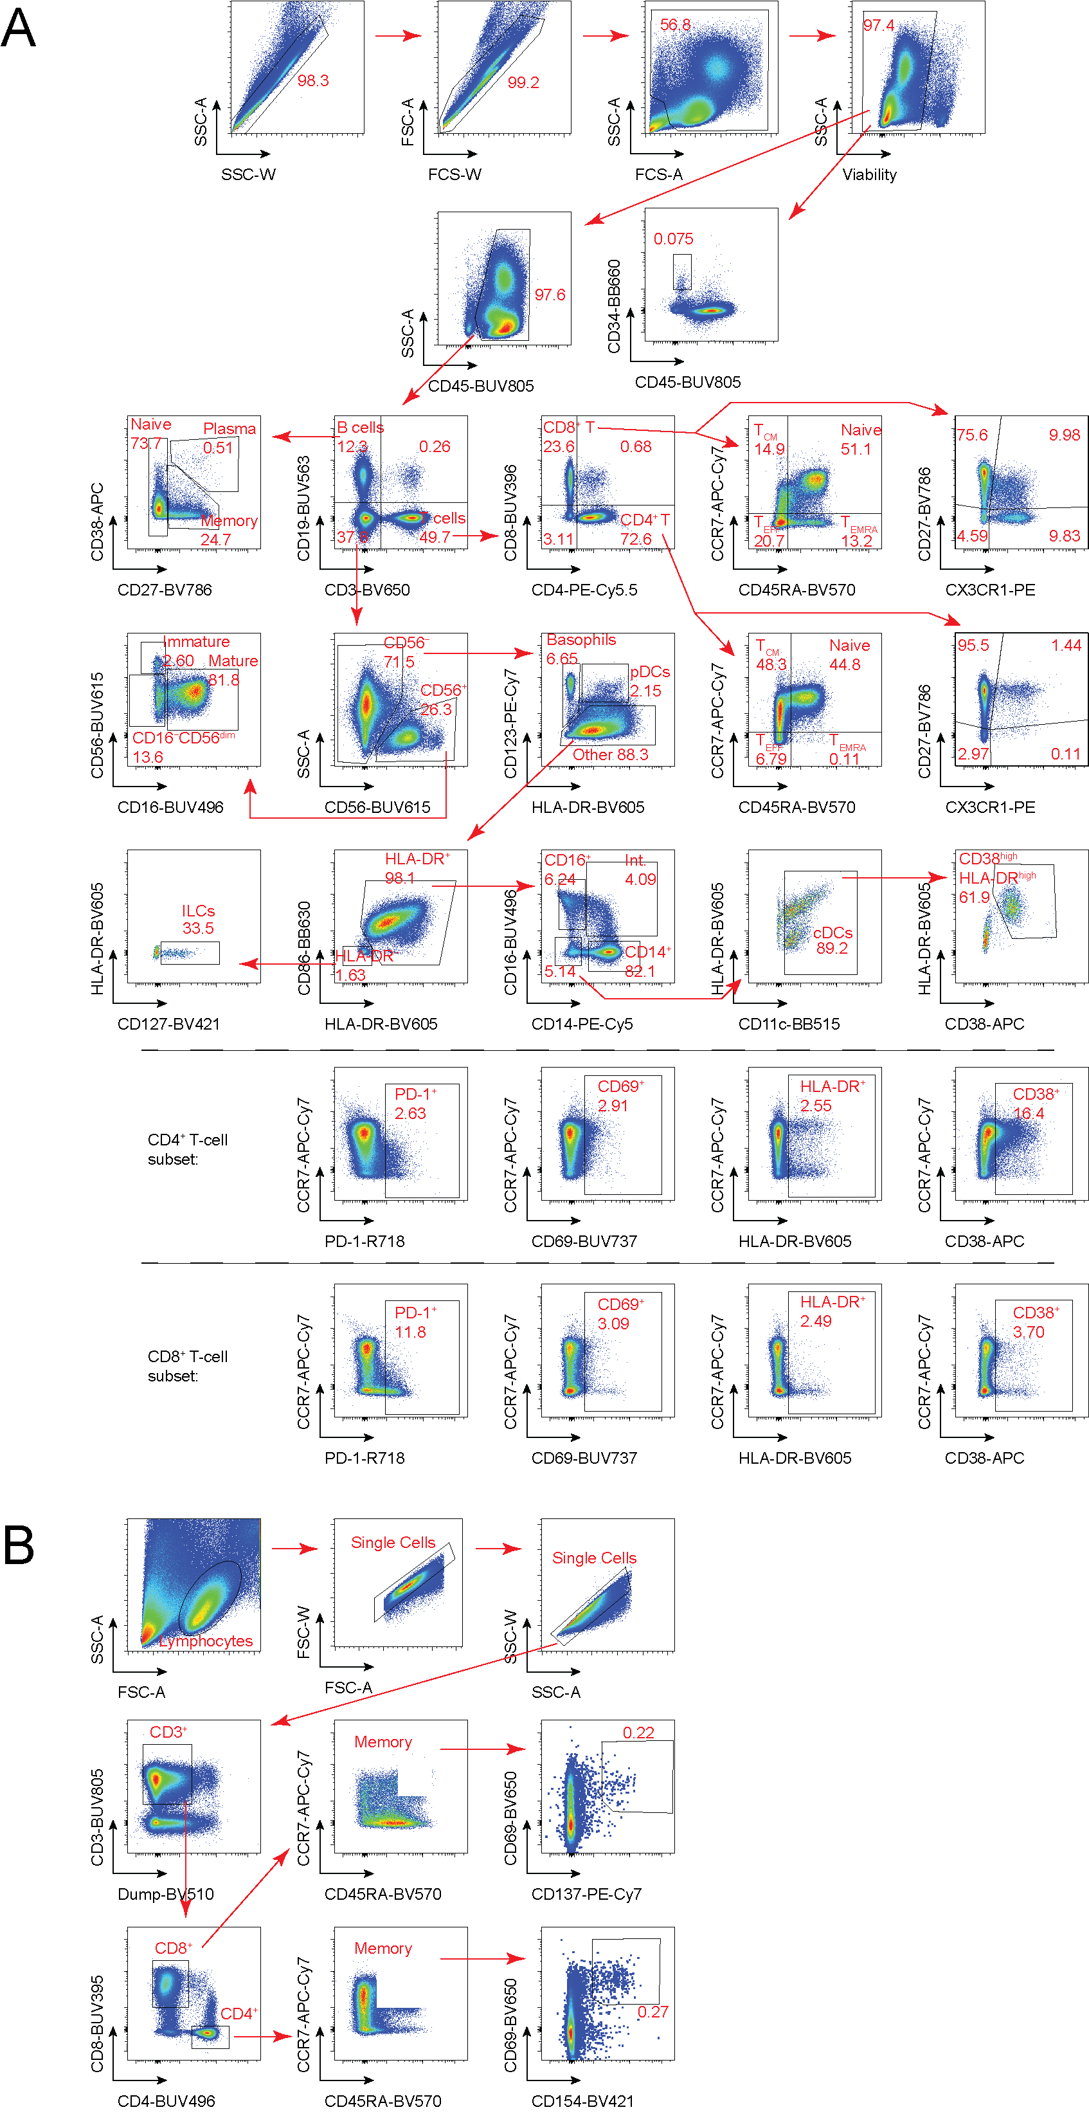
Supplemental Figure 2. Flow cytometric gating strategies for the identification of immune cell lineages and activation-induced marker upregulation. (A) Flow cytometric gating strategy for immune cell lineage characterization. Numbers indicate percentages in the drawn gates. (B) Flow cytometric gating strategy for the identification of antigen-specific CD4⁺ and CD8⁺ T cells via upregulation of the activation-induced markers CD69 and CD154 or CD69 and CD137, respectively. Numbers indicate percentages in the drawn gates.
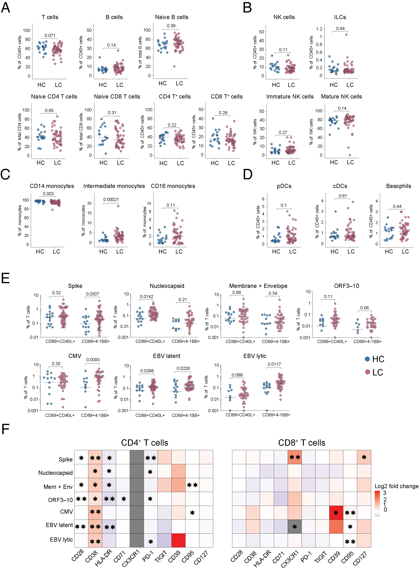
Supplemental Figure 3. Immune cell lineages and T cell immunity in healthy convalescent individuals and patients with long COVID recruited from Sweden. (A) Scatter dot plots showing the frequencies of naive and total B and T cells (top) and naive and total CD4⁺ and CD8⁺ T cells (bottom) for healthy convalescent individuals (HC, n = 20) and patients with long COVID (LC, n = 56). Significance was evaluated using the Mann–Whitney U test. (B) Scatter dot plots showing the frequencies of total NK cells and ILCs (top) and immature and mature NK cells (bottom) for healthy convalescent individuals (HC, n = 20) and patients with long COVID (LC, n = 56). Significance was evaluated using the Mann–Whitney U test. (C) Scatter dot plots showing the frequencies of monocyte subsets for healthy convalescent individuals (HC, n = 20) and patients with long COVID (LC, n = 56). Significance was evaluated using the Mann–Whitney U test. (D) Scatter dot plots showing the frequencies of basophils, cDCs, and pDCs for healthy convalescent individuals (HC, n = 20) and patients with long COVID (LC, n = 56). Significance was evaluated using the Mann–Whitney U test. (E) Scatter dot plots showing the frequencies of CD4⁺ and CD8⁺ T cells targeting defined proteins from SARS-CoV-2, CMV, or EBV for healthy convalescent individuals (HC, n = 20) and patients with long COVID (LC, n = 56). Horizontal bars represent median values. Significance was evaluated using the Mann–Whitney U test. (F) Heatmap showing the phenotypic attributes of CD4⁺ and CD8⁺ T cells targeting defined proteins from SARS-CoV-2, CMV, or EBV for healthy convalescent individuals (HC, n = 20) and patients with long COVID (LC, n = 56). Data are shown as fold change in geometric mean fluorescence intensity (gMFI). *p < 0.05, **p < 0.01 (Mann–Whitney U test).
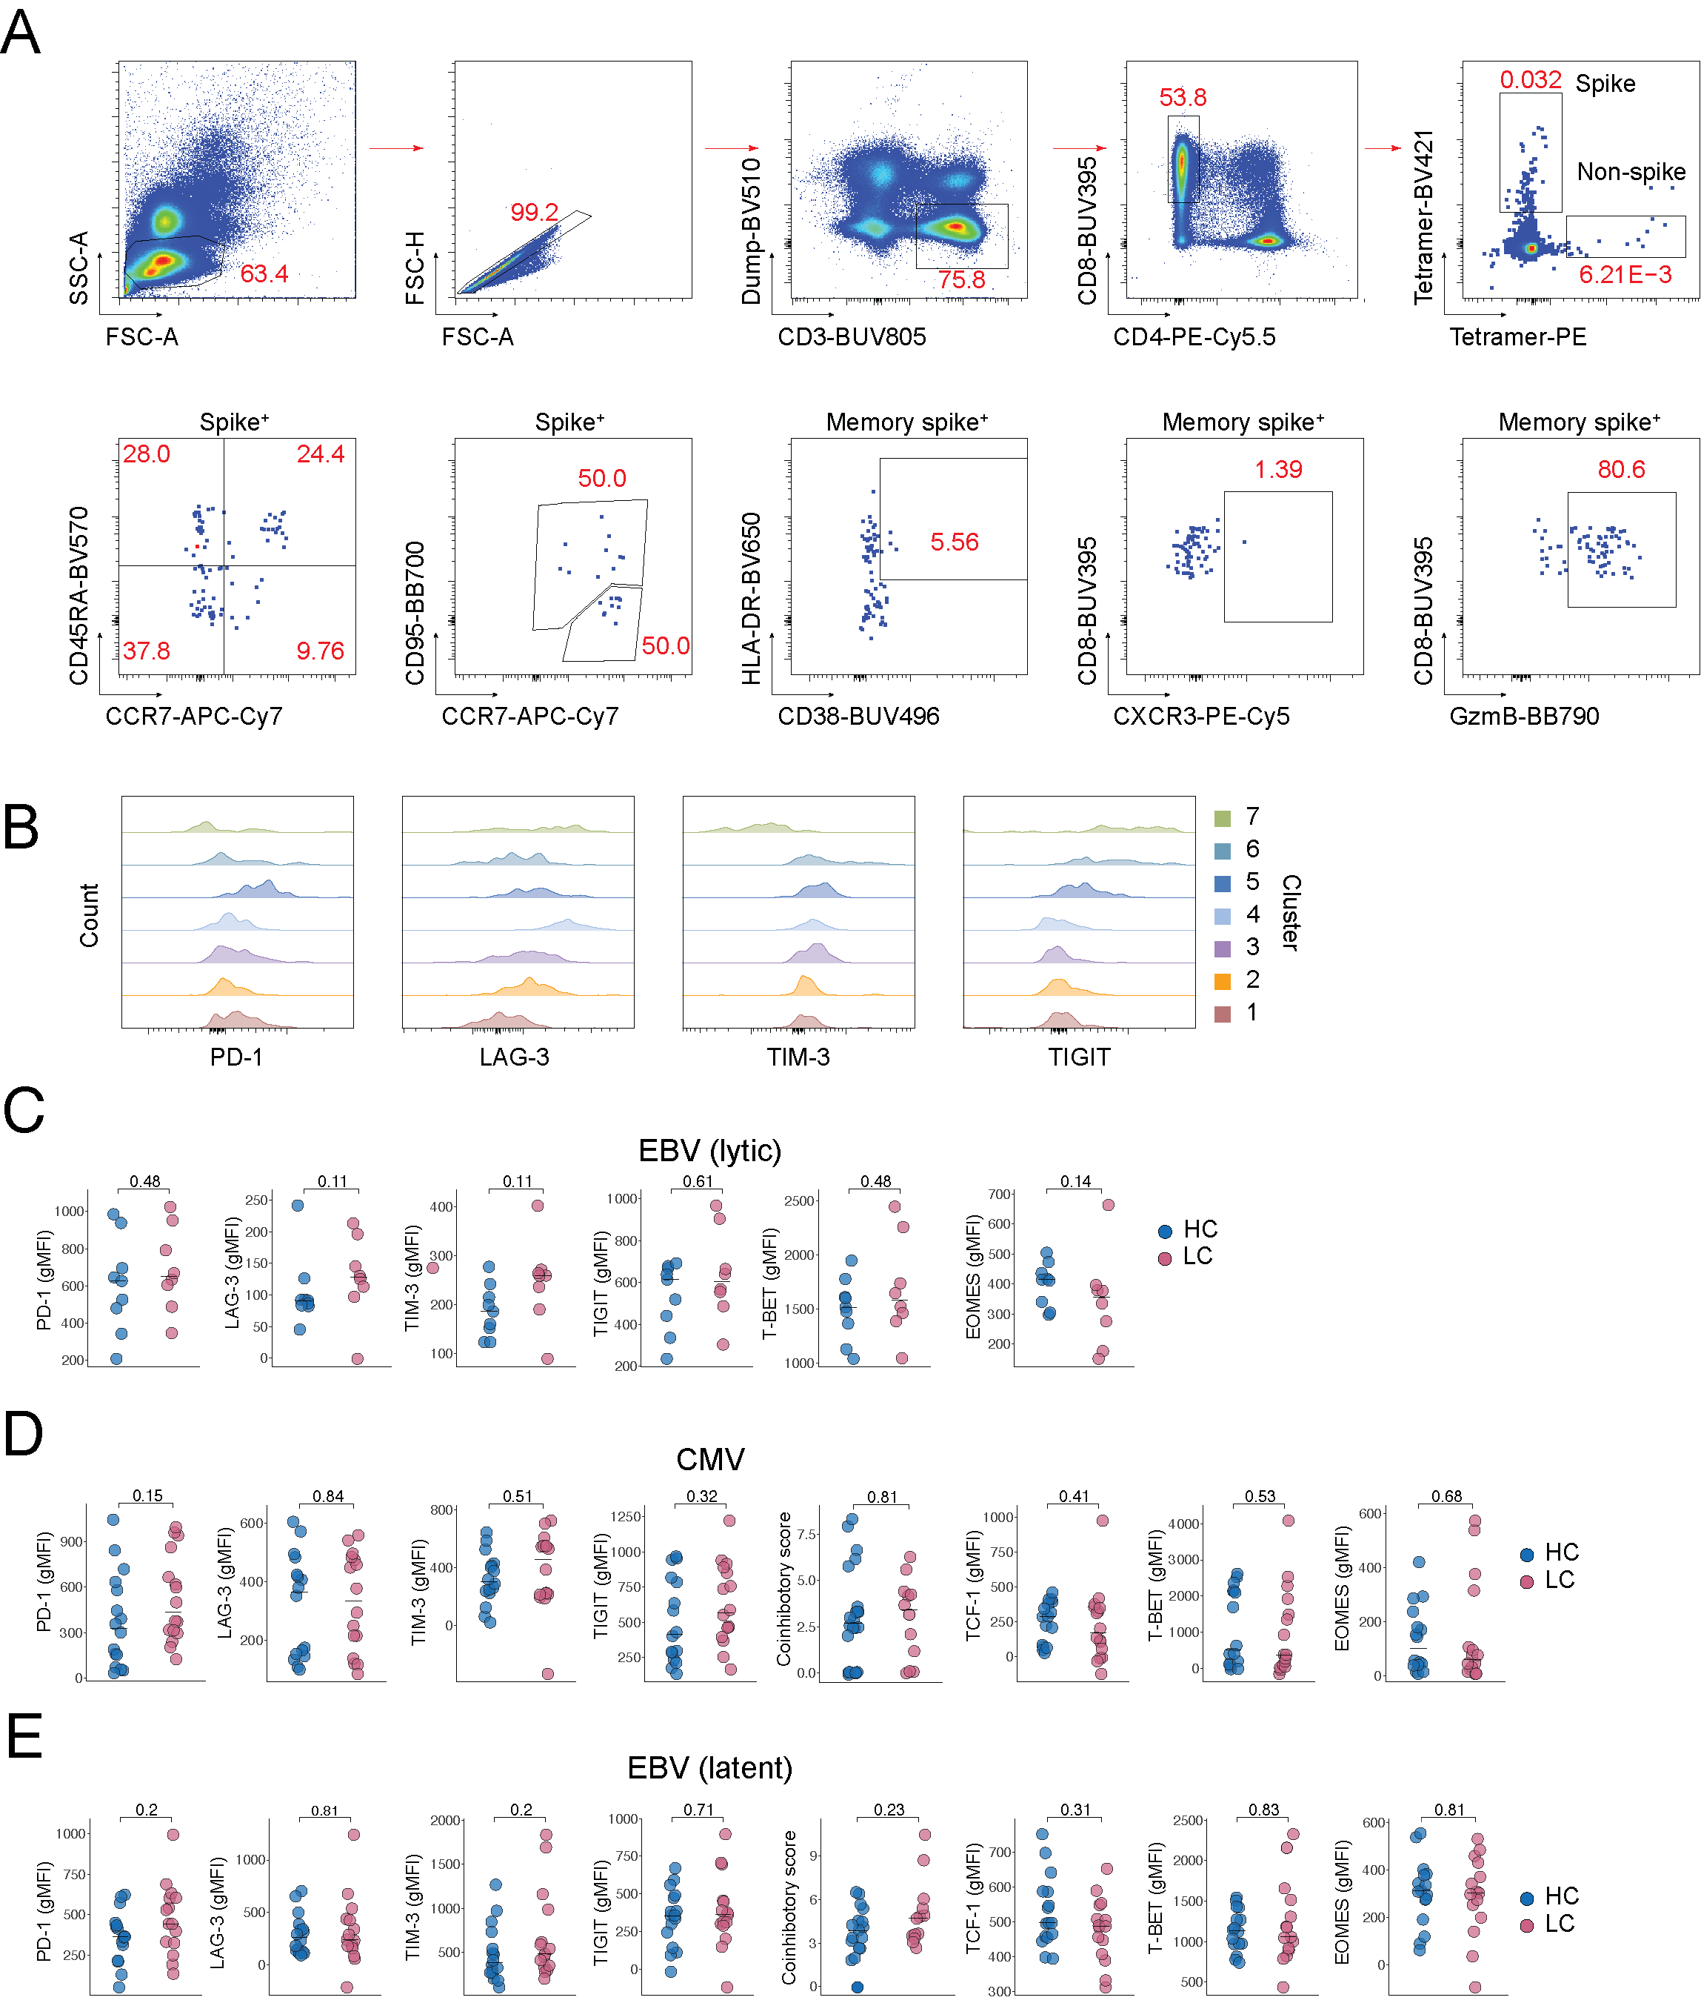
Supplemental Figure 4. Additional phenotypic characteristics of virus-specific CD8⁺ T cells in healthy convalescent individuals and patients with long COVID recruited from the UK. (A) Flow cytometric gating strategy for the identification of tetramer⁺ CD8⁺ T cells directly ex vivo. Numbers indicate percentages in the drawn gates. (B) Flow cytometry histograms showing the expression patterns of PD-1, TIM-3, LAG-3, and TIGIT among clusters of tetramer⁺ CD8⁺ T cells targeting nonspike epitopes from SARS-CoV-2 identified using Phenograph for healthy convalescent individuals (HC, n = 17) and patients with long COVID (LC, n = 15). (C) Scatter dot plots showing the expression intensities of PD-1, TIM-3, LAG-3, TIGIT, T-BET, and EOMES among tetramer⁺ CD8⁺ T cells targeting lytic epitopes from EBV for healthy convalescent individuals (HC, n = 17) and patients with long COVID (LC, n = 15). Horizontal bars represent median values. Significance was evaluated using the Mann–Whitney U test. gMFI, geometric mean fluorescence intensity. (D) Scatter dot plots showing the expression intensities of PD-1, TIM-3, LAG-3, TIGIT, TCF-1, T-BET, and EOMES and coinhibitory scores among tetramer⁺ CD8⁺ T cells targeting epitopes from CMV for healthy convalescent individuals (HC, n = 17) and patients with long COVID (LC, n = 15). Horizontal bars represent median values. Significance was evaluated using the Mann–Whitney U test. gMFI, geometric mean fluorescence intensity. (E) Scatter dot plots showing the expression intensities of PD-1, TIM-3, LAG-3, TIGIT, TCF-1, T-BET, and EOMES and coinhibitory scores among tetramer⁺ CD8⁺ T cells targeting latent epitopes from EBV for healthy convalescent individuals (HC, n = 17) and patients with long COVID (LC, n = 15). Horizontal bars represent median values. Significance was evaluated using the Mann–Whitney U test. gMFI, geometric mean fluorescence intensity.
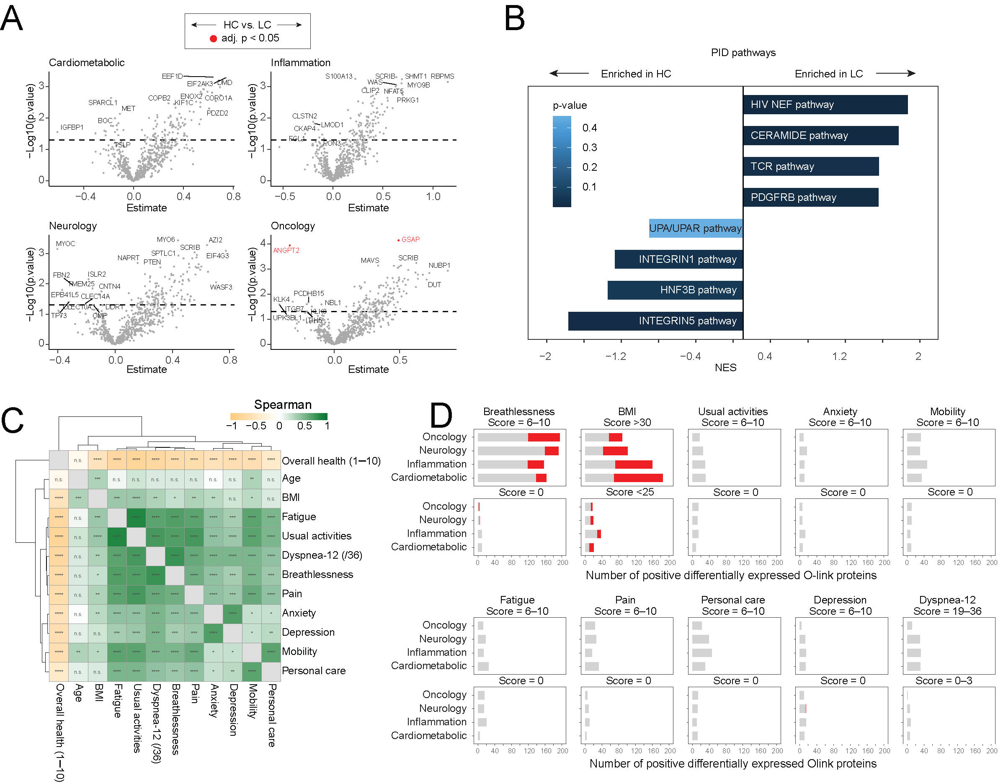
Supplemental Figure 5. Dysregulation of the plasma proteome associated with clinical assignation and symptomatology in healthy convalescent individuals and patients with long COVID recruited from the UK. (A) Volcano plots showing differentially expressed plasma proteins from each panel versus clinical assignation for healthy convalescent individuals (n = 51) and patients with long COVID (n = 51). Significance was evaluated using the Wilcoxon rank sum test with (red) or without Benjamini-Hochberg correction (gray). (B) Gene set enrichment analysis showing differentially expressed plasma proteins by rank versus clinical assignation for healthy convalescent individuals (n = 51) and patients with long COVID (n = 51). Significance was evaluated using the Spearman rank test. NES, normalized enrichment score. PID, Pathway Interaction Database. (C) Heatmap showing correlations among all recorded clinical scores for healthy convalescent individuals (n = 51) and patients with long COVID (n = 51), irrespective of clinical assignation (total, n = 102). Significance was evaluated using the Spearman rank test. (D) Bar plots showing differentially upregulated plasma proteins from each panel versus the highest and lowest symptom score tiers for healthy convalescent individuals (HC, n = 51) and patients with long COVID (LC, n = 51), irrespective of clinical assignation (total, n = 102). Significance was evaluated using the Wilcoxon rank sum test with (red) or without Benjamini-Hochberg correction (gray).
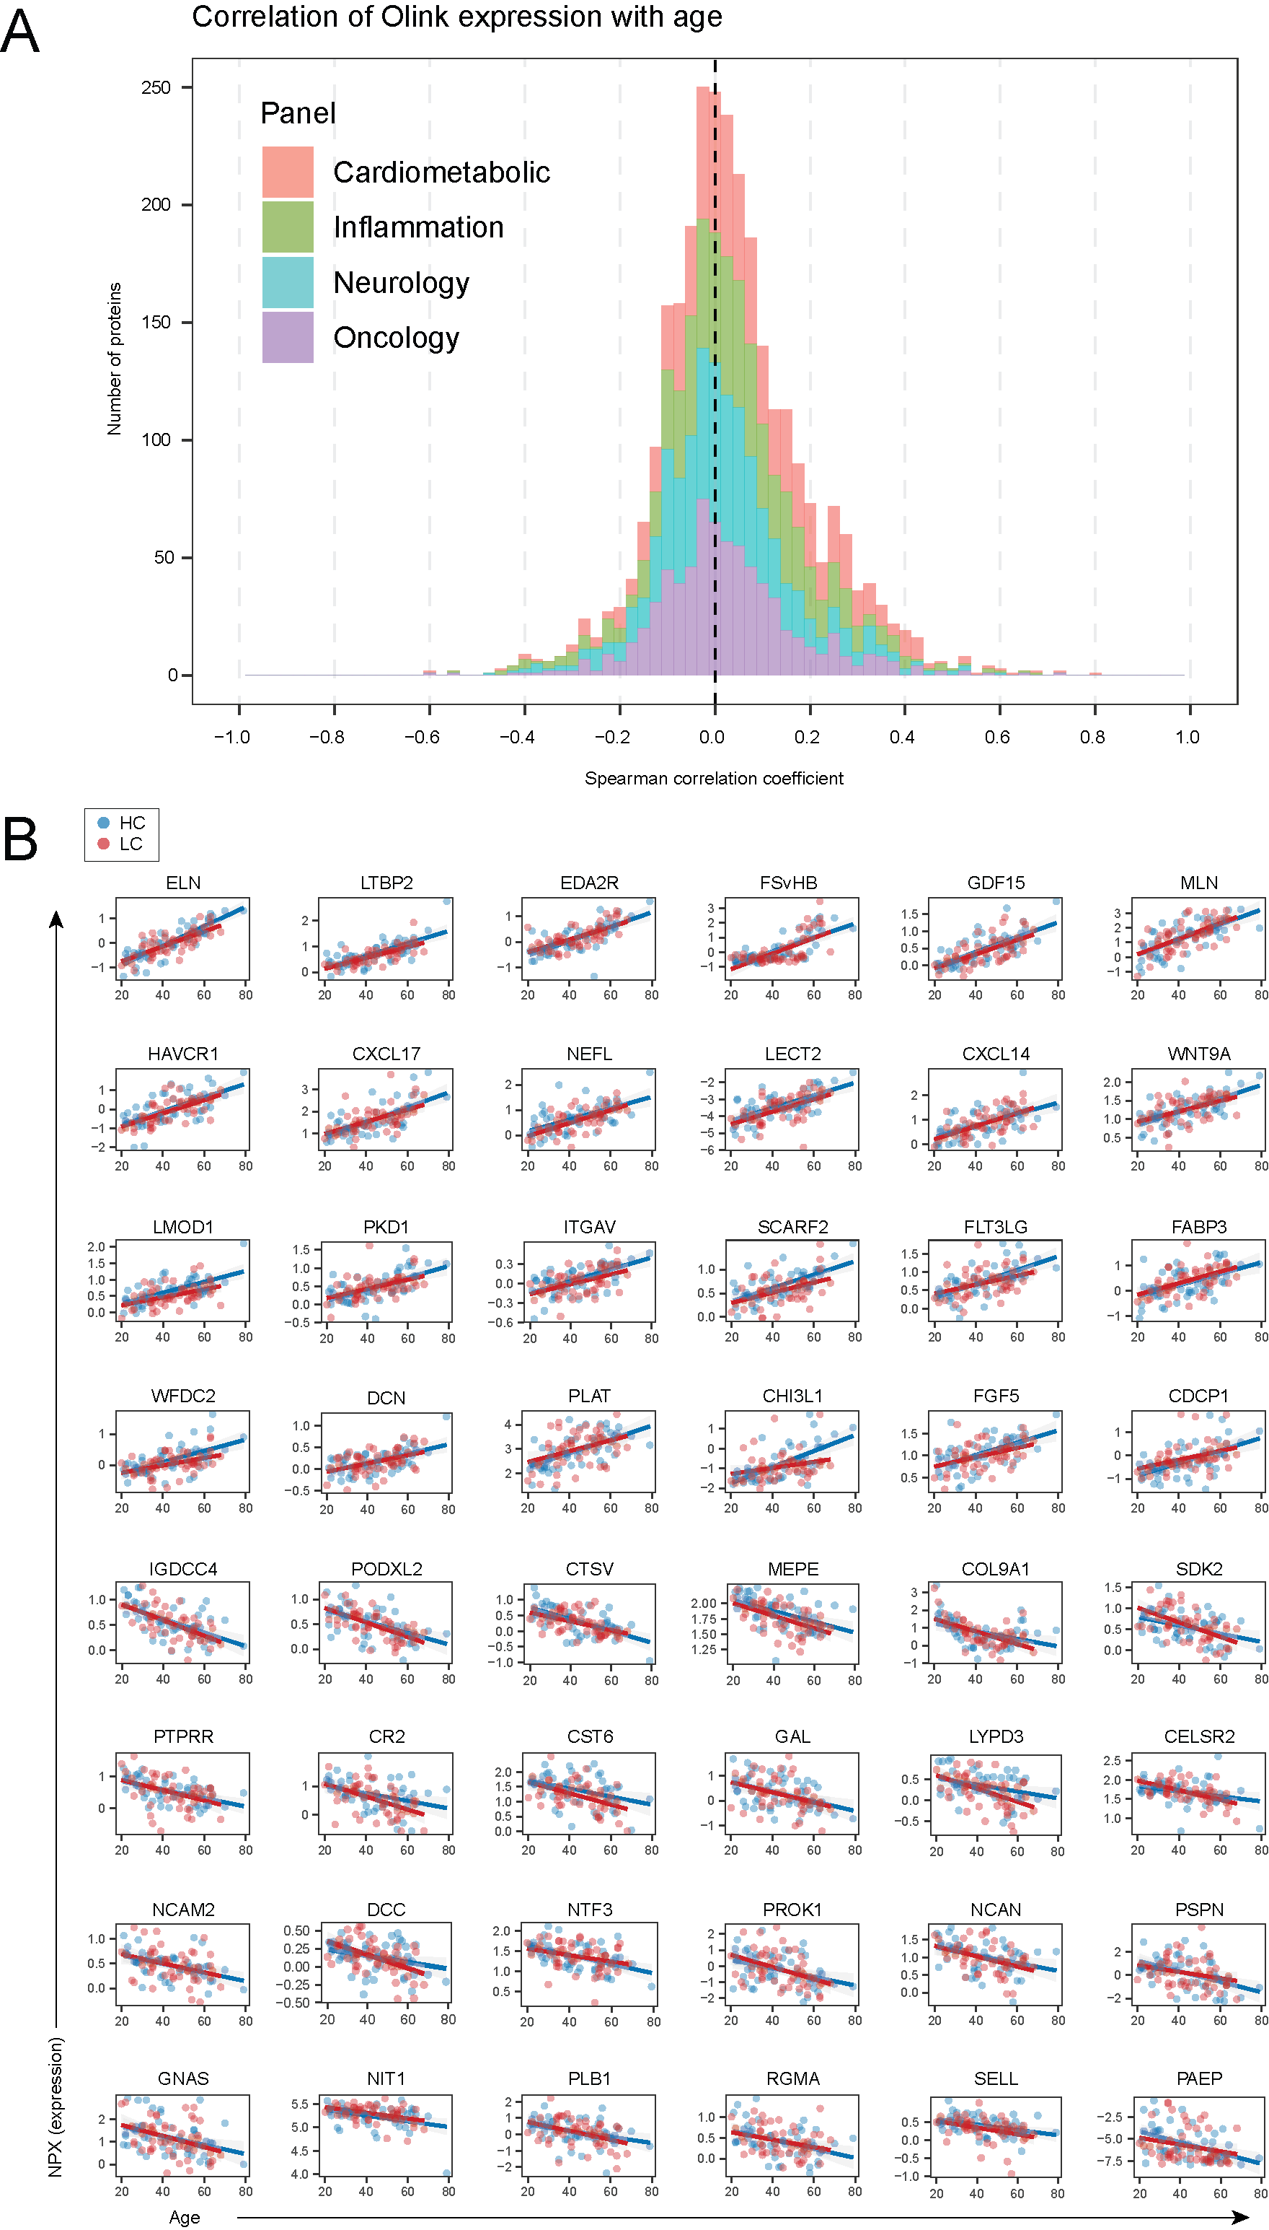
Supplemental Figure 6. Dysregulation of the plasma proteome associated with age in healthy convalescent individuals and patients with long COVID recruited from the UK. (A) Stacked histogram showing correlations from pairwise comparisons of plasma protein concentrations versus age for healthy convalescent individuals (n = 51) and patients with long COVID (n = 51), irrespective of clinical assignation (total, n = 102). Significance was evaluated using the Spearman rank test. (B) Correlation dot plots showing the highest and lowest ranked plasma proteins in terms of normalized expression versus age for healthy convalescent individuals (n = 51) and patients with long COVID (n = 51). Significance was evaluated using the Spearman rank test. NPX, normalized protein expression.

