Supplementary Table 1
Type 1 Diabetes associated variants used in this study for calculating the GRS (corresponding GRCh37 loci were used to score the 1000 Genomes-imputed array genotypes), along with their corresponding 1000 Genomes imputation INFO score & TOPMed imputation R²:
 | rsID | Locus  (GRCh38) | Risk  Allele | Weight | Type | INFO  score | R²
1 | rs6679677 | chr1-113761186-C-A | A | 0.64 | Non-HLA | 1.000 | 0.991
2 | rs3024505 | chr1-206766559-G-A | A | -0.15 | Non-HLA | 1.000 | 1.003
3 | rs2111485 | chr2-162254026-A-G | G | 0.16 | Non-HLA | 1.000 | 0.999
4 | rs3087243 | chr2-203874196-G-A | A | -0.17 | Non-HLA | 1.000 | 0.997
5 | rs17388568 | chr4-122408207-G-A | A | 0.12 | Non-HLA | 1.000 | 0.994
6 | rs9500974 | chr6-29760476-G-T | T | 0.63 | HLA | 0.992 | 0.993
7 | rs1233320 | chr6-29840255-C-G | G | 0.74 | HLA | 1.000 | 0.996
8 | rs72848653 | chr6-29868825-C-T | T | 0.78 | HLA | 0.997 | 1.000
9 | rs9259118 | chr6-29883132-T-C | T | 0.31 | HLA | 0.999 | 1.000
10 | rs12153924 | chr6-29946312-G-A | A | 0.44 | HLA | 0.997 | 1.000
11 | rs12189871 | chr6-31284147-C-T | T | 0.45 | HLA | 1.000 | 0.997
12 | rs540653847 | chr6-31307016-G-GC | GC | 1.78 | HLA | 0.963 | 0.989
13 | rs9266268 | chr6-31358273-G-A | A | 0.39 | HLA | 1.000 | 1.000
14 | rs16899379 | chr6-31375490-G-A | A | -0.83 | HLA | 0.967 | 0.992
15 | rs149663102 | chr6-31376405-TG-T | T | -0.94 | HLA | 0.999 | 1.000
16 | rs2524277 | chr6-31439802-G-A | A | -0.60 | HLA | 1.000 | 1.000
17 | rs9268500 | chr6-32408740-C-T | C | 1.24 | HLA | 1.000 | 1.000
18 | rs17840116 | chr6-32415221-G-C | C | -0.63 | HLA-DQ69 | 0.998 | 0.992
19 | rs75658393 | chr6-32427740-T-C | T | 0.81 | HLA | 0.996 | 0.991
20 | rs9269173 | chr6-32479411-T-A | A | 0.67 | HLA | 0.900 | 0.983
21 | rs9271347 | chr6-32615766-A-G | G | 1.69 | HLA | 0.999 | 1.000
22 | rs1281935 | chr6-32616043-G-T | T | -0.65 | HLA-DQ73 | 0.901 | 0.993
23 | rs1281943 | chr6-32630313-T-C | C | 0.90 | HLA | 0.919 | 0.991
24 | rs9405117 | chr6-32634974-C-A | A | 1.39 | HLA-DQ93 | 1.000 | 0.992
25 | rs9469200 | chr6-32635435-T-C | C | -1.32 | HLA-DQ75 | 0.992 | 0.993
26 | rs9273032 | chr6-32644083-A-G | A | -1.43 | HLA-DQ62 | 0.993 | 1.000
27 | rs17211699 | chr6-32658260-G-T | T | -0.75 | HLA-DQ22 | 0.993 | 0.992
28 | rs117806464 | chr6-32658670-G-A | A | 0.48 | HLA-DQ61 | 1.000 | 0.994
29 | rs9273369 | chr6-32658707-T-C | C | 1.26 | HLA-DQ25 | 1.000 | 1.000
30 | rs28746898 | chr6-32680817-A-G | G | -2.35 | HLA-DQ92 | 0.970 | 1.000
31 | rs62406889 | chr6-32704437-G-T | T | -2.22 | HLA-DQ63 | 0.980 | 0.994
32 | rs9275490 | chr6-32705608-C-G | G | 2.08 | HLA-DQ81 | 1.000 | 0.997
33 | rs1794265 | chr6-32706960-C-G | G | -0.89 | HLA-DQ53 | 0.999 | 0.996
34 | rs10947332 | chr6-32709663-G-A | A | -0.03 | HLA-DQ51 | 1.000 | 1.000
35 | rs12527228 | chr6-32712215-C-T | T | -0.46 | HLA-DQ42 | 0.987 | 0.987
36 | rs6934289 | chr6-33077179-T-C | C | -0.68 | HLA | 0.998 | 1.000
37 | rs17214657 | chr6-33079396-T-C | C | -0.19 | HLA | 0.998 | 0.996
38 | rs2567287 | chr6-33081408-G-A | A | 0.84 | HLA | 0.997 | 0.993
39 | rs9378176 | chr6-33081532-A-G | G | -0.49 | HLA | 1.000 | 1.000
40 | rs3129197 | chr6-33103130-G-A | A | 0.24 | HLA | 1.000 | 1.000
41 | rs72928038 | chr6-90267049-G-A | A | 0.18 | Non-HLA | 1.000 | 1.000
42 | rs9388489 | chr6-126377573-A-G | A | 0.16 | Non-HLA | 1.000 | 0.998
43 | rs1738074 | chr6-159044945-T-C | C | 0.08 | Non-HLA | 1.000 | 0.992
44 | rs4948088 | chr7-50959497-A-C | C | 0.26 | Non-HLA | 1.000 | 1.000
45 | rs6476839 | chr9-4290823-A-T | T | 0.11 | Non-HLA | 0.998 | 1.000
46 | rs61839660 | chr10-6052734-C-T | T | -0.48 | Non-HLA | 1.000 | 0.994
47 | rs41295121 | chr10-6087680-C-T | T | -0.71 | Non-HLA | 0.955 | 0.959
48 | rs60888743 | chr10-88291560-A-G | A | 0.18 | Non-HLA | 0.994 | 0.986
49 | rs3842753 | chr11-2159830-T-G | G | 0.83 | Non-HLA | 0.988 | 0.970
50 | rs10492166 | chr12-9733403-G-A | A | -0.14 | Non-HLA | 0.996 | 0.992
51 | rs11170466 | chr12-53192075-C-T | T | 0.17 | Non-HLA | 0.997 | 1.000
52 | rs4759229 | chr12-56080696-A-G | A | 0.22 | Non-HLA | 0.997 | 0.991
53 | rs653178 | chr12-111569952-C-T | C | 0.26 | Non-HLA | 1.000 | 1.000
54 | rs9585056 | chr13-99429512-C-T | C | 0.11 | Non-HLA | 1.000 | 0.999
55 | rs56994090 | chr14-100840110-T-C | C | -0.13 | Non-HLA | 0.997 | 0.994
56 | rs72727394 | chr15-38554821-C-T | T | 0.14 | Non-HLA | 0.991 | 0.986
57 | rs2289702 | chr15-78944951-C-T | C | 0.28 | Non-HLA | 0.990 | 0.981
58 | rs12708716 | chr16-11086016-A-G | G | -0.19 | Non-HLA | 1.000 | 1.000
59 | rs9924471 | chr16-28580209-G-A | A | 0.22 | Non-HLA | 0.992 | 0.980
60 | rs1893217 | chr18-12809341-A-G | G | 0.19 | Non-HLA | 1.000 | 1.000
61 | rs1615504 | chr18-69859408-T-C | C | 0.12 | Non-HLA | 0.999 | 0.992
62 | rs144309607 | chr19-10381598-C-T | T | -0.40 | Non-HLA | 0.951 | 0.982
63 | rs425105 | chr19-46705224-T-C | T | 0.15 | Non-HLA | 1.000 | 0.993
64 | rs2281808 | chr20-1629905-T-C | C | 0.10 | Non-HLA | 1.000 | 0.999
65 | rs9981624 | chr21-42405613-G-C | C | 0.17 | Non-HLA | 0.996 | 0.992
66 | rs5763779 | chr22-30108663-A-G | A | 0.15 | Non-HLA | 0.995 | 0.992
67 | rs229541 | chr22-37195278-G-A | A | 0.10 | Non-HLA | 1.000 | 1.000

Supplementary Table 2
Minor allele frequency association testing using Fisher’s exact test adjusted for multiple testing with Bonferroni correction for all variants, for both all participants and stratified by genetic ancestry, with significant results highlighted in bold:
Genetic  ancestry | Locus  (GRCh38) | Allele frequency |  |  | Fisher’s exact p-value  (threshold = 7.64×10⁻⁴)
Genetic  ancestry | Locus  (GRCh38) | WGS | 1000G | TOPMed | 1000G | TOPMed
All | chr1-113761186-C-A | 0.096 | 0.096 | 0.096 | 0.7614 | 0.8395
All | chr1-206766559-G-A | 0.151 | 0.151 | 0.151 | 0.7556 | 0.7556
All | chr2-162254026-A-G | 0.408 | 0.408 | 0.409 | 0.9706 | 0.9119
All | chr2-203874196-G-A | 0.450 | 0.450 | 0.450 | 0.9772 | 0.973
All | chr4-122408207-G-A | 0.263 | 0.263 | 0.263 | 0.8762 | 0.8994
All | chr6-29760476-G-T | 0.009 | 0.009 | 0.009 | 0.6138 | 0.9027
All | chr6-29840255-C-G | 0.041 | 0.042 | 0.042 | 0.8762 | 0.8456
All | chr6-29868825-C-T | 0.078 | 0.078 | 0.078 | 0.8772 | 1
All | chr6-29883132-T-C | 0.142 | 0.142 | 0.142 | 0.9734 | 0.9527
All | chr6-29946312-G-A | 0.275 | 0.275 | 0.275 | 0.5734 | 0.4369
All | chr6-31284147-C-T | 0.091 | 0.091 | 0.091 | 0.8537 | 0.8678
All | chr6-31307016-G-GC | 0.007 | 0.006 | 0.007 | *3.27×10⁻⁴ | 0.8738
All | chr6-31358273-G-A | 0.037 | 0.037 | 0.037 | 0.6695 | 0.967
All | chr6-31375490-G-A | 0.007 | 0.006 | 0.007 | *1.23×10⁻⁶ | 0.9755
All | chr6-31376405-TG-T | 0.039 | 0.039 | 0.039 | 0.8104 | 0.9521
All | chr6-31439802-G-A | 0.059 | 0.059 | 0.060 | 0.9913 | 0.8353
All | chr6-32408740-C-T | 0.049 | 0.049 | 0.049 | 0.8286 | 0.9233
All | chr6-32415221-G-C | 0.012 | 0.012 | 0.012 | 0.3035 | 0.9525
All | chr6-32427740-T-C | 0.018 | 0.018 | 0.018 | 0.8466 | 0.9923
All | chr6-32479411-T-A | 0.021 | 0.021 | 0.021 | 0.07393 | 0.7265
All | chr6-32615766-A-G | 0.151 | 0.150 | 0.151 | 0.9423 | 0.925
All | chr6-32616043-G-T | 0.088 | 0.079 | 0.088 | *8.06×10⁻³⁵ | 0.6541
All | chr6-32630313-T-C | 0.052 | 0.073 | 0.051 | *1.54×10⁻²⁴⁵ | 0.5696
All | chr6-32634974-C-A | 0.013 | 0.013 | 0.013 | 0.9456 | 0.9818
All | chr6-32635435-T-C | 0.092 | 0.089 | 0.092 | *1.86×10⁻⁴ | 0.8437
All | chr6-32644083-A-G | 0.146 | 0.143 | 0.144 | 0.00216 | 0.08833
All | chr6-32658260-G-T | 0.106 | 0.106 | 0.106 | 0.8462 | 0.599
All | chr6-32658670-G-A | 0.009 | 0.009 | 0.009 | 0.8784 | 0.8784
All | chr6-32658707-T-C | 0.143 | 0.143 | 0.143 | 0.7815 | 0.8302
All | chr6-32680817-A-G | 0.039 | 0.035 | 0.039 | *1.08×10⁻¹⁰ | 0.9571
All | chr6-32704437-G-T | 0.053 | 0.051 | 0.052 | *3.59×10⁻⁴ | 0.2168
All | chr6-32705608-C-G | 0.100 | 0.101 | 0.101 | 0.8464 | 0.8162
All | chr6-32706960-C-G | 0.024 | 0.024 | 0.024 | 0.5948 | 0.9259
All | chr6-32709663-G-A | 0.119 | 0.120 | 0.120 | 0.7616 | 0.7616
All | chr6-32712215-C-T | 0.020 | 0.020 | 0.020 | 0.4838 | 0.9927
All | chr6-33077179-T-C | 0.108 | 0.110 | 0.110 | 0.04988 | 0.01599
All | chr6-33079396-T-C | 0.065 | 0.065 | 0.065 | 0.5381 | 0.9122
All | chr6-33081408-G-A | 0.009 | 0.009 | 0.009 | 0.794 | 0.9562
All | chr6-33081532-A-G | 0.022 | 0.022 | 0.022 | 0.9374 | 0.993
All | chr6-33103130-G-A | 0.167 | 0.167 | 0.167 | 0.672 | 0.6544
All | chr6-90267049-G-A | 0.170 | 0.171 | 0.171 | 0.831 | 0.8203
All | chr6-126377573-A-G | 0.457 | 0.457 | 0.457 | 0.9648 | 0.973
All | chr6-159044945-T-C | 0.440 | 0.440 | 0.440 | 0.9376 | 0.9979
All | chr7-50959497-A-C | 0.045 | 0.044 | 0.044 | 0.2575 | 0.8115
All | chr9-4290823-A-T | 0.408 | 0.408 | 0.407 | 0.8083 | 0.4016
All | chr10-6052734-C-T | 0.094 | 0.094 | 0.094 | 0.601 | 0.6704
All | chr10-6087680-C-T | 0.012 | 0.011 | 0.011 | *6.50×10⁻⁶ | 0.002301
All | chr10-88291560-A-G | 0.264 | 0.262 | 0.262 | 0.06951 | 0.04584
All | chr11-2159830-T-G | 0.293 | 0.290 | 0.295 | 0.01779 | 0.2692
All | chr12-9733403-G-A | 0.496 | 0.496 | 0.496 | 0.9917 | 0.8476
All | chr12-53192075-C-T | 0.051 | 0.051 | 0.051 | 0.6295 | 0.7999
All | chr12-56080696-A-G | 0.346 | 0.346 | 0.346 | 0.8146 | 0.6808
All | chr12-111569952-C-T | 0.465 | 0.465 | 0.465 | 0.9917 | 0.9111
All | chr13-99429512-C-T | 0.252 | 0.252 | 0.252 | 0.743 | 0.9003
All | chr14-100840110-T-C | 0.412 | 0.411 | 0.412 | 0.389 | 0.6889
All | chr15-38554821-C-T | 0.199 | 0.198 | 0.197 | 0.2976 | 0.09301
All | chr15-78944951-C-T | 0.102 | 0.102 | 0.098 | 0.8574 | *4.54×10⁻⁷
All | chr16-11086016-A-G | 0.357 | 0.357 | 0.357 | 0.9741 | 1
All | chr16-28580209-G-A | 0.160 | 0.158 | 0.157 | 0.1177 | 0.001258
All | chr18-12809341-A-G | 0.167 | 0.167 | 0.167 | 0.9695 | 0.9585
All | chr18-69859408-T-C | 0.480 | 0.480 | 0.480 | 0.9215 | 0.9731
All | chr19-10381598-C-T | 0.047 | 0.042 | 0.045 | *8.43×10⁻²⁰ | *3.01×10⁻⁴
All | chr19-46705224-T-C | 0.163 | 0.164 | 0.164 | 0.7106 | 0.7634
All | chr20-1629905-T-C | 0.355 | 0.355 | 0.355 | 0.9353 | 0.9676
All | chr21-42405613-G-C | 0.333 | 0.333 | 0.332 | 0.5992 | 0.345
All | chr22-30108663-A-G | 0.379 | 0.379 | 0.381 | 0.8264 | 0.3112
All | chr22-37195278-G-A | 0.431 | 0.431 | 0.431 | 0.9417 | 0.9646
European | chr1-113761186-C-A | 0.101 | 0.101 | 0.101 | 0.7715 | 0.8476
European | chr1-206766559-G-A | 0.154 | 0.154 | 0.154 | 0.7683 | 0.7683
European | chr2-162254026-A-G | 0.392 | 0.392 | 0.392 | 0.9626 | 0.8946
European | chr2-203874196-G-A | 0.451 | 0.452 | 0.452 | 0.9763 | 0.9827
European | chr4-122408207-G-A | 0.273 | 0.273 | 0.273 | 0.8823 | 0.9038
European | chr6-29760476-G-T | 0.008 | 0.007 | 0.008 | 0.6184 | 0.8769
European | chr6-29840255-C-G | 0.043 | 0.043 | 0.043 | 0.8836 | 0.8627
European | chr6-29868825-C-T | 0.076 | 0.076 | 0.076 | 0.8588 | 0.9959
European | chr6-29883132-T-C | 0.147 | 0.147 | 0.147 | 0.9818 | 0.9575
European | chr6-29946312-G-A | 0.283 | 0.284 | 0.284 | 0.6365 | 0.4749
European | chr6-31284147-C-T | 0.091 | 0.091 | 0.091 | 0.8476 | 0.8697
European | chr6-31307016-G-GC | 0.007 | 0.006 | 0.007 | *4.62×10⁻⁴ | 0.9228
European | chr6-31358273-G-A | 0.037 | 0.037 | 0.037 | 0.7262 | 0.9658
European | chr6-31375490-G-A | 0.006 | 0.006 | 0.006 | *2.41×10⁻⁵ | 1
European | chr6-31376405-TG-T | 0.040 | 0.040 | 0.040 | 0.9288 | 0.9561
European | chr6-31439802-G-A | 0.060 | 0.060 | 0.060 | 0.9683 | 0.8115
European | chr6-32408740-C-T | 0.051 | 0.051 | 0.051 | 0.8398 | 0.9365
European | chr6-32415221-G-C | 0.010 | 0.011 | 0.010 | 0.8222 | 0.9578
European | chr6-32427740-T-C | 0.019 | 0.019 | 0.019 | 0.9682 | 0.9841
European | chr6-32479411-T-A | 0.018 | 0.017 | 0.018 | 0.04862 | 0.8872
European | chr6-32615766-A-G | 0.150 | 0.150 | 0.150 | 0.9368 | 0.9278
European | chr6-32616043-G-T | 0.094 | 0.084 | 0.093 | *2.14×10⁻³⁴ | 0.6669
European | chr6-32630313-T-C | 0.055 | 0.077 | 0.055 | *2.63×10⁻²³⁶ | 0.5823
European | chr6-32634974-C-A | 0.013 | 0.013 | 0.013 | 0.9524 | 0.9905
European | chr6-32635435-T-C | 0.089 | 0.086 | 0.089 | *4.63×10⁻⁴ | 0.8055
European | chr6-32644083-A-G | 0.148 | 0.146 | 0.147 | 0.006269 | 0.1153
European | chr6-32658260-G-T | 0.107 | 0.106 | 0.107 | 0.8202 | 0.6038
European | chr6-32658670-G-A | 0.004 | 0.004 | 0.004 | 0.9355 | 0.9355
European | chr6-32658707-T-C | 0.147 | 0.147 | 0.147 | 0.7871 | 0.8372
European | chr6-32680817-A-G | 0.039 | 0.036 | 0.039 | *3.77×10⁻¹⁰ | 0.9614
European | chr6-32704437-G-T | 0.053 | 0.051 | 0.052 | *2.36×10⁻⁴ | 0.2673
European | chr6-32705608-C-G | 0.102 | 0.103 | 0.103 | 0.852 | 0.8139
European | chr6-32706960-C-G | 0.022 | 0.023 | 0.022 | 0.8773 | 0.9638
European | chr6-32709663-G-A | 0.120 | 0.120 | 0.120 | 0.7651 | 0.7619
European | chr6-32712215-C-T | 0.020 | 0.019 | 0.020 | 0.6185 | 0.9767
European | chr6-33077179-T-C | 0.108 | 0.110 | 0.110 | 0.04825 | 0.01834
European | chr6-33079396-T-C | 0.060 | 0.060 | 0.060 | 0.9184 | 0.8869
European | chr6-33081408-G-A | 0.008 | 0.008 | 0.008 | 0.841 | 0.9386
European | chr6-33081532-A-G | 0.021 | 0.021 | 0.021 | 0.9254 | 1
European | chr6-33103130-G-A | 0.169 | 0.170 | 0.170 | 0.685 | 0.6666
European | chr6-90267049-G-A | 0.178 | 0.179 | 0.179 | 0.8411 | 0.8549
European | chr6-126377573-A-G | 0.453 | 0.453 | 0.453 | 0.9633 | 0.9655
European | chr6-159044945-T-C | 0.435 | 0.435 | 0.435 | 0.9393 | 0.9805
European | chr7-50959497-A-C | 0.045 | 0.045 | 0.045 | 0.2456 | 0.8058
European | chr9-4290823-A-T | 0.402 | 0.402 | 0.401 | 0.8067 | 0.5938
European | chr10-6052734-C-T | 0.098 | 0.098 | 0.098 | 0.6214 | 0.6867
European | chr10-6087680-C-T | 0.011 | 0.010 | 0.010 | 0.001107 | 0.2479
European | chr10-88291560-A-G | 0.262 | 0.260 | 0.260 | 0.1299 | 0.2261
European | chr11-2159830-T-G | 0.288 | 0.287 | 0.289 | 0.1583 | 0.4804
European | chr12-9733403-G-A | 0.494 | 0.494 | 0.494 | 0.9162 | 0.9076
European | chr12-53192075-C-T | 0.051 | 0.051 | 0.051 | 0.5851 | 0.8876
European | chr12-56080696-A-G | 0.349 | 0.349 | 0.350 | 0.8254 | 0.7069
European | chr12-111569952-C-T | 0.485 | 0.485 | 0.485 | 0.9742 | 0.9248
European | chr13-99429512-C-T | 0.247 | 0.248 | 0.247 | 0.7502 | 0.9651
European | chr14-100840110-T-C | 0.415 | 0.414 | 0.415 | 0.4146 | 0.7928
European | chr15-38554821-C-T | 0.202 | 0.202 | 0.201 | 0.4677 | 0.2912
European | chr15-78944951-C-T | 0.104 | 0.103 | 0.101 | 0.5862 | *2.34×10⁻⁴
European | chr16-11086016-A-G | 0.354 | 0.354 | 0.354 | 0.9753 | 0.9775
European | chr16-28580209-G-A | 0.159 | 0.158 | 0.157 | 0.1617 | 0.004233
European | chr18-12809341-A-G | 0.169 | 0.170 | 0.170 | 0.9656 | 0.9456
European | chr18-69859408-T-C | 0.475 | 0.475 | 0.474 | 0.9355 | 0.9892
European | chr19-10381598-C-T | 0.048 | 0.044 | 0.047 | *3.30×10⁻¹⁸ | 8.85×10⁻⁴
European | chr19-46705224-T-C | 0.164 | 0.165 | 0.165 | 0.7137 | 0.7602
European | chr20-1629905-T-C | 0.365 | 0.365 | 0.365 | 0.9398 | 0.9688
European | chr21-42405613-G-C | 0.338 | 0.337 | 0.337 | 0.5781 | 0.4581
European | chr22-30108663-A-G | 0.396 | 0.395 | 0.397 | 0.6427 | 0.57
European | chr22-37195278-G-A | 0.423 | 0.423 | 0.423 | 0.9261 | 0.95
African | chr1-113761186-C-A | 0.005 | 0.005 | 0.005 | 1 | 1
African | chr1-206766559-G-A | 0.030 | 0.030 | 0.029 | 1 | 1
African | chr2-162254026-A-G | 0.167 | 0.167 | 0.167 | 1 | 0.9782
African | chr2-203874196-G-A | 0.190 | 0.190 | 0.189 | 1 | 0.9377
African | chr4-122408207-G-A | 0.022 | 0.022 | 0.022 | 1 | 1
African | chr6-29760476-G-T | 0.065 | 0.064 | 0.065 | 0.8678 | 1
African | chr6-29840255-C-G | 0.026 | 0.026 | 0.026 | 0.9493 | 1
African | chr6-29868825-C-T | 0.012 | 0.012 | 0.012 | 0.9263 | 1
African | chr6-29883132-T-C | 0.072 | 0.072 | 0.072 | 0.9685 | 1
African | chr6-29946312-G-A | 0.094 | 0.096 | 0.096 | 0.7275 | 0.7539
African | chr6-31284147-C-T | 0.066 | 0.066 | 0.067 | 1 | 0.9673
African | chr6-31307016-G-GC | 0.001 | 0.001 | 0.001 | 1 | 1
African | chr6-31358273-G-A | 0.030 | 0.031 | 0.030 | 0.9056 | 1
African | chr6-31375490-G-A | 0.050 | 0.041 | 0.049 | 0.04324 | 0.9624
African | chr6-31376405-TG-T | 0.003 | 0.005 | 0.003 | 0.1067 | 1
African | chr6-31439802-G-A | 0.072 | 0.071 | 0.071 | 0.9056 | 0.8743
African | chr6-32408740-C-T | 0.004 | 0.004 | 0.004 | 1 | 1
African | chr6-32415221-G-C | 0.082 | 0.093 | 0.081 | 0.06564 | 0.8815
African | chr6-32427740-T-C | 0.001 | 0.001 | 0.001 | 1 | 1
African | chr6-32479411-T-A | 0.040 | 0.040 | 0.038 | 0.8754 | 0.673
African | chr6-32615766-A-G | 0.169 | 0.169 | 0.169 | 1 | 0.9783
African | chr6-32616043-G-T | 0.007 | 0.004 | 0.006 | 0.06616 | 0.7975
African | chr6-32630313-T-C | 0.002 | 0.004 | 0.002 | 0.07249 | 1
African | chr6-32634974-C-A | 0.001 | 0.001 | 0.001 | 1 | 1
African | chr6-32635435-T-C | 0.115 | 0.104 | 0.114 | 0.1011 | 0.8476
African | chr6-32644083-A-G | 0.218 | 0.215 | 0.218 | 0.7839 | 0.9802
African | chr6-32658260-G-T | 0.102 | 0.105 | 0.103 | 0.6589 | 0.8927
African | chr6-32658670-G-A | 0.001 | 0.001 | 0.001 | 1 | 1
African | chr6-32658707-T-C | 0.062 | 0.062 | 0.062 | 1 | 1
African | chr6-32680817-A-G | 0.008 | 0.008 | 0.008 | 1 | 1
African | chr6-32704437-G-T | 0.021 | 0.026 | 0.021 | 0.1575 | 0.9436
African | chr6-32705608-C-G | 0.032 | 0.032 | 0.032 | 1 | 1
African | chr6-32706960-C-G | 0.009 | 0.016 | 0.009 | 9.95×10⁻⁴ | 1
African | chr6-32709663-G-A | 0.153 | 0.153 | 0.153 | 1 | 1
African | chr6-32712215-C-T | 0.080 | 0.077 | 0.079 | 0.5678 | 0.9399
African | chr6-33077179-T-C | 0.121 | 0.122 | 0.123 | 0.8753 | 0.8022
African | chr6-33079396-T-C | 0.377 | 0.377 | 0.377 | 1 | 1
African | chr6-33081408-G-A | 0.064 | 0.063 | 0.064 | 0.8346 | 1
African | chr6-33081532-A-G | 0.003 | 0.003 | 0.003 | 1 | 1
African | chr6-33103130-G-A | 0.057 | 0.057 | 0.057 | 1 | 1
African | chr6-90267049-G-A | 0.010 | 0.010 | 0.010 | 1 | 1
African | chr6-126377573-A-G | 0.161 | 0.162 | 0.161 | 1 | 1
African | chr6-159044945-T-C | 0.298 | 0.299 | 0.298 | 0.9644 | 1
African | chr7-50959497-A-C | 0.043 | 0.043 | 0.043 | 0.9598 | 0.9199
African | chr9-4290823-A-T | 0.468 | 0.459 | 0.472 | 0.3757 | 0.758
African | chr10-6052734-C-T | 0.004 | 0.004 | 0.004 | 1 | 1
African | chr10-6087680-C-T | 0.000 | 0.000 | 0.000 | 1 | 1
African | chr10-88291560-A-G | 0.359 | 0.354 | 0.349 | 0.6172 | 0.3276
African | chr11-2159830-T-G | 0.194 | 0.186 | 0.186 | 0.3467 | 0.3161
African | chr12-9733403-G-A | 0.488 | 0.490 | 0.487 | 0.9009 | 0.9178
African | chr12-53192075-C-T | 0.037 | 0.036 | 0.033 | 0.8697 | 0.4042
African | chr12-56080696-A-G | 0.359 | 0.364 | 0.361 | 0.6632 | 0.8625
African | chr12-111569952-C-T | 0.028 | 0.028 | 0.028 | 1 | 1
African | chr13-99429512-C-T | 0.436 | 0.437 | 0.436 | 0.9672 | 0.9671
African | chr14-100840110-T-C | 0.427 | 0.428 | 0.423 | 0.934 | 0.6936
African | chr15-38554821-C-T | 0.062 | 0.055 | 0.059 | 0.17 | 0.5184
African | chr15-78944951-C-T | 0.016 | 0.033 | 0.013 | *2.78×10⁻⁸ | 0.3003
African | chr16-11086016-A-G | 0.443 | 0.443 | 0.443 | 1 | 0.9836
African | chr16-28580209-G-A | 0.160 | 0.155 | 0.156 | 0.5298 | 0.6323
African | chr18-12809341-A-G | 0.046 | 0.046 | 0.046 | 1 | 1
African | chr18-69859408-T-C | 0.271 | 0.271 | 0.270 | 0.9817 | 0.945
African | chr19-10381598-C-T | 0.003 | 0.003 | 0.003 | 0.8504 | 1
African | chr19-46705224-T-C | 0.135 | 0.135 | 0.135 | 1 | 0.9762
African | chr20-1629905-T-C | 0.219 | 0.219 | 0.218 | 1 | 0.8821
African | chr21-42405613-G-C | 0.171 | 0.154 | 0.159 | 0.02438 | 0.1244
African | chr22-30108663-A-G | 0.025 | 0.029 | 0.025 | 0.2269 | 0.844
African | chr22-37195278-G-A | 0.338 | 0.339 | 0.337 | 0.9142 | 0.9655
South  Asian | chr1-113761186-C-A | 0.019 | 0.019 | 0.019 | 0.9497 | 1
South  Asian | chr1-206766559-G-A | 0.124 | 0.124 | 0.124 | 0.9372 | 0.8956
South  Asian | chr2-162254026-A-G | 0.455 | 0.455 | 0.455 | 0.9723 | 1
South  Asian | chr2-203874196-G-A | 0.404 | 0.404 | 0.404 | 1 | 1
South  Asian | chr4-122408207-G-A | 0.150 | 0.150 | 0.150 | 0.9807 | 1
South  Asian | chr6-29760476-G-T | 0.014 | 0.014 | 0.014 | 1 | 1
South  Asian | chr6-29840255-C-G | 0.013 | 0.013 | 0.013 | 1 | 1
South  Asian | chr6-29868825-C-T | 0.139 | 0.139 | 0.139 | 1 | 1
South  Asian | chr6-29883132-T-C | 0.071 | 0.072 | 0.072 | 0.9732 | 0.9732
South  Asian | chr6-29946312-G-A | 0.138 | 0.139 | 0.138 | 0.9202 | 0.98
South  Asian | chr6-31284147-C-T | 0.129 | 0.129 | 0.129 | 1 | 1
South  Asian | chr6-31307016-G-GC | 0.001 | 0.001 | 0.001 | 0.6042 | 0.8019
South  Asian | chr6-31358273-G-A | 0.026 | 0.027 | 0.026 | 0.8716 | 1
South  Asian | chr6-31375490-G-A | 0.002 | 0.002 | 0.002 | 0.6898 | 1
South  Asian | chr6-31376405-TG-T | 0.056 | 0.056 | 0.056 | 1 | 1
South  Asian | chr6-31439802-G-A | 0.065 | 0.065 | 0.065 | 0.972 | 1
South  Asian | chr6-32408740-C-T | 0.024 | 0.024 | 0.024 | 1 | 0.9099
South  Asian | chr6-32415221-G-C | 0.014 | 0.014 | 0.014 | 1 | 1
South  Asian | chr6-32427740-T-C | 0.010 | 0.013 | 0.010 | 0.1476 | 1
South  Asian | chr6-32479411-T-A | 0.115 | 0.117 | 0.113 | 0.7431 | 0.7232
South  Asian | chr6-32615766-A-G | 0.206 | 0.206 | 0.206 | 1 | 1
South  Asian | chr6-32616043-G-T | 0.006 | 0.007 | 0.006 | 0.7458 | 0.9138
South  Asian | chr6-32630313-T-C | 0.001 | 0.006 | 0.001 | *4.63×10⁻⁷ | 1
South  Asian | chr6-32634974-C-A | 0.008 | 0.009 | 0.008 | 1 | 1
South  Asian | chr6-32635435-T-C | 0.102 | 0.102 | 0.103 | 0.9772 | 0.9773
South  Asian | chr6-32644083-A-G | 0.079 | 0.067 | 0.073 | 0.008365 | 0.2372
South  Asian | chr6-32658260-G-T | 0.100 | 0.099 | 0.100 | 0.84 | 1
South  Asian | chr6-32658670-G-A | 0.143 | 0.144 | 0.144 | 0.9803 | 0.9803
South  Asian | chr6-32658707-T-C | 0.120 | 0.120 | 0.120 | 0.9788 | 0.9788
South  Asian | chr6-32680817-A-G | 0.054 | 0.051 | 0.055 | 0.3514 | 0.9696
South  Asian | chr6-32704437-G-T | 0.077 | 0.074 | 0.075 | 0.4316 | 0.6015
South  Asian | chr6-32705608-C-G | 0.072 | 0.071 | 0.072 | 1 | 1
South  Asian | chr6-32706960-C-G | 0.086 | 0.084 | 0.086 | 0.8041 | 0.9507
South  Asian | chr6-32709663-G-A | 0.091 | 0.091 | 0.091 | 0.976 | 0.976
South  Asian | chr6-32712215-C-T | 0.010 | 0.010 | 0.010 | 1 | 1
South  Asian | chr6-33077179-T-C | 0.073 | 0.073 | 0.074 | 1 | 0.8417
South  Asian | chr6-33079396-T-C | 0.073 | 0.056 | 0.073 | *4.45×10⁻⁵ | 0.9735
South  Asian | chr6-33081408-G-A | 0.010 | 0.010 | 0.010 | 1 | 1
South  Asian | chr6-33081532-A-G | 0.012 | 0.012 | 0.012 | 1 | 1
South  Asian | chr6-33103130-G-A | 0.184 | 0.185 | 0.185 | 0.9822 | 0.9822
South  Asian | chr6-90267049-G-A | 0.064 | 0.064 | 0.065 | 1 | 0.9157
South  Asian | chr6-126377573-A-G | 0.349 | 0.349 | 0.349 | 1 | 1
South  Asian | chr6-159044945-T-C | 0.394 | 0.395 | 0.396 | 0.9576 | 0.8733
South  Asian | chr7-50959497-A-C | 0.043 | 0.042 | 0.042 | 0.8305 | 0.864
South  Asian | chr9-4290823-A-T | 0.471 | 0.469 | 0.464 | 0.8486 | 0.433
South  Asian | chr10-6052734-C-T | 0.045 | 0.046 | 0.045 | 0.9008 | 0.9337
South  Asian | chr10-6087680-C-T | 0.078 | 0.067 | 0.061 | 0.01375 | *1.46×10⁻⁴
South  Asian | chr10-88291560-A-G | 0.326 | 0.323 | 0.308 | 0.7093 | 0.03118
South  Asian | chr11-2159830-T-G | 0.179 | 0.173 | 0.186 | 0.3582 | 0.3642
South  Asian | chr12-9733403-G-A | 0.470 | 0.464 | 0.471 | 0.5065 | 0.9578
South  Asian | chr12-53192075-C-T | 0.029 | 0.028 | 0.028 | 0.8757 | 0.917
South  Asian | chr12-56080696-A-G | 0.237 | 0.237 | 0.238 | 1 | 0.8705
South  Asian | chr12-111569952-C-T | 0.116 | 0.116 | 0.116 | 1 | 1
South  Asian | chr13-99429512-C-T | 0.340 | 0.341 | 0.338 | 0.9709 | 0.7697
South  Asian | chr14-100840110-T-C | 0.302 | 0.300 | 0.299 | 0.7337 | 0.6632
South  Asian | chr15-38554821-C-T | 0.164 | 0.153 | 0.144 | 0.08493 | 0.001296
South  Asian | chr15-78944951-C-T | 0.133 | 0.128 | 0.097 | 0.3527 | *1.59×10⁻¹⁰
South  Asian | chr16-11086016-A-G | 0.380 | 0.380 | 0.379 | 1 | 0.9574
South  Asian | chr16-28580209-G-A | 0.127 | 0.125 | 0.115 | 0.7742 | 0.02809
South  Asian | chr18-12809341-A-G | 0.185 | 0.185 | 0.185 | 1 | 1
South  Asian | chr18-69859408-T-C | 0.493 | 0.493 | 0.491 | 0.9586 | 0.8353
South  Asian | chr19-10381598-C-T | 0.029 | 0.021 | 0.021 | 0.002139 | 0.00318
South  Asian | chr19-46705224-T-C | 0.158 | 0.158 | 0.158 | 1 | 1
South  Asian | chr20-1629905-T-C | 0.166 | 0.166 | 0.166 | 0.9629 | 1
South  Asian | chr21-42405613-G-C | 0.336 | 0.336 | 0.330 | 1 | 0.5058
South  Asian | chr22-30108663-A-G | 0.116 | 0.113 | 0.116 | 0.5481 | 0.9345
South  Asian | chr22-37195278-G-A | 0.463 | 0.463 | 0.462 | 0.9862 | 0.9862
Others | chr1-113761186-C-A | 0.047 | 0.047 | 0.047 | 0.9748 | 1
Others | chr1-206766559-G-A | 0.129 | 0.129 | 0.129 | 0.9683 | 0.9841
Others | chr2-162254026-A-G | 0.458 | 0.458 | 0.458 | 1 | 0.9466
Others | chr2-203874196-G-A | 0.433 | 0.433 | 0.434 | 1 | 0.9571
Others | chr4-122408207-G-A | 0.191 | 0.191 | 0.191 | 0.9865 | 0.9729
Others | chr6-29760476-G-T | 0.020 | 0.020 | 0.020 | 1 | 1
Others | chr6-29840255-C-G | 0.033 | 0.033 | 0.033 | 0.9403 | 0.9403
Others | chr6-29868825-C-T | 0.116 | 0.115 | 0.115 | 0.9667 | 1
Others | chr6-29883132-T-C | 0.098 | 0.099 | 0.099 | 0.9821 | 0.9822
Others | chr6-29946312-G-A | 0.223 | 0.224 | 0.225 | 0.7852 | 0.7732
Others | chr6-31284147-C-T | 0.087 | 0.087 | 0.087 | 1 | 1
Others | chr6-31307016-G-GC | 0.005 | 0.004 | 0.005 | 0.5475 | 0.922
Others | chr6-31358273-G-A | 0.041 | 0.042 | 0.041 | 0.8673 | 1
Others | chr6-31375490-G-A | 0.009 | 0.008 | 0.009 | 0.3116 | 1
Others | chr6-31376405-TG-T | 0.025 | 0.026 | 0.025 | 0.6127 | 1
Others | chr6-31439802-G-A | 0.044 | 0.043 | 0.044 | 0.8958 | 1
Others | chr6-32408740-C-T | 0.027 | 0.027 | 0.027 | 0.9671 | 1
Others | chr6-32415221-G-C | 0.018 | 0.020 | 0.018 | 0.3516 | 0.8797
Others | chr6-32427740-T-C | 0.020 | 0.020 | 0.020 | 0.7761 | 1
Others | chr6-32479411-T-A | 0.039 | 0.039 | 0.039 | 0.9447 | 0.9726
Others | chr6-32615766-A-G | 0.127 | 0.127 | 0.127 | 1 | 1
Others | chr6-32616043-G-T | 0.035 | 0.035 | 0.035 | 0.7959 | 0.9712
Others | chr6-32630313-T-C | 0.018 | 0.032 | 0.018 | *2.88×10⁻¹¹ | 1
Others | chr6-32634974-C-A | 0.026 | 0.026 | 0.026 | 1 | 1
Others | chr6-32635435-T-C | 0.154 | 0.150 | 0.153 | 0.4679 | 0.9705
Others | chr6-32644083-A-G | 0.101 | 0.096 | 0.099 | 0.2415 | 0.5921
Others | chr6-32658260-G-T | 0.090 | 0.090 | 0.090 | 0.9814 | 0.9814
Others | chr6-32658670-G-A | 0.037 | 0.037 | 0.037 | 0.8878 | 0.8878
Others | chr6-32658707-T-C | 0.094 | 0.095 | 0.095 | 0.9818 | 1
Others | chr6-32680817-A-G | 0.021 | 0.019 | 0.021 | 0.1515 | 0.9261
Others | chr6-32704437-G-T | 0.051 | 0.050 | 0.050 | 0.9272 | 0.7602
Others | chr6-32705608-C-G | 0.101 | 0.101 | 0.101 | 0.9647 | 0.9823
Others | chr6-32706960-C-G | 0.031 | 0.033 | 0.032 | 0.5202 | 0.8786
Others | chr6-32709663-G-A | 0.117 | 0.117 | 0.117 | 0.9834 | 1
Others | chr6-32712215-C-T | 0.020 | 0.020 | 0.020 | 0.7739 | 1
Others | chr6-33077179-T-C | 0.112 | 0.112 | 0.113 | 0.8819 | 0.7508
Others | chr6-33079396-T-C | 0.059 | 0.058 | 0.059 | 0.6702 | 0.9775
Others | chr6-33081408-G-A | 0.016 | 0.016 | 0.016 | 1 | 1
Others | chr6-33081532-A-G | 0.070 | 0.070 | 0.070 | 0.9792 | 1
Others | chr6-33103130-G-A | 0.144 | 0.144 | 0.144 | 0.9093 | 0.9093
Others | chr6-90267049-G-A | 0.107 | 0.107 | 0.107 | 0.9656 | 0.9656
Others | chr6-126377573-A-G | 0.439 | 0.439 | 0.439 | 1 | 0.9893
Others | chr6-159044945-T-C | 0.470 | 0.470 | 0.471 | 1 | 0.9574
Others | chr7-50959497-A-C | 0.025 | 0.025 | 0.026 | 0.9662 | 0.9324
Others | chr9-4290823-A-T | 0.459 | 0.457 | 0.455 | 0.8616 | 0.5912
Others | chr10-6052734-C-T | 0.068 | 0.068 | 0.068 | 0.9157 | 0.9367
Others | chr10-6087680-C-T | 0.010 | 0.007 | 0.008 | 0.0125 | 0.02348
Others | chr10-88291560-A-G | 0.241 | 0.237 | 0.234 | 0.5506 | 0.2826
Others | chr11-2159830-T-G | 0.264 | 0.254 | 0.269 | 0.0934 | 0.3649
Others | chr12-9733403-G-A | 0.481 | 0.480 | 0.482 | 0.9359 | 0.9571
Others | chr12-53192075-C-T | 0.077 | 0.077 | 0.077 | 1 | 0.9601
Others | chr12-56080696-A-G | 0.319 | 0.318 | 0.319 | 0.8405 | 0.9542
Others | chr12-111569952-C-T | 0.367 | 0.367 | 0.367 | 0.9779 | 0.9669
Others | chr13-99429512-C-T | 0.238 | 0.239 | 0.239 | 0.9626 | 0.9875
Others | chr14-100840110-T-C | 0.395 | 0.393 | 0.393 | 0.7842 | 0.7844
Others | chr15-38554821-C-T | 0.196 | 0.191 | 0.189 | 0.3314 | 0.1512
Others | chr15-78944951-C-T | 0.086 | 0.087 | 0.077 | 0.8121 | 0.01768
Others | chr16-11086016-A-G | 0.363 | 0.363 | 0.362 | 0.9889 | 0.9557
Others | chr16-28580209-G-A | 0.187 | 0.185 | 0.183 | 0.6671 | 0.5015
Others | chr18-12809341-A-G | 0.140 | 0.140 | 0.140 | 1 | 0.954
Others | chr18-69859408-T-C | 0.494 | 0.494 | 0.495 | 0.9044 | 0.8832
Others | chr19-10381598-C-T | 0.029 | 0.025 | 0.028 | 0.1156 | 0.7776
Others | chr19-46705224-T-C | 0.154 | 0.154 | 0.154 | 0.9411 | 0.9558
Others | chr20-1629905-T-C | 0.260 | 0.260 | 0.260 | 0.9879 | 0.9879
Others | chr21-42405613-G-C | 0.294 | 0.292 | 0.289 | 0.8368 | 0.4791
Others | chr22-30108663-A-G | 0.285 | 0.289 | 0.289 | 0.5327 | 0.4575
Others | chr22-37195278-G-A | 0.488 | 0.488 | 0.488 | 0.9894 | 1

Supplementary Table 3
Accuracy of array genotype-derived T1DGRS at clinically useful levels of disease risk, using WGS-derived T1DGRS as a reference and split by genetic ancestry. For example, using the WGS-derived 50th centile threshold, of the 67,677 Europeans having a T1DGRS classified to be below this threshold, 4.48% of them are misclassified to be above it when using the 1000 Genomes-imputed array-based T1DGRS.
 |  |  | T1DGRS_1000G  centiles % (N) |  | T1DGRS_TOPMed  centiles % (N)
 |  |  | <50th | ≥50th | <50th | ≥50th
T1DGRS_WGS  centiles (N) | European | <50th  (67,677) | 95.52  (64,647) | 4.48  (3,030) | 98.97  (66,981) | 1.03  (696)
T1DGRS_WGS  centiles (N) | European | ≥50th  (70,211) | 0.96  (673) | 99.04  (69,538) | 0.78  (547) | 99.22  (69,664)
T1DGRS_WGS  centiles (N) | African | <50th  (2,031) | 97.05  (1,971) | 2.95  (60) | 98.72  (2,005) | 1.28  (26)
T1DGRS_WGS  centiles (N) | African | ≥50th  (373) | 10.19  (38) | 89.81  (335) | 4.56  (17) | 95.44  (356)
T1DGRS_WGS  centiles (N) | South  Asian | <50th  (2,113) | 95.84  (2,025) | 4.16  (88) | 98.01  (2,071) | 1.99  (42)
T1DGRS_WGS  centiles (N) | South  Asian | ≥50th  (1,233) | 3.16  (39) | 96.84  (1,194) | 2.92  (36) | 97.08  (1,197)
T1DGRS_WGS  centiles (N) | Others | <50th  (2,812) | 95.06  (2,673) | 4.94  (139) | 98.15  (2,760) | 1.85  (52)
T1DGRS_WGS  centiles (N) | Others | ≥50th  (2,815) | 1.85  (52) | 98.15  (2,763) | 1.42  (40) | 98.58  (2,775)
 |  |  | <90th | ≥90th | <90th | ≥90th
T1DGRS_WGS  centiles (N) | European | <90th  (123,744) | 98.51  (121,896) | 1.49  (1,848) | 99.71  (123,387) | 0.29  (357)
T1DGRS_WGS  centiles (N) | European | ≥90th  (14,144) | 3.98  (563) | 96.02  (13,581) | 2.10  (297) | 97.90  (13,847)
T1DGRS_WGS  centiles (N) | African | <90th  (2,387) | 99.92  (2,385) | 0.08  (2) | 99.96  (2,386) | 0.04  (1)
T1DGRS_WGS  centiles (N) | African | ≥90th  (17) | 29.41  (5) | 70.59  (12) | 11.76  (2) | 88.24  (15)
T1DGRS_WGS  centiles (N) | South  Asian | <90th  (3,126) | 99.46  (3,109) | 0.54  (17) | 99.65  (3,115) | 0.35  (11)
T1DGRS_WGS  centiles (N) | South  Asian | ≥90th  (220) | 6.36  (14) | 93.64  (206) | 7.27  (16) | 92.73  (204)
T1DGRS_WGS  centiles (N) | Others | <90th  (5,084) | 98.74  (5,020) | 1.26  (64) | 99.63  (5,065) | 0.37  (19)
T1DGRS_WGS  centiles (N) | Others | ≥90th  (543) | 6.26  (34) | 93.74  (509) | 4.05  (22) | 95.95  (521)

Supplementary Figure 1
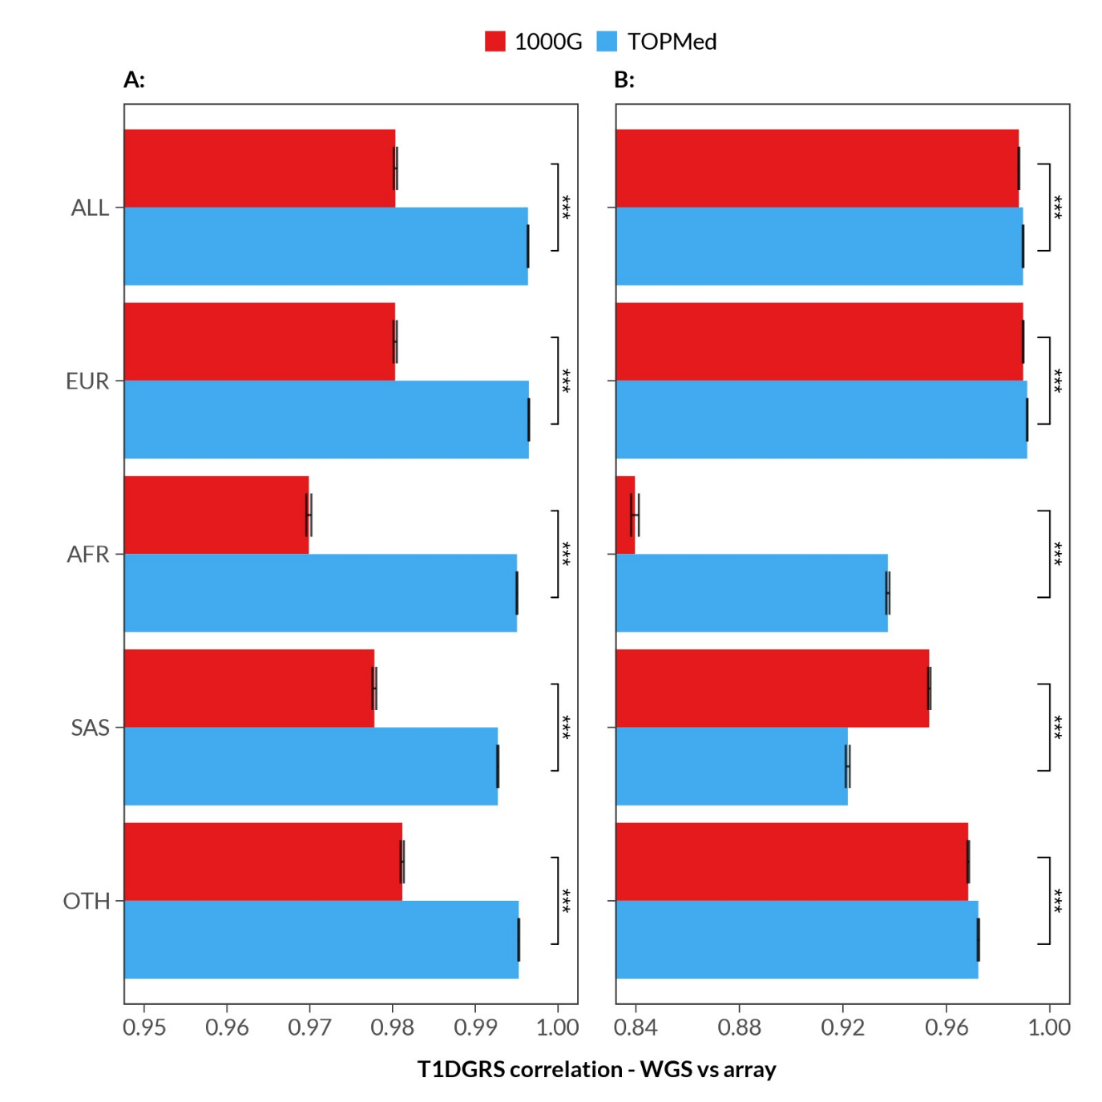
Supplementary Figure 1: Bar plots showing Spearman’s rank correlation between array genotype-derived T1DGRS against WGS-derived T1DGRS stratified by imputation reference panel, split by effect of variants lying in the HLA region (A) and those that are outside it (B). Also denotes whether the differences in correlation between corresponding imputation panel pairs are statistically significant, using the correlation z-test by Meng et al. and the correlation confidence intervals by Zou. ***p < 0.001 from the correlation z-test (by Meng et al.) between imputation panels.

Supplementary Figure 2
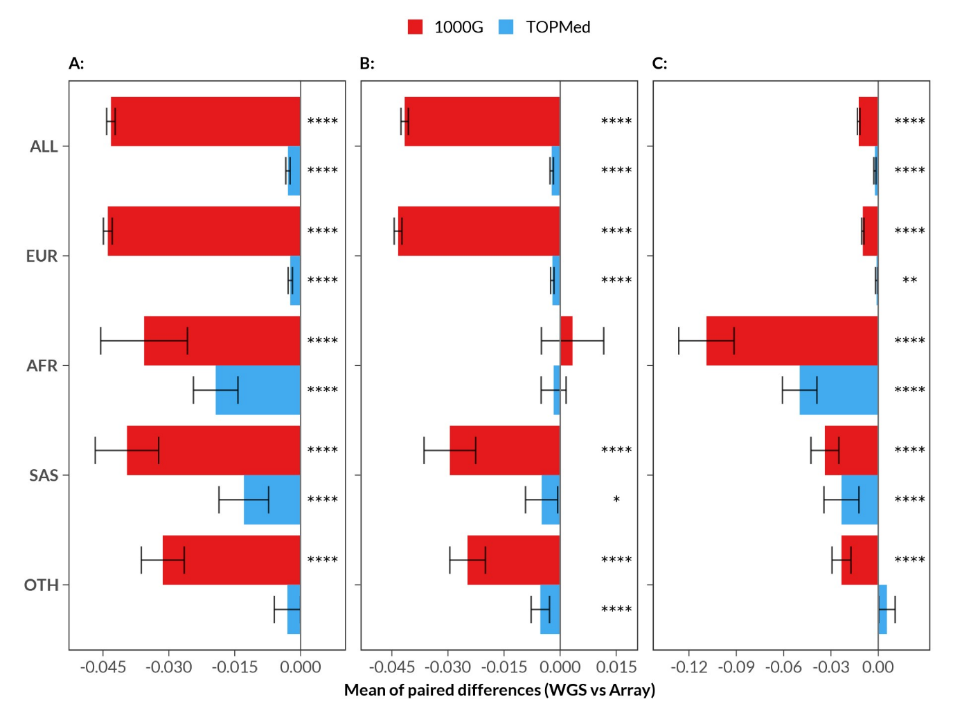
Supplementary Figure 2: Mean difference between WGS-derived T1DGRS and array-derived T1DGRS stratified by genetic ancestry. Bar graph showing mean differences between WGS and array are calculated for the (A) overall score, and also split by the (B) HLA and (C) non-HLA components of the T1DGRS. (EUR/European, n=137,888; AFR/African, n=2,404; SAS/South Asian, n=3,346; OTH/Others, n=5,627). *p < 0.05, **p < 0.01, ***p < 0.001, **p < 0.0001 from the Bonferroni-corrected paired t-test comparisons between WGS vs array GRS.

Supplementary Figure 3
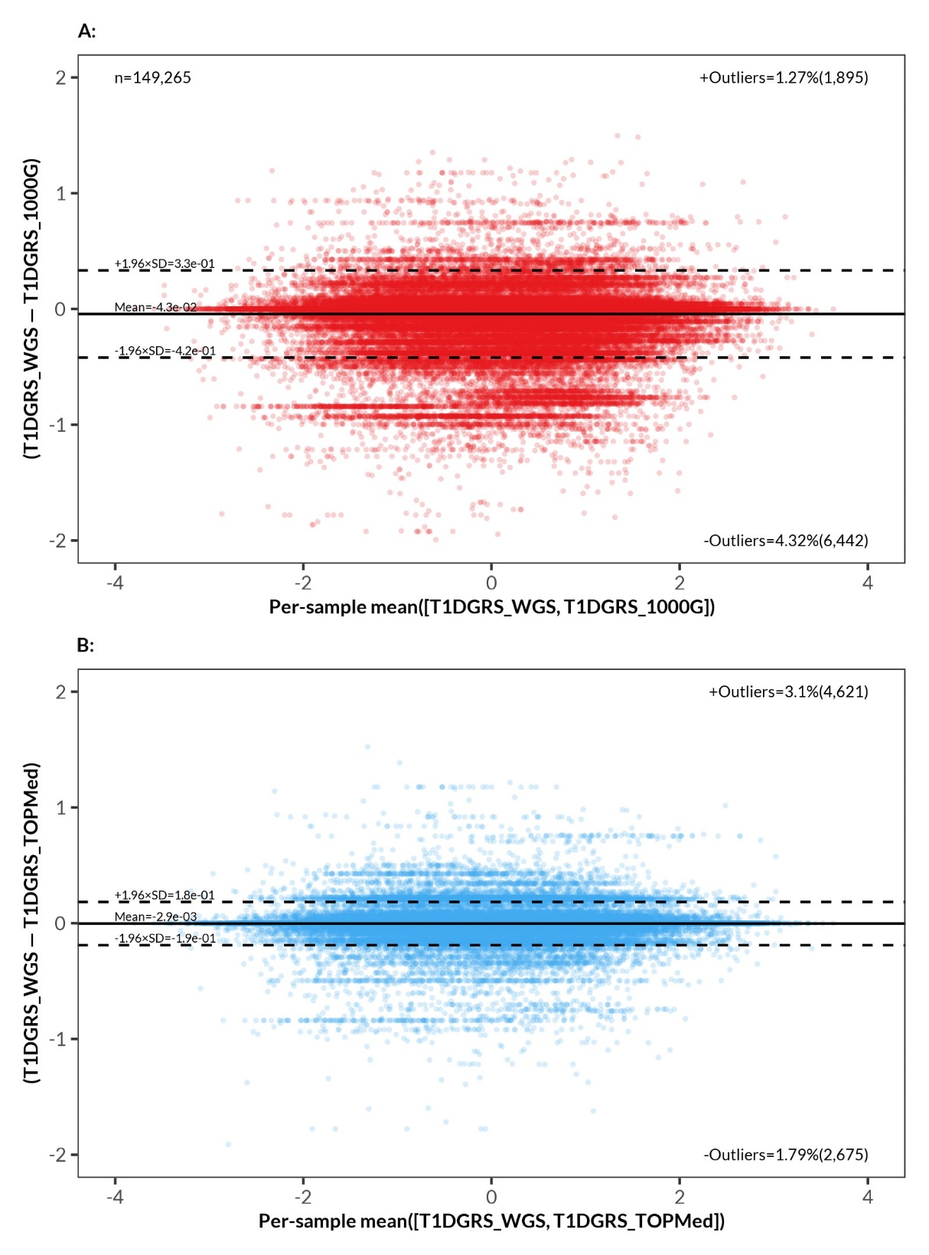
Supplementary Figure 3: Bland-Altman plots showing fixed bias but no proportional bias between (A) WGS-derived v. 1000 Genomes-derived T1DGRS and (B) WGS-derived v. TOPMed-derived T1DGRS, when compared per individual. The x-axis denotes the per-individual WGS v. array mean T1DGRS, and the y-axis denotes their differences. Mean of the differences was found to be ten-fold larger in the 1000 Genomes comparison than in the TOPMed one (against WGS), with larger 95% confidence intervals. However, proportion of outliers seem to be about the same in both imputation panels.

Supplementary Figure 4
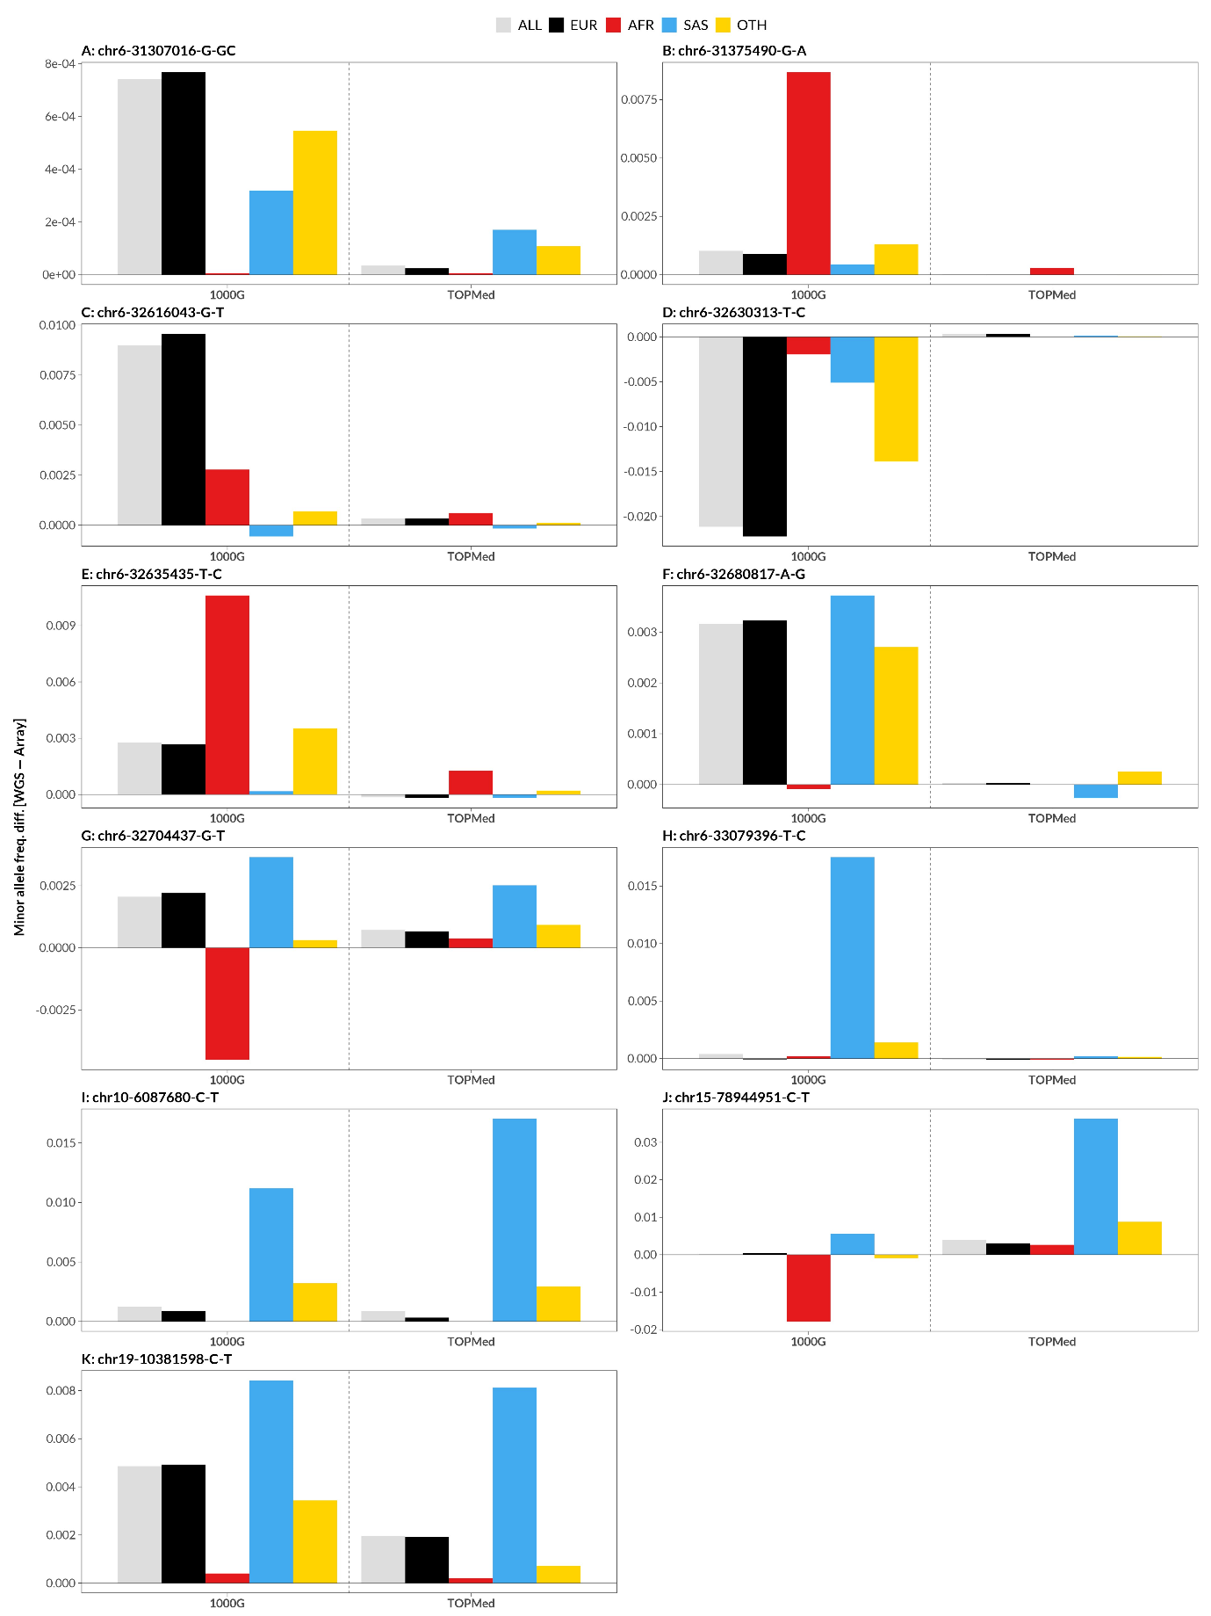
Supplementary Figure 4: Comparison of minor allele frequency differences between variants (GRCh38) in the WGS data and the imputed array genotypes data (WGS-array) that are Bonferroni significant, split by imputation reference panel and stratified by genetic ancestry.

Supplementary Figure 5
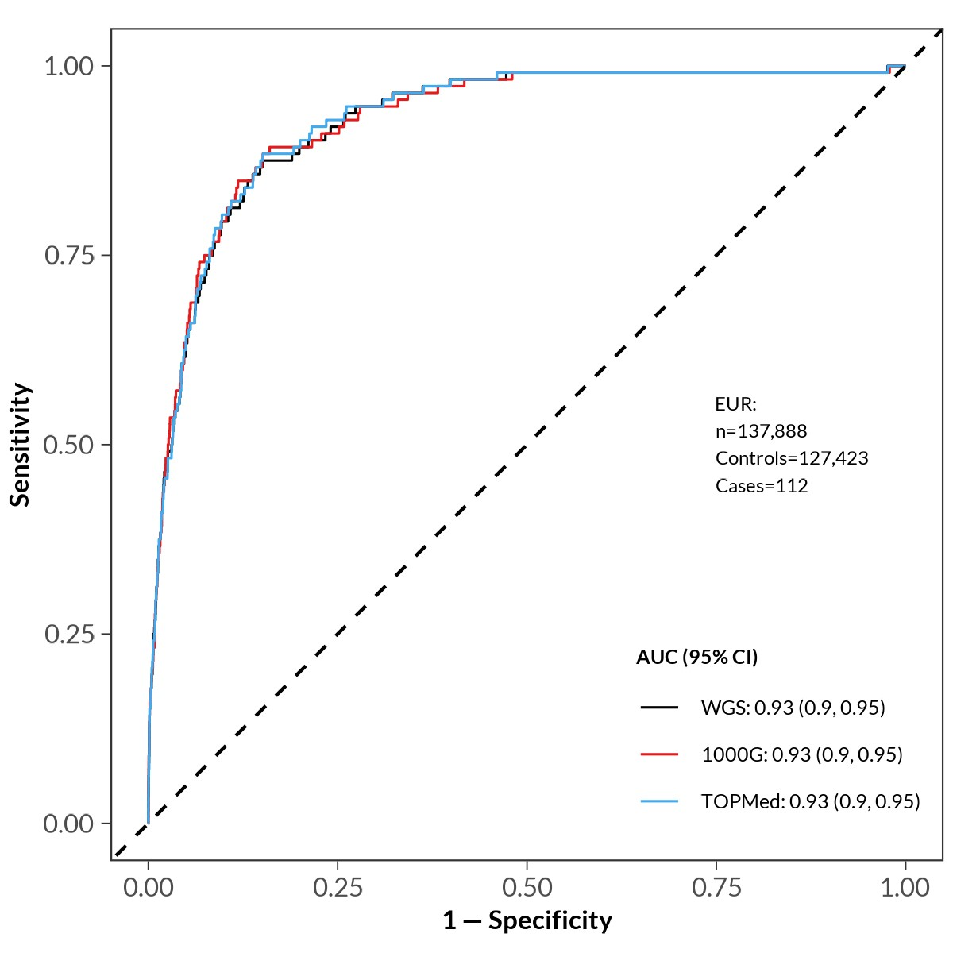
Supplementary Figure 5: Receiver-operator characteristics (ROC) curve analysis to assess the ability of the T1DGRS to discriminate between T1D cases and controls for European individuals (EUR/European, n=137,888), showing nearly identical discrimination across sequencing technologies. The discriminative ability is quantified using the area under the curve (AUC) with 95% confidence intervals, with AUC = 0.5 achieving case/control discrimination equal to a 50% chance and AUC = 1.0 achieving perfect discrimination.

Supplementary Figure 6
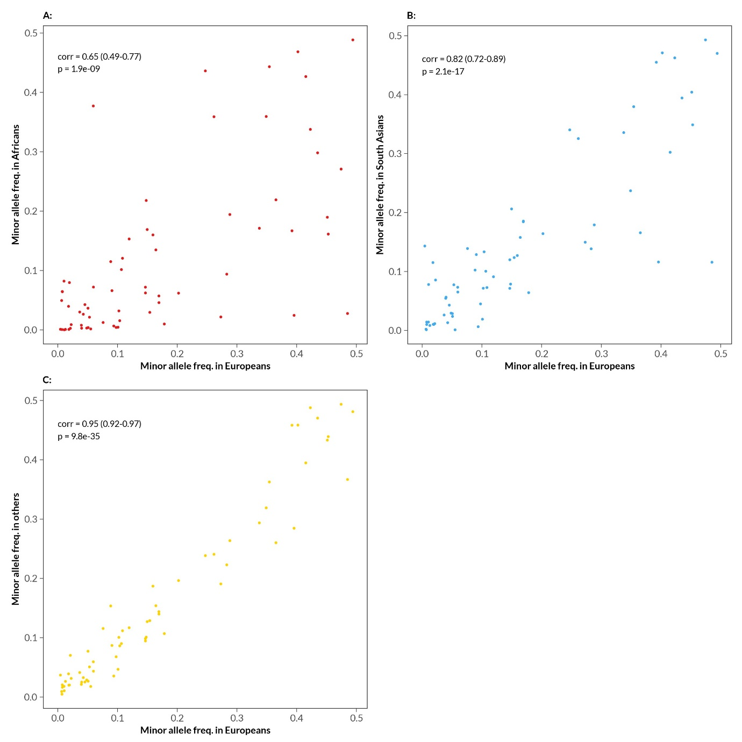
Supplementary Figure 6: Scatter plots showing WGS-derived minor allele frequency comparison between European and (A) African, (B) South Asian and (C) other genetic ancestry individuals for each variant of the T1DGRS (n=67), with their corresponding correlation coefficients, 95% confidence intervals and p-values.

Supplementary Figure 7
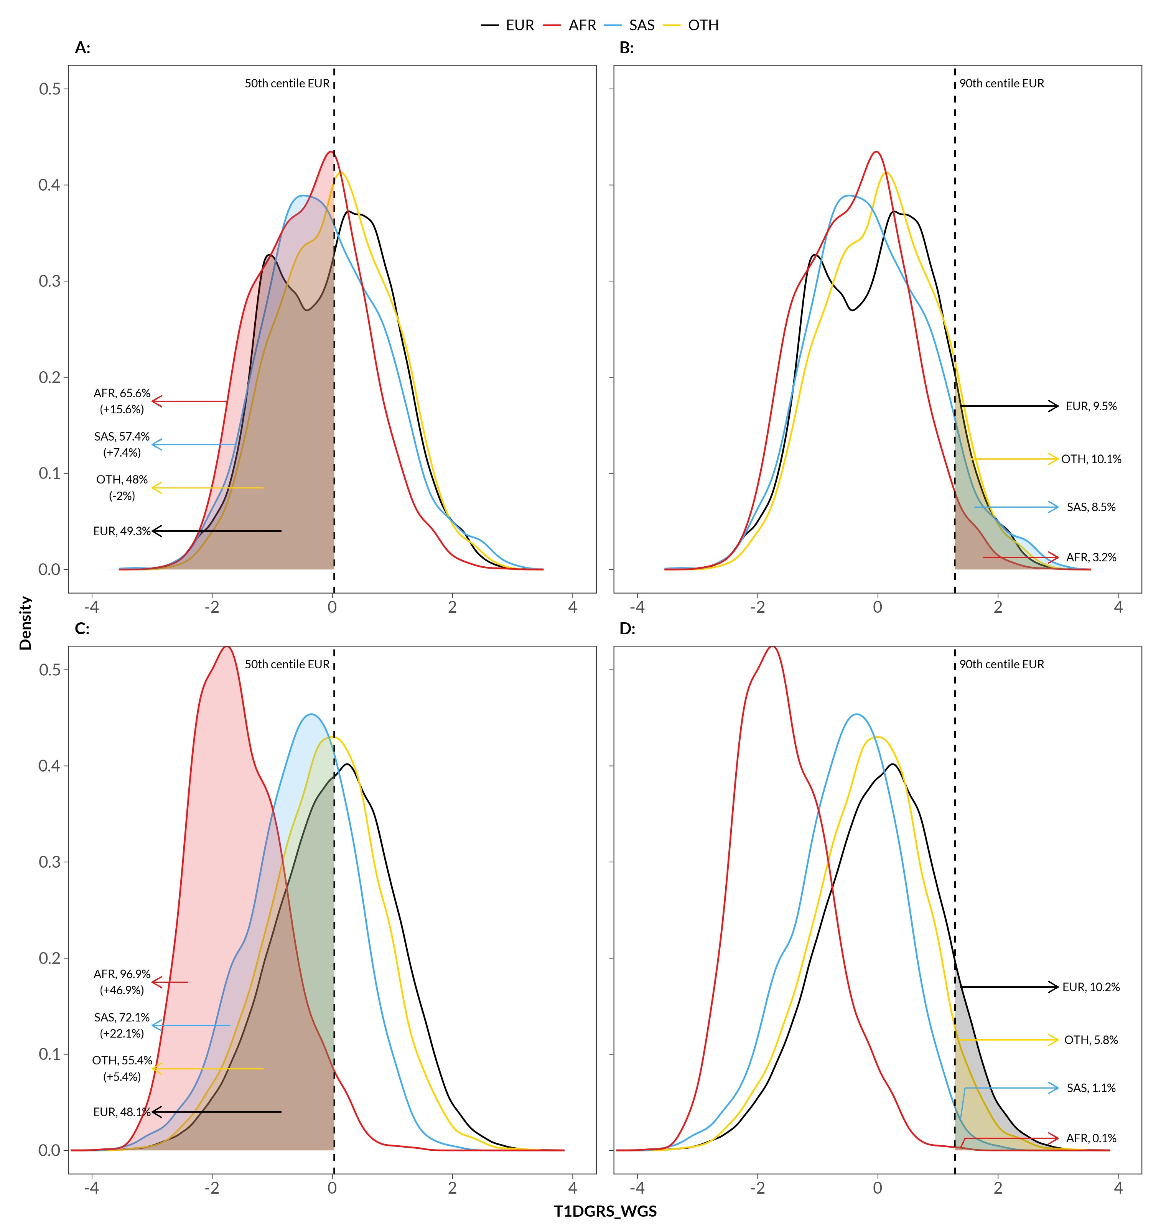
Supplementary Figure 7: Density plots of standardised WGS-derived T1DGRS stratified by genetic ancestry and split by the effect of variants within the HLA region (A and B) and those outside it (C and D) (EUR/European, n=137,888; African/AFR, n=2,404; SAS/South Asian, n=3,346; OTH/Others, n=5,627). Shows clinically relevant risk thresholds (A and C) 50th centile and (B and D) 90th centile used in T1D screening processes, calculated based on the total scores (i.e., not split by HLA or non-HLA components) of the European genetic ancestry individuals, and the proportion of individuals captured by them.

