Supplementary material

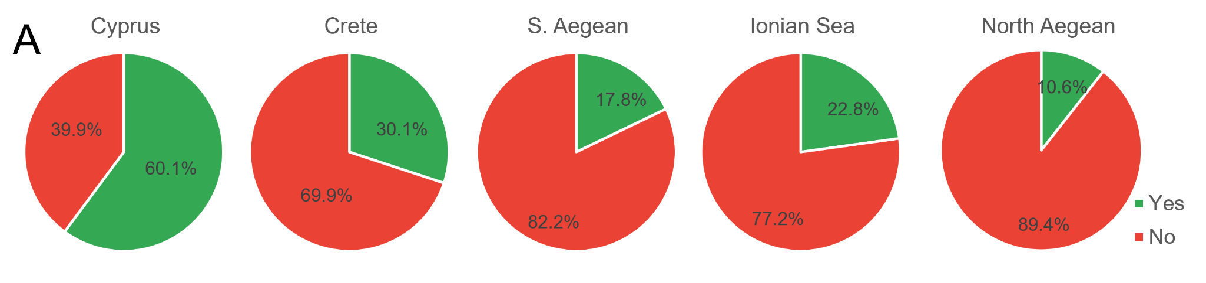
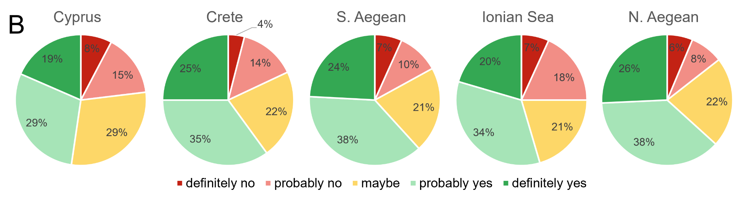
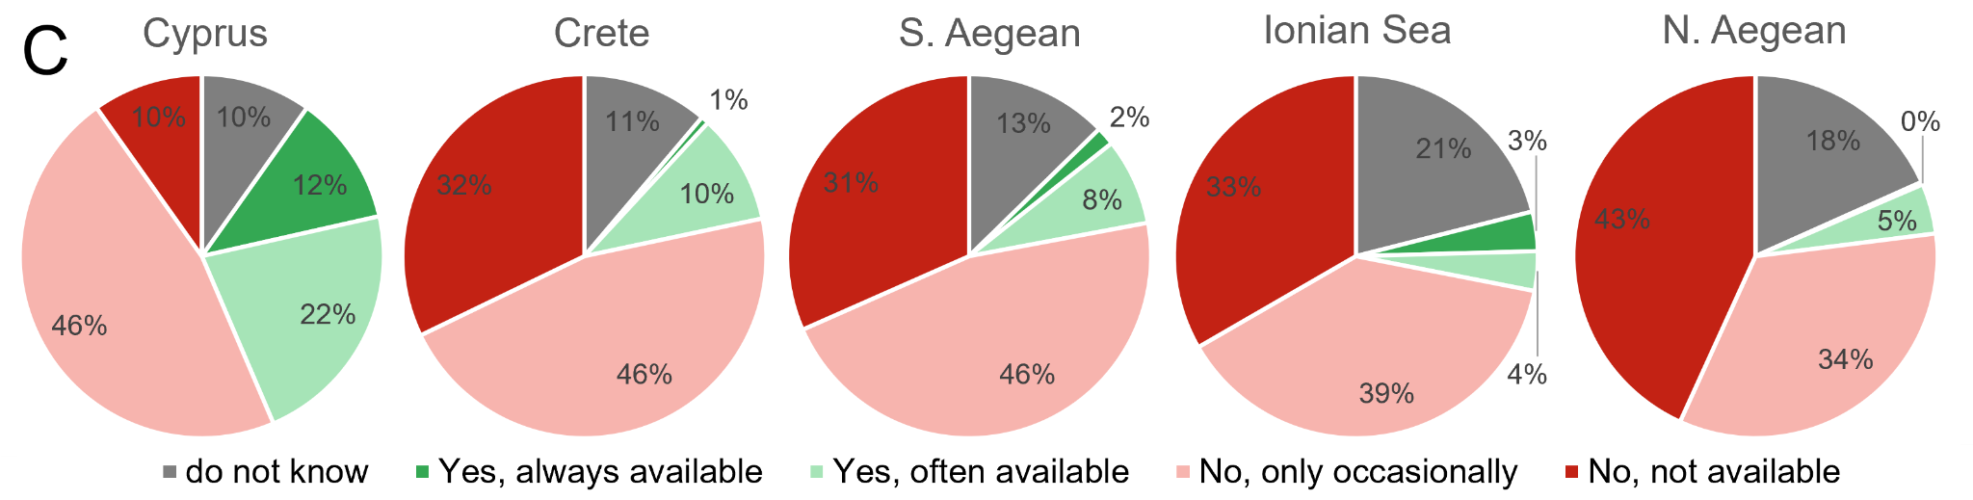
Fig. S1: Questionnaire responses (n=1,333) regarding consuming patterns of rabbitfishes: (A) “Have you ever consumed rabbitfishes?”; (B) If the answer in A is ‘No’, would you try to consume rabbitfishes, being aware that they are considered high-quality fishes?; (C) Is it easy to find rabbitfishes in the market?

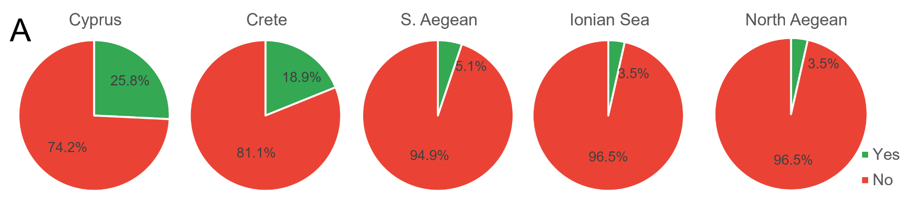
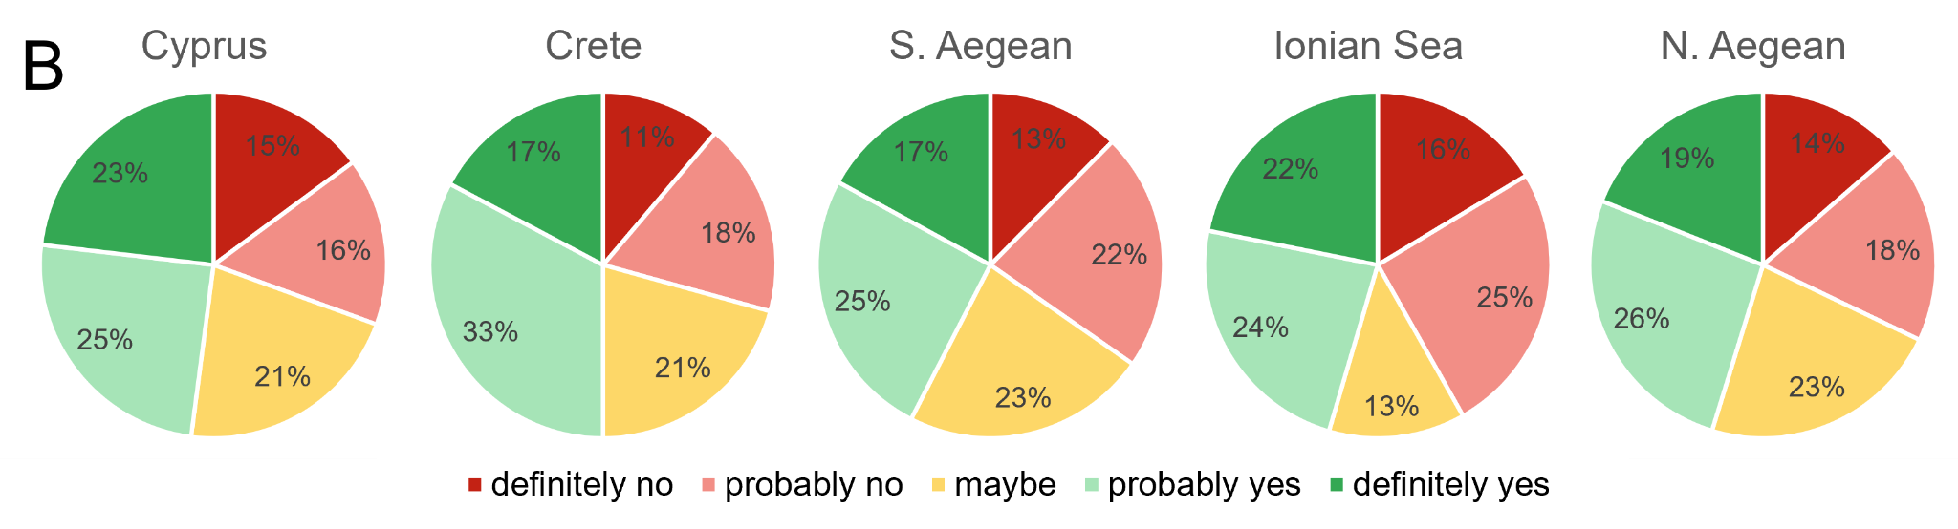
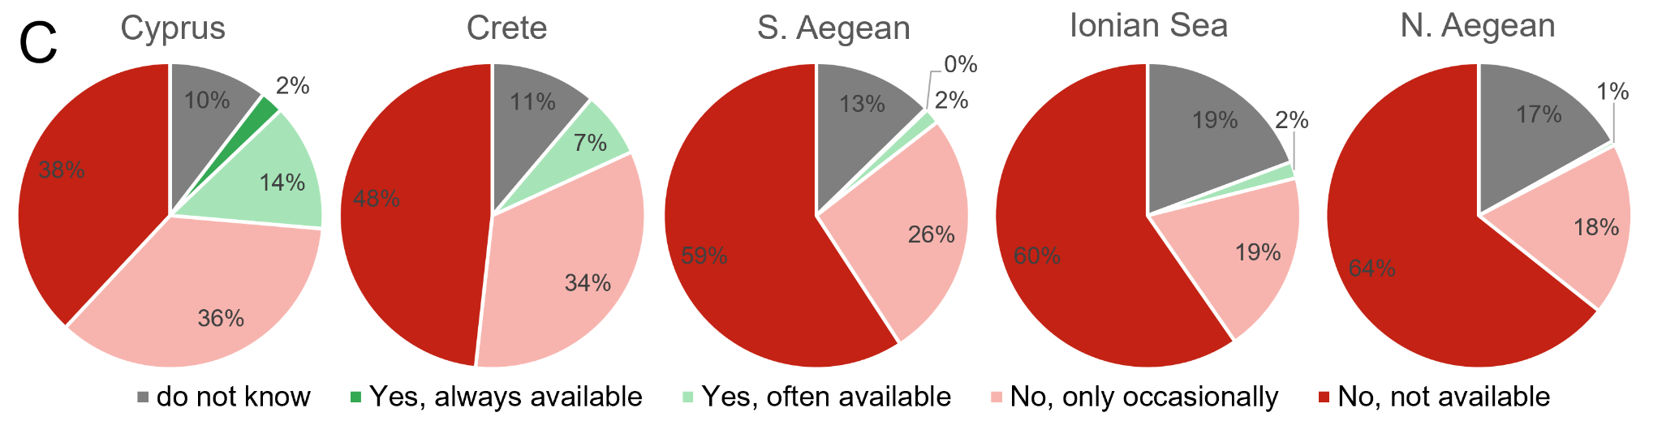
Fig. S2: Questionnaire responses (n=1,333) regarding consuming patterns of lionfish: (A) “Have you ever consumed lionfish?”; (B) If the answer in A is ‘No’, would you try to consume lionfish, being aware that they are considered high-quality fishes?; (C) Is it easy to find lionfish in the market?

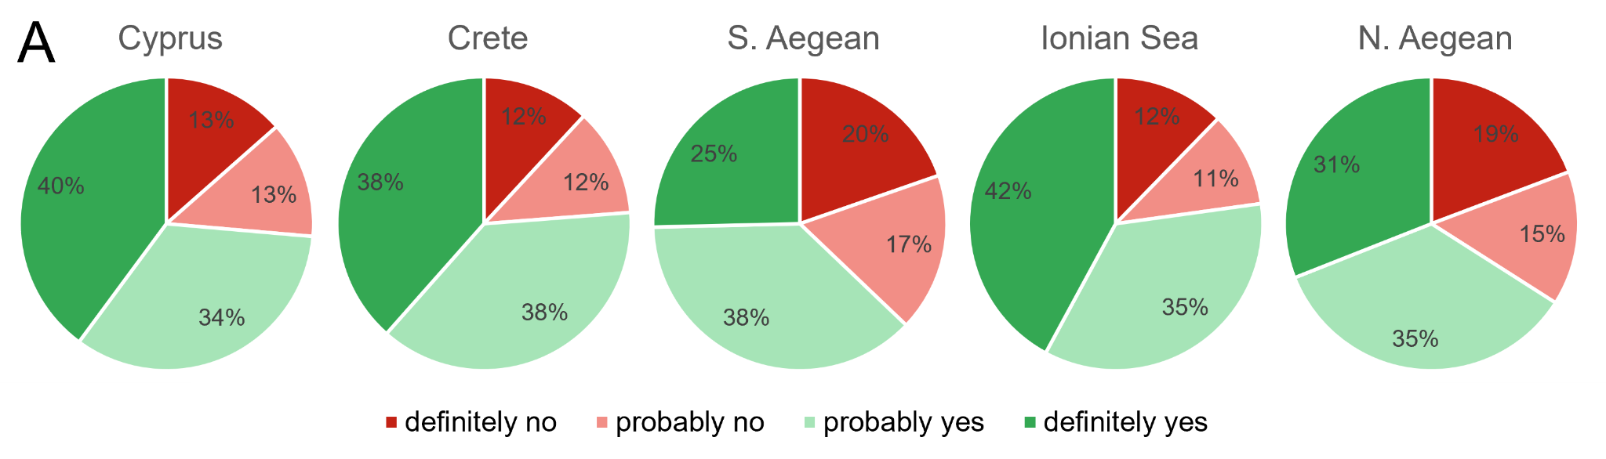
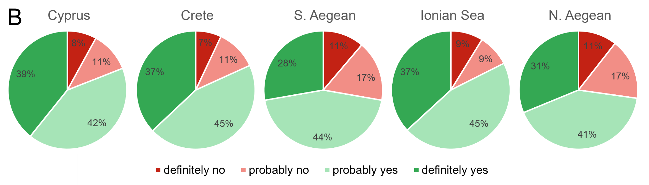
Fig. S3: Questionnaire responses about future consumer behavior regarding alien fish. (A) Considering that consuming invasive alien species could be a means to control their populations and mitigate their impacts, would you consider starting/increasing the consumption of invasive alien species such as rabbitfish and lionfish replacing some of your commonly consumed native fish? (B) If in the future, fish that you used to consume become less available and of higher cost, would you be willing to try new invasive species that may become abundant due to climate change?

