Supplementary material for Modulation of Neural Correlates of Model-based Performance with Impulsivity and Compulsivity

Computational modelling

Following Kool et al.¹, the task involved two stages with three possible states s (stage 1: s_{A}; stage 2: s_{B} or s_{C}), and two possible actions a (a_{A} and a_{B}). All models learn to maximize the value Q (s, a). At a given trial t, states are denoted as s_{1,t} (always s_{A}) and s_{2,t} (s_{B} or s_{C}), actions as a_{1,t} and a_{2,t}, and rewards as r_{1,t} (always equal to zero) and r_{2,t}.

Model-free. MF agents solve the task according to the SARSA(λ) temporal difference learning algorithm ², such that at each stage i and trial t
$Q_{MF}\left(s,a\right)= Q_{MF}\left(s,a\right)+ αδ_{i,t}e_{i,t}(s,a)$.

Here, α denotes the free learning rate parameter (indicating how fast values are updated), δ_{i,t} denotes the reward prediction error, and e_{i,t}(s, a) denotes the free eligibility trace parameter.
As r_{1,t} is always equal to zero, the first-stage reward prediction error depends on the second stage action:
$δ_{1,t}= Q_{MF}\left(s_{2,t},a_{2,t}\right)- Q_{MF}(s_{1,t},a_{1,t})$.

The second-stage reward prediction error depends on r_{2,t}:
$δ_{2,t}= r_{2,t}-Q_{MF}(s_{2,t},a_{2,t})$.

The eligibility trace equals 0 at the beginning of each trial and is updated before the Q value according to

$e_{i,t}\left(s_{i,t},a_{i,t}\right)=e_{i-1,t}\left(s_{i,t},a_{i,t}\right)+1$.

First- and second-stage value updates occurred at the second stage. Here, prediction errors of first-stage values were weighted by the eligibility trace decay (also referred to as λ, which, if equal to zero, indicates that only values of the current stage receive an update) .

Model-based. MB agents extend the model-free algorithm at the first stage by taking into account the transition structure P linking the first and second stages:

$Q_{MB}\left(s_{A},a_{j}\right)=P\left(s_{B} | s_{A},a_{j}\right)\max_{a∈\left\{a_{A},a_{B}\right\}}{Q_{MF}\left(s_{B},a\right)+P\left(s_{C} | s_{A},a_{j}\right)\max_{a∈\left\{a_{A},a_{B}\right\}}{Q_{MF}\left(s_{C},a\right)}}$.

At the second stage, model-free and model-based agents perform equivalent updates, such that Q_{MF} = Q_{MB}.

Hybrid. Hybrid agents arbitrate between the Q values according to a weighting parameter w:

$Q_{net}\left(s_{A},a_{j}\right)=wQ_{MB}\left(s_{A},a_{j}\right)+(1-w)Q_{MF}(s_{A},a_{j})$.

Decision rule. Finally, Q values were subjected to a softmax function to determine choice probabilities:

$P\left(a_{i,t}=a | s_{i,t}\right)=\frac{e^{β(Q_{net}\left(s_{i,t},a\right)+π*rep\left(a\right)+ρ*resp(a))}}{\sum{e^{β(Q_{net}\left(s_{i,t},a^{'}\right)+π*rep\left(a^{'}\right)+ρ*resp(a'))}}}$.

Here, β indicates the stochasticity of behavior, π a choice stickiness parameter (multiplied by rep(a) = 1 if first-stage action a was chosen on the current as well as the previous trial, otherwise zero), and ρ a response stickiness parameter (multiplied by resp(a) = 1 if the first-stage action a involved the same response key on the current as well as the previous trial, otherwise zero). We compared models excluding π and ρ (pure hybrid model), including π (hybrid + choice stickiness model), and including π and ρ (hybrid + choice + response stickiness model).
We performed parameter estimation and model fit with the fmincon algorithm implemented in the mfit toolbox for MATLAB. This minimized the negative log likelihood across trials T, such that the probability of the model’s choices given a set of parameters, P(c_{t} | θ) and those of the participant converged:
$-LL= \sum_{t=1}^{T}{\log{P\left(c_{t}\right|θ)}}$
We used Bayesian Information Criterion (BIC) for model comparison, choosing the model with the lowest BIC mean, i.e. the most parsimonious fit. Starting values for the learning rate α, eligibility trace decay λ, and weighting w were drawn from flat distributions with 0 and 1 as lower and upper bounds. Inverse temperature β received starting values from gamma distribution with shape parameter = 4.82 and scale parameter = 0.88 as well as 0 and 20 as lower and upper bounds. Choice and response stickiness parameters π and ρ were drawn from normal distributions with M±SD = 0.15±1.42 and -20 and 20 as lower and upper bounds.

Fitting results
We first looked at hybrid models, which we expected to show the best fit to behavioral data¹. The pure hybrid model (mean BIC = 983.05) was outperformed by a model including choice stickiness (mean BIC = 929.35). However, adding response stickiness (mean BIC = 929.38) did not improve the model.
The hybrid + choice stickiness model also outperformed a purely model-based model with the choice stickiness parameter (mean BIC = 931.45) and a purely model-free model with the choice stickiness parameter (mean BIC = 978.11). In sum, the hybrid + choice stickiness yielded the most parsimonious solution and became the winning model.
From the winning model, we obtained an inverse temperature of M±SD = 4.88±1.37, a learning rate of M±SD = 0.82±0.18, an eligibility trace decay of M±SD = 0.58±0.39, and a choice stickiness of M±SD = 0.19±0.09.

First-level regression for transition*RPE interaction

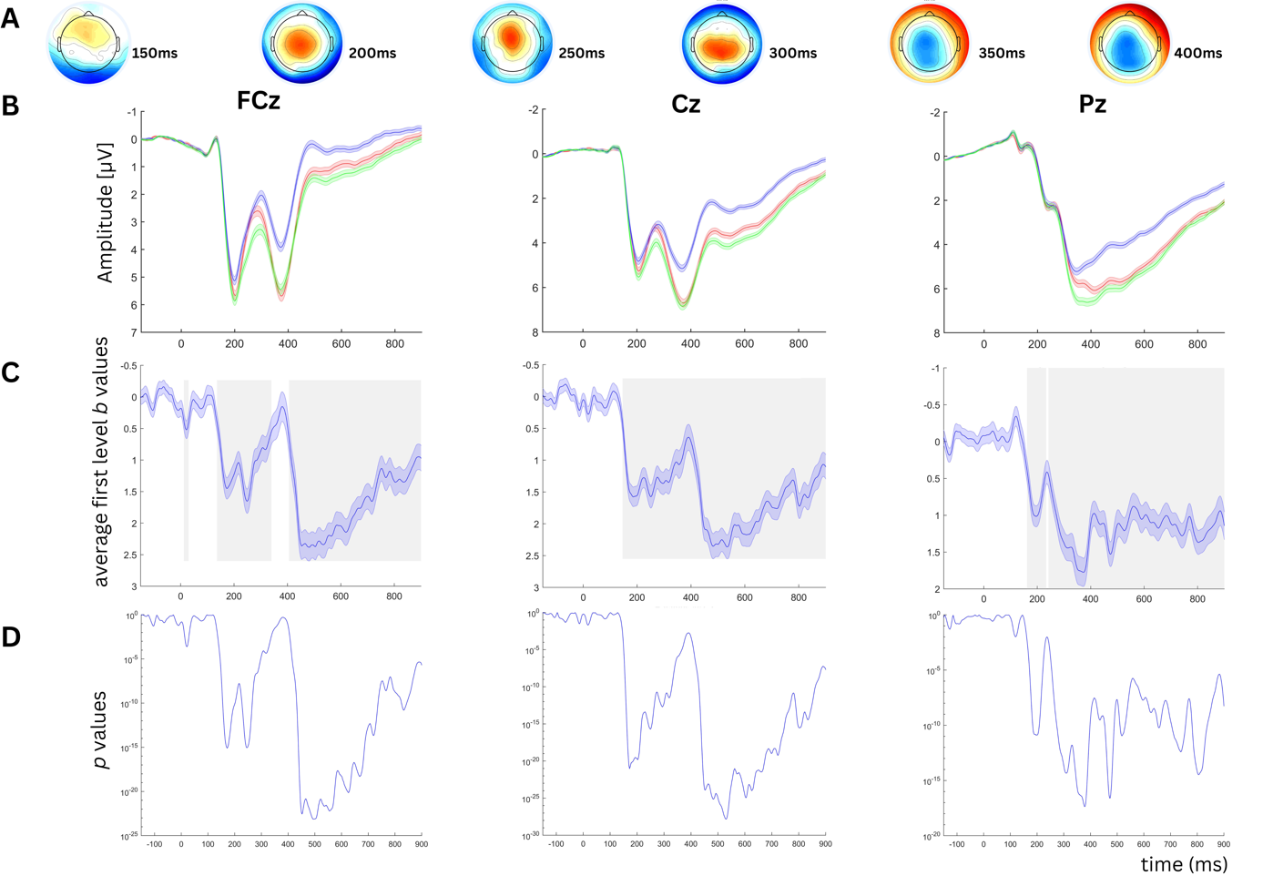
Figure S1. First-level regression for transition*RPE interaction at FCz (left), Cz (middle) and Pz (right). A EEG topography of transition*RPE interaction (150-400 ms). B EEG time course for transition*RPE interaction. C Grand-averaged b values for the transition*RPE regressor. Grey areas are significant after FDR-correction. D Average p-values for the transition*RPE regressor.

Reaction time difference as a marker for MB learning

Table S1. Robust regression on reaction time difference (rare minus common)
 | β | SE | t | p
(Intercept) | 351.63 | 9.39 | 37.44 | <.001
BIS | -8.30 | 9.49 | -.88 | .380
OCI | 1.28 | 9.41 | .14 | .892
BIS*OCI | -7.52 | 9.28 | -.82 | .410
Notes. BIS = z-scored sum score 11th Barratt Impulsiveness Scale. OCI = z-scored sum score Obsessive Compulsive Inventory Revised

Prolonged second-stage reaction times (RT) after rare transitions, indicating surprise, are based on knowledge on the transition structure, i.e. a mental model of the task³. RT difference was thus analyzed as a marker for MB learning. Regression analysis revealed neither main, nor interaction effects with impulsivity or compulsivity.

References

1 Kool W, Cushman FA, Gershman SJ. When Does Model-Based Control Pay Off? Plos Comput Biol 2016; 12: e1005090.
2 Rummery G, Niranjan M. On-line Q-learning using connectionist systems. Engineering Department, Cambridge University, 1994.
3 Seow TXF, Benoit E, Dempsey C, Jennings M, Maxwell A, O’Connell R et al. Model-Based Planning Deficits in Compulsivity Are Linked to Faulty Neural Representations of Task Structure. J Neurosci 2021; 41: 6539–6550.

