Table S1. Predicted KEGG functional pathway differences at level 2 inferred from 16S rRNA gene sequences using PICRUSt after short-term 2’-FL supplementation

KO functional categories
Level 1 | Level 2 | Con mean (SD) | 2'-FL mean (SD) | P value
Biosynthesis | Amino Acid Biosynthesis | 35771.54(2517.14) | 39089.25(2106.5) | 0.018146
Biosynthesis | Fatty Acid and Lipid Biosynthesis | 14383.25(452.77) | 15748.7(1359.51) | 0.024445
Biosynthesis | Metabolic Regulator Biosynthesis | 100.54(53.14) | 43.54(44.08) | 0.046446
Biosynthesis | Other Biosynthesis | 125.11(47.12) | 302.74(157.65) | 0.012693
Degradation/Utilization/Assimilation | Alcohol Degradation | 111.15(39.93) | 48.82(20.49) | 0.002501
Degradation/Utilization/Assimilation | Carboxylate Degradation | 8381.1(377.35) | 7374.37(684.71) | 0.004254
Degradation/Utilization/Assimilation | Polymeric Compound Degradation | 3181.52(386.43) | 3611.31(305.83) | 0.036829
Generation of Precursor Metabolite and Energy | Glycolysis | 5702.97(251.15) | 5289.18(409.61) | 0.038903
Generation of Precursor Metabolite and Energy | Pentose Phosphate Pathways | 3443.26(153.94) | 3220.02(185.09) | 0.027856
Generation of Precursor Metabolite and Energy | Superpathway of glycolysis and Entner-Doudoroff | 747.25(235.9) | 460.49(143.01) | 0.015637
Glycan Pathways | Glycan Biosynthesis | 1540.99(150.92) | 1693.64(88.43) | 0.036727

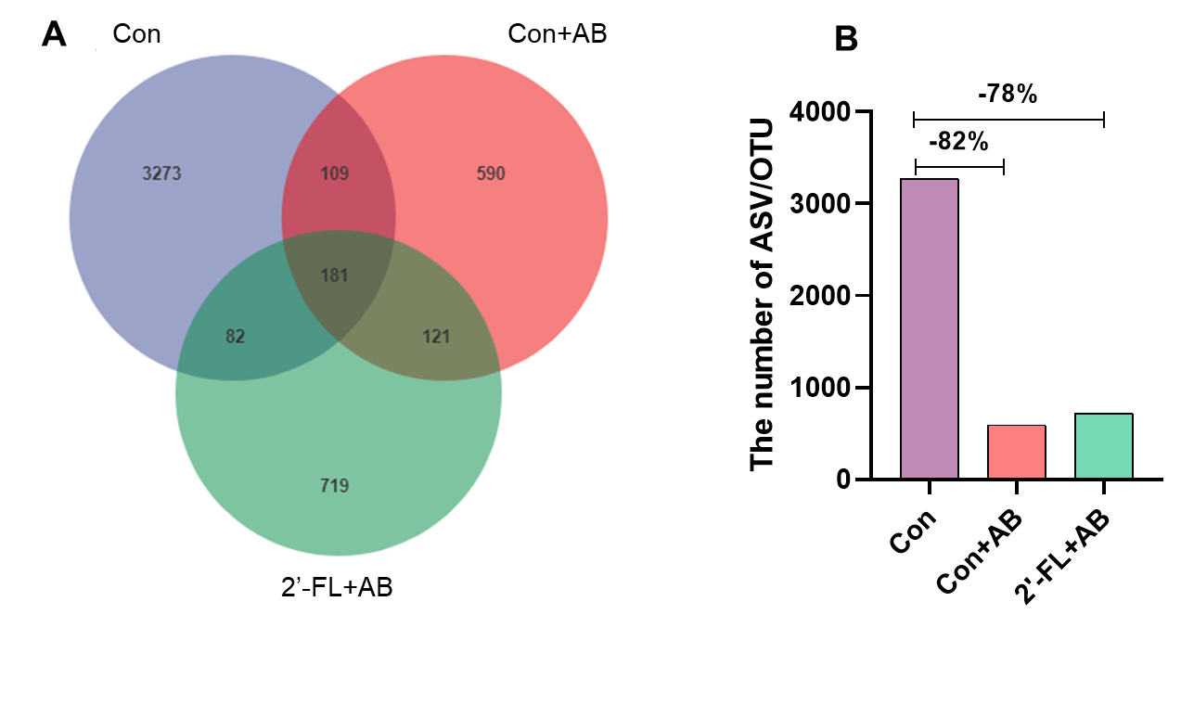Figure S1. Antibiotics significantly reduced the abundance of gut microbiota in 2’- FL +AB group mice. A. Venn diagram. The OTUs are shared among different groups; B. The number of ASV/OUT in different groups.

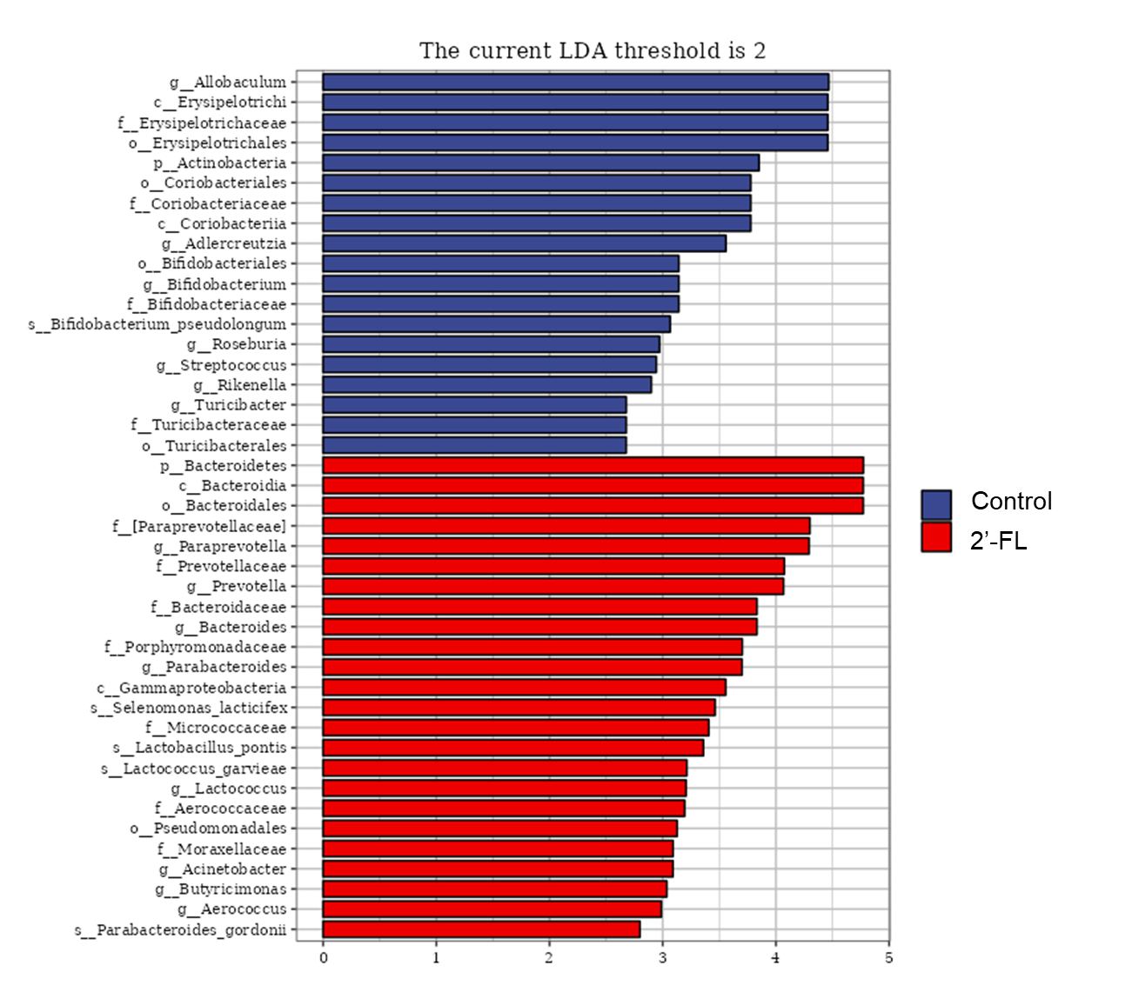
Figure S2. LEfSe analysis of long-term 2’-FL treatment. LDA> 2 is considered to be the biomarker of the group.

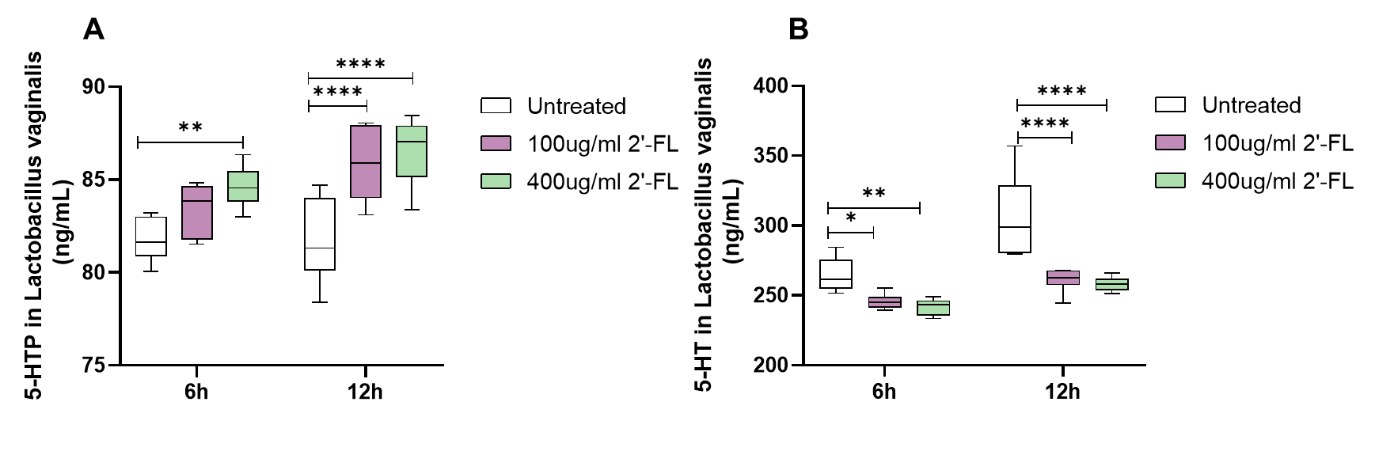
Figure S3. 2FL significantly affects the 5-HT synthesis pathway of Lactobacillus vaginalis in vitro. A. The levels of 5-HTP in the gut microbiota cultures in vitro after incubation with 2’-FL (100 or 400 mg/mL) for 6 and 12 h. B. The levels of 5-HT in the gut microbiota cultures in vitro after incubation with 2’-FL (100 or 400 mg/mL) for 6 and 12 h.

