SUPPLEMENTAL DIGITAL CONTENT
Chest CT indices | Description | Formula
Haller index (HI) | The ratio of the widest transverse distance (TD) of the inside of the chest cage to the shortest sternal-vertebral distance (SVD) | TD/SVD
Correction index (CI) | sternum sinking distance (C-SVD) normalized by largest anterior chest wall-vertebral distance (C) | (C-SVD / C) x100 %
Asymmetry index (AI) | The ratio of the right (R) and left (L) vertical height of inner chest cage multiplied by 100 | (R/L) ×100  When  >1, right asymmetric  =1, symmetric  <1, left asymmetric
Flatness index (FI) | Transverse distance (TD) divided by anterior-posterior distance (APd) chest cage (right or left, choose longer one) | TD/max (R; L) APd
Illustration

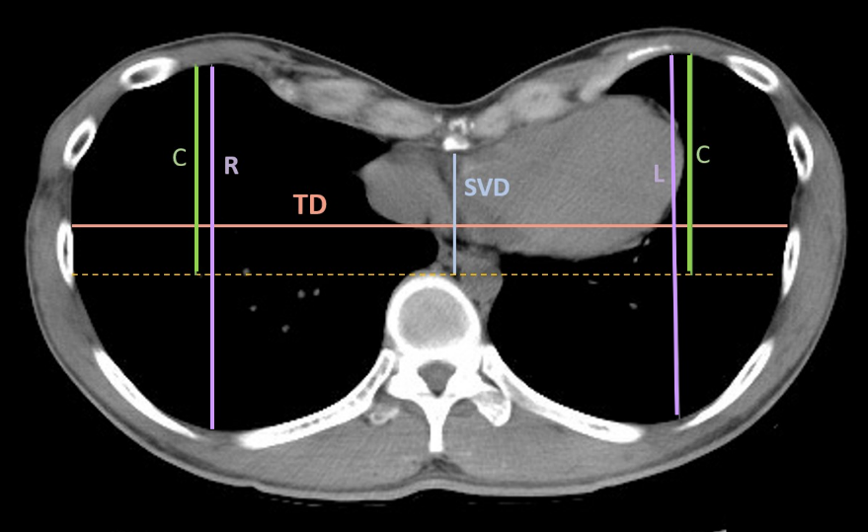
TD: transverse distance
SVD: sternal-vertebral distance
R: maximum right hemithorax
anterior-posterior distance
L: maximum left hemithorax
anterior-posterior distance
C: max (R; L)- vertebral
distance

