Supplementary Information
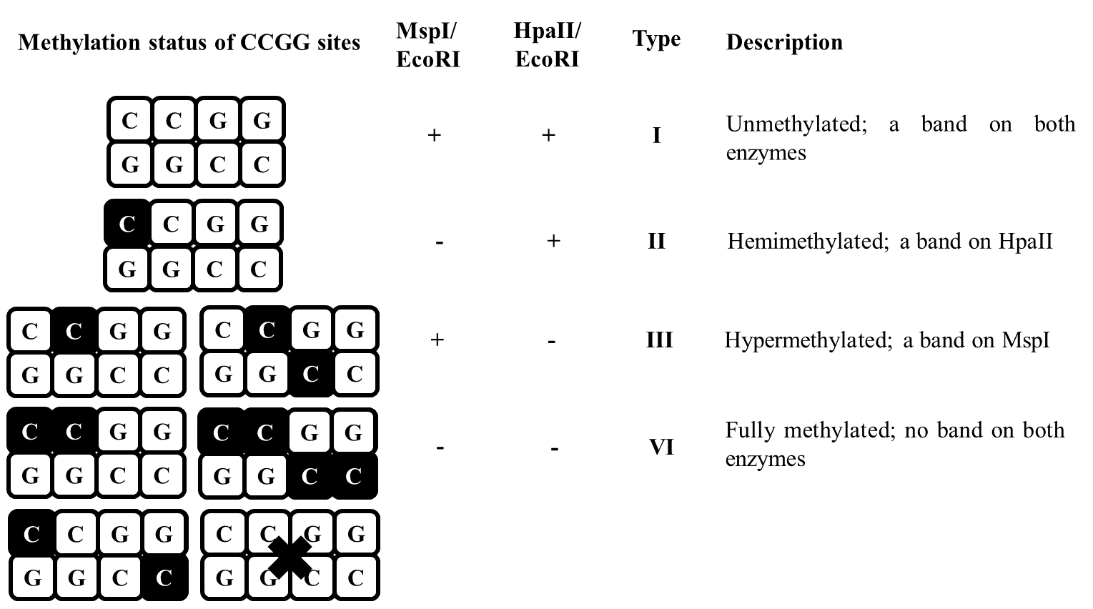
Figure S1 MSAP band patterns established by using HpaII/EcoRI and MspI/EcoRI and the correspondence methylation status of CCGG sites. Black squares denote methylated cytosines and +/− whether a sequence was cut/not cut or a band was/was not present.

Table S1 List of DNA methylases and demethylases primers used for the RT-qPCR.
 | Q. ilex gene | Primer sequence (5' 3') | Size (bp)
DNA methyltransferase
QiMET1 | Gene-16946 | GTTGTTTGGCAGGTTGGATT | 134
QiMET1 |  | GAGAACGAGCACATTCACGA | 134
QiCMT1 | Gene-6353 | CCTAGGTGGGCTGTTGACAT | 126
QiCMT1 |  | CAGCTTTGTCCATGCTTTCA | 126
QiCMT2 | Gene-37003 | AATGCAATGTGAGGTGGTCA | 116
QiCMT2 |  | TTTCGGACTTTCCCAAACTG | 116
QiCMT3 | Gene-7580 | CTCCCCAGACAGAGTTCCAG | 117
QiCMT3 |  | TATTCAATGCCAATGGACGA | 117
QiDNMT2 | Gene-33301 | GCTAATGAAGGCGGGTGTAA | 101
QiDNMT2 |  | GATAGGGACGGTGACCAAAA | 101
QiDRM2 | Gene-35436 | TCTCAACGCATCTCTTGTGG | 104
QiDRM2 |  | GCTTAGGCCTTGGCTTTTCT | 104
QiDRM3 | Gene-4322 | TGCAATCGATAAGCTTGGTG | 103
QiDRM3 |  | CTTCATCCCCCTGAGCTGTA | 103
DNA demethylases
QiDME | Gene-23797 | TCCCAGATTCCTCAGAATGG | 111
QiDME |  | GAACTGGAGGGTGTCGGTAA | 111
QiROS1 | Gene-31205 | CGTGAAGCAAATTCCCAGAT | 118
QiROS1 |  | GGTCGGCAAATACCTCGTTA | 118

Table S2 List of primers used. ECO denotes digestion with EcoRI and HM digestion with HpaII or MspI.
Primer | Primer sequence (5’ 3’)
ECO_adaptor I | CTCGTAGACTGCGTACC
ECO_adaptor II | AATTGGTACGCAGTCTAC
HM_adaptor I | GATCATGAGTCCTGCT
HM_adaptor II | CGAGCAGGACTCATGA
Pre-Selective PCR
Pre_ECO | GACTGCGTACCAATTCA
Pre_HM | ATCATGAGTCCTGCTCGG
Selective PCR
ECO_ACG | GACTGCGTACCAATTCACG
ECO_ACC | GACTGCGTACCAATTCACC
HM_TTA | ATCATGAGTCCTGCTCGGTTA
HM_TCG | ATCATGAGTCCTGCTCGGTCG

Table S3 Gene ontology classification of DNA methyltransferases and demethylases in holm oak.
 |  | Enzyme name | Enzyme abbreviation | Biological  process | Molecular  function | Cellular component
DNA methyltransferase | Maintenance | METHYLTRANSFERASE 1 | MET1 | DNA methylation | Methyltransferase activity | Nucleus
DNA methyltransferase | Maintenance | CHROMOMETHYLASE 1 | CMT1 | Maintenance of DNA methylation | DNA (cytosine-5-)-methyltransferase activity | Nucleus
DNA methyltransferase | Maintenance | CHROMOMETHYLASE 2 | CMT2 | DNA methylation on cytosine within a CHH sequence | DNA (cytosine-5-)-methyltransferase activity | Nucleus
 |  |  |  | DNA methylation on cytosine within a CHH sequence | DNA (cytosine-5-)-methyltransferase activity | Nucleus
 |  |  |  | DNA methylation on cytosine within a CHH sequence | DNA (cytosine-5-)-methyltransferase activity | Nucleus
DNA methyltransferase | Maintenance | CHROMOMETHYLASE 3 | CMT3 | DNA methylation on cytosine within a CNG sequence | DNA (cytosine-5-)-methyltransferase activity | Nucleus
 |  |  |  | DNA methylation on cytosine within a CNG sequence | DNA (cytosine-5-)-methyltransferase activity | Nucleus
DNA methyltransferase | Maintenance | DNA METHYLTRANSFERASE HOMOLOG 2 | DNMT2 | Methylation | Methyltransferase activity | Nucleus
DNA methyltransferase | De novo | DOMAINS REARRANGED METHYLTRANSFERASE 2 | DRM2 | DNA methylation | DNA (cytosine-5-)-methyltransferase activity | Nucleus
 |  |  |  | DNA methylation | DNA (cytosine-5-)-methyltransferase activity | Nucleus
DNA methyltransferase | De novo | DOMAINS REARRANGED METHYLTRANSFERASE-like | DRM2-like | DNA binding | DNA (cytosine-5-)-methyltransferase activity | Nucleus
 |  |  |  | DNA binding | DNA (cytosine-5-)-methyltransferase activity | Nucleus
DNA methyltransferase | De novo | DOMAINS REARRANGED METHYLTRANSFERASE 3 | DRM3 | DNA demethylation | Methyltransferase activity | Nucleus
DNA demethylases |  | DEMETER | DME | DNA demethylation | DNA demethylase activity | Nucleus
 |  | DEMETER-LIKE | DML-like | DNA demethylation | DNA demethylase activity | Nucleus
 |  | REPRESSOR OF SILENCING 1 | ROS1 | DNA demethylation | DNA demethylase activity | Nucleus
Table S4 Percent identity in DNA methyltransferase and demethylase protein sequences between Q. ilex and Q. lobata, Q. robur, Q. suber and Q. variabilis.
Enzyme abbrev | Q. ilex | Q. lobata | Identity | Q. robur | Identity | Q. suber * | Identity | Q. variabilis | Identity
MET1 | gene-16946 (Chr10) | LOC115963274 (Chr10) | 97.7 | LOC126701416 (Chr10) | 98.0 | LOC111984282 | 98.2 | GWHGBQTN062546 (Chr10) | 98.2
CMT1 | gene-6353 (Chr6) | LOC115950848 (Chr6) | 91.9 | LOC126690475 (Chr6) | 91.9 | LOC112002245 | 92.8 | GWHGBQTN043181 (Chr6) | 92.8
CMT2 | gene-37003 (Chr12) | LOC115971602 (Chr12) | 77.5 | LOC126708627 (Chr12) | 92.1 | LOC112001521 | 93.6 | GWHGBQTN074494 (Chr12) | 93.6
CMT2 | gene-37004 (Chr12) | LOC115971602 (Chr12) | 90.0 | LOC126708627 (Chr12) | 90.2 | LOC112001521 | 93.1 | GWHGBQTN072108 (Chr12) | 91.5
CMT2 | gene-37005 (Chr12) | LOC115971602 (Chr12) | 97.9 | LOC126708627 (Chr12) | 98.5 | LOC112001522 | 97.9 | GWHGBQTN072108 (Chr12) | 97.4
CMT3 | gene-7580 (Chr1) | LOC115978052 (Chr1) | 96.7 | LOC126720423(Chr1) | 96.7 | LOC112031183 | 97.7 | GWHGBQTN000780 (Chr1) | 97.3
CMT3 | gene-19767 (Chr5) | LOC115978052 (Chr1) | 54.6 | LOC126720423(Chr1) | 54.6 | LOC112034635 | 54.1 | GWHGBQTN000780 (Chr1) | 55.7
DNMT2 | gene-33301 (Chr2) | LOC115974994 (Chr2) | 97.8 | LOC126712974 (Chr2) | 98.1 | LOC112003961 | 98.3 | GWHGBQTN011922 (Chr2) | 98.3
DRM2 | gene-35436 (Chr2) | LOC115976632 (Chr2) | 99.7 | LOC126714848 (Chr2) | 99.3 | LOC111996565 | 99.5 | GWHGBQTN014068 (Chr2) | 99.3
DRM2 | gene-19781 (Chr5) | LOC115976632 (Chr2) | 76.9 | LOC126714848 (Chr2) | 76.6 | LOC111996565 | 77.2 | GWHGBQTN014068 (Chr2) | 75.3
DRM2-like | gene-6758 (Chr0) | LOC115978847 (Chr3) | 96.5 | LOC126718475 (Chr3) | 96.7 | LOC112033986 | 96.4 | GWHGBQTN018159 (Chr3) | 95.2
DRM2-like | gene-28358 (Chr3) | LOC115978847 (Chr3) | 97.5 | LOC126718475 (Chr3) | 98.0 | LOC112033986 | 97.7 | GWHGBQTN018159 (Chr3) | 98.2
DRM3 | gene-4322 (Chr6) | LOC115994898 (Chr6) | 97.3 | LOC126688831 (Chr6) | 96.9 | LOC112025925 | 97.7 | GWHGBQTN038272 (Chr6) | 97.9
DME | gene-23797 (Chr4) | LOC115986551 (Chr4) | 97.1 | LOC126722918 (Chr4) | 96.7 | LOC111983111 | 97.4 | GWHGBQTN023678 (Chr4) | 96.9
DML-like | gene-25932 (Chr3) | LOC115981714 (Chr3) | 97.0 | OW028767.1 (Chr3) | 80.5 | LOC112020085 | 97.6 | GWHGBQTN016268 (Chr3) | 96.6
ROS1 | gene-31205 (Chr7) | LOC115952978 (Chr7) | 98.4 | LOC126692047 (Chr7) | 98.2 | LOC112039671 | 98.5 | GWHGBQTN045215 (Chr7) | 97.9
The accession numbers of Q. lobata, Q. robur, and Q. suber were from NCBI. Identity in percentage. *Q. suber assembled in scaffolds
Table S5 Global DNA patterns and levels for holm oak adults, embryos and seedlings.
MSAP band type | Adult | Embryos | Seedlings
I (unmethylated) | 103 | 101 | 110
II (hemimethylated) | 13 | 8 | 3
III (hypermethylated) | 27 | 14 | 19
IV (fully methylated) | 28 | 48 | 39
Total amplified fragments | 171 | 171 | 171
Full methylated fragments (%)¹ | 32.16 | 36.26 | 33.92
Hemimethylated fragments (%)² | 7.60 | 4.68 | 1.75
Total methylated fragments (%)³ | 39.77 | 40.94 | 35.67
The percentage of polymorphic MSAP, fully methylated and hemimethylated fragments as well as total methylation were estimated using the formulas described by Abid et al., (2017): ¹ Fully methylated fragments (%) = [(III + IV)/(I + II + III + IV)] × 100; ² Hemimethylated fragments (%) = [(II)/(I + II + III + IV)] × 100; ³ Total methylation (%) = [(II + III + IV)/(I + II + III + IV)] × 100.

Table S6 List of genomic sequences identified in holm oak adults, embryos and seedlings including methylation type (I, II, III and IV denote non-methylated, hemimethylated, hypermethylated and fully methylated genes, respectively). A GO analysis (biological process, molecular function and cellular component) was done with the nuclear genes.
Attached Excel document.

