Supplementary material

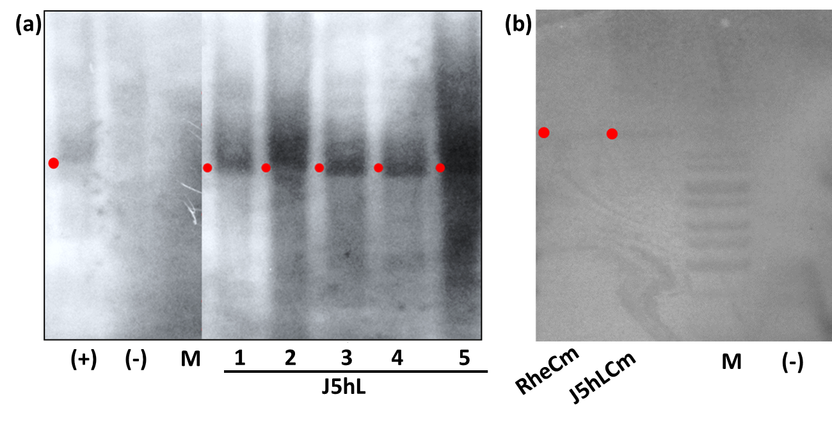
Figure S1. Southern blot of DNA from transgenic plants. a J5hL DNA digested with BamHI and hybridized with the PCR-DIG-labeled NFP probe. b RheCm and J5hLCm DNA digested with BamHI and hybridized with the PCR-DIG-labeled Cameleon probe.

Figure S2. YFP fluorescence in J5hLCm seedlings by shining Dual Fluorescent Protein.

Figure S3. a seeds kept on media for germination. b seedling germinated on media. c customized hole microslide. d Slide temporarily sealed with cover glass to hole the imaging solution and seedling and agarose block to hold the roots. E Image taken under scanning confocal microscope.

Figure S4. Ca²⁺ flux in region of interest (ROI) 1 and Ca²⁺ oscillation in ROI 2 of trichoblast cell. a J5hLCm root hair and b RheCm root hair. Images with false color showing change Ca²⁺ concentration at different time with different inoculum. Scale bar 10 µm.

Figure S5. Calculation graph of Ca²⁺ spiking in transgenic rice plants trichoblast cell: J5hLCm (a – d) and RheCm (e – h). Comparative analysis of normalized ratio values corresponding flux and Ca²⁺ oscillation over time in ROI 1 and ROI 2 for ReNF (a, b, e and f) and for pentaose (c, d, g and h) treatment. (n=3 biological replicates).

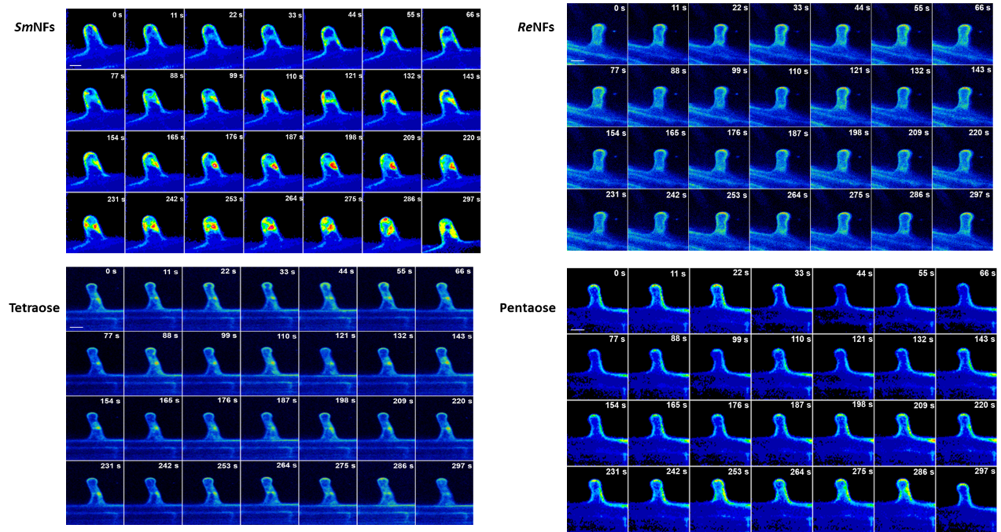
Figure S6. Time series of trichoblast cell of J5hLCm plant roots treated with different NFs (SmNF and ReNF) and COs (tetraose and pentaose). Scale bar 10 µm

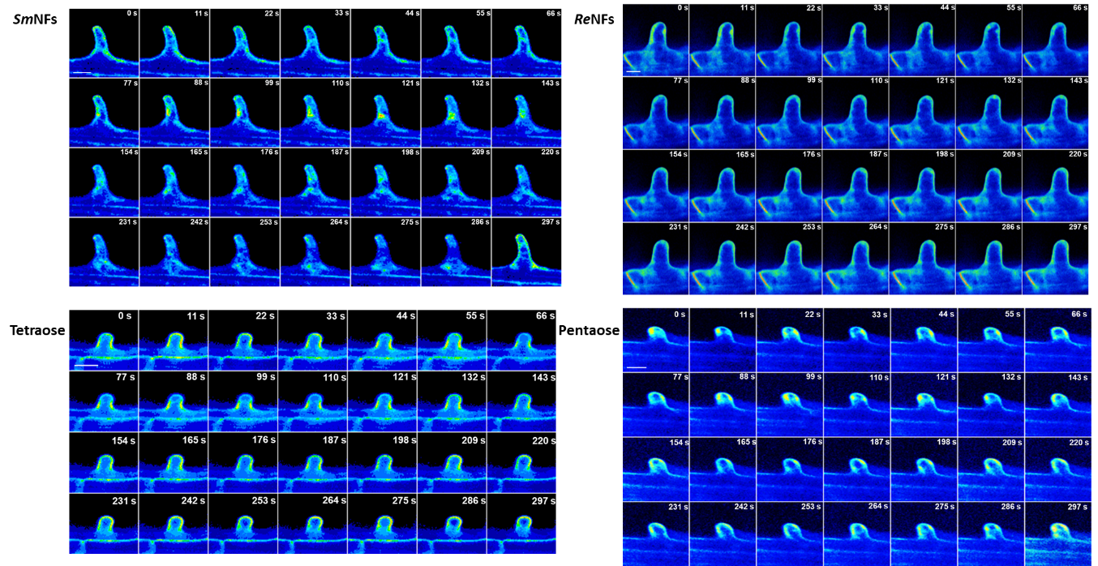
Figure S7. Time series of trichoblast cell of RheCM plant roots treated with different NFs (SmNF and ReNF) and COs (tetraose and pentaose). Scale bar 10 µm

Figure S8. Time series of atrichoblast cell of J5hLCm plant roots treated. a SmNF. b Tetraose. Scale bar 10 µm

Figure S9. Time series of atrichoblast cell of RheCm plant roots treated a SmNF. b Tetraose. Scale bar 10 µm

