Supplementary materials to:
Woody component of tropical rainforest recovers slower from drought than the upper canopy layer and leaves
Yujie Dou, Feng Tian, Jean-Pierre Wigneron, Xiaojun Li, Wenmin Zhang, Yaoliang Chen, Luwei Feng, Qi Xie, Rasmus Fensholt

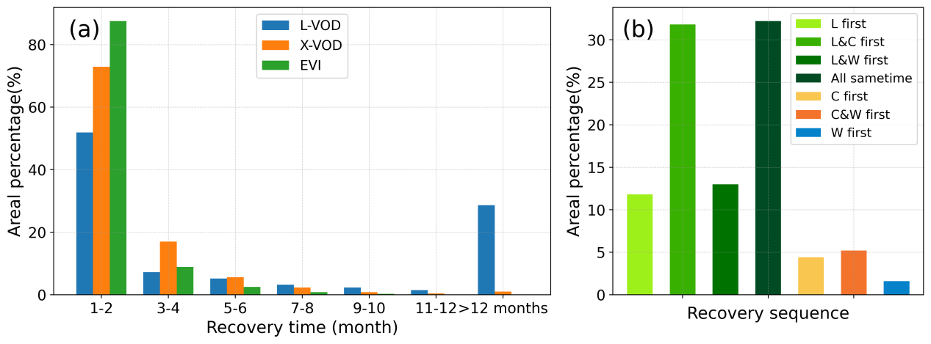
Figure S 1. Statistical distribution of (a) the recovery time of the woody component, the upper canopy component, and the leaf component, (b) the area percentage cover of different temporal sequences of vegetation component recovery. L indicates the leaves, C indicates the upper canopy layer, and W represents the woody component.
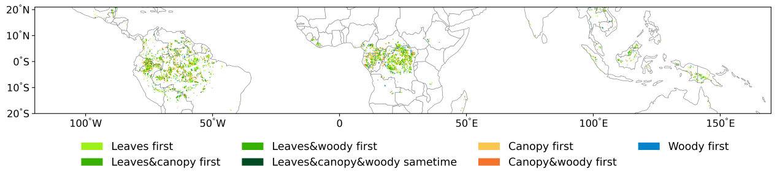
Figure S 2. Spatial distribution of different temporal sequences of vegetation component recovery from the 2015-2016 drought.

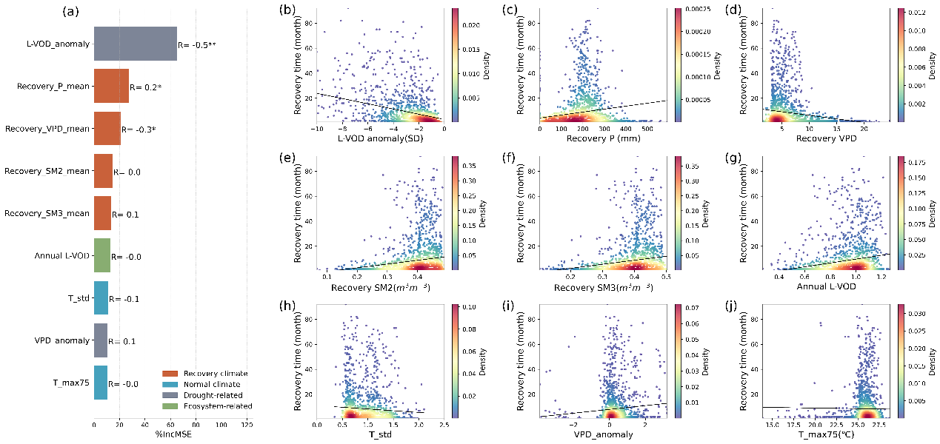
Figure S 3. Attributions of long-term climate conditions, climate conditions during the woody recovery period, drought-related, and ecosystem-related factors to the woody component recovery time across South America evergreen broadleaf forests. (a) The relative importance of the predictor variables in the random forest model is shown by the percentage increase of mean squared error (%IncMSE). The scatterplots illustrate the relationships between the woody recovery time and various factors: (b) L-VOD anomaly during the drought period, (c-f) mean monthly precipitation, VPD, soil moisture of layer2 and layer3 during the recovery period, (g) annual L-VOD pre-El Niño period, (h) monthly temperature variation, (i) the VPD anomaly during the drought period, and (j) maximum monthly temperature.

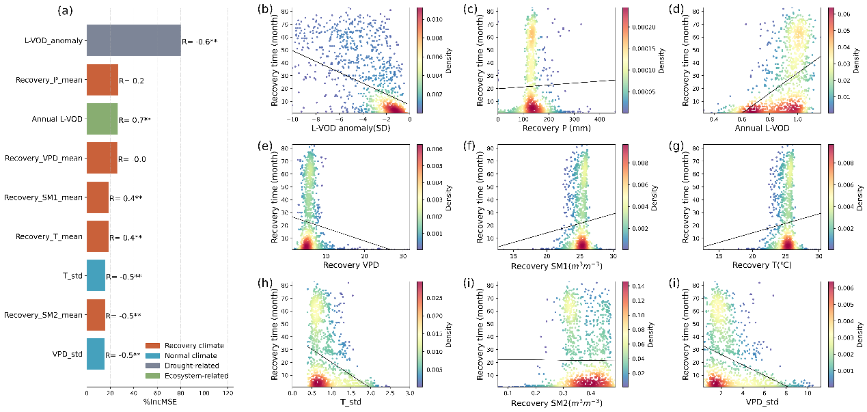
Figure S 4. Attributions of long-term climate conditions, climate conditions during the woody recovery period, drought-related, and ecosystem-related factors to the woody component recovery time across Africa evergreen broadleaf forests. (a) The relative importance of the predictor variables in the random forest model is shown by the percentage increase of mean squared error (%IncMSE). The scatterplots illustrate the relationships between the woody recovery time and various factors: (b) L-VOD anomaly during the drought period, (c) mean monthly precipitation during the recovery period, (d) annual L-VOD pre-El Niño period, (e-i) mean monthly VPD, soil moisture of layer1, and temperature during the recovery period, (h) monthly temperature variation, (i) mean monthly soil moisture of layer 2 during the recovery period, and (i) monthly VPD variation.

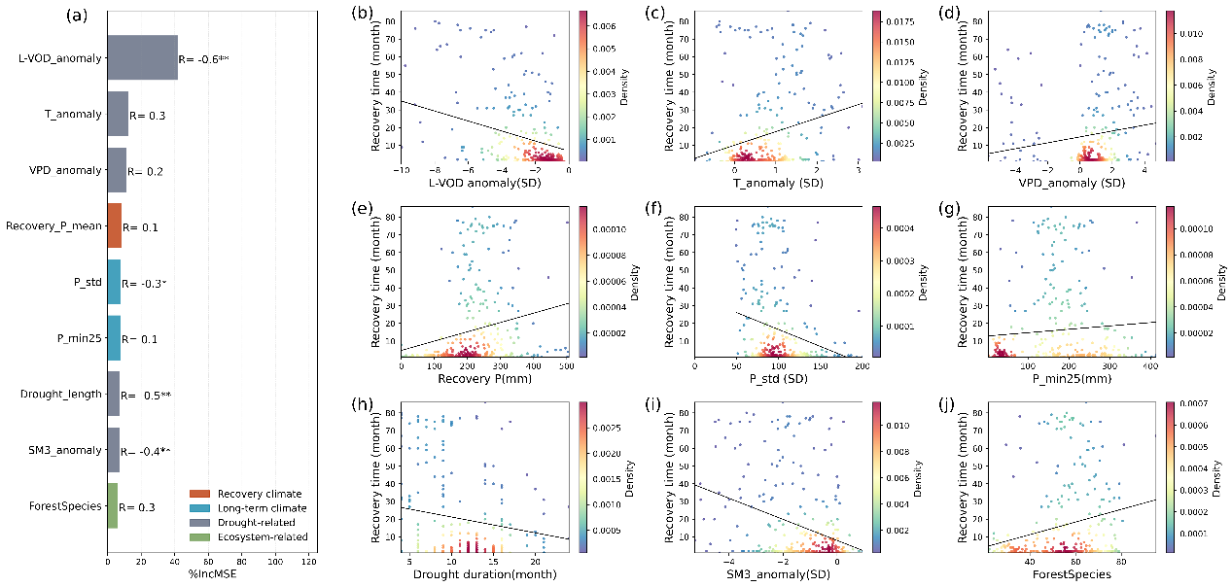
Figure S 5. Attributions of long-term climate conditions, climate conditions during the woody recovery period, drought-related, and ecosystem-related factors to the woody component recovery time across Asia evergreen broadleaf forests. (a) The relative importance of the predictor variables in the random forest model is shown by the percentage increase of mean squared error (%IncMSE). The scatterplots illustrate the relationships between the woody recovery time and various factors: (b-d) L-VOD, temperature, and VPD anomaly during the drought period, (e) mean monthly precipitation during the recovery period, (f) monthly precipitation variation, (g) minimum monthly precipitation, (h) drought duration, (i) soil moisture of layer 3 anomalies during the drought period, and (j) forest species diversity.

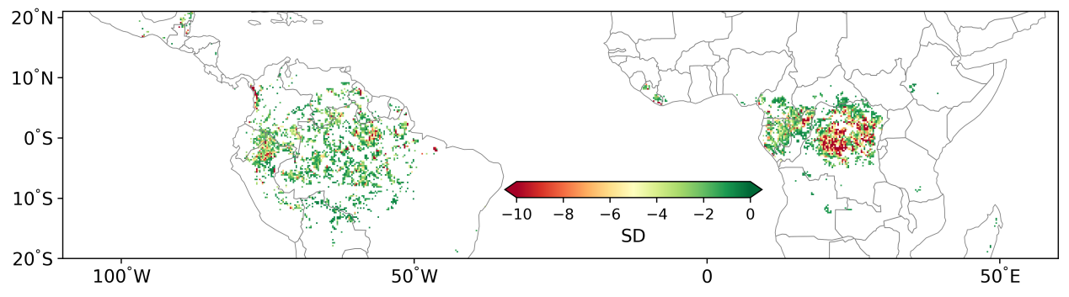
Figure S 6. Spatial distribution of the L-VOD anomaly during the 2015-2016 drought event in South America and Africa.

