Supplementary material

The short-chain fatty acid propionate exacerbates anxiety and cognitive deficits in high-fat diet-induced obese mice by impairing hippocampal neurogenesis and neuroinflammation

Xiang Zuo¹, Huijuan Bai¹, Qili Zhao², Xin Zhao^{2,*}, Xizeng Feng^{1,*}

Affiliation
¹ College of Life Science， State Key Laboratory of Medicinal Chemical Biology, Nankai University, Tianjin, 300071, China.
² Institute of Robotics & Automatic Information System, College of Artificial Intelligence, Nankai University, Tianjin, 300071, China

* Corresponding author：
E-mail address: xzfeng@nankai.edu.cn (X.-Z.Feng), zhaoxin@nankai.edu.cn (X.Zhao). Address: Weijin Road 94, Tianjin, 300071, China.
Results
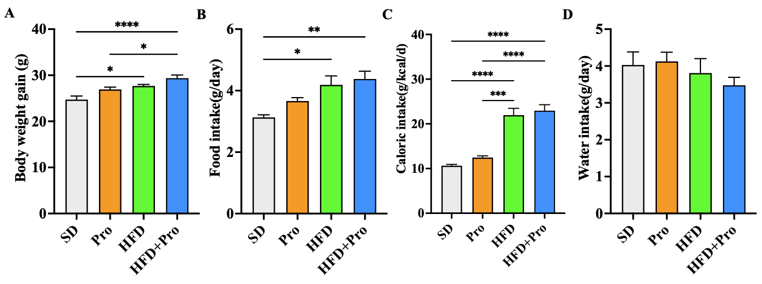
Supplementary Figure .1 Effects of propionate exposure on hyperglycemic glucose, insulin, liver and fat pathological changes in HFD mice. A Body weight. B Food intake. C Caloric intake. D Water intake (n=10). P* < 0.05, **<0.01, ***< 0.001, **** < 0.0001. Data are presented as mean ± SEM.

Table S1 List of qRT-PCR primers information.

Gene | Forward primer | Reverse primer
TNF-α | GTCTACTGAACTTCGGGGTGAT | ATGATCTGAGTGTGAGGGTCTG
IL-6 | ACAAAGCCAGAGTCCTTCAGAG | CATTGGAAATTGGGGTAGGA
IL-1β | GGCAACTGTTCCTGAACTCAACTG | CCATTGAGGTGGAGAGCTTTCAGC
IL-1α | ACGTCAAGCAACGGGAAGAT | AAGGTGCTGATCTGGGTTGG
IL-4 | CCATATCCACGGATGCGACA | CTGTGGTGTTCTTCGTTGCTG
Il-10 | GCATGGCCCAGAAATCAAGG | GAGAAATCGATGACAGCGCC
GAPDH | ACACTGAGGACCAGGTTGTCTC | TACTCCTTGGAGGCCATGTAG

