Supplementary Information for:

Ecosystem transformation upon Aptian seawater ingress into the Proto-South Atlantic Ocean
Jian Ma^{1,2*}, Leonardo F. Cury³, Anelize M. B. Rumbelsperger³, Heidi L. Albrecht⁴, Erwin W. Adams⁵, Joachim E. Amthor⁶, Xingqian Cui², Antoine Cremiere^{7,8}, Kei Sato⁹, Kristin D. Bergmann¹ and Roger E. Summons^{1*}
1. Department of Earth, Atmospheric and Planetary Sciences, Massachusetts Institute of Technology, Cambridge, MA, USA.
2. School of Oceanography, Shanghai Jiao Tong University, Shanghai, China.
3. Federal University of Paraná, LAMIR Institute, Curitiba, PR, Brazil
4. Shell Exploration and Production Company, Houston, USA
5. Shell Global Solutions International BV, Den Haag, the Netherlands
6. Division of Earth Sciences and Geography, Rhine-Westphalia Technical University of Aachen, Germany
7. Division of Geological and Planetary Sciences, California Institute of Technology, Pasadena, CA, USA
8. Geo-Ocean, Université de Bretagne Occidentale, CNRS, Ifremer, Plouzane, France
9. São Paulo University, São Paulo, SP, Brazil

Corresponding authors: R.E.S. (rsummons@mit.edu) or J. M. (majian_geo@sjtu.edu.cn)

Supplemental file contents:
Supplementary text
Supplementary Figures 1 to 7
Supplementary Tables 1 to 2
Supplementary References

Geological setting and core information
The main region of the South Atlantic Ocean (SAO) is bounded to the north by the Ascension Fracture Zone with its southern limit is defined by the Agulhas-Falkland Fracture Zone ^{1, 2}. A further subdivision of the central SAO into northern and southern sectors is demarcated by the Florianopolis Fracture Zone and associated Rio Grande Rise – Walvis Ridge. This latter feature served as a geographic barrier to marine water intrusion during break-up, seafloor spreading and the rapid deepening that commenced in the southern sector ³. The northern sector contains a series of conjugate rift basins along the African and Brazilian margins where a diachronous rift and complex paleogeographic evolution of lacustrine basins has been recorded ^{1, 4}. Specifically, during the Late Berriasian, the extension of the SAO began in the north in a domain ranging from the Espírito Santo – Kwanza Basins to the Sergipe – Alagoas – Gabon Basins, migrated southward and eventually evolved to a deep lake in the Aptian. Correspondingly, extension in the southern domain, including the Namibe, Santos and Campos Basins, started during the Early Barremian and the transition between rift and sag phases occurred in the Middle to Late Aptian ¹. The paleoenvironmental and paleogeographic evolution of these basins during the Early Cretaceous has already received considerable attention owing to the fact that they are the habitat of numerous large ‘pre-salt’ and ‘post-salt’ hydrocarbon accumulations ⁵. Located offshore of SE Brazil, the Campos Basin sits north of the Santos Basin and south of the Espírito Santo Basin (Fig. 1-A, B). The strata in the distal, outboard sector of the Campos Basin comprises Barremian-Aptian aged rift sequences represented by the Atafona and Coqueiros Formations and the post-rift, sag phase Macabu and Retiro Formations of Aptian age ⁶.
The 6-DEV-18PA-RJS, otherwise known as the Fragata well, is located at the edge of the so-called External High of the Campos Basin (Fig. 1-C, D). A ponded, deeper lake system is observed in the East Graben of the Campos Basin; two adjacent wells (Well 1 and Well 2, Fig. 1) contain pre-salt ostracod biostratigraphic data and calibrate the stratigraphy to the Jiquiá and Alagoas zones or Coqueiros and Macabu Formations, respectively ⁷. In the Fragata subsurface, seismic data indicate an erosional, escarpment setting for the upper strata of the Macabu Fm. before the Retiro Fm. was deposited (Fig. 1-C). The Macabu Fm. is considered equivalent to the Barra Velha Fm. of the Santos Basin based on sedimentological correlation ⁸ and Sr-isotope ratios. Specifically, the ⁸⁷Sr/⁸⁶Sr ratios of the Macabu Fm., measured on samples from two wells, range from 0.7099 to 0.7149 (0.7132 on average) and completely overlap with the values of the SK46/48 sequence in the Santos Basin (Fig. S3) ^{9, 10}. While the ⁸⁷Sr/⁸⁶Sr data from the overlying evaporites (SK 50 and Retiro Fm.) indicate a similar trend to more marine values. Accordingly, the age of the Macabu Fm. penetrated in the Fragata well is constrained to be approximately 116 Ma, based on the age constraint which is provided by a LA-ICP-MS U-Pb age of ca. 116 Ma on a Barra Velha Fm. carbonate ⁹.
The cored interval of the Macabu Fm. is characterized by profundal to sublittoral settings with the development of rhythmically laminated carbonate with spherulites, shrubs, and crinkly laminated mudstone (Fig. S1, S2). Breccias composed of intraclasts may occur at the top of this facies association and interbedded with boundstone represented by stromatolites and dendrolites, mainly interpreted as the lower shoreface. Soft-sediment deformation structures (SSDSs) like micro-faults, fractures, convolute laminations, thrust faults, and truncation surfaces are prevalent, particularly at the top of the facies association. The seismic activity coeval to the sedimentation suggests pulsed faulting triggered by syn-rift structures and forecasts a fracture system related to the extensional setting, that can promote connectivity between aquifers on a large scale. In contrast, the sedimentary successions of the Retiro Fm. are comprised of the lithologic evolution of laminated anhydrite, anhydritic carbonates, halite, and matrix-supported carbonate breccia successions (Fig. S1, Table S1).

Thermal history
Despite the distinct switch in lithologies from the Macabu Fm. to the Retiro Fm., however, the paragenesis of the carbonate facies in Fragata is complicated. For instance, the spherulitic and shrub facies intervals of the Macabu Formation display evidence for extensive silicification, dissolution, and replacement of primary crystal fabrics. Matrix that once was Mg-silicate clays has since been replaced with dolomite (Fig. S2). These observations complicate the maturity evaluation for biomarker interpretation.
Clumped isotopes provide clues of paleotemperature estimation. Compared to the current borehole temperature of 5018.4 – 5148.7m at 76°C, the average clumped isotope temperature of the Fragata carbonates is 83°C, with a minimum temperature of 55.6°C and maximum of 103.6°C. Clumped isotope analyses were not possible in the Retiro Formation due to the sulfur contamination associated with anhydrite. As a result, we applied the model of Hemingway and Henkes ¹¹ to explore the potential temperature contribution from solid state reordering under four different scenarios. Each assumes a carbonate precipitated at 30°C experienced rapid burial to a specific temperature. The temperature scenarios are as follows: the current measured borehole temperature (~76°C) for 114 million years, the maximum measured clumped isotope temperature (103.6°C ) for 10 Ma, a temperature just below peak oil window that aligns with the degree of biomarker preservation (120°C) for 10 Ma, a temperature required to drive all measured temperatures by solid state reordering alone (170°C) for 10 Ma (Fig. S4). This approach estimates that only the last scenario drives more than a 10°C change from solid-state reordering. While it is possible that there was higher heat flow in the past associated with basaltic intrusions and rift related volcanism, we view temperatures of 170°C for extended time unlikely given the biomarker results. The consistent temperatures that bracket today’s geotherm instead suggest another process is responsible for setting the current clumped isotope temperature. Our preferred mechanism for driving the majority of the clumped isotope temperature change is burial diagenetic processes including dissolution and reprecipitation associated with the extensive silicification, dolomitization, and in situ organic maturation reactions. There is abundant petrographic evidence for dissolution, enhanced secondary porosity, silica replacement of spherulitic and shrub textures, and dolomitization throughout the cored interval as well as more minor late-stage carbonate fracture cements and stylolites (Fig. S2).
Compositional patterns and the stereochemical configurations of biomarker hydrocarbons provide further information to evaluate the organic maturity. A wide array of lipid biomarkers, including n-alkanes, acyclic isoprenoids, terpanes, steranes, hopanes and carotenoids, were present in both free and desulfurized fractions. However, their total ion chromatograms (TICs) have revealed strikingly different patterns (Fig. S5). Specifically, in the free-NP fractions, the C₁₆ – C₁₈ n-alkanes were devoid of carbon number preference (Fig. 3-A). In contrast, an abundance of C₂₉ – C₃₇ n-alkanes featuring an even over odd preference was released by the Raney-Ni treatment of the polar fractions (Fig. 3-B). Carbon-number preferences diminish with increasing maturity since thermal cracking of organic compounds tends to produce smooth distributions ¹². Thus, lipids in the sulfurized fractions have been somewhat protected from thermal cracking and deemed to preserve a relatively original signature compared to those in the free biomarker fractions ¹³. Likewise, stereoisomer ratios of C₂₇ – C₃₀ steranes and C₂₇ – C₃₅ hopanes in the RN-NP fraction displayed less mature distributions (Fig. 2; Fig. S6) compared to the free lipids. The C₃₀ hopane βα/αβ+βα ratios and C₃₁ hopane 22S/(22S+22R) ratios are consistent throughout the Fragata core, exhibiting a narrow range from 0.07 ± 0.02 and 0.48 ± 0.08 respectively (1σ, Table S2). Considering these ratios are below the ~0.11 and ~0.55 values observed at the peak phase of oil generation ¹², the consistent ratios of the hopane stereoisomers suggests that the Fragata drill core was just below peak oil generation maturity. Mirroring the downcore consistency in biomarker stereoisomer patterns, temperatures recovered from clumped isotope thermometry hover around a mean of ~83°C with a maximum of 103.6°C, corroborating maturity estimates below peak oil generation window (Table S1). Other proxies, including Ts/(Ts+Tm) and diasterane/sterane ratios, which are also influenced by lithology ¹⁴, show similarly constant distributions downcore, ranging from 0.35 ± 0.10 and 0.35 ± 0.11 respectively (1σ, Table S2) albeit with slightly lower values below 5024.3 m. Significantly, stereoisomers of steranes and hopanes in RN-NP show a distinct preference for the biological configurations. For instance, C₃₁ homohopane stereoisomers after the desulfurization all present lower αβ 22S/(αβ 22S + 22R) ratios (0.48 ± 0.08 on average, 1σ) to higher ratios (0.45 ± 0.08, 1σ) (Table S2, Fig. S6-B). Accordingly, we propose that indigenous signals of biomarker were mostly preserved in sulfurized lipids considering their less mature signature than free lipids.

Supplementary Figures

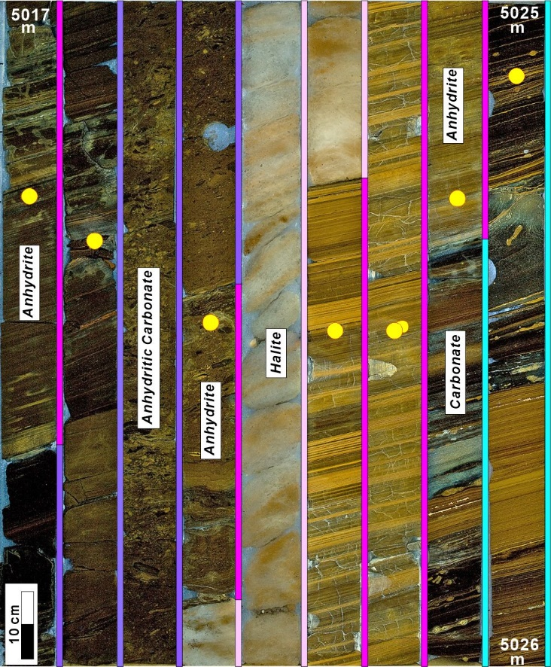
Figure S1 The cored interval of the transitions from upper Macabu to lower Retiro Formations from 5017 m to 5026 m under UV light. Different lithologic successions are colored (blue, pink, pinkish and purple), including carbonates, anhydrites, halites, anhydritic carbonates. Sampled intervals are denoted as yellow dots.

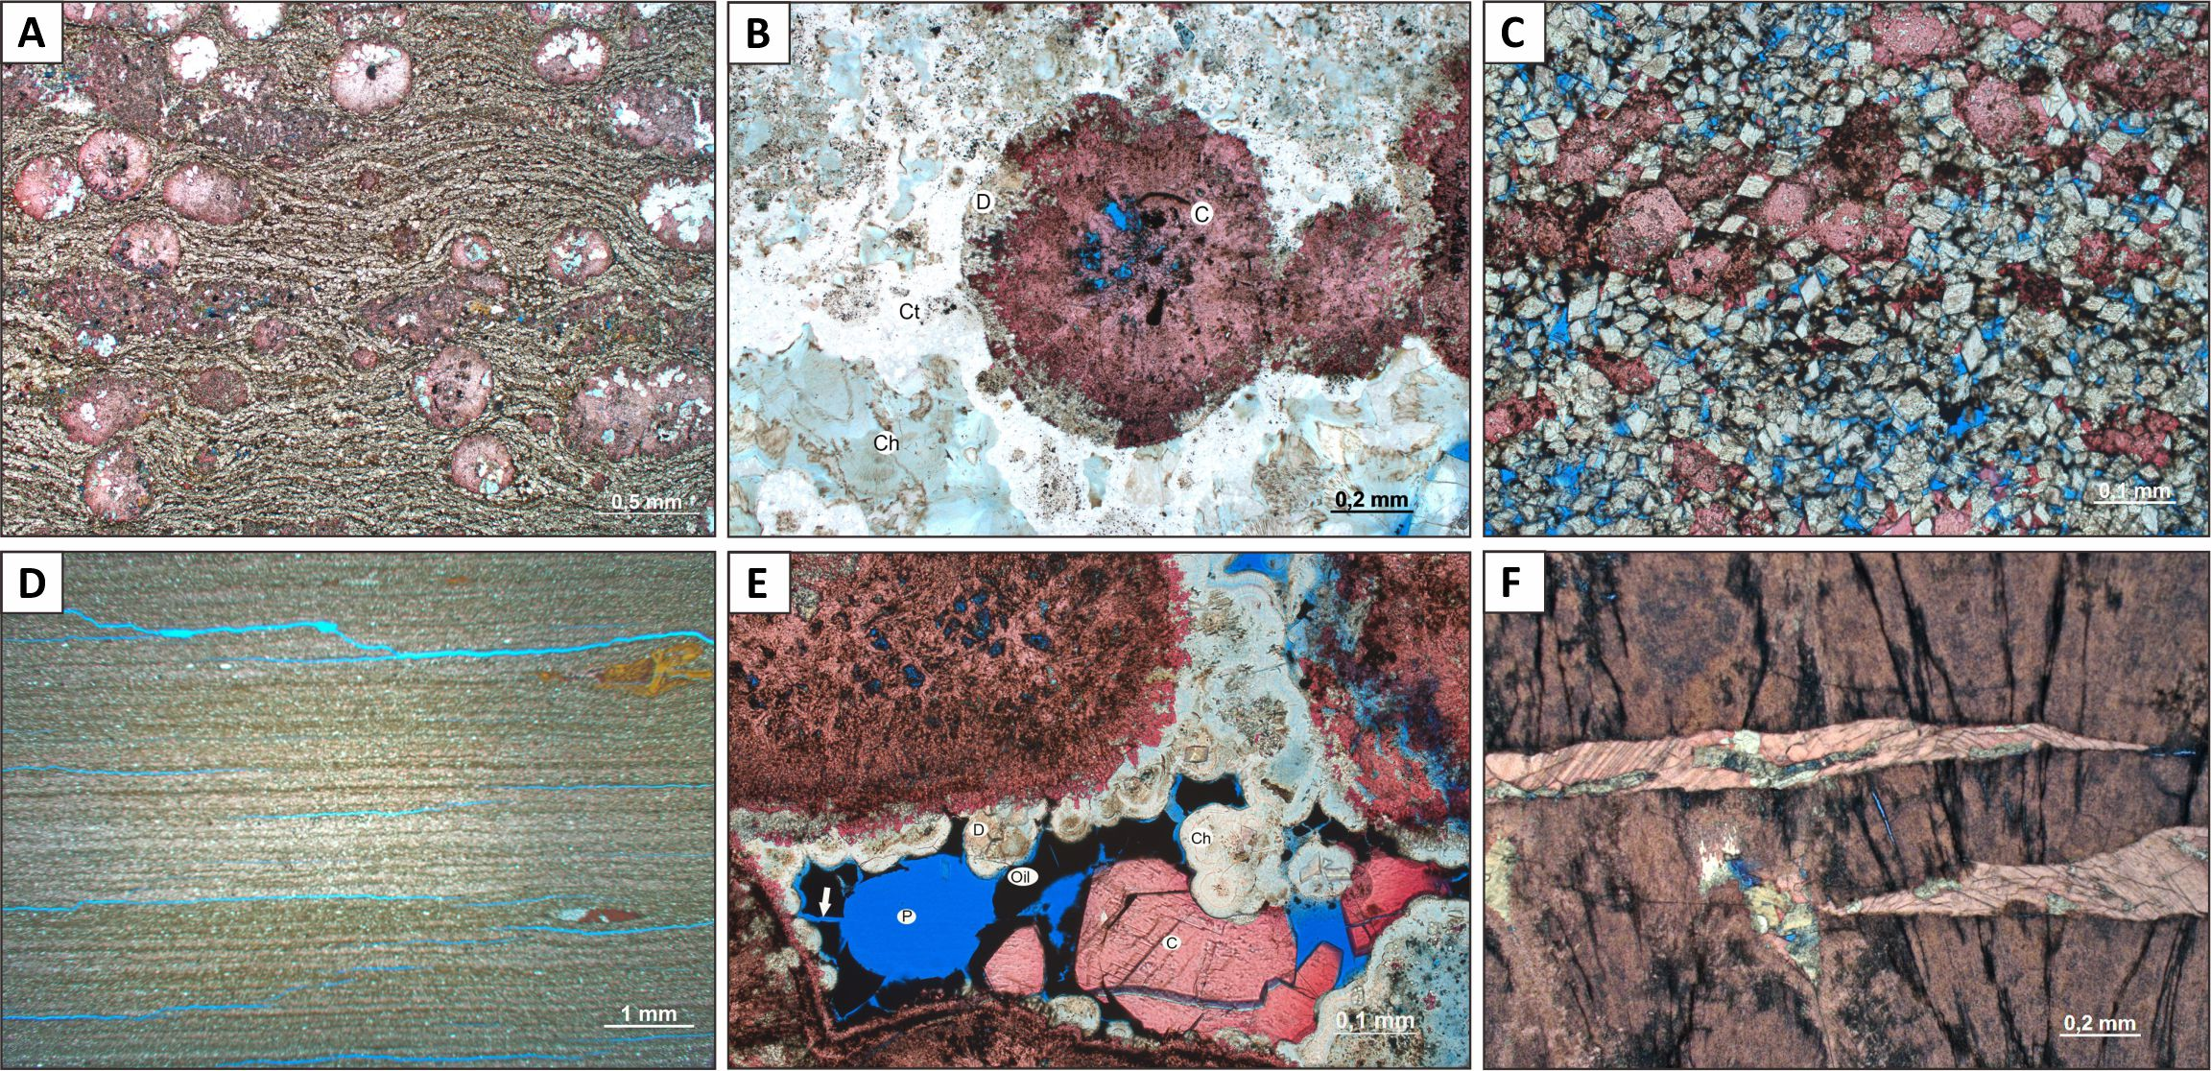
Figure S2 Petrographic images (crossed polarized light) from Fragata well. (A) Calcitic spherulties in a dolomitic matrix which replaced a primary Mg silicate clay (5046.60 m) (B) Evidence for multiple generations of silica replacement of matrix and partial replacement of spherulites (5086.58 m) (C) Dolomite rhombohedral crystals and calcitic spherulites with significant secondary porosity (5085.84 m) (D) Fractures in laminated sediments (5061.80 m) (E) Oil migration postdates silicification (5086.8 m) (F) Coarse calcite cements fill late stage fractures that cross cut shrub fabrics (5083.89 m).

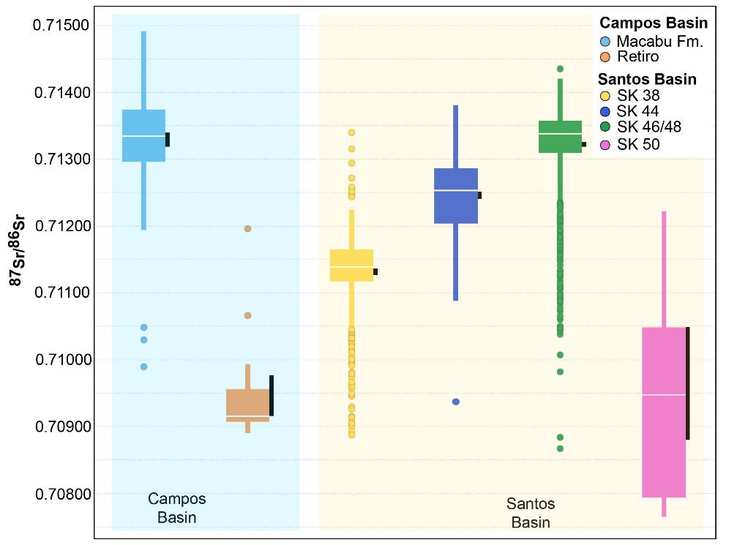
Figure S3 The comparisons of ⁸⁷Sr/⁸⁶Sr ratios between Campos Basin (Macabu Formation and Retiro Formation) and Santos Basin (SK 38, SK 44, SK 46/48 and SK 50). Results show that isotopic ratios of the Macabu Formation completely overlap with the values of the SK46/48 sequence in the Santos Basin, while the isotopic composition of the Retiro Formation is similar to the overlaying evaporite sequences in SK 50 and some of SK 46/48.

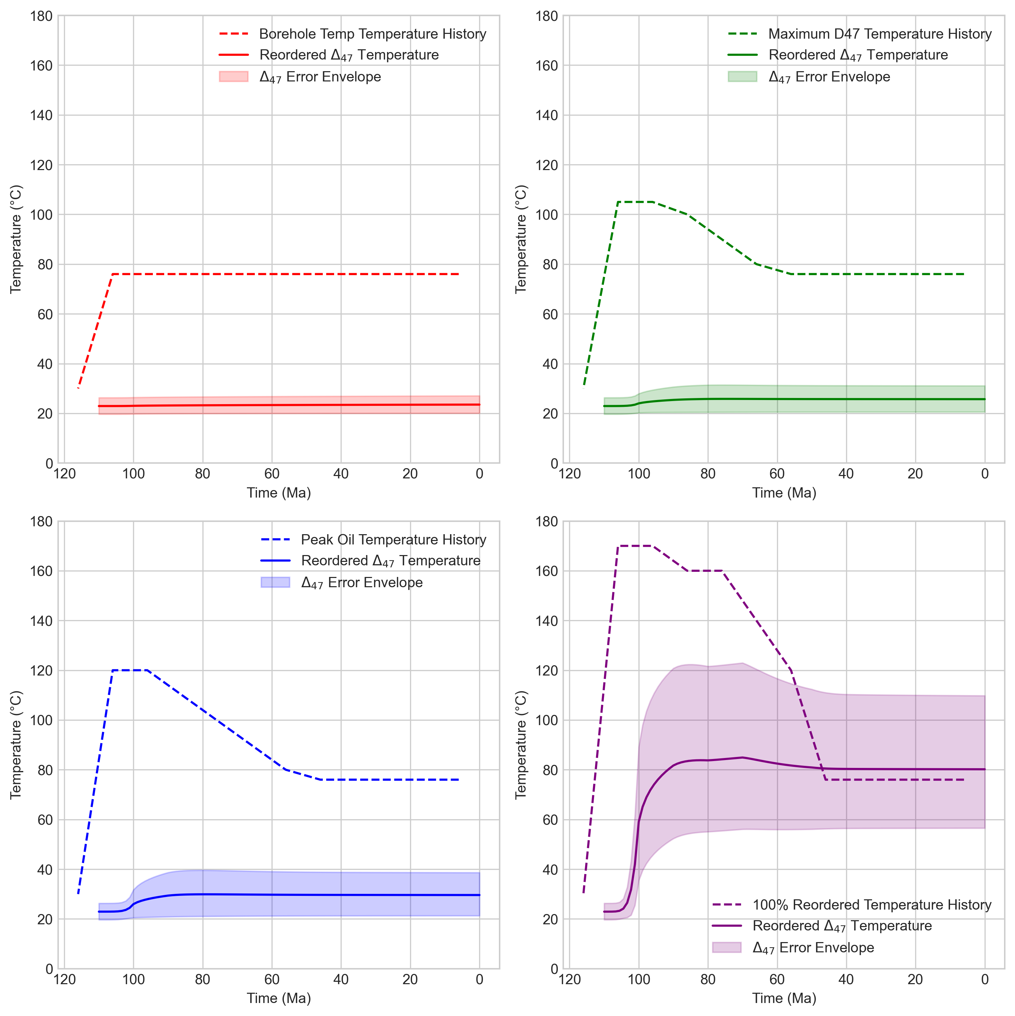

Figure S4 Predicted changes in apparent calcite clumped isotope temperature resulting from different scenarios of burial history and peak temperatures using the reordering model from Hemingway and Henkes (2021).

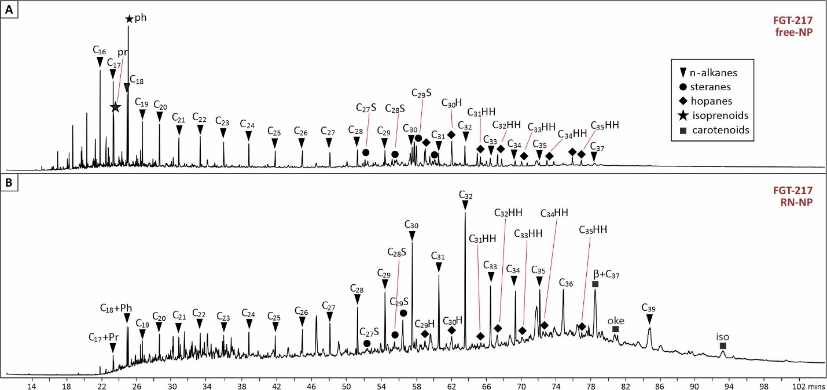
Figure S5 TIC (GC-MS) comparison of free biomarker (free-NP, free non-polar fractions (A) and desulfurized lipids (RN-NP, non-polar fractions by Raney Ni treatment of polar fractions (B) for the sample FGT 217 (5020.48 m).

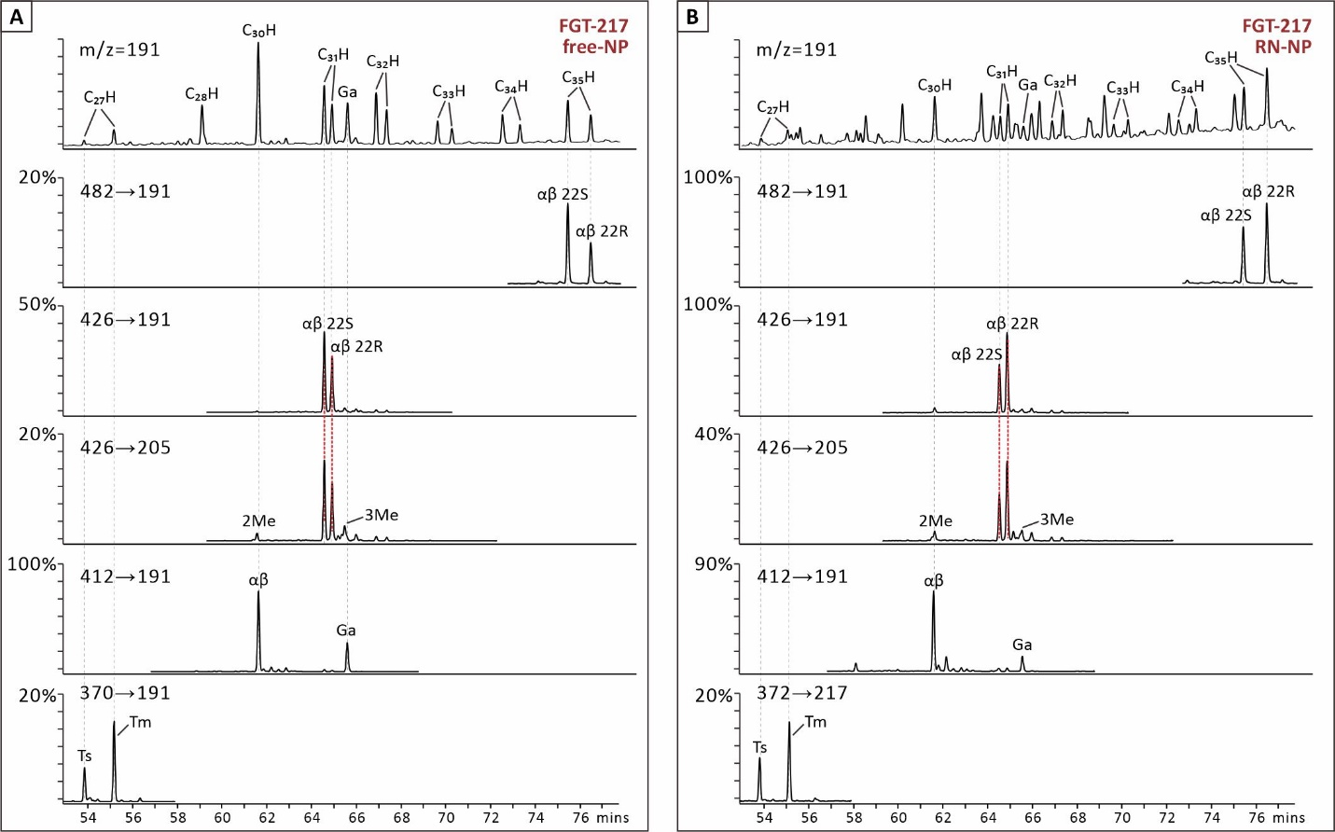
Figure S6 Hopane comparisons of the free hydrocarbons (free-NP, free non-polar fractions, A) and hydrocarbons released by desulfurization (RN-NP, non-polar fractions by Raney Ni treatment on polar fractions, B) for sample FGT 217 (5020.48 m). Hopanes in the free-NP fractions feature a higher relative abundance of geological ‘S’ configurations while, contrastingly, biological ‘R’ configurations dominate among C₃₀-C₃₅ homohopanes in RN-NP fractions. The chromatograms at the top of the A and B stacks show m/z 191 from full scan GC-MSD data. Chromatograms for individual sterane carbon numbers are from GC-QQQ data; scales in each chromatogram are normalized to the highest peaks (shown as 100%).

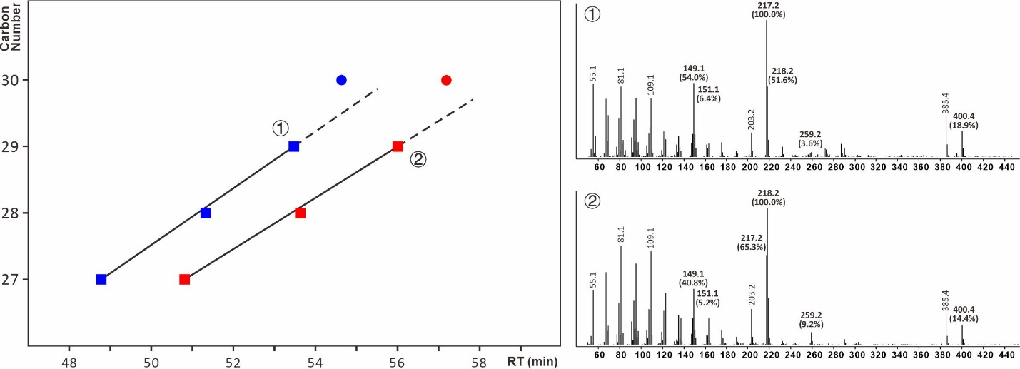
Figure S7 Correlations of carbon numbers of unconventional C₂₇-C₂₉ 5α,14α,17β(H) 20R (ααβ, blue squares) and 5α,14β,17α (H) 20R (αβα, red squares) steranes and their retention time (RT) on GC-MS (left panel). Notably, there is an offset between methyl ααβ and αβα steranes (blue and red dots, respectively) and the trendlines of C₂₇-C₂₉ ααβ and αβα steranes. The mass spectra of the C₂₉ ααβ and αβα steranes (① and ②) are shown in the right panel.

Table S1. Mineral and isotopic composition of core samples from the Fragata Well
Samples | Depth (m) | Calcite (%) | Dolomite (%) | Silic. (%) | Anhydrite (%) | ⁸⁷Sr/⁸⁶Sr (‰) | δ¹³C (‰) | δ¹⁸O (‰) | △₄₇ (‰) | △₄₇ T (°C)
FGT-224 NP | 5017.30 | 6.70 | 2.50 | 90.80 | 82.10 | 0.7089
FGT-221 NP | 5018.37 | 63.40 | 16.40 | 20.20 | 5.30 | 0.7098 | -8.89
FGT-217 NP | 5020.48 | 14.20 | 8.90 | 76.90 | 55.50
FGT-211 NP | 5022.51 | 0.00 | 23.50 | 76.50 | 73.50 | 0.7091
FGT-208 NP | 5023.50 | 0.90 | 9.50 | 89.60 | 83.10 | 0.7091
FGT-206 NP | 5024.30 | 0.00 | 0.00 | 100.00 | 0.00 | 0.7135
FGT-203 NP | 5025.12 | 46.00 | 37.00 | 17.00 | 0.00 | 0.7133
FGT-200 NP | 5026.32 | 62.00 | 25.00 | 13.00 | 1.90 | 0.7137 | 2.14 | 0.74 | 0.463 | 82.1
FGT-197 NP | 5027.29 | 66.30 | 8.70 | 25.00 | 1.60 | 0.7138
FGT-194 NP | 5028.15 | 51.80 | 28.40 | 19.80 | 1.50 | 0.7138
FGT-191 NP | 5029.00 | 55.40 | 30.30 | 14.30 | 1.90 | 0.7138
FGT-184 NP | 5031.10 | 42.00 | 41.00 | 17.00 | 0.60 | 0.7132
FGT-177 NP | 5034.16 | 17.00 | 13.70 | 69.30 | 0.00 | 0.7131 | 2.97 | 3.31 | 0.473 | 76.8
FGT-175 NP | 5036.00 | 48.30 | 18.50 | 33.20 | 0.00 | 0.7124
FGT-172 NP | 5038.58 | 7.80 | 62.40 | 29.80 | 0.00 | 0.7120 | 0.8 | 1.51 | 0.455 | 87.5
FGT-171 NP | 5049.70 | 17.00 | 57.30 | 25.70 | 0.00 | 0.7105
FGT-169 NP | 5050.97 | 32.10 | 44.10 | 23.80 | 0.00 | 0.7132
FGT-166 NP | 5052.10 | 21.60 | 59.30 | 19.10 | 0.00 | 0.7143
FGT-163 NP | 5053.33 | 21.10 | 52.50 | 26.40 | 0.00 | 0.7134
FGT-158 NP | 5056.74 | 40.30 | 24.20 | 35.50 | 0.00 | 0.7138
FGT-153 NP | 5058.65 | 36.80 | 28.10 | 35.10 | 0.00 | 0.7137 | 1.31 | 1.64 | 0.463 | 82.6
FGT-152 NP | 5059.02 | 8.90 | 56.40 | 34.70 | 0.00 | 0.7143 | 0.72 | 3.08 | 0.492 | 67
FGT-146 NP | 5063.40 | 11.80 | 79.70 | 8.50 | 0.00 | 0.7149 | 0.86 | 2.14 | 0.456 | 86.6
FGT-135 NP | 5068.36 | 17.40 | 59.20 | 23.40 | 0.00 |  | 2.09 | -0.19 | 0.467 | 80.1
FGT-123 NP | 5074.36 | 29.00 | 37.90 | 33.10 | 0.00 | 0.7138 | 1.52 | 5.77 | 0.474 | 76.3
FGT-115 NP | 5083.00 | 51.30 | 27.00 | 21.70 | 0.00 | 0.7146
FGT-102 NP | 5093.33 | 68.50 | 8.90 | 22.60 | 0.00 | 0.7127
FGT-090 NP | 5096.03 | 45.40 | 31.00 | 23.60 | 0.00 | 0.7125 | 1.54 | -0.62 | 0.458 | 85.5
FGT-087 NP | 5101.86 | 29.00 | 53.50 | 17.50 | 0.00 |  | 1.87 | 1.89 | 0.473 | 98.4
FGT-082 NP | 5105.47 | 46.90 | 38.50 | 14.60 | 0.00 | 0.7130 | 1.81 | 1.25 | 0.483 | 71.5
FGT-081 NP | 5106.40 | 53.30 | 27.90 | 18.80 | 0.00 | 0.7128 | 1.84 | 1..48 | 0.498 | 64.2
FGT-069 NP | 5114.02 | 66.10 | 15.00 | 18.90 | 0.00 | 0.7128
FGT-060 NP | 5119.25 | 55.70 | 25.50 | 18.80 | 0.00 | 0.7137 | 2.62 | 0.70 | 0.460 | 84.1
FGT-050 NP | 5124.49 | 63.50 | 14.10 | 22.40 | 0.00 | 0.7139
FGT-042 NP | 5128.38 | 27.40 | 54.30 | 18.30 | 0.00 | 0.7131 | 1.66 | 1.54 | 0.463 | 82.2
FGT-036 NP | 5132.67 | 31.80 | 52.00 | 16.20 | 0.00
FGT-025 NP | 5138.27 | 0.00 | 64.60 | 35.40 | 0.00 | 0.7134
FGT-016 NP | 5143.87 | 0.00 | 64.20 | 35.80 | 0.00 | 0.7130
FGT-010 NP | 5146.61 | 23.60 | 67.00 | 9.40 | 0.00 | 0.7124 | -0.8 | 1.65 | 0.468 | 79.7
FGT-005 NP | 5148.70 | 1.80 | 95.50 | 2.70 | 0.00 | 0.7141 | -0.15 | 3.79 | 0.434 | 100.3

Table S2. Biomarker data of the core samples from the Fragata Well
Samples | Depth | dia/  Steranes | Ts/  (Ts+Tm) | C₃₀H βα/  (βα+αβ) | C₃₁H 22s/  (22s+22R) | S/H | C₂₇S/  C₂₇₋₂₉S | C₂₈S/  C₂₇₋₂₉S | C₂₉S/  C₂₇₋₂₉S | 24-npc | pr/ph | GI | HHI | MTTCI | iso/all | chl/all | oke/all | ren+rnp  /all | C₃₈/all | C₃₉/all | β-iso  /all
FGT-224 NP | 5017.30 | 0.03 | 0.30 | 0.03 | 0.40 | 3.84 | 0.07 | 0.15 | 0.77 | 0.33 | 0.30 | 0.25 | 0.16 | 0.03 | 0.39 | 0.00 | 0.01 | 0.00 | 0.18 | 0.12 | 0.04
FGT-221 NP | 5018.37 | 0.07 | 0.26 | 0.03 | 0.46 | 1.99 | 0.18 | 0.17 | 0.64 | 0.18 | 0.39 | 0.30 | 0.11 | 0.03 | 0.50 | 0.01 | 0.01 | 0.00 | 0.13 | 0.14 | 0.05
FGT-217 NP | 5020.48 | 0.05 | 0.30 | 0.04 | 0.41 | 2.26 | 0.16 | 0.17 | 0.68 | 0.20 | 0.40 | 0.37 | 0.12 | 0.03 | 0.53 | 0.01 | 0.01 | 0.00 | 0.11 | 0.12 | 0.04
FGT-211 NP | 5022.51 | 0.37 | 0.30 | 0.03 | 0.42 | 2.83 | 0.10 | 0.21 | 0.69 | 0.16 | 0.19 | 0.17 | 0.14 | 0.16 | 0.51 | 0.02 | 0.01 | 0.00 | 0.13 | 0.13 | 0.06
FGT-208 NP | 5023.50 | 0.41 | 0.25 | 0.06 | 0.45 | 10.60 | 0.03 | 0.20 | 0.77 | 0.40 | 0.31 | 0.06 | 0.33 | 0.42 | 0.22 | 0.00 | 0.04 | 0.00 | 0.16 | 0.00 | 0.00
FGT-206 NP | 5024.30 | 0.10 | 0.22 | 0.06 | 0.46 | 5.08 | 0.05 | 0.18 | 0.77 | 0.32 | 0.36 | 0.07 | 0.38 | 0.26 | 0.18 | 0.01 | 0.11 | 0.00 | 0.24 | 0.09 | 0.05
FGT-203 NP | 5025.12 | 0.38 | 0.54 | 0.05 | 0.43 | 1.11 | 0.44 | 0.22 | 0.34 | 0.00 | 1.97 | 0.16 | 0.04 | 0.00 | 0.10 | 0.00 | 0.02 | 0.00 | 0.16 | 0.05 | 0.03
FGT-200 NP | 5026.32 | 0.37 | 0.55 | 0.05 | 0.57 | 0.91 | 0.42 | 0.24 | 0.34 | 0.00 | 0.83 | 0.18 | 0.04 | 0.04 | 0.01 | 0.00 | 0.00 | 0.00 | 0.02 | 0.00 | 0.00
FGT-197 NP | 5027.29 | 0.39 | 0.50 | 0.05 | 0.37 | 0.66 | 0.47 | 0.23 | 0.30 | 0.00 | 2.17 | 0.11 | 0.03 | 0.00 | 0.29 | 0.00 | 0.00 | 0.00 | 0.17 | 0.05 | 0.00
FGT-194 NP | 5028.15 | 0.39 | 0.46 | 0.05 | 0.38 | 0.83 | 0.46 | 0.21 | 0.33 | 0.00 | 1.33 | 0.18 | 0.03 | 0.00 | 0.20 | 0.00 | 0.01 | 0.00 | 0.10 | 0.05 | 0.02
FGT-191 NP | 5029.00 | 0.36 | 0.39 | 0.06 | 0.42 | 0.56 | 0.47 | 0.21 | 0.32 | 0.00 | 1.93 | 0.11 | 0.05 | 0.00 | 0.24 | 0.01 | 0.02 | 0.00 | 0.14 | 0.07 | 0.03
FGT-184 NP | 5031.10 | 0.34 | 0.41 | 0.06 | 0.47 | 0.80 | 0.49 | 0.21 | 0.30 | 0.00 | 1.53 | 0.50 | 0.05 | 0.02 | 0.23 | 0.00 | 0.01 | 0.00 | 0.19 | 0.05 | 0.02
FGT-177 NP | 5034.16 | 0.30 | 0.36 | 0.07 | 0.58 | 0.42 | 0.53 | 0.21 | 0.25 | 0.00 | 0.09 | 0.20 | 0.03 | 0.02 | 0.08 | 0.01 | 0.12 | 0.00 | 0.10 | 0.04 | 0.02
FGT-175 NP | 5036.00 | 0.37 | 0.49 | 0.06 | 0.39 | 0.63 | 0.49 | 0.23 | 0.29 | 0.00 | 2.07 | 0.15 | 0.03 | 0.00 | 0.21 | 0.00 | 0.00 | 0.00 | 0.15 | 0.10 | 0.00
FGT-172 NP | 5038.58 | 0.36 | 0.49 | 0.08 | 0.57 | 0.80 | 0.42 | 0.24 | 0.34 | 0.00 | 2.15 | 0.17 | 0.02 | 0.02 | 0.01 | 0.00 | 0.00 | 0.00 | 0.01 | 0.00 | 0.00
FGT-171 NP | 5049.70 | 0.32 | 0.38 | 0.07 | 0.39 | 0.43 | 0.44 | 0.23 | 0.33 | 0.00 | 1.99 | 0.10 | 0.03 | 0.01 | 0.20 | 0.00 | 0.00 | 0.00 | 0.18 | 0.09 | 0.03
FGT-169 NP | 5050.97 | 0.34 | 0.48 | 0.06 | 0.45 | 0.49 | 0.49 | 0.23 | 0.29 | 0.00 | 1.96 | 0.13 | 0.03 | 0.01 | 0.22 | 0.00 | 0.00 | 0.00 | 0.17 | 0.10 | 0.02
FGT-166 NP | 5052.10 | 0.39 | 0.39 | 0.05 | 0.37 | 0.70 | 0.47 | 0.22 | 0.31 | 0.00 | 1.75 | 0.10 | 0.03 | 0.02 | 0.17 | 0.00 | 0.01 | 0.00 | 0.06 | 0.06 | 0.03
FGT-163 NP | 5053.33 | 0.36 | 0.35 | 0.06 | 0.40 | 0.58 | 0.47 | 0.22 | 0.31 | 0.00 | 1.51 | 0.12 | 0.03 | 0.01 | 0.22 | 0.00 | 0.00 | 0.00 | 0.20 | 0.12 | 0.03
FGT-158 NP | 5056.74 | 0.37 | 0.51 | 0.05 | 0.42 | 1.00 | 0.45 | 0.23 | 0.32 | 0.00 | 2.19 | 0.14 | 0.04 | 0.03 | 0.09 | 0.00 | 0.00 | 0.00 | 0.11 | 0.04 | 0.03
FGT-153 NP | 5058.65 | 0.29 | 0.31 | 0.09 | 0.57 | 0.38 | 0.49 | 0.22 | 0.29 | 0.00 | N.D. | 0.14 | 0.03 | 0.01 | 0.06 | 0.01 | 0.00 | 0.00 | 0.07 | 0.03 | 0.02
FGT-152 NP | 5059.02 | 0.36 | 0.31 | 0.07 | 0.40 | 0.41 | 0.48 | 0.22 | 0.30 | 0.00 | N.D. | 0.08 | 0.02 | 0.04 | 0.33 | 0.00 | 0.00 | 0.00 | 0.11 | 0.13 | 0.03
FGT-146 NP | 5063.40 | 0.36 | 0.41 | 0.08 | 0.58 | 0.57 | 0.45 | 0.23 | 0.31 | 0.00 | N.D. | 0.13 | 0.04 | 0.04 | 0.03 | 0.00 | 0.00 | 0.00 | 0.02 | 0.01 | 0.01
FGT-135 NP | 5068.36 | 0.38 | 0.41 | 0.08 | 0.56 | 0.59 | 0.45 | 0.23 | 0.32 | 0.00 | N.D. | 0.11 | 0.03 | 0.03 | 0.02 | 0.00 | 0.00 | 0.00 | 0.01 | 0.00 | 0.01
FGT-123 NP | 5074.36 | 0.33 | 0.38 | 0.08 | 0.57 | 0.52 | 0.46 | 0.25 | 0.29 | 0.00 | N.D. | 0.18 | 0.03 | 0.02 | 0.04 | 0.00 | 0.00 | 0.00 | 0.02 | 0.01 | 0.01
FGT-115 NP | 5083.00 | 0.37 | 0.38 | 0.07 | 0.43 | 0.61 | 0.45 | 0.23 | 0.32 | 0.00 | 1.12 | 0.10 | 0.03 | 0.04 | 0.34 | 0.01 | 0.00 | 0.00 | 0.09 | 0.08 | 0.03
FGT-102 NP | 5093.33 | 0.36 | 0.38 | 0.07 | 0.39 | 0.44 | 0.47 | 0.20 | 0.32 | 0.00 | 1.48 | 0.12 | 0.04 | 0.03 | 0.34 | 0.01 | 0.00 | 0.00 | 0.14 | 0.08 | 0.03
FGT-090 NP | 5096.03 | 0.36 | 0.33 | 0.09 | 0.57 | 0.45 | 0.48 | 0.22 | 0.30 | 0.00 | N.D. | 0.13 | 0.04 | 0.03 | 0.06 | 0.01 | 0.00 | 0.00 | 0.05 | 0.01 | 0.02
FGT-087 NP | 5101.86 | 0.37 | 0.31 | 0.09 | 0.57 | 0.42 | 0.49 | 0.22 | 0.29 | 0.00 | 1.32 | 0.13 | 0.04 | 0.03 | 0.12 | 0.01 | 0.01 | 0.00 | 0.05 | 0.02 | 0.02
FGT-082 NP | 5105.47 | 0.37 | 0.31 | 0.10 | 0.57 | 0.46 | 0.49 | 0.22 | 0.29 | 0.00 | N.D. | 0.14 | 0.03 | 0.03 | 0.05 | 0.01 | 0.00 | 0.00 | 0.03 | 0.01 | 0.01
FGT-081 NP | 5106.40 | 0.34 | 0.28 | 0.09 | 0.58 | 0.32 | 0.51 | 0.21 | 0.28 | 0.00 | N.D. | 0.13 | 0.04 | 0.04 | 0.35 | 0.01 | 0.01 | 0.00 | 0.06 | 0.03 | 0.03
FGT-069 NP | 5114.02 | 0.37 | 0.28 | 0.08 | 0.43 | 0.41 | 0.50 | 0.21 | 0.29 | 0.00 | 1.65 | 0.11 | 0.05 | 0.03 | 0.70 | 0.01 | 0.01 | 0.00 | 0.09 | 0.05 | 0.03
FGT-060 NP | 5119.25 | 0.36 | 0.25 | 0.09 | 0.58 | 0.36 | 0.50 | 0.21 | 0.29 | 0.00 | N.D. | 0.12 | 0.05 | 0.04 | 0.33 | 0.02 | 0.01 | 0.00 | 0.07 | 0.02 | 0.04
FGT-050 NP | 5124.49 | 0.40 | 0.28 | 0.08 | 0.37 | 0.42 | 0.53 | 0.20 | 0.27 | 0.00 | 1.71 | 0.09 | 0.05 | 0.03 | 0.75 | 0.01 | 0.00 | 0.00 | 0.08 | 0.04 | 0.03
FGT-042 NP | 5128.38 | 0.39 | 0.25 | 0.09 | 0.59 | 0.41 | 0.47 | 0.22 | 0.31 | 0.00 | N.D. | 0.12 | 0.05 | 0.02 | 0.34 | 0.02 | 0.01 | 0.00 | 0.13 | 0.02 | 0.04
FGT-036 NP | 5132.67 | 0.49 | 0.24 | 0.07 | 0.59 | 0.62 | 0.42 | 0.24 | 0.33 | 0.00 | 1.55 | 0.12 | 0.05 | 0.01 | 0.43 | 0.02 | 0.01 | 0.00 | 0.32 | 0.03 | 0.04
FGT-025 NP | 5138.27 | 0.52 | 0.24 | 0.09 | 0.60 | 0.82 | 0.46 | 0.18 | 0.37 | 0.00 | 1.52 | 0.12 | 0.06 | 0.01 | 0.81 | 0.01 | 0.01 | 0.00 | 0.07 | 0.02 | 0.03
FGT-016 NP | 5143.87 | 0.57 | 0.17 | 0.08 | 0.41 | 1.09 | 0.48 | 0.16 | 0.35 | 0.00 | 1.83 | 0.14 | 0.04 | 0.01 | 0.91 | 0.01 | 0.00 | 0.00 | 0.04 | 0.03 | 0.01
FGT-010 NP | 5146.61 | 0.54 | 0.17 | 0.10 | 0.37 | 0.75 | 0.50 | 0.16 | 0.33 | 0.00 | 1.55 | 0.11 | 0.05 | 0.01 | 0.92 | 0.01 | 0.01 | 0.00 | 0.02 | 0.01 | 0.02
FGT-005 NP | 5148.70 | 0.42 | 0.23 | 0.11 | 0.56 | 0.38 | 0.57 | 0.18 | 0.24 | 0.00 | N.D. | 0.11 | 0.06 | 0.04 | 0.74 | 0.02 | 0.01 | 0.00 | 0.03 | 0.02 | 0.04
FGT-221-P-RN NP | 5018.37 | 0.22 | 0.36 | 0.04 | 0.38 | 5.53 | 0.11 | 0.19 | 0.70 | 0.46 | 0.22 | 0.25 | 0.40 | 0.15 | 0.58 | 0.02 | 0.02 | 0.02 | 0.04 | 0.05 | 0.06
FGT-217-P-RN NP | 5020.48 | 0.33 | 0.35 | 0.04 | 0.37 | 7.12 | 0.05 | 0.16 | 0.79 | 0.73 | 0.27 | 0.20 | 0.30 | 0.16 | 0.63 | 0.02 | 0.02 | 0.01 | 0.04 | 0.06 | 0.06
FGT-211 P-RN-NP | 5022.51 | 0.49 | 0.33 | 0.04 | 0.33 | 3.57 | 0.05 | 0.15 | 0.80 | 0.37 | 0.26 | 0.24 | 0.74 | 0.09 | 0.51 | 0.04 | 0.03 | 0.01 | 0.04 | 0.06 | 0.09
FGT-208 P-RN-NP | 5023.50 | 0.32 | 0.29 | 0.07 | 0.41 | 7.06 | 0.03 | 0.17 | 0.80 | 0.35 | 0.22 | 0.06 | 0.71 | 0.11 | 0.05 | 0.02 | 0.25 | 0.00 | 0.09 | 0.01 | 0.07
FGT-206-P-RN NP | 5024.30 | 0.18 | 0.31 | 0.11 | 0.46 | 2.21 | 0.05 | 0.18 | 0.77 | 0.68 | 0.33 | 0.05 | 0.83 | 0.10 | 0.03 | 0.01 | 0.33 | 0.00 | 0.11 | 0.01 | 0.06
FGT-203-P-RN NP | 5025.12 | 0.34 | 0.47 | 0.05 | 0.57 | 1.10 | 0.39 | 0.23 | 0.38 | 0.00 | N.D. | 0.17 | 0.28 | 0.04 | 0.42 | 0.02 | 0.12 | 0.00 | 0.20 | 0.05 | 0.04
FGT-197-P-RN NP | 5027.29 | 0.39 | 0.35 | 0.09 | 0.50 | 0.92 | 0.43 | 0.25 | 0.32 | 0.00 | N.D. | 0.16 | 0.12 | 0.08 | 0.52 | 0.02 | 0.02 | 0.00 | 0.18 | 0.11 | 0.04
FGT-194-P-RN NP | 5028.15 | 0.41 | 0.42 | 0.08 | 0.51 | 1.19 | 0.42 | 0.25 | 0.33 | 0.00 | 0.73 | 1.74 | 0.15 | 0.01 | 0.42 | 0.02 | 0.03 | 0.00 | 0.19 | 0.05 | 0.05
FGT-191-P-RN NP | 5029.00 | 0.34 | 0.22 | 0.12 | 0.47 | 0.55 | 0.44 | 0.24 | 0.33 | 0.00 | N.D. | 0.38 | 0.26 | 0.02 | 0.35 | 0.02 | 0.18 | 0.01 | 0.16 | 0.08 | 0.04

dia/steranes=C₂₇-₂₉ diasteranes/(C₂₇-₂₉ diasteranes + regular steranes); Tm = 22,29,30,17α-Trisnorhopane, Ts = 22,29,30,18α(H)-neohopane; C₃₀H βα/(βα+αβ) = C₃₀ 17β,21α(H) hopane/(C₃₀ 17β,21α(H) + 17α,21β(H) hopanes); C₃₁H 22s/(22s+22R) = C₃₁H 17α,21β(H) 22s/(22s+22R); S/H = C₂₇-C₂₉ steranes/C₂₇-C₃₅ hopanes; C₂₇S/C₂₇₋₂₉S = C₂₇ steranes/C₂₇-₂₉ steranes; C₂₈S/C₂₇₋₂₉S = C₂₈ steranes/C₂₇-₂₉ steranes; C₂₉S/C₂₇₋₂₉S = C₂₉ steranes/C₂₇-₂₉ steranes; 24-npc = 24-n-propylcholesterane (24-npc) / 4-methylsterane; Pr / Ph = pristane/phytane; GI = gammacerane / C₃₀ 17α,21β(H) hopane; HHI = C₃₅ homohopanes / C₃₀ αβ hopane; MTTCI = Methyl MTTC (Methyltrimethyltridecylchromans) / trimethyl MTTC; iso/all = isorenieratane / all carotenoids; chl/all = chlorobactane / all carotenoids; oke/all = okenane / all carotenoids; C₃₈/all = C₃₈ carotenoids / all carotenoids; C₃₉/all = C₃₉ carotenoids / all carotenoids; β-iso/all = β-isorenieratane / all carotenoids; N.D. = Not detected.

References
1. Chaboureau A-C, Guillocheau F, Robin C, Rohais S, Moulin M, Aslanian D. Paleogeographic evolution of the central segment of the South Atlantic during Early Cretaceous times: Paleotopographic and geodynamic implications. Tectonophysics 604, 191-223 (2013).

2. Moulin M, Aslanian D, Unternehr P. A new starting point for the South and Equatorial Atlantic Ocean. Earth-Science Reviews 98, 1-37 (2010).

3. Heine C, Zoethout J, Müller RD. Kinematics of the South Atlantic rift. Solid Earth 4, 215-253 (2013).

4. Karner GD, Driscoll NW. Tectonic and stratigraphic development of the West African and eastern Brazilian Margins: insights from quantitative basin modelling. Geological Society, London, Special Publications 153, 11-40 (1999).

5. Mello MR, Katz BJ. Petroleum systems of South Atlantic margins. American Association of Petroleum Geologists (2000).

6. Muniz M, Bosence D. Lacustrine carbonate platforms: facies, cycles, and tectonosedimentary models for the presalt Lagoa Feia Group (Lower Cretaceous), Campos Basin, Brazil. AAPG Bulletin 102, 2569-2597 (2018).

7. Poropat SF, Colin J-P. Early Cretaceous ostracod biostratigraphy of eastern Brazil and western Africa: An overview. Gondwana Research 22, 772-798 (2012).

8. Wright VP. The mantle, CO2 and the giant Aptian chemogenic lacustrine carbonate factory of the South Atlantic: Some carbonates are made, not born. Sedimentology 69, 47-73 (2022).

9. Lawson M, et al. New age and lake chemistry constraints on the Aptian pre-salt carbonates of the central South Atlantic. Bulletin 135, 595-607 (2023).

10. Obermaier M, Amthor J, Barnett A, Manzo E, Adams E. 87Sr/86Sr Isotope Ratios as a Tool for Stratigraphic Correlations in Pre-Salt Carbonates, Santos Basin, Offshore Brazil. In: 2019 AAPG Annual Convention and Exhibition: ) (2019).

11. Hemingway JD, Henkes GA. A disordered kinetic model for clumped isotope bond reordering in carbonates. Earth and Planetary Science Letters 566, 116962 (2021).

12. Peters KE, Walters CC, Moldowan JM. The Biomarker Guide. Cambridge University Press (2005).

13. Ma J, French KL, Cui X, Bryant DA, Summons RE. Carotenoid biomarkers in Namibian shelf sediments: Anoxygenic photosynthesis during sulfide eruptions in the Benguela Upwelling System. Proceedings of the National Academy of Sciences 118, (2021).

14. French K, Sepúlveda J, Trabucho-Alexandre J, Gröcke D, Summons R. Organic geochemistry of the early Toarcian oceanic anoxic event in Hawsker Bottoms, Yorkshire, England. Earth and Planetary Science Letters 390, 116-127 (2014).

