Supplementary information for

Inequitable Distribution of Heat Exposure Risks Driven by Trade

Contents
Supplementary Figure 1-21 2
Model framework 2
Exposure distribution on the production side 4
Exposure distribution on the consumption-side 5
Relationship between heat exposure per capita and GDP per capita 6
Countries’ labor heat exposure on the production and consumption side 12
Lorenz curve and Gini index of global work force heat exposure 16
Socio-economic characteristics of major economies 18
Top flows of exposure embedded in trade 19
Exposure embedded in exports and imports 20
Heavy work labor and their exposure to extreme heat 22
Heat Stress for analysed economies 27
Supplementary Table 1-3 90
Countries/regions and sectors in EORA database 90
Concordance between EORA sectors and ILO economic activities 94
UTCI index and heat stress categories 96
Supplementary Methods 97
Estimating Missing values for working hours 97
References 98

Supplementary Figure 1-21

Model framework
Supplementary Figure 1 | Model framework.

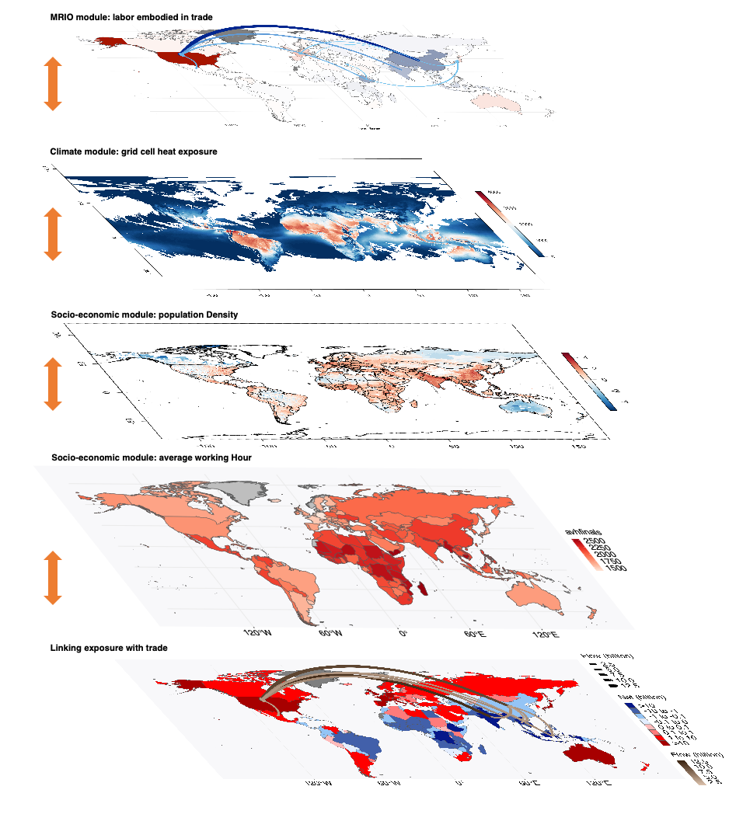
Supplementary Figure 2 | Model framework combining a multi-regional input-output analysis module.

Exposure distribution on the production side
Supplementary Figure 3 | Exposure distribution on the production-side. a, 1995. b, 2000. c, 2005. d, 2010. e, 2015. f, 2020.

Exposure distribution on the consumption-side
Supplementary Figure 4 | Exposure distribution on the consumption-side. a, 1995. b, 2000. c, 2005. d, 2010. e, 2015. f, 2020.

Relationship between heat exposure per capita and GDP per capita
Supplementary Figure 5 | Relationship between heat exposure per capita and GDP per capita in 1995. a, production-side exposure. b, consumption-side exposure.
Supplementary Figure 6 | Relationship between heat exposure per capita and GDP per capita in 2000. a, production-side exposure. b, consumption-side exposure.
Supplementary Figure 7 | Relationship between heat exposure per capita and GDP per capita in 2005. a, production-side exposure. b, consumption-side exposure.
Supplementary Figure 8 | Relationship between heat exposure per capita and GDP per capita in 2010. a, production-side exposure. b, consumption-side exposure.

Supplementary Figure 9 | Relationship between heat exposure per capita and GDP per capita in 2015. a, production-side exposure. b, consumption-side exposure.
Supplementary Figure 10 | Relationship between heat exposure per capita and GDP per capita in 2020. a, production-side exposure. b, consumption-side exposure.

Countries’ labor heat exposure on the production and consumption side
Supplementary Figure 11 | Production-based labor force heat exposure in 1995. a, total labor force. b, female labor. c, male labor.
Supplementary Figure 12 | Production-based labor force heat exposure in 2015. a, total labor force. b, female labor. c, male labor.
Supplementary Figure 13 | Consumption-based labor force heat exposure in 1995 (unit: person-hour). a, total labor force. b, female labor. c, male labor.
Supplementary Figure 14 | Consumption-based labor force heat exposure in 2015. a, total labor force. b, female labor. c, male labor.

Lorenz curve and Gini index of global work force heat exposure
Supplementary Figure 15 | Lorenz curve of global work force heat exposure on the production side. a, 1995. b, 2000. c, 2005. d, 2010. e, 2015. f, 2020.
Supplementary Figure 16 | Lorenz curve of global work force heat exposure on the consumption side. a, 1995. b, 2000. c, 2005. d, 2010. e, 2015. f, 2020.

Socio-economic characteristics of major economies
Supplementary Figure 17 | Socio-economic characteristics of major economies in 1995 and 2020. a, GDP per capita. b, Share of heavy work. c, Average annual per capita work hours. d, Annual per capita work hours under heat. The yellow dots represent year 1995 and the blue dots represent year 2015.

Top flows of exposure embedded in trade
Supplementary Figure 18 | Top flows of exposure embedded in trade a, 1995. b, 2000. c, 2005. d, 2010. e, 2015. f, 2020.

Exposure embedded in exports and imports
Supplementary Figure 19 | Exposure embedded in exports and imports for top twenty countries with the largest exposure trading volume. a, 1995. b, 2000. c, 2005. d, 2010. e, 2015. f, 2020.

Heavy work labor and their exposure to extreme heat

Supplementary Figure 20 | Comparison between all work and heavy work. a, d, World’s total exposure and total exposure of heavy work to extreme heat classified by domestic-production-related and trade-related and by female and female. The connected lines represent relevant growth compared to the base year 1995. b, e, World’s total labor employment classified by domestic-production-related and trade-related. The connected lines represent relevant growth. c, f, The average annual exposure per capital for domestic-production-related and trade-related workers. The connected lines represent relevant growth.
Supplementary Figure 21 | Share of heavy exposure distribution on the consumption-side. a, 1995. b, 2000. c, 2005. d, 2010. e, 2015. f, 2020.
Supplementary Figure 22 | Heavy work Heat exposure distribution on the production-side. a, 1995. b, 2000. c, 2005. d, 2010. e, 2015. f, 2020

Supplementary Figure 23 | Top flows of heavy work exposure embedded in trade in (a) 1995, (b) 2000, (c) 2005, (d) 2010, (e) 2015, (f) 2020. The filled color of countries represents their exposure balance measured by the difference between their consumption-side exposure and production-side exposure. Countries filled in red have net exposure import via trade (outsourcing to foreign counties) and those filled in blue have net exposure export via trade (produce for foreign countries). The arrows represent the top ten exposure flows between different countries, in which the color and arrow width corresponds to the size of the flow.

Heat Stress for analysed economies
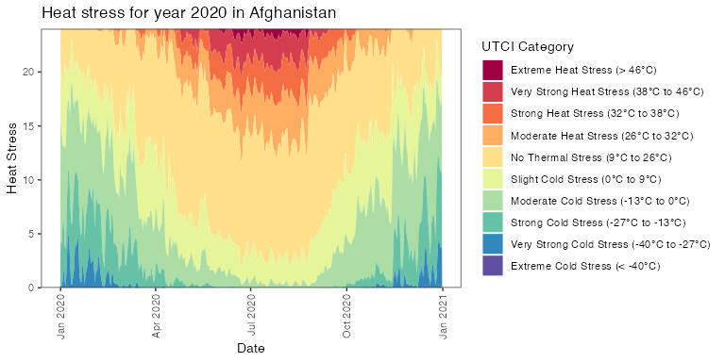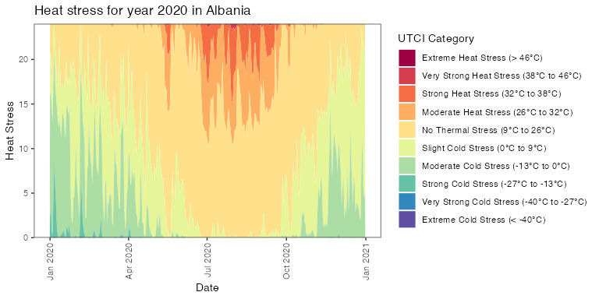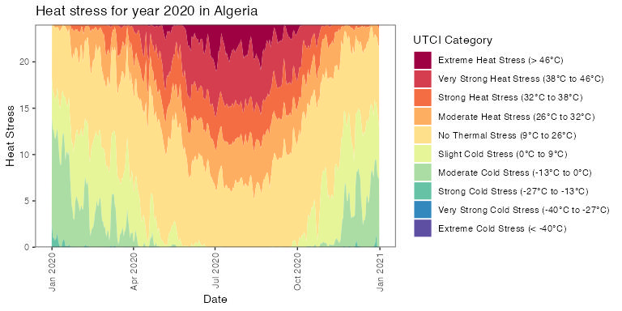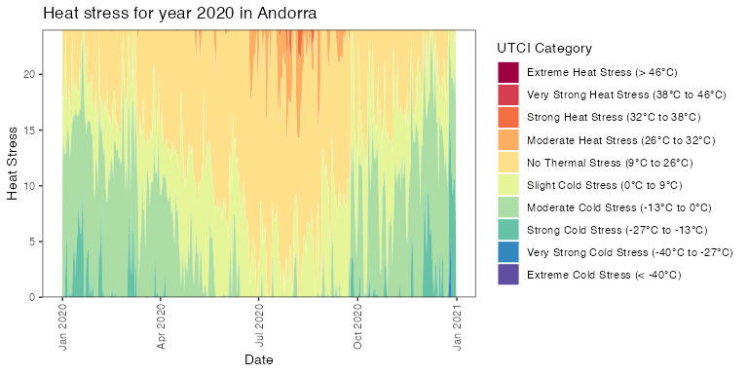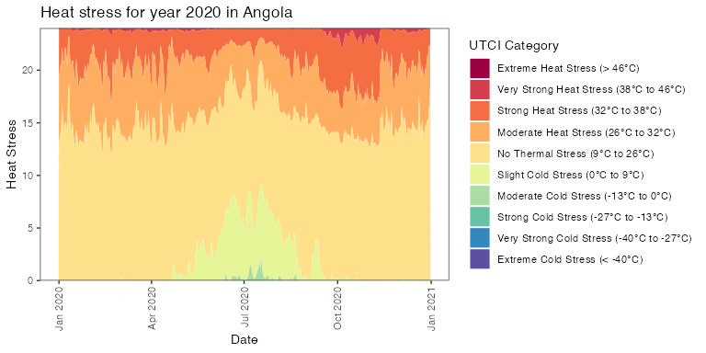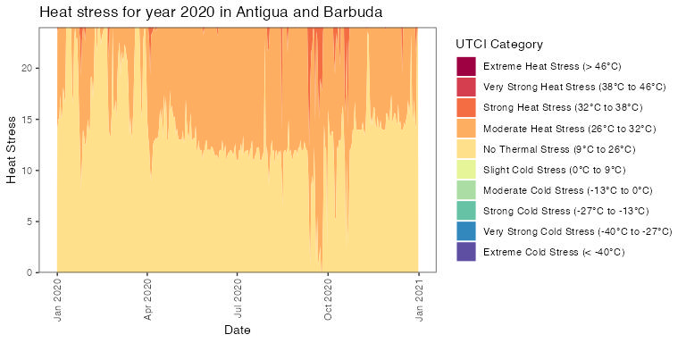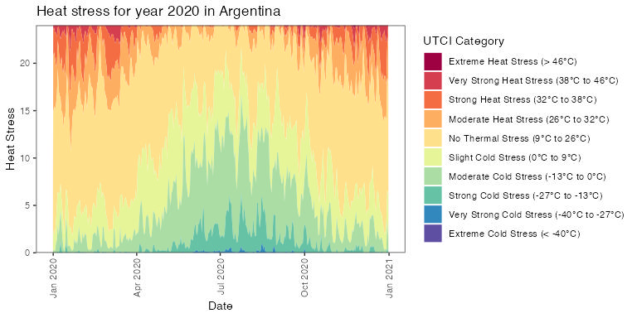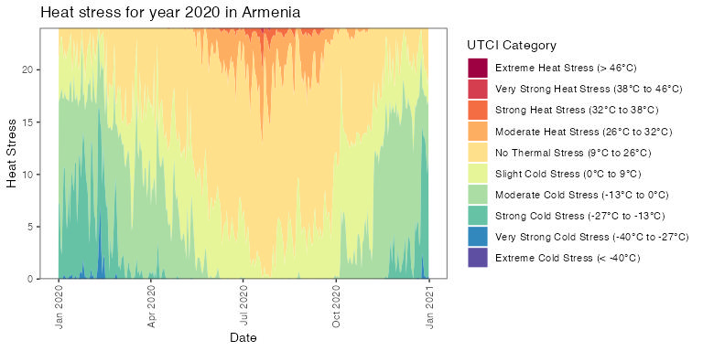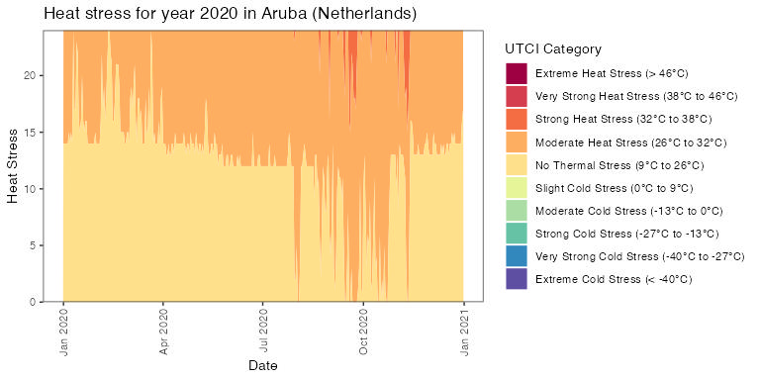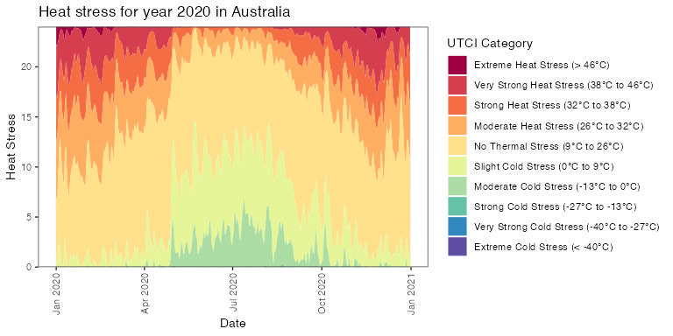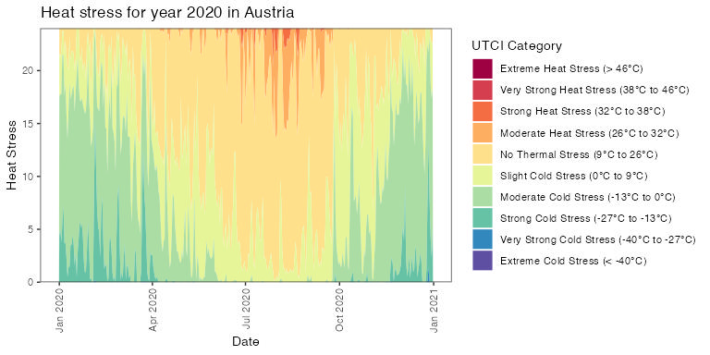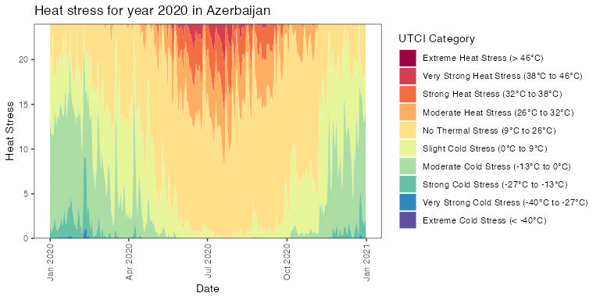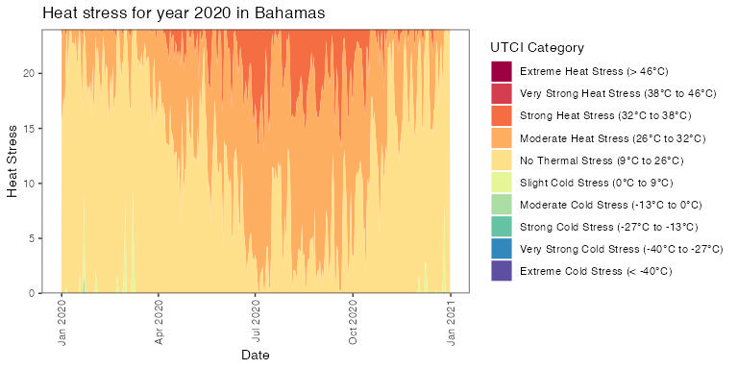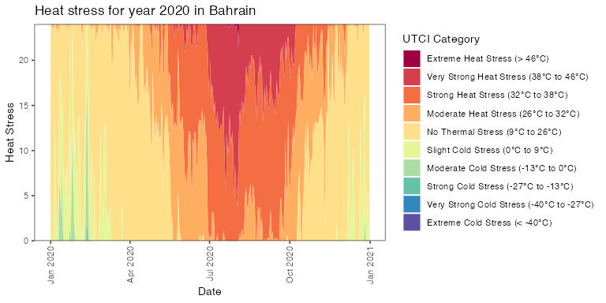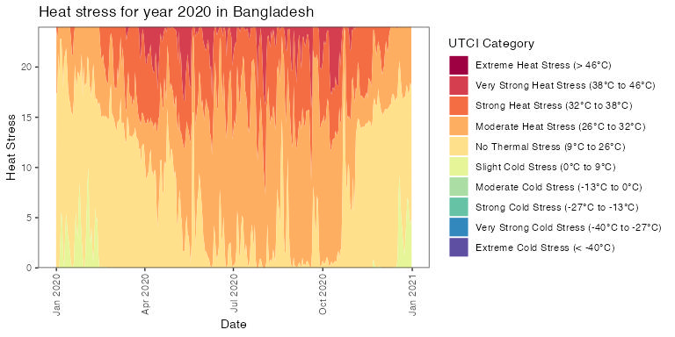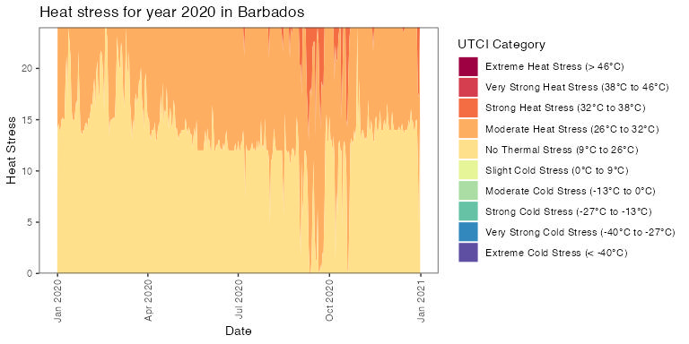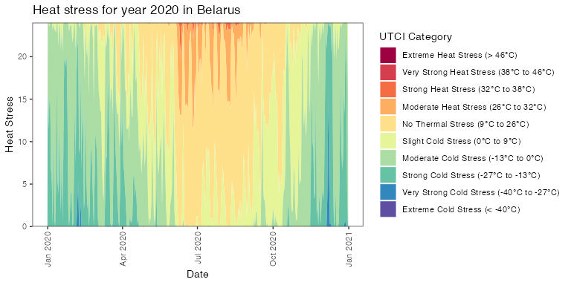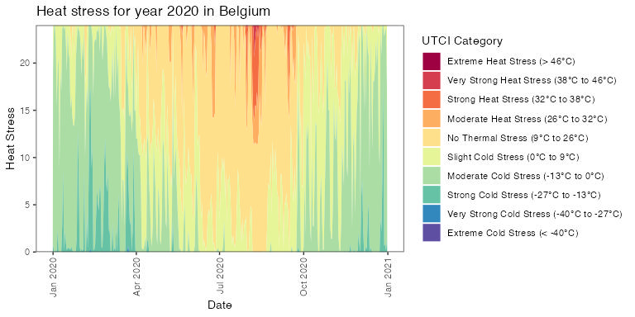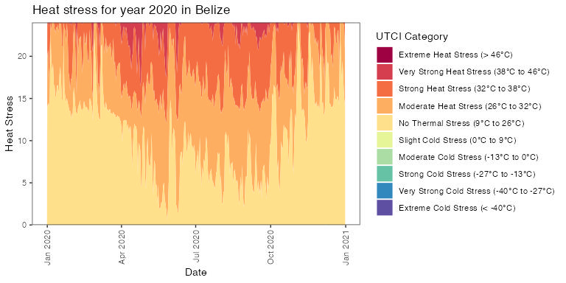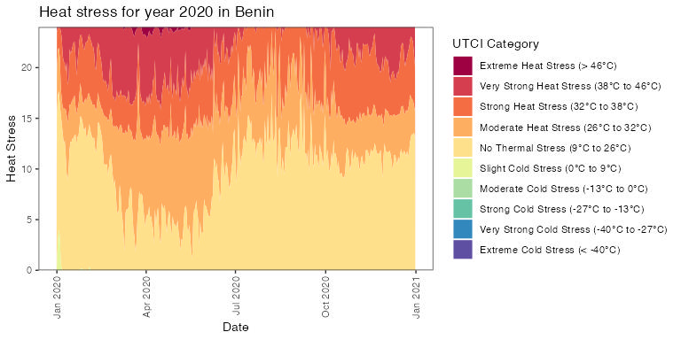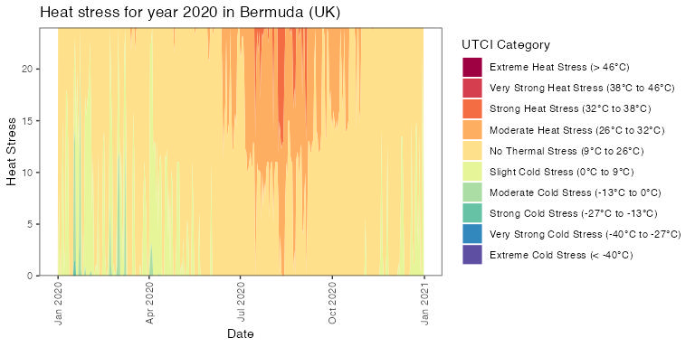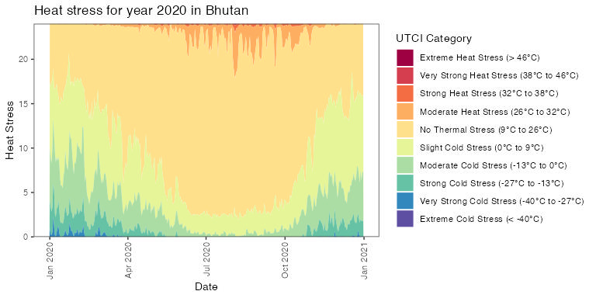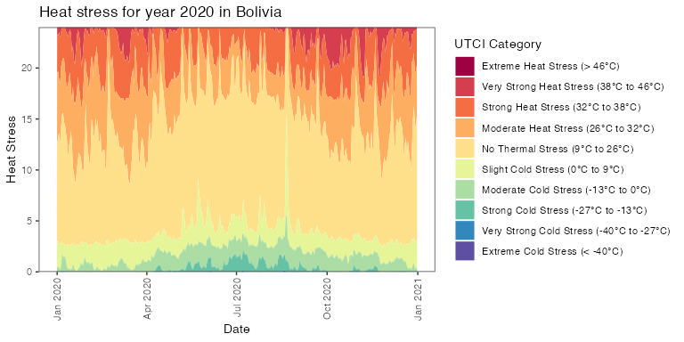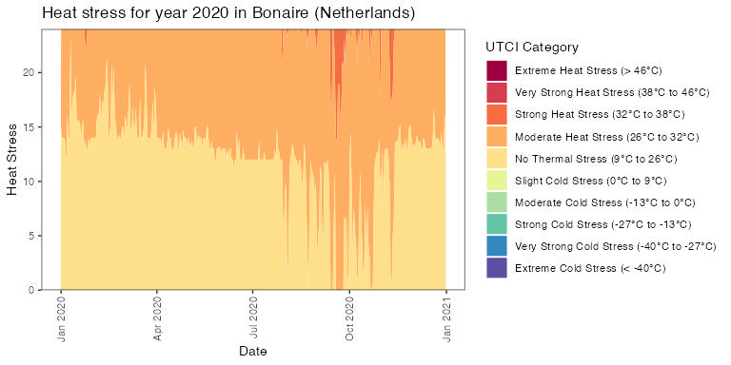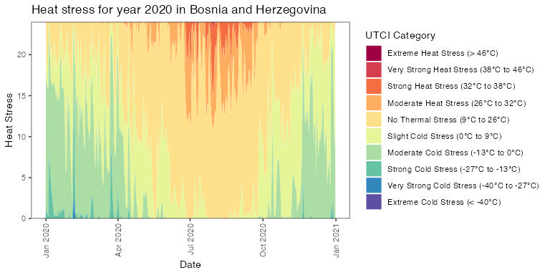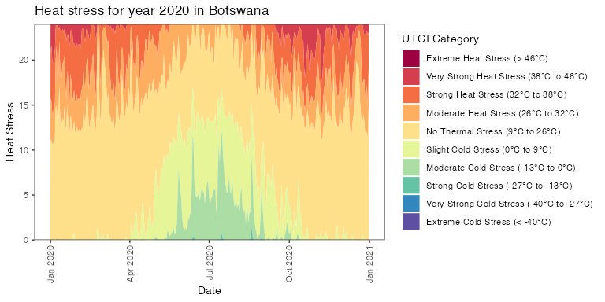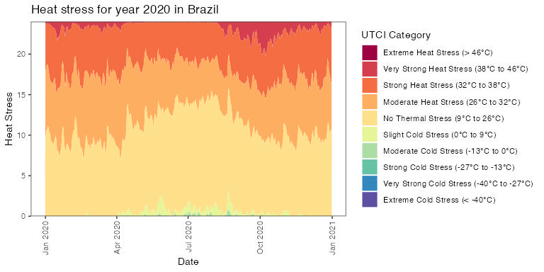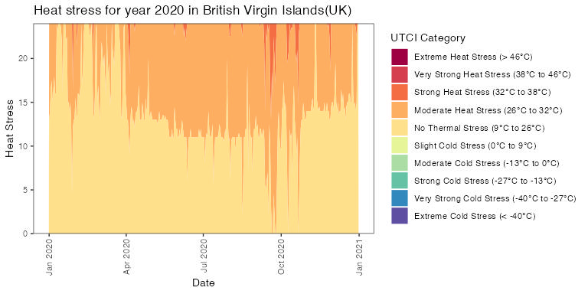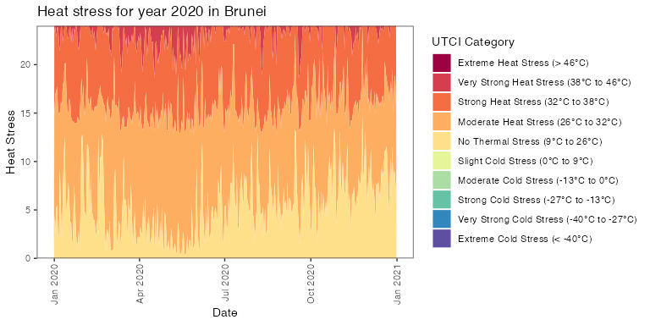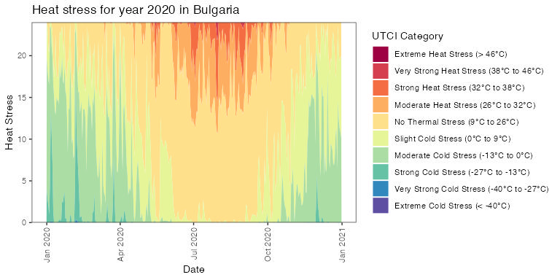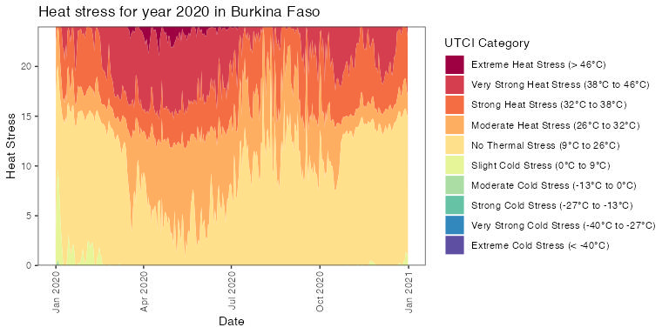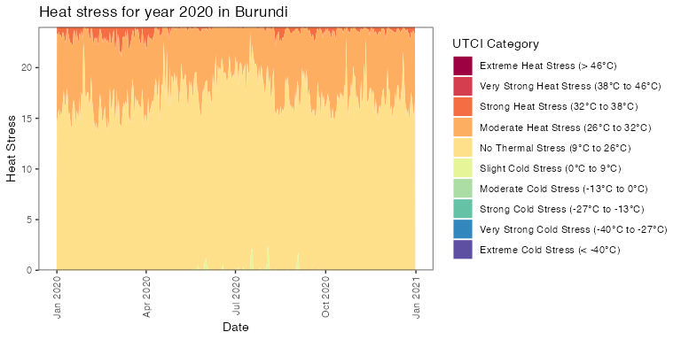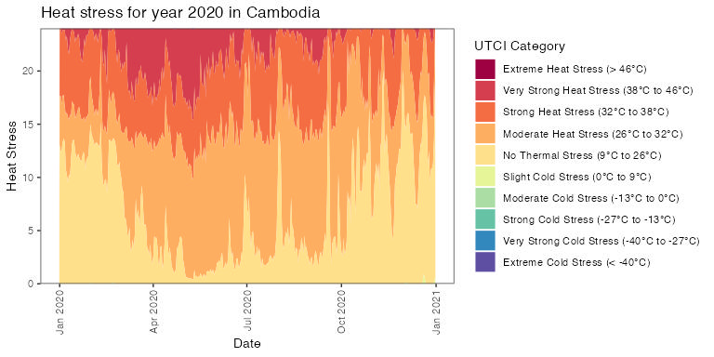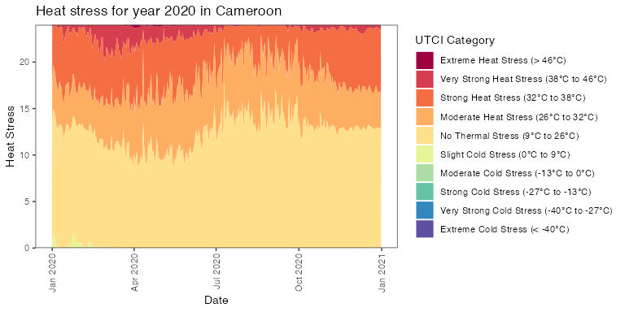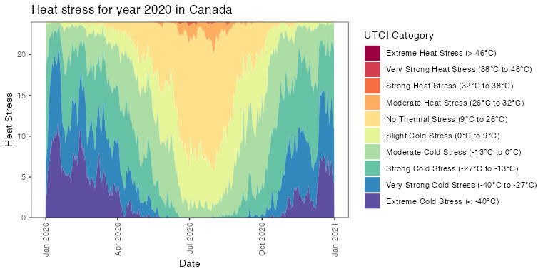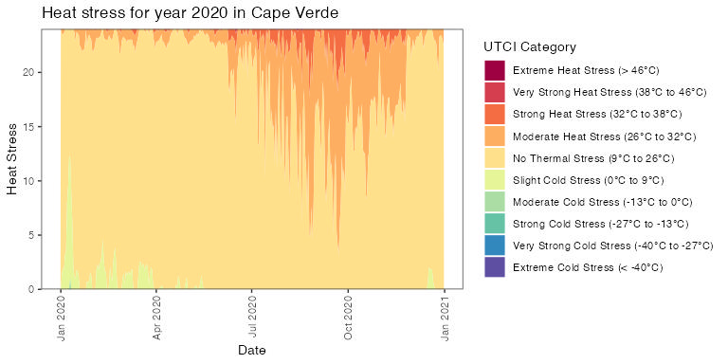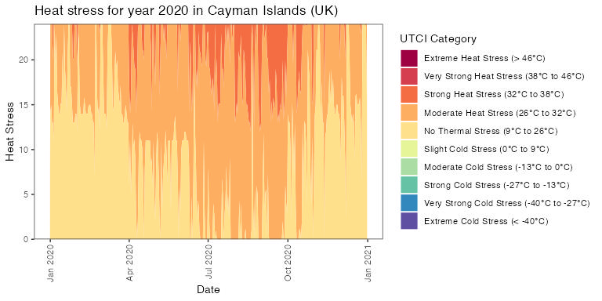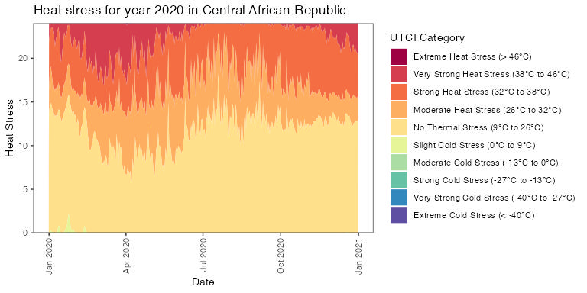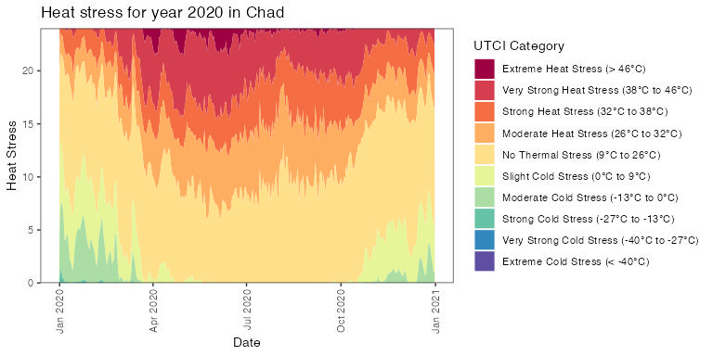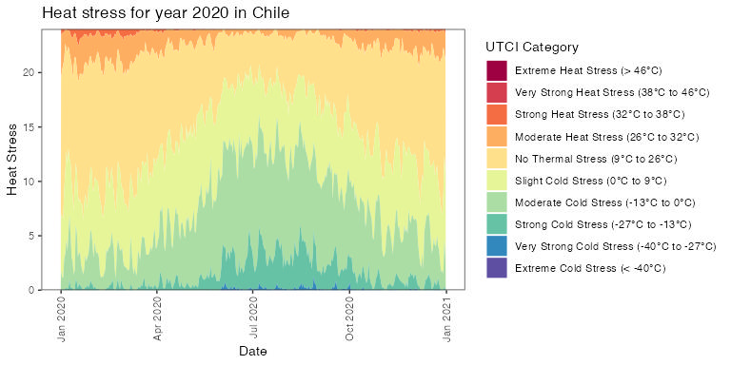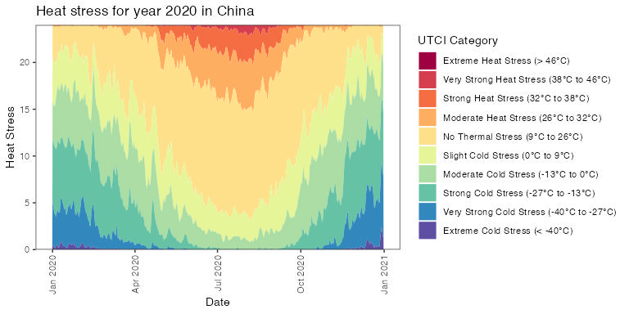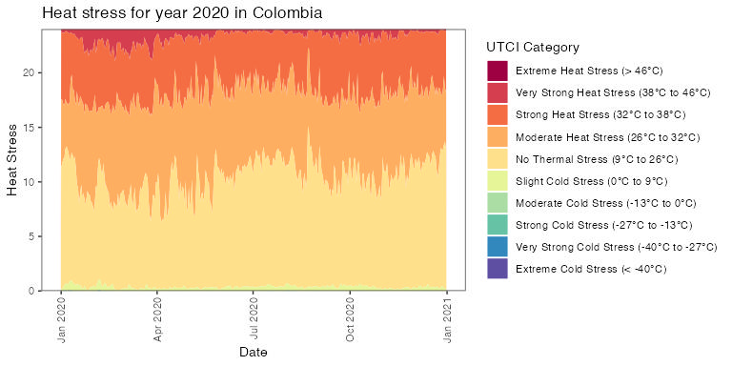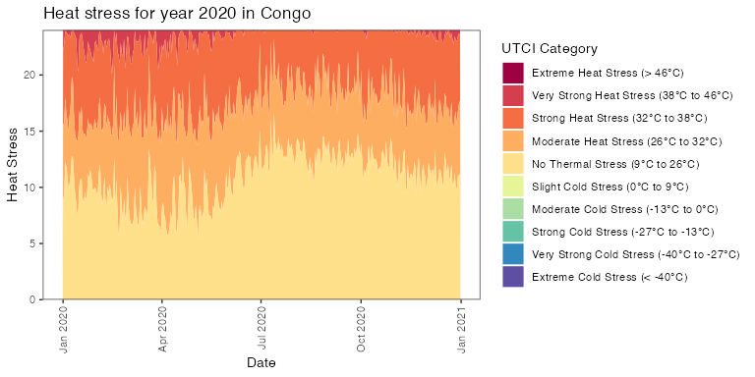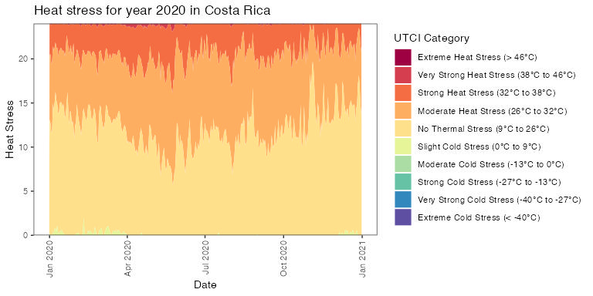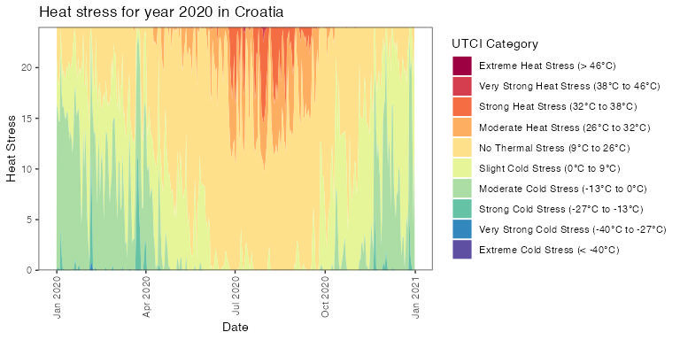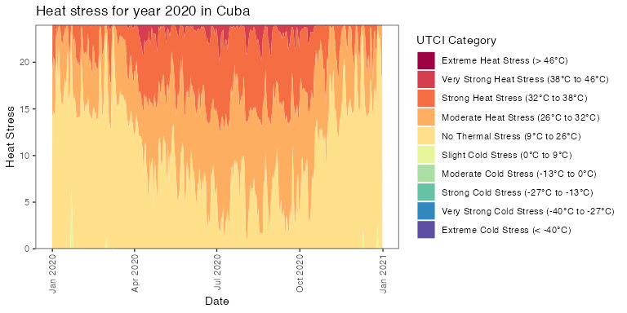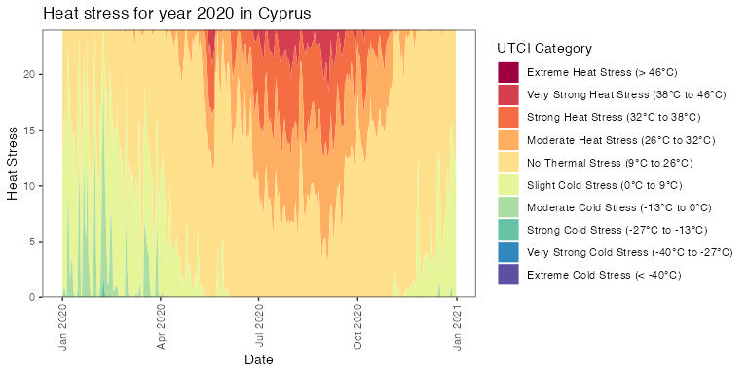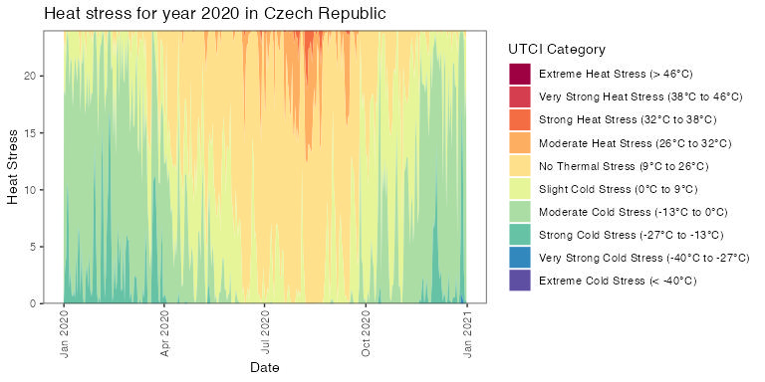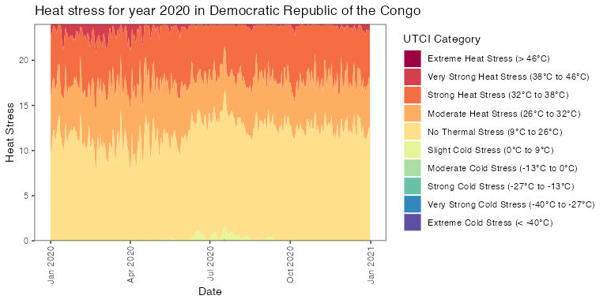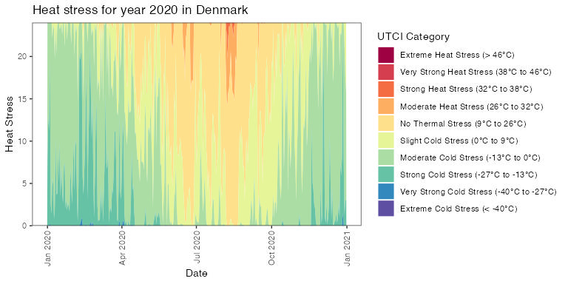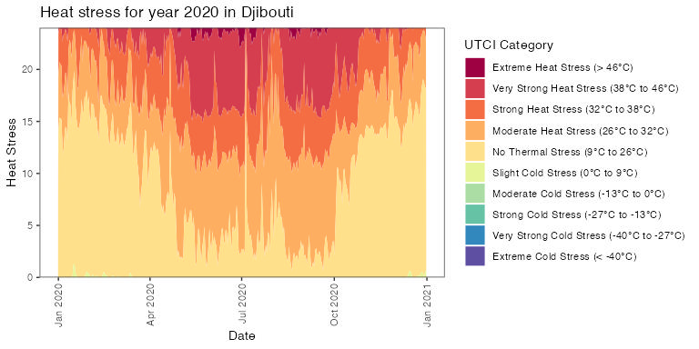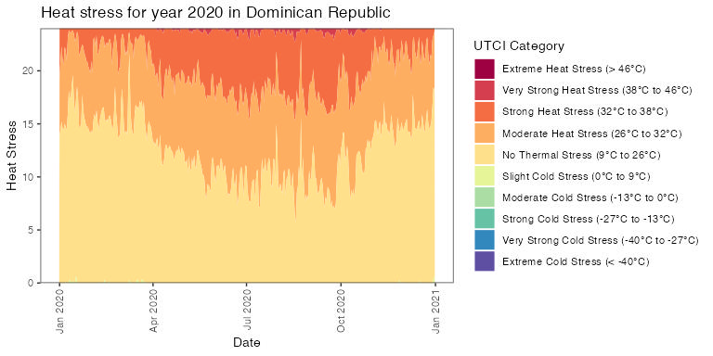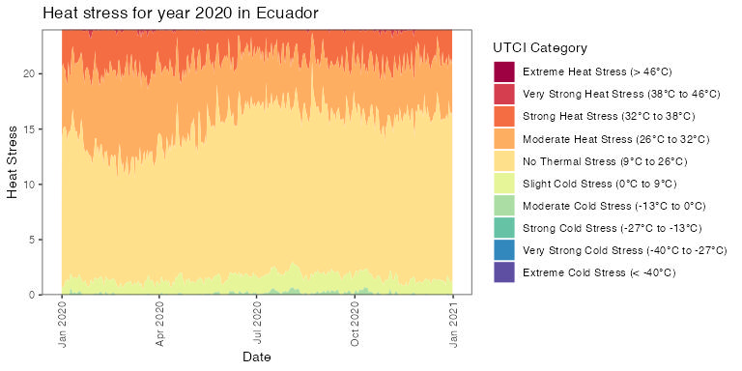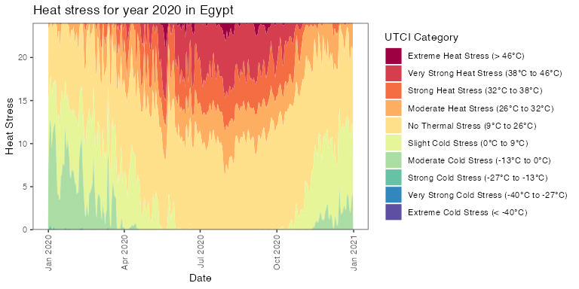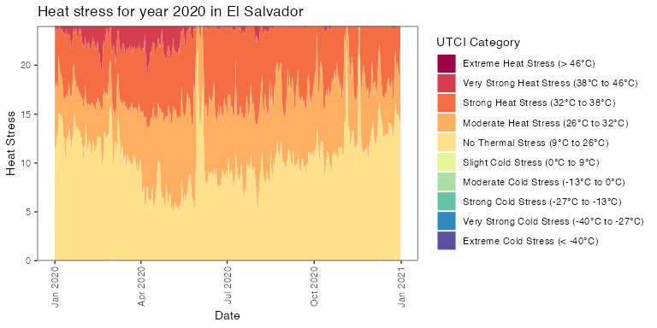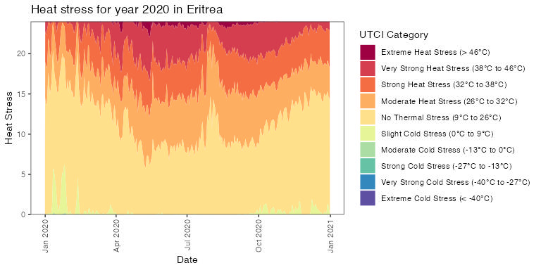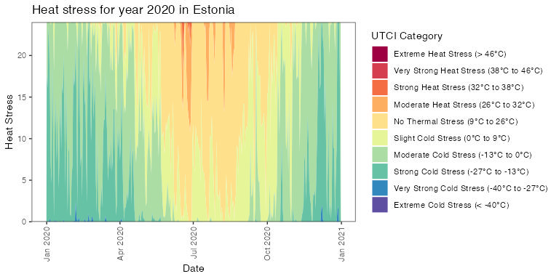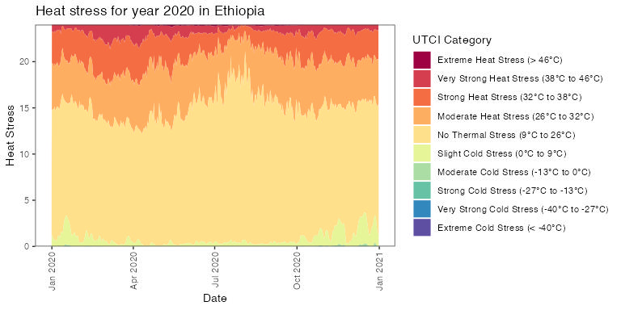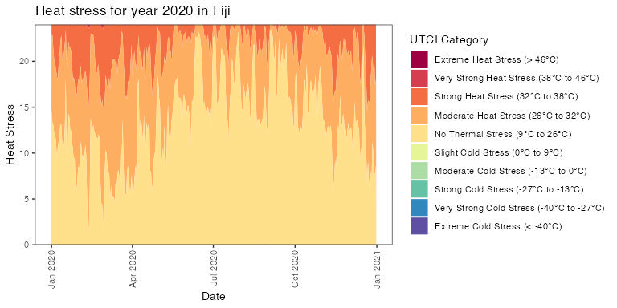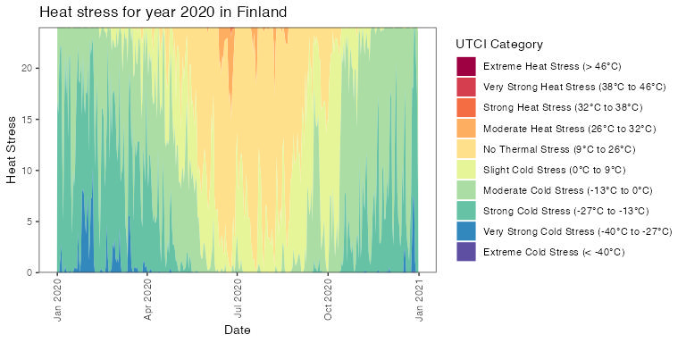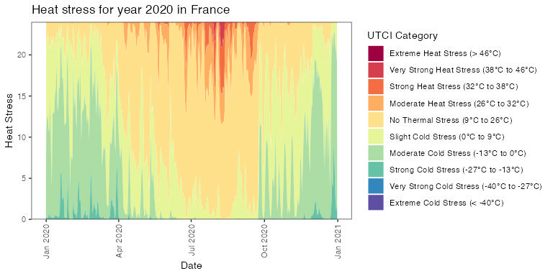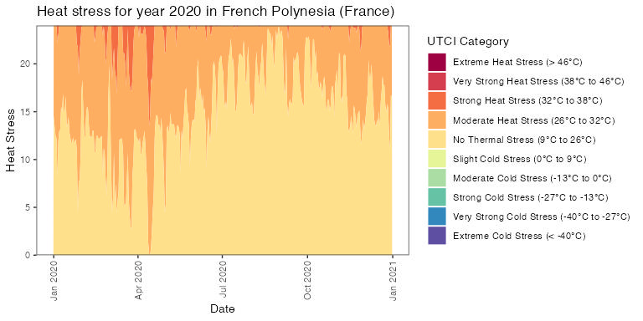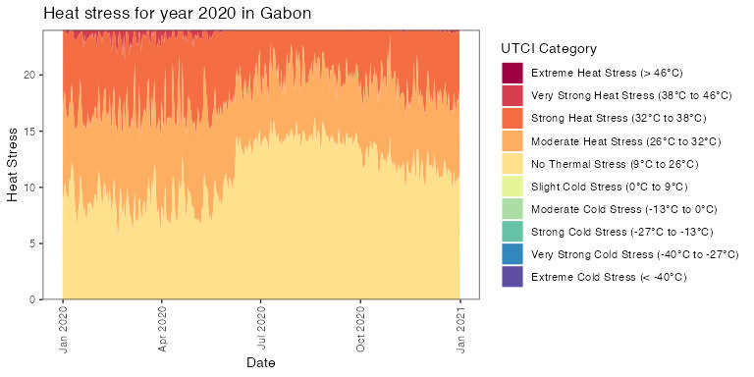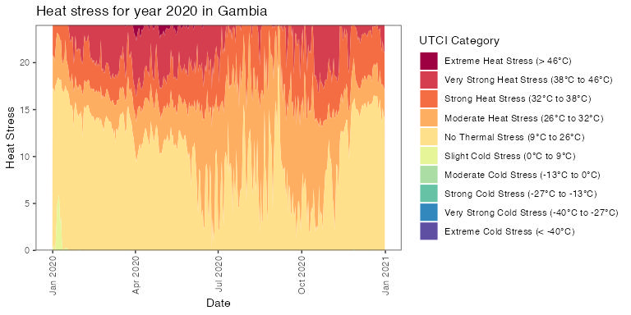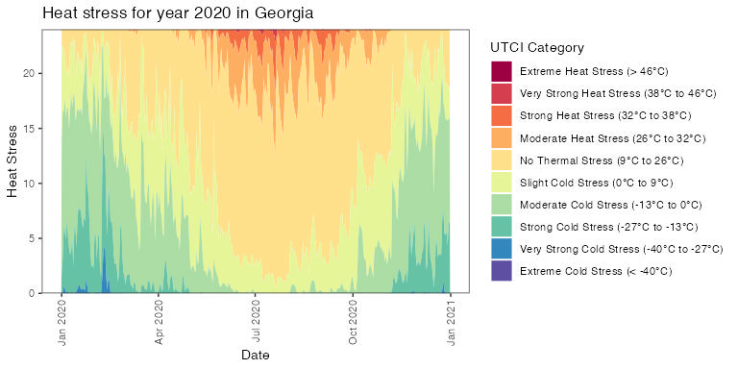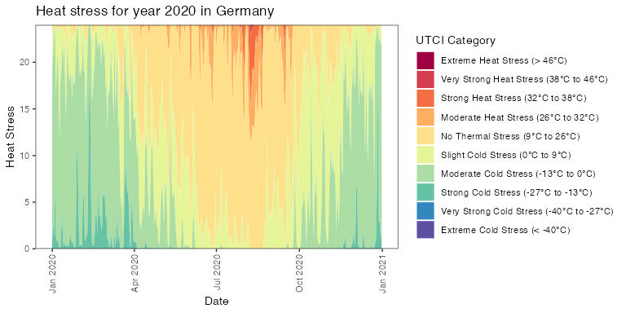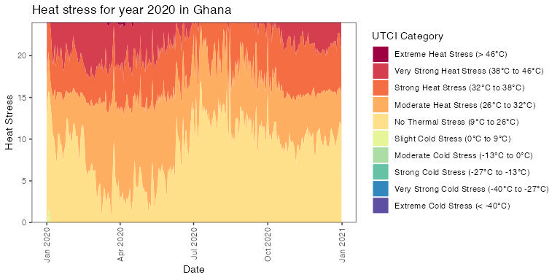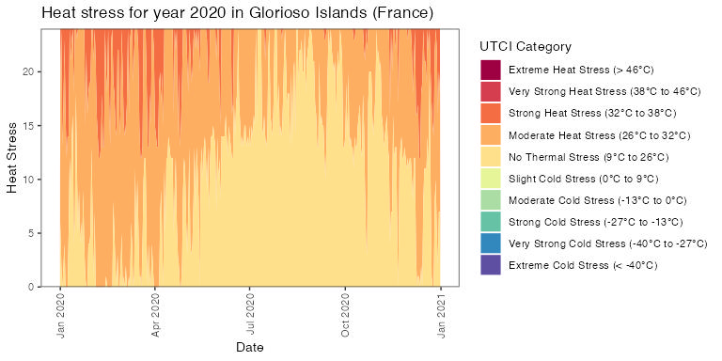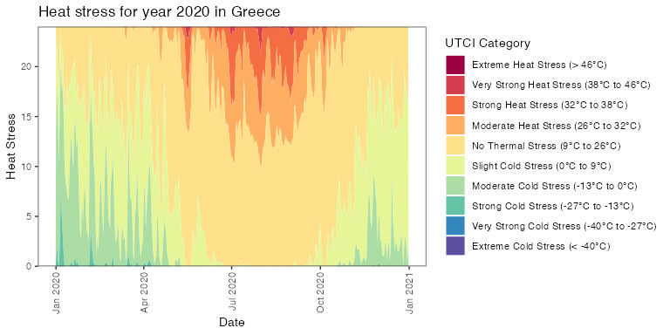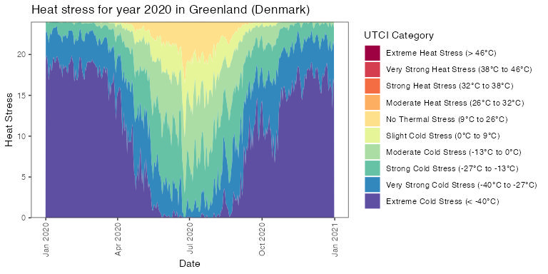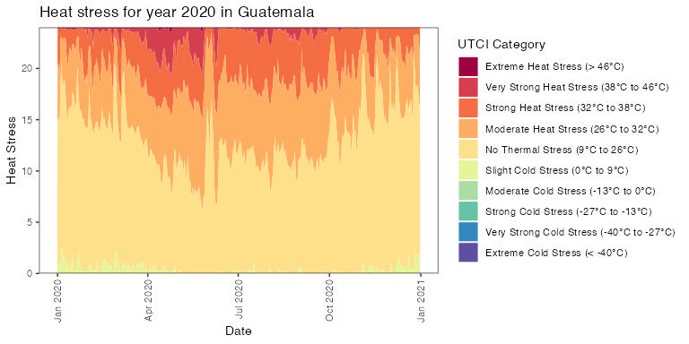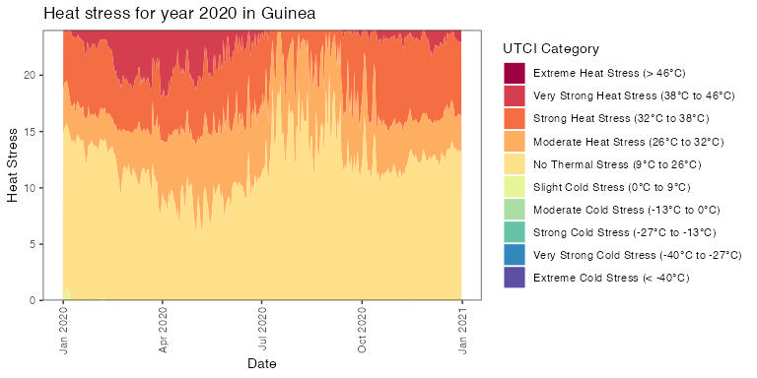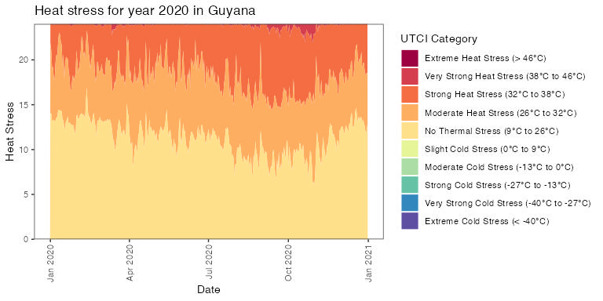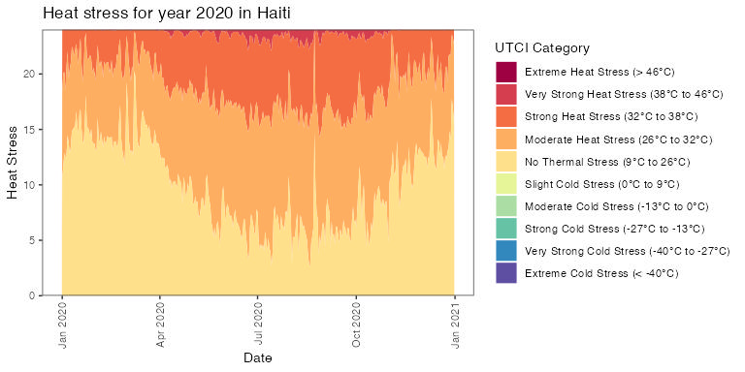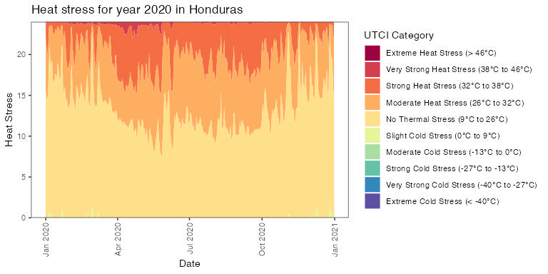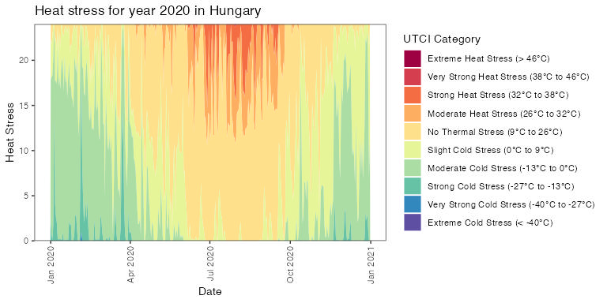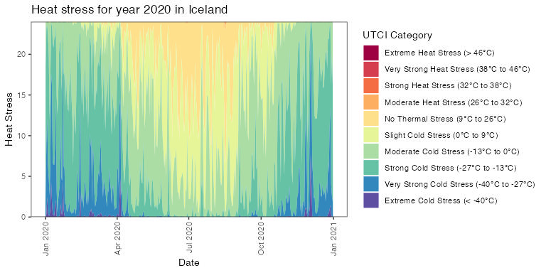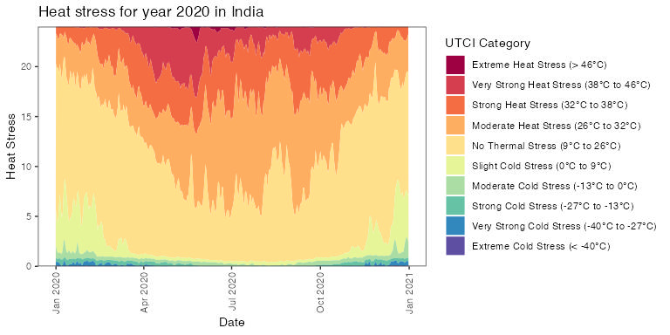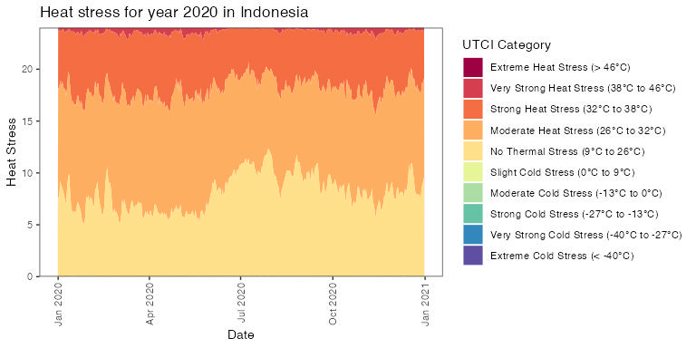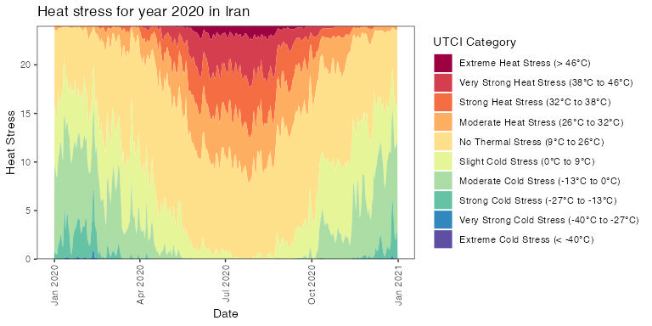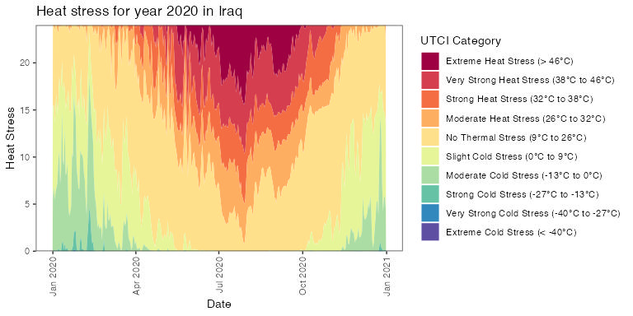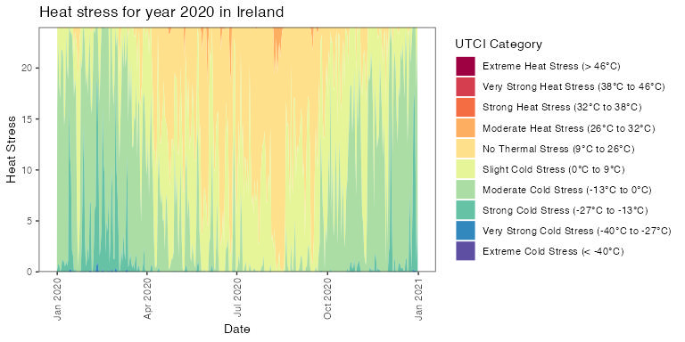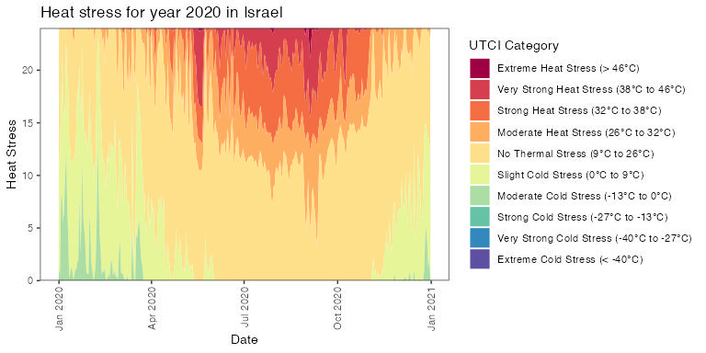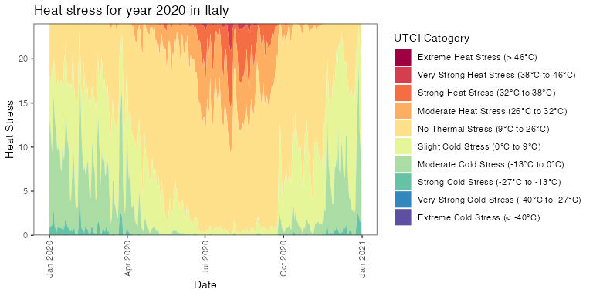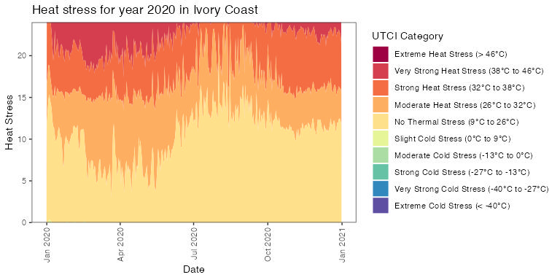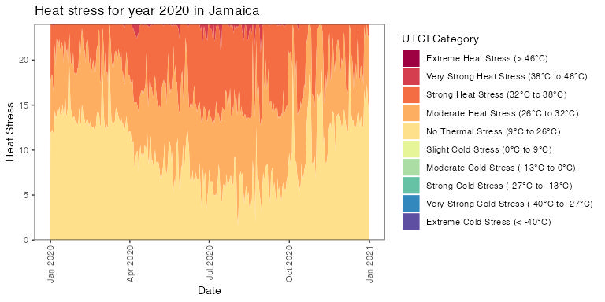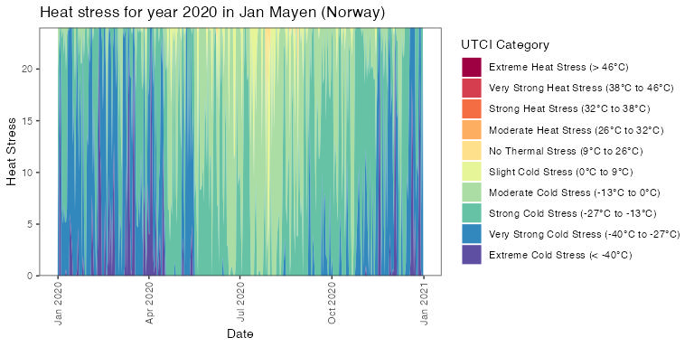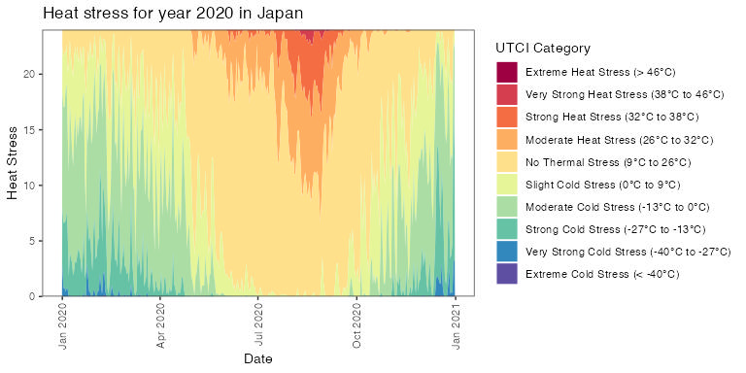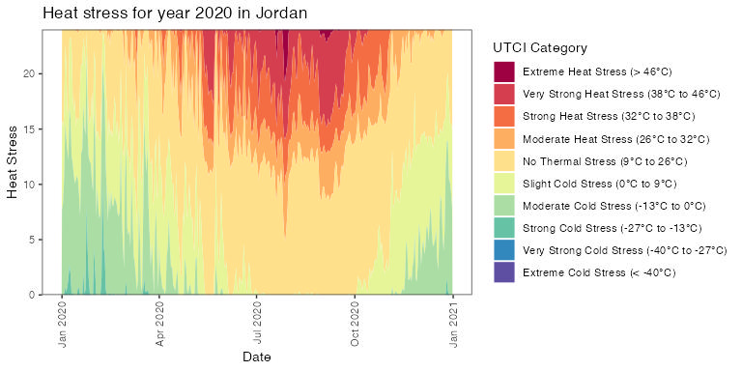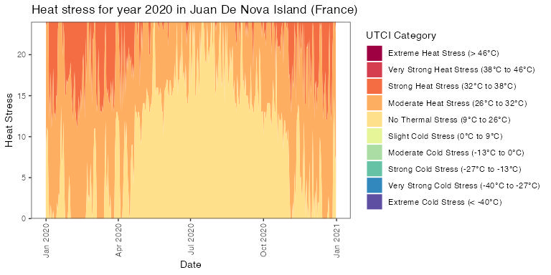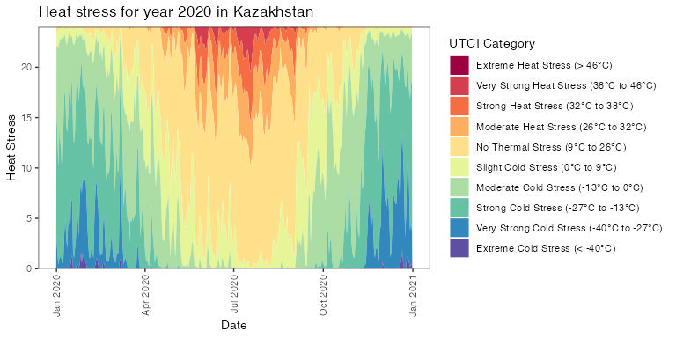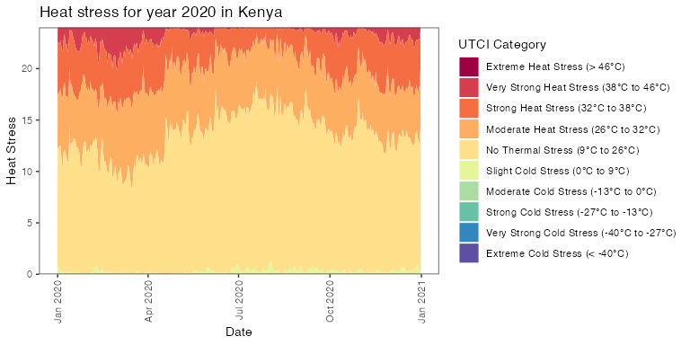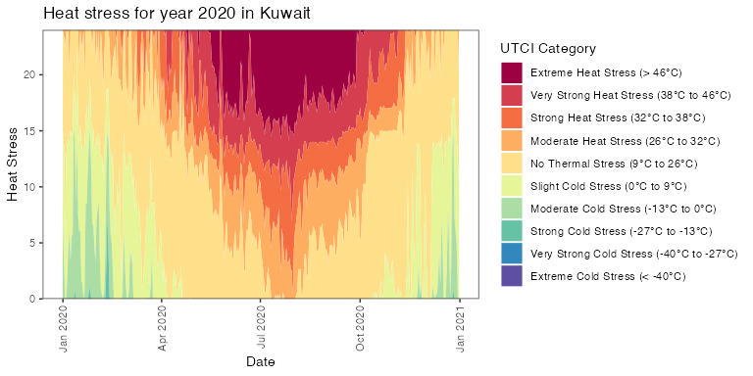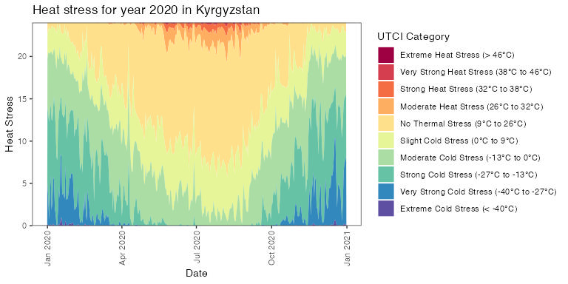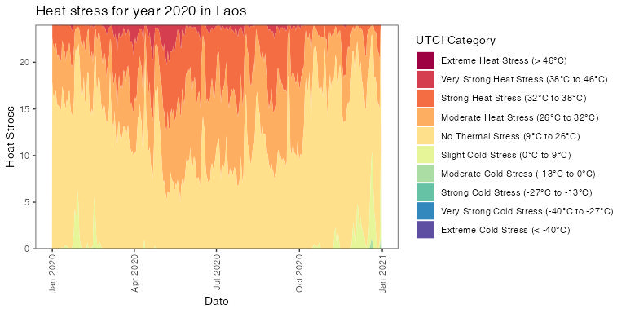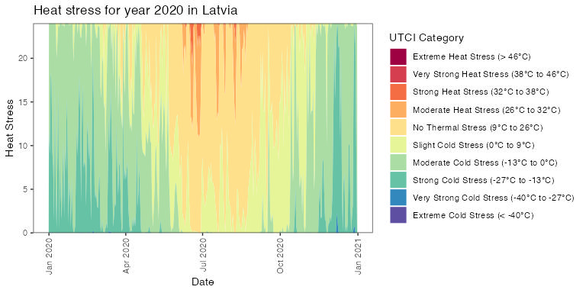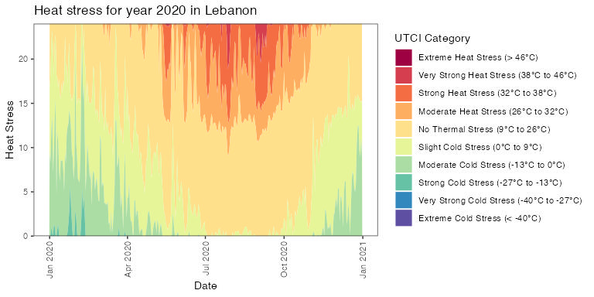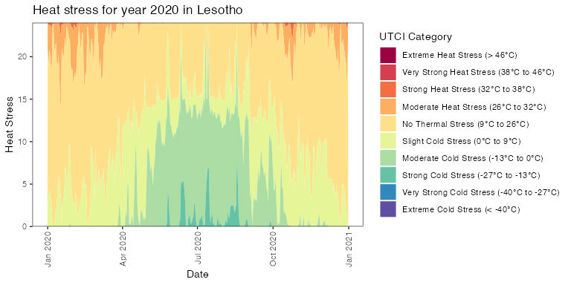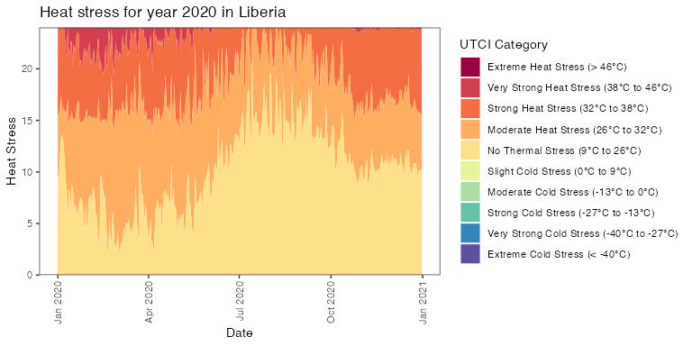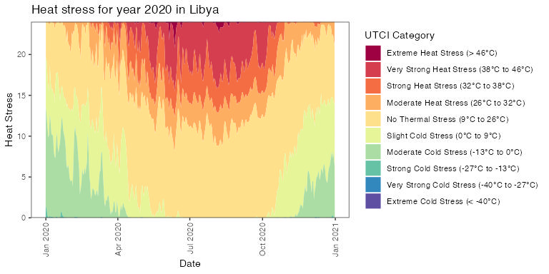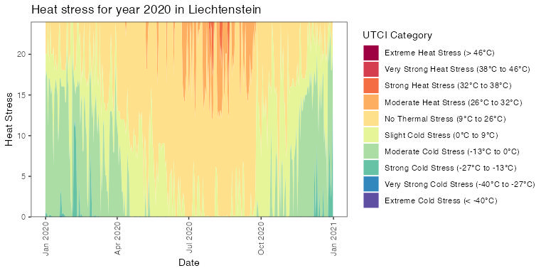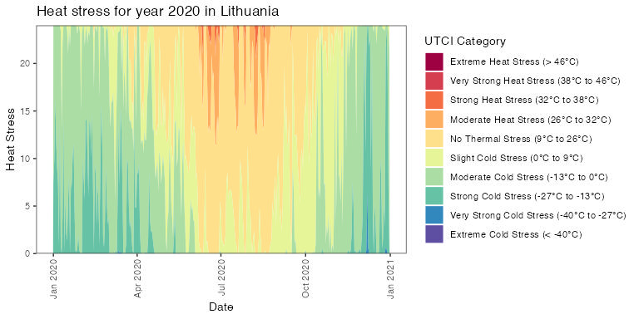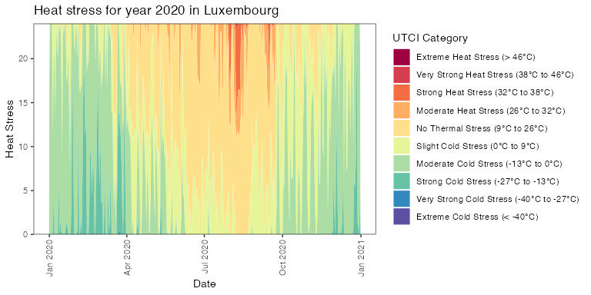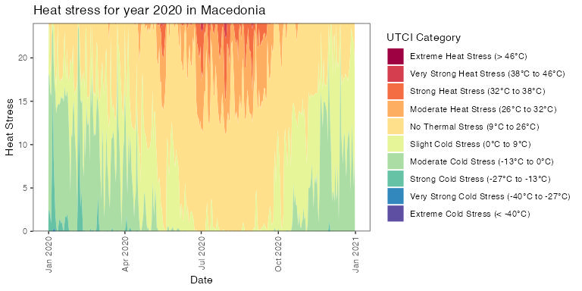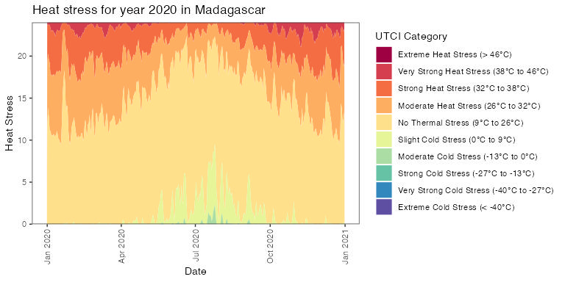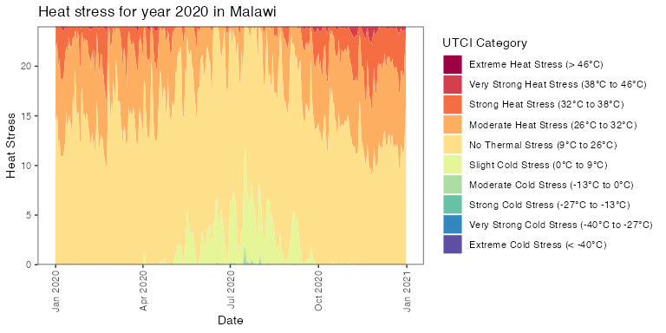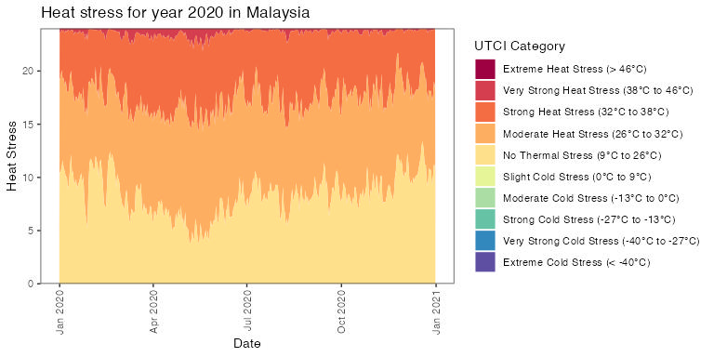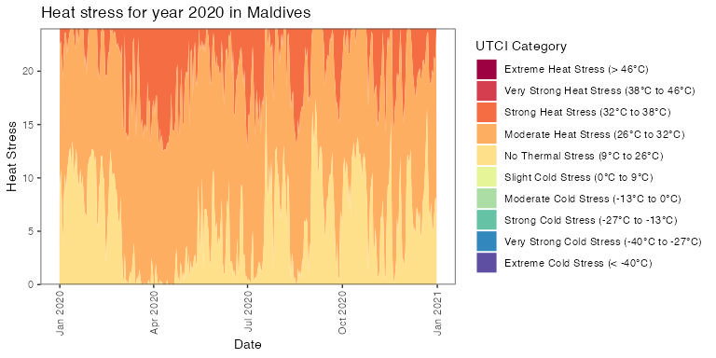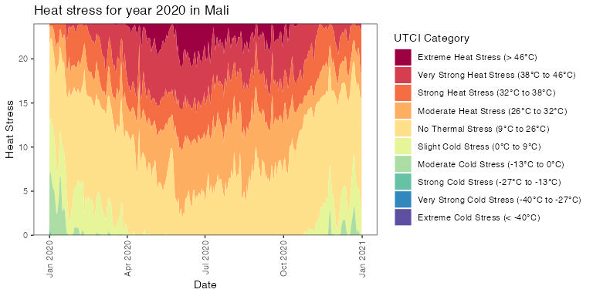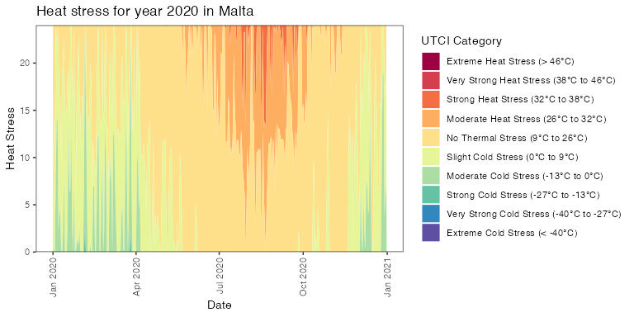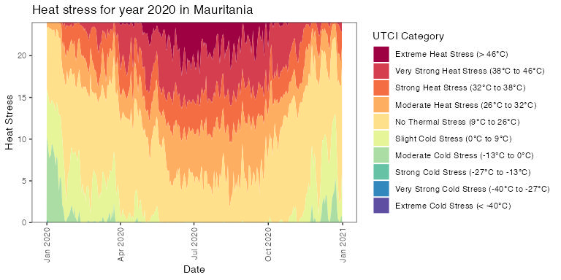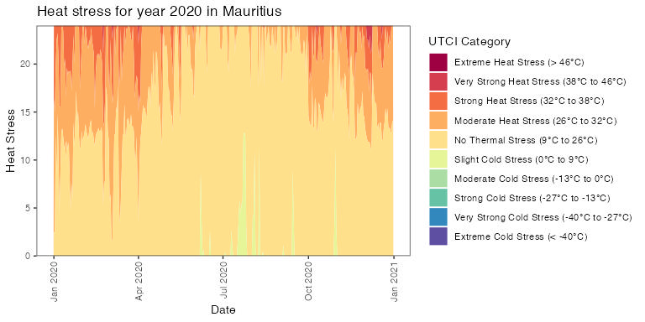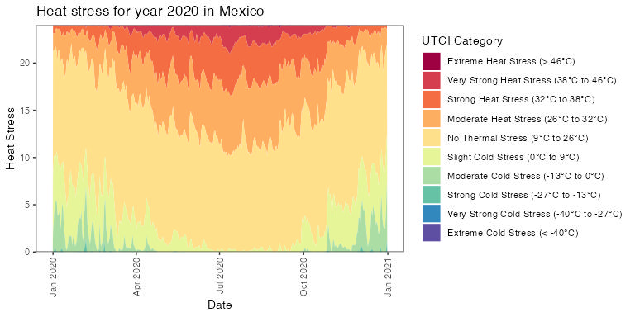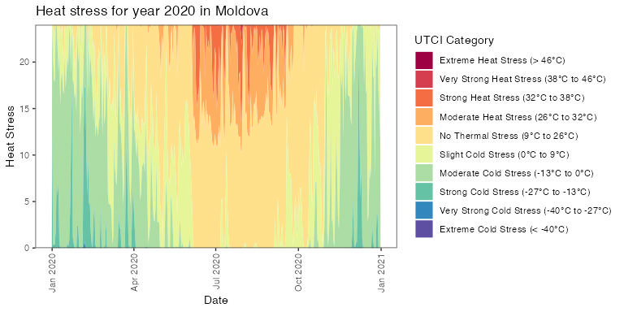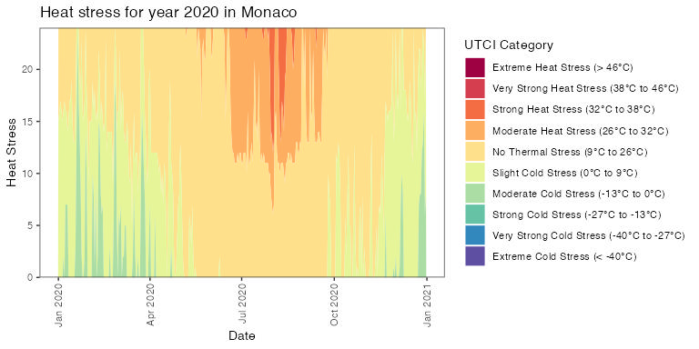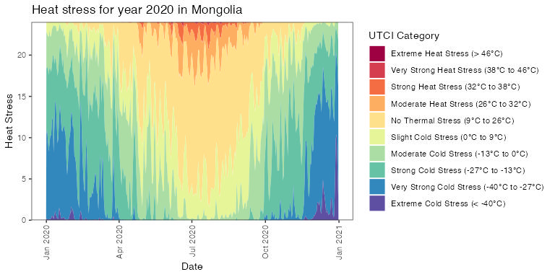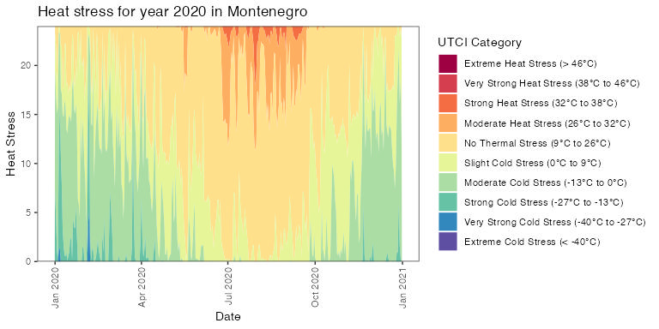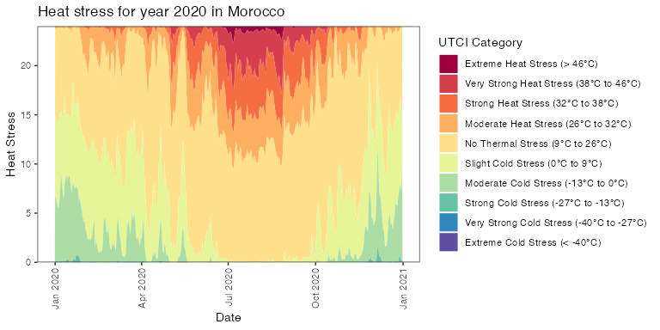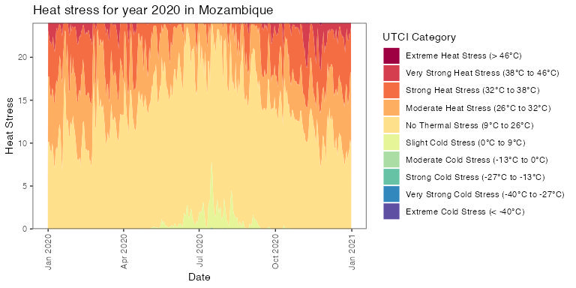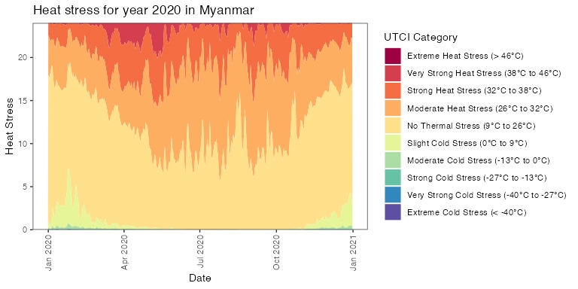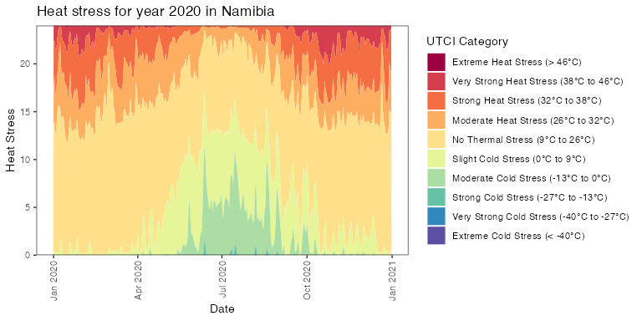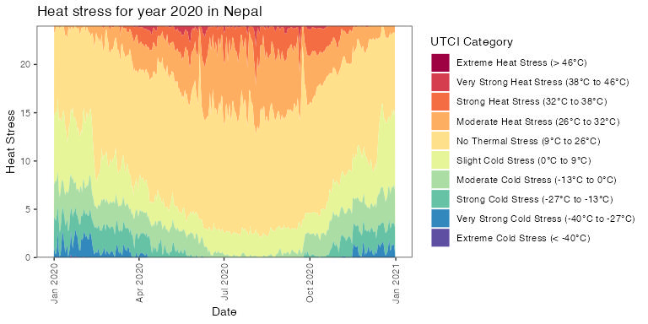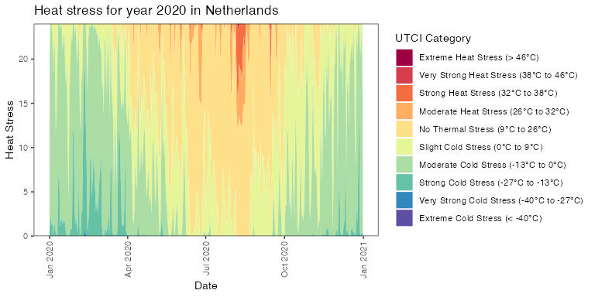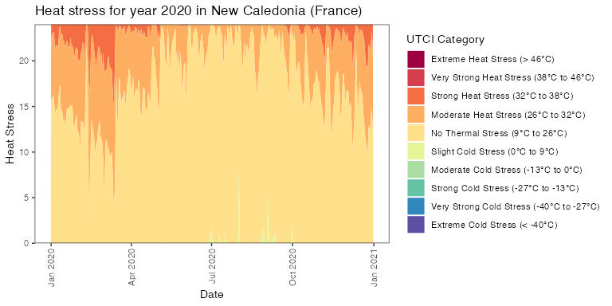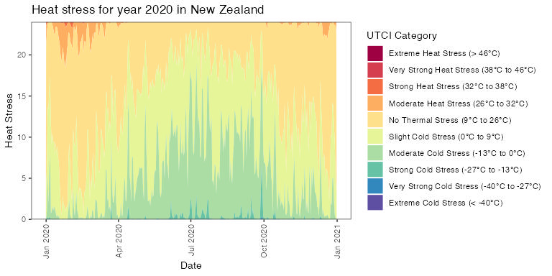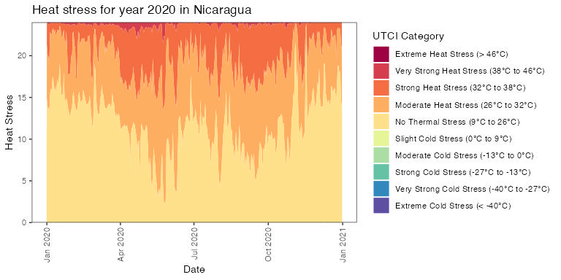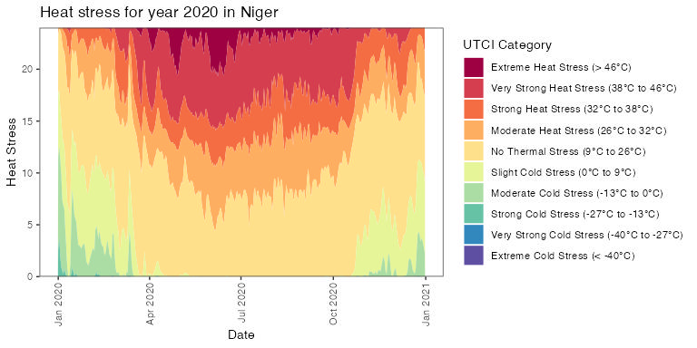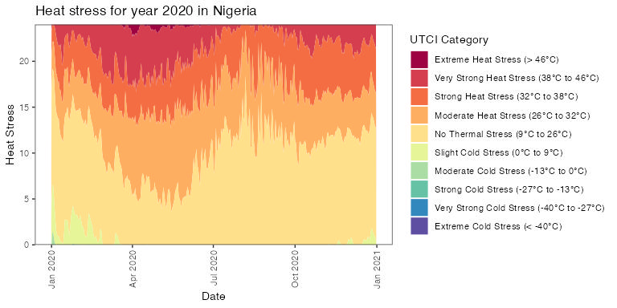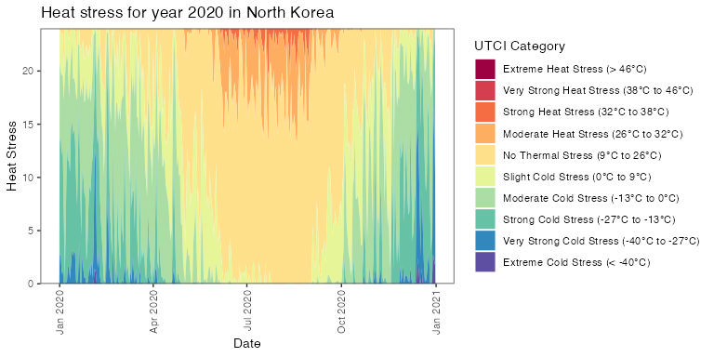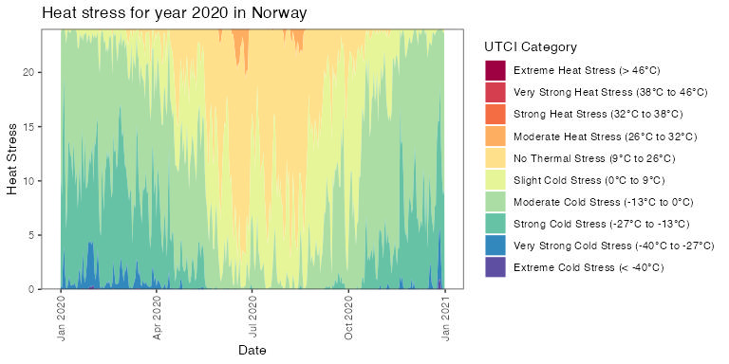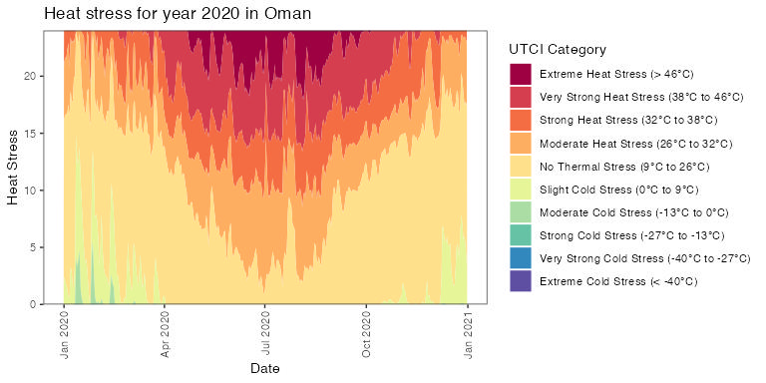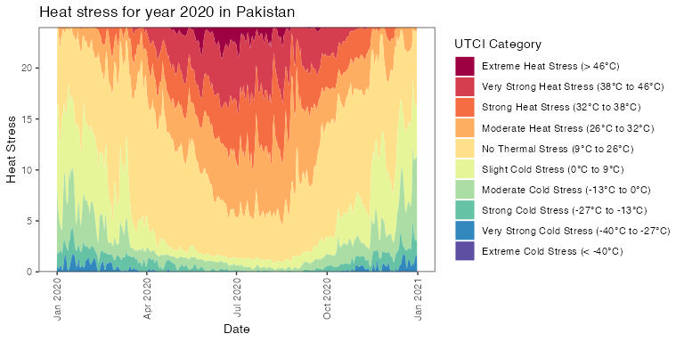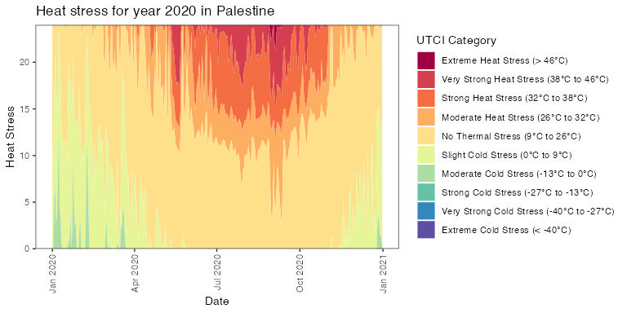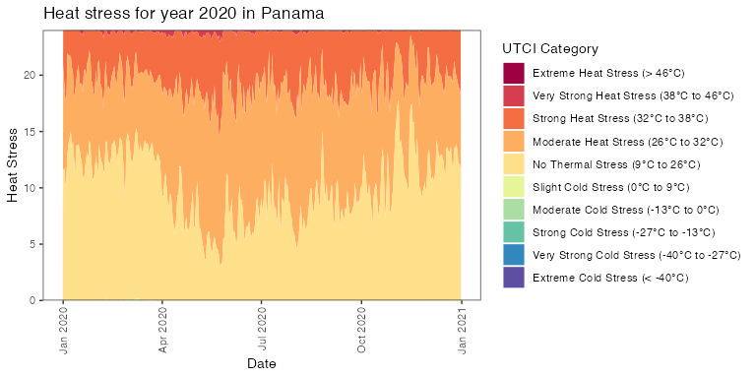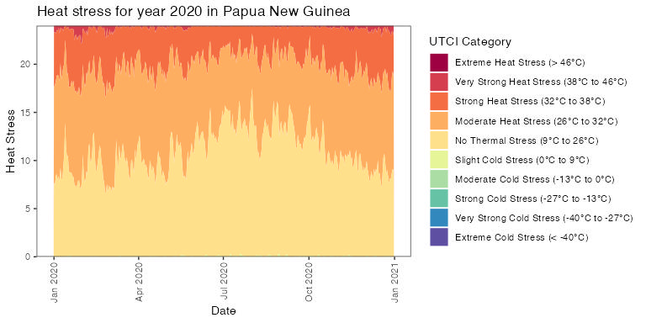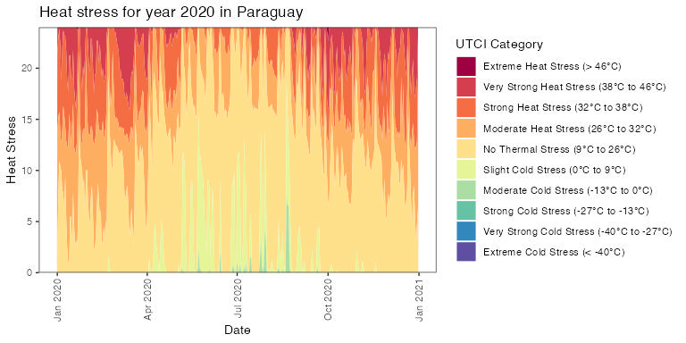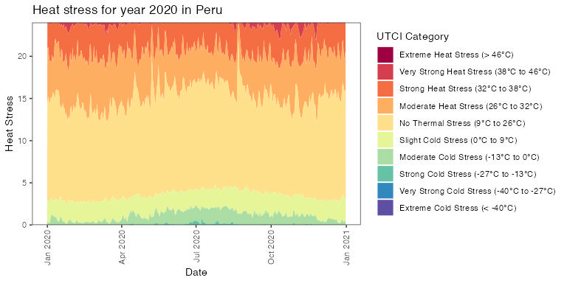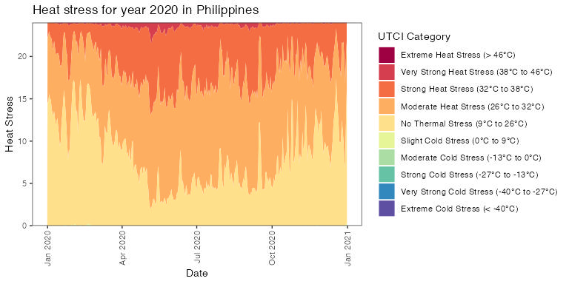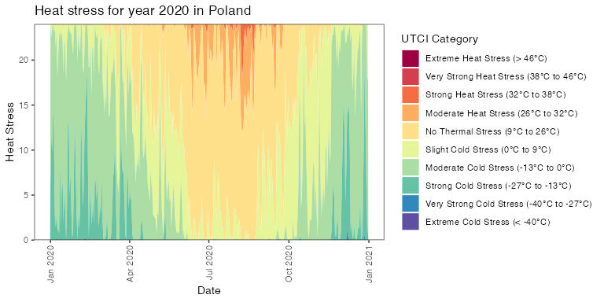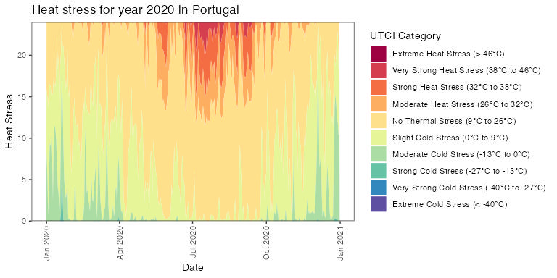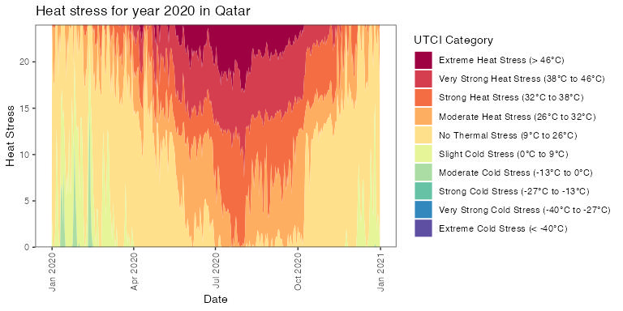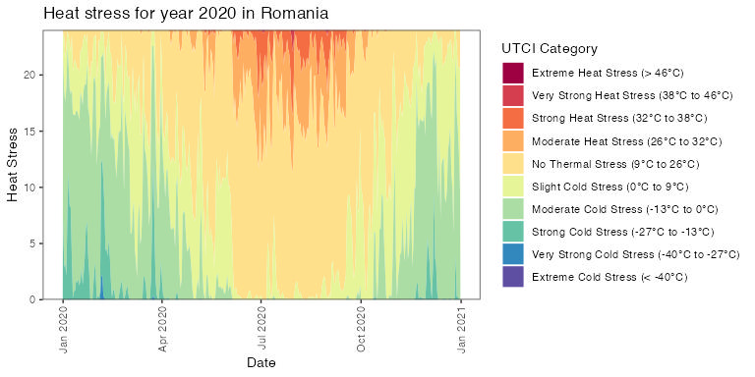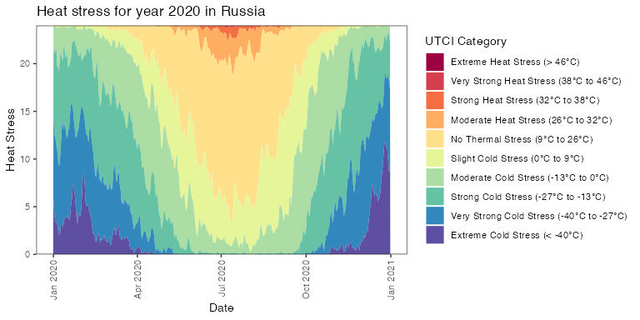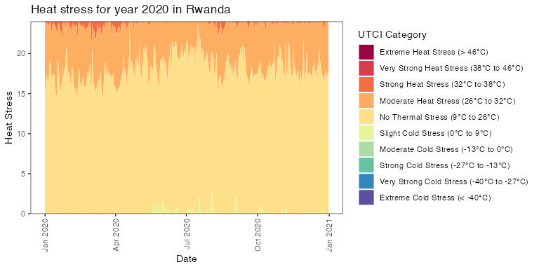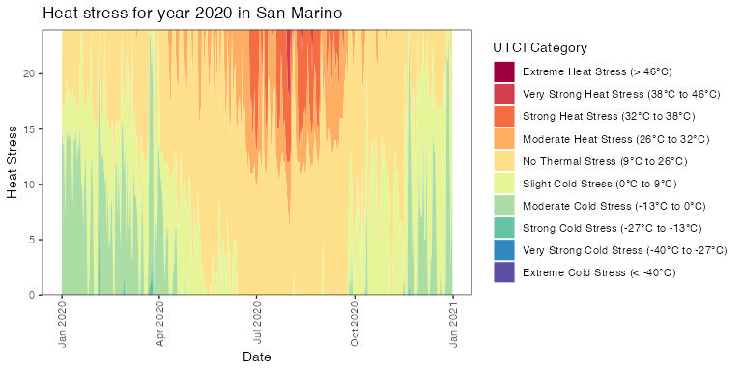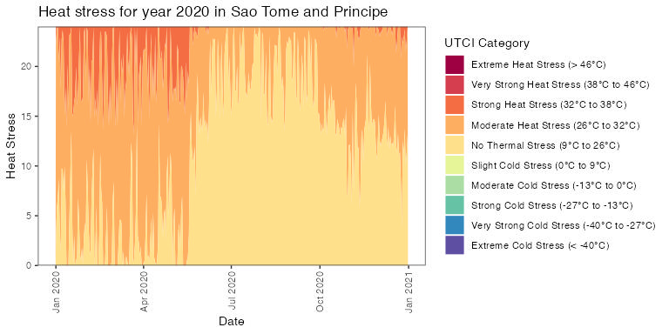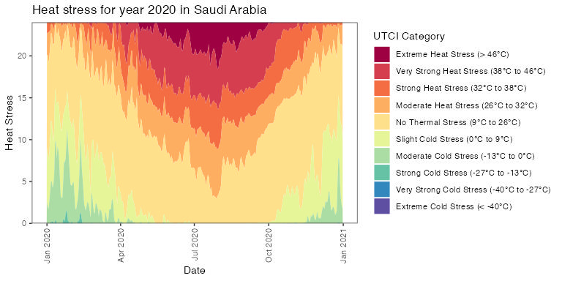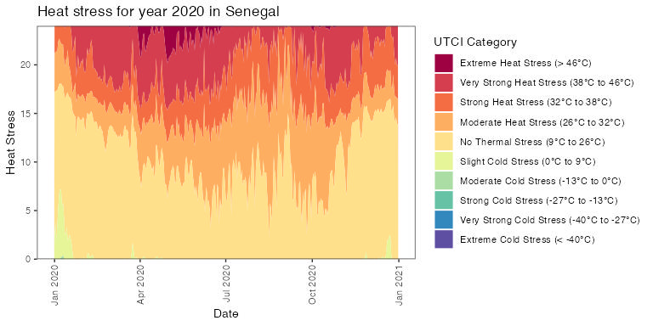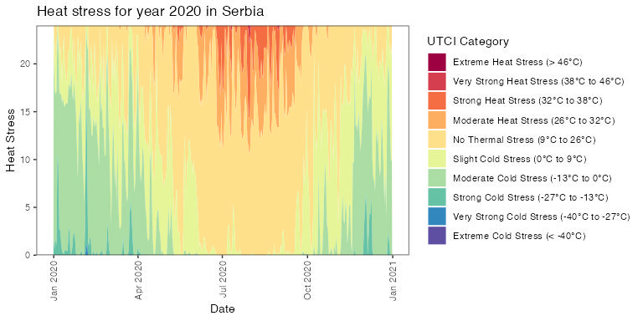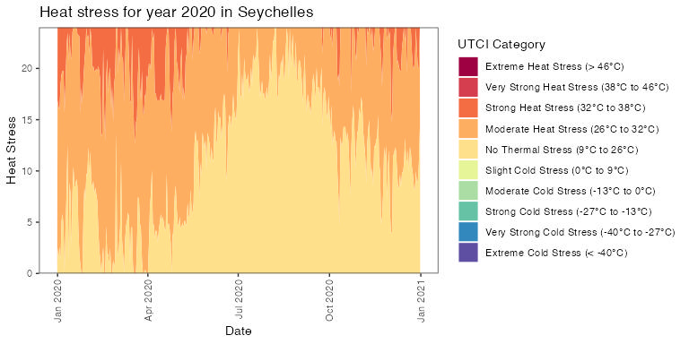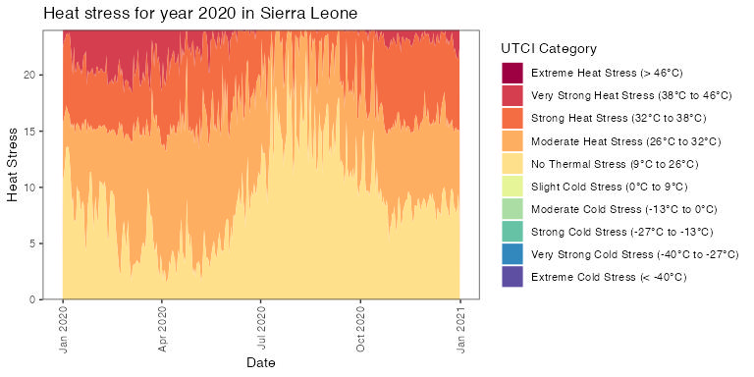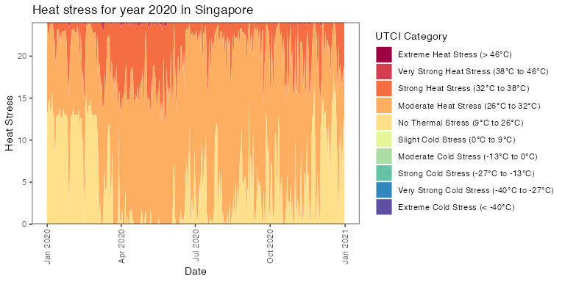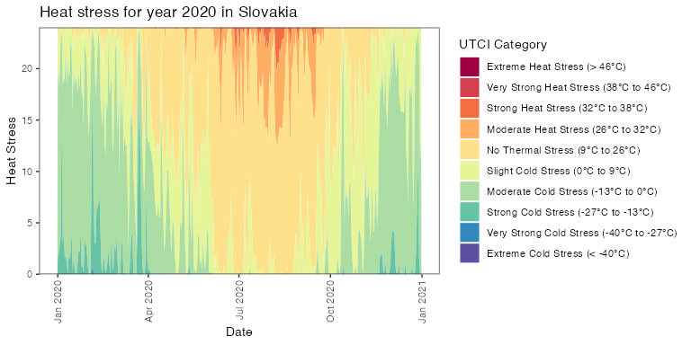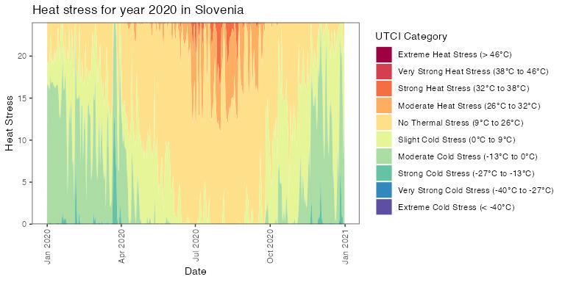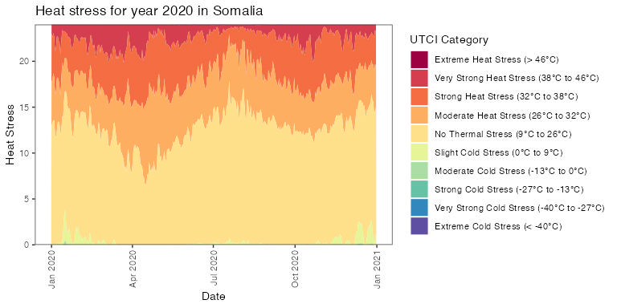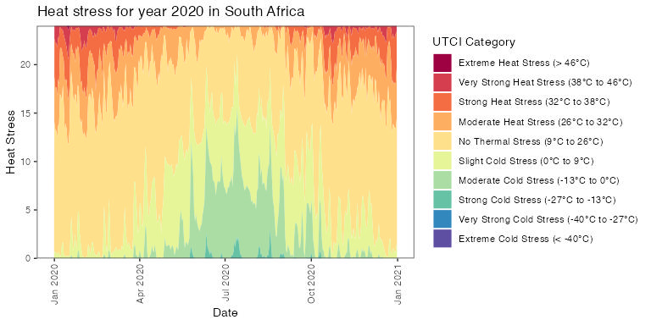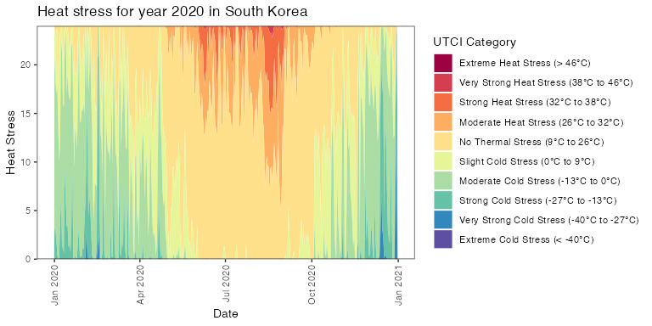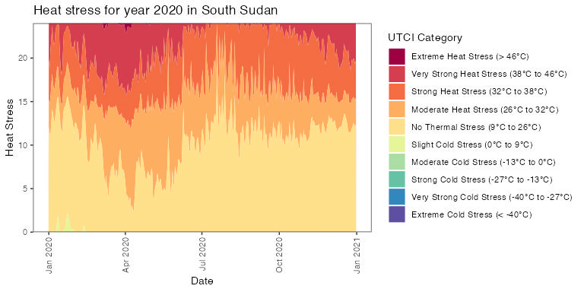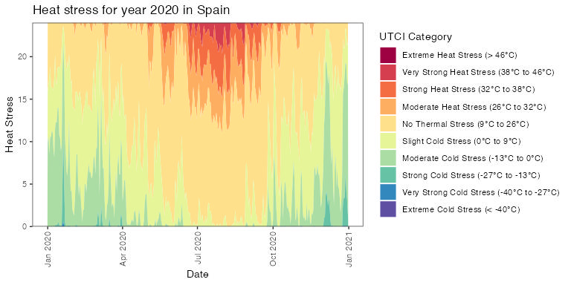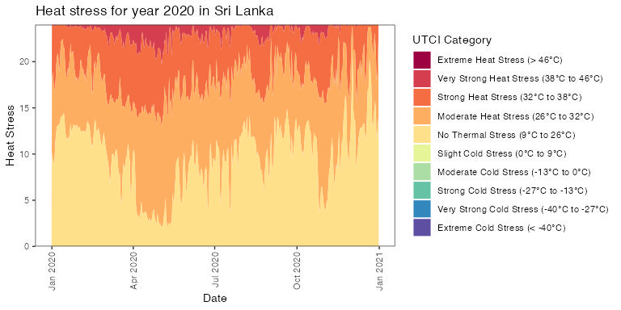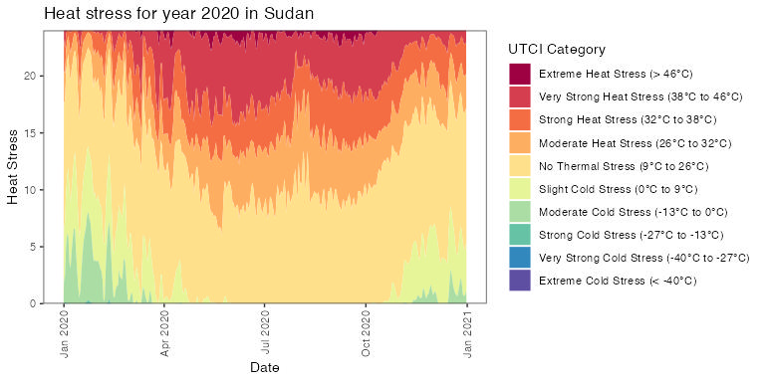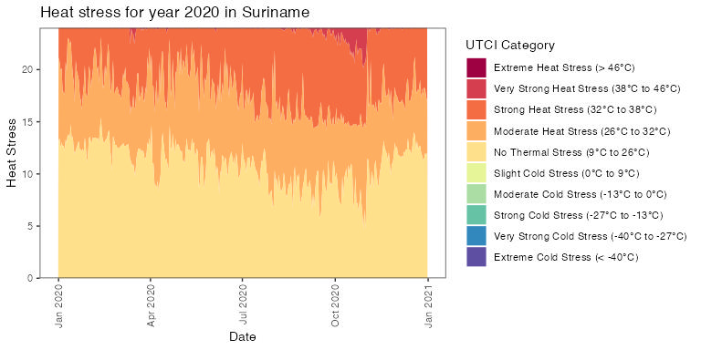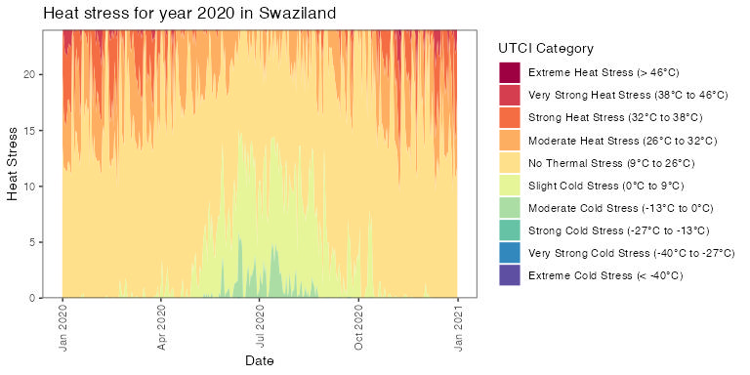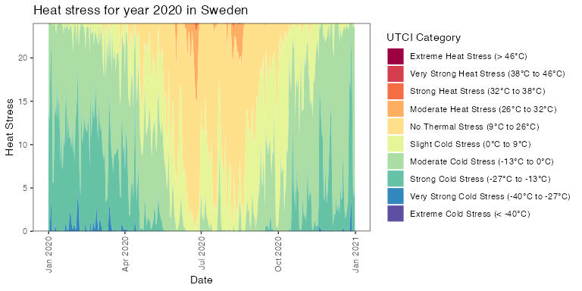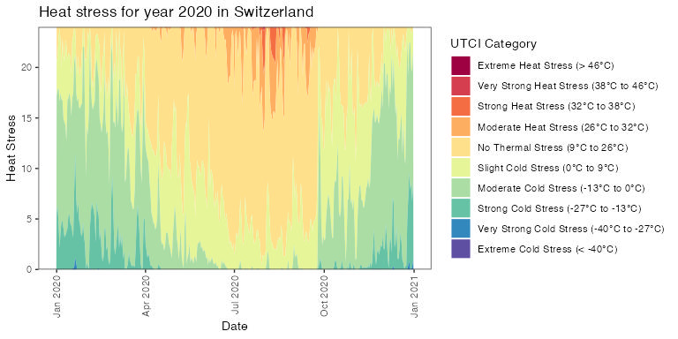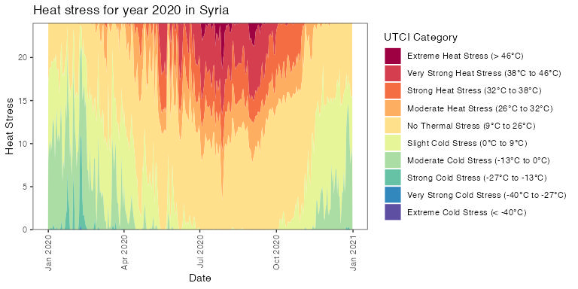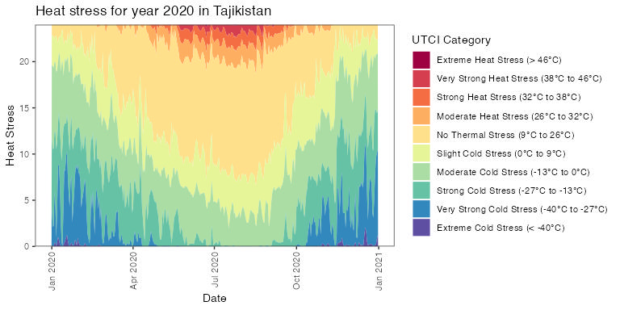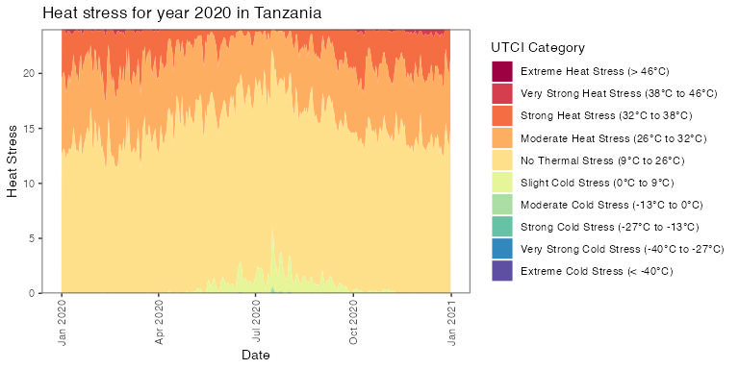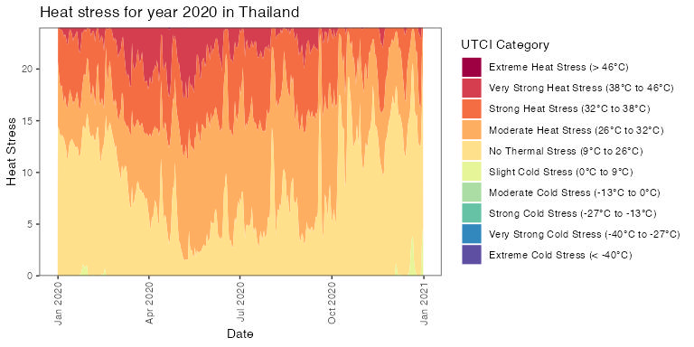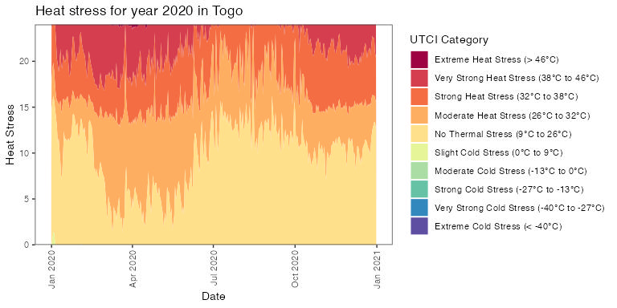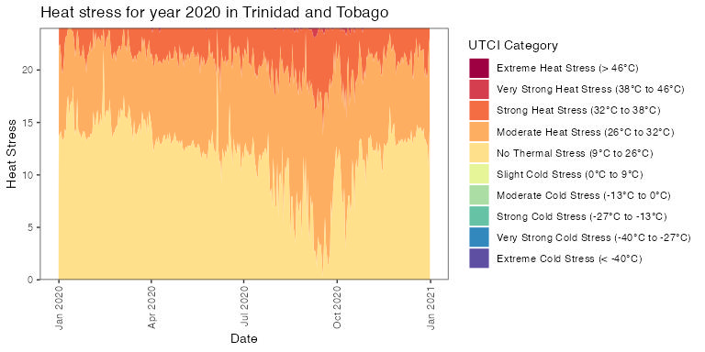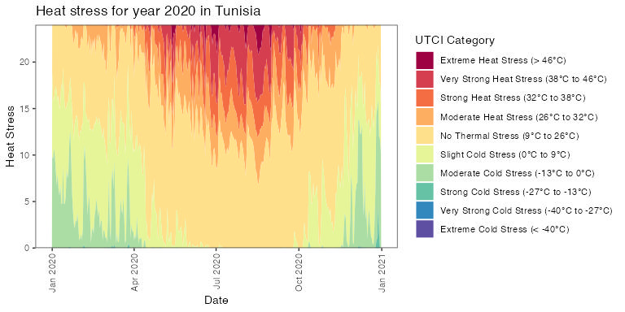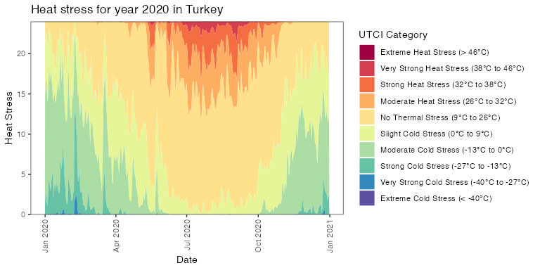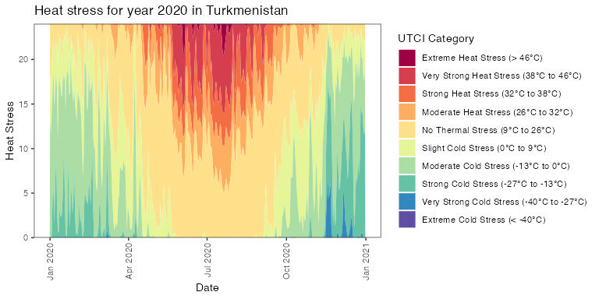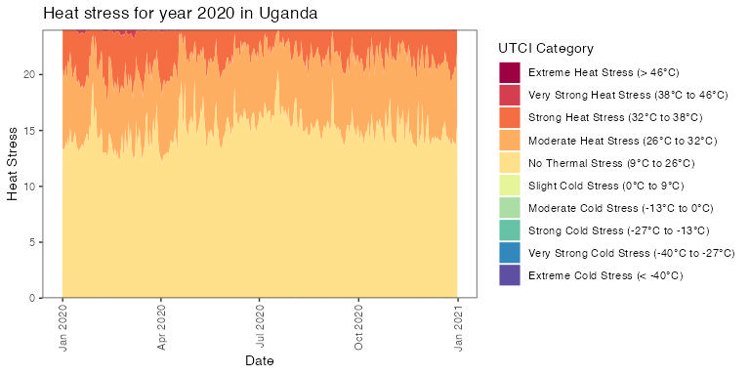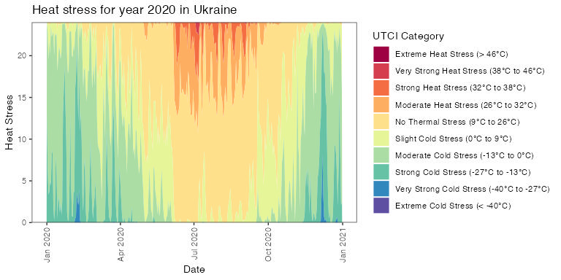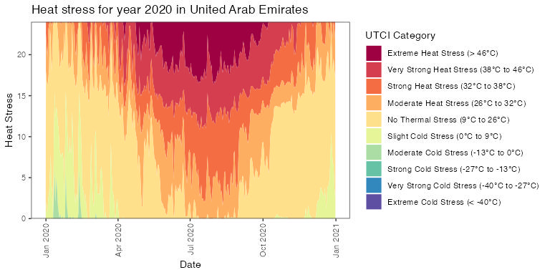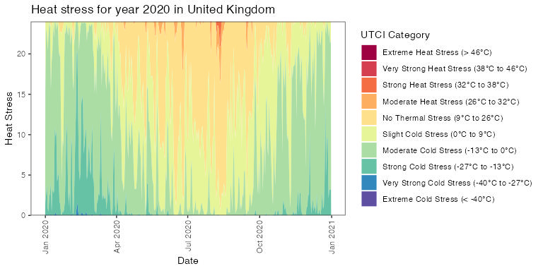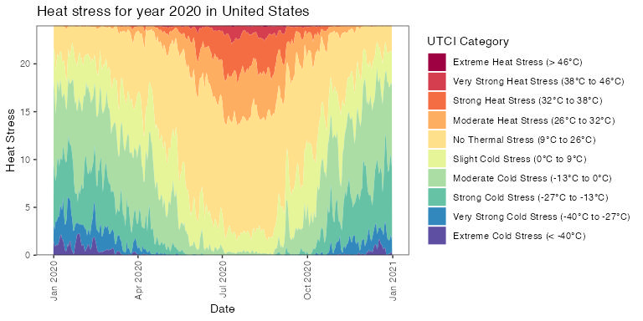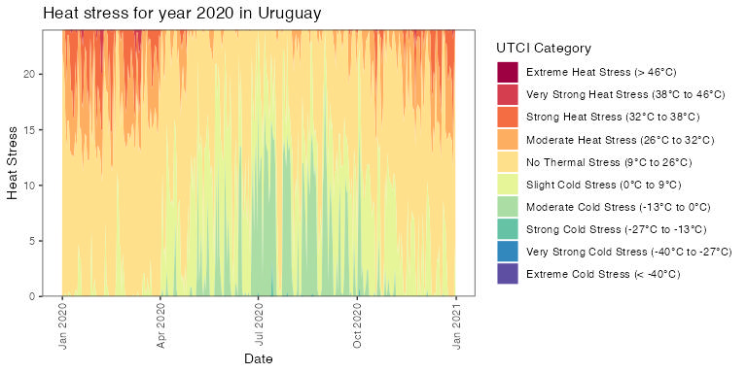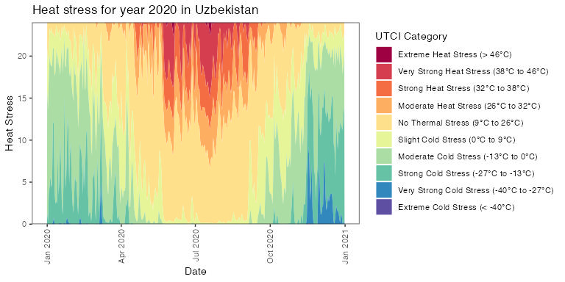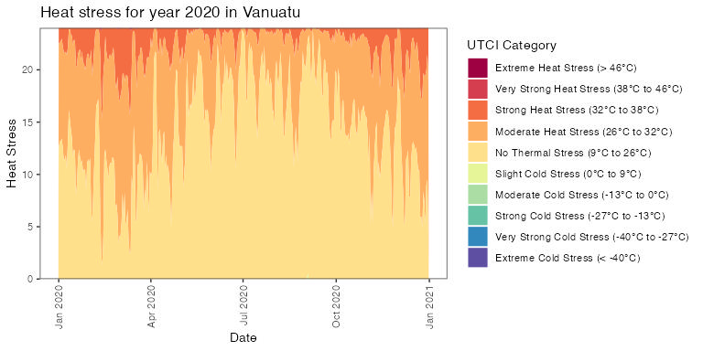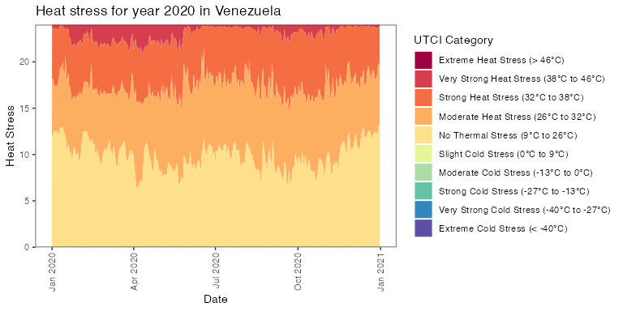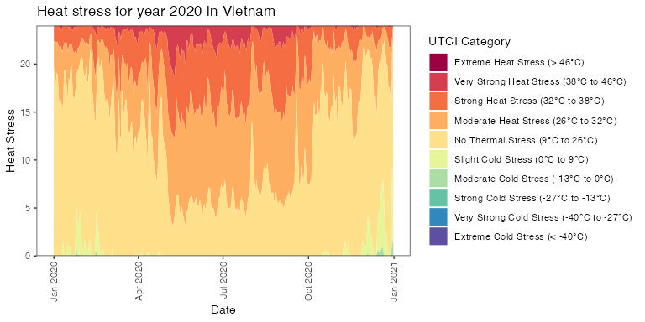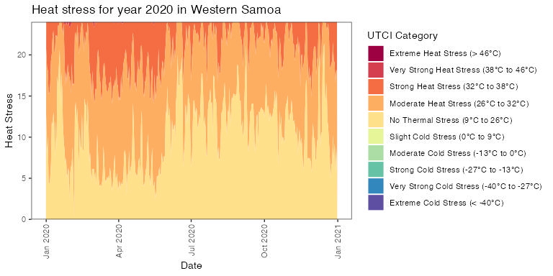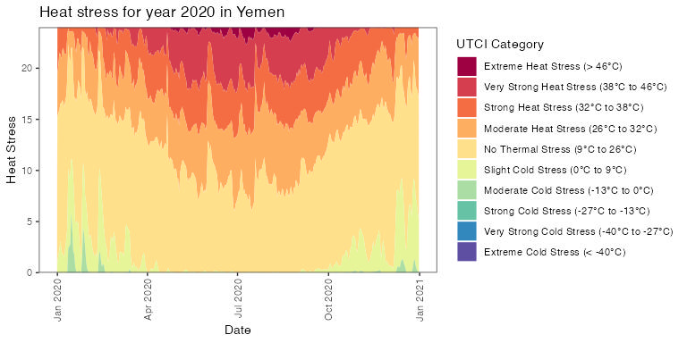
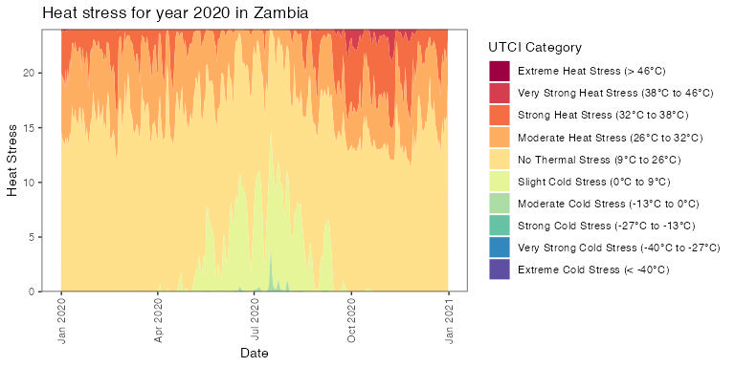
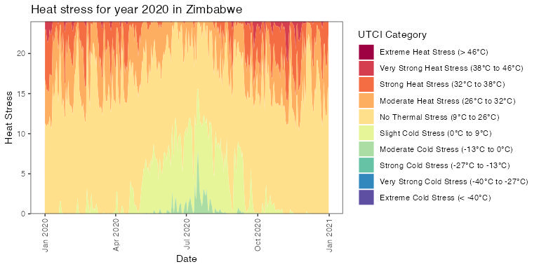
Supplementary Figure 24 | Daily heat stress distribution based on UTCI index for major countries/regions in 2020.

Supplementary Table 1-3

Countries/regions and sectors in EORA database
This study employs the multi-regional input-output tables from the Eora Global Supply Chain Database (https://worldmrio.com)¹. The Eora global supply chain database consists of a multi-region input-output table (MRIO) model that provides a time series of high-resolution IO tables with matching environmental and social satellite accounts for 190 countries since 1990. Supplementary Table 1 presents the income group in the EORA database and their relevant classifications for each year in the World Bank Database—which is computed based on the GNI per capita of each country/region. In this study, the classification by EORA is applied to ensure the classification does not vary over time.
Supplementary Table 1 | Countries/regionsin the EORA and income group classification
Code | Territory Name | Income Group Classification  By EORA Database | Income Group Classification by the World Bank
Code | Territory Name | Income Group Classification  By EORA Database | 1995 | 2000 | 2005 | 2010 | 2015 | 2020
AFG | Afghanistan | Low Income | L | L | L | L | L | L
ALB | Albania | Upper middle income | L | LM | LM | UM | UM | UM
DZA | Algeria | Upper middle income | LM | LM | LM | UM | UM | LM
AND | Andorra | High Income | H | H | H | H | H | H
AGO | Angola | Lower middle income | L | L | LM | LM | UM | LM
ATG | Antigua | Upper middle income | UM | UM | H | UM | H | H
ARG | Argentina | Upper middle income | UM | UM | UM | UM | UM | UM
ARM | Armenia | Lower middle income | L | L | LM | LM | LM | UM
ABW | Aruba | High Income | H | H | H | H | H | H
AUS | Australia | High Income | H | H | H | H | H | H
AUT | Austria | High Income | H | H | H | H | H | H
AZE | Azerbaijan | Upper middle income | L | L | LM | UM | UM | UM
BHS | Bahamas | High Income | H | H | H | H | H | H
BHR | Bahrain | High Income | UM | UM | H | H | H | H
BGD | Bangladesh | Low Income | L | L | L | L | LM | LM
BRB | Barbados | High Income | UM | H | UM | H | H | H
BLR | Belarus | Upper middle income | LM | LM | LM | UM | UM | UM
BEL | Belgium | High Income | H | H | H | H | H | H
BLZ | Belize | Lower middle income | LM | LM | UM | LM | UM | LM
BEN | Benin | Low Income | L | L | L | L | L | LM
BMU | Bermuda | High Income | H | H | H | H | H | H
BTN | Bhutan | Lower middle income | L | L | L | LM | LM | LM
BOL | Bolivia | Lower middle income | LM | LM | LM | LM | LM | LM
BIH | Bosnia and Herzegovina | Upper middle income | L | LM | LM | UM | UM | UM
BWA | Botswana | Upper middle income | LM | UM | UM | UM | UM | UM
BRA | Brazil | Upper middle income | UM | UM | LM | UM | UM | UM
VGB | British Virgin Islands | High Income | .. | .. | .. | .. | H | H
BRN | Brunei | High Income | H | H | H | H | H | H
BGR | Bulgaria | Upper middle income | LM | LM | LM | UM | UM | UM
BFA | Burkina Faso | Low Income | L | L | L | L | L | L
BDI | Burundi | Low Income | L | L | L | L | L | L
KHM | Cambodia | Low Income | L | L | L | L | LM | LM
CMR | Cameroon | Lower middle income | L | L | LM | LM | LM | LM
CAN | Canada | High Income | H | H | H | H | H | H
CPV | Cape Verde | Lower middle income | LM | LM | LM | LM | LM | LM
CYM | Cayman Islands | High Income | H | H | H | H | H | H
CAF | Central African Republic | Low Income | L | L | L | L | L | L
TCD | Chad | Low Income | L | L | L | L | L | L
CHL | Chile | Upper middle income | UM | UM | UM | UM | H | H
CHN | China | Upper middle income | L | LM | LM | UM | UM | UM
COL | Colombia | Upper middle income | LM | LM | LM | UM | UM | UM
COG | Congo | Lower middle income | L | L | LM | LM | LM | LM
CRI | Costa Rica | Upper middle income | LM | UM | UM | UM | UM | UM
HRV | Croatia | High Income | UM | UM | UM | H | H | H
CUB | Cuba | Upper middle income | LM | LM | LM | UM | UM | UM
CYP | Cyprus | High Income | H | H | H | H | H | H
CZE | Czech Republic | High Income | UM | UM | UM | H | H | H
CIV | Cote dIvoire | Lower middle income | L | L | L | LM | LM | LM
PRK | North Korea | Low Income | LM | L | L | L | L | L
COD | DR Congo | Low Income | L | L | L | L | L | L
DNK | Denmark | High Income | H | H | H | H | H | H
DJI | Djibouti | Lower middle income | LM | LM | LM | LM | LM | LM
DOM | Dominican Republic | Upper middle income | LM | LM | LM | UM | UM | UM
ECU | Ecuador | Lower middle income | LM | LM | LM | UM | UM | UM
EGY | Egypt | Lower middle income | LM | LM | LM | LM | LM | LM
SLV | El Salvador | Lower middle income | LM | LM | LM | LM | LM | LM
ERI | Eritrea | Low Income | L | L | L | L | L | L
EST | Estonia | High Income | LM | UM | UM | H | H | H
ETH | Ethiopia | Low Income | L | L | L | L | L | L
FJI | Fiji | Upper middle income | LM | LM | LM | LM | UM | UM
FIN | Finland | High Income | H | H | H | H | H | H
FRA | France | High Income | H | H | H | H | H | H
PYF | French Polynesia | High Income | H | H | H | H | H | H
GAB | Gabon | Upper middle income | UM | UM | UM | UM | UM | UM
GMB | Gambia | Low Income | L | L | L | L | L | L
GEO | Georgia | Lower middle income | L | L | LM | LM | UM | UM
DEU | Germany | High Income | H | H | H | H | H | H
GHA | Ghana | Low Income | L | L | L | LM | LM | LM
GRC | Greece | High Income | UM | H | H | H | H | H
GRL | Greenland | High Income | H | H | H | H | H | H
GTM | Guatemala | Lower middle income | LM | LM | LM | LM | LM | UM
GIN | Guinea | Low Income | L | L | L | L | L | L
GUY | Guyana | Lower middle income | L | LM | LM | LM | UM | UM
HTI | Haiti | Low Income | L | L | L | L | L | LM
HND | Honduras | Lower middle income | L | LM | LM | LM | LM | LM
HUN | Hungary | High Income | UM | UM | UM | H | H | H
ISL | Iceland | High Income | H | H | H | H | H | H
IND | India | Lower middle income | L | L | L | LM | LM | LM
IDN | Indonesia | Lower middle income | LM | L | LM | LM | LM | LM
IRN | Iran | Upper middle income | LM | LM | LM | UM | UM | LM
IRQ | Iraq | Lower middle income | LM | LM | LM | LM | UM | UM
IRL | Ireland | High Income | H | H | H | H | H | H
ISR | Israel | High Income | H | H | H | H | H | H
ITA | Italy | High Income | H | H | H | H | H | H
JAM | Jamaica | Upper middle income | LM | LM | LM | UM | UM | UM
JPN | Japan | High Income | H | H | H | H | H | H
JOR | Jordan | Lower middle income | LM | LM | LM | UM | UM | UM
KAZ | Kazakhstan | Upper middle income | LM | LM | LM | UM | UM | UM
KEN | Kenya | Low Income | L | L | L | L | LM | LM
KWT | Kuwait | High Income | H | H | H | H | H | H
KGZ | Kyrgyzstan | Low Income | L | L | L | L | LM | LM
LAO | Laos | Low Income | L | L | L | LM | LM | LM
LVA | Latvia | High Income | LM | LM | UM | UM | H | H
LBN | Lebanon | Upper middle income | LM | UM | UM | UM | UM | UM
LSO | Lesotho | Lower middle income | LM | L | LM | LM | LM | LM
LBR | Liberia | Low Income | L | L | L | L | L | L
LBY | Libya | Upper middle income | UM | UM | UM | UM | UM | UM
LIE | Liechtenstein | High Income | H | H | H | H | H | H
LTU | Lithuania | Upper middle income | LM | LM | UM | UM | H | H
LUX | Luxembourg | High Income | H | H | H | H | H | H
MDG | Madagascar | Low Income | L | L | L | L | L | L
MWI | Malawi | Low Income | L | L | L | L | L | L
MYS | Malaysia | Upper middle income | UM | UM | UM | UM | UM | UM
MDV | Maldives | Lower middle income | LM | LM | LM | UM | UM | UM
MLI | Mali | Low Income | L | L | L | L | L | L
MLT | Malta | High Income | UM | H | H | H | H | H
MRT | Mauritania | Low Income | L | L | L | LM | LM | LM
MUS | Mauritius | Upper middle income | UM | UM | UM | UM | UM | UM
MEX | Mexico | Upper middle income | UM | UM | UM | UM | UM | UM
MCO | Monaco | High Income | H | H | H | H | H | H
MNG | Mongolia | Lower middle income | L | L | L | LM | LM | LM
MNE | Montenegro | Upper middle income | .. | .. | .. | UM | UM | UM
MAR | Morocco | Lower middle income | LM | LM | LM | LM | LM | LM
MOZ | Mozambique | Low Income | L | L | L | L | L | L
MMR | Myanmar | Low Income | L | L | L | L | LM | LM
NAM | Namibia | Upper middle income | LM | LM | LM | UM | UM | UM
NPL | Nepal | Low Income | L | L | L | L | L | LM
NLD | Netherlands | High Income | H | H | H | H | H | H
NCL | New Caledonia | High Income | H | H | H | H | H | H
NZL | New Zealand | High Income | H | H | H | H | H | H
NIC | Nicaragua | Lower middle income | L | L | LM | LM | LM | LM
NER | Niger | Low Income | L | L | L | L | L | L
NGA | Nigeria | Lower middle income | L | L | L | LM | LM | LM
NOR | Norway | High Income | H | H | H | H | H | H
PSE | Gaza Strip | Lower middle income | LM | LM | LM | LM | LM | LM
OMN | Oman | High Income | UM | UM | UM | H | H | H
PAK | Pakistan | Lower middle income | L | L | L | LM | LM | LM
PAN | Panama | Upper middle income | LM | UM | UM | UM | UM | UM
PNG | Papua New Guinea | Lower middle income | LM | LM | L | LM | LM | LM
PRY | Paraguay | Lower middle income | LM | LM | LM | LM | UM | UM
PER | Peru | Upper middle income | LM | LM | LM | UM | UM | UM
PHL | Philippines | Lower middle income | LM | LM | LM | LM | LM | LM
POL | Poland | High Income | LM | UM | UM | H | H | H
PRT | Portugal | High Income | H | H | H | H | H | H
QAT | Qatar | High Income | H | H | H | H | H | H
KOR | South Korea | High Income | H | UM | H | H | H | H
MDA | Moldova | Lower middle income | LM | L | LM | LM | LM | UM
ROU | Romania | Upper middle income | LM | LM | UM | UM | UM | UM
RUS | Russia | Upper middle income | LM | LM | UM | UM | UM | UM
RWA | Rwanda | Low Income | L | L | L | L | L | L
WSM | Samoa | Lower middle income | LM | LM | LM | LM | LM | LM
SMR | San Marino | High Income | .. | H | H | H | H | H
STP | Sao Tome and Principe | Lower middle income | L | L | L | LM | LM | LM
SAU | Saudi Arabia | High Income | UM | UM | H | H | H | H
SEN | Senegal | Lower middle income | L | L | L | LM | L | LM
SRB | Serbia | Upper middle income | .. | .. | .. | UM | UM | UM
SYC | Seychelles | Upper middle income | UM | UM | UM | UM | H | H
SLE | Sierra Leone | Low Income | L | L | L | L | L | L
SGP | Singapore | High Income | H | H | H | H | H | H
SVK | Slovakia | High Income | LM | UM | UM | H | H | H
SVN | Slovenia | High Income | UM | H | H | H | H | H
SOM | Somalia | Low Income | L | L | L | L | L | L
ZAF | South Africa | Upper middle income | UM | UM | UM | UM | UM | UM
SSD | South Sudan | Low Income | .. | .. | .. | .. | L | L
ESP | Spain | High Income | H | H | H | H | H | H
LKA | Sri Lanka | Lower middle income | L | LM | LM | LM | LM | LM
SDN | Sudan | Low Income | L | L | L | LM | LM | L
SUR | Suriname | Upper middle income | LM | LM | LM | UM | UM | UM
SWZ | Swaziland | Lower middle income | LM | LM | LM | LM | LM | LM
SWE | Sweden | High Income | H | H | H | H | H | H
CHE | Switzerland | High Income | H | H | H | H | H | H
SYR | Syria | Lower middle income | LM | LM | LM | LM | LM | L
TJK | Tajikistan | Low Income | L | L | L | L | LM | LM
THA | Thailand | Lower middle income | LM | LM | LM | UM | UM | UM
MKD | TFYR Macedonia | Upper middle income | LM | LM | LM | UM | UM | UM
TGO | Togo | Low Income | L | L | L | L | L | L
TTO | Trinidad and Tobago | High Income | UM | UM | UM | H | H | H
TUN | Tunisia | Lower middle income | LM | LM | LM | UM | LM | LM
TUR | Turkey | Upper middle income | LM | UM | UM | UM | UM | UM
TKM | Turkmenistan | Lower middle income | LM | LM | LM | LM | UM | UM
UGA | Uganda | Low Income | L | L | L | L | L | L
UKR | Ukraine | Lower middle income | LM | L | LM | LM | LM | LM
ARE | UAE | High Income | H | H | H | H | H | H
GBR | UK | High Income | H | H | H | H | H | H
TZA | Tanzania | Low Income | L | L | L | L | L | LM
USA | USA | High Income | H | H | H | H | H | H
URY | Uruguay | Upper middle income | UM | UM | UM | UM | H | H
UZB | Uzbekistan | Lower middle income | LM | L | L | LM | LM | LM
VUT | Vanuatu | Lower middle income | LM | LM | LM | LM | LM | LM
VEN | Venezuela | Upper middle income | LM | UM | UM | UM | UM | ..
VNM | Viet Nam | Lower middle income | L | L | L | LM | LM | LM
YEM | Yemen | Lower middle income | L | L | L | LM | LM | L
ZMB | Zambia | Low Income | L | L | L | LM | LM | LM
ZWE | Zimbabwe | Low Income | L | L | L | L | L | LM
Note: .. represents missing value in the World Bank Database. The source of income group information from the World Bank can be obtained at https://blogs.worldbank.org/en/opendata/new-world-bank-country-classifications-income-level-2022-2023. Income classification coloured in Red represents the type of classification adopted in the EORA Database.

Concordance between EORA sectors and ILO economic activities
In the simplified model of EORA26 all countries have been aggregated to a common 26-sector classification. Supplementary Table 2 presents the concordance between EORA sectors and the ILO economic actitivies.
Supplementary Table 2 | Concordance between EORA sectors and ILO economic activities
Code | Industry | Code | Industry
1 | Agriculture | 1 | Agriculture; forestry and fishing ~ISIC rev.4 A
2 | Fishing | 1 | Agriculture; forestry and fishing ~ISIC rev.4 A
3 | Mining and Quarrying | 2 | Mining and quarrying ~ISIC rev.4 B
4 | Food & Beverages | 3 | Manufacturing ~ISIC rev.4 C
5 | Textiles and Wearing Apparel | 3 | Manufacturing ~ISIC rev.4 C
6 | Wood and Paper | 3 | Manufacturing ~ISIC rev.4 C
7 | Petroleum, Chemical and Non-Metallic Mineral Products | 3 | Manufacturing ~ISIC rev.4 C
8 | Metal Products | 3 | Manufacturing ~ISIC rev.4 C
9 | Electrical and Machinery | 3 | Manufacturing ~ISIC rev.4 C
10 | Transport Equipment | 3 | Manufacturing ~ISIC rev.4 C
11 | Other Manufacturing | 3 | Manufacturing ~ISIC rev.4 C
12 | Recycling | 3 | Manufacturing ~ISIC rev.4 C
13 | Electricity, Gas and Water | 4 | Utilities ~ISIC rev.4 D; E
14 | Construction | 5 | Construction ~ISIC rev.4 F
15 | Maintenance and Repair | 6 | Wholesale and retail trade; repair of motor vehicles and motorcycles ~ISIC rev.4 G
16 | Wholesale Trade | 6 | Wholesale and retail trade; repair of motor vehicles and motorcycles ~ISIC rev.4 G
17 | Retail Trade | 6 | Wholesale and retail trade; repair of motor vehicles and motorcycles ~ISIC rev.4 G
18 | Hotels and Restaurants | 8 | Accommodation and food service activities ~ISIC rev.4 I
19 | Transport | 7 | Transport; storage and communication ~ISIC rev.4 H; J
20 | Post and Telecommunications | 7 | Transport; storage and communication ~ISIC rev.4 H; J
21 | Financial Intermediation and Business Activities | 9 | Financial and insurance activities ~ISIC rev.4 K
 |  | 10 | Real estate; business and administrative activities ~ISIC rev.4 L; M; N
22 | Public Administration | 11 | Public administration and defense; compulsory social security ~ISIC rev.4 O
23 | Education, Health and Other Services | 12 | Education ~ISIC rev.4 P
 |  | 13 | Human health and social work activities ~ISIC rev.4 Q
24 | Private Households | 14 | Other services ~ISIC rev.4 R; S; T; U
25 | Others | 14 | Other services ~ISIC rev.4 R; S; T; U
26 | Re-export & Re-import | 14 | Other services ~ISIC rev.4 R; S; T; U

UTCI index and heat stress categories
Supplementary Table 3 | UTCI index and heat stress categories
No. | UTCI | Heat Stress
1 | > +46 | extreme heat stress
2 | +38 to +46 | very strong heat stress
3 | +32 to +38 | strong heat stress
4 | +26 to +32 | moderate heat stress
5 | +9 to +26 | no thermal stress
6 | +9 to 0 | slight cold stress
7 | 0 to -13 | moderate cold stress
8 | -13 to -27 | strong cold stress
9 | -27 to -40 | very strong cold stress
10 | < -40 | extreme cold stress

Supplementary Methods

Estimating Missing values for working hours
To measure the number of hours at work exposed to high temperatures, we need to know the number of hours worked by each worker. The average number of annual working hours for labor force in each country is obtained from Penn World Table version 10.01, which is a database with information on relative levels of income, output, input and productivity, covering 183 countries between 1950 and 2019². The data is accessible on www.ggdc.net/pwt. We use variable avh in the database—average annual hours worked by persons engaged—as the working hours for each country. Although this is the best source of data, to our best knowledge, there are still lots of missing values. For those countries that have missing data, we use random forest to fill in the missing values.

This study employs a Random Forest algorithm to estimate the missing values. The Random Forest model, renowned for its ensemble approach combining multiple decision trees, offers a robust framework for addressing both linear and non-linear relationships without presupposing data distribution patterns. First, we build a subset subpenndata from the original data penndata, which is specifically selected so that it contains no missing values across key variables. There are 7 key variables in subpenndata: year (the observation year), rgdpe (real gross domestic product), pop (population), hc (human capital index), lngdpcapita (log of GDP per capita), lnpop (log of population), and reavh (a normalized measure of average working hours avh, where reavh=(avh-1200)/2300)). These variables collectively provide a comprehensive framework for analyzing economic performance, demographic trends, and human capital development over time.

Then we use Random Forest to train the model based on this subset. The subpenndata was bifurcated into training (train_data, 70%) and testing (test_data, 30%) segments, facilitated by a predetermined seed to ensure reproducibility. This segmentation strategy aims to support the validation of the Random Forest model, enabling an assessment of its predictive performance on unseen data. Upon training the Random Forest model on the train_data, with reavh serving as the response variable, the model’s predictive capabilities were rigorously evaluated against the test_data. The evaluation metrics—Root Mean Square Error (RMSE), Mean Absolute Error (MAE), and R-square (R²)—were computed to quantify the model's accuracy, precision, and explanatory power, respectively. The model results in an RMSE of 0.0365 and an MAE of 0.0226, indicating that predictions closely align with observed values, demonstrating minimal deviation. Most notably, an R-squared of 0.9242 reveals that the model accounts for a significant portion of the variance in the working hours, affirming its capability to capture the underlying dynamics within the dataset. The performance of the Random Forest model can also be found in Supplementary Figure 20, where the actual working hours and the predicted working hours are highly correlated. Finally, the trained model was applied to the entire penndata and used to fill in the missing working hours in it. This extension aims to predict the reavh and avh variable for further analysis.

Supplementary Figure 25 | The performance of the Random Forest model.

References
1. Lenzen, M., Moran, D., Kanemoto, K. & Geschke, A. BUILDING EORA: A GLOBAL MULTI-REGION INPUT–OUTPUT DATABASE AT HIGH COUNTRY AND SECTOR RESOLUTION. Economic Systems Research 25, 20–49 (2013).
2. Feenstra, R. C., Inklaar, R. & Timmer, M. P. The Next Generation of the Penn World Table. American Economic Review 105, 3150–3182 (2015).

