Isolation and characterization of a triplet nitrene
Dongmin Wang^{1,3}†, Wang Chen^{2,4}†, Haonan Chen^{1,3}†, Yizhen Chen¹, Shengfa Ye²*, Gengwen Tan^{1,3}*

¹Key Laboratory of Bioinorganic and Synthetic Chemistry of Ministry of Education, Guangdong Basic Research Center of Excellence for Functional Molecular Engineering, School of Chemistry, IGCME, Sun Yat-sen University, Guangzhou 510275, China
² State Key Laboratory of Catalysis, Dalian Institute of Chemical Physics, Chinese Academy of Sciences, 457 Zhongshan Road, Dalian 116023, China
³Innovation Center for Chemical Sciences, Key Laboratory of Organic Synthesis of Jiangsu Province, College of Chemistry, Chemical Engineering and Materials Science, Soochow University, Suzhou, 215123, China
⁴ University of Chinese Academy of Sciences, Beijing 100049, China
* Corresponding author. tangw55@mail.sysu.edu.cn; shengfa.ye@dicp.ac.cn
† These authors contributed equally to this work.
Content
Isolation and characterization of a triplet nitrene 1
Experimental methods 3
Studies of photolysis of 1 under different conditions with UV-Vis and EPR spectroscopy 8
Crystal structures reported in this manuscript 11
ESI-MS of 1-5 15
Crystallographic data and refinement results 21
Selected NMR spectra 23
References 28

Experimental methods
General methods
All experiments were carried out under dry oxygen-free nitrogen using standard Schlenk techniques or in a N₂ filled-glove box (Vigor) unless otherwise stated. Solvents were dried by standard methods: n-Hexane, toluene and THF were dried by distilling from Na/benzoquinone under N₂ atmosphere; deuterated benzene was distilled from Na, and deuterated chloroform was distilled from CaH₂ under N₂ atmosphere. All the solvents were stored in activated 4 Å molecular sieves in the glovebox. Commercially available reagents were purchased from Energy Chemical and used as received. The starting materials M^{s}Fluid*-Li(thf)₂¹ were synthesized according to the reported procedures.

NMR and ESI-MS measurements
The ¹H and ¹³C NMR spectra were recorded on Bruker spectrometers (AV400 or AV600) referenced to residual solvent signals as internal standards. Chemical shift values for protons are referenced to the residual proton resonance of CDCl₃ (δ: 7.26), C₆D₆ (δ: 7.16); chemical shift values for carbons are referenced to the carbon resonance of CDCl₃ (δ: 77.16), C₆D₆ (δ: 128.06). NMR multiplicities are abbreviated as follows: s = singlet, d = doublet, t = triplet, q = quartet, sept = septet, m = multiplet, br = broad signal. Chemical shifts are quoted in δ (ppm) and coupling constants in Hz. The samples were dissolved in deuterated solvents, and were sealed off in J-Young NMR tubes for measurements. ESI-MS spectra were measured on Bruker ESI-Q-TOF maxis 4G.

Single-Crystal X-ray Diffraction Analyses
For the single crystal X-ray structure analyses, the crystals were each mounted on a glass capillary in perfluorinated oil and measured in a cold N₂ flow. The data for all compounds were collected on an XtaLAB Synergy R, DW system, HyPix diffractometer at low temperatures. Structures were solved by intrinsic phasing method using the SHELXT 2018/2 program² and refined with full-matrix least squares on F² using the SHELXL 2018/2 program³ by using OLEX2 1.5⁴ as the graphical interface. All non-hydrogen atoms in the structure were refined anisotropically and all hydrogen atoms were assigned isotropic displacement coefficients U(H) = 1.2 U or 1.5 U and their coordinates were allowed to ride on their respective atoms. The highly disordered solvent molecules were removed with PLATON SQUEEZE routine.⁵
Elemental Analysis
Element analyses were performed on an ElementarVario EL III instrument.

EPR measurements
Continuous-wave (cw) X-band EPR measurements of powder samples are performed on a CIQTEK EPR100 spectrometer operating in the X-band, equipped with a liquid He cryostat and a goniometer. Continuous-wave (cw) X-band EPR measurements of solution samples were performed on a Bruker A200 spectrometer equipped with a high sensitivity cavity (ER4119HS) in conjunction with microwave bridge Bruker A40X. For variable temperature control, cryostat (A4131VT) was employed. EPR simulations have been carried out with esim due to Dr. Eckhard Bill at Max-Planck-Institut für Chemische Energiekonversion and Easyspin program.⁶

UV-vis measurements
UV-vis measurements were carried out on Olis 8453 UV/VIS equipped with cryostat Coolspek UV USP-203-B.

Synthesis and characterization
Synthesis and characterization of M^{s}Fluid*-N₃ (1)
In a N₂-filled glovebox, anhydrous THF (25 mL) was added a 100 mL Schlenk flask containing M^{s}Fluid*-Li(thf)₂ (2.85 g, 2.58 mmol) at -30 ºC. Tosyl azide (1.07g, 5.41 mmol) diluted in anhydrous THF (5 mL) was added via a syringe. The mixture was stirred for 18 hours with its color changing from purple to yellow. Afterwards, all the volatiles were removed under vacuum to give a yellow solid, which was extracted with CH₂Cl₂ (30 mL) and dried over anhydrous magnesium sulfate and filtered. All the filtrate were removed under reduced pressure, and the solid was washed with EtOH to yield the product as a yellow solid. Yield: 2.18 g, 2.19 mmol, 85%. Yellow crystals of 1 suitable for single crystal X-ray diffraction (SC-XRD) analysis were obtained from n-hexane at room temperature. ¹H NMR (CDCl₃, 400 MHz, 298 K, ppm): δ = 1.04 (s, 12H, C(CH₃)₂), 1.23 (s, 12H, C(CH₃)₂), 1.27 (s, 12H, C(CH₃)₂), 1.32 (s, 12H, C(CH₃)₂), 1.55-1.75 (m, 28H, C(CH₃)₂ + CH₂CH₂), 2.45 (m, 4H, CCH₂C(CH₃)₂), 6.97 (s, 4H, fluorenyl-H), 7.16 (s, 1H, Ar-H), 7.46 (s, 4H, fluorenyl-H); ¹³C{¹H} NMR (C₆D₆, 100 MHz, 298 K, ppm): δ = 32.2, 32.3, 32.4, 32.5, 32.9, 34.5, 34.6, 35.3, 35.4, 35.5, 35.7, 43.6, 57.8 ((CH₃)₂CCH₂C), 61.1 ((CH₃)₂CCH₂C), 115.0, 116.9, 121.2, 121.8, 132.3, 137.7, 140.3, 143.1, 143.8, 151.0, 156.0. ESI-MS [M – N₂ + H]⁺ (m/z): Calcd: 968.7068; Found: 968.7087. Elemental analysis for C₇₂H₈₉N₃ (%): Calcd: C 86.78, H 9.00, N 4.22; Found: C 86.39, H 8.75, N 4.32.

Synthesis and characterization of M^{s}Fluid*-N (2)
To a 50 ml Schlenk flask containing 1 (299 mg, 0.30 mmol) dissolved in dry C₆H₆ (30 ml). The mixture was irradiated in an ice bath for 5 hours with UV Light (313 nm) with its color changed from yellow to purple-red. The mixture was filtered. The filtrate was concentrated to ca. 5 mL, and left at 6 ºC to produce a dark red solid of 2. Yield: 150 mg, 0.16 mmol, 52%. Red crystals for SC-XRD analysis were formed from benzene at 6 ºC. ESI-MS [M – N₂ + H]⁺ (m/z): Calcd: 968.7068; Found: 968.7047. Elemental analysis for C₇₂H₈₉N (%): Calcd: C 89.29, H 9.26, N 1.45; Found: C 89.56, H 8.83, N 1.73.

Synthesis and characterization of M^{s}Fluid*-NH₂ (3)
Method A: 1 (299 mg, 0.30 mmol) was dissolved in dry n-hexane or THF (30 ml). The mixture was irradiated in an ice bath for 5 hours with UV Light (313 nm). Afterwards, the mixture was stirred at room temperature for an additional 4 hours at room temperature to give a pale yellow solution. All the volatiles were removed under vacuum, and the residue was extracted with n-hexane (5 ml). The extraction was filtered via a syringe, and then left to slowly evaporate in the glove box to afford 3 as colorless crystals. Yield: 134 mg, 0.14 mmol, 46%. Colorless crystals for SC-XRD analysis were formed from n-hexane at room temperature. ¹H NMR (C₆D₆, 298 K, 400 MHz, ppm): δ = 1.19 (s, 12H, C(CH₃)₂), 1.20 (s, 12H, C(CH₃)₂), 1.26 (s, 12H, C(CH₃)₂), 1.33 (s, 12H, C(CH₃)₂), 1.59-1.68 (m, 28H, CH₂CH₂ + C(CH₃)₂), 2.52 (s, 4H, CH₂C(CH₃)₂), 6.87 (s, 1H, Ar-H), 7.39 (s, 4H, fluorenyl-H), 7.76 (s, 4H, fluorenyl-H); ¹³C{¹H} NMR (C₆D₆, 298 K, 100 MHz, ppm): δ = 32.1, 32.4, 32.5, 32.7, 32.9, 34.6, 34.9, 35.5, 35.6, 35.7, 43.5, 59.3 ((CH₃)₂CCH₂C), 61.6 ((CH₃)₂CCH₂C), 105.2, 116.9, 117.2, 121.9, 122.1, 126.4, 137.8, 140.0, 143.2, 143.6, 143.7, 144.0, 144.4, 150.7, 152.0, 156.5 (Ar-C). ESI-MS [M + H]⁺ (m/z): Calcd: 970.7224; Found: 970.7188. Elemental analysis for C₇₂H₉₁N (%): Calcd: C 89.11, H 9.45, N 1.44; Found: C 79.72, H 7.95.
Method B: 1 (299 mg, 0.30 mmol) was dissolved in THF (30 ml), and LiAlH₄ (3 mL, 1 M in THF) was added at room temperature. The mixture was stirred at 60 ºC for 24 hours. Afterwards, the reaction mixture was quenched with aqueous HCl solution. The organic phase was extracted with n-hexane. All the volatiles in the combined organic phase were removed under vacuum, and the residue was purified by column chromatography to afford 3 as a colorless solid.

Synthesis and characterization of M^{s}Fluid*-N=PMe₃ (4)
In a glove box, 1 (299 mg, 0.30 mmol) was dissolved in dry benzene (20 ml). The mixture was irradiated in an ice bath for 5 hours with UV Light (313 nm). To the mixture PMe₃ ( 34 mg, 0.45 mmol) was added and stirred for an additional 5 hours at room temperature. All the volatiles were removed under vacuum to obtain a yellow solid, which was extracted with n-hexane (9 ml) and filtrated via a syringe. The filtrate was concentrated to 3 ml and left at –30 °C for 24 h. The yellow solid of 4 was isolated by removing the mother liquor with a cannula and dried under vacuum for 5 hours. Yield: 244 mg, 0.23 mmol, 78%. Yellow crystals for SC-XRD analysis were formed from n-hexane at room temperature. ¹H NMR (CDCl₃, 298 K, 400 MHz, ppm): δ = -0.20 (d, 9H, P(CH₃)₃), 1.30 (s, 12H, C(CH₃)₂), 1.43 (s, 12H, C(CH₃)₂), 1.47 (s, 12H, C(CH₃)₂), 1.57 (s, 12H, C(CH₃)₂), 1.69 (s, 12H, C(CH₃)₂), 1.81-1.90 (m, 16H, CH₂CH₂), 2.37 (s, 4H, CH₂C(CH₃)₂), 7.47 (s, 1H, Ar-H), 7.58 (s, 3H, fluorenyl-H), 7.63 (s, 5H, fluorenyl-H); ¹³C{¹H} NMR (CDCl₃, 298 K, 100 MHz, ppm): δ = 16.9 (d, ¹J(C, P) = 72.8 Hz), 32.1, 32.4, 32.5, 32.8, 34.5, 34.7, 35.3, 35.4, 35.5, 42.3, 61.2 ((CH₃)₂CCH₂C), 62.9 ((CH₃)₂CCH₂C), 105.7, 116.5, 116.7, 121.7, 121.8, 128.5, 137.7, 142.3, 143.1, 150.1, 153.4, 156.5; ¹³C{¹H} NMR (CDCl₃, 298 K, 160 MHz, ppm): δ = -19.1. ESI-MS [M –+ H]⁺ (m/z): Calcd: 1044.7510; Found: 1044.7483. Elemental analysis for C₇₅H₉₈NP (%): Calcd: C 86.24, H 9.46, N 1.34; Found: C 86.56, H 9.95, N 1.86.

Synthesis and characterization of M^{s}Fluid*-N(CH₂CH)Ph (5)
In a glove box, 1 (299 mg, 0.30 mmol) was dissolved in dry benzene (20 ml). The mixture was irradiated in an ice bath for 5 hours with UV Light (313 nm). Afterwards, styrene (460 mg, 4.5 mmol) was added and stirred vigorously for an additional 6 hours at room temperature. The solution was filtered via a syringe, and then left to slowly evaporate in the glove box to afford 5 as light yellow crystals. Yield: 209 mg, 0.195 mmol, 65%. Light yellow crystals for SC-XRD analysis were formed from benzene at room temperature. ¹H NMR (C₆D₆, 298 K, 600 MHz, ppm): δ = 0.39 (br, 1H, PhCHCH₂), 0.94 (br, 1H, PhCHCH₂), 1.13 (s, 6H, C(CH₃)₂), 1.14 (s, 6H, C(CH₃)₂), 1.24 (s, 6H, C(CH₃)₂), 1.26 (s, 6H, C(CH₃)₂), 1.32 (br, 15H, C(CH₃)₂), 1.37 (s, 9H, C(CH₃)₂), 1.53-1.68 (m, 28H, CH₂CH₂ + C(CH₃)₂), 2.19 (br, 1H, PhCHCH₂), 2.46-2.52 (m, 4H, CH₂C(CH₃)₂), 6.17 (br, 2H, Ph), 6.80 (br, 3H, Ph), (s, 4H, O-C₆H₄-O), 7.16 (s, 1H, Ar-H), 7.37 (s, 2H, fluorenyl-H), 7.47 (s, 2H, fluorenyl-H), 7.64 (s, 2H, fluorenyl-H), 7.84 (s, 2H, fluorenyl-H); ¹³C{¹H} NMR (C₆D₆, 298 K, 150 MHz, ppm): δ = 32.1, 32.3, 32.4, 32.5, 32.6, 32.7, 33.1, 33.2, 34.5, 34.7, 34.8, 34.9, 35.6, 35.7, 35.8, 35.9, 37.1 (PhCHCH₂), 41.5 (PhCHCH₂), 42.8, 61.2 ((CH₃)₂CCH₂C), 63.2 ((CH₃)₂CCH₂C), 111.2, 117.2, 117.5, 121.9, 122.0, 125.1, 125.7, 127.2, 128.3, 133.9, 137.8, 138.0, 141.2, 143.3, 143.6, 143.9, 144.0, 146.6, 152.8, 154.1, 158.4 (Ar-C). ESI-MS [M –+ H]⁺ (m/z): Calcd: 1072.7694; Found: 1072.7673. Elemental analysis for C₈₀H₉₇N (%): Calcd: C 89.58, H 9.12, N 1.31; Found: C 90.01, H 9.45, N 1.67.

Studies of photolysis of 1 under different conditions with UV-Vis and EPR spectroscopy
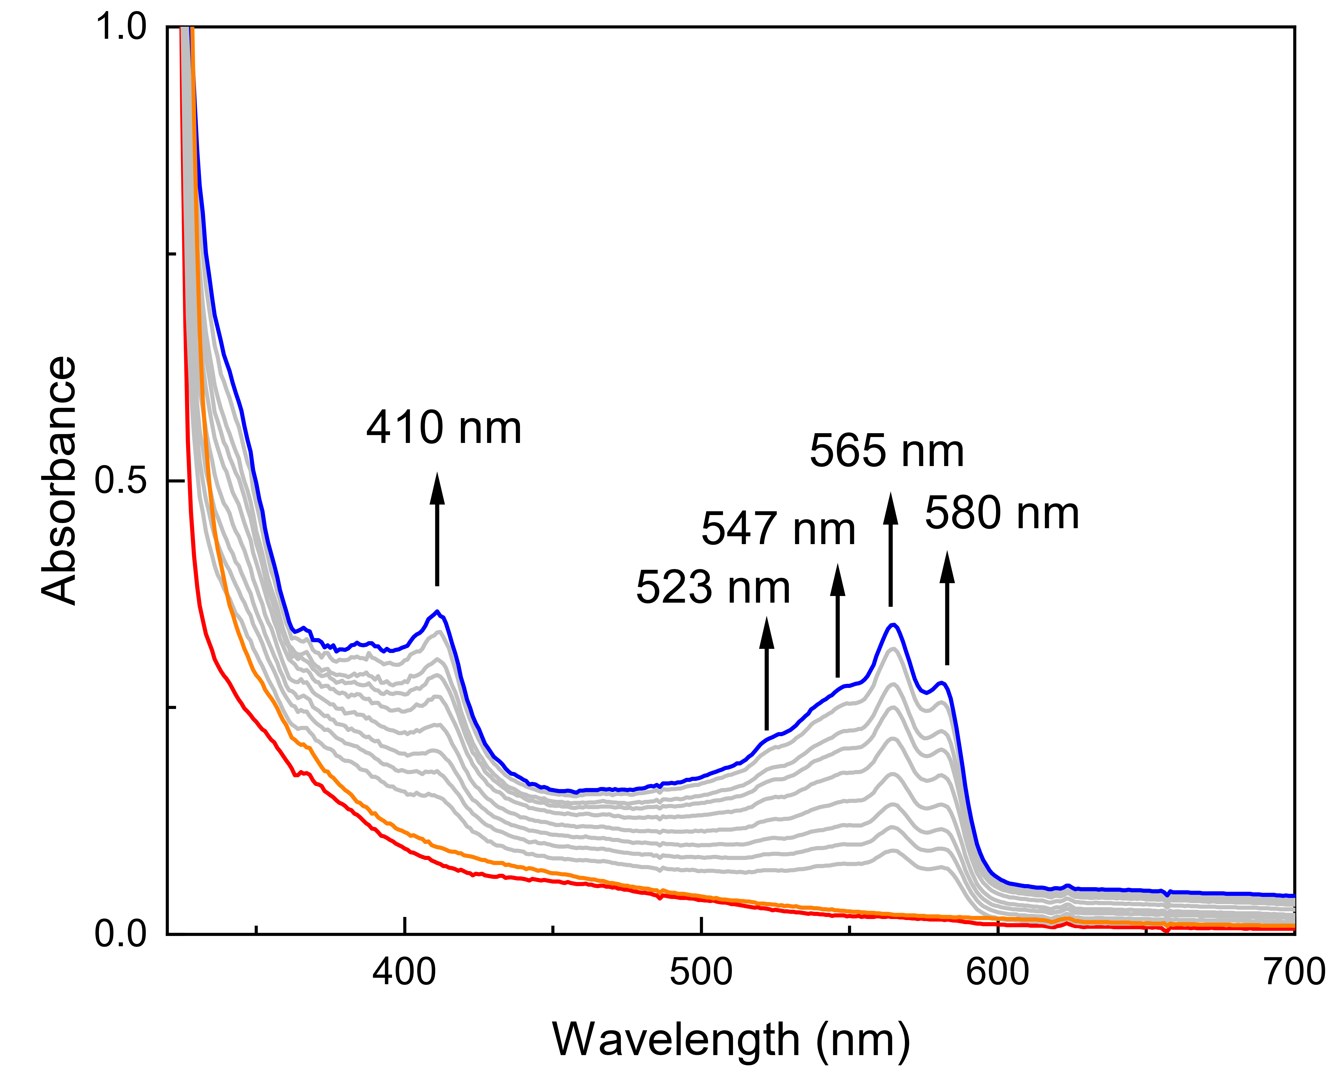
Supplementary Information Fig. S1 UV-Vis spectra of in situ photolysis of a 2-MeTHF solution of 1 at 173 K. Red, blue and orange lines represent 1, photolysis product of 1 under 313 nm radiation within 20 min and decay product at 298 K, respectively.
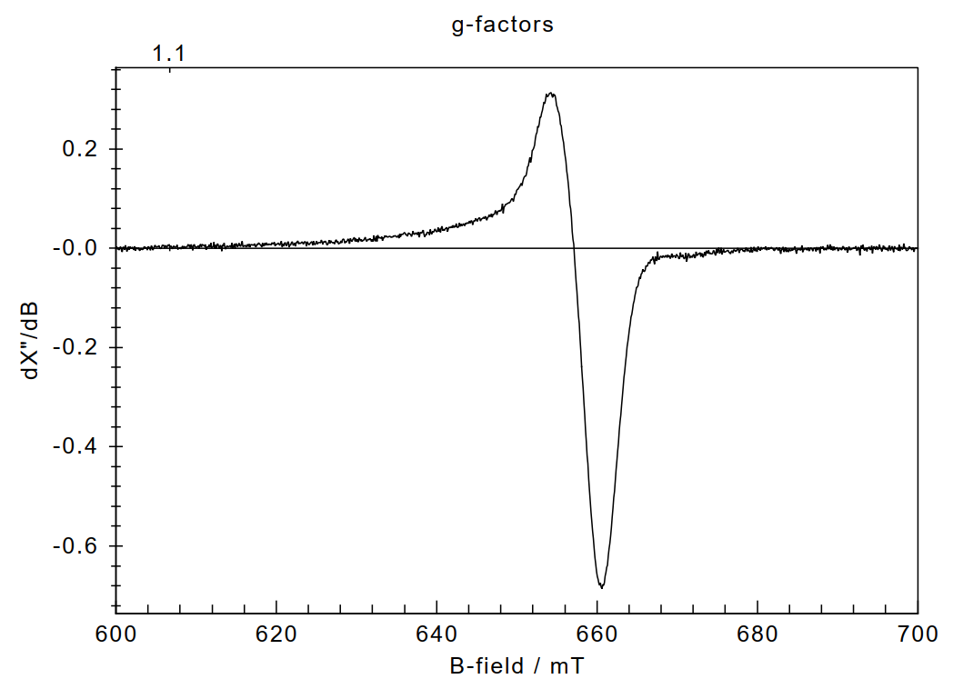
Supplementary Information Fig. S2 X-band EPR spectrum of in situ photolysis of a 2-MeTHF solution of 1 at 107 K. Acquisition conditions: temperature = 107 K, microwave power = 4 mW, and modulation amplitude = 0.5 mT.
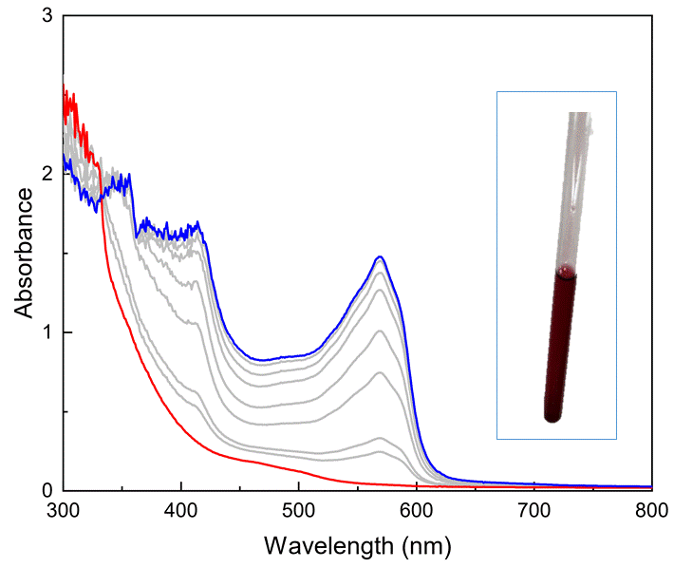
Supplementary Information Fig. S3 UV-Vis spectra of in situ photolysis of a 2mM C₆D₆ solution of 1 at 283 K. Red, blue and orange lines represent 1, photolysis product of 1 under 313 nm radiation within 4 h. Inset shows a picture of a photolysis sample for 1 hour at 0 ºC in C₆D₆ solution.

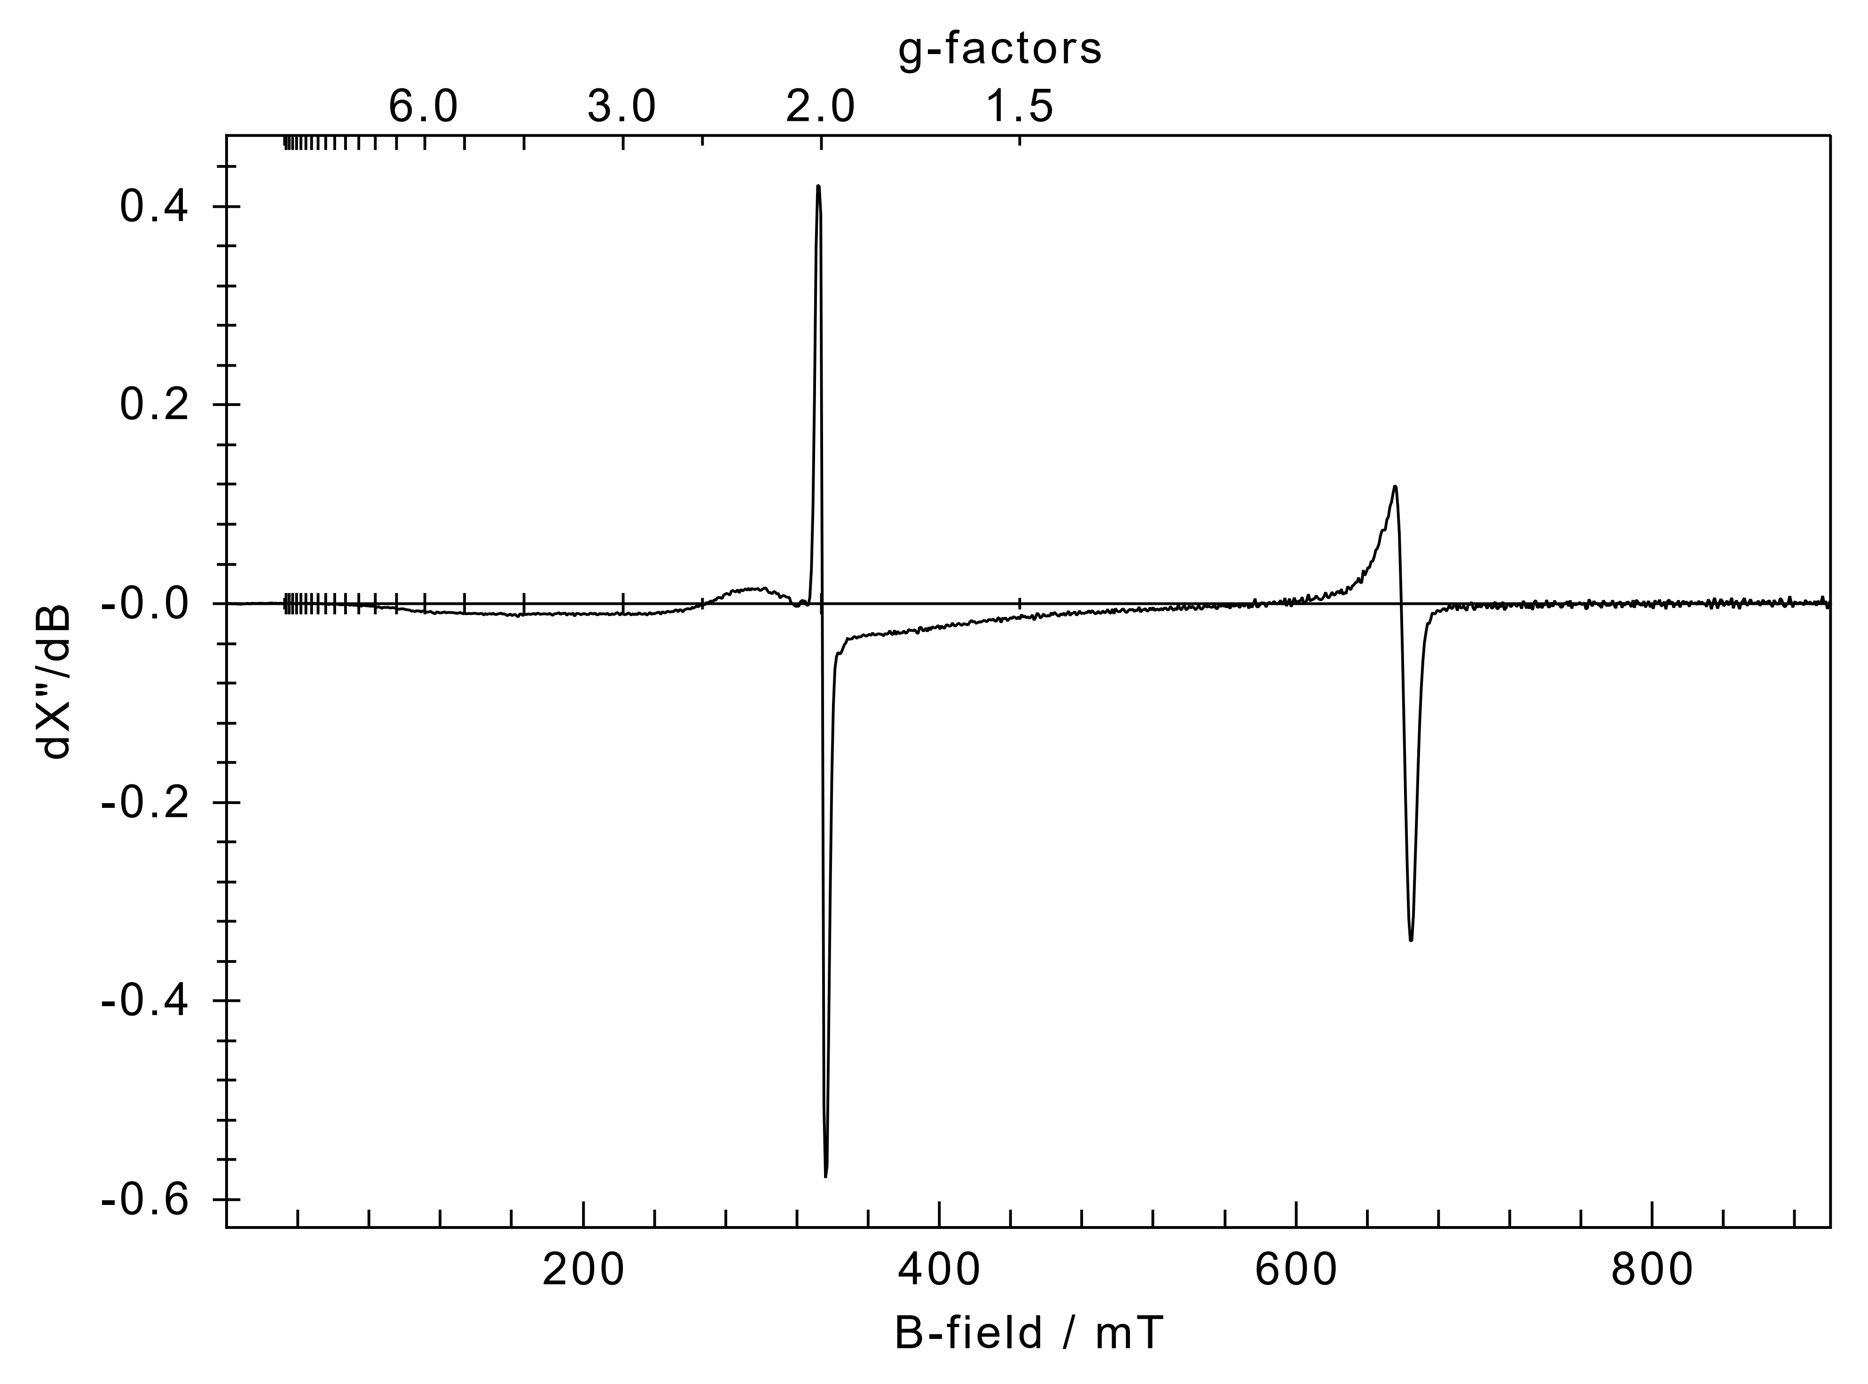
Supplementary Information Fig. S4 X-band EPR spectrum of photolysis product of a 2mM C₆D₆ solution of 1 at 283 K. Acquisition conditions: temperature = 115 K, microwave power = 1 mW, and modulation amplitude = 2.2 mT.
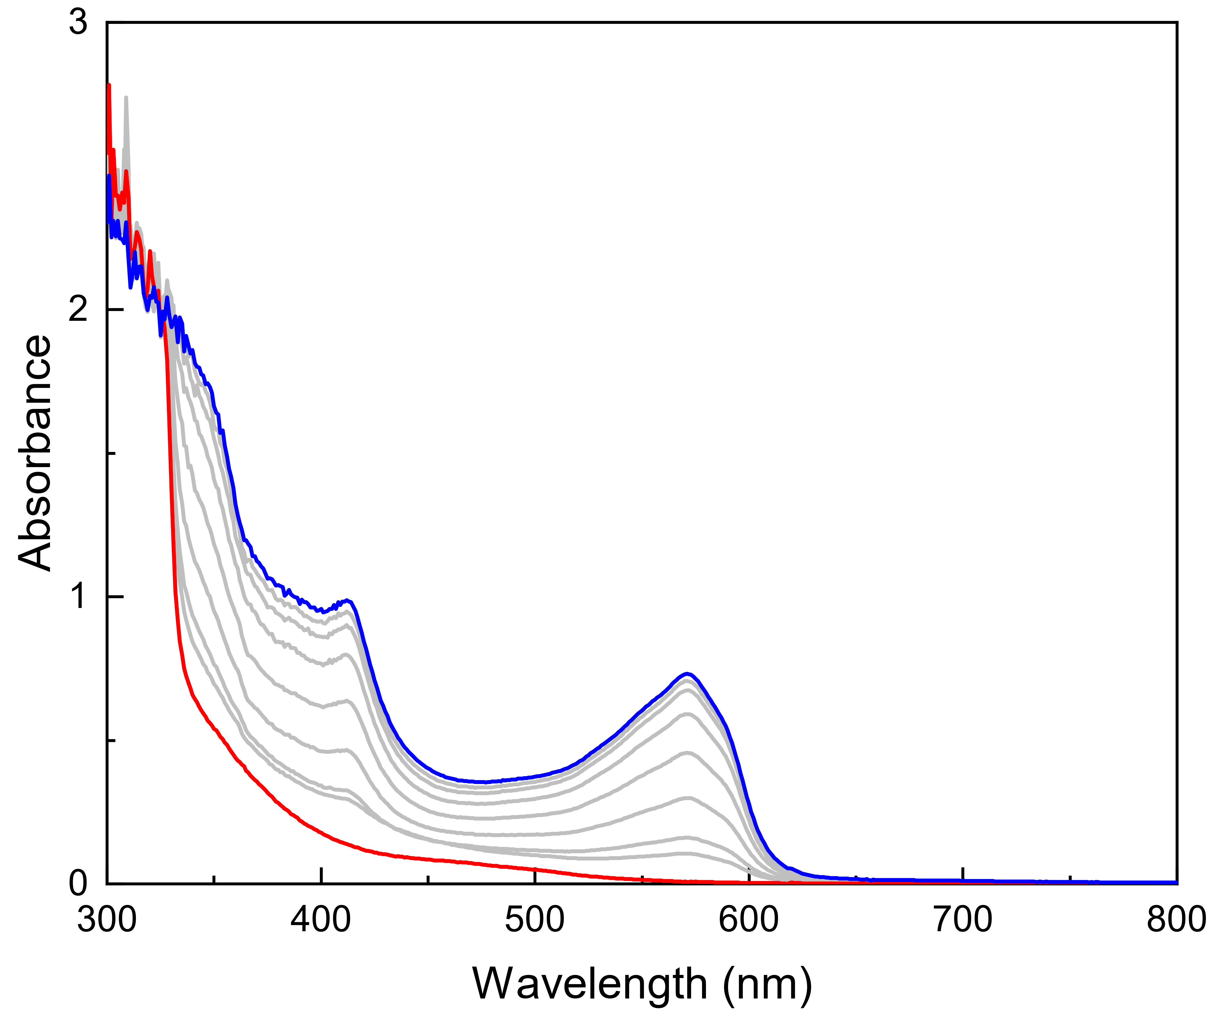
Supplementary Information Fig. S5 UV-Vis spectra of in situ photolysis of a 1mM fluorobenzene solution of 1 at 283 K. Red, blue and orange lines represent 1, photolysis product of 1 under 313 nm radiation within 1 h.

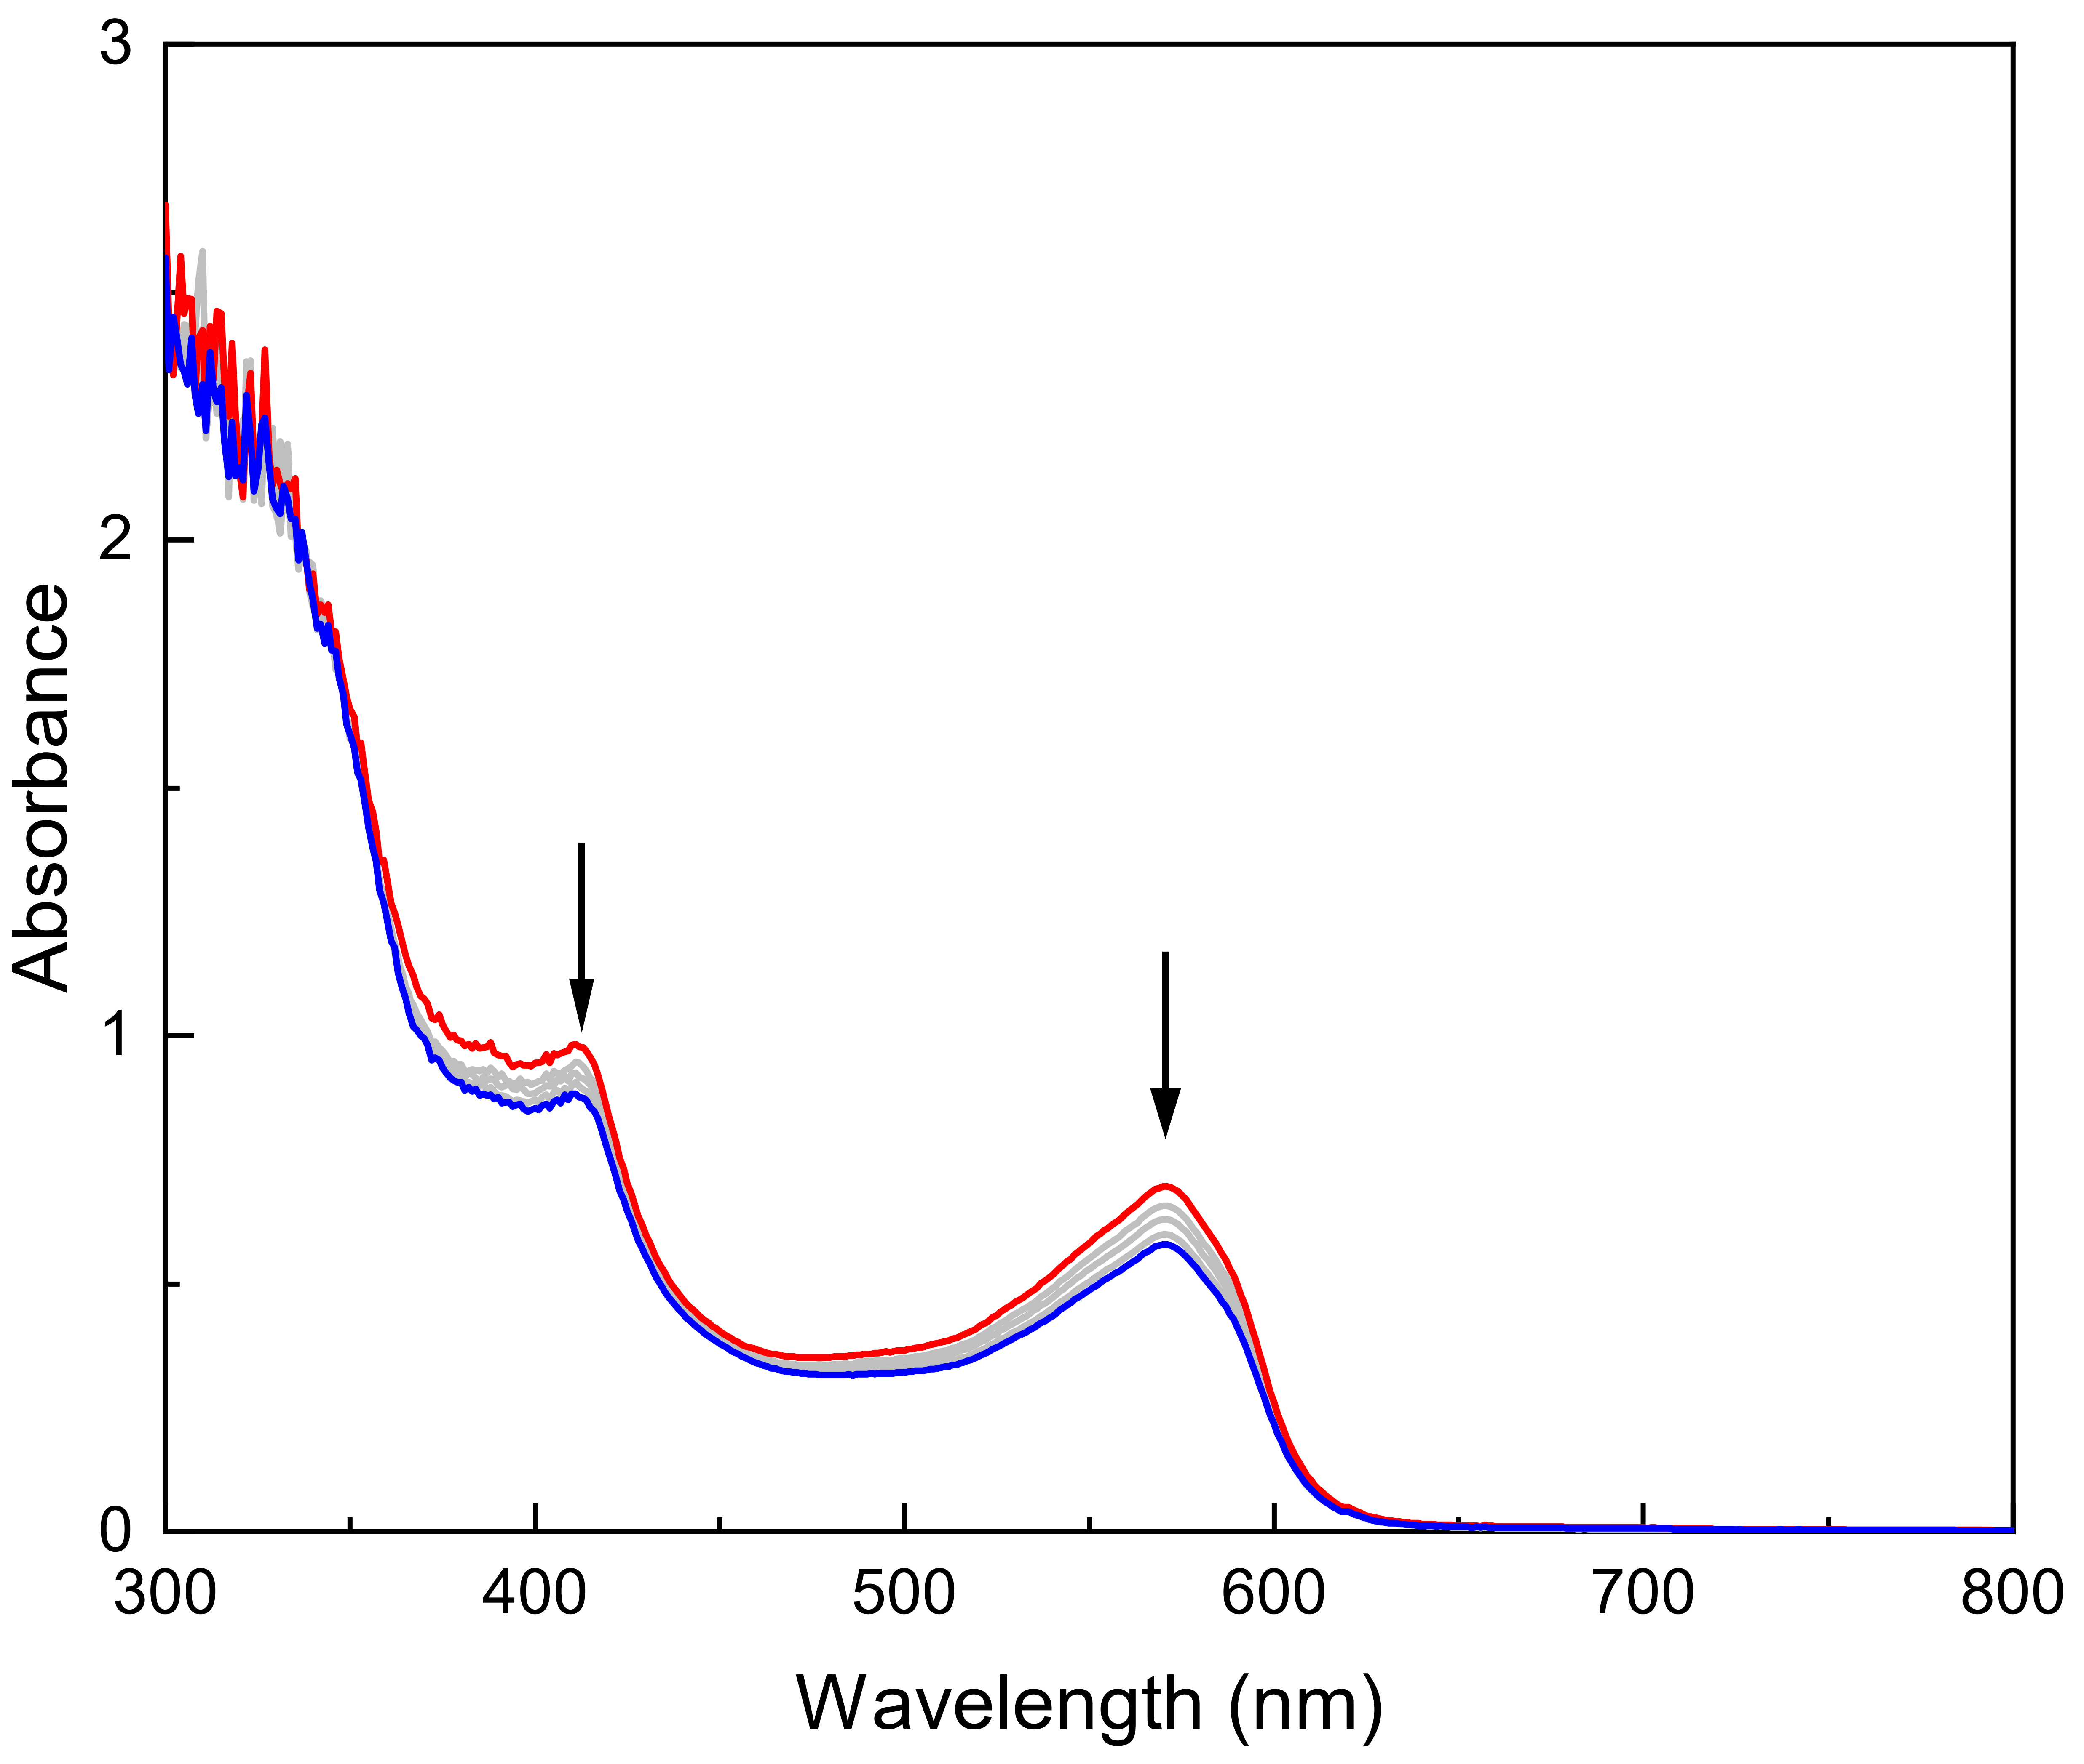
Supplementary Information Fig. S6 UV-Vis spectra of decay process of photolysis product in fluorobenzene solution at 298 K within 2 h.

Crystal structures reported in this manuscript
Supplementary Information Fig. S7 Thermal ellipsoids of the molecular structures of 1 depicted at 50% probability. The flanking fluorenyl moieties are shown in a wireframe style, and hydrogen atoms are omitted for clarity. Selected bond lengths (Å) and angles (º): C1–N1 1.426(4), C1–C2 1.407(4), C2–C3 1.388(4), C3–C4 1.402(4), C4–C5 1.394(4), C5–C6 1.389(4), C1–C6 1.401(4), N1–N2 1.238(5), N2–N3 1.145(6); C1-N1-N2 117.1(3), N1-N2-N3 172.2(5).

Supplementary Information Fig. S8 Thermal ellipsoids of the molecular structures of 3 depicted at 50% probability. The flanking fluorenyl moieties are shown in a wireframe style, and hydrogen atoms (except those at N1) are omitted for clarity. Selected bond lengths (Å) and angles (º): C1–N1 1.404(5), C1–C2 1.403(5), C2–C3 1.389(5), C3–C4 1.399(5), C4–C5 1.393(5), C5–C6 1.384(5), C1–C6 1.394(5); C2-C1-N1 122.0(3), C6-C1-N1 120.7(3).
Supplementary Information Fig. S9 Thermal ellipsoids of the molecular structures of 4 depicted at 50% probability. The flanking fluorenyl moieties are shown in a wireframe style, and hydrogen atoms are omitted for clarity. Selected bond lengths (Å) and angles (º): C1–N1 1.388(3), C1–C2 1.419(3), C2–C3 1.395(4), C3–C4 1.394(4), C4–C5 1.383(4), C5–C6 1.403(4), C1–C6 1.420(3); C2-C1-N1 121.1(2), C6-C1-N1 123.1(2), C1-N1-P1 142.7(2).

Supplementary Information Fig. S10 Thermal ellipsoids of the molecular structures of 5 depicted at 50% probability. The flanking fluorenyl moieties are shown in a wireframe style, and hydrogen atoms are omitted for clarity. Selected bond lengths (Å) and angles (º): C1–N1 1.445(3), N1–C73 1.449(3), N1–C74 1.449(3), C1–C2 1.415(3), C2–C3 1.403(3), C3–C4 1.386(3), C4–C5 1.392(3), C5–C6 1.395(3), C1–C6 1.416(3); C2-C1-N1 122.17(17), C6-C1-N1 119.68(17), C1-N1-C73 119.01(16), C1-N1-C74 122.60(16).

ESI-MS of 1-5
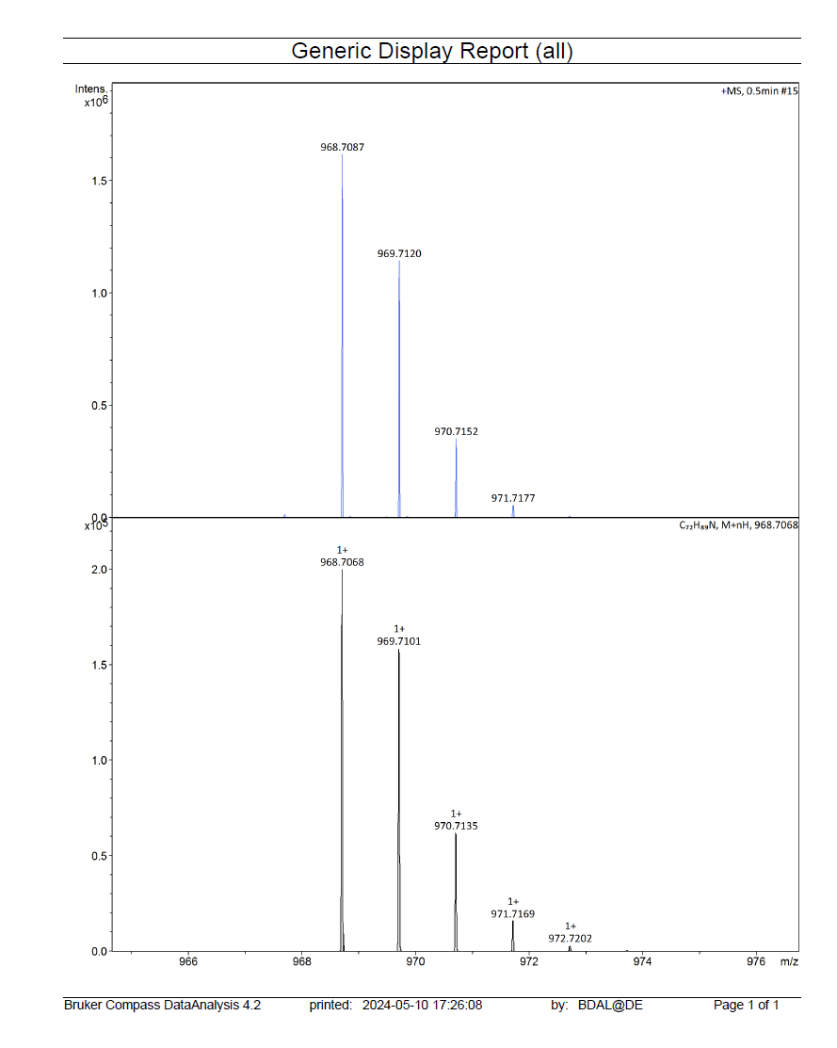
Supplementary Information Fig. S11 ESI-MS of 1.
. 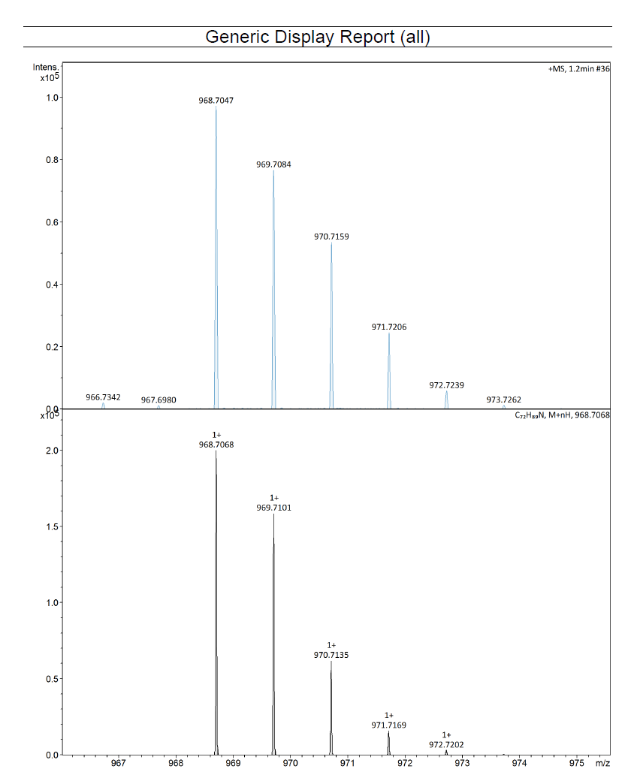

Supplementary Information Fig. S12 ESI-MS of 2.

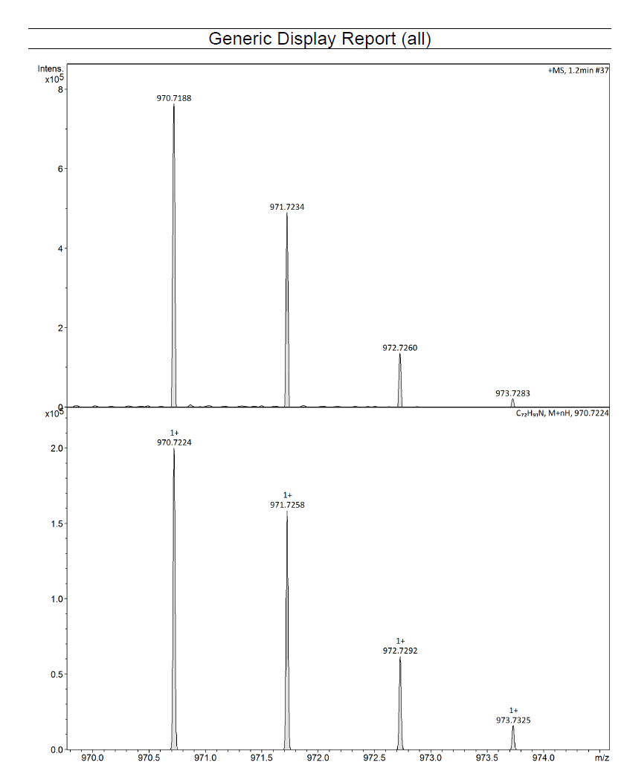
Supplementary Information Fig. S13 ESI-MS of 3.
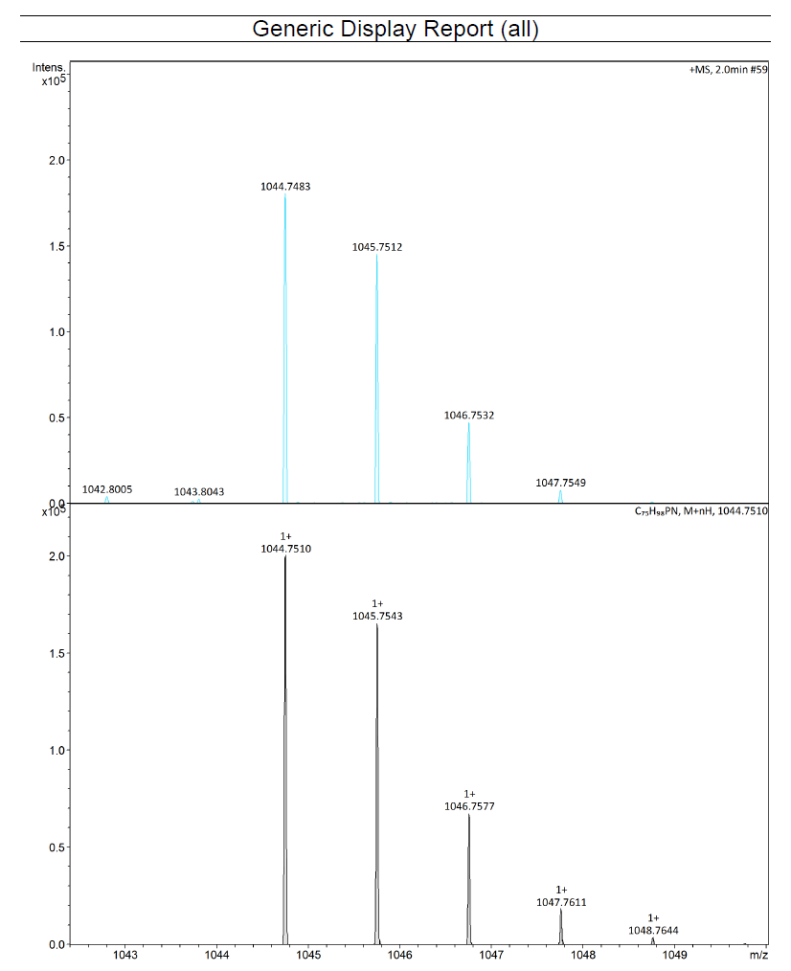
Supplementary Information Fig. S14 ESI-MS of 4.
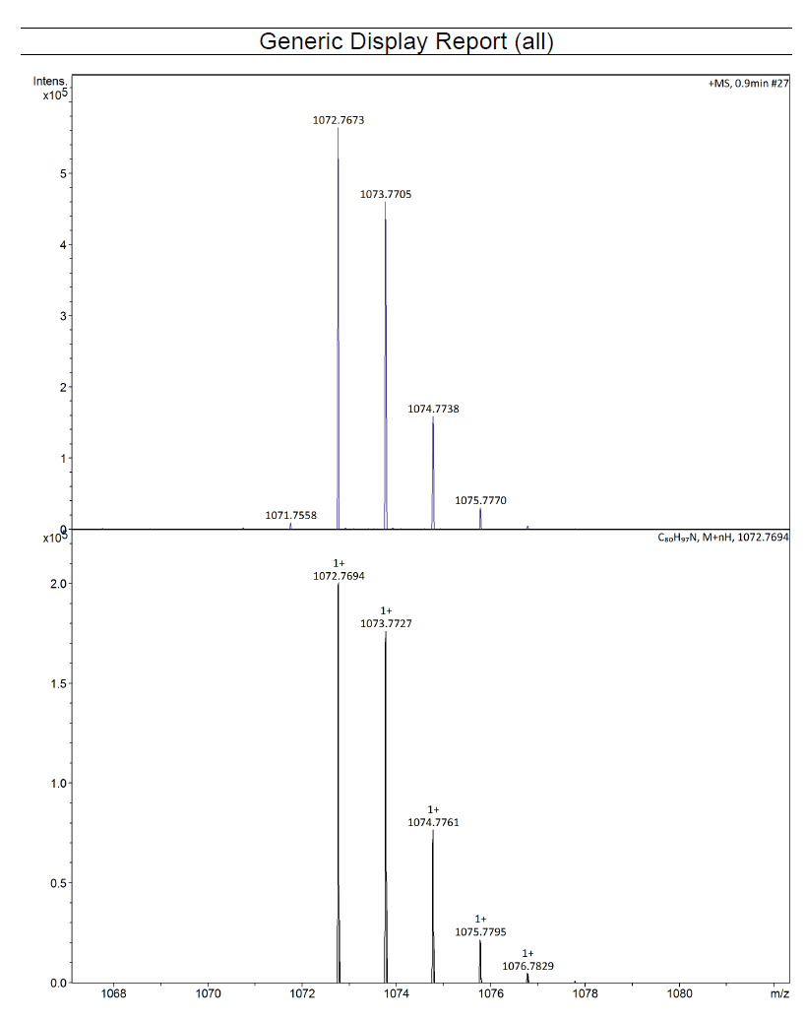. Supplementary Information Fig. S15 ESI-MS of 5.

Computation details
All calculations were performed by using ORCA 5.0 quantum chemical program ⁷. The crystal structure of complex 2 was used in highly correlated wavefunction based ab initio calculations. To reduce computational costs, a truncated model (2’) was employed, in which the alkyl substituents on the supporting ligand were replaced by hydrogen atoms, and their positions were optimized by using the B3LYP functional ^{8, 9} in combination with def2-SVP basis set ¹⁰ for all atoms. Noncovalent interaction was accounted for by using D3BJ corrections due to Grimme ¹¹. For complete active space self-consistent field (CASSCF) computations ¹², the active space was chosen to distribute 10 electrons into 10 orbitals including N–C σ and σ*, N 2p orbitals as well as the six π orbitals of the Ph ring. CASSCF computations employs def2-TZVP basis set for all atoms along with def2/JK auxiliary basis set ¹³ for the RIJK approximation ¹⁴. Quasi-restricted orbitals ¹⁵ from DFT calculations were chosen as the initial guess of the active orbitals. In addition, computations employing second order N-electron valence perturbation theory (NEVPT2) ¹⁶ were undertaken to capture dynamic correlations.

Crystallographic data and refinement results

 | 1 | 2 | 3
CCDC | 2354664 | 2354665 | 2354666
formula | C₇₈H₁₀₃N₃ | C₉₀H₁₀₇N | C_{76.5}H_{100.5}N
formula weight | 1074.54 | 1202.76 | 1034.07
crystal system | orthorhombic | monoclinic | orthorhombic
space group | P2₁2₁2₁ | I2/a | P2₁2₁2₁
a/Å | 13.00000(10) | 20.2164(2) | 12.9863(2)
b/Å | 21.9077(2) | 13.45550(10) | 21.9423(3)
c/Å | 23.1623(2) | 27.5485(2) | 23.0764(3)
α/deg
β/deg |  | 98.9900(10)
γ/deg
V/Å³ | 6596.63(10) | 7401.73(11) | 6575.60(16)
Z | 4 | 4 | 4
ρ_{calcd}/g∙cm⁻³ | 1.082 | 1.079 | 1.045
μ/mm⁻¹ | 0.455 | 0.450 | 0.433
F(000) | 2352.0 | 2616.0 | 2266.0
crystal size/mm³ | 0.16 × 0.11 × 0.10 | 0.20 × 0.10 × 0.08 | 0.14 × 0.10 × 0.08
2θ range/deg | 5.552 – 156.18 | 6.496 – 134.998 | 5.558 - 134.976
index ranges | -16 ≤ h ≤ 6  -27 ≤ k ≤ 27  -28 ≤ l ≤ 29 | -22 ≤ h ≤ 24  -16 ≤ k ≤ 13  -32 ≤ l ≤ 32 | -9 ≤ h ≤ 15  -26 ≤ k ≤ 26  -27 ≤ l ≤ 27
collected data | 28786 | 22843 | 35245
unique data | 12870  (R_{int} = 0.0275) | 6674  (R_{int} = 0.0332) | 11507  (R_{int} = 0.0494)
GOF on F² | 1.038 | 1.043 | 1.046
final R indices [I>2σ(I)] | R₁ = 0.0597  wR₂ = 0.1680 | R₁ = 0.0547  wR₂ = 0.1499 | R₁ = 0.0627  wR₂ = 0.1698
R indices (all data) | R₁ = 0.0632  wR₂ = 0.1716 | R₁ = 0.0591  wR₂ = 0.1537 | R₁ = 0.0715  wR₂ = 0.1756
Largest diff. peak/hole (e⋅Å⁻³) | 0.59/-0.53 | 0.45/-0.33 | 0.65/-0.29

 | 4 | 5
CCDC | 2354667 | 2354668
formula | C₇₅H₉₈NP | C₈₃H₁₀₀N
formula weight | 1044.51 | 1111.63
crystal system | triclinic | triclinic
space group | P-1 | P-1
a/Å | 13.9886(2) | 14.0778(3)
b/Å | 15.0489(2) | 15.2117(3)
c/Å | 17.0157(2) | 17.8173(3)
α/deg | 111.1420(10) | 111.887(2)
β/deg | 94.3650(10) | 95.649(2)
γ/deg | 100.7980(10) | 106.478(2)
V/Å³ | 3241.15(8) | 3304.51(12)
Z | 2 | 2
ρ_{calcd}/g∙cm⁻³ | 1.070 | 1.117
μ/mm⁻¹ | 0.670 | 0.466
F(000) | 1140.0 | 1210.0
crystal size/mm³ | 0.18 × 0.16 × 0.12 | 0.16 × 0.12 × 0.10
2θ range/deg | 5.638 – 155.982 | 5.492 – 134.992
index ranges | -17 ≤ h ≤ 17  -14 ≤ k ≤ 19  -21 ≤ l ≤ 21 | -16 ≤ h ≤ 16  -18 ≤ k ≤ 15  -21 ≤ l ≤ 21
collected data | 54732 | 45896
unique data | 13395  (R_{int} = 0.0270) | 11912  (R_{int} = 0.0366)
GOF on F² | 1.108 | 1.055
final R indices [I>2σ(I)] | R₁ = 0.0787  wR₂ = 0.2025 | R₁ = 0.0577  wR₂ = 0.1624
R indices (all data) | R₁ = 0.0825  wR₂ = 0.2043 | R₁ = 0.0681  wR₂ = 0.1679
Largest diff. peak/hole (e⋅Å⁻³) | 0.92/-0.72 | 0.47/-0.32

Selected NMR spectra
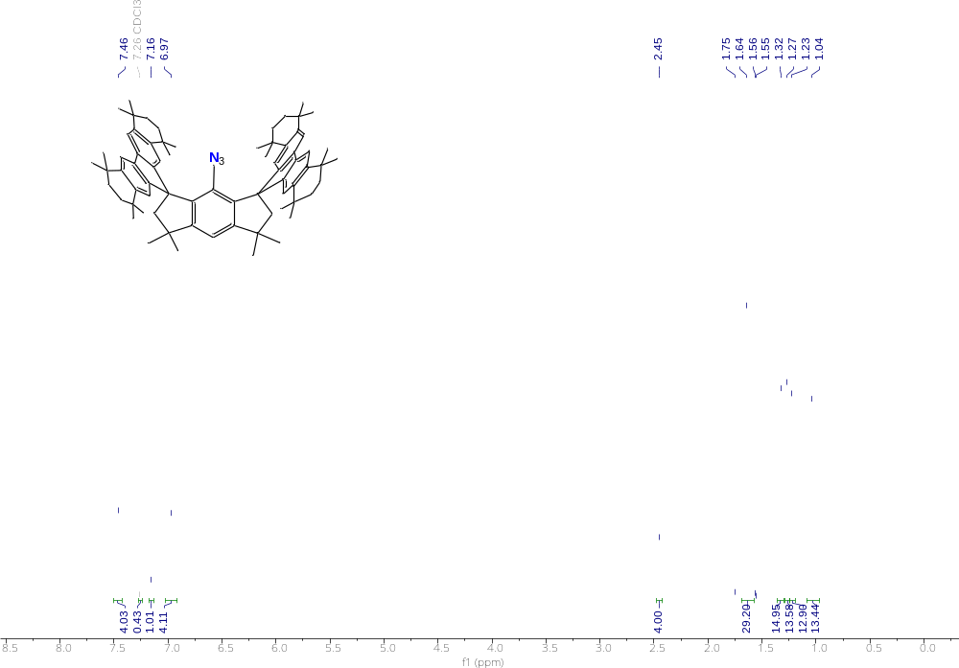
Supplementary Information Fig. S16 ¹H NMR spectrum of 1 in CDCl₃ at room temperature.

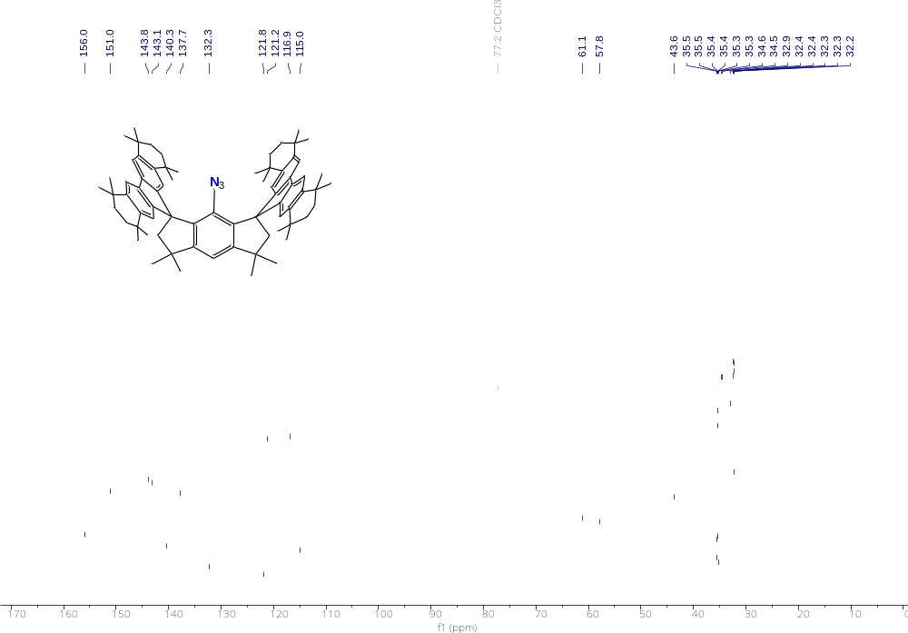
Supplementary Information Fig. S17 ¹³C{¹H} NMR spectrum of 1 in CDCl₃ at room temperature.
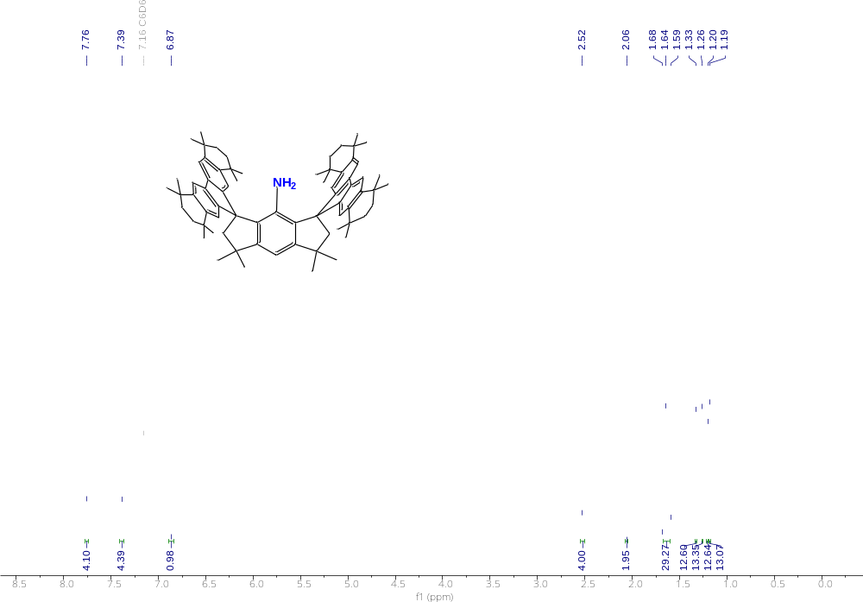
Supplementary Information Fig. S18 ¹H NMR spectrum of 3 in C₆D₆ at room temperature.

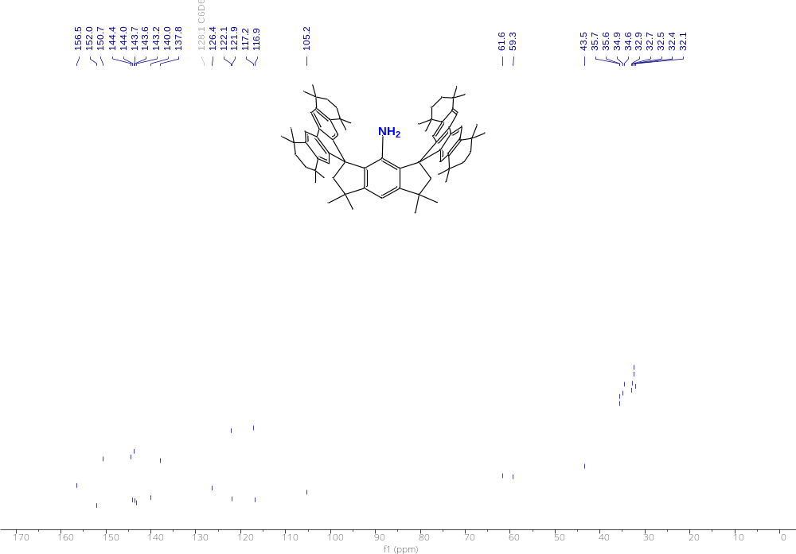
Supplementary Information Fig. S19 ¹³C{¹H} NMR spectrum of 3 in C₆D₆ at room temperature.

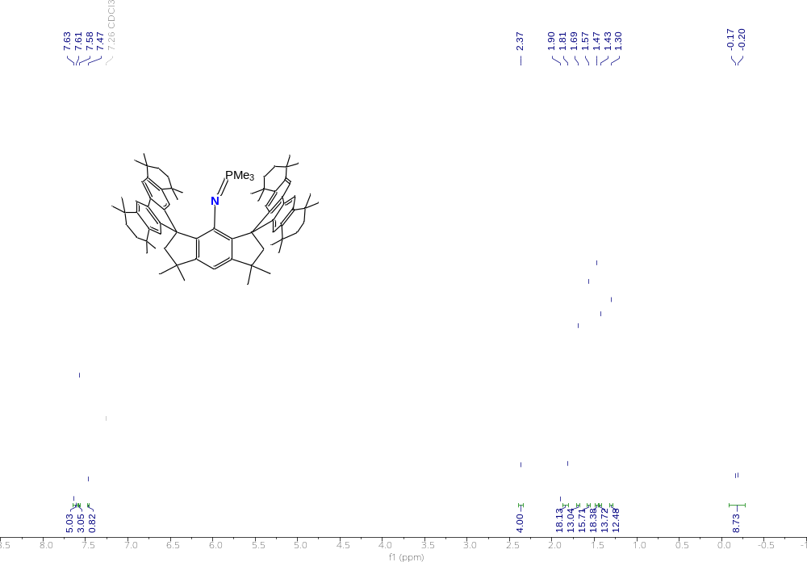
Supplementary Information Fig. S20 ¹H NMR spectrum of 4 in CDCl₃ at room temperature.

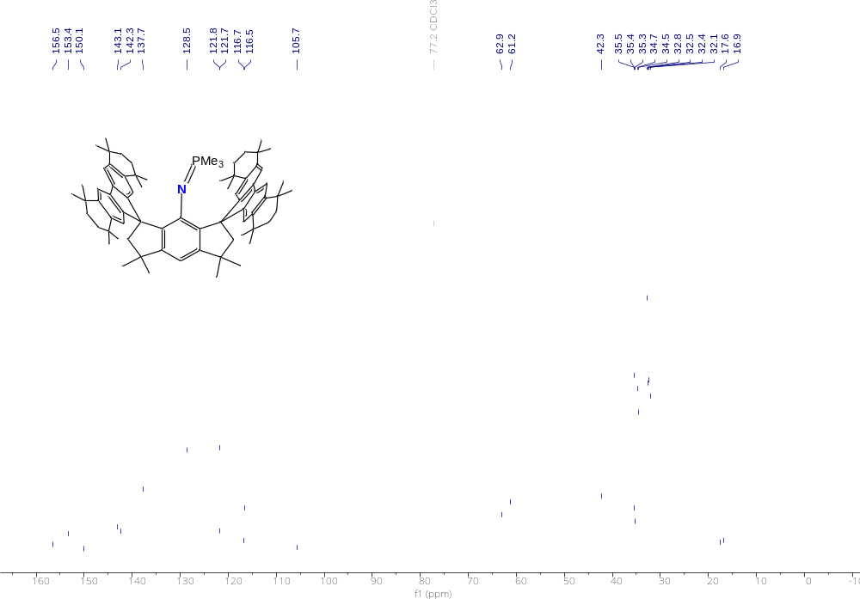
Supplementary Information Fig. S21 ¹³C{¹H} NMR spectrum of 4 in CDCl₃ at room temperature.
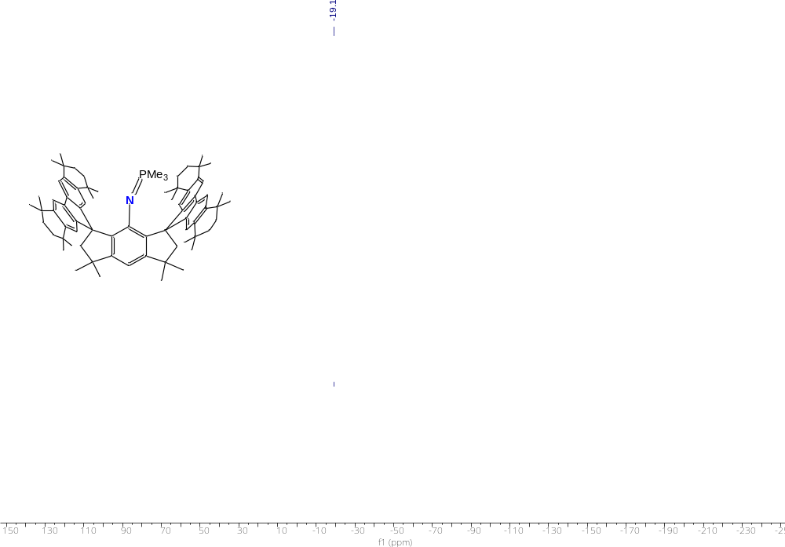
Supplementary Information Fig. S22 ³¹P{¹H} NMR spectrum of 4 in CDCl₃ at room temperature.

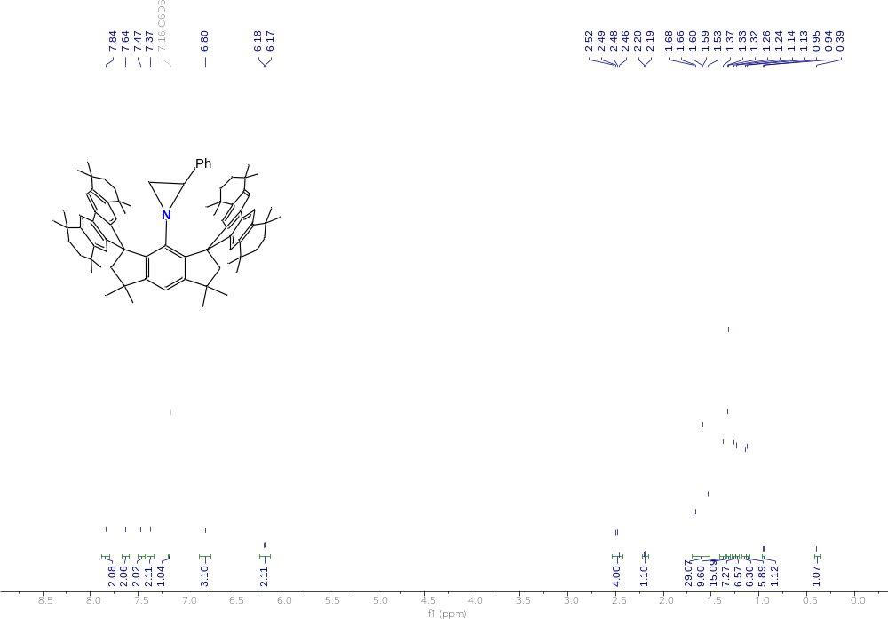
Supplemental Material Fig. S23 ¹H NMR spectrum of 5 in C₆D₆ at room temperature.
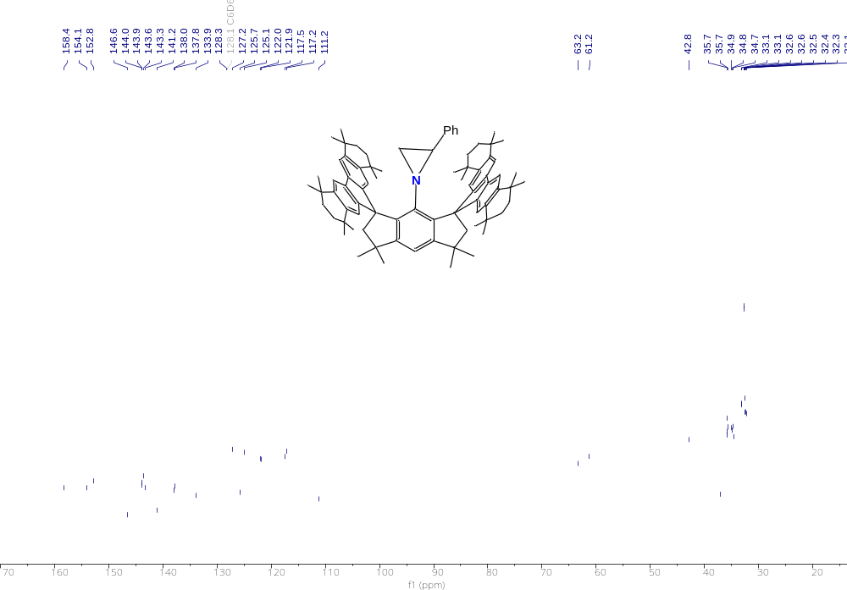
Supplemental Material Fig. S24 ¹³C{¹H} NMR spectrum of 5 in C₆D₆ at room temperature.

References
1. Wang, D. et al., An isolable germylyne radical with a one-coordinate germanium atom. Nat. Chem. 15, 200–205 (2023).
2. Sheldrick, G., Shelxt - integrated space-group and crystal-structure determination. Acta Cryst. A A71, 3-8 (2015).
3. Sheldrick, G. M., Crystal structure refinement with shelxl. Acta Cryst. C71, 3-8 (2015).
4. Dolomanov, O. V., Bourhis, L. J., Gildea, R. J., Howard, J. A. K., Puschmann, H., Olex2: A complete structure solution, refinement and analysis program. J. App. Cryst. 42, 339-341 (2009).
5. Spek, A., Platon squeeze: A tool for the calculation of the disordered solvent contribution to the calculated structure factors. Acta Cryst. C71, 9-18 (2015).
6. Stoll, S., Schweiger, A., Easyspin, a comprehensive software package for spectral simulation and analysis in epr. J. Mag. Res. 178, 42-55 (2006).
7. Neese, F., Wennmohs, F., Becker, U., Riplinger, C., The orca quantum chemistry program package. J. Chem. Phys. 152, 224108 (2020).
8. Becke, A. D., Density‐functional thermochemistry. III. The role of exact exchange. J. Chem. Phys. 98, 5648-5652 (1993).
9. Lee, C., Yang, W., Parr, R. G., Development of the colle-salvetti correlation-energy formula into a functional of the electron density. Phys. Rev. B 37, 785-789 (1988).
10. Weigend, F., Ahlrichs, R., Balanced basis sets of split valence, triple zeta valence and quadruple zeta valence quality for H to Rn: Design and assessment of accuracy. Phys. Chem. Chem. Phys. 7, 3297-3305 (2005).
11. Grimme, S., Ehrlich, S., Goerigk, L., Effect of the damping function in dispersion corrected density functional theory. J. Comput. Chem. 32, 1456-1465 (2011).
12. Malmqvist, P.-Å., Roos, B. O., The casscf state interaction method. Chem. Phys. Lett. 155, 189-194 (1989).
13. Weigend, F., Hartree–fock exchange fitting basis sets for H to Rn . J. Comput. Chem. 29, 167-175 (2008).
14. Kollmar, C., Sivalingam, K., Helmich-Paris, B., Angeli, C., Neese, F., A perturbation-based super-CI approach for the orbital optimization of a CASSCF wave function. J. Comput. Chem. 40, 1463-1470 (2019).
15. Neese, F., Importance of direct spin−spin coupling and spin-flip excitations for the zero-field splittings of transition metal complexes: A case study. J. Am. Chem. Soc. 128, 10213-10222 (2006).
16. Angeli, C., Cimiraglia, R., Malrieu, J.-P., N-electron valence state perturbation theory: A spinless formulation and an efficient implementation of the strongly contracted and of the partially contracted variants. J. Chem. Phys. 117, 9138-9153 (2002).

