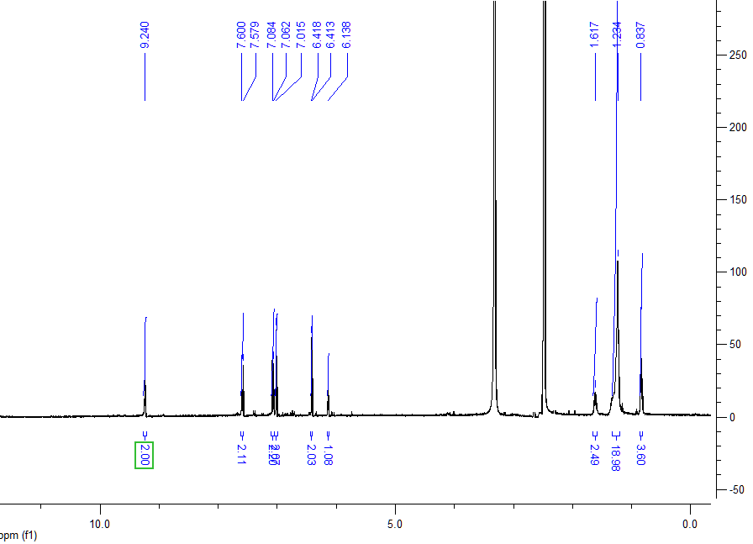
Figure 1. ¹H-NMR spectra compound 1 in DMSO
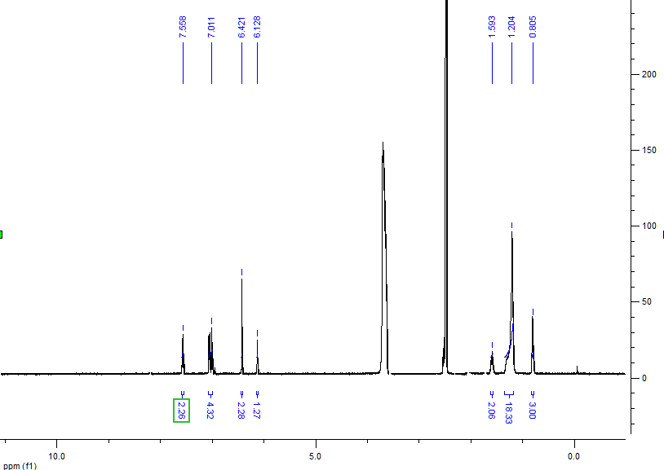
Figure 2. ¹H-NMR spectra compound 1 in DMSO with one drop D₂O

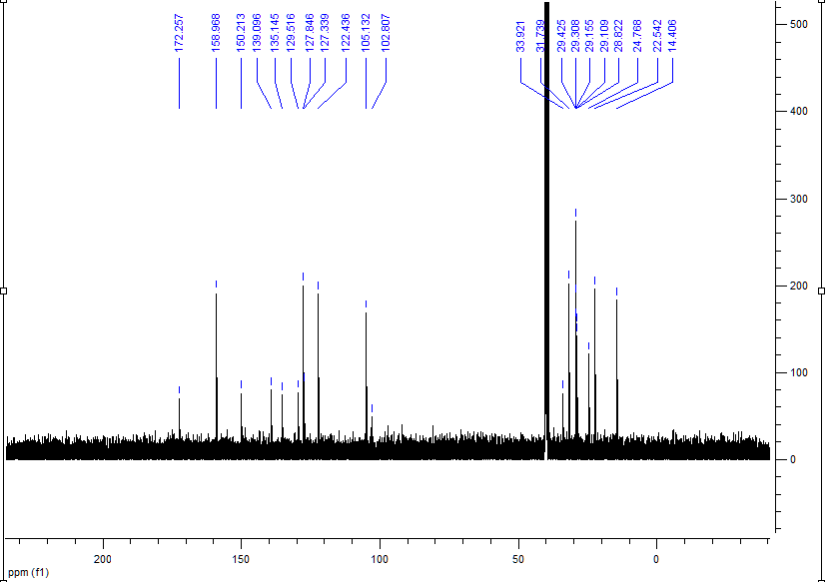
Figure 3. ¹³C-NMR spectra compound 1 in DMSO
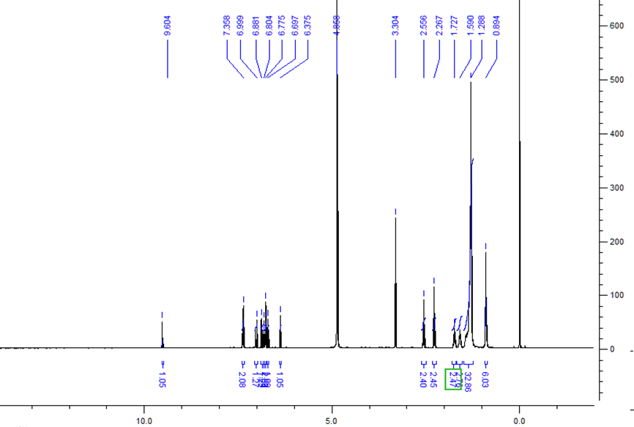
Figure 4. ¹H-NMR spectra compound 2 in MeOD

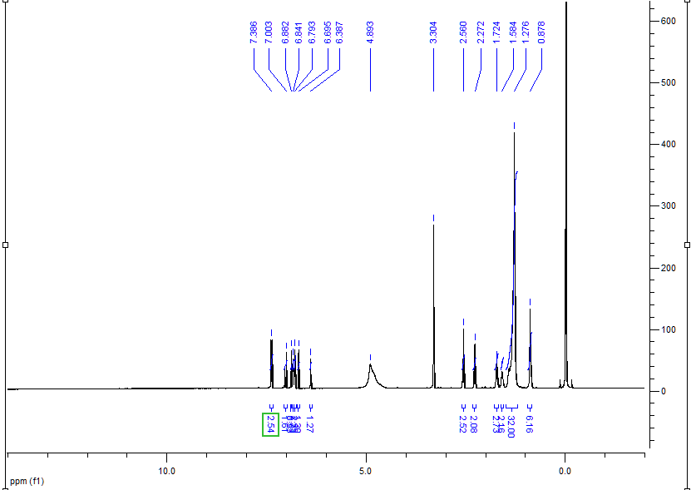
Figure 5. ¹H-NMR spectra compound 2 in MeOD with one drop D₂O
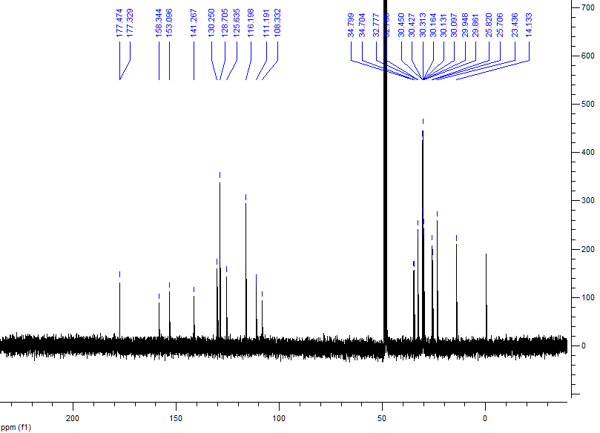
Figure 6. ¹³C-NMR spectra compound 2 in CDCl₃
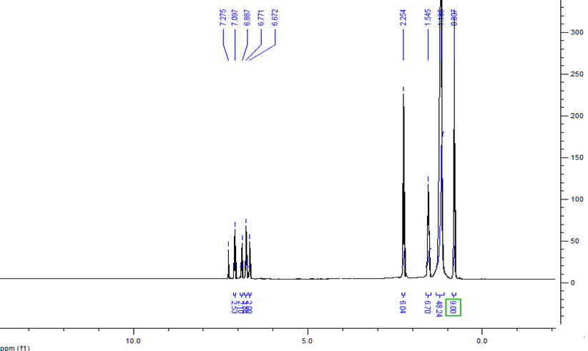
Figure 7. ¹H-NMR spectra compound 3 in CDCl₃
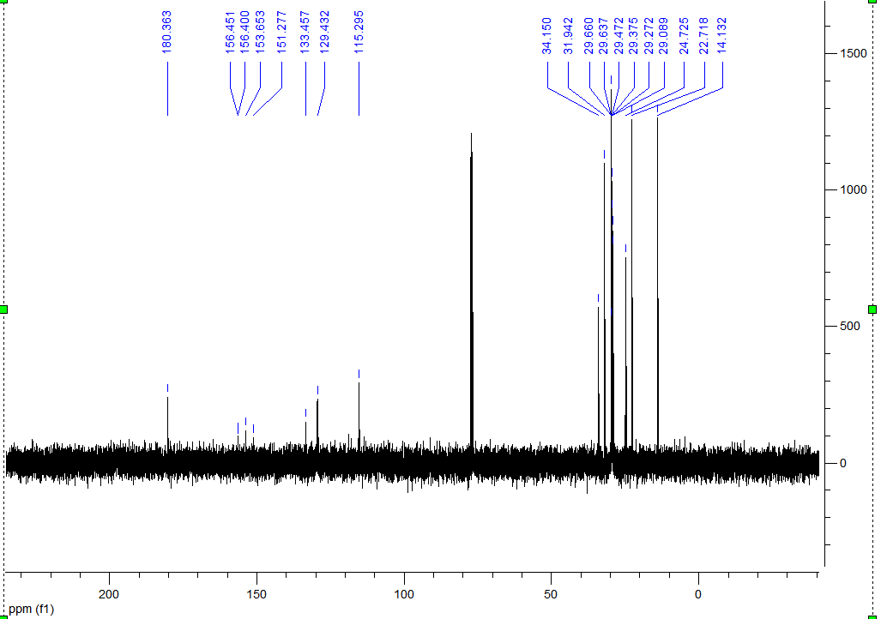
Figure 8. ¹³C-NMR spectra compound 3 in CDCl₃

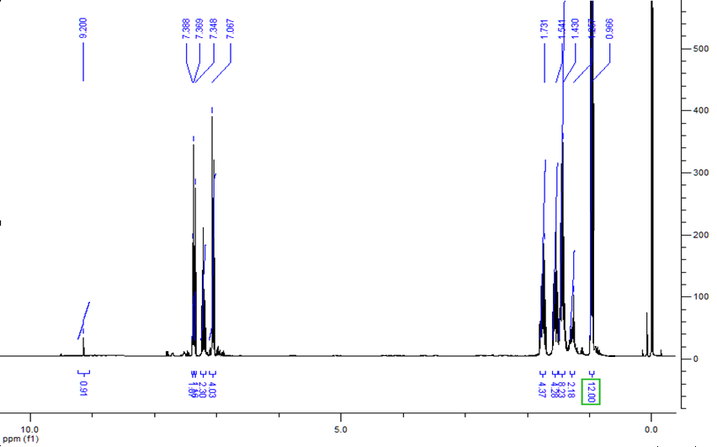
Figure 9. ¹H-NMR spectra of compound 4 in CDCl₃
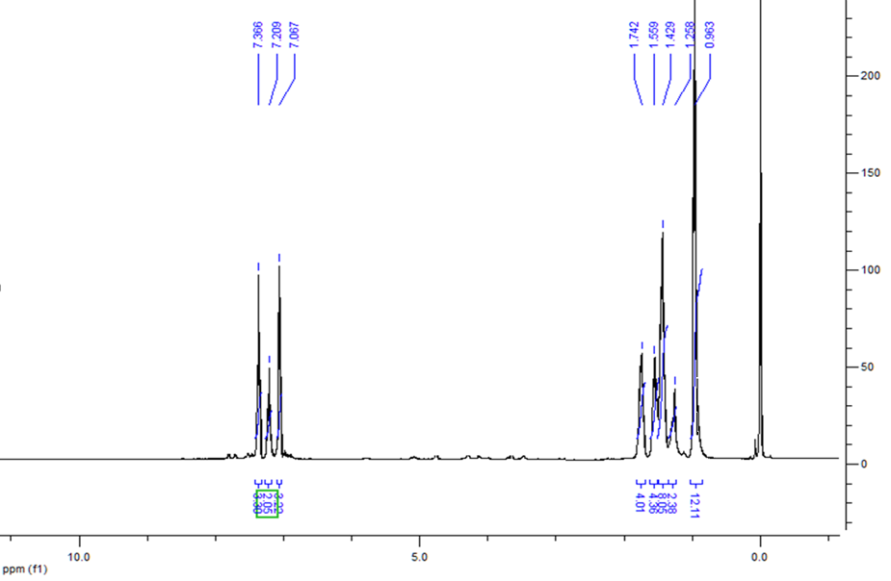
Figure 10. ¹H-NMR spectra of compound 4 in CDCl₃ with one drop D₂O

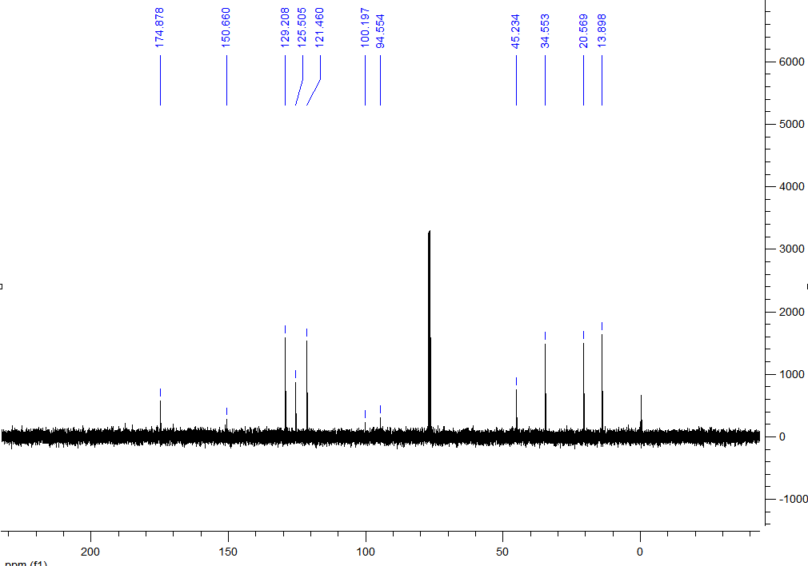
Figure 11. ¹³C-NMR spectra compound 4 in CDCl₃
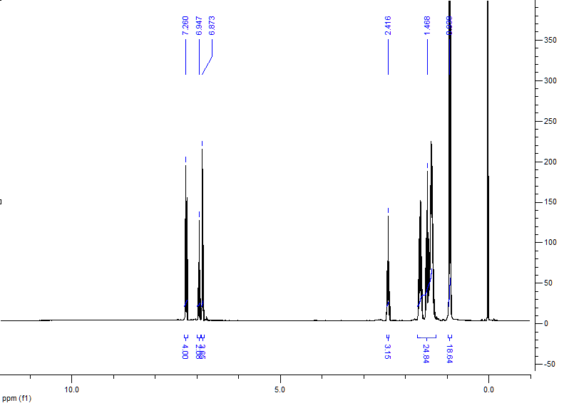
Figure 12. ¹H-NMR spectra of compound 5 in CDCl₃

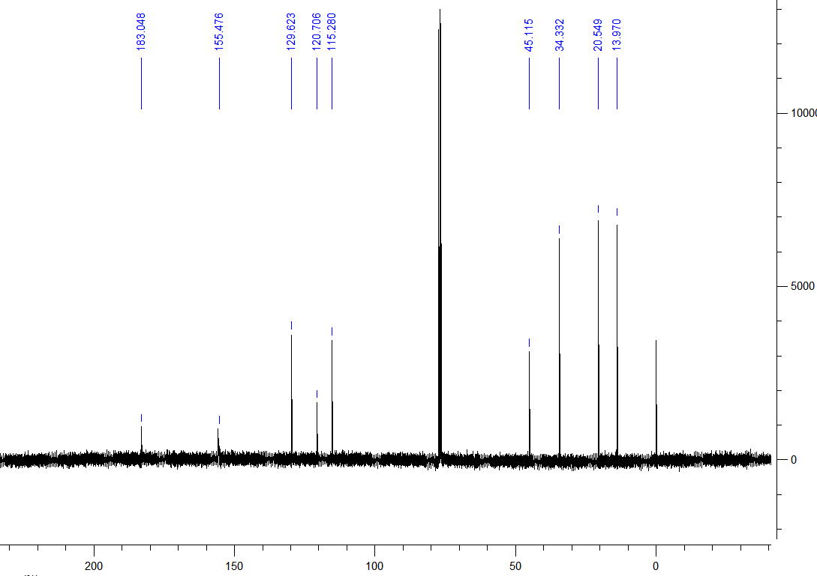
Figure 13. ¹³C-NMR spectra compound 5 in CDCl₃
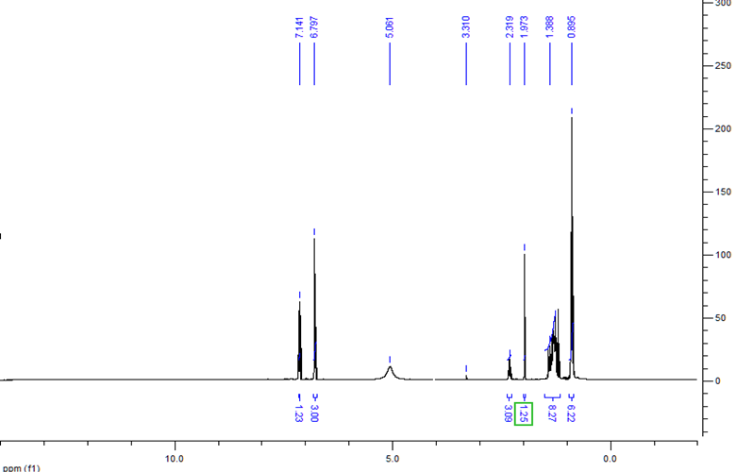
Figure 14. ¹H-NMR spectra compound 6 in MeOD

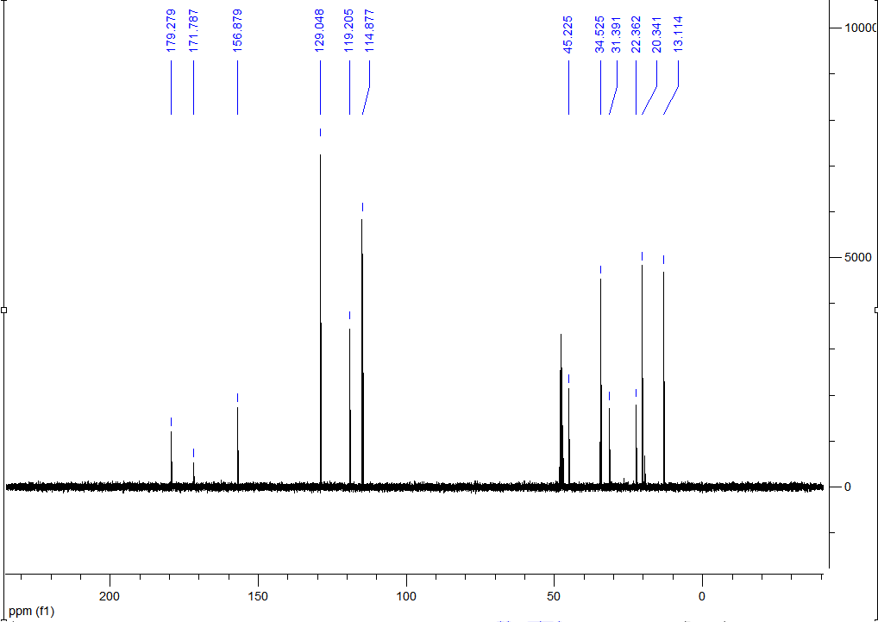
Figure 15. ¹³C-NMR spectra compound 6 in MeOD
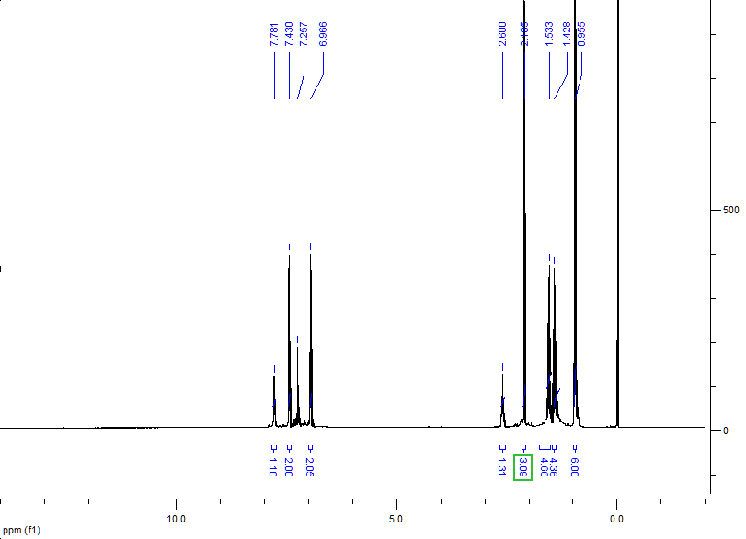
Figure 16. ¹H-NMR spectra compound 7 in CDCl₃
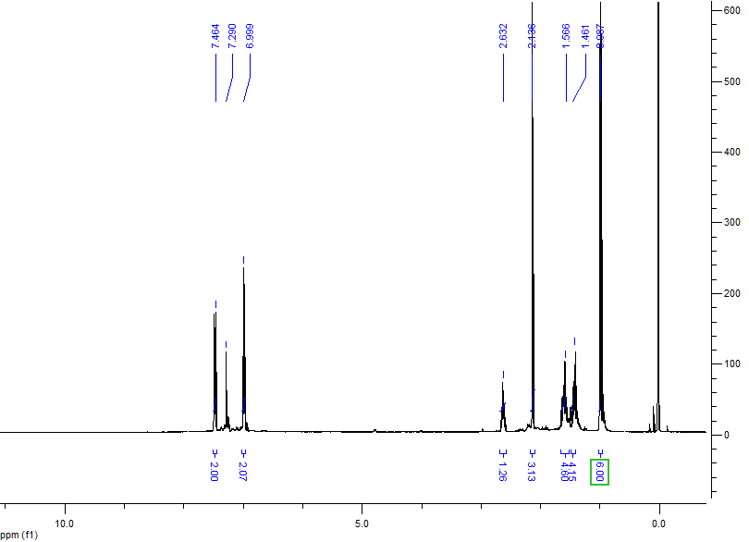
Figure 17. ¹H-NMR spectra compound 7 in CDCl₃ with one drop D₂O

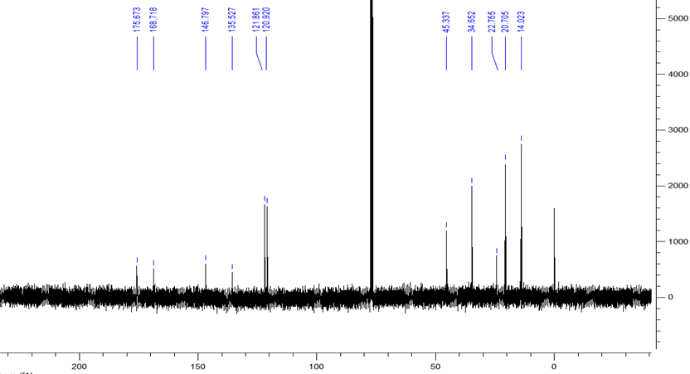
Figure 18. ¹³C-NMR spectra compound 7 in CDCl₃
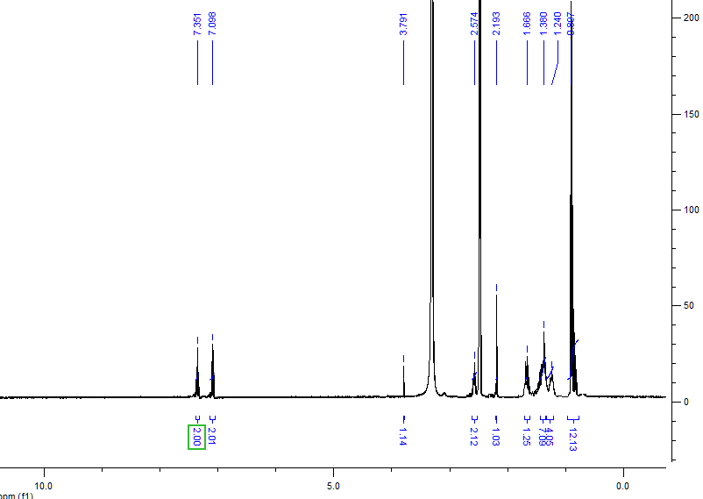
Figure 19. ¹H-NMR spectra compound 8 in DMSO

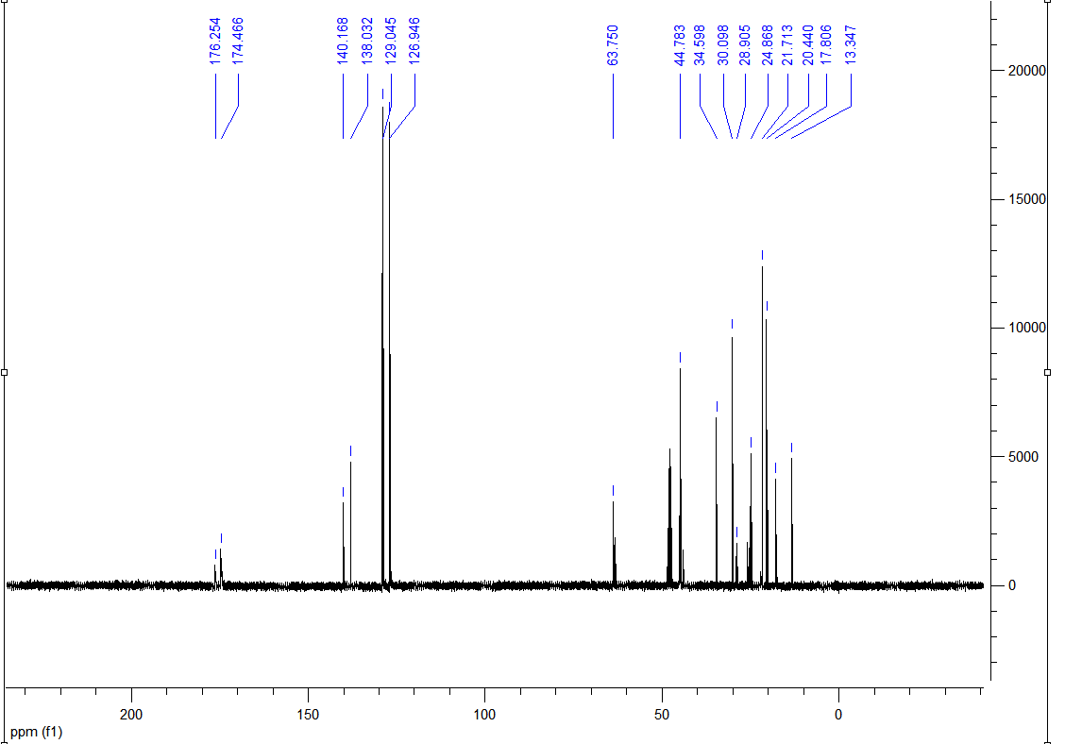
Figure 20. ¹³C-NMR spectra compound 8 in MeOD

