Supplementary Material

Exploring the potential of the Tachigali vulgaris wood from an experimental planting for producing charcoal in the Eastern Amazonia

Udson de Oliveira Barros Junior¹, Michael Douglas Roque Lima², Maíra Reis de Assis³, Elvis Vieira dos Santos³, Jonathan Dias Marques², Edgar A. Silveira⁴, Lina Bufalino², Delman de Almeida Gonçalves⁵, Mario Tomazello-Filho⁶, Paulo Fernando Trugilho³, Thiago de Paula Protásio^{3*}

¹Department of Forestry and Wood Sciences, Federal University of Espírito Santo – UFES, Zip code 29550-000, Jerônimo Monteiro, Espírito Santo, Brazil
²Institute of Agricultural Sciences, Federal Rural University of Amazonia – UFRA, Zip code 66077-830, Belém, Pará, Brazil
³Department of Forest Science, Federal University of Lavras – UFLA, Zip code 37203-202, Lavras, Minas Gerais, Brazil
⁴University of Brasília – UnB, Mechanical Sciences Graduate Program, Laboratory of Energy and Environment, Zip code 70910-900, Brasília, Distrito Federal, Brazil
⁵Brazilian Agricultural Research Corporation/Eastern Amazonia Embrapa, Zip code 66095-903, Belém, Pará, Brazil
⁶Department of Forest Sciences, University of São Paulo – ESALQ, Zip code 13418-900, Piracicaba, São Paulo, Brazil

*Corresponding author Email address: thiago.protasio@ufla.br
ORCiD: 0000-0002-5560-8350

The data/information in this document is the supplementary material for the paper Exploring the potential of the Tachigali vulgaris wood from an experimental planting for producing charcoal in the Eastern Amazonia.

Authors' ORCiD

Author | ORCiD
Udson de Oliveira Barros Junior | 0000-0002-9562-9391
Michael Douglas Roque Lima | 0000-0002-4789-1205
Maíra Reis de Assis | 0000-0001-5223-8019
Elvis Vieira dos Santos | 0000-0002-0821-6143
Jonathan Dias Marques | 0000-0002-4792-752X
Edgar Amaral Silveira | 0000-0002-7582-5010
Lina Bufalino | 0000-0002-7688-3140
Delman de Almeida Gonçalves | 0000-0002-6876-4192
Mario Tomazello-Filho | 0000-0002-9814-0778
Paulo Fernando Trugilho | 0000-0002-6230-5462
Thiago de Paula Protásio | 0000-0002-5560-8350

List of figures
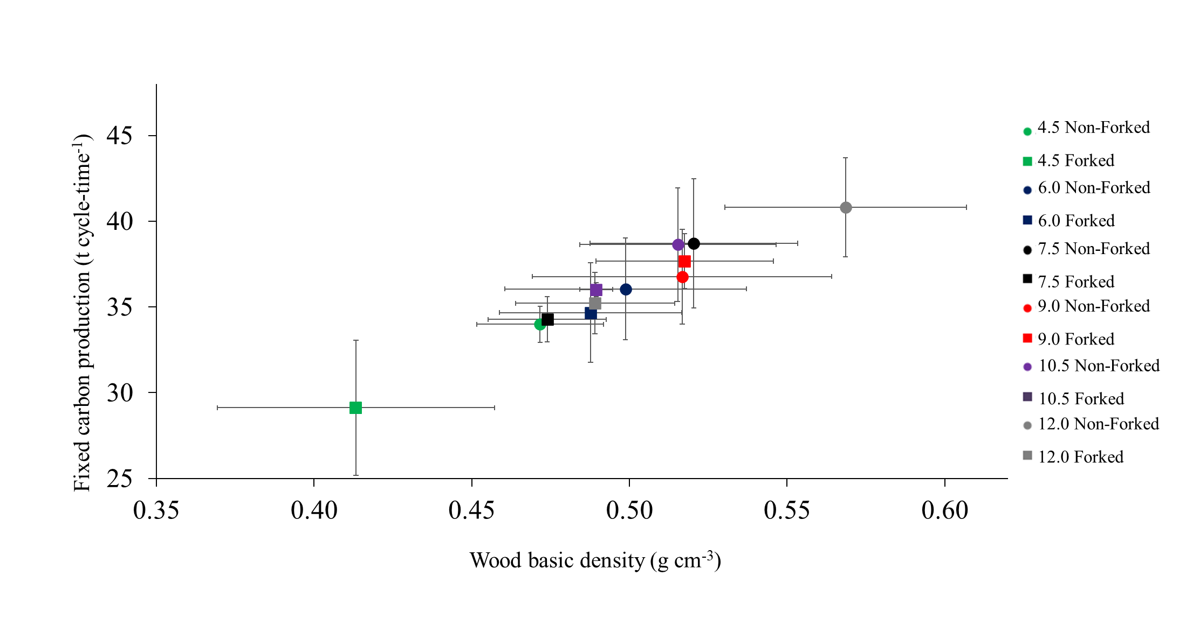
Figure S1. fixed carbon per carbonization cycle of Tachigali vulgaris due to the basic density.

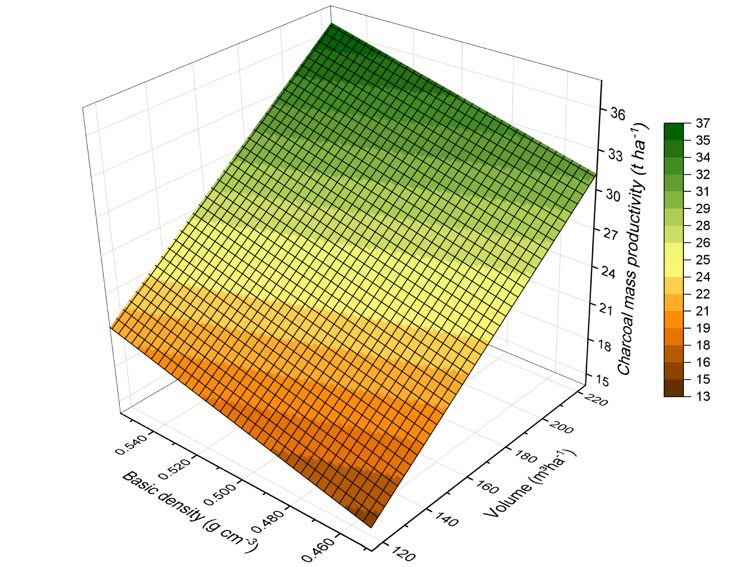
Figure S2. Charcoal mass productivity of Tachigali vulgaris due to the basic density of the wood and volume per hectare.

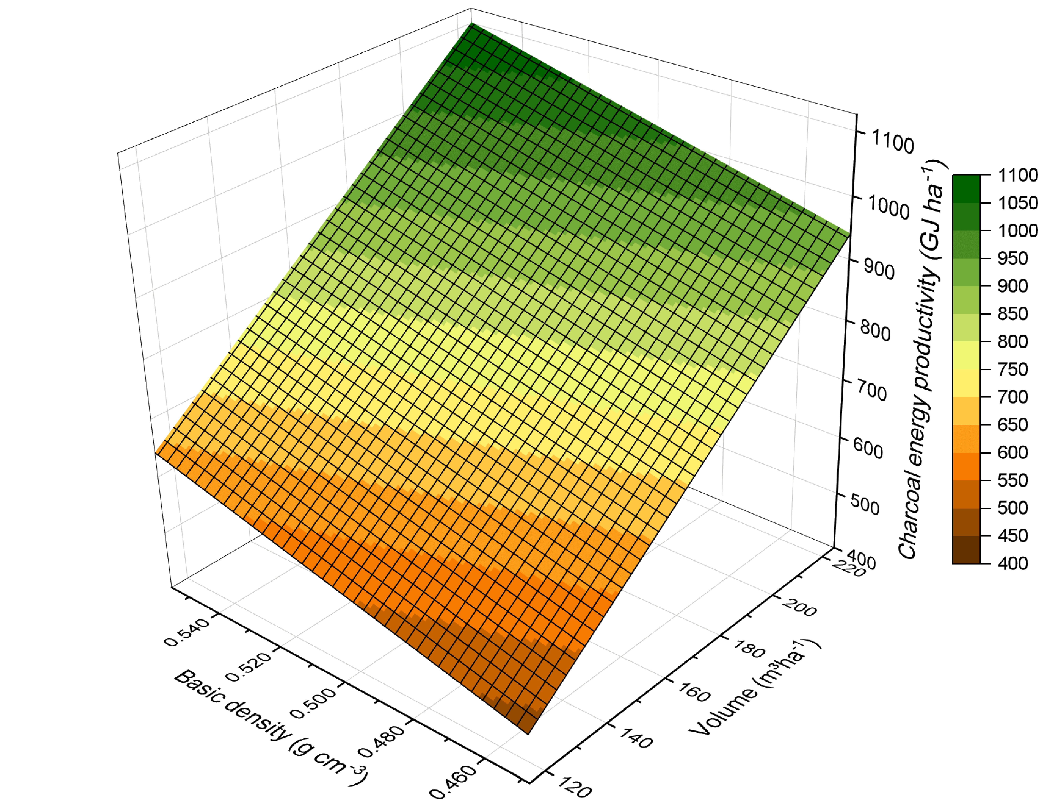

Figure S3. Charcoal energy productivity of Tachigali vulgaris due to the basic density of the wood and volume per hectare.

