Supplementary Figures/Tables:

Supplementary Figure 1: Different categories of renal tumours evaluated in this study. Note that this final evaluation includes not only RO and RCC but also other entities such as angiomyolipoma, lymphoma as well as metanephric adenoma. Of note is that tumours containing papillary adenomas were given the same letter as the bigger renal tumour found with.

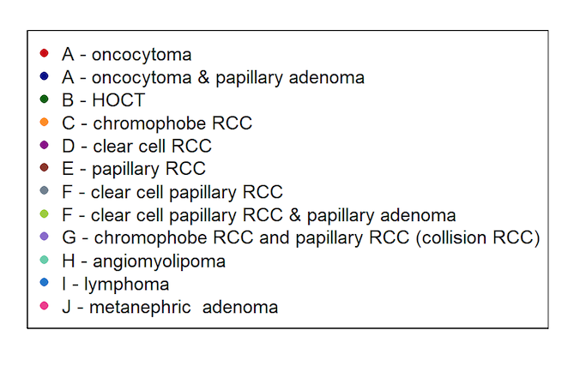

Supplementary Table 1: Patient and tumour characteristics
Number of patients |  | 52
Number of renal tumours |  | 57
Age in years (median [IQR]) |  | 68.00 [60.00, 76.00]
Sex (%) | female | 19 (33.3)
 | male | 38 (66.7)

Supplementary Figure 2: Relative ratio (0.407) of ^{99m}Tc-Sestamibi uptake based on SUV_{mean} measurements on the renal tumour (T) and the non-tumoral renal parenchyma (N) resulted in 82% sensitivity and 54% specificity in detecting RO.

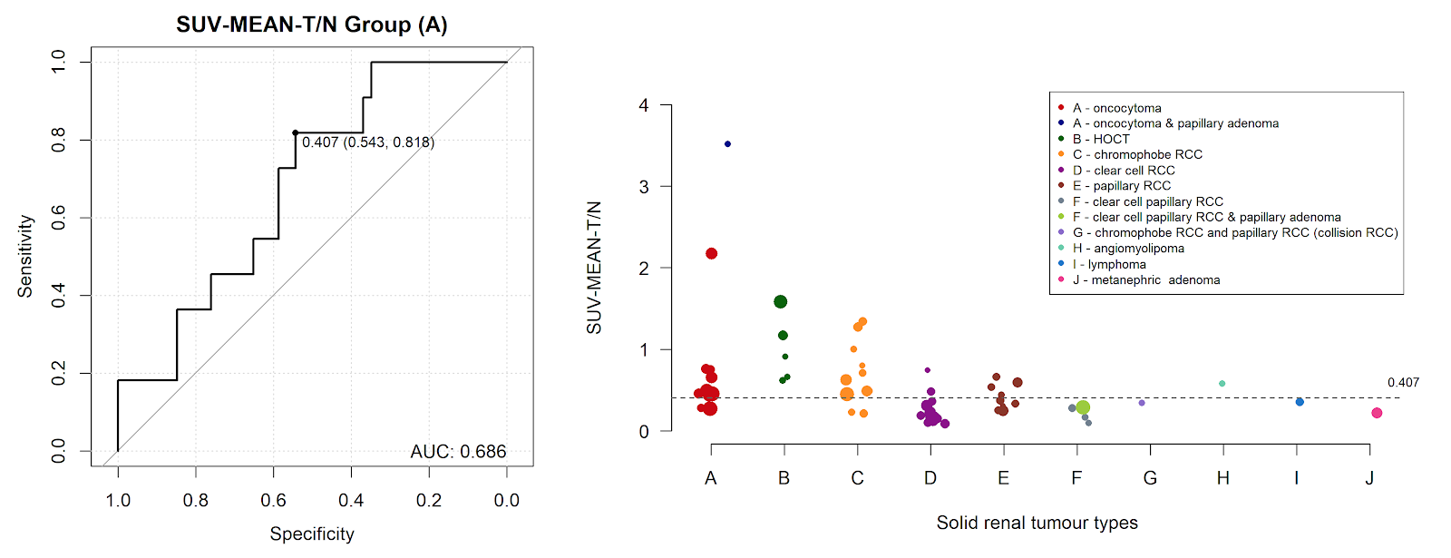

Supplementary Table 2: Sestamibi uptake correlated to mitochondrial content.
SDHB score was analysed as categorical ordinal variable and compared to Sestamibi uptake/no uptake using Cochran–Armitage test for trend.

 |  | no uptake | uptake
n |  | 6 | 13
SDHB, n (%) | 0 | 1 (16.7) | 0 (0.0)
 | 1 | 1 (16.7) | 0 (0.0)
 | 2 | 0 (0.0) | 1 (7.7)
 | 3 | 3 (50.0) | 5 (38.5)
 | 4 | 1 (16.7) | 7 (53.8)

Cochran-Armitage test for trend
Data: tabb
Z = -2.1346, dim = 5, p-value = 0.0328
Alternative hypothesis: two sided

