Figure S1: FOREST PLOT OF META-ANALYSIS OF THE INCLUDED STUDIES

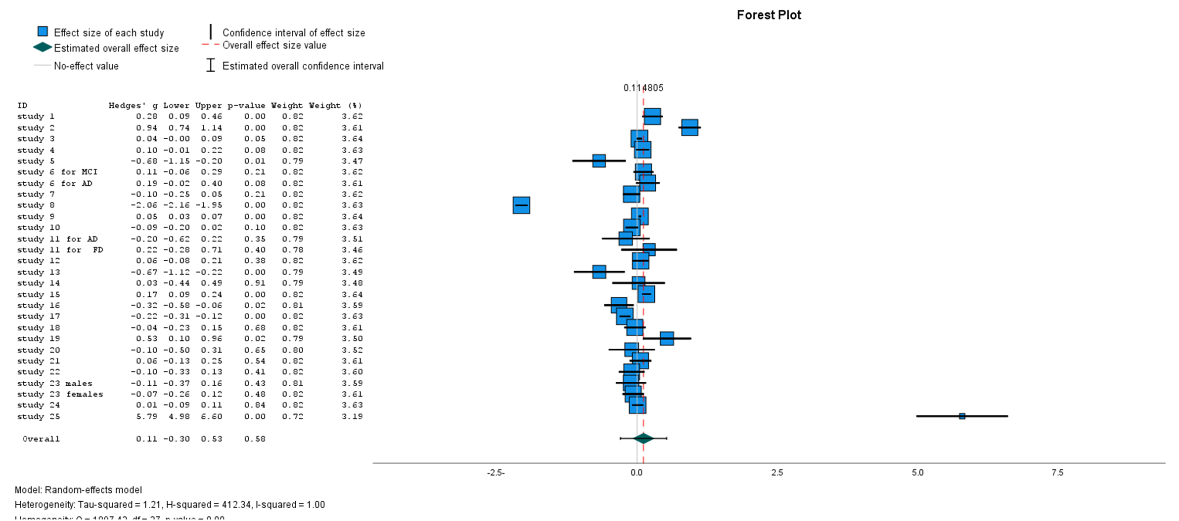

FIGURE S2: FUNNEL PLOT OF META-ANALYSIS OF THE INCLUDED STUDIES
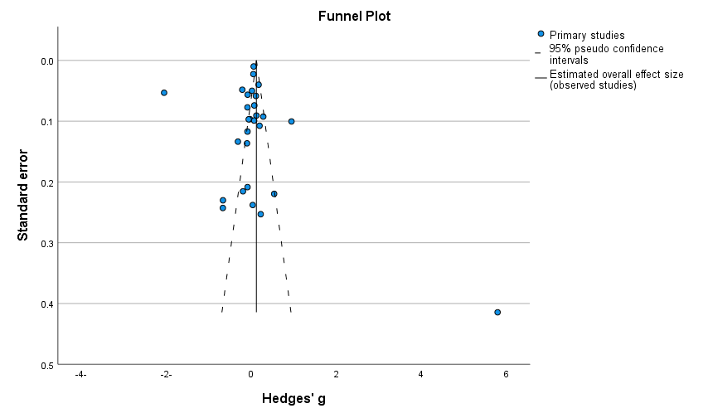

Figure S3: FOREST PLOT OF META-ANALYSIS OF STUDIES SHOWING HIGH TRIGLYCERIDE LEVELS EXCEEDING THE NORMAL LEVEL
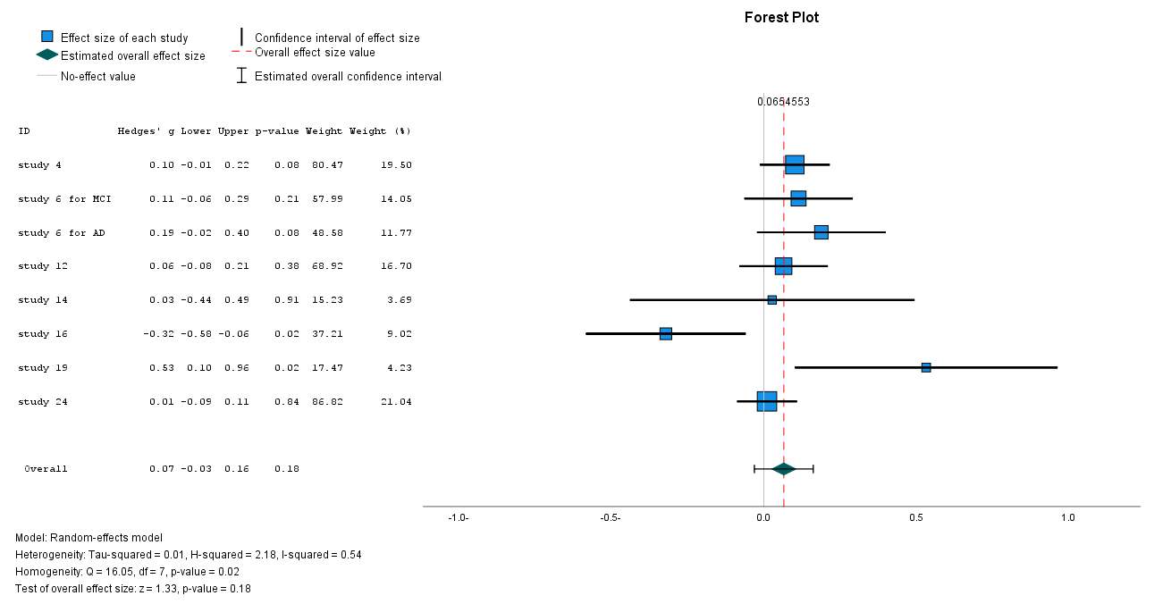

Figure S4: FUNNEL PLOT OF META-ANALYSIS OF STUDIES SHOWING HIGH TRIGLYCERIDE LEVELS EXCEEDING THE NORMAL LEVEL
