Supplementary Information

Supplementary Materials and Methods
Animals
For the ex vivo electrophysiology experiment at Boehringer Ingelheim, male BL/6 mice were obtained from Janvier Labs (Le Genest-Saint-Isle, France) aged 4-6 weeks, and were group housed with food and water available ad libitum; the light-dark cycle was lights on at 07:00-19:00 h. Mice were 6 weeks old at the onset of the experiment. For in vivo experiments at the University of Zurich, BL/6 mice were bred in-house and weaned with same-sex littermates at 4 weeks and caged in littermate pairs from 5-6 weeks. Cages measured 33 × 21 × 14 cm in an individually ventilated caging system. Temperature was kept at 21-23°C and humidity at 50-60%, and the light cycle was reversed with lights off at 07:00-19:00 h. Standard diet (Complete pellet, Provimi, Kliba AG, Kaiseraugst, Switzerland) was provided ad libitum except during behavioral conditioning and testing (see below). Water was provided ad libitum including during behavioral conditioning/testing. All experimental procedures were conducted during the dark phase and between 09:00-17:00 h. Mice were 10 weeks old and weighed 26-30 g at the onset of the experiments.
GPR52 inverse agonist
Cellular assay for in vitro potency determination
The on-target potency, EC₅₀, of the GPR52 inverse agonist (GPR52-IA) was determined using dose-dependent lowering of cAMP levels on CHO cells overexpressing murine GPR52. The compound was diluted in DMSO followed by assay buffer (HBSS/HEPES pH 7.4) and plated onto a 384-well plate. Assay buffer (including 0.5 mM IBMX and 0.1% BSA) as well as 12000 suspended cells were added to each well and incubated for 1h at RT. Subsequently, cAMP Gs Dynamic kit reagents (CisBio) were added to each well and again incubated for 1 h at RT. The data were assessed on a Perkin Elmer Envision and % response was calculated relative to vehicle control set as 100%.
In vitro plasma protein binding assays
Equilibrium dialysis (ED) was applied to determine the approximate in vitro fractional binding of GPR52-IA to mouse plasma proteins. A RED device (Thermo Scientific™ Rapid Equilibrium Dialysis (RED) inserts and plates), consisting of a donor and an acceptor chamber being separated by an ultra-thin semipermeable membrane, was used to dialyze mouse plasma spiked with GPR52-IA (10 µM final concentration) against the dialysis buffer (phosphate-buffered saline, pH 7.4 containing 32 g/L Dextran). Incubation was carried out for 3-6 h under rotation at 37°C, and samples of both dialysates were analyzed for GPR52-IA using HPLC-MS/MS. The percentage of bound GPR52-IA was calculated from GPR52-IA concentrations in plasma ($C_{p}$) and buffer ($C_{b}$) according to the equation $\% bound= \frac{C_{p}-C_{b}}{C_{b}}∙100$. The percentage of free (unbound) GPR52-IA was calculated from the equation $\% free=100-\% bound$, i.e. fraction unbound ($f_{u}$) is $\frac{\%free}{100}$.
In vivo pharmacokinetic and tissue distribution studies in mice
These in vivo experiments were conducted at Boehringer Ingelheim (Biberach, Germany) in compliance with the respective animal welfare regulations and approved by the responsible local authorities and committees. The animals were group-housed under standard laboratory housing conditions with lights on during the day and free access to water and standardized pelleted food. GPR52-IA was administered to fed adult male C57BL/6NRj mice, either intravenously (i.v.) as a solution at a dose of 0.4 mg/kg and a maximal dose volume of 5 mL/kg, or orally (p.o.) as a suspension at a dose of 4 mg/kg or 20 mg/kg and a maximal dose volume of 10 mL/kg. Blood was sampled serially from the vena saphena at several time points during up to 24 h post-dosing. Blood samples were anticoagulated by use of potassium-EDTA-coated tubes and centrifuged within 1 h after sampling, for 10 min at 4°C, 1600 x g. The plasma was separated and stored at -20°C until bioanalytical quantification of GPR52-IA. Muscle and brain tissues, as well as blood, were sampled terminally at 1 h following oral dosing of 20 mg/kg GPR52-IA to determine the in vivo efflux (tissue partition coefficients). GPR52-IA concentrations in plasma and tissue homogenates were determined by liquid chromatography coupled to tandem mass spectrometry (LC-MS/MS) according to standard procedures, including an internal standard and a calibration curve. For PK evaluation, the program ToxKin was used. Individual plasma concentration-time curves of GPR52-IA were analyzed by non-compartmental methods. Statistics were performed with sample size (N) ≥ 2. Primary statistics were N, mean, coefficient of variation (CV) and standard deviation (SD). GPR52-IA exposures in plasma, $c_{plasma}$ $\left[\frac{nmol}{l}\right]$, brain, $c_{brain}$ $\left[\frac{pmol }{g_{tissue}}\right]$or muscle, $c_{muscle}$ $\left[\frac{pmol }{g_{tissue}}\right]$were used to calculate the tissue partition coefficients $K_{p,brain}= \frac{c_{brain }}{c_{plasma}}$ and $K_{p,\frac{muscle}{brain}}= \frac{c_{muscle }}{c_{brain}}$. The partition coefficient $K_{p,\frac{muscle}{brain}}$ was used as a surrogate for the partition coefficient of unbound GPR52-IA in brain $K_{p,uu,brain}$. The concentration of free (unbound) GPR52-IA in brain was estimated using the formula $c_{u,brain}$ $={ c}_{plasma}∙K_{p,\frac{muscle}{brain}}∙f_{u}$.
Off-target activity
To assess selectivity of the compound, its activity at other receptors was studied using the Eurofin SafetyScreen44™ Panel, with blockage of target-specific radioligand binding or enzyme/uptake activity at 44 common targets by pre-application of 10 µM GPR52-IA used to assess activity of the latter at each target. Referring to Table S3, $\%CTRL= \frac{s_{c}}{s_{0}}*100,$ Where $s_{0}$ is the signal in the absence of and $s_{c}$ the signal in the presence of, GPR52-IA. A %CTRL value close to 100 indicates no test compound-target interaction, and a value of 0 indicates interaction leading to full blockage (values >100 are considered to include artefacts). In accordance with Eurofin’s recommendation, only values below 50 are considered further: this was the case for 5-HT1B, 5-HT2A, 5-HT2B, adrenergic α-1a, L-type calcium channel, DRD1, potassium channel hERG, and norepinephrine transporter (Table S3). Given that on-target potency (EC₅₀) was estimated as 8 nM, only %CTRL values <10 are relevant, which was the case only for 5-HT2A (%CTRL = 3). In the absence of experimental data on GPR52-IA potency at 5-HT2A, a definitive statement cannot be made on the potential contribution of 5-HT2A to the observed effects of GPR52-IA. Nonetheless, we can estimate the potency of GPR52-IA at 5-HT2A: Assuming a Hill coefficient of 1 in binding of GPR52-IA to 5-HT2A, and equating EC₅₀ to K_{D}, potency can be estimated using the following form of Hill’s equation: $EC_{x}={\left(\frac{x}{100-x}\right)}^{1/H}EC_{50},$ where H is the Hill coefficient, and we use S_{o}-S_{c} = 97 for x, and EC₉₇ was measured as 10 µM. This yields an $EC_{50}≈300 \text{nM}$. Given that C_{u,brain} was in the range of 10 nM, it is unlikely that GPR52-IA was active at 5-HT2A at the doses used in experiments.
Main experiments
The vehicle was 0.5% Natrosol (hydroxyethyl-cellulose) and 0.015% Tween in purified water. GPR52-IA was prepared for administration at 3 mg/kg and 10 mg/kg in sealed glass containers. It was prepared on the day before it was first required and when not in use was stored at 4 ֯C for a maximum of 7 days. During use, the preparations were kept at room temperature and stirred continuously.
Slice preparation electrophysiology
In Experiment 1, mice were anesthetized with isoflurane (1.2-2%) and placed into a stereotactic apparatus (Kopf). A viral vector expressing channel rhodopsin (ssAAV8-hSyn-mChr2-mCherry, 2.92 x 1014 VG/ml, 200 nl) was injected bilaterally in the NAc (AP: 1.5, ML: ± 1.2, DV: -4.25, relative to Bregma), at 100 nl/min using a beveled 33-gauge Hamilton syringe. Animals were treated with Metacam prior to and three days after surgery. Mice were monitored daily and allowed to recover from surgery for at least 3 weeks prior to ex vivo electrophysiology. After 3-4 weeks, mice aged 9-10 weeks were decapitated under deep isoflurane anesthesia, brains quickly removed and placed in ice-cold modified artificial cerebrospinal fluid (aCSF) (3 mM KCl, 1.3 mM CaCl₂, 2.5 mM MgSO₄, 1.25 mM NaH₂PO4, 10 mM glucose, 26 mM NaHCO₃, and 0.218 M sucrose) that was bubbled with 95% O₂/5% CO₂ (pH 7.3-7.4). Brains were extracted and coronal slices (250 µm) were cut in ice-cold modified aCSF using a vibratome (VT1200; Leica). Slices were then stored in a holding chamber containing standard aCSF (0.126 M NaCl, 3 mM KCl, 1.3 mM MgCl₂, 2.5 nM CaCl₂, 10 mM glucose, 1.25 mM NaH₂PO₄ and 26 mM NaHCO₃) bubbled with 95% O₂/5% CO₂ (pH 7.3) at room temperature for at least 1 h. Individual slices were transferred to a submerged recording chamber perfused with standard aCSF bubbled continuously with 95% O₂/5% CO₂ at 30-32˚C. Neurons were visualized with a 40x water-immersion objective on an upright fluorescence microscope (Leica DM6 FS) equipped with infrared video microscopy and differential interference contrast (DIC) optics. Whole-cell voltage-clamp recordings from ventral pallidum neurons were performed using glass pipettes (pulled from borosilicate glass capillaries) that had a resistance of 3-5 MΩ when filled with intracellular solution (0.115 M cesium methylsulphate, 20 mM CsCl, 0.6 mM EGTA, 10 mM HEPES, 10 mM potassium phosphocreatine, 4 mM MgATP, and 0.4 mM NaGTP, pH 7.35 (290 mOsm). Signals were amplified-filtered at 3 kHz and digitized at 10 kHz using an EPC-10 patch-clamp amplifier and PatchMaster v2x91 software. Series resistance was monitored constantly, and the cells were rejected from analysis if resistance change was >20%. ChR2-mCherry expressing NAc MSN terminals were visualized by epifluorescence and activated by flashing blue light (470 nm; 1 ms at 0.1 Hz) through the light path of the microscope (Leica DM6 FS) using a powered LED (pE-400^{max}, CoolLED, UK). Inhibitory postsynaptic currents (IPSCs) in VP neurons were evoked by paired photo-stimulation (50 ms inter-stimulus interval) at holding potential of 0 mV. Baseline responses were measured for 10-15 min, after which GPR52-IA or vehicle (DMSO 0.1%), was washed in for 40 min. Analysis was performed using Clampfit (Molecular Devices), Igor pro 8 software (Wavemetrics), and GraphPad (version 9.5, GraphPad Software Inc.).

Behavioral conditioning and testing
In Experiments 2 and 3, behavioural conditioning and training procedures were conducted according to our previously published protocol {Kukelova, 2018 #4004;Madur, 2023 #5107}. Prior to the onset of conditioning (training), body weight (BW) per mouse and food intake per littermate pair were measured for each 24 h period across 1 week, For each mouse the mean daily value provided its baseline; for food intake per mouse, the respective BWs of the 2 littermates were taken into account assuming that the heavier mouse would consume proportionately more. Beginning the following week, mice were food restricted so that BW was reduced to 90%-95% of baseline (BBW); this ensured adequate motivation for conditioning using sucrose pellet reinforcement.
Four modular conditioning chambers (TSE Systems, Bad Homburg, Germany) contained a feeder port into which sucrose pellets were delivered singly from a pellet dispenser and could be retrieved by the mouse (feeder response). An operant port activated by nose-poke (operant response) could be inserted next to the feeder. Conditioning sessions were conducted on consecutive days and were 30 min maximum. Mice were trained with sucrose pellets (14 mg, F05684 Dustless Precision Pellets, Bio-Serv). All training steps were conducted in the absence of tone stimuli. Mice were conditioned to nose poke into the feeder to trigger pellet delivery and then to nose poke into the operant port to trigger pellet delivery into the feeder. In the final conditioning session, chocolate-flavored sucrose pellets (20 mg, F05301 Dustless Precision Pellets, Bio-Serv) were used; mice preferred these to the training pellets, and they were the relatively novel gustatory stimulus used for behavioral testing. In Experiment 2, mice required 12-15 sessions to complete the training stages. In Experiment 3, after feeder and operant-port conditioning in standard chambers, mice underwent operant-port conditioning in a photometry conditioning/test chamber, running with IntelliMaze software and connected with a TTL module (TSE Systems) {Madur, 2023 #5107}; they required 15-17 days for conditioning. After conditioning, mice were returned to ad libitum feeding. Further details of the conditioning steps are provided elsewhere {Ineichen, 2012 #2464;Kukelova, 2018 #4004;Madur, 2023 #5107;Münster, 2022 #4934}.
During the CSS/CON procedure, BW and food intake were measured to provide re-baseline values (re-BBW, re-B-food intake). Chronic social stress leads to increased food intake to maintain body weight (BW) (Table S4), associated with a decrease in plasma leptin and an increase in plasma ghrelin {Bergamini, 2016 #3544;Carneiro-Nascimento, 2020 #4681;Kukelova, 2018 #4004;Madur, 2023 #5107;Münster, 2022 #4934}. Therefore, during behavioral testing, CSS mice need to be provided with more normal diet than CON mice to maintain their re-BBW (Table S4). For testing, only mild restriction was used, to achieve 95%-100% re-BBW, to minimize the influence of homeostatic hunger on sucrose-related behavior and thereby maximize test sensitivity to detect differences in gustatory-reward salience {Kukelova, 2018 #4004;Münster, 2022 #4934}. Each test day the required amount of normal diet was placed in the home cage 2-3 h after testing, and all food was consumed prior to testing on the next day. To ensure that there were no differences in homeostatic hunger between CSS and CON mice, or between mice receiving different doses of GPR52-IA, in the final behavioral test, a pellet of normal diet (3 g) was provided as a low-effort/low-reward alternative to chocolate pellets (choice test): typically, CON and CSS mice consume a low and similar amount of normal diet under these test conditions {Kukelova, 2018 #4004;Madur, 2023 #5107;Münster, 2022 #4934}.

Fibre photometry
In Experiment 3, stereotactic surgery was conducted according to our previously published protocol {Ineichen, 2020 #4769}. Both mice per littermate pair were operated successively on the same day. For analgesia, buprenorphine (0.1 mg/kg s.c.) was administered pre-operatively, and mice were anaesthetized using isoflurane (1.5%-1.75%) in pure oxygen. The mouse was placed in a stereotactic frame: an incision was made at the cranial midline, skin and connective tissue were pulled to the side, and a burr hole (Ø = 300 µm) was drilled into the cranium. A GRAB_{DA} viral vector was injected using a 10 µl micro-syringe fitted with a 33G beveled stainless-steel needle and connected to an ultra-micro pump, at a rate of 50 nl/min. After viral vector injection, the micro-syringe remained in position for 10 min and was then withdrawn slowly. The coordinates were set to inject into the nucleus accumbens (NAc) core (at the border with the shell) at bregma anterior-posterior (AP) +1.10 mm, medial-lateral (ML) ±1.50 mm, dorsal-ventral (DV) -4.60 mm, according to a mouse brain atlas {Paxinos, 2019 #4936}. A fibre-optic probe (Ø = 200 µm) was implanted 0.15 mm above the injection site (bregma AP +1.10 mm, ML ±1.50 mm, DV -4.45 mm). The burr hole was filled with bone wax and stainless steel wound clips were applied for wound closure. The mouse was returned to its home cage and remained on a heating pad until it was observed to be active. Buprenorphine was injected again at 4-5 h post-surgery and administered via the drinking water for 3 days. Mice were weighed and wound healing was controlled for 10 days post-surgery. Mice were then given two additional behavioral conditioning sessions with the fibre photometry patch cord attached, to allow them to adapt to conditions to be used at testing.
Fibre photometry for optical recording of NAc DA activity, or EGFP activity as a control for movement-related signal artefacts, in freely-moving mice during REV behavioral testing was conducted as described previously for recording of calcium activity {Ineichen, 2020 #4769;Madur, 2023 #5107;Poggi, 2024 #5199}. Briefly, a laser as excitation light source, a high-sensitivity photoreceiver, and customized software for signal processing, were used. A 488 nm laser light was focused into a fibre patch cord and delivered at the optic fibre tip in the NAc. Openings in the center of the ceilings of attenuation and behavioral-test chambers allowed for unrestricted movement of the patch cord. The latter was connected to the optic fibre ferrule on the mouse cranium via a ceramic sheath. Back-propagated GRAB_{DA}-sensor or EGFP fluorescence was focused on the photoreceiver, and custom-written software code was used for data acquisition (LABView, 2020). Fibre photometry data were analyzed using MATLAB. Each of feeder response, operant response and tone onset, generated a TTL signal that was recorded simultaneously with the photometry signal. Optical signal data were demodulated at 970 Hz and down sampled to a sampling frequency of 20 Hz {Ineichen, 2020 #4769;Madur, 2023 #5107;Poggi, 2024 #5199}.
For analysis of NAc DA activity (and EGFP signal) during the REV-test, trials were grouped and analyzed according to progressive ratio (e.g. PR 3 or PR 5) to which they pertained. Each trial was divided into the following phases: the 10 s prior to the first operant response of a trial was its baseline phase. From operant response 1 until final operant response required to complete the current PR was the operant phase; it was time-normalized and divided into 10 equivalent intervals. From final operant response and the 1-s DS that it elicited until feeder response was the post-operant phase; it was time-normalized and divided into 10 equivalent intervals. From feeder-response onset until 5 s had elapsed was the feeder phase, divided into 10 x 0.5 s intervals. Time-normalization involves fixing a time phase of variable length to one standard size of arbitrary units; the time-normalized period can be divided into n intervals of equal duration {Yoshida, 2019 #4672}. For each completed trial at PR 3, PR 5 or PR 7, during the operant phase, post-operant phase or feeder phase, for each 0.05 s time bin (t), the z-scored (normalized) signal intensity (F) was calculated using the formula ((F(t) – F₀)/SD₀), where F₀ and SD₀ denote mean and standard deviation of baseline-phase signal intensity. These mean z-scored signal F(t) values were then binned into time-normalized intervals or 0.5 s intervals for statistical analysis {Madur, 2023 #5107}.
After completion of behavior-fibre photometry testing, mice were deeply anaesthetized and underwent brain perfusion-fixation for histological assessment in terms of NAc probe placement and NAc GRAB_{DA} or EGFP expression {Ineichen, 2020 #4769}.

References

Supplementary Figures

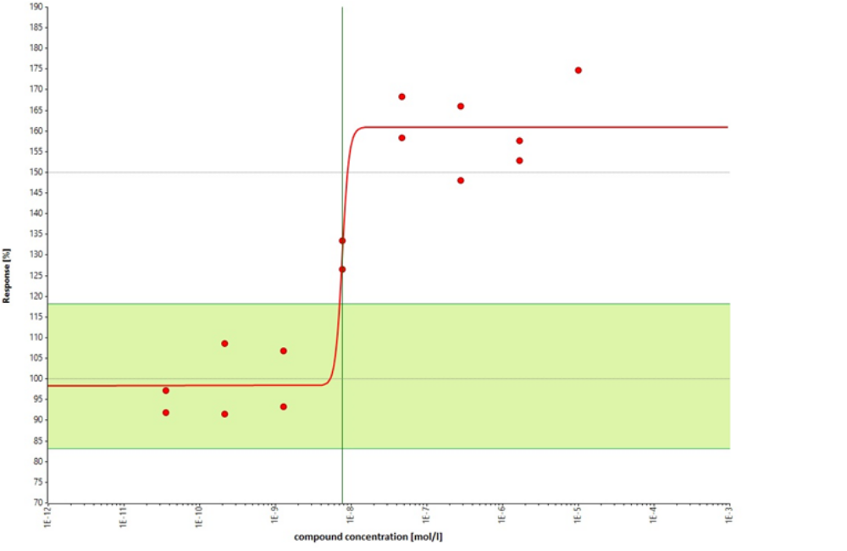
Figure S1. Cellular assay to determine effect of GPR52-IA on cAMP concentration in CHO cells expressing GPR52. One replicate is shown; for mean EC50 see Table S1.

Compartment | Mean exposures [nM] at 1h post dosing of cpd1 | SD
Plasma | 6630 | 2670
Muscle | 9650 | 3450
Brain | 19400 | 9750
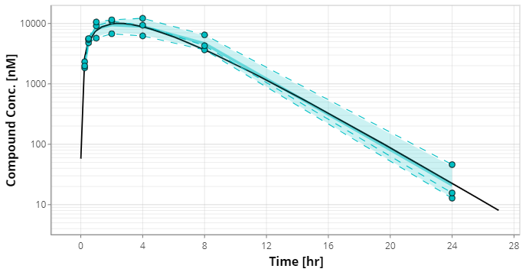

Figure S2. Pharmacokinetics of GPR52-IA determined in C57BL/6NRj mice (p.o. dosing, 20 mg/kg). The time plot shows total plasma concentration.

Figure S3. Validation of AAV vector injection/expression and optic fibre placement for mice in the CSS-REV-fibre photometry experiment.
(A), (B). GRAB_{DA} sensor. (A) Representative microscope image (5x) of Nissl-stained coronal brain section, showing the location of the optic fibre implant including its tip in the NAc (1.18 mm relative to bregma) of a CON mouse and the colocalized AAV vector-expressed GRAB_{DA} fluorescence. (B) Schematics of coronal sections (Franklin & Paxinos, 2019) showing the estimated NAc location of the optic fibre tip and GRAB_{DA} sensor expression in CON and CSS mice, based on histological assessments. For illustration purposes all location estimates are depicted in the right hemisphere.
(C), (D). EGFP. (C) Representative microscope images (5x) of Nissl-stained coronal brain sections, showing the location of the optic fibre implant including its tip in the NAc (0.98 mm relative to bregma) and the colocalized AAV vector-expressed EGFP fluorescence. (D) Schematics of coronal sections (Franklin & Paxinos, 2019) showing the estimated NAc location of the optic fibre tip and EGFP expression in mice, based on histological assessments. For illustration purposes all location estimates are depicted in the right hemisphere.
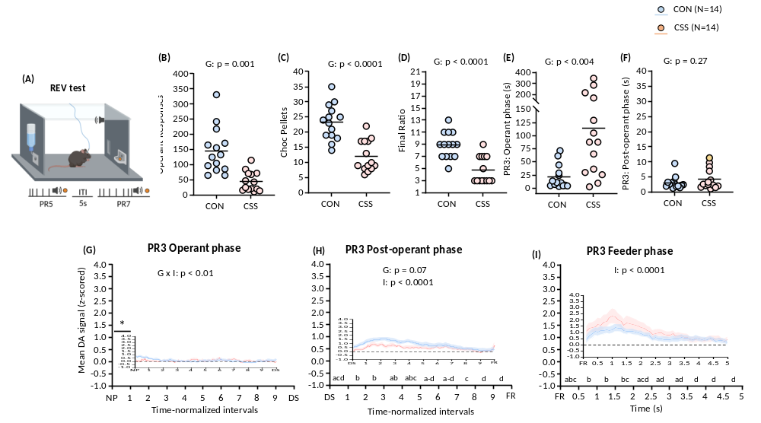
Figure S4. Effects of chronic social stress on reward motivation and nucleus accumbens dopamine release. (A) Reward-to-effort valuation (REV) test with fibre photometry.
REV test 1 behaviour: Statistical analysis was conducted using unpaired t-tests to investigate group differences. (B) Number of operant responses: t₂₆=4.57, p<0.0001. (C) Number of gustatory rewards earned: t₂₆=5.34, p<0.0001. (D) Final ratio attained: t₂₆=5.05, p<0.0001. (E) Operant phase duration i.e. time from 1st until 5th operant response: t₂₆=3.22, p<0.004. (F) DS phase duration i.e. time from DS onset until feeder response.
REV test 1 NAc DA activity: Statistical analysis was conducted using linear mixed models with fixed effects of group (G) and interval or time (T, S) and a random effect of mouse subject. Significant main or interaction effects were analysed using Sidak’s multiple comparison test. * p<0.05, *** p<0.001. (G) PR 3 operant phase z-scored DA activity following time-normalization using 10 equal intervals. Group x interval interaction effect: F_{9, 234}=2.51, p<0.01. (H) PR 3 DS phase z-scored DA activity following time-normalizaion using 10 equal intervals. Interval main effect: F_{9, 234}=8.77, p<0.0001. (I) PR 3 feeder phase z-scored DA activity divided into 10 intervals of 0.5 s. Interval main effect: F_{9, 234}=11.73, p<0.0001.

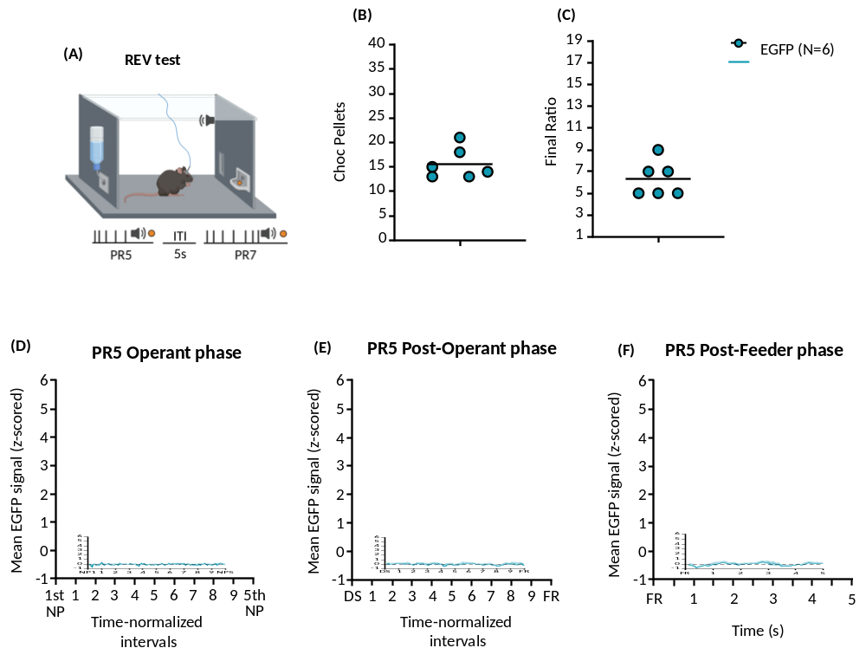
Figure S5. Behaviour and fluorescence signal in the REV test in EGFP-expressing control mice.
(A) Schematic of the DRLM test with fibre photometric recording. (B), (C) Behavioural scores in the REV test. (D)-(F). Data for z-scored EGFP fluorescence signal during the 3 phases of the REV test. Data are given as mean±s.e.m. Statistical analysis was conducted using 1-way repeated measures ANOVA.

Supplementary Tables
Table S1. In vitro and mouse in vivo pharmacokinetic properties of GPR52-IA.
Parameter | Unit | Mean value
EC50 mGPR52 | nM | 8
f_{u} (mouse plasma) | - | <0.00179
in vivo efflux | - | 0.54
CL | [mL/(min*kg)] | 34.5
V_{ss} | [L/kg] | 4.61
T_{max} | [h] | 1.33
T_{1/2} | [h] | 1.73
MRT_{disp} | [h] | 2.24
MRT_{tot} | [h] | 4.51

Abbreviations: f_{u}: Fraction unbound; in vivo efflux: muscle/brain ratio at 1h post dosing of 20 mg/kg, p.o.; CL: in vivo clearance; V_{ss}: steady-state volume of distribution; MRT_{disp}: T_{max}: time to maximum concentration in plasma; T_{1/2}: half-life; MRT_{disp}: mean residence time, disposition; MRT_{tot}: mean residence time, total (from 4mg/kg, p.o.).

Table S2. Estimated parameters for GPR52-IA at 1-2h post-dosing of 3-10mg/kg
Parameter | Unit | Estimation
estimated C_{plasma} | nM | ≈700-2500
estimated C_{u,brain} | nM | ≈2-8
estimated fraction of EC50 unbound in brain | - | 0.3-1.0

Abbreviations: c_{plasma}: plasma concentration; C_{u,brain}: concentration of unbound (free) GPR52-IA in brain.

Table S3. Eurofin SafetyScreen44™ Panel assessment of off-target activity
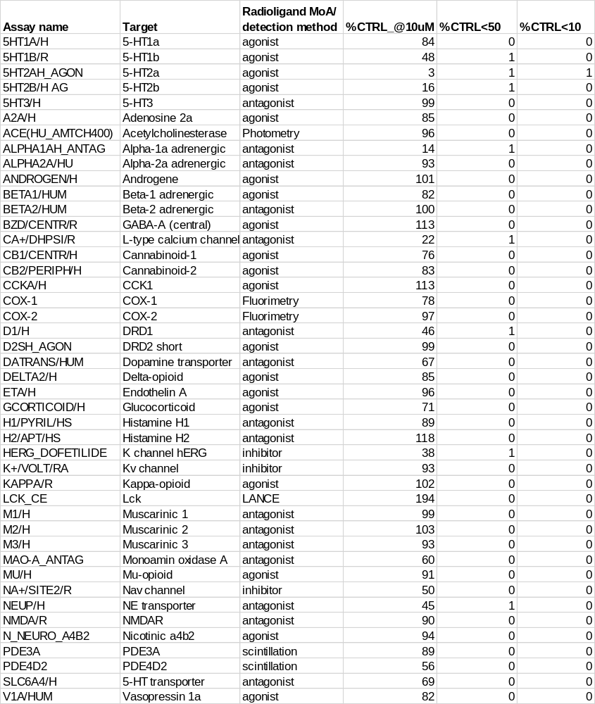

Table S4. Details of mouse body weight and food intake at baseline, re-baseline and during behavioural testing

Expt Group Baseline Re-Baseline Testing
BW (g) Food (g) BW (g) Food (g) % re-BBW % %re-B Food Food (g)

CSS-GPR52-IA CON-VEH (14) 29.3±2.1 3.5±0.3 29.1±1.9 3.4±0.3 98.2±3.4 84.4±5.0 2.6±0.3
CON-3 (12) 28.7±2.0 3.4±0.2 28.4±1.7 3.5±0.3 97.5±2.1 86.9±10.1 3.0±0.4
CON-10 (14) 28.1±2.3 3.4±0.3 28.2±2.2 3.6±0.5 98.6±4.8 85.7±8.4 3.1±0.4
CSS-VEH (14) 29.8±3.5 3.6±0.2 30.5±3.2 4.6±1.0*** 98.7±3.2 88.8±10.3 4.1±0.5****
CSS-3 (13) 29.0±1.9 3.5±0.4 29.5±1.8 4.5±0.4*** 98.0±4.3 87.5±8.2 3.9±0.7****
CSS-10 (13) 27.3±2.6 3.5±0.5 28.5±2.3 4.5±0.8*** 99.2±3.3 89.8±9.1 4.0±0.7****

CSS-GPR52-IA CON (14) 30.5±1.5 3.8±0.3 30.0±1.1 3.8±0.2 97.1±3.0 95.0±15.7 3.6±0.5
-Photometry CSS (14) 30.0±1.3 3.7±0.5 31.7±1.6 5.1±0.5**** 98.9±1.7 94.4±7.0 4.8±0.6***

Values are mean±SD
CSS-GPR52-IA: CSS > CON, *** p<0.001, **** p<0.0001, group main effect in linear mixed models with fixed effects, group and dose
CSS-GPR52-IA
Photometry: CSS > CON, **** p<0.0001, unpaired t-tests

