APPENDIX
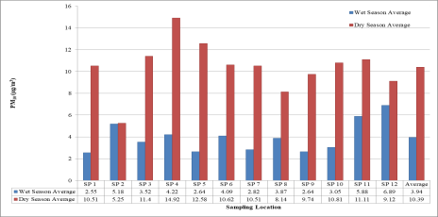
Figure 2: Average Dry and Wet Season Concentration of PM_{10µm} at Computer Village, Ikeja

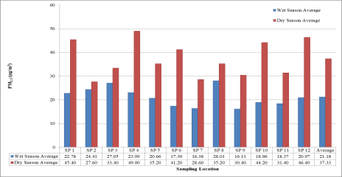
Figure 3: Average Dry and Wet Season Concentration of PM_{2.5µm} at Computer Village, Ikeja

Figure 4: Respondents’ Academic Qualifications

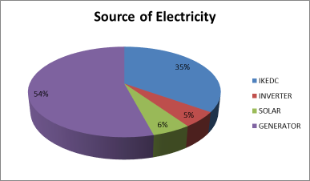
Figure 5: Source of electricity in buildings in Computer Village Ikeja

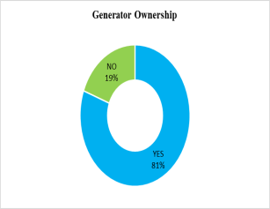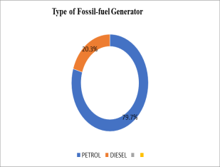
Figure 6: Ownership and Type of Fossil-fuel Generator at Computer Village, Ikeja

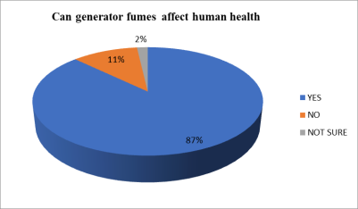
Figure 7: Respondents opinion on generators’ fumes on human health

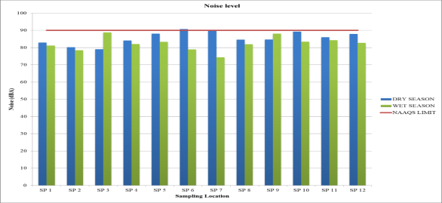
Figure 8: Wet season and dry season noise levels at Computer Village, Ikeja with NAAQS Limit.

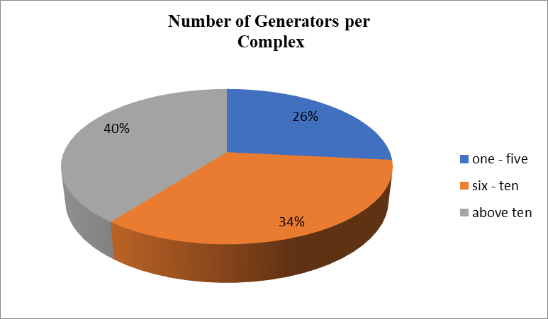
Figure 9: Number of Generators per Shopping complex in Computer-Village

Table 2: Dry and Wet Season concentration of Carbon monoxide, Nitrogen dioxide at Computer Village
 | CO (ppm) |  | NO₂ (ppm) |  | SO₂ (ppm) |  | VOC (ppm)
NAAQS (FMENV) | 10 ppm |  | 0.04 -0.06ppm |  | 0.01ppm |  | 10 ppm
WHO LIMIT | 0.035ppm |  | 0.2ppm |  | 0.175ppm |  | 0.035ppm
 | DRY SEASON | WET SEASON | DRY SEASON | WET SEASON | DRY SEASON | WET SEASON | DRY SEASON | WET SEASON
 | AVERAGE
SP 1 | 25.4 | 57.0 | <0.01 | 0.342 | <0.01 | <0.01 | 0.396 | 0.287
SP 2 | 81.2 | 66.3 | <0.01 | 0.896 | 1.65 | <0.01 | 0.342 | 0.170
SP 3 | 67.6 | 49.4 | <0.01 | 0.590 | 1.3 | <0.01 | 0.896 | 0.104
SP 4 | 76.2 | 51.0 | 0.4 | 0.266 | 1.1 | 1.2 | 0.590 | 0.119
SP 5 | 39.4 | 44.4 | <0.01 | 0.257 | <0.01 | <0.01 | 0.266 | 0.169
SP 6 | 34.2 | 30.3 | <0.01 | 0.166 | 0.5 | 0.8 | 0.257 | 0.165
SP 7 | 35.0 | 11.3 | 1.1 | 0.081 | <0.01 | <0.01 | 0.166 | 0.171
SP 8 | 23.0 | 14.8 | <0.01 | 0.286 | <0.01 | 1.1 | 0.081 | 0.151
SP 9 | 52.3 | 45.2 | <0.01 | 0.218 | 1.6 | <0.01 | 0.286 | 0.137
SP 10 | 42.0 | 29.0 | 0.9 | 0.472 | <0.01 | <0.01 | 0.218 | 0.128
SP 11 | 31.2 | 59.2 | <0.01 | 0.526 | <0.01 | <0.01 | 0.472 | 0.103
SP 12 | 27.6 | 62.2 | <0.01 | 0.375 | <0.01 | <0.01 | 0.526 | 0.113
Average | 44.6 | 43.3 | 0.7 | 0.396 | 1.3 | 1.0 | 0.375 | 0.151
Notes: ppm = parts per million SP= Sampling Point
Source: Field Studies, 2022

Table 3: Respondents’ Opinions on the likelihood of generator usage to cause environmental and structural defect in Computer Village Ikeja
 | Very Minimal  (4) | Minimal (3) | Great  (2) | Don’t Know  (1) | Mean
Air pollution | 22 | 30 | 52 | 5 | 3.63
Noise pollution | 19 | 29 | 59 | 2 | 3.60
Building defect | 19 | 30 | 43 | 17 | 3.47
Climate Change | 15 | 27 | 49 | 18 | 3.36

Table 4: Respondents’ Opinion on the effect of Generator noise to health
How likely is the noise from generator cause the following?
Noise Concerns | Extremely Likely (5) | Very Likely (4) | Somewhat Likely (3) | Unlikely (2) | Very Unlikely (1) | Mean
Deafness | 28 | 44 | 15 | 16 | 6 | 3.66
Hearing problem | 33 | 48 | 22 | 4 | 2 | 3.97
Headache | 42 | 45 | 18 | 4 | 0 | 4.15
Sleeping problem | 16 | 43 | 16 | 23 | 11 | 3.28
High blood pressure | 12 | 35 | 37 | 12 | 13 | 3.19

Table 5: Respondents’ Opinions on level of knowledge and awareness of generator use on health in Computer-Village, Ikeja
Health Concerns | Extremely Likely (5) | Very Likely (4) | Somewhat Likely (3) | Unlikely (2) | Very Unlikely (1) | Mean
Skin burns from generator exhaust | 34 | 48 | 21 | 6 | 0 | 4.01
Choking | 36 | 56 | 9 | 7 | 1 | 4.09
Nausea | 35 | 45 | 23 | 6 | 0 | 4.00
Nose bleeding | 22 | 34 | 26 | 19 | 8 | 3.39
Fainting Sensation | 30 | 43 | 22 | 9 | 5 | 3.77
Dizziness | 30 | 39 | 23 | 15 | 2 | 3.73
Coughing | 30 | 41 | 22 | 9 | 7 | 3.72
Vomiting | 21 | 30 | 26 | 22 | 10 | 3.28
Respiratory problem | 39 | 48 | 16 | 2 | 4 | 4.06
Eye, Nose or Throat Irritation | 45 | 44 | 13 | 4 | 3 | 4.14
Chest pain | 31 | 42 | 17 | 12 | 7 | 3.72
Heart Problem | 32 | 36 | 17 | 14 | 10 | 3.61
Asthma attack | 41 | 45 | 10 | 8 | 5 | 4.00
Fatigue | 27 | 41 | 24 | 12 | 5 | 3.67
Lung disease | 23 | 37 | 33 | 8 | 8 | 3.54
Cancer | 21 | 48 | 20 | 11 | 9 | 3.56
Death | 49 | 29 | 16 | 8 | 7 | 3.96

Table 6: Respondents reaction to the sound of generator noise
 | Frequency |  | Percent (%)
Upset |  | 37 |  | 34.0
Annoying |  | 57 |  | 52.3
Irritating |  | 10 |  | 9.2
Comfortable |  | 5 |  | 4.6
Source: Calculated from Survey Data, 2022
Table 7: Educational Qualification * Level of Knowledge/Awareness of generator use on health (Respiratory Problem and Asthma Attack)
 |  | ^{Value} | ^{Approximate Significance} | ^{Value} | ^{Approximate Significance}
 |  | Educational Qualification * Level of Knowledge/Awareness of generator use on health (Respiratory Problem) |  | Educational Qualification * Level of Knowledge/Awareness of generator use on health (Asthma Attack)
^{Pearson Chi-Square} |  | ^{126.347} | ¹² | ^{176.227} | ¹⁵
^{Likelihood Ratio} |  | ^{54.804} | ¹² | ^{54.833} | ¹⁵
^{Nominal by Nominal} | ^{Phi} | ^{1.159} | ^{.000} | ^{1.369} | ^{.000}
^{Nominal by Nominal} | ^{Cramer's V} | ^{.669} | ^{.000} | ^{.791} | ^{.000}
^{Nominal by Nominal} | ^{Contingency Coefficient} | ^{.757} | ^{.000} | ^{.808} | ^{.000}
^{N of Valid Cases} |  | ⁹⁴ |  |  | ⁹⁴

Table 8: How long have you been working in Computer Village / Level of Knowledge/Awareness of generator use on health
^{Nominal by Nominal} | ^{Uncertainty Coefficient} | ^{Value} | ^{Asymptotic Standardized Error} | ^{Approximate Tb} | ^{Monte Carlo Significance}
 |  |  |  |  | ^{Asymptotic Significance} | ^{99% Confidence Interval}
 |  |  |  |  |  | ^{Lower Bound} | ^{Upper Bound}
^{Choking} | ^{Symmetric}  How long have you been working in Computer Village? Dependent  ^{Choking Dependent} | ^{.566} | ^{.025} |  | ^{.000d} | ^{.000} | ^{.041}
^{Choking} |  | ^{.585} | ^{.030} |  | ^{.000d} | ^{.000} | ^{.041}
^{Choking} |  | ^{.548} | ^{.027} | ^{11.774} | ^{.000d} | ^{.000} | ^{.041}
^{Asthma Attack} | ^{Symmetric}  How long have you been working in Computer Village? Dependent  ^{Asthma Attack Dependent} | ^{.558} | ^{.023} | ^{12.050} | ^{.000d} | ^{.000} | ^{.041}
^{Asthma Attack} |  | ^{.574} | ^{.029}
^{Asthma Attack} |  | ^{.543} | ^{.026}
^{Nausea} | ^{Symmetric}  How long have you been working in Computer Village? Dependent  ^{Nausea Dependent} | ^{.520} | ^{.038} | ^{10.137} | ^{.000d} | ^{.000} | ^{.041}
^{Nausea} |  | ^{.540} | ^{.043}
^{Nausea} |  | ^{.500} | ^{.039}
^{Respiratory Problem} | ^{Symmetric}  How long have you been working in Computer Village? Dependent  ^{Respiratory Problem Dependent} | ^{.522} | ^{.027} | ^{11.312} | ^{.000d} | ^{.000} | ^{.041}
^{Respiratory Problem} |  | ^{.505} | ^{.027}
^{Respiratory Problem} |  | ^{.540} | ^{.033}
a. Not assuming the null hypothesis.
b. Using the asymptotic standard error assuming the null hypothesis.
c. Likelihood ratio chi-square probability.
d. Based on 109 sampled tables with starting seed 2000000.
Table 9: Chi-Square Tests on Level of Knowledge/Awareness of generator use on health
 |  | ^{Chi-Square Tests} |  |  | ^{Symmetric Measures} |  |  | ^{df}
 | ^{Pearson Chi-Square value} | ^{Asymptotic Significance}  ^{(2-sided)} | ^{Likelihood Ratio value} | ^{Fisher's Exact Test} | ^{Phi Value} | ^{Cramer's V} | ^{Contingency Coefficient} | ^{df}
^{Choking} | ^{198.083a} | ^{.000d} | ^{164.323} | ^{135.946} | ^{1.348} | ^{.674} | ^{.803} | ²⁰
^{Nausea} | ^{170.852a} | ^{.000d} | ^{151.648} | ^{122.832} | ^{1.252} | ^{.626} | ^{.781} | ¹⁶
^{Asthma Attack} | ^{182.943a} | ^{.000d} | ^{161.125} | ^{131.840} | ^{1.296} | ^{.648} | ^{.792} | ²⁰
^{Respiratory Problem} | ^{148.610a} | ^{.000d} | ^{141.786} | ^{118.368} | ^{1.168} | ^{.584} | ^{.760} | ¹⁶

