Supplementary Information

nip-type Sn-based perovskite solar cells with metal chalcogenide electron extraction layers

Tianpeng Li,^{a,#} Bin Li,^{b,#} Yingguo Yang^{c,d} Zuoming Jin,ª Zhiguo Zhang,ª Peilin Wang,ª Liangliang Deng,^{e} Yiqiang Zhan,^{e} Qinghong Zhang,^{b} Jia Liang,^{a,}*

ª Department of Materials Science and State Key Laboratory of Photovoltaic Science and Technology, Fudan University, 220 Handan Road, Shanghai 200433, China
^{b} State Key Laboratory for Modification of Chemical Fibers and Polymer Materials, College of Materials Science and Engineering, Donghua University, Shanghai 201620, China
^{c} School of Microelectronics, Fudan University, 220 Handan Road, Shanghai, 200433 China
^{d} Shanghai Synchrotron Radiation Facility (SSRF), Zhangjiang Lab, Shanghai Advanced Research Institute, Shanghai Institute of Applied Physics, Chinese Academy of Sciences, Shanghai, 201800 China
^{e} Center of Micro-Nano System, School of Information Science and Technology, Fudan University, 220 Handan Road, Shanghai 200433, China
# These authors contributed equally to this work.

Contents‘’
Methods 3
Supplementary Fig. 1. 6
Supplementary Fig. 2. 7
Supplementary Fig. 3. 8
Supplementary Fig. 4. 9
Supplementary Fig. 5. 10
Supplementary Fig. 6. 11
Supplementary Fig. 7. 12
Supplementary Fig. 8. 13
Supplementary Fig. 9. 14
Supplementary Fig. 10. 15
Supplementary Fig. 11. 16
Supplementary Fig. 12. 17
Supplementary Fig. 13. 18
Supplementary Fig. 14. 19
Supplementary Fig. 15. 20
Supplementary Fig. 16. 23
Supplementary Fig. 17. 24
Supplementary Fig. 18. 25
Supplementary Fig. 19. 26
Supplementary Fig. 20. 27
Supplementary Fig. 21. 28
Supplementary Fig. 22. 29
Supplementary Table 1. 30
Supplementary Table 2. 31
Supplementary Table 3. 32
Supplementary Table 4. 33
Supplementary Table 5. 34
References 35

Methods
Materials
Tin(IV) chloride pentahydrate (SnCl₄·5H₂O, 98%), Selenourea (CH₄N₂Se, 98%), Thioacetamide (ACS, ≥99.0%) and 2-(2-Aminoethyl) isothiourea dihydrobromide (AET, 99%) were purchased from Aladdin. Formamidinium Iodide (FAI) was purchased from TCI. Phenethylammonium bromide (PEABr, 97%), Tin iodide (SnI₂, AnhydroBeads, 99.99%), tin fluoride (SnF₂, 99%), N, N-dimethylformamide (DMF, anhydrous, 99.8%), dimethyl sulfoxide (DMSO, anhydrous, 99.9%) and chlorobenzene (CB, anhydrous, 99.8%), were obtained from Sigma-Aldrich and used as received with no further purification. a poly (triaryl amine) semiconductor (PTAA) was purchased from Xi'an Baolaite Optoelectronics Technology Co.,

Device Fabrication
Synthesis of metal chalcogenide nanocrystalline (Sn(S_{x}Se_{y})₂): In a typical synthesis, SnCl₄·5H₂O (1 mmol) and thioacetamide (4 mmol) were dissolved in deionized water (50 mL) under vigorously magnetic stirring. The mixed solution was stirred for 1 h until a transparent solution was formed. The as-obtained transparent solution was transferred to a Teflon-lined stainless-steel autoclave and a quartz vessel was put into Teflon-lined autoclave to contain the HCl aqueous solution (0.5 ml HCl 37 wt% aqueous solution in 5ml DI). Then heated in an electric oven at 160°C for 6 h. After the hydrothermal synthesis, the obtained SnS₂ powder was cleaned with distilled water and ethanol, twice. Eventually, the SnS₂ precipitation was collected and redispersed in ethanol. For the synthesis of Sn(S_{x}Se_{y})₂ (x+y=1), Selenourea (CH₄N₂Se) was added to the mixing solution of SnCl₄·5H₂O and thioacetamide under vigorously magnetic stirring, and the reaction steps were the same as before.
Fabrication of ETL Layers: The patterned ITO glass substrates were cleaned in an ultrasonic bath for 15 minutes with detergent, deionized water three times, and anhydrous ethanol, sequentially. Then, the ITO glass substrates were dried and cleaned with UV-Ozone for 20 mins. After that, the synthesized SnS₂ or Sn(S_{x}Se_{y})₂ were spin-coated on the ITO at 2000 rpm for 30s. The substrates heated in a tube furnace under the protection of a nitrogen atmosphere at 150℃ for 30 minutes.
Fabrication of Perovskite Layers: The deposition of the Sn perovskite layers prepared in a glove box with oxygen content of 0.1 ppm nitrogen. For the perovskite precursor solution, a 0.8 M perovskite precursor comprised of PEABr, FAI, SnI₂, SnF₂ and AET with the molar ratio of 0.15:0.85:1:0.075:0.05 was added in a mixed solvent ((DMSO: DMF = 1:4 v/v) heated at 70 ℃ for 1 h. The perovskite precursors were spin-coated on the surfaces of the ETL films at 1000 and 5000 rpm for 10 s and 30 s respectively. During the second stage, 320 μL Chlorobenzene was dropped onto the substrates. Finally, the substrates were annealed at temperature of 60 °C for 5 min and 80 °C for 10 min.
Fabrication of HTL Layers: The PTAA solution (20mg PTAA and 2.25 mg DPI-TPFB dissolved in 1ml chlorobenzene) was spin coated on the surfaces of the perovskite layers at 2000 rpm for 30 s and then annealed at 70 °C for 10 min. Finally, a 120 nm Ag layer was deposited using the thermal evaporation system.

Characterizations
The morphologies of the films (Morphologies of ETLs) and devices were characterized by a field-emission scanning electron microscope (FESEM) (SU8010, Hitachi). X-ray diffraction pattern data for 2θ values were collected using a Bruker AXD8 Advance diffractometer with nickel filtered Cu Kα radiation (λ=1.5406 Å). X-ray photoelectron spectroscopy (XPS) was collected using an Escalab 250Xi XPS system (Thermo Scientific). The ex(in)-situ GIWAXS experiments were carried out at beamline BL14B1 in Shanghai Synchrotron Radiation Facility (SSRF). Time-resolved photoluminescence (TRPL) spectra were achieved by a streak camera (Hamamatsu, C6860). The laser source is an amplified titanium/sapphire laser providing 800 nm 35-fs pulses at 2 kHz which is then frequency doubled for 400 nm excitation. Steady-state Photo-Luminescence (PL) spectra were measured by a FLS920 transient optical spectrometer (Edinburgh Instruments). The space-charge-limited current (SCLC) results were obtained using a Keithley 2400 source-meter unit. AFM images of perovskite films were obtained using AFM5500.
The J–V curves were performed using a Keithley 2400 source-meter unit under AM 1.5 G light illumination at 100 mW cm⁻² (1 sun). (ENLITECH SS-X100R) with forward/reverse scanning modes (rate 0.01 V s⁻¹). Before testing, the light intensity was calibrated using a standard Si reference cell (ENLITECH SRC-2020-KG1-RTD). The active area is 0.04-1cm². The IPCE measurement was carried out by the QE-R system (Enlitech). Impedance spectroscopic measurements were recorded by an alternating bias of 50 mV by Zennium-pro (Zahner). The corresponding spectra were fitted by Z-View software.

Computational details
Spin-polarized electronic structure calculations were performed using the plane-wave basis set approach as implemented in the Vienna ab initio simulation package (VASP) ^{[62]}. The projector augmented wave (PAW) method was used to represent the ion–core electron interactions ^{[63]}. The valence electrons were represented with a plane wave basis set with an energy cutoff of 450 eV. Electronic exchange and correlation were described with the Perdew–Burke–Ernzerhof (PBE) functional ^{[64]}. DFT-D3 method was used to treat the van der Waals interaction ^{[65]}. A 15 Å vacuum space was used to avoid interactions between surface slabs. A 2×2×1 Monkhorst–Pack scheme was used to generate the k-point grid for the modeled Pt materials ^{[66]}. The convergence criteria for the self-consistent electronic structure and geometry were set to 10⁻⁵ eV and 0.05 eV/Å, respectively.

Supplementary Fig. 1. Statistics of the recently reported V_{OC} and PCE of nip-type TPSCs. The theorectical values were also listed here for comparison.

Supplementary Fig. 2. XPS spectra. High-resolution XPS sepctum in the Ti 2p region of the TiO₂ ETL.

Supplementary Fig. 3. XPS spectra. High-resolution XPS spectra in the a, C 1s and b, Ti 2p regions of the Sn-based perovskite films deposited on the TiO₂ ETL. The concentration of presursor solution of the Sn-based perovskite is 0.1 M.

Supplementary Fig. 4. XPS spectra. High-resolution XPS spectra in the Sn 3d region of fresh Sn-based perovskite layers deposited on a, ITO and b, ITO/TiO₂ substrates.

Supplementary Fig. 5. UPS spectra. UPS spectra of VBM onset and photoemission cutoff energy boundary of a, Sn-based perovskites and b, TiO₂ ETLs.

Supplementary Fig. 6. UV-vis absorption spectra. UV–vis absorption spectra of a, the perovskite layer and c, the TiO₂ ETL. The tauc plots of b, the perovskite layer and d, the TiO₂ ETL derived from the corresponding UV-vis absorption spectra. e, Energy level diagram of the nip-type TPSCs with the structure of FTO/ETL/Sn-based perovskite/PTAA/Ag, utilizing TiO₂, SnS₂, and Sn(S_{0.92}Se_{0.08})₂ films as ETLs, which shows the maximum attainable photovoltage is determined by the quasi-Fermi level splitting of the ETL and hole-transport layer (HTL).

Supplementary Fig. 7. Schematic diagram of the synthetic process of the metal mixed-chalcogenide ETL (Sn(S_{x}Se_{y})₂) and the fabrication process of the corresponding nip-type TPSCs.

Supplementary Fig. 8. Compositions of metal chalcogenide ETLs. High resolution XPS spectra of the metal chalcogenide ETLs (SnS₂ and Sn(S_{0.92}Se_{0.08})₂) in the a, Sn 3d, b, S 2P, and c, Se 3d regions. Transmission electron microscope (TEM) energy dispersive X-ray spectroscopy (EDS) elemental mapping images of d, Sn, e, S, and f, Se elements in the Sn(S_{0.92}Se_{0.08})₂ ETL.

Supplementary Fig. 9. UV-vis absorption spectra of metal chalcogenide ETLs. UV–vis absorption spectra of a, the SnS₂ ETL and c, the Sn(S_{0.92}Se_{0.08})₂ ETL. The tauc plots of b, the SnS₂ ETL and d, the Sn(S_{0.92}Se_{0.08})₂ ETL derived from the corresponding UV-vis absorption spectra.

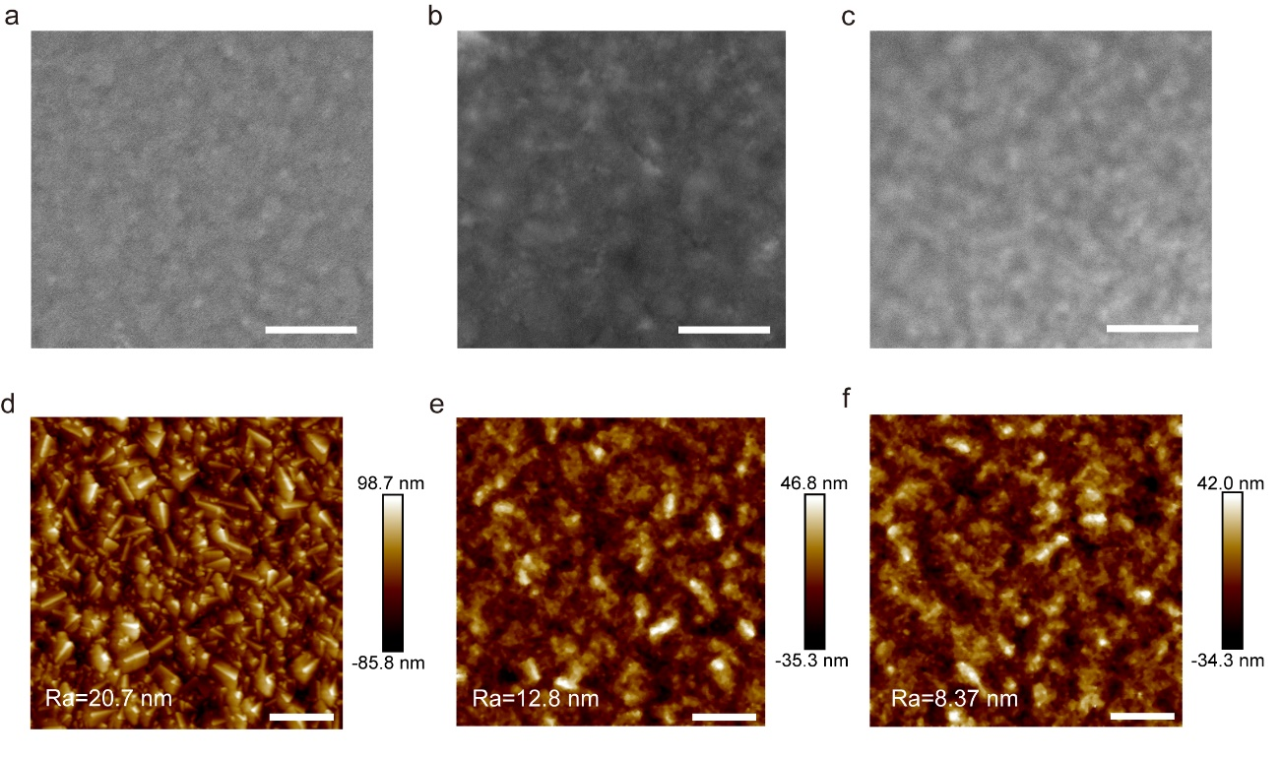

Supplementary Fig. 10. Morphologies of metal chalcogenide ETLs. Top-view SEM images of a, TiO₂, b, SnS₂ and c, Sn(S_{0.92}Se_{0.08})₂ ETLs. The scalebars are 500 nm. AFM images of d, TiO₂, e, SnS₂ and f, Sn(S_{0.92}Se_{0.08})₂ ETLs. The scalebars are 1 um.

Supplementary Fig. 11. Conductivities of metal chalcogenide ETLs. I–V characteristics of the TiO₂, SnS₂ and Sn(S_{0.92}Se_{0.08})₂ ETLs. The Sn(S_{0.92}Se_{0.08})₂ ETL reveals the highest conductivity of 13.8 × 10⁻³ S cm⁻¹ among the three types of ETLs.

Supplementary Fig. 12. Mobilities of metal chalcogenide ETLs. SCLC spectra of the device with the structure of FTO/Ag/ETL/Ag, the ETLs are a, TiO₂, b, SnS₂ and c, Sn(S_{0.92}Se_{0.08})₂ films respectively.

Supplementary Fig. 13. DFT results. The adsorption energy of the Sn-based perovskites reacting with a, O₂, b, SnS₂ and c, Sn(S_{0.92}Se_{0.08})₂ molecules, respectively.

Supplementary Fig. 14. Schematic diagram of the testing mode of illuminating from the back side of the Sn-based perovskite films deposited on PEN/ITO/ETL substrates.

Supplementary Fig. 15. XPS spectra. High-resolution XPS spectra in Sn 3d regions of 2 weeks-aged Sn-based perovskite films deposited on different ETLs, including a, TiO₂, b, SnS₂ and c, Sn(S_{0.92}Se_{0.08})₂ ETLs.
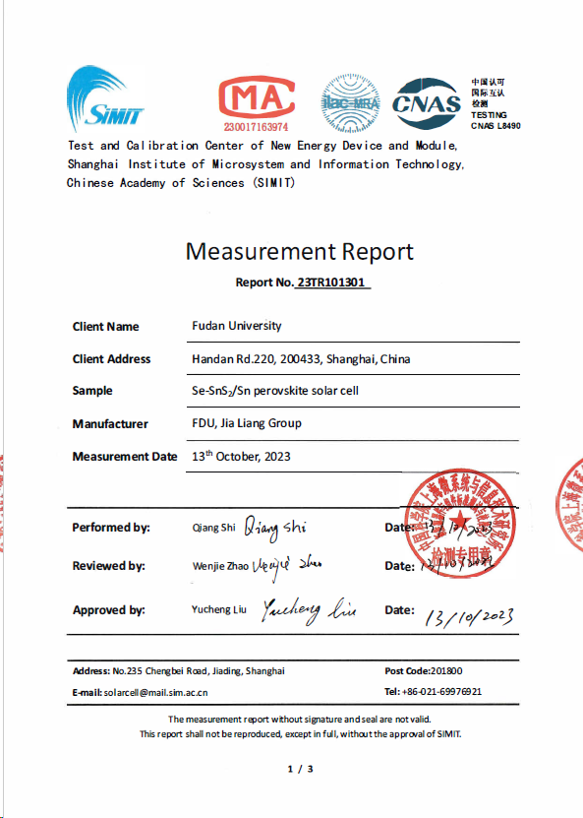
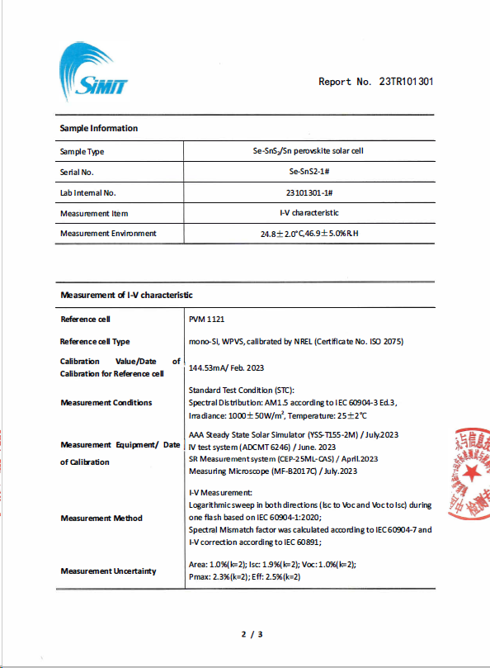
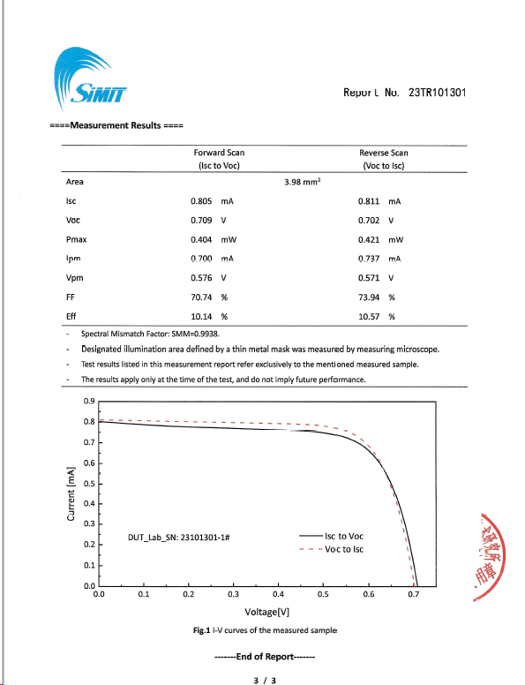

Supplementary Fig. 16. Photovoltaic performance. Certified performance of the nip-type TPSC with the Sn(S_{0.92}Se_{0.08})₂ ETL. The certified efficiency is 10.57% under reverse scannign mode with short-circuit current (I_{SC}) = 0.81 mA, V_{OC} = 0.70 V and FF = 73.94%.

Supplementary Fig. 17. GIWAXS characterization. GIWAXS patterns of Sn-based perovskite layers grown on a, TiO₂, b, SnS₂, and c, Sn(S_{0.92}Se_{0.08})₂ ETLs.

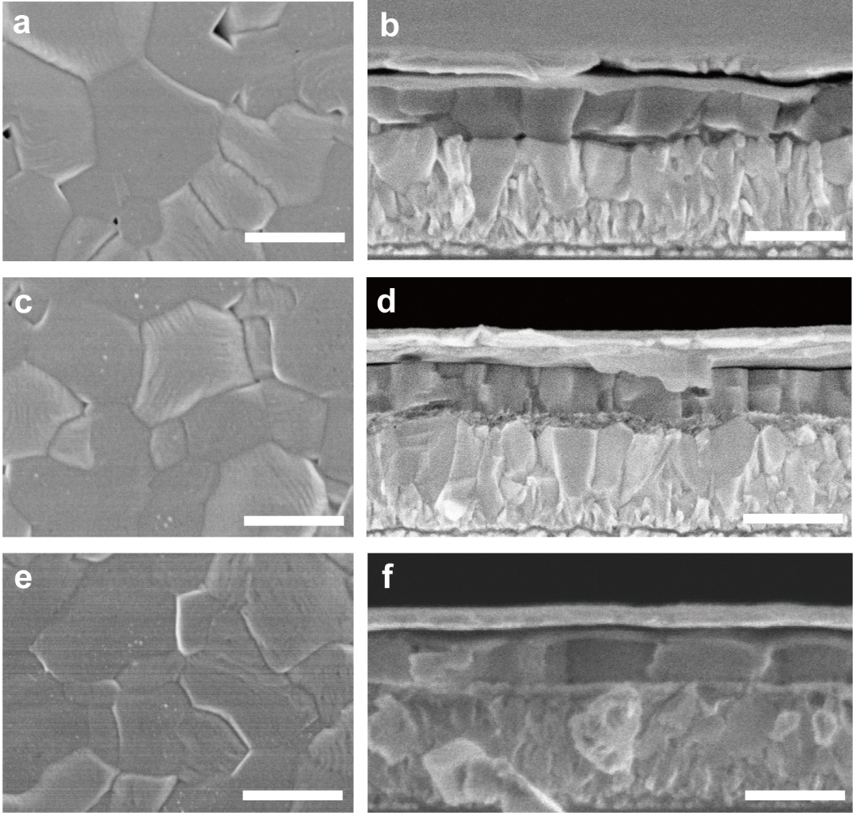

Supplementary Fig. 18. SEM characterizations. Top-view SEM images of the perovskite based on a, TiO₂, c, SnS₂, and e, Sn(S_{0.92}Se_{0.08})₂ ETLs. The scalebars are 500 nm. Cross-sectional SEM images of nip-type TPSCs with b, TiO₂, d, SnS₂, and f, Sn(S_{0.92}Se_{0.08})₂ ETLs. The scalebars are 500 nm.

Supplementary Fig. 19. Photovoltaic performances. Photovoltaic performance of the nip-type TPSCs based on Sn(S_{x}Se_{y})₂ (x+y=1, y = 0.03, 0.05, 0.07, 0.08, 0.09, and 0.10). With the increase of the concentration of Se, the PCEs increased first and then decreased and the nip-type TPSC with the Sn(S_{0.92}Se_{0.08})₂ ETL shows the best performance.

Supplementary Fig. 20. Photovoltaic performance. The statistics of photovoltaic parameters of nip-type TPSCs, including a, PCE, b, V_{OC}, c, FF, and d, J_{SC}.

Supplementary Fig. 21. Linear relationship of V_{OC} to the light intensity of the nip-type TPSCs with a, TiO₂, b, SnS₂ and c, Sn(S_{0.92}Se_{0.08})₂ ETLs, respectively.

Supplementary Fig. 22. XRD patterns. XRD patterns of Sn-based perovskite layers gown on a, TiO₂, b, SnS₂ and c, Sn(S_{0.92}Se_{0.08})₂ ETLs after aging a period of time in air. The XRD patterns of Sn-based perovskite layers gown on d, TiO₂, e, SnS₂ and f, Sn(S_{0.92}Se_{0.08})₂ ETLs after aging for 24 days were plotted individually.

Supplementary Table 1. Photovoltaic parameter comparison of this work and existing nip-type TPSCs.
Devices | V_{OC}  (V) | J_{SC}  (mA cm⁻²) | FF  (%) | PCE  (%) | Stability/Condition | Year | Ref*
FTO/Se-SnS₂/ PEA_{0.15}FA_{0.85}SnI_{2.85}Br_{0.15}-AET/PTAA/Ag | 0.73 | 22.28 | 72.68 | 11.78 | Maintaining 95% of its initial PCE for 1600 h/in a N₂ glovebox
FTO/c-TiO₂/mp- TiO₂/MASnI₃/Spiro-OMeTAD/Au | 0.88 | 16.80 | 42.00 | 6.40 | — | 2014 | 37
FTO/bl-TiO₂/mp- TiO₂/MASnI₃/Spiro-OMeTAD/Au | 0.68 | 16.30 | 48.00 | 5.23 | Maintaining 64% of its initial PCE for 24 h/in a N₂ glovebox | 2014 | 38
FTO/c-TiO₂/mp-TiO₂/CsSnI₃+SnF₂/HTM/Au | 0.24 | 22.70 | 37.00 | 2.02 | — | 2014 | 39
FTO/bl-TiO₂/mp-TiO₂/FASnI₃+SnF₂/spiro-OMeTAD/Au | 0.24 | 24.45 | 36.00 | 2.10 | — | 2015 | 40
FTO/bl-TiO₂/mp- TiO₂/MASnI₃/Au | 0.32 | 21.40 | 46.00 | 3.15 | — | 2015 | 41
FTO/bl-TiO₂/mp-TiO₂/FASnI₃+SnF₂+Pyrazine/spiro-OMeTAD/Au | 0.32 | 23.70 | 63.00 | 4.80 | Maintaining 98% of its initial PCE for 100 days/with encapsulation | 2016 | 42
FTO/TiO₂/Al₂O₃/CsSnIBr₂+SnF₂+HPA/Carbon | 0.31 | 17.40 | 57.00 | 3.20 | No significant decay for 77 days/with encapsulation | 2016 | 43
FTO/c-TiO₂/mp-TiO₂/CsSnBr₃+N₂H₄/PTAA/Au | 0.38 | 19.92 | 51.73 | 3.89 | — | 2017 | 44
FTO/bl-TiO₂/mp-TiO₂/BA₂MA₃Sn₄I₁₃ +TEP/PTAA/Au | 0.23 | 24.10 | 45.7 | 2.53 | Maintaining 90% of its initial PCE for 30 days/with encapsulation | 2017 | 45
FTO/c-TiO₂/mp-TiO₂/{en}FASnI₃/PTAA/Au | 0.48 | 22.54 | 65.96 | 7.14 | Maintaining 96% of its initial PCE for 1000 h/with encapsulation | 2017 | 46
FTO/c-TiO₂/mp-TiO₂/{en}MASnI₃/PTAA/Au | 0.43 | 24.28 | 63.72 | 6.63 | Maintaining ∼60% of its initial efficiency for 10 min/constant illumination in air | 2017 | 47
FTO/c-TiO₂/mp-TiO₂/MASnIBr₂+SnF₂/spiro-OMeTAD/Au | 0.45 | 13.77 | 59.58 | 3.70 | Maintaining 80% of its initial PCE for 60 days/in a N₂ glovebox | 2018 | 48
FTO/TiO₂/HEA_{0.4}FA_{0.6}Sn_{0.67}I_{2.33}/Carbon | 0.37 | 18.52 | 56.20 | 3.90 | No significant decay for 100 h/in a N₂ glovebox | 2018 | 49
ITO/nanoporous TiO₂ ZrO₂/carbon/ (4AMP) (FA)₃Sn₄I₁₃ | 0.64 | 14.90 | 44.30 | 4.22 | Maintaining 91% of its initial PCE for 100 h/constant illumination in N₂ atmosphere at 45 °C | 2018 | 50
FTO/ c-TiO₂/mp-TiO₂/MASnI₃ /PTAA/Au | 0.49 | 22.91 | 64.00 | 7.13 | — | 2019 | 51
FTO/c-TiO₂/mp- TiO₂/{en}FASnI₃/BDT-4D/Au | 0.497 | 22.41 | 68.21 | 7.59 | — | 2019 | 52
FTO/bl-TiO₂/mp-TiO₂/BA₂(FA)_{n-1}Sn_{n}I_{3n+1}/PTAA/Au | 0.42 | 23.98 | 40.21 | 4.04 | Maintaining 80% of its initial PCE for 14 days/in a N₂ glovebox | 2020 | 53
FTO/c-TiO₂/mp-TiO₂/CsSnI₃+MBAA/P3HT/Ag | 0.45 | 24.85 | 67 | 7.5 | the average PCE of MBAA-modified devices maintained 60.2% of their original value after being stored under an inert RT condition for 1440 h | 2021 | 54
FTO/bl-TiO₂/mp-TiO₂/Cs_{0.1}FA_{0.9}SnI₃+ThMAI/PTAA/Au | 0.52 | 24.12 | 72.02 | 9.06 | — | 2021 | 55
FTO/bl-TiO₂/mp-TiO₂/FASnI₃/spiro-OMeTAD:DPI-TPFB/Au /Ag | 0.649 | 23.59 | 71.25 | 10.9 | The encapsulated device retained 86% of its initial PCE after  storing for 2832 h at room temperature (RT) in the dark with a humidity level of ≈30% | 2023 | 56

Supplementary Table 2. The VBMs, CBMs, and bandgaps of the perovksite film, TiO₂ ETL, SnS₂ ETL, and Sn(S_{0.92}Se_{0.08})₂ ETL, respectively.
 | VBM (eV) | CBM (eV) | Bandgap (eV)
Perovskite | -5.14 | -3.73 | 1.41
TiO₂ | -7.23 | -4.23 | 3.00
SnS₂ | -6.62 | -3.98 | 2.64
Sn(S_{0.92}Se_{0.08}) | -6.43 | -3.83 | 2.60

Supplementary Table 3. The conductivities and mobilities of TiO₂, SnS₂ and Sn(S_{0.92}Se_{0.08})₂ films, respectively.
Samples | TiO₂ | SnS₂ | 8%-Se-SnS₂
Conductivity (S cm⁻¹x10⁻³) | 8.41 | 12.7 | 13.8
Mobility (x10⁻³ cm²v⁻¹s⁻¹) | 7.15 | 54.3 | 63.4

Supplementary Table 4. The fitted data of TRPL characterization.
Sample | TiO₂/Perovskite | SnS₂/Perovskite | Sn(S_{0.92}Se_{0.08})₂/Perovskite
τ₁ (ns) | 1.94 | 1.23 | 0.73

Supplementary Table 5. Photovoltaic parameters of nip-type TPSCs based on TiO₂, SnS₂, and Sn(S_{x}Se_{y})₂ (y = 3%, 5%, 7%, 8%, 9% and 10%, x+y=1), respectively.
Samples |  | V_{oc} (V) | J_{sc} (mA/cm²) | FF (%) | Efficiency (%)
TiO₂ | Best | 0.48 | 20.47 | 71.11 | 6.98
 | Average | 0.42±0.06 | 21.21±0.72 | 67.96±2.80 | 6.03±0.86
SnS₂ | Best | 0.57 | 21.89 | 72.88 | 9.03
 | Average | 0.54±0.02 | 20.18±0.82 | 72.48±0.99 | 7.89±0.45
Sn(S_{0.97}Se_{0.03})₂ | Best | 0.61 | 20.12 | 74.45 | 9.17
 | Average | 0.59±0.02 | 20.24±0.33 | 72.58±1.29 | 8.72±0.39
Sn(S_{0.95}Se_{0.05})₂ | Best | 0.65 | 20.02 | 75.76 | 9.88
 | Average | 0.63±0.02 | 20.25±0.51 | 73.68±1.55 | 9.37±0.43
Sn(S_{0.93}Se_{0.07})₂ | Best | 0.68 | 20.43 | 76.52 | 10.58
 | Average | 0.66±0.02 | 20.33±0.29 | 73.93±1.55 | 9.98±0.49
Sn(S_{0.92}Se_{0.08})₂ | Best | 0.73 | 22.28 | 72.68 | 11.78
 | Average | 0.70±0.01 | 20.73±0.88 | 73.97±1.47 | 10.77±0.47
Sn(S_{0.91}Se_{0.09})₂ | Best | 0.73 | 22.25 | 71.54 | 11.60
 | Average | 0.70±0.02 | 20.35±0.71 | 73.14±1.85 | 10.45±0.56
Sn(S_{0.90}Se_{0.10})₂ | Best | 0.74 | 20.42 | 74.56 | 11.31
 | Average | 0.71±0.02 | 19.72±0.63 | 72.89±1.35 | 10.24±0.55

References
*The reference numbers in the supplemental information are the same with those in the main text.
37. Noel, N. K. et al. Lead-free organic-inorganic tin halide perovskites for photovoltaic applications. Energy Environ. Sci. 7, 3061–3068 (2014).
38. Hao, F. et al. Lead-free solid-state organic-inorganic halide perovskite solar cells. Nat. Photon. 8, 489–494 (2014).
39. Kumar, M. H. et al. Lead-free halide perovskite solar cells with high photocurrents realized through vacancy modulation. Adv. Mater. 26, 7122–7127 (2014).
40. Koh, T. M. et al. Formamidinium tin-based perovskite with low Eg for photovoltaic applications. J. Mater. Chem. A. 3, 14996–15000 (2015).
41. Hao, F. et al. Solvent-mediated crystallization of CH₃NH₃SnI₃ Films for heterojunction depleted perovskite solar cells. J. Am. Chem. Soc. 137, 11445–11452 (2015).
42. Lee, S. J. et al. Fabrication of efficient formamidinium tin iodide perovskite solar cells through SnF₂–pyrazine complex. J. Am. Chem. Soc. 138, 3974–3977 (2016).
43. Li, W. et al. Addictive-assisted construction of all-inorganic CsSnIBr₂ mesoscopic perovskite solar cells with superior thermal stability up to 473 K. J. Mater. Chem. A. 4, 17104–17110 (2016).
44. Song, T. -B. et al. Importance of reducing vapor atmosphere in the fabrication of tin-based perovskite solar cells. J. Am. Chem. Soc. 139, 836–842 (2017).
45. Cao, D. H. et al. Thin films and solar cells based on semiconducting two-dimensional Ruddlesden–Popper (CH₃(CH₂)₃NH₃)₂(CH₃NH₃)_{n−1}SnnI_{3n+1} perovskites. ACS Energy Lett. 2, 982–990 (2017).
46. Ke, W. et al. Enhanced photovoltaic performance and stability with a new type of hollow 3D perovskite {en}FASnI₃. Sci. Adv. 3, e1701293 (2017).
47. Ke, W. et al. Efficient lead-free solar cells based on hollow {en}MASnI₃ perovskites. J. Am. Chem. Soc. 139, 14800–14806 (2017).
48. Xiao, M. et al. Tin-based perovskite with improved coverage and crystallinity through tin-fluoride-assisted heterogeneous nucleation. Adv. Optical Mater. 6, 1700615 (2018).
49. Tsai, C. -M. et al. Control of crystal structures and optical properties with hybrid formamidinium and 2-hydroxyethylammonium cations for mesoscopic carbon-electrode tin-based perovskite solar cells. ACS Energy Lett. 3, 2077–2085 (2018).
50. Chen, M. et al. Lead-free Dion–Jacobson tin halide perovskites for photovoltaics. ACS Energy Lett. 4, 276–277 (2019).
51. Li, F. et al. A cation-exchange approach for the fabrication of efficient methylammonium tin iodide perovskite solar cells. Angew. Chem. Int. Ed. 58, 6688–6692 (2019).
52. Vegiraju, S. et al. Benzodithiophene hole-transporting materials for efficient tin-based perovskite solar cells., Adv. Funct. Mater. 29, 1905393 (2019).
53. Li, F. et al. Effects of alkyl chain length on crystal growth and oxidation process of two-dimensional tin halide perovskites. ACS Energy Lett. 5, 1422–1429 (2020).
54. Tao, Y. et al. Ambient-air-stable lead-free CsSnI₃ solar cells with greater than 7.5% efficiency., J. Am. Chem. Soc. 143, 4319−4328 (2021)
55. Hu, M. et al. Regulating the surface passivation and residual strain in pure tin perovskite films. ACS Energy Lett. 6, 3555−3562 (2021).
56. Hu, M. et al. Highly stable n–i–p structured formamidinium tin triiodide solar cells through the stabilization of surface Sn²⁺ cations. Adv. Funct. Mater. 33, 2300693 (2023).
62. Kresse, G. et al. Efficiency of ab-initio total energy calculations for metals and semiconductors using a plane-wave basis set. Computational Materials Science. 6, 15-50 (1996).
63. Kresse, G. et al. From ultrasoft pseudopotentials to the projector augmented-wave method. Physical Review B. 59, 1758-1775 (1999).
64. Perdew, J. P. et al. Generalized gradient approximation made simple. PHYSICAL REVIEW LETTERS. 1996, 77, 3865-3868 (1996).
65. Grimme, S. et al. A consistent and accurate ab initio parametrization of density functional dispersion correction (DFT-D) for the 94 elements H-Pu. The Journal of Chemical Physics. 132, (2010).
66. Chadi, D. J. et al. Special points for brillouin-zone integrations. PHYSICAL REVIEW B. 16, 1746-1747 (1977).

