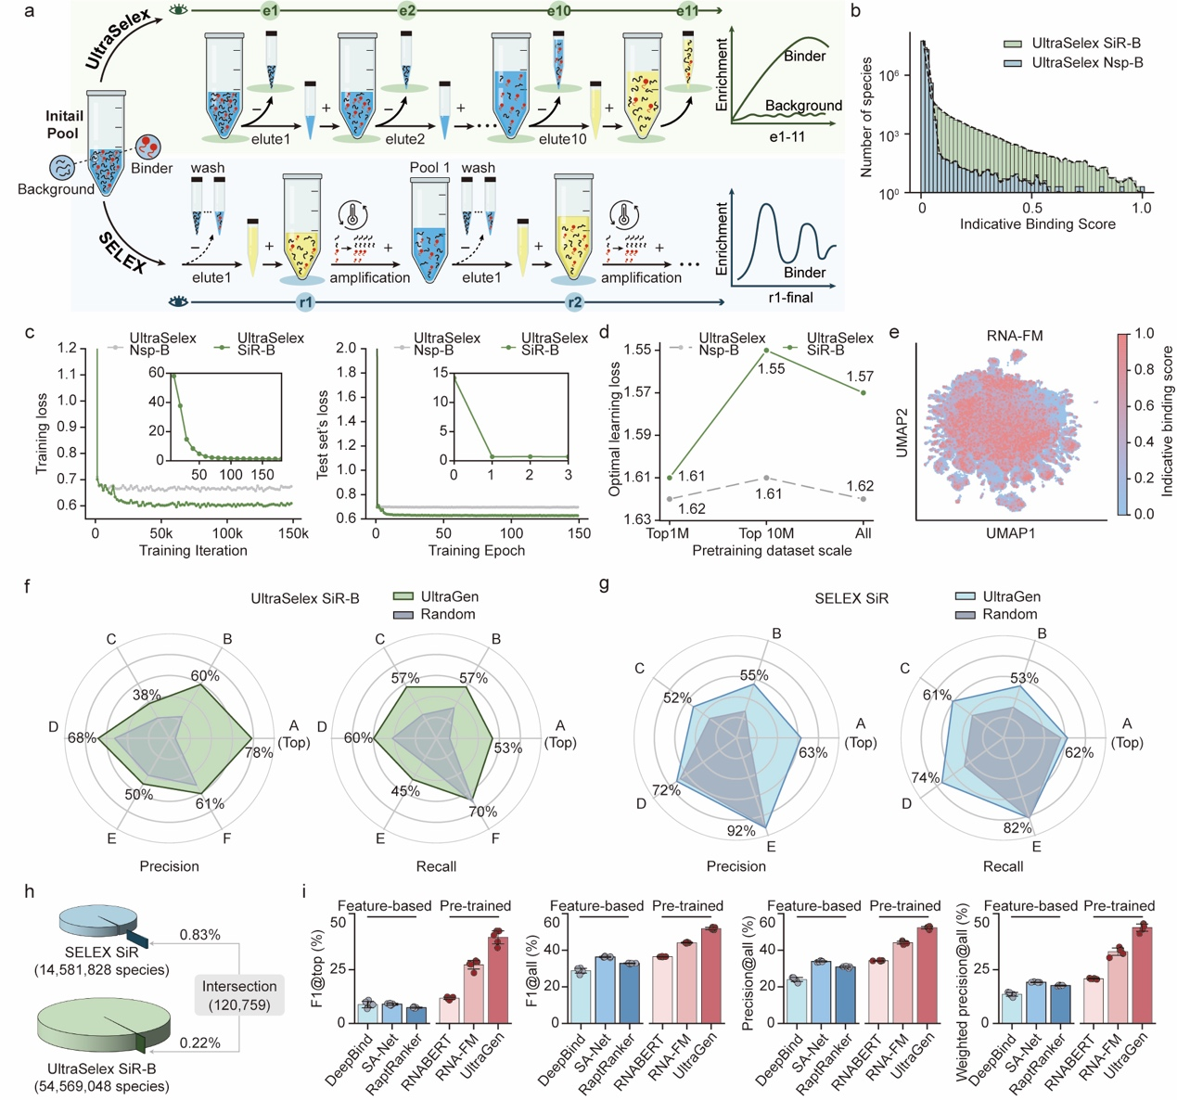
Supplementary Figure. 1: Pre-training UltraGen on various RNA systems and comparing model performance.
a, Differential enrichment pathway of RNA-target binding between SELEX and UltraSelex⁶ techniques. SELEX discontinuously enriches RNA binders, with certain losses occurring during washing steps across multiple rounds. This iterated process introduces intermediate enzymatic amplification biases, such as T7 RNA polymerase and reverse transcriptase, which leverage RNA abundance regardless of binding strength. In contrast, UltraSelex exhibits a continuous monotonic distribution of enriching RNA binders in a systematic gradient trend within a single round.
b, Distribution of RNA species based on the normalized UltraSelex SGREELI auc values, here referred to as "Indicative binding score”, compared between UltraSelex SiR-B and UltraSelex non-structure protein 12 (Nsp)-B RNA dataset.
c, UltraGen’s average learning loss on the training (left) and test (right) set of UltraSelex SiR-B and UltraSelex Nsp-B RNA dataset throughout the learning process. The inset line plots depict the learning loss in the initial training phase. The held-out test set comprised 2% of the total sequences, ensuring less than 90% identity to the training set as determined by CD-HIT.
d, Comparing the exponential learning loss on the held-out test sets for different sizes of the training set. The UltraSelex SiR-B and UltraSelex Nsp-B dataset were analyzed and sorted by SGREELI auc value in descending order for corresponding binning. The held-out test set was constructed as same in panel c.
e, UMAP projections of top one million RNA binders from UltraSelex SiR-B by RNA-FM model, colored by UltraSelex SGREELI auc values ("Indicative Binding Score”).
f&g, Model performance metrics in ranking the UltraSelex SiR-B system and SELEX SiR system, respectively. Pre-trained UltraGen ("UltraGen”, depicted in red or blue) was compared against the randomly initialized UltraGen (“Random”, depicted in grey). The UltraSelex SiR-B RNA set, ordered alphabetically from A (top 0.01%), B (top 0.01-0.05%), C (top 0.05-0.1%), D (top 0.1-0.5%), E (top 0.5-1%) to F(top 1-100%), was based on the UltraSelex SGREELI auc values. The SELEX SiR RNA set, ordered from A (top 1%), B (top 1-5%), C (top 5-12%), D (12-100%), E (Background, no detection on the final round), was based on the sequence abundance in the final round (the 14th). For classification details, see Supplementary Table 1.
h, Marginal intersection between UltraSelex SiR-B and SELEX SiR RNA datasets. All overlapped species were excluded from the SELEX SiR dataset for model evaluation in Fig. 2c, irrespective of their binding labels.
I, Model ranking comparison for top binders ("@top”, identical to that in Fig. 1c) and all binders ("Weighted”) between UltraGen and other deep learning models on the held-out test sets. The test sets consist of 30% of the total sequences, containing multiple categories (Supplementary Table 1).

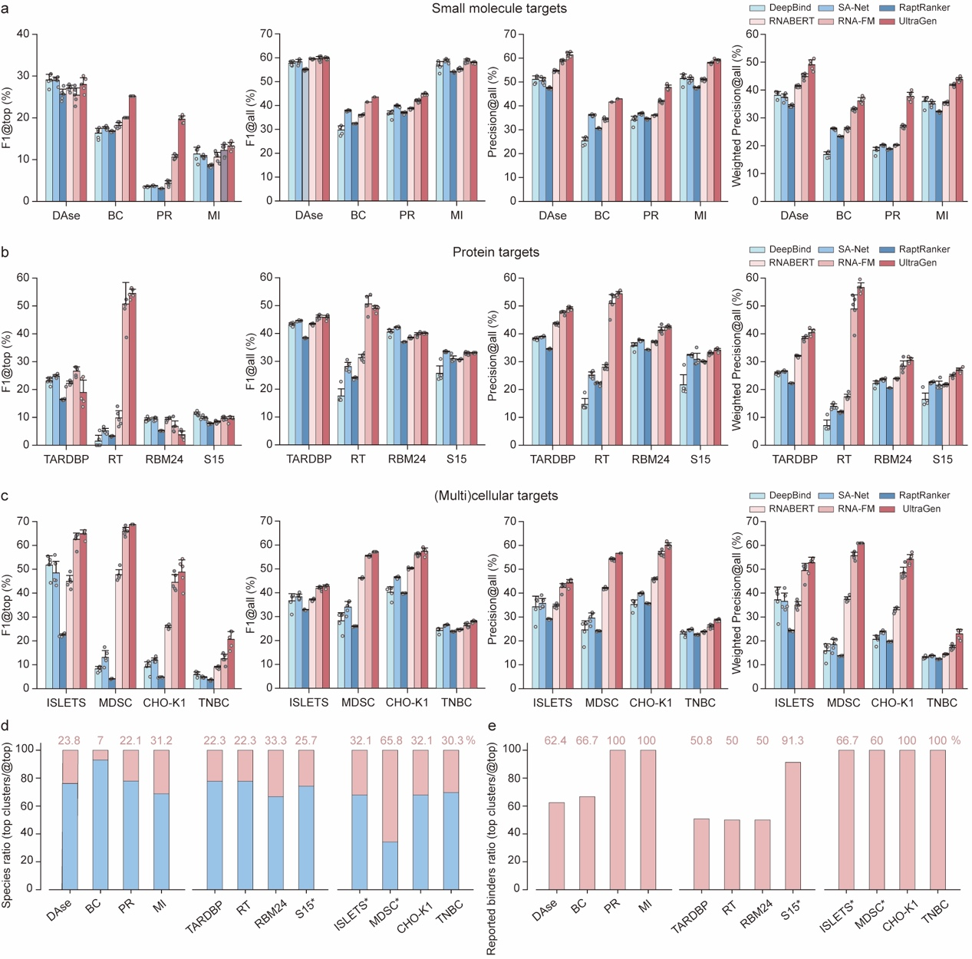
Supplementary Figure 2: Comprehensive ranking of RNA binders in SELEX systems by UltraGen and other deep learning models.
a&b&c, Ranking performance on RNA binding system to small molecule, protein, and (multi)cellular targets between UltraGen and other deep learning models. The evaluated model metrics includes F1@top, F1@all, Precision@all, and Weighted Precision@all. The '@top' metrics focus on the top binders, while '@all' metrics address all RNA species. The weighting approach was based on categories with hierarchical binding potential. Full names of targets are in Supplementary Table 2. Error bars represents mean+standard deviation. Model replicates were initiated with independent random seeds, with n=5.
d, The ratio of the RNA species from the top clusters of UltraGen predictions to that in the top category, colored in red. The top five clusters (denoted without “*”) and the top twelve clusters (denoted with “*”) based on their total HTS counts were summarized.
e, The ratio of known RNA binders in the top clusters of UltraGen predictions (panel d) to that in the top category. The known binders in DAse, MI, TARDBP, RBM24 were inferred from the corresponding reported core binding patterns^{14, 17}, while the S15 binders¹⁸ were inferred from similar sequences with an edit distance no more than four bases. The known binders of the remaining dataset were directly experimental verified^{15, 20-23, 19, 16}.
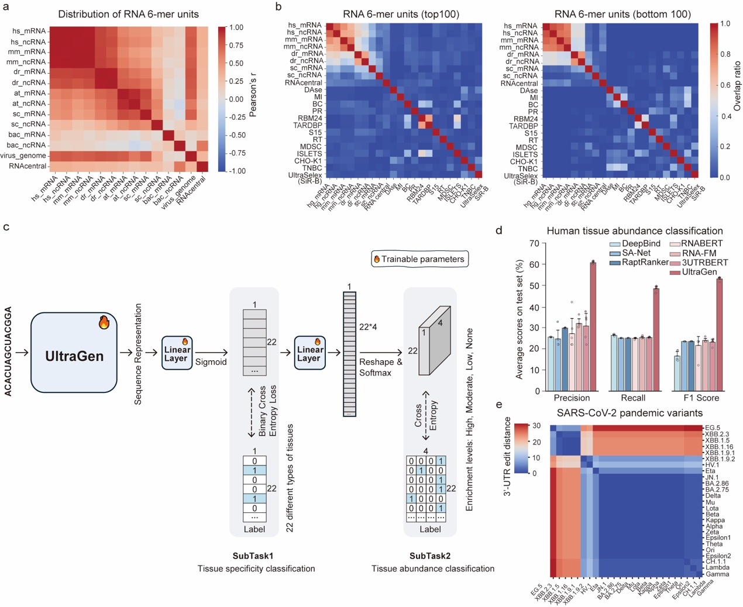
Supplementary Figure. 3: Fine-tuning UltraGen with somatic 3’-UTRs from human tissues and RNA viruses.
a, Evolutionarily conserved distribution of RNA hexamer units across species. mRNA and ncRNA from Homo sapiens (“hs”), Mus musculus (“mm”), Danio rerio (“dr”), Saccharomyces cerevisiae (“sc”), Arabidopsis thaliana (“at”), 5508 random selected bacterial species (“bac”), RNAcentral source (“RNAcentral”), and RNA viruses (“virus_genome”) were compared, with colors representing Pearson correlations coefficient ("Pearson’s r”).
b, Disparity in overlap ratio among the top 100 enriched ("top 100”, left) and bottom 100 enriched ("bottom 100”, right) RNA hexamer units across species. Species abbreviations are consistent with panel a, while SELEX and UltraSelex dataset abbreviations are identical to those in Fig. 1e.
c, A multi-task joint framework of UltraGen integrating 22 human tissue types and 4 abundance levels.
d, Identical model performance comparison to Fig.2a, but focusing on the classification of 3’-UTR abundance levels. Error bars represents mean ± standard deviation. Model replicates were initiated with independent random seeds, n=5.
e, Evolutionarily conserved 3’-UTR of SARS-CoV-2 variants over time. The last 100 nucleotides of each 3’-UTR were compared with edit distance. At the genomic level, a mutation rate in spike (23403A>G, 6294/10022 variants) versus 3’-UTR (29870C>A, 115/10022 variants) was reported⁴⁰.

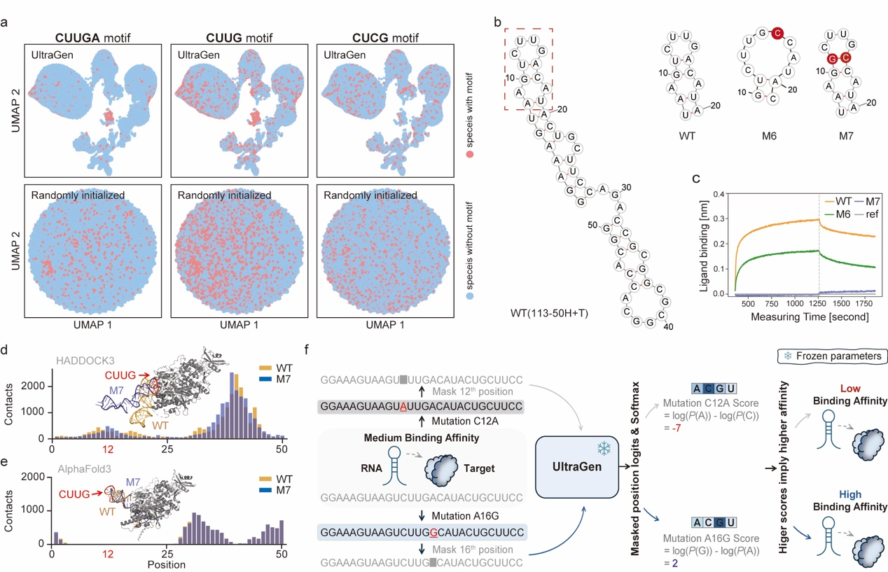
Supplementary Figure. 4: UltraGen delineates SARS-CoV-2 replicase binding with single-base resolution.
a, UMAP projections of the top one million RNA binder species from UltraSelex Nsp-B by UltraGen, colored according to the presence or absence of the denoted CUUGA, CUUG, and CUCG motifs.
b, Sequence of wild type (WT, 113-50H+T) RNA and mutants (M6, M7, with mutated bases denoted in red) for studying SARS-CoV-2 replicase binding features. RNA secondary structures were distinguished within the region outlined by a red dashed frame. The reported sequences and K_{D} values of M1-5 mutants⁶ are given in Supplementary Table 8.
c, Bio-layer interferometry measurement of RNA interaction with nsp12 protein. The association phase (left) and dissociates phases (right) were separated by a grey dashed line within the line plot. The reference control ("ref”) indicates the detection signal in the absence of RNA during the measurement.
d, Molecular docking of the interaction between SARS-CoV-2 replicase subunit nsp12 protein (PDB: 7btf, chain A) and the tertiary RNA (FARFAR2 sampling). The simulated binding interface of the protein-RNA interaction results was visualized for WT (orange) and M7 (blue) RNA via PyMOL (top panel). A total of 630 interaction simulations were conducted using HADDOCK3⁴¹, including the defined individual (35) or paired (595) combination of reported RNA-interacting amino acids⁴². Individual RNA base-contacting amino acids within the effective distance (<10 Å) were then summed (bottom panel), using the formula $\sum_{i=1}^{n}{\sum_{j=1}^{m}{\frac{10-{distance}_{ij}}{10}}}$ . Here, “n” represents the number of docking results, “m” stands for the interacted amino acid residues, and “distance_{ij}” denotes the minimum distance between the alpha carbon atom of the amino acid residue and any heavy atom within the RNA residue. The CUUG structural binding core was colored in red and additionally denoted with its RNA starting position 12. Similar simulation of RNA-protein contacts between WT (binding to nsp12) and M7 (not binding to nsp12) variant with the replicase was carried out.
e, AlphaFold3 (AF3)³¹ predictions of the interaction between SARS-CoV-2 replicase subunit nsp12 protein (PDB: 7btf, chain A) and the tertiary RNA (FARFAR2 sampling). Total 100 web server predictions with 20 different random initiation seeds (range from 1000 to 20000, step size 1000). The contacting amino acids of the predicted results (average pIDDT < 70, AF3 web server interpreted as “Low” confident) were calculated in the same way as in panel d. None of AF3 predictions successfully predicted the experimentally verified CUUG binding core (neither WT nor M7 RNA variant) close to the protein interface, indicating its limitation to identify the correct RNA-protein binding interface.
f, UltraGen’s framework for zero-shot inference on SARS-CoV-2 replicase binding. Initially, individual bases are masked. Subsequently, the framework computes the probabilities of predicting bases at the masked positions within the RNA context. This computation relies on the log ratio of the mutant base probability to the wild type base probability."

Supplementary Table 1. Model ranking criteria for SiR-binding RNA systems.
Dataset | Metrics | Category A | Category B | Category C | Category D | Category E | Category F
UltraSelex SiR-B (whole) | Top Rank* | 0.01% | 0.01-0.05% | 0.05-0.1% | 0.1-0.5% | 0.5-1% | 1-100%
UltraSelex SiR-B (whole) | RNA Species | 5,456 | 21,828 | 27,285 | 218,276 | 272,845 | 54,023,358
SELEX SiR (whole) | Top Rank** | 1% | 1-5% | 5-12% | 12%-100% | Background | _
SELEX SiR (whole) | Enrichment | ≥47 | [7, 47) | [3, 7) | [1, 3) | 0 | _
SELEX SiR (whole) | RNA Species | 7,793 | 32,290 | 52,699 | 688,150 | 13,800,896 | _
SELEX SiR (exclusive) | Top Rank** | 0.5% | 0.5-1% | 1-5% | 5-16% | 16-100% | Background
SELEX SiR (exclusive) | Enrichment | ≥37 | [19, 37) | [5, 19) | [2, 5) | 1 | 0
SELEX SiR (exclusive) | RNA Species | 3,561 | 3,842 | 24,862 | 82,213 | 594,381 | 13,752,210
* UltraSelex SiR-B RNA species were sorted in a descending order based on SGREELI auc values.
**SELEX SiR RNA species were sorted based on their detected enrichment in the final round (the 14th). Background indicates no detection of these RNA species in the final selection round.

Supplementary Table 2. Summary of twelve benchmark RNA SELEX systems and their high-throughput sequencing libraries.
Target | Name | Dataset | Method | Total  rounds | Sequenced rounds | # of species | Length (nt) | PMID
Small  molecules | Benzopyrylium-coumarin fluorophores | BC | SELEX | 11 | 1-11 | 65,299,912 | 98-106 | 34309994
Small  molecules | Paromomycin | PR | Capture-SELEX | 11 | 0-11 | 15,234,700 | 119-125 | 30957848
Small  molecules | Maleimide involved in Diels-Alderase | DAse | SELEX | 10 | 1-10 | 323,414 | 152-162 | 24157838
Small  molecules | Mechanistic inhibitor of serine proteases PPACK | MI | SELEX | 14 | 1-14 | 555,707 | 228-238 | 24157838
Proteins | TAR DNA binding protein 43 | TARDBP | HTR-SELEX | 4 | 1-4 | 1,019,953 | 109 | 32703884
Proteins | Ribosomal protein S15 | S15 | SELEX | 11 | 11 | 1,585,543 | 87 | 28587636
Proteins | RNA-binding motif protein 24 | RBM24 | HTR-SELEX | 4 | 1-4 | 749,249 | 109 | 32703884
Proteins | HIV-1 reverse transcriptase | RT | SELEX | 15 | 15 | 62,444 | 115-121 | 23385524
Cells & tissue | Triple-negative breast cancer cells | TNBC | Cell-SELEX | 14 | 0, 3, 5, 8, 9, 10, 11, 12, 13, 14 | 45,922,615 | 84 | 32222697
Cells & tissue | Chinese hamster ovary K1 cells | CHO-K1 | Cell-SELEX | 15 | 0-15 | 8,432,785 | 94-99 | 29982617
Cells & tissue | Myeloid-derived suppressor cells | MDSC | Cell-SELEX | 11 | 1,6,10,11 | 15,297,461 | 74-78 | 32554710
Cells & tissue | Human islets | ISLETS | Tissue-SELEX | 8 | 1-8 | 89,694,683 | 80-84 | 35383192

Supplementary Table 3. Model ranking criteria for RNA SELEX systems with small-molecule targets.
Dataset | Metrics | Category A | Category B | Category C | Category D | Category E
BC | Top rank* | 1% | 1-5% | 5-15% | 15-100% | Background
BC | Enrichment | ≥20 | [4, 20) | [2, 4) | 1 | 0
BC | RNA species | 22,034 | 97,948 | 200,504 | 1,829,680 | 63,149,746
PR | Top rank* | 1% | 1-5% | 5-10% | 10-100% | Background
PR | Enrichment | ≥50 | [7, 50) | [3, 7) | [1, 3) | 0
PR | RNA species | 1,410 | 5,714 | 9,060 | 124,388 | 15,094,128
DAse | Top rank* | 20% | 20-100% | Background | _ | _
DAse | Enrichment | ≥2 | 1 | 0 | _ | _
DAse | RNA species | 1,720 | 6,863 | 314,831 | _ | _
MI | Top rank* | 3% | 3-100% | Background | _ | _
MI | Enrichment | ≥2 | 1 | 0 | _ | _
MI | RNA species | 924 | 33,635 | 521,148 | _ | _
* SELEX RNA species were sorted based on their detected enrichment in the final SELEX round. Background indicates no detection of these RNA species in the final selection round.

Supplementary Table 4. Model ranking criterial for RNA SELEX systems with protein targets.
Dataset | Metrics | Category A | Category B | Category C | Category D | Category E
TARDBP | Top rank* | 4% | 4-12% | 12-100% | Background | _
TARDBP | Enrichment | ≥3 | [2, 3) | [1, 2) | 0 | _
TARDBP | RNA species | 7,985 | 13,314 | 162,401 | 836,253 | _
S15 | Top rank* | 1% | 1-5% | 5-11% | 11-100% | _
S15 | Enrichment | ≥38 | [6, 38) | [3, 6) | [1, 3) | _
S15 | RNA species | 6,720 | 68,956 | 99,348 | 1,410,519 | _
RBM24 | Top rank* | 1% | 1-6% | 6-100% | Background | _
RBM24 | Enrichment | ≥3 | [2, 3) | [1, 2) | 0 | _
RBM24 | RNA species | 2,365 | 8,226 | 170,684 | 567,974 | _
RT | Top rank* | 1% | 1-5% | 5-10% | 10-31% | 31-100%
RT | Enrichment | ≥153 | [17, 153) | [6, 17) | [2, 6) | [1, 2)
RT | RNA species | 625 | 2,496 | 3,783 | 13,340 | 42,200
* SELEX RNA species were sorted based on their detected enrichment in the final SELEX round. Background indicates no detection of these RNA species in the final selection round.

Supplementary Table 5. Model ranking criteria for RNA SELEX systems with (multi)cellular targets.
Dataset | Metrics | Category A | Category B | Category C | Category D | Category E | Category F | Category G
TNBC | Top rank* | 0.1% | 0.1-0.5% | 0.5-1% | 1-5% | 5-9% | 9-100% | Background
TNBC | Enrichment | ≥115 | [26, 115) | [14, 26) | [5, 14) | [4, 5) | [1, 4) | 0
TNBC | RNA species | 1,711 | 6,931 | 9,455 | 64,549 | 70,968 | 1,547,821 | 44,221,180
CHO-K1 | Top rank* | 1% | 1-5% | 5-12% | 12-100% | Background | _ | _
CHO-K1 | Enrichment | ≥32 | [4, 32) | [2, 4) | [1, 2) | 0 | _ | _
CHO-K1 | RNA species | 1,250 | 5,432 | 8,561 | 108,438 | 8,309,104 | _ | _
MDSC | Top rank* | 0.1% | 0.1-0.5% | 0.5-1% | 1-5% | 5-10% | 10-100% | Background
MDSC | Enrichment | ≥165 | [30, 165) | [14, 30) | [3, 14) | [2, 3) | [1, 2) | 0
MDSC | RNA species | 3,642 | 14,698 | 19,087 | 158,808 | 161,512 | 3,277,166 | 11,662,548
ISLETS | Top rank* | 0.1% | 0.1-2% | 2-100% | Background | _ | _ | _
ISLETS | Enrichment | >=3 | [2, 3) | [1, 2) | 0 | _ | _ | _
ISLETS | RNA species | 13,599 | 373,679 | 17,547,704 | 71,759,701 | _ | _ | _
* SELEX RNA species were sorted based on their detected enrichment in the final SELEX round. Background indicates no detection of these RNA species in the final selection round.

Supplementary Table 6. Summary of human-pathogenic RNA viruses and their tissue-specific inference.
Name | Abbreviation | Accession ID | PolyA length | 3'-UTR* | Tissue top2 prediction | Tissue literature (PMID)
Zika virus | Zika | NC_012532.1 | 0 | 100 | bladder, lymph node | 29494684
Tick-borne encephalitis virus | TBE | NC_001672.1 | 0 | 100 | thymus, bladder | 2389567, 36205381
Chikungunya virus | Chikungunya | NC_004162.2 | 0 | 100 | lung,  lymph node | 36016408
Leishmania RNA virus 1 - 1 | Leishmania | NC_002063.1 | 0 | 36 | lung,  spleen | 31999729
Dengue virus 1 | Dengue | NC_001477.1 | 0 | 100 | heart,  skeletal muscle | 20032806
Yellow fever virus | Yellow Fever | NC_002031.1 | 0 | 100 | lymph node, spleen | 30134625, 25412185
Measles virus | Measles | NC_001498.1 | 0 | 97 | lung,  spleen | 17715217, 10490102
Middle East respiratory syndrome-related coronavirus | MERS | NC_019843.3 | 12 | 100 | kidney, spleen | 31668197, 26203058
Rabies virus | Rabies | NC_001542.1 | 0 | 74 | skeletal muscle,  heart | 4282379, 33738007
Human coxsackievirus A2 strain Fleetwood | Coxsackie | NC_038306.1 | 0 | 71 | testis, thyroid | 33102086, 35909527
* The length of sequence from the end of the 3'-UTR that was utilized for model prediction.

Supplementary Table 7. Summary of SARS-CoV-2 variants for tissue-specific inference.
Name | Lineage | Accession ID | PolyA length | 3'-UTR*
Ori | B | NC_045512.2 | 33 | 100
Epsilon2 | B.1.429 | MZ722827.1 | 33 | 100
Zeta | P.3 | OL981152.1 | 33 | 100
Epsilon1 | B.1.427 | OK245663.1 | 33 | 100
Theta | P.2 | MZ169917.1 | 33 | 100
Eta | B.1.525 | MW791296.1 | 33 | 100
Lambda | C.37 | MW937858.1 | 33 | 100
Gamma | P.1 | OP855417.1 | 33 | 100
Alpha | B.1.1.7 | OX590588.1 | 33 | 100
Kappa | B.1.617.1 | OK246830.1 | 33 | 100
Beta | B.1.351 | OK246830.1 | 33 | 100
Lota | B.1.526 | OK246905.1 | 33 | 100
Mu | B.1.621 | MZ411658.1 | 33 | 100
Delta | B.1.617.2 | OR129998.1 | 33 | 100
Omicron_multiple | BA.2.75 | OP998291.1 | 33 | 100
Omincron_XBB_1.16_multiple | XBB.1.16 | BS007362.1 | 21 | 100
Omicron_CH1.1_multiple | CH.1.1 | OR180688.1 | 33 | 100
Omincron_XBB_1.9.1_multiple | XBB.1.9.1 | BS007360.1 | 21 | 100
Omincron_XBB_1.5_multiple | XBB.1.5 | BS007567.1 | 21 | 100
Omincron_XBB_1.9.2_multiple | XBB.1.9.2 | BS007596.1 | 30 | 100
Omincron_XBB_2.3_multiple | XBB.2.3 | BS007565.1 | 21 | 100
BA.2.86_multiple | BA.2.86 | OR558991.1 | 33 | 100
Omicron_EG.5_multiple | EG.5 | BS007694.1 | 24 | 100
HV.1 | HV.1 | OR815854.1 | 29 | 100
JN.1 | JN.1 | OR815892.1 | 33 | 100
* The length of the sequence from the end of 3'-UTR that was utilized for model prediction.

Supplementary Table 8. Consistence between experimental and computational methods for nsp12 RNA binding.
113-50H+L | Mutation | K_{D} (nM) | Experimental binding* | Computational binding** | RNA Sequence
WT | _ | 4.1 | _ | _ | GGAAAGUAAGUCUUGACAUACUGCUUCCAGACCGCGGCGCGGCACCACGG
M1 | C12A | no binding (>1000) | 0.1448 | -8.6362 | GGAAAGUAAGUAUUGACAUACUGCUUCCAGACCGCGGCGCGGCACCACGG
M2 | U13C | no binding (>1000) | 0.1448 | -7.4149 | GGAAAGUAAGUCCUGACAUACUGCUUCCAGACCGCGGCGCGGCACCACGG
M3 | U14C | 22.2 | 0.3226 | -4.5929 | GGAAAGUAAGUCUCGACAUACUGCUUCCAGACCGCGGCGCGGCACCACGG
M4 | G15C | no binding (>1000) | 0.1448 | -7.4056 | GGAAAGUAAGUCUUCACAUACUGCUUCCAGACCGCGGCGCGGCACCACGG
M5 | A16G | 9.6 | 0.4421 | -2.0393 | GGAAAGUAAGUCUUGGCAUACUGCUUCCAGACCGCGGCGCGGCACCACGG
M6 | A16C | 30.8 | 0.2918 | -6.9735 | GGAAAGUAAGUCUUGCCAUACUGCUUCCAGACCGCGGCGCGGCACCACGG
M7 | U11G&A16C | no binding (>1000) | 0.1448 | -7.1336 | GGAAAGUAAGGCUUGCCAUACUGCUUCCAGACCGCGGCGCGGCACCACGG
* Experimental binding scores were calculated as 1/ln(K_{D}).
** Computational binding scores, with higher values indicating greater binding potential, were predicted by UltraGen.

