Title: Higher urban heat hazard in wealthier neighborhoods in the Global South – Supplementary Information

Authors: TC Chakraborty^{1*}
Affiliations: ¹Pacific Northwest National Laboratory; Richland, WA, USA
*Corresponding author. Email: tc.chakraborty@pnnl.gov

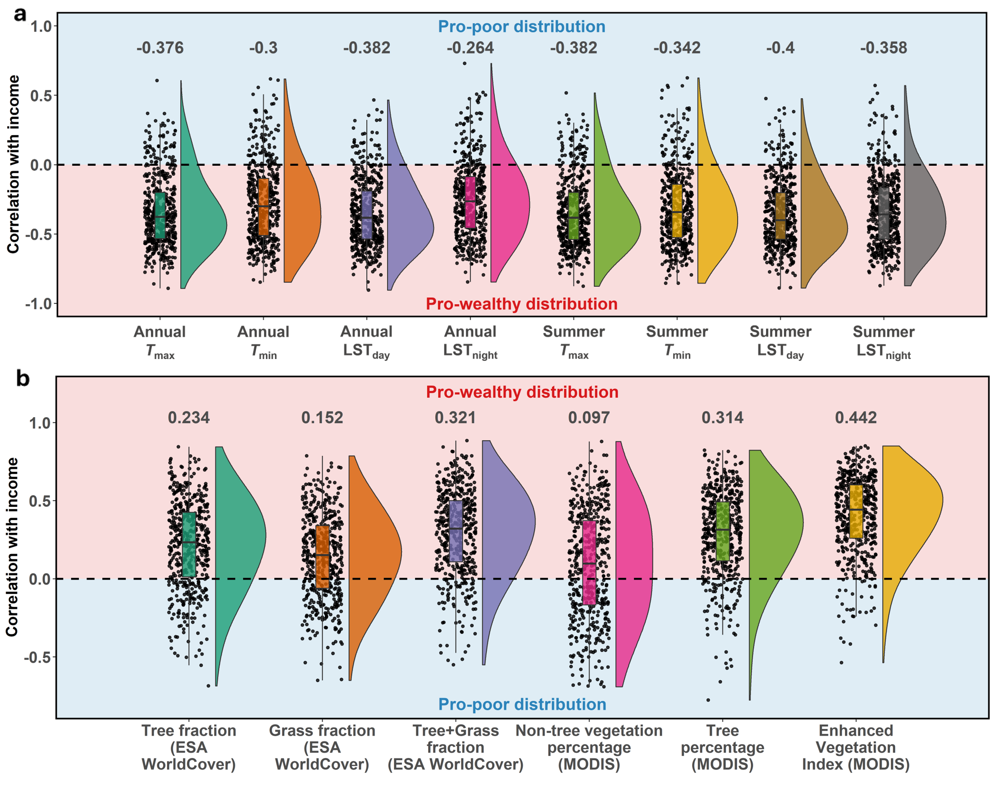

Fig. S1: Intra-urban disparities in heat hazard and tree cover for U.S. cities. a, Distributions of correlation coefficient between median income and various proxies for heat exposure (LST represents satellite-derived Land Surface Temperature) for different cases for U.S. cities (n=492). b, Distributions of correlation coefficient between median income and various direct and indirect estimates of urban vegetation and its subcategories from multiple sources.

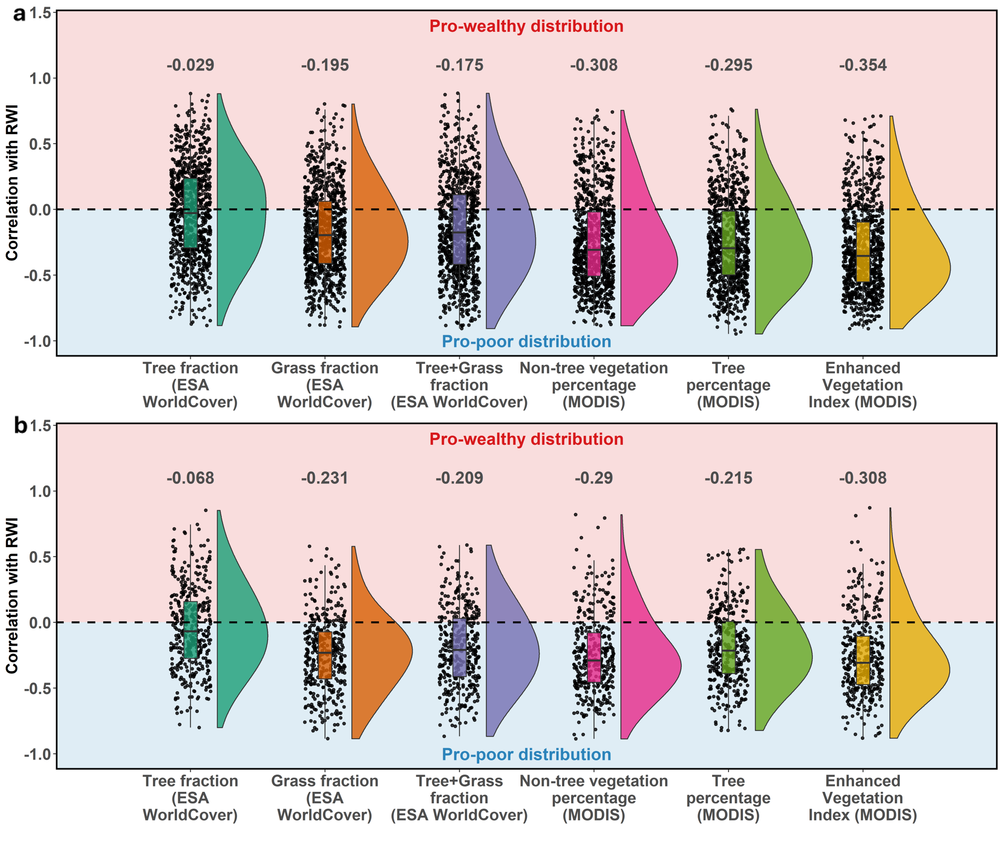

Fig. S2: Intra-urban disparities in tree cover for Global South. Distributions of correlation coefficient between Relative Wealth Index (RWI) and various direct and indirect estimates of urban vegetation and its subcategories from multiple sources in the Global South for a urban clusters derived from population thresholds (n=924) and b urban clusters derived from global land cover data (n=384).

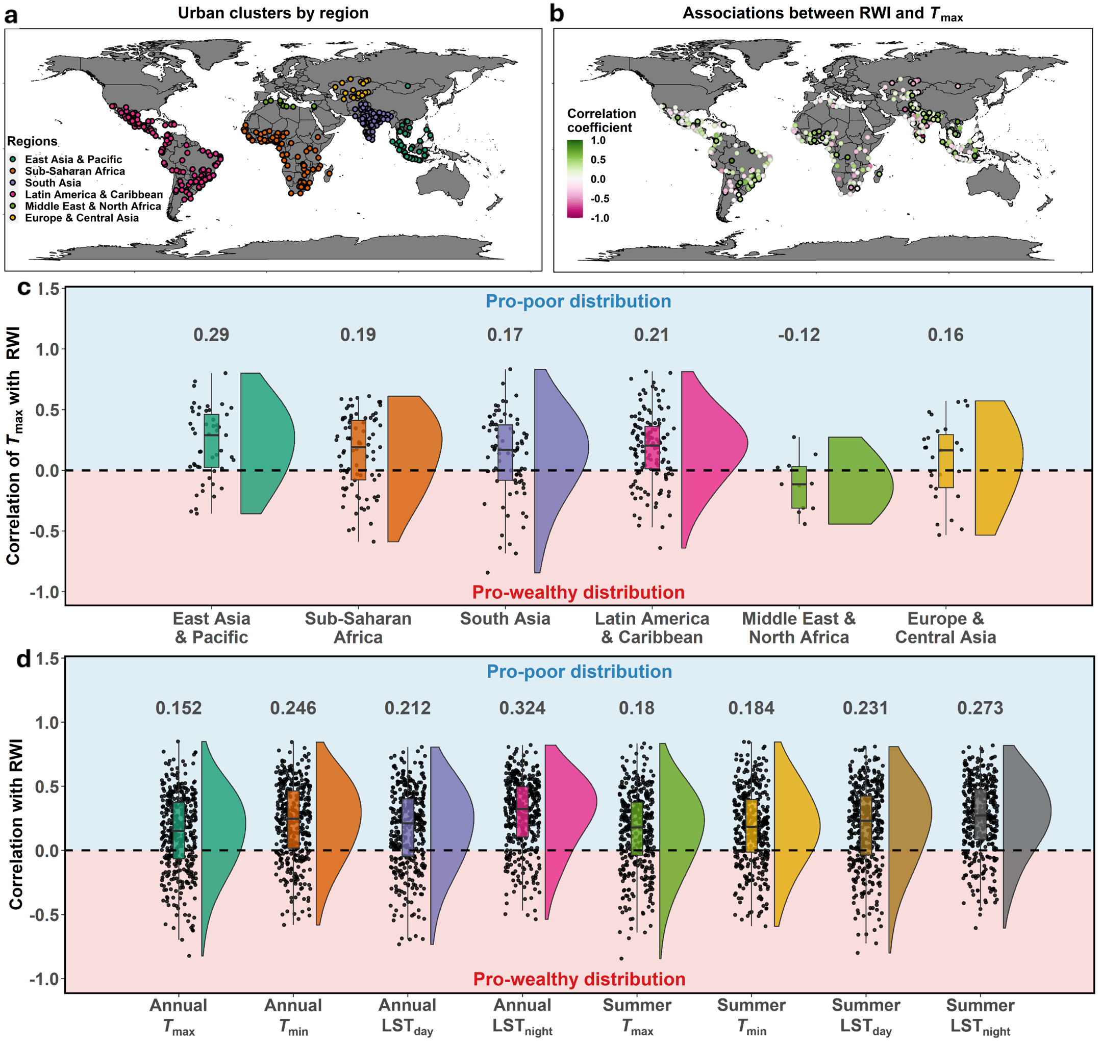Fig. S3: Urban clusters in the Global South and their intra-urban heat hazard disparities. Same as Fig. 1 of main text, but using urban clusters derived from global land cover data (n=384).

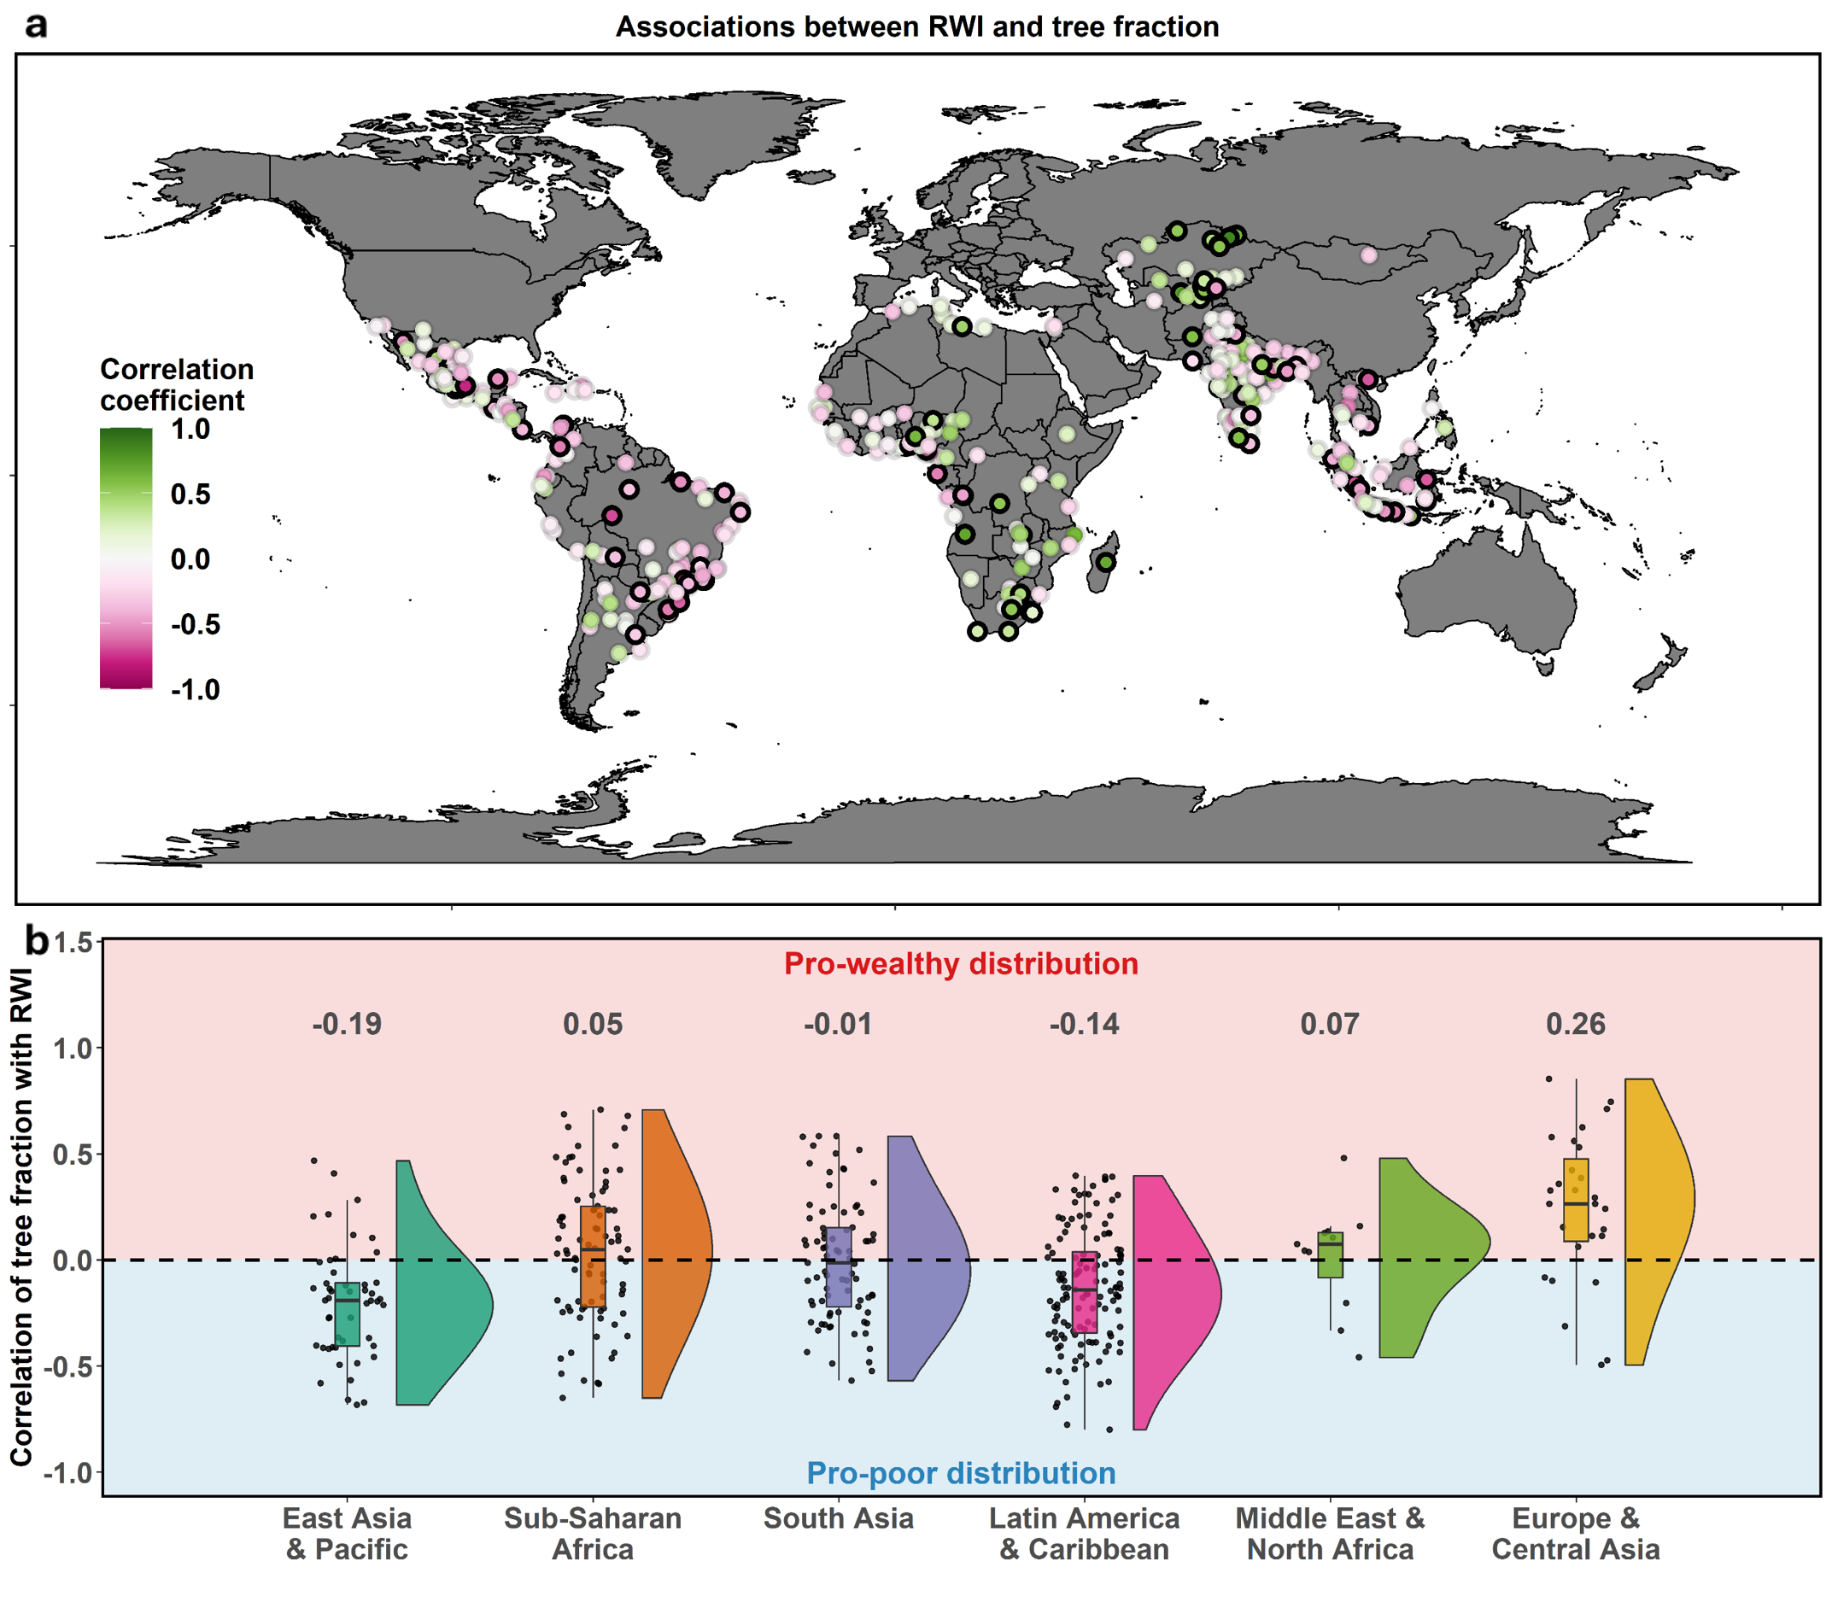Fig. S4: Intra-urban disparities in tree cover. Same as Fig. 2 of main text, but using urban clusters derived from global land cover data (n=384).

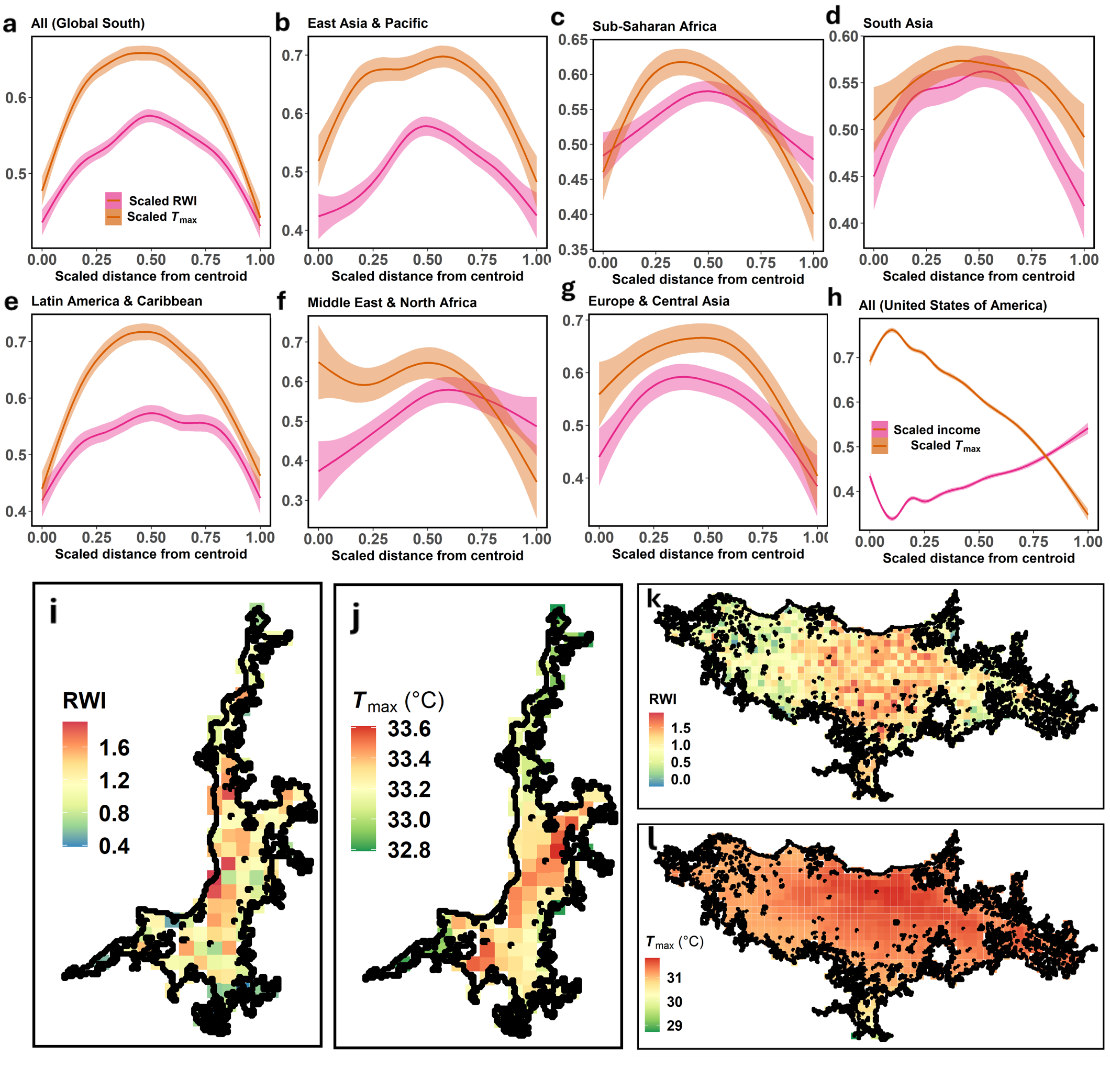

Fig. S5: Heat and wealth distributions across cities with examples. Same as Figs 3 and 4 of main text, but using urban clusters derived from global land cover data (n=384).

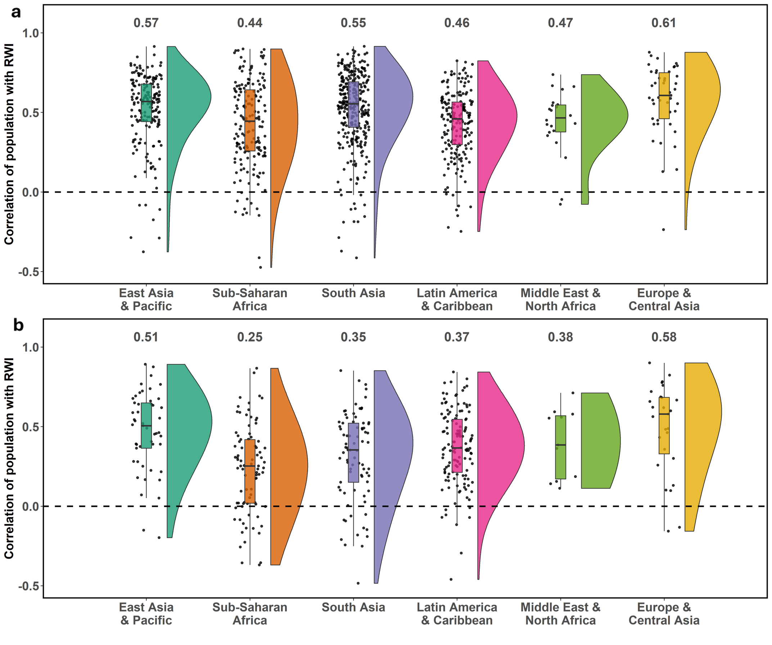Fig. S6: Correlations between population and wealth for Global South. Distributions of correlation coefficient between Relative Wealth Index (RWI) and total population for sub-region of the Global South (median correlation coefficients noted for each case) for a urban clusters derived from population thresholds (n=924) and b urban clusters derived from global land cover data (n=384).

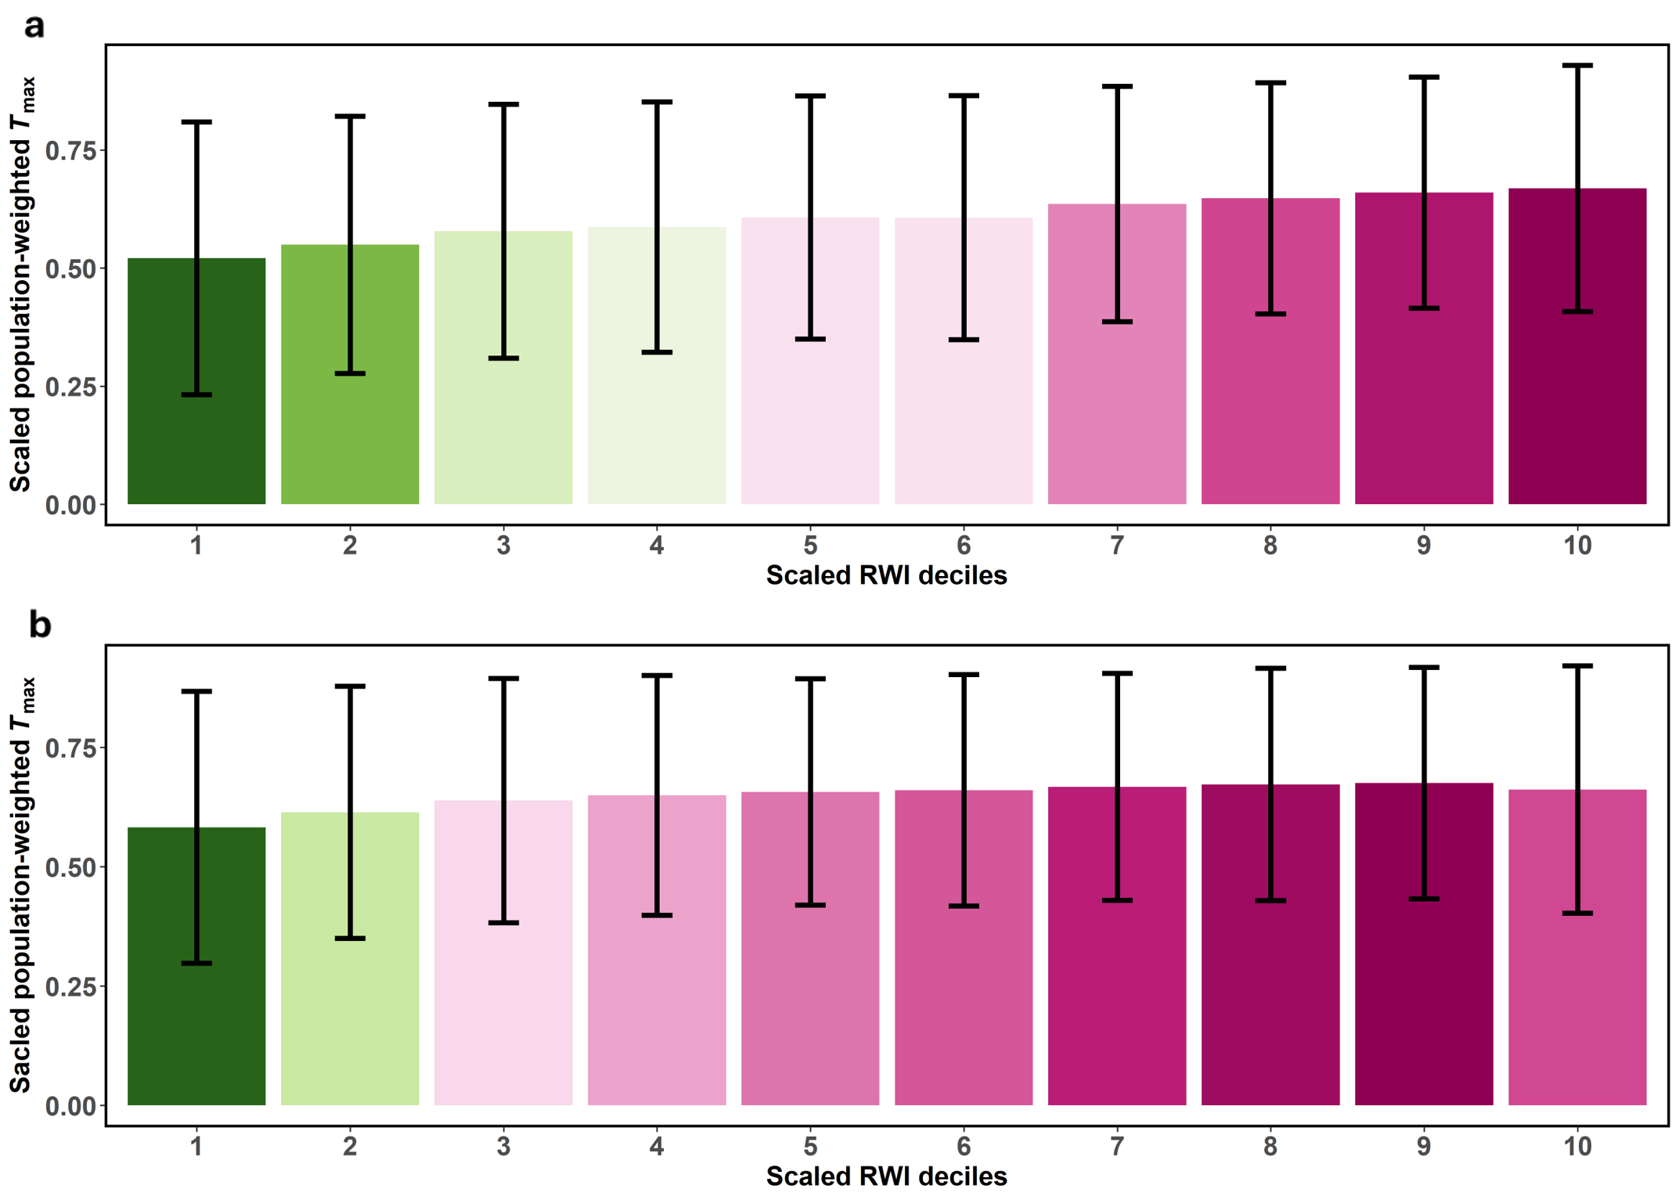Fig. S7: Population-weighted heat hazard by wealth deciles. Scaled (both population and temperature between 0 and 1 for which urban cluster) population-weighted mean and standard deviation of maximum average (for 2010-2019) summer air temperature (T_{max}) for scaled deciles of Relative Wealth Index (RWI) for a urban clusters derived from population thresholds (n=924) and b urban clusters derived from global land cover data (n=384). Colors of the bar represent the values (green is low and dark pink is high).
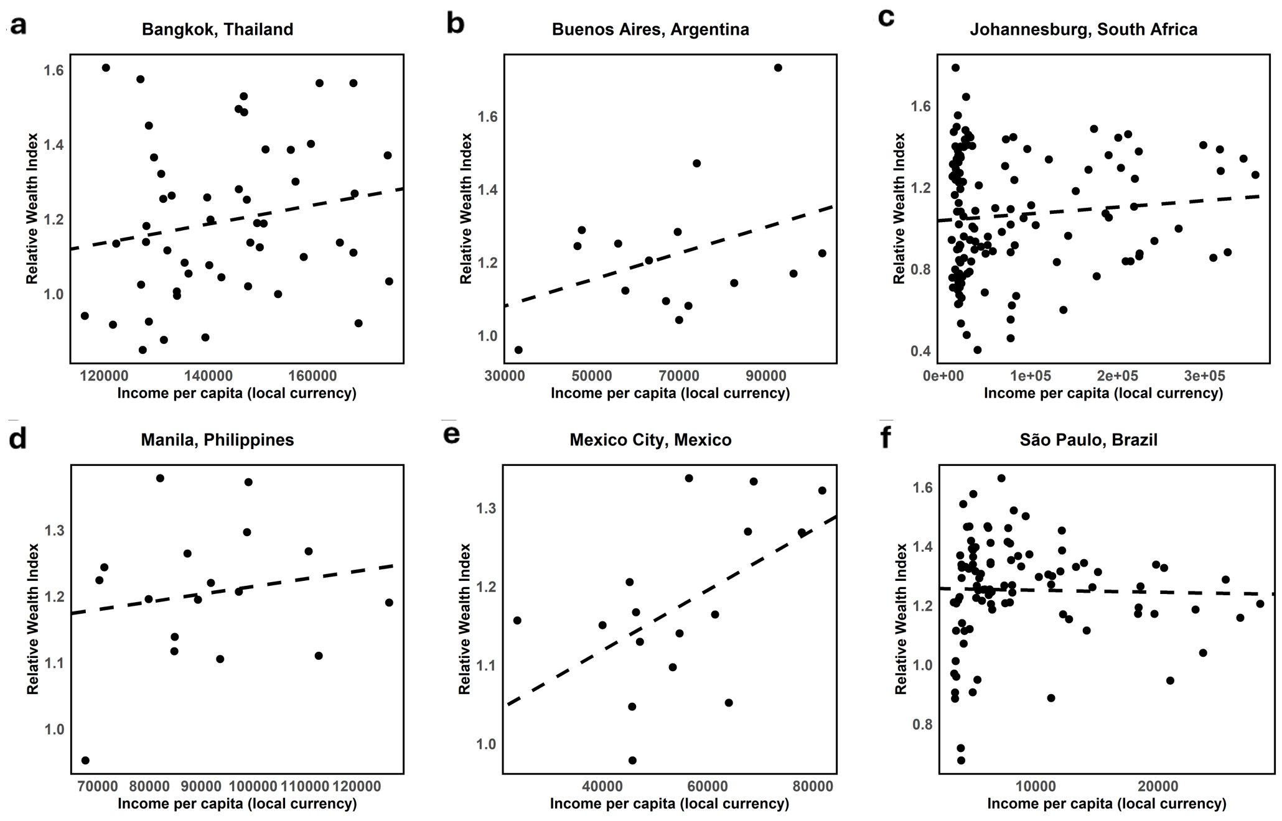Fig. S8: Validation of income distributions within select cities. Associations between sub-city income per capita and Relative Wealth Index (RWI) for a Bangkok, b Buenos Aires, c Johannesburg, d Manila, e Mexico City, and f São Paulo. The lines of best fit are shown.

