Differential influences of island biogeographic effects on the diversity of three plant life-forms
Sai-Qiang Li¹, Qin-Qin Pan¹, Xiao-Dong Yang^{1,2*}, Yong-Chao Gao³
1 Department of Geography & Spatial Information/Center for Land and Marine Spatial Utilization and Governance Research, Ningbo University, Ningbo 315211, China;
2 College of Ecology and Environment, Xinjiang University, Urumqi, Xinjiang 830046, China；
3 Shandong Provincial Key Laboratory of Applied Microbiology, Ecology Institute, Qilu University of Technology (Shandong Academy of Sciences), Jinan 250103, China.

*Corresponding author: Xiao-Dong Yang. Ningbo University
E-mail address: xjyangxd@sina.com

Runtitle: Island biogeographic effects on the diversity

Table S1 Basic information of the 30 study islands in County, Zhejiang Province, eastern China. Ele: Elevation, SI: Shape Index, DM: closest distance from each island to the mainland, SDM: stepping stone distance, LUI: land use intensity, H: habitat heterogeneity, SR: total number of species, Trees: number of tree species, Shrubs: number of shrub species, Herbs: number of herb species. Bio4: Temperature Seasonality (standard deviation ×100), Bio7: Temperature Annual Range (℃), and Bio18: Precipitation of Warmest Quarter(mm).
Island | Area/km² | Ele/m | SI | DM | SDM | LUI | H | Samples | Sample Line /m | SR | Trees | Shrubs | Herbs | Invasive species | Bio4 | Bio7 | Bio18
1 | 0.184177 | 59 | 1.543 | 0.95 | 1.04 | 0.105 | 0.67 | 1 | 96 | 40 | 8 | 14 | 18 | 5 | 787.97 | 27.917 | 384
2 | 0.022352 | 25.4 | 1.457 | 1.99 | 7.84 | 0 | 0 | 1 | 75 | 53 | 7 | 15 | 31 | 4 | 789.76 | 28.02 | 386
3 | 0.144 | 40 | 1.785 | 0.36 | 1.28 | 0.370 | 1 | 1 | 90 | 39 | 9 | 12 | 18 | 4 | 788.31 | 28.02 | 381
4 | 1.33712 | 83 | 1.35 | 0.62 | 7.41 | 0.764 | 0.772 | 3 | 162 | 55 | 12 | 16 | 27 | 3 | 785.4 | 27.855 | 381
5 | 0.013778 | 24.7 | 1.453 | 4.42 | 14.25 | 0 | 0 | 1 | 57 | 28 | 3 | 11 | 14 | 0 | 768.39 | 26.6 | 376
6 | 0.026672 | 28.7 | 1.434 | 5.6 | 6.92 | 0 | 0 | 1 | 79 | 43 | 5 | 14 | 24 | 1 | 765.97 | 26.578 | 388
7 | 0.022618 | 33.1 | 1.164 | 1.2 | 4.06 | 0.115 | 0.707 | 1 | 181 | 38 | 8 | 7 | 23 | 3 | 777.92 | 27.242 | 386
8 | 0.105679 | 48.5 | 1.528 | 0.87 | 3.24 | 0.174 | 0.971 | 1 | 196 | 50 | 6 | 16 | 28 | 3 | 777.92 | 27.242 | 386
9 | 0.060851 | 59 | 1.305 | 10.39 | 21.02 | 0.027 | 0.355 | 1 | 149 | 36 | 9 | 12 | 15 | 3 | 773.15 | 27.01 | 378
10 | 0.012488 | 26.6 | 1.569 | 17.46 | 18.61 | 0 | 0 | 1 | 88 | 20 | 0 | 7 | 13 | 0 | 772.98 | 27.01 | 374
11 | 1.038803 | 156.3 | 2.931 | 14.85 | 1.72 | 0 | 0 | 3 | 377 | 66 | 11 | 23 | 32 | 2 | 772.87 | 26 | 374
12 | 0.007825 | 19.6 | 1.873 | 1.95 | 5.92 | 0.137 | 0.399 | 1 | 57 | 23 | 3 | 5 | 15 | 3 | 782.05 | 27.6 | 375
13 | 0.754313 | 128 | 1.626 | 1.06 | 7.62 | 0.058 | 0.388 | 2 | 385 | 58 | 13 | 20 | 25 | 6 | 783.82 | 27.737 | 378
14 | 0.027327 | 25 | 1.109 | 0.43 | 1.11 | 0.757 | 0.554 | 1 | 143 | 44 | 9 | 15 | 20 | 4 | 776.6 | 27.1 | 383
15 | 0.020849 | 32.1 | 1.258 | 1.47 | 5.34 | 0 | 0 | 1 | 70 | 32 | 3 | 16 | 13 | 1 | 775.22 | 27 | 377
16 | 0.001427 | 10.1 | 1.253 | 1.5 | 2.95 | 0 | 0 | 1 | 51 | 19 | 2 | 4 | 13 | 0 | 775.22 | 27 | 377
17 | 0.815626 | 73 | 2.518 | 1.65 | 1.14 | 0 | 0 | 2 | 367 | 49 | 6 | 18 | 25 | 1 | 774.32 | 26.9 | 371
18 | 0.06176 | 45.2 | 1.987 | 3.68 | 10.96 | 0 | 0 | 1 | 118 | 31 | 0 | 17 | 14 | 0 | 783.49 | 26.35 | 379
19 | 0.106104 | 40.8 | 3.029 | 3.27 | 15.35 | 0 | 0 | 1 | 144 | 41 | 2 | 16 | 23 | 2 | 784.78 | 26.4 | 378
20 | 0.007917 | 20.3 | 1.482 | 0.15 | 0.15 | 0.003 | 0.367 | 1 | 81 | 34 | 3 | 9 | 22 | 2 | 797.28 | 28.54 | 391
21 | 0.161506 | 47.8 | 1.199 | 0.4 | 0.4 | 0.666 | 0.869 | 1 | 133 | 61 | 14 | 25 | 22 | 6 | 796.52 | 28.405 | 399
22 | 0.343755 | 95 | 2.536 | 4.89 | 12.25 | 0 | 0.686 | 1 | 237 | 49 | 8 | 12 | 29 | 2 | 785.18 | 26.5 | 385
23 | 0.016959 | 24.3 | 1.899 | 4.05 | 21.85 | 0 | 0 | 1 | 164 | 49 | 1 | 19 | 29 | 1 | 789.08 | 26.6 | 382
24 | 0.007519 | 20.2 | 1.749 | 7.24 | 17.94 | 0 | 0 | 1 | 61 | 14 | 0 | 4 | 10 | 0 | 785.18 | 26.5 | 385
25 | 0.038124 | 29.5 | 1.775 | 0.41 | 0.41 | 0.366 | 0.746 | 1 | 157 | 57 | 13 | 17 | 27 | 4 | 797.62 | 28.458 | 406
26 | 0.005677 | 20.5 | 1.479 | 9.42 | 5.02 | 0 | 0 | 1 | 52 | 24 | 0 | 8 | 16 | 0 | 779.91 | 26.5 | 384
27 | 0.006108 | 23.7 | 1.468 | 11.1 | 0.52 | 0.08 | 0.279 | 1 | 67 | 17 | 0 | 6 | 11 | 0 | 782.42 | 26.5 | 379
28 | 0.035352 | 56.8 | 1.666 | 17.62 | 35.62 | 0 | 0 | 1 | 126 | 22 | 0 | 2 | 20 | 1 | 765.74 | 25.7 | 356
29 | 0.041735 | 50.1 | 1.464 | 12.38 | 26.14 | 0 | 0 | 1 | 115 | 41 | 0 | 10 | 31 | 3 | 766.7 | 26.4 | 360
30 | 0.006884 | 20.9 | 1.109 | 11.12 | 18.28 | 0 | 0 | 1 | 93 | 10 | 0 | 2 | 8 | 0 | 764.83 | 26.35 | 368

Table S2 All variables in this study.
Category | Factors | Abbreviation
Island attributes | area | /
Island attributes | remotenesss | /
Island attributes | elevation | /
Island attributes | shape Index | SI
Human activities | land use intensity | LUI
Human activities | habitat heterogeneity | H
Climatic factors | annual mean temperature | Bio1
Climatic factors | mean diurnal range | Bio2
Climatic factors | isothermality | Bio3
Climatic factors | temperature seasonality | Bio4
Climatic factors | maximum temperature of warmest month | Bio5
Climatic factors | minimum temperature of coldest month | Bio6
Climatic factors | temperature annual range | Bio7
Climatic factors | mean temperature of wettest quarter | Bio8
Climatic factors | mean temperature of driest quarter | Bio9
Climatic factors | mean temperature of warmest quarter | Bio10
Climatic factors | mean temperature of coldest quarter | Bio11
Climatic factors | annual precipitation | Bio12
Climatic factors | precipitation of wettest month | Bio13
Climatic factors | precipitation of driest month | Bio14
Climatic factors | precipitation seasonality | Bio15
Climatic factors | precipitation of wettest quarter | Bio16
Climatic factors | precipitation of driest quarter | Bio17
Climatic factors | precipitation of warmest quarter | Bio18
Climatic factors | precipitation of coldest quarter | Bio19

Table S3. The factors with a Variance Inflation Factor (VIF) below 10 after conducting a collinearity diagnosis.
No. | Variable | VIF
1 | Remoteness | 4.103
2 | Area | 1.284
3 | LUI | 2.248
4 | H | 2.937
5 | Bio4 | 2.639
6 | Bio7 | 2.920
7 | Bio18 | 4.402
Dependent Variable：SR

Table S4 The optimal multiple linear regression model selected using the Akaike Information Criterion (AIC).
Factors | Models | R² | Adj.R² | P-Value | AIC
LUI | LUI=0.075-0.08Re | 0.38 | 0.36 | <0.001 | -79.01
H | H=0.092-0.073Re+0.719LUI | 0.59 | 0.56 | <0.0001 | -65.48
Bio4 | Bio4=2.89-0.006Re | 0.43 | 0.41 | <0.0001 | -242.37
Bio7 | Bio7=1.439-0.018Re | 0.71 | 0.7 | <0.0001 | -211.82
Bio18 | Bio18=2.58-0.012Re | 0.38 | 0.35 | <0.001 | -193.64

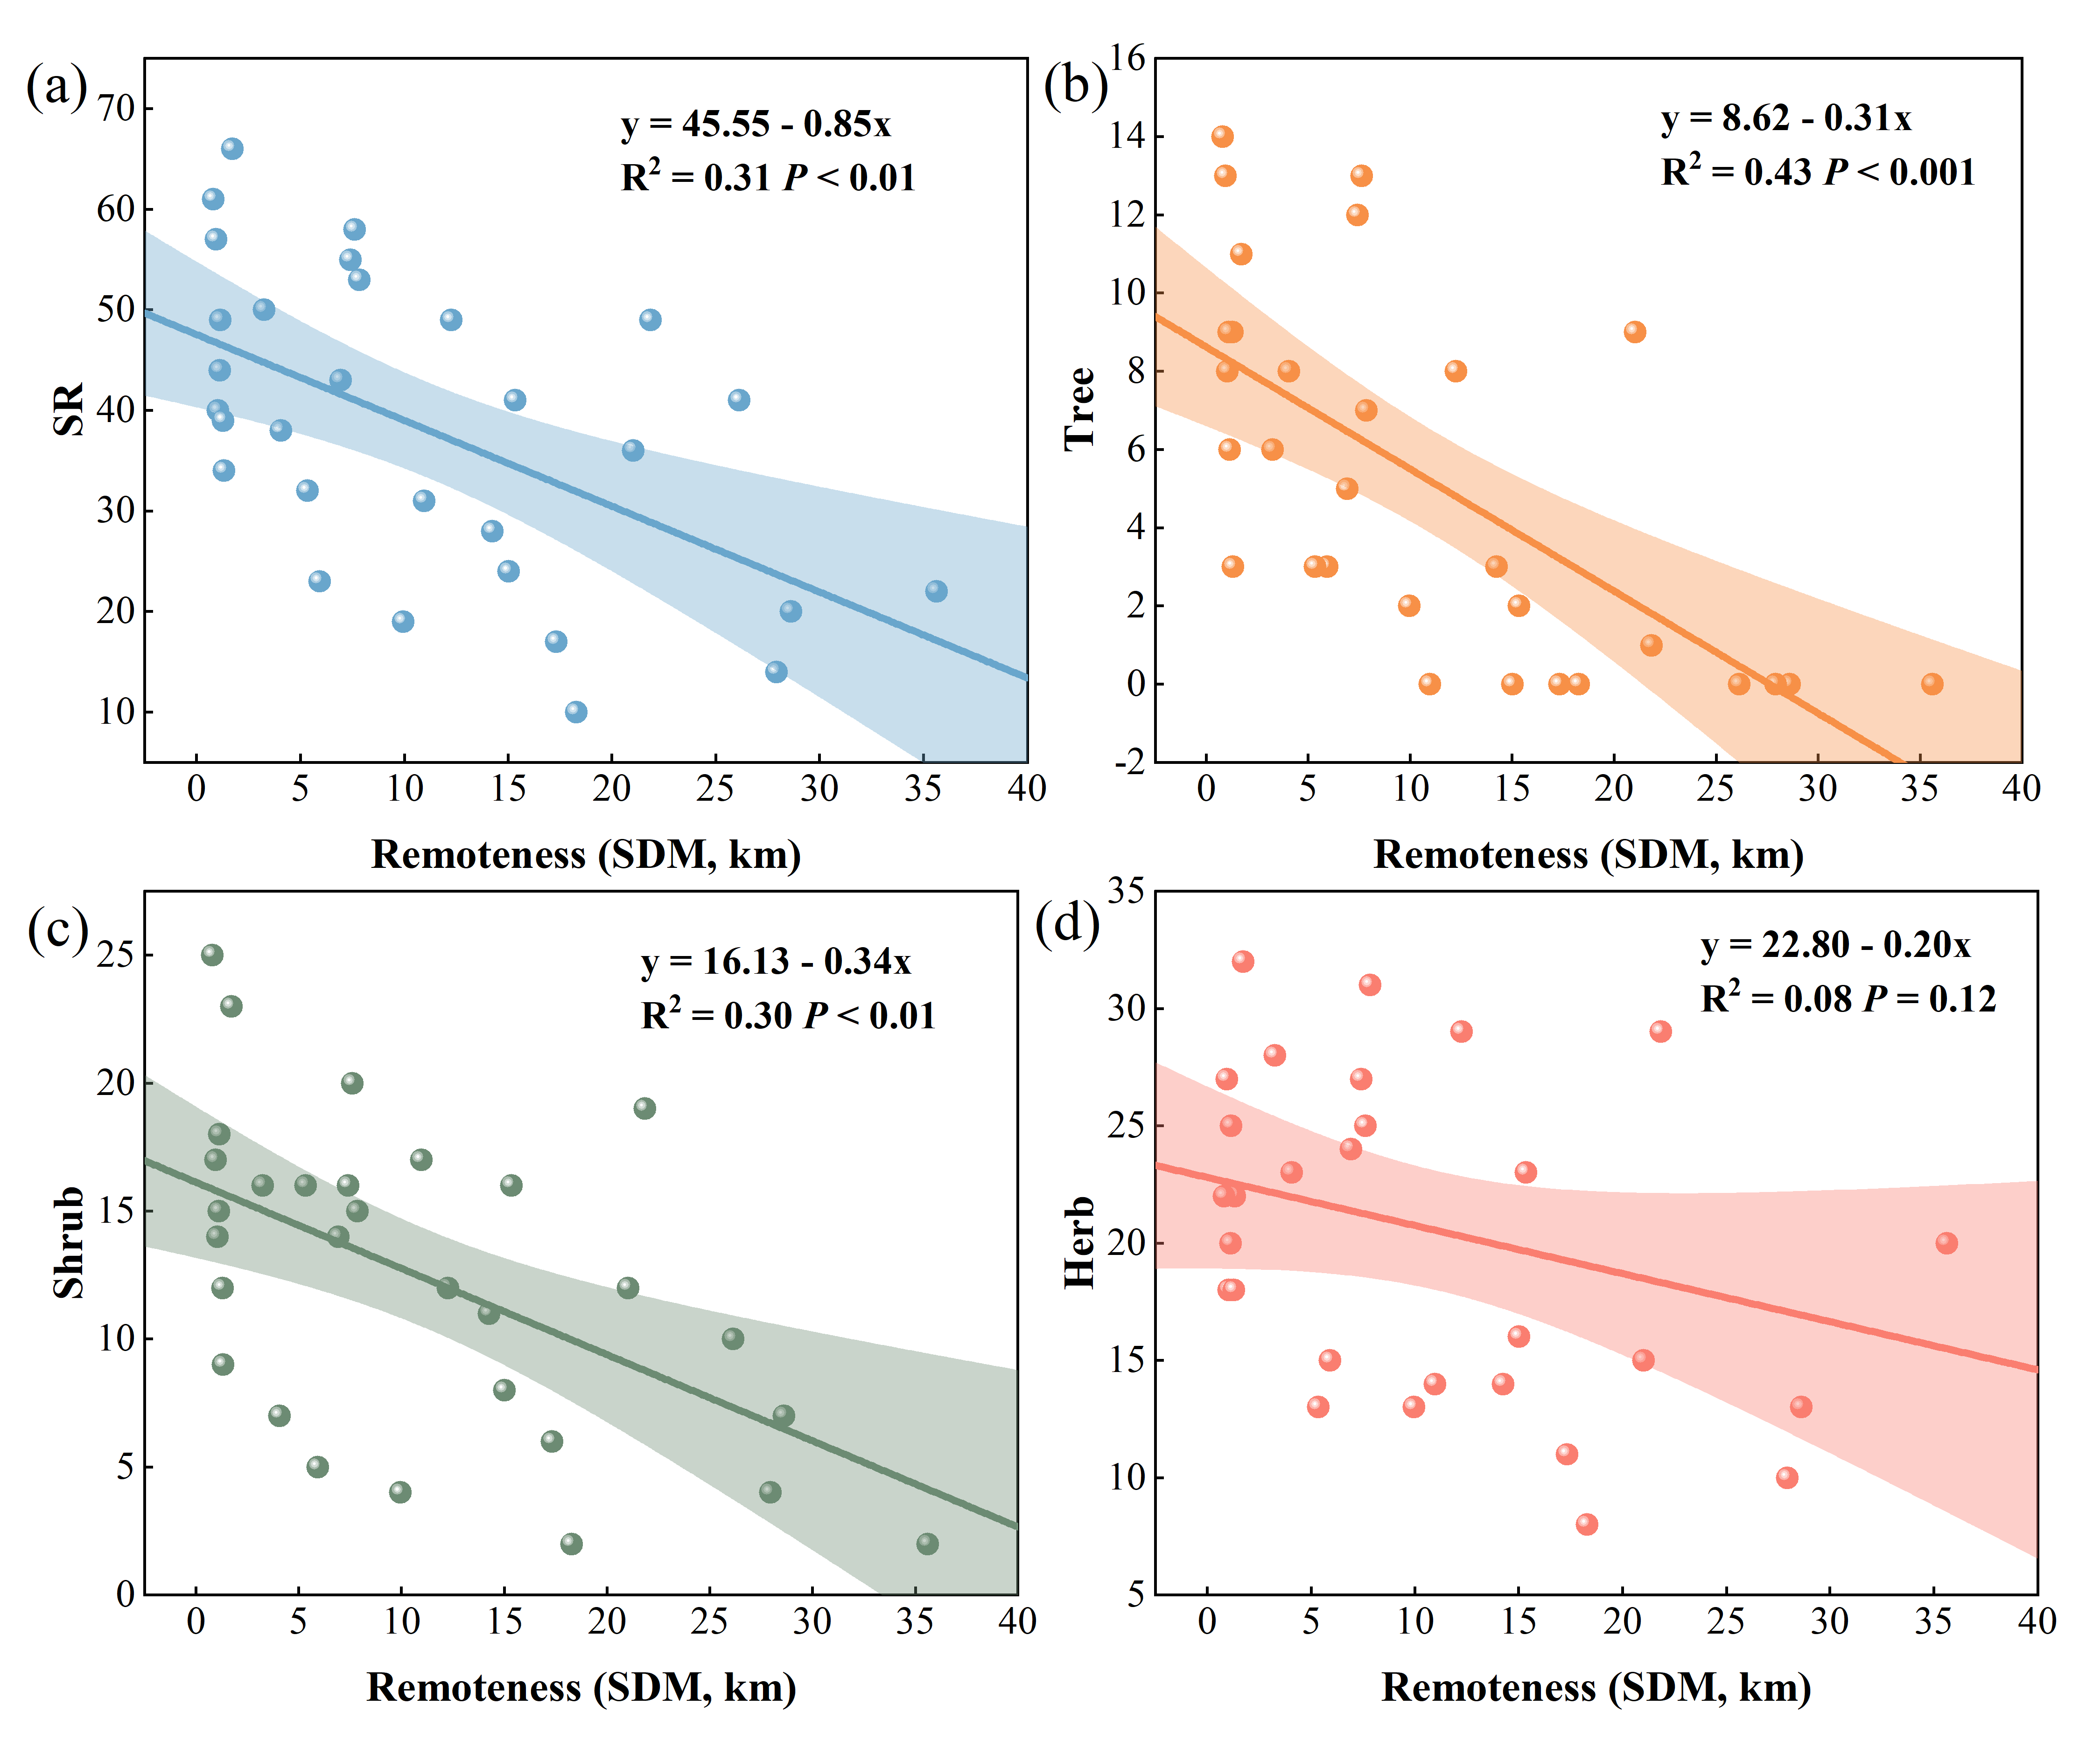
Fig. S1. Relationships of species richness with stepping stone distance (SDM).

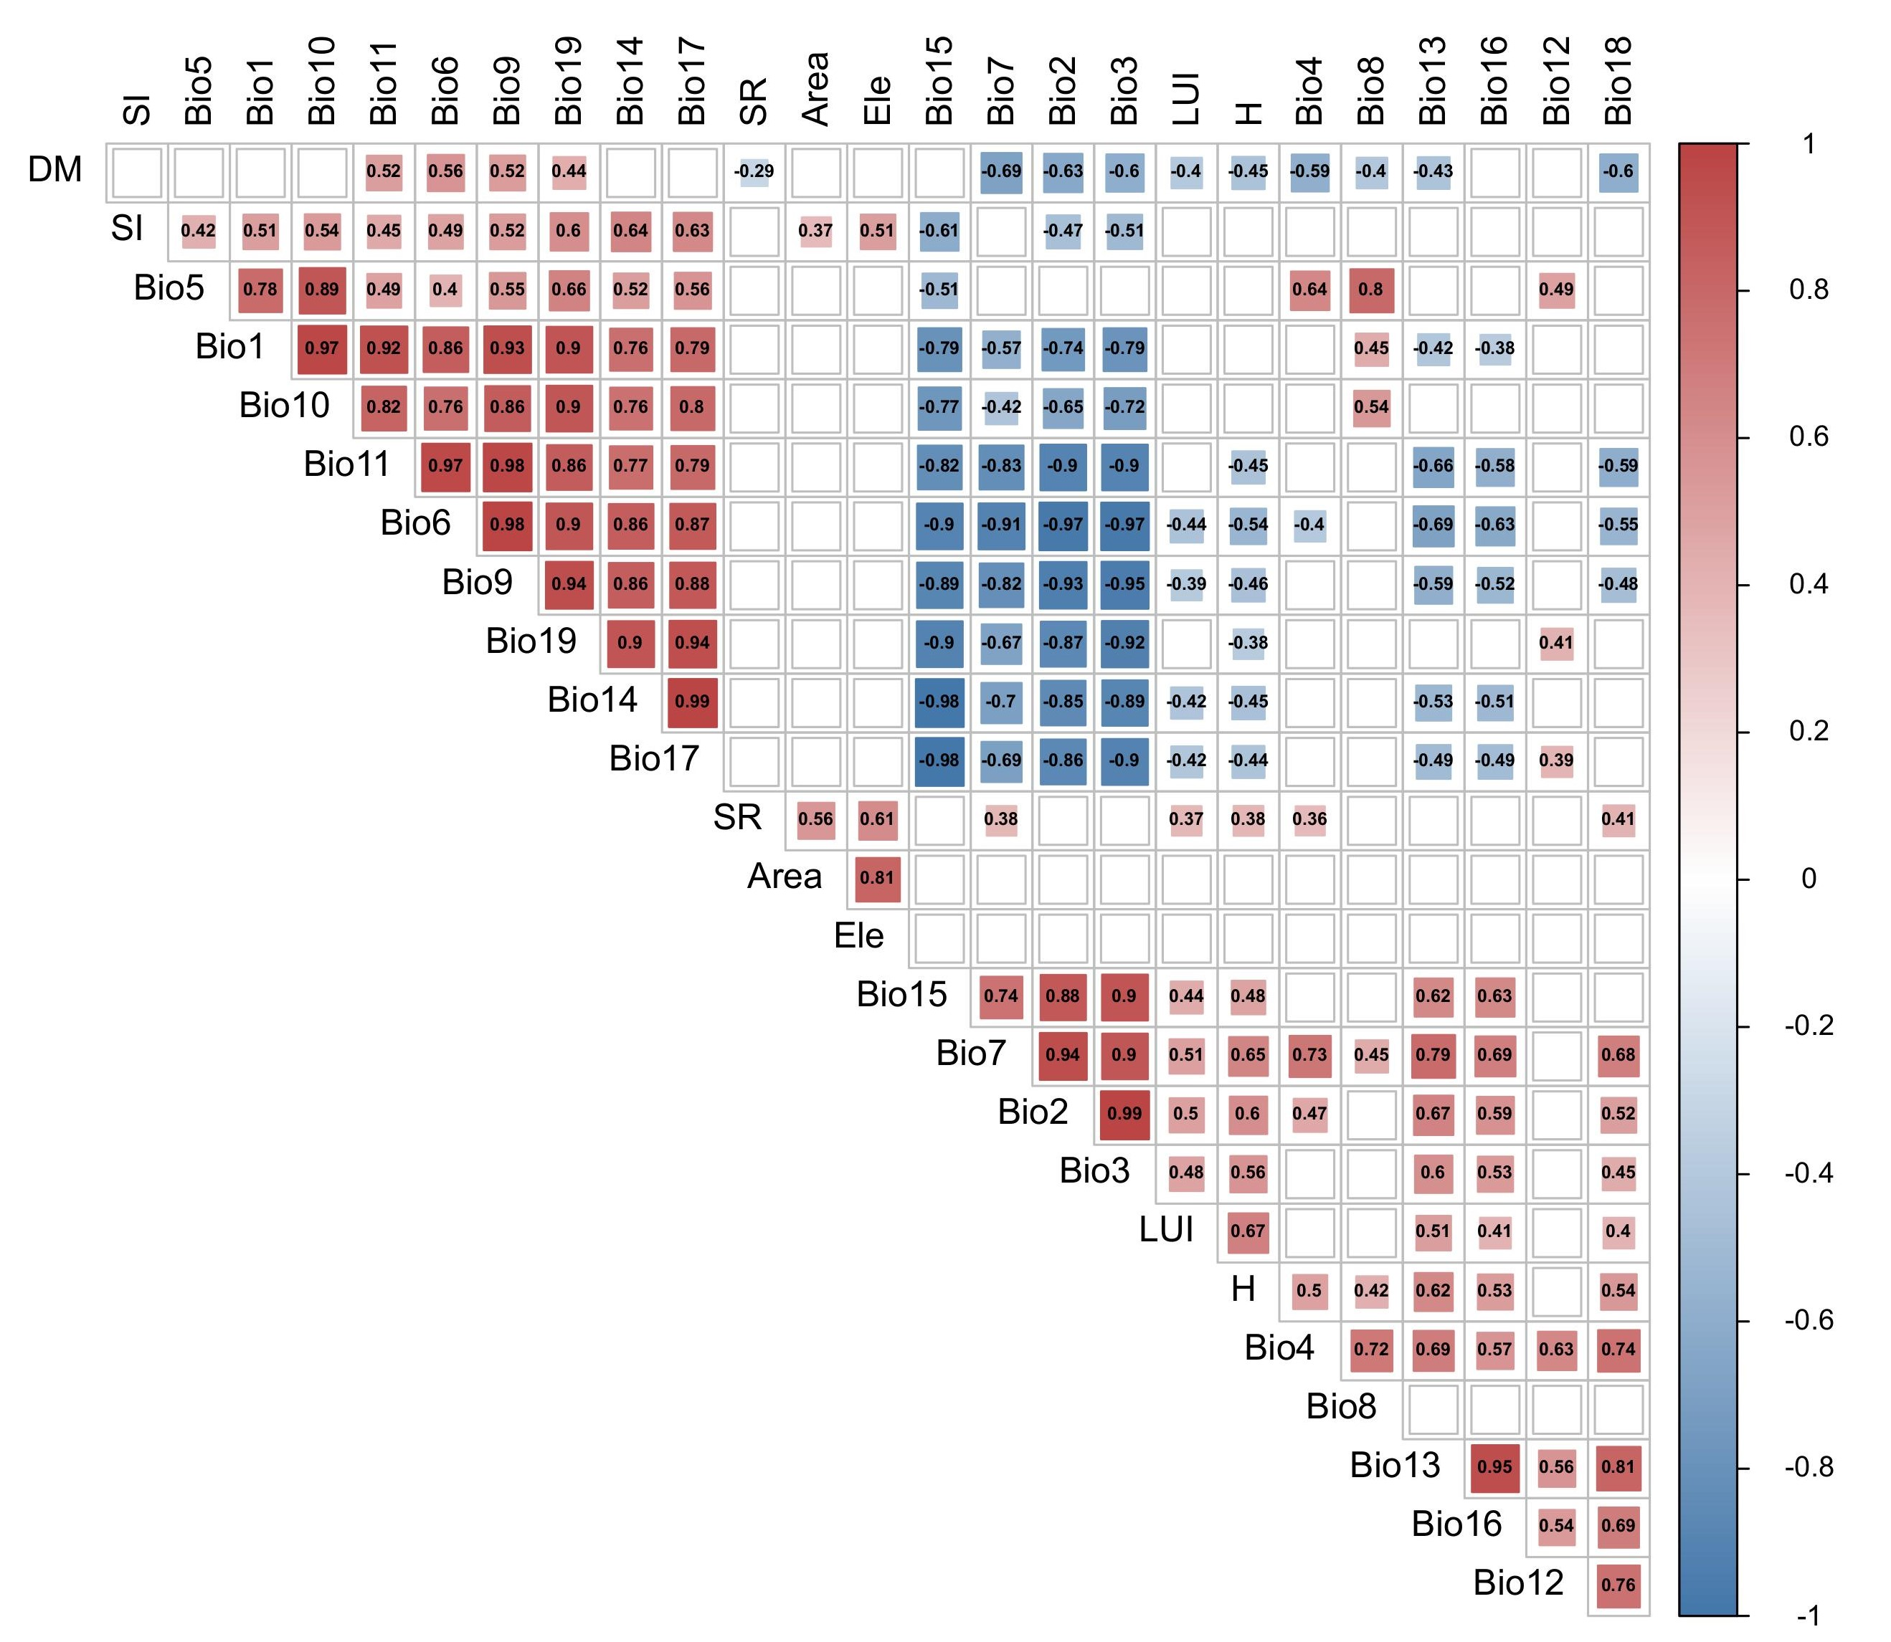
Fig. S2. Heat map of correlations between SR and island attributes, climatic factors and human activities, with blanks indicating significant non-correlation (p > 0.05).

The species accumulation curve (Fig. S3) shows that these methods are sufficient to capture all or most of the species present on the island, ensuring the comprehensiveness and accuracy of the study. A total of 304 plant species from 95 families and 220 genera were recorded in our study, including 46 tree species (15.13% of total species), 87 shrub species (28.62%), and 171 herb species (55.92%). The species richness on each island ranged from 10 to 66, with the number of tree species varying from 0 to 14, shrub species from 2 to 25, and herb species from 8 to 32. The species accumulation curve suggests that the total, trees, shrubs, and herbs species richness all initially rise and then flatten out with the increase of the number of islands (Fig. S3), indicating that the plant survey and sampling design across the 30 islands were comprehensive.
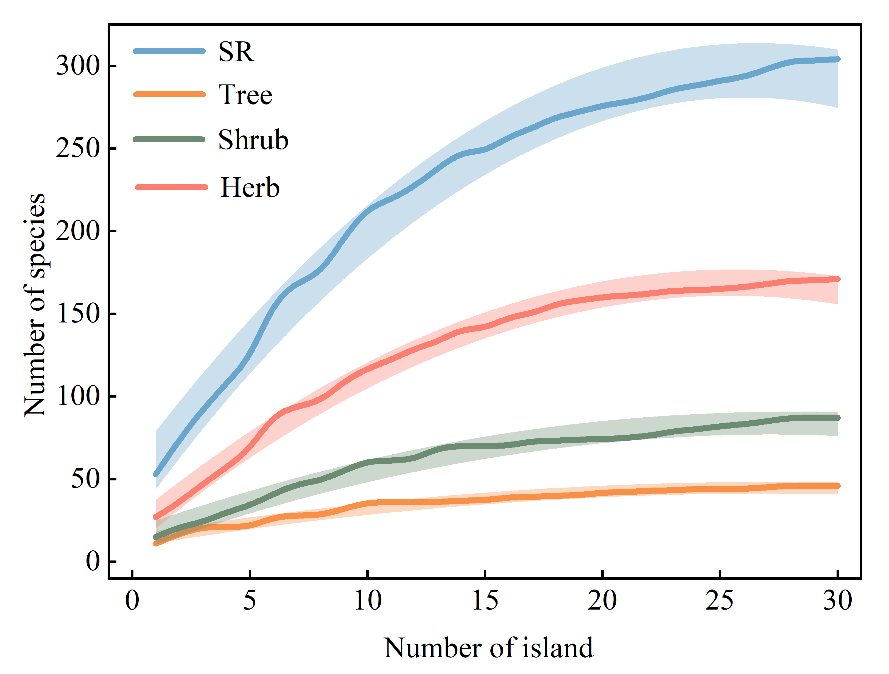
Fig. S3. Species accumulation curves for island plants and different plant growth forms, where 'SR' represents the total species richness of the islands.

