Extended Data for
Growth and assemblage dynamics of temperate forest tree species match physiological resilience to changes in atmospheric chemistry

Filip Oulehle^{1,2,*}, Pavel Šamonil^{3,4}, Otmar Urban², Josef Čáslavský², Alexander Ač², Ivana Vašíčková³, Jakub Kašpar³, Pavel Hubený⁵, Rudolf Brázdil^{2,6}, Miroslav Trnka²

¹ Czech Geological Survey, 118 21 Prague, Czech Republic
² Global Change Research Institute of the Czech Academy of Sciences, 603 00 Brno, Czech Republic
³ Department of Forest Ecology, The Silva Tarouca Research Institute, Brno, Czech Republic, Lidicka 25/27, 602 00 Brno
⁴ Faculty of Forestry and Wood Technology, Mendel University in Brno, Zemědělská 3, 613 00 Brno, Czech Republic
⁵ Šumava National Park, 1.máje 260, 385 01 Vimperk, Czech Republic
⁶ Institute of Geography, Masaryk University, 611 37 Brno, Czech Republic

*Filip Oulehle
Email: filip.oulehle@geology.cz

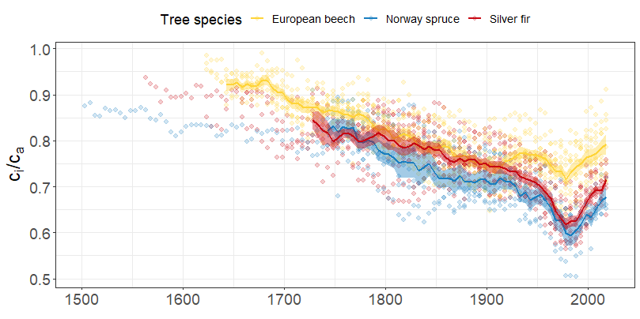Fig. S1. Individual species-specific values (points) of the ratio of intercellular to ambient CO₂ concentration (c_{i}/c_{a}) calculated for aggregated 5-year tree-ring segments. Points are fitted with a mean line starting in the year when the number of trees for each species reached at least 50% of all individuals analyzed. Shading corresponds to the standard error of the mean.

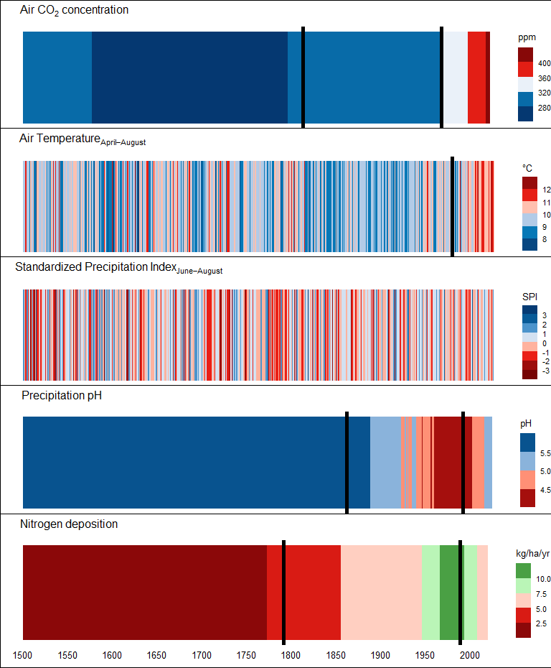Fig. S2. Temporal patterns (1501-2020 CE) of environmental parameters with an indication of the years (vertical black line) when there was a significant change in the trend (identified by breakpoint analysis).

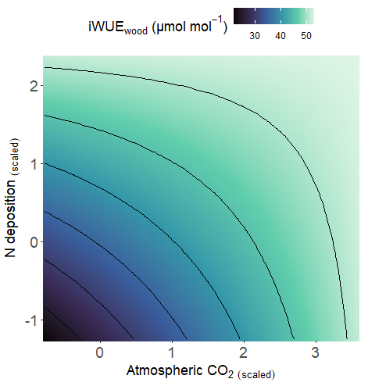

Fig. S3. Nature of the interaction between nitrogen (N) deposition and atmospheric CO₂ on the intrinsic water-use efficiency (iWUE) of European beech trees. Values for each environmental factor were scaled by dividing the centred original values by their standard deviations. The parameter estimates for the interaction are presented in Table 1.

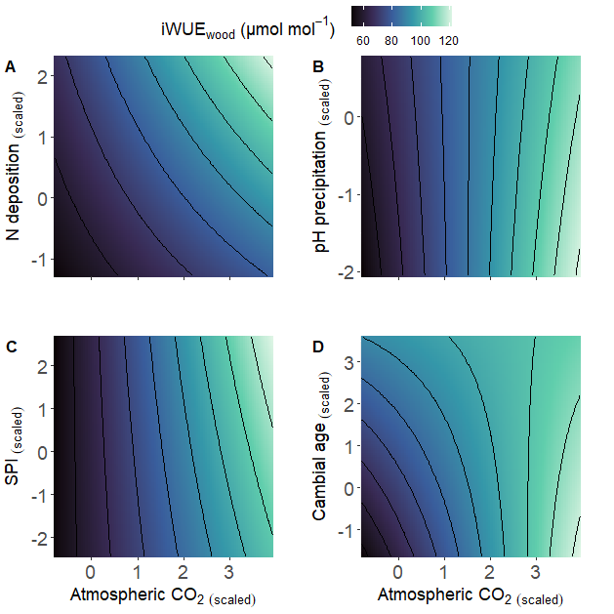

Fig. S4. Nature of the interactions between nitrogen (N) deposition and atmospheric CO₂ (A), precipitation pH and atmospheric CO₂ (B), June-August standardised precipitation index (SPI_{Jun-Aug}) and atmospheric CO₂ (C) and cambial age and atmospheric CO₂ (D) on intrinsic water-use efficiency (iWUE) in Norway spruce trees. Values for each environmental factor were scaled by dividing the centred original values by their standard deviations. The parameter estimates for the interaction are presented in Table 1.

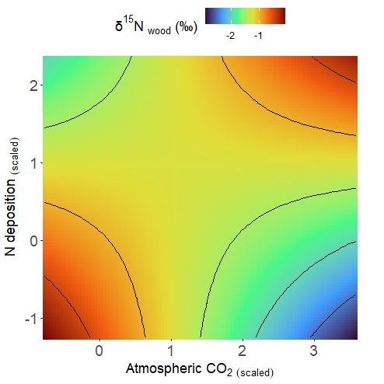

Fig. S5. Nature of the interaction between nitrogen (N) deposition and atmospheric CO₂ on δ¹⁵N_{wood} in European beech trees. Values for each environmental factor were scaled by dividing the centred original values by their standard deviations. Parameter estimates for the interaction are presented in Table 2.

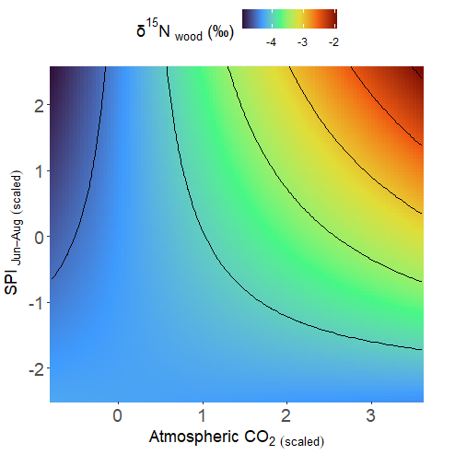

Fig. S6. Nature of the interaction between June-August standardised precipitation index (SPI_{Jun-Aug}) and atmospheric CO₂ on δ¹⁵N_{wood} in Norway spruce trees. Values for each environmental factor were scaled by dividing the centred original values by their standard deviations. Parameter estimates for the interaction are presented in Table 2.

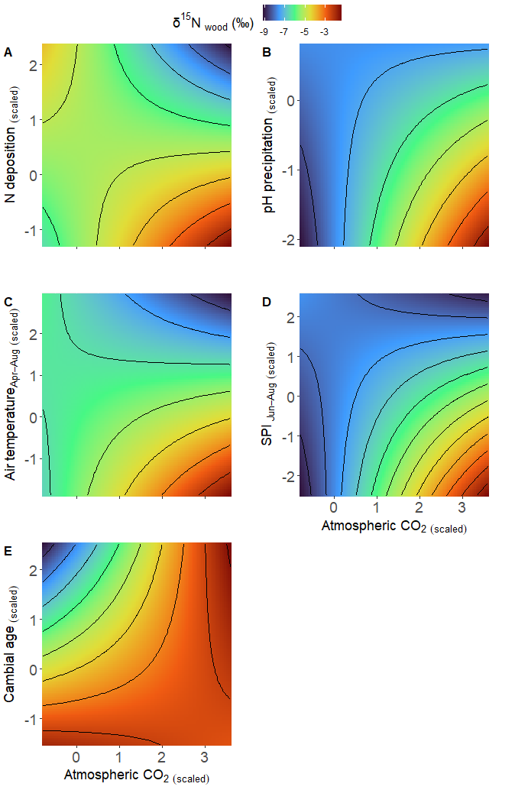
Fig. S7. Nature of the interactions between nitrogen (N) deposition and atmospheric CO₂ (A), precipitation pH and atmospheric CO₂ (B), April-August air temperature and atmospheric CO₂ (C), June-August standardised precipitation index (SPI_{Jun-Aug}) and atmospheric CO₂ (D), and cambial age and atmospheric CO₂ (E) on δ¹⁵N_{wood} in Silver fir. Values for each environmental factor were scaled by dividing the centred original values by their standard deviations. Parameter estimates for the interaction are presented in Table 2.

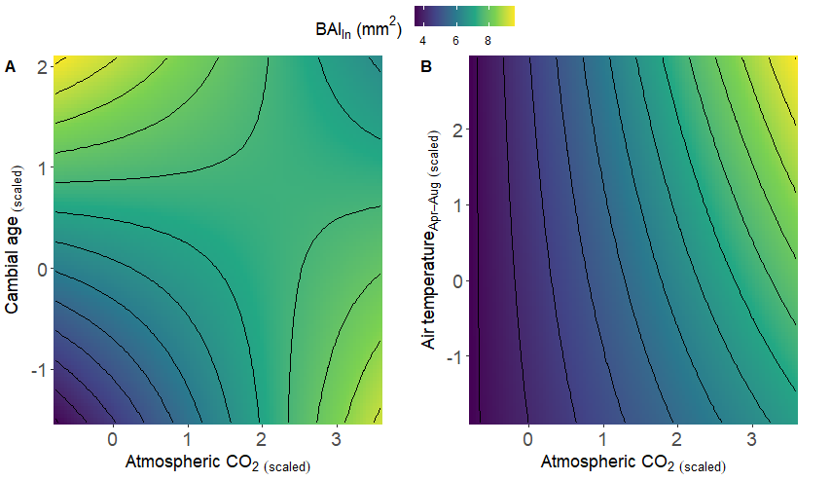
Fig. S8. Nature of the interactions between cambial age and atmospheric CO₂ (A), April-August air temperature and atmospheric CO₂ (B) on basal area increment (BAI) in European beech trees. The values for each environmental factor were scaled by dividing the centred original values by their standard deviations. Parameter estimates for the interaction are presented in Table 3.

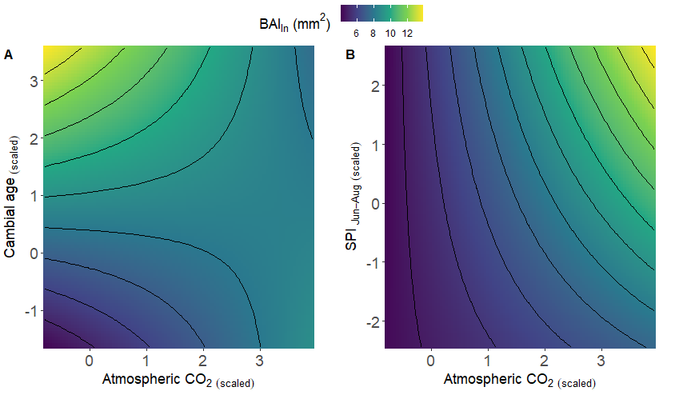
Fig. S9. Nature of the interactions between cambial age and atmospheric CO₂ (A), June-August standardised precipitation index (SPI_{Jun-Aug}) and atmospheric CO₂ (B) on basal area increment (BAI) in Norway spruce trees. The values for each environmental factor were scaled by dividing the centred original values by their standard deviations. The parameter estimates for the interaction are presented in Table 3.

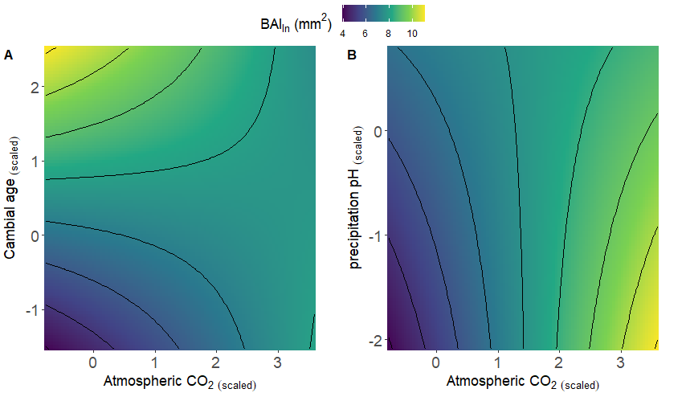
Fig. S10. Nature of the interactions between cambial age and atmospheric CO₂ (A), precipitation pH and atmospheric CO₂ (B) on basal area increment (BAI) in silver fir trees. The values for each environmental factor were scaled by dividing the centred original values by their standard deviations. The parameter estimates for the interaction are presented in Table 3.

