SUPPLEMENTARY INFORMATION

Facile Synthesis of new 7-morpholino-6-(Aryl-1,3,4-oxadiazol)-1,8-naphthyridines and, evaluation of Antimicrobial and molecular Docking studies
Kasaboina Kalyani Priya, Kavati Shireesha, and Kumara Swamy Jella*
Heterocyclic Chemistry Laboratory, Department of Chemistry, Chaitanya (Deemed to be University), Hyderabad, Telangana, India-500075
E -mail*: jkchem14@gmail.com

List of figures Page no

Fig. 1 ¹H NMR spectrum of compound 6a 2
Fig. 2 ¹³C NMR spectrum of compound 6a 2
Fig. 3 Mass spectrum of compound 6a 3
Fig. 4 ¹HNMR spectrum of compound 6b 3
Fig. 5 ¹³C NMR spectrum of compound 6b 4
Fig. 6 ¹H NMR spectrum of compound 6c 4
Fig. 7 ¹³C NMR spectrum of compound 6c 5
Fig. 8 Mass spectrum of compound 6c 5
Fig. 9 ¹H NMR spectrum of compound 6d 6
Fig. 10 ¹³C NMR spectrum of compound 6d 6
Fig. 11 ¹H NMR spectrum of compound 6e 7
Fig. 12 ¹³C NMR spectrum of compound 6e 7
Fig. 13 IR spectrum of compound 6f 8
Fig. 14 ¹H NMR spectrum of compound 6f 8
Fig. 15 IR spectrum of compound 6g 9
Fig. 16 ¹H NMR spectrum of compound 6g 9
5

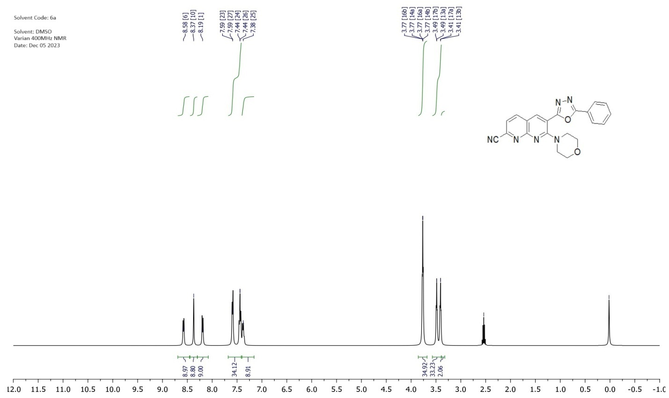
Fig. 1 ¹H NMR spectrum of compound 6a
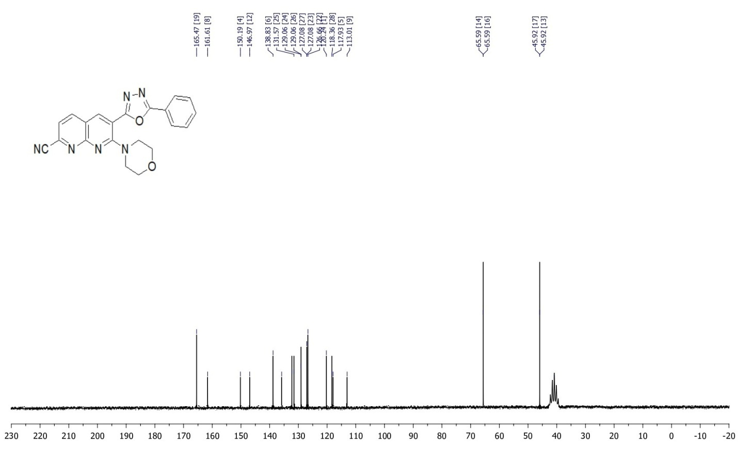
Fig. 2 ¹³C NMR spectrum of compound 6a
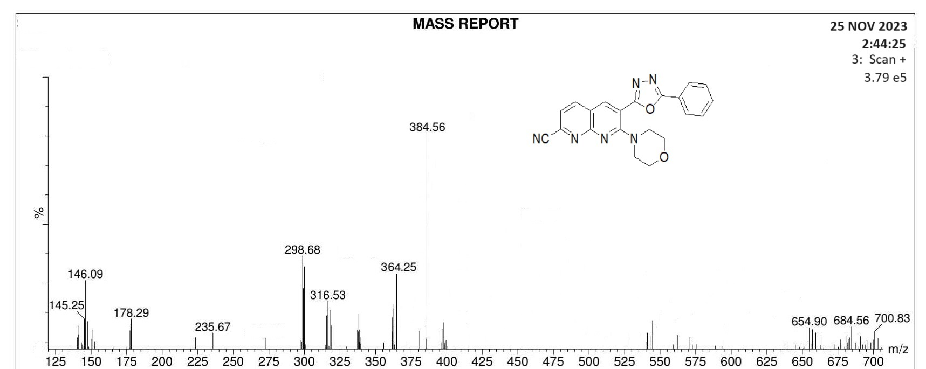
Fig. 3 Mass spectrum of compound 6a
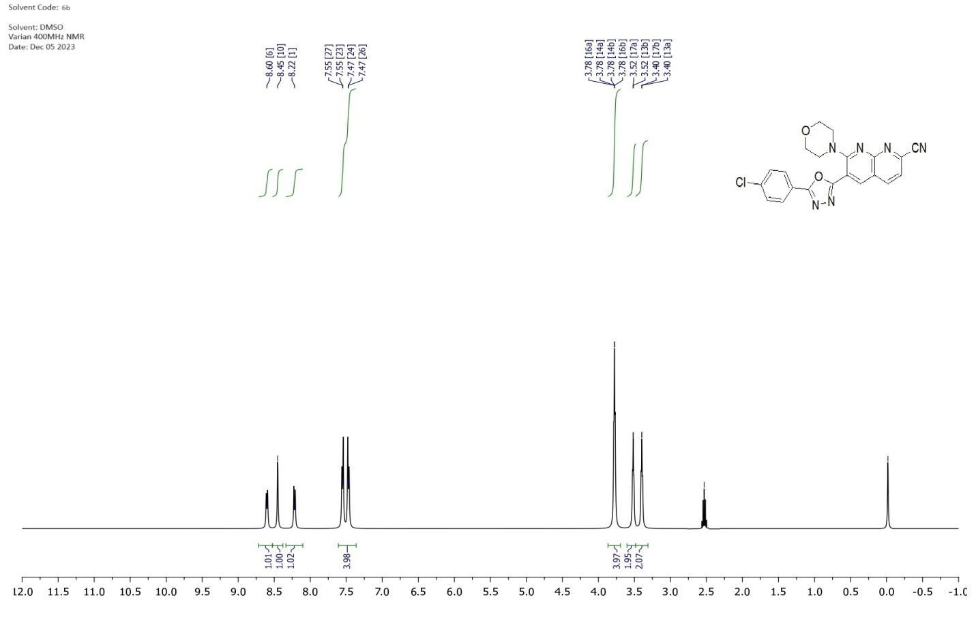
Fig. 4 ¹HNMR spectrum of compound 6b
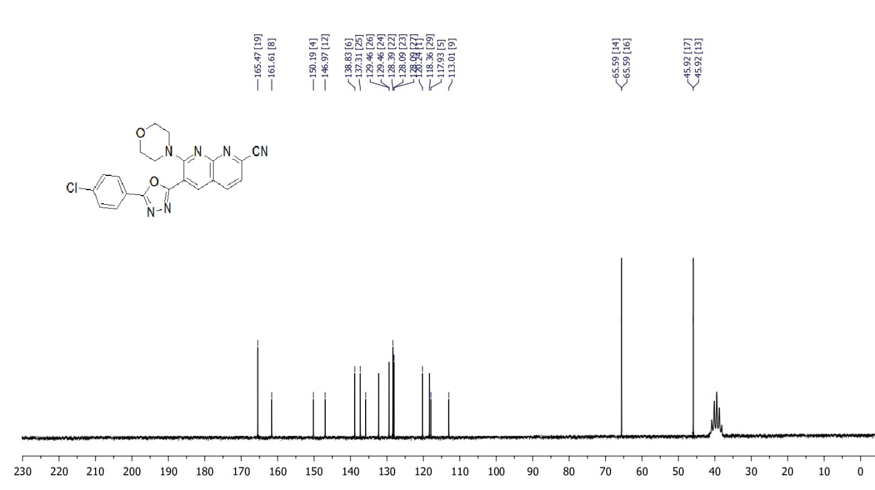
Fig. ¹³C NMR spectrum of compound 6b
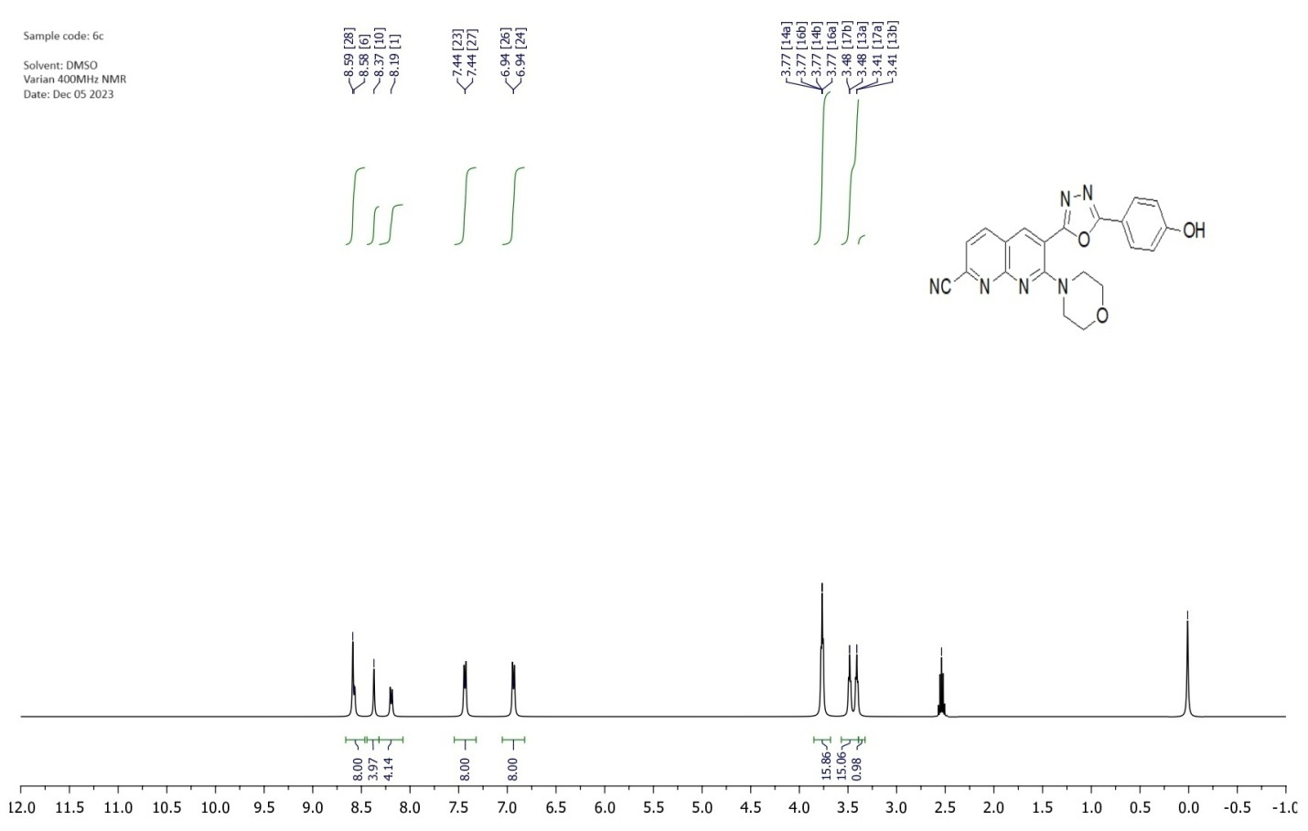
Fig. 6 ¹H NMR spectrum of compound 6c
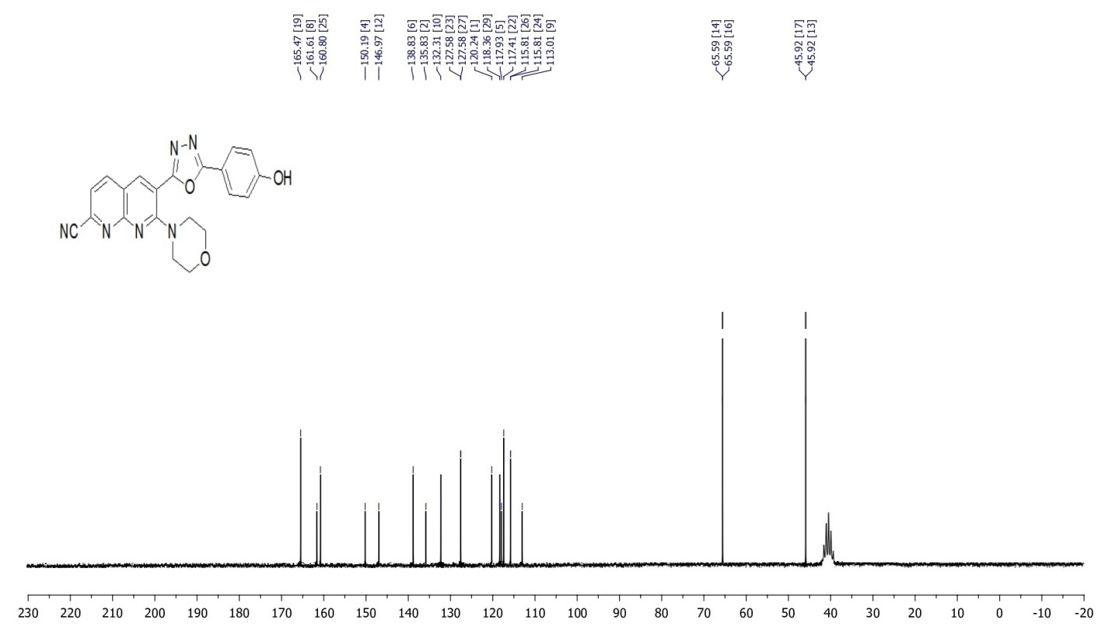
Fig. 7 ¹³C NMR spectrum of compound 6c

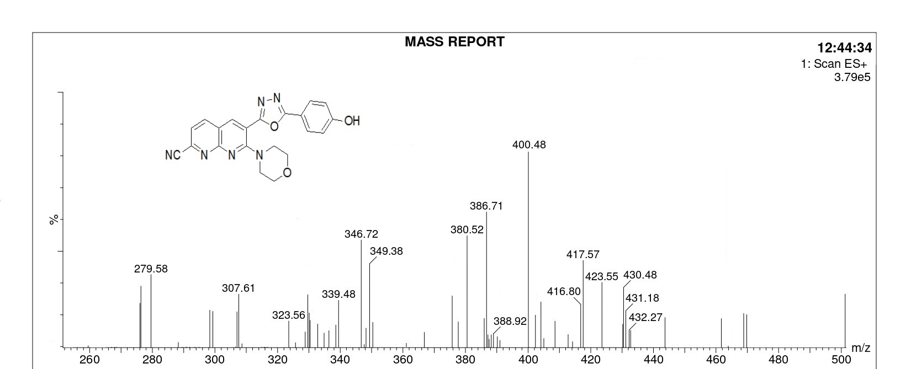
Fig. 8 Mass spectrum of compound 6c
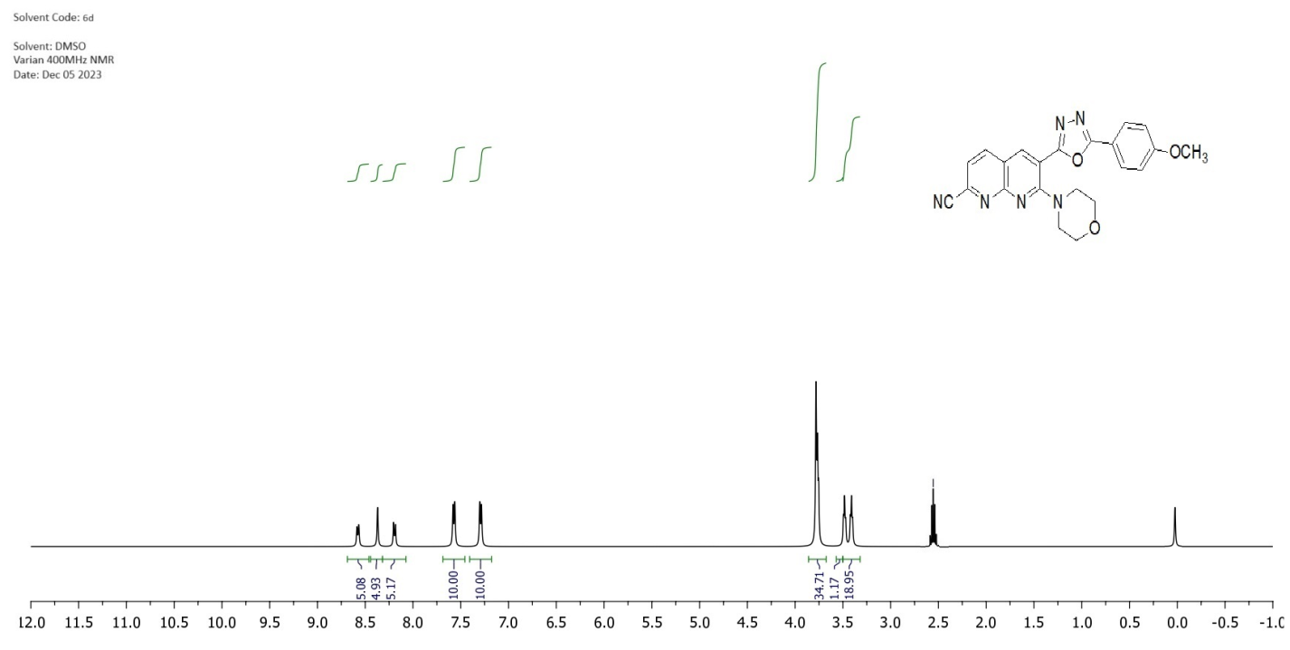
Fig. 9 ¹H NMR spectrum of compound 6d

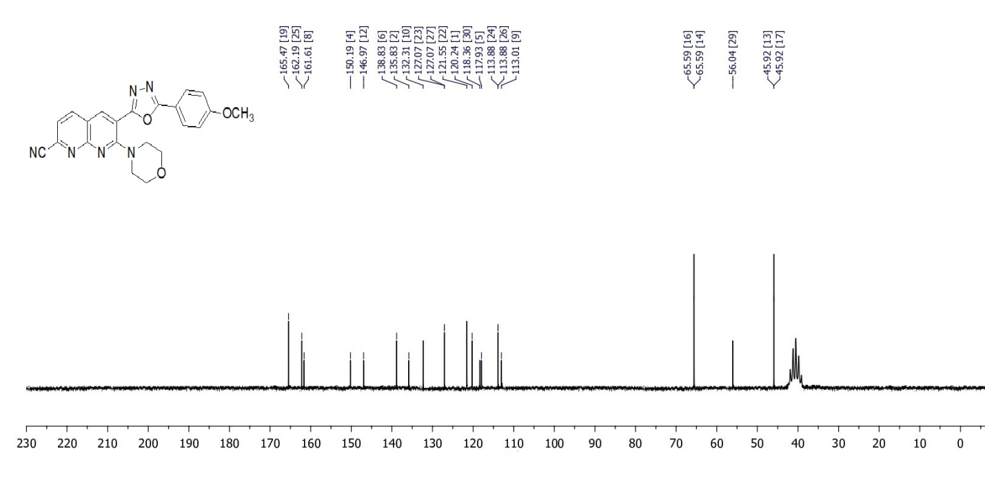
Fig. 10 ¹³C NMR spectrum of compound 6d
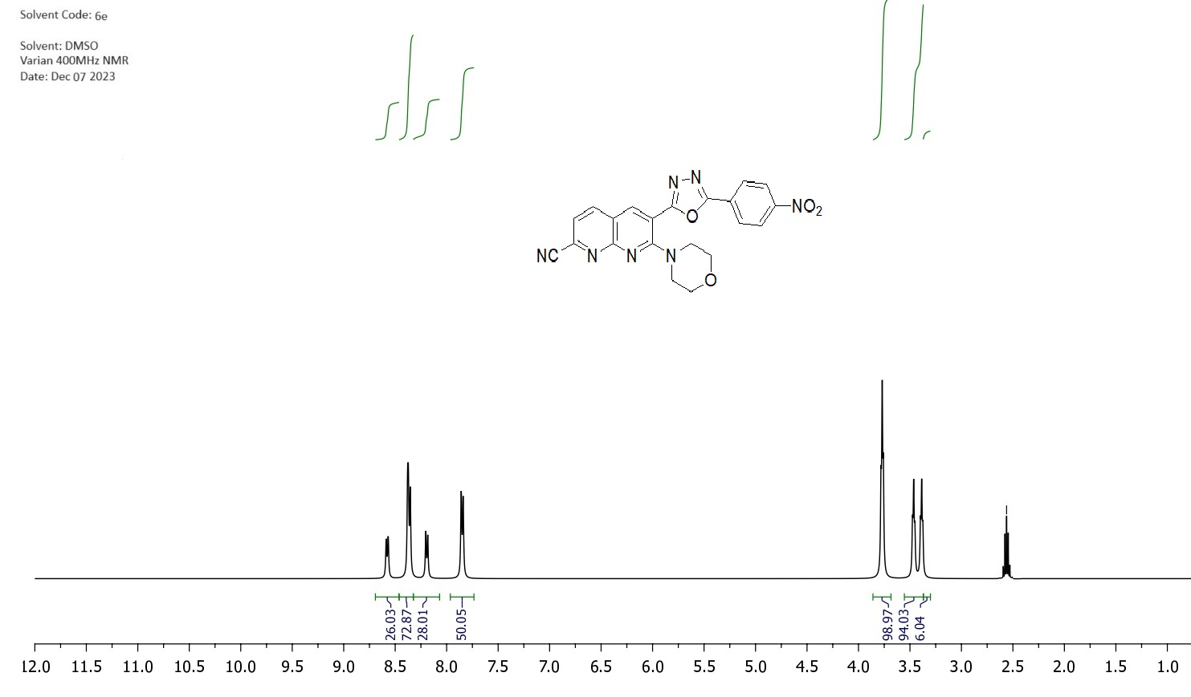
Fig. 11 ¹H NMR spectrum of compound 6e

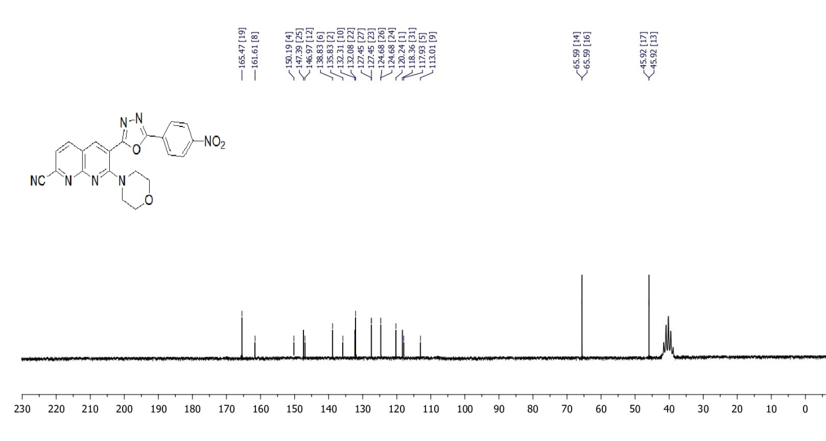
Fig. 12 ¹³C NMR spectrum of compound 6e

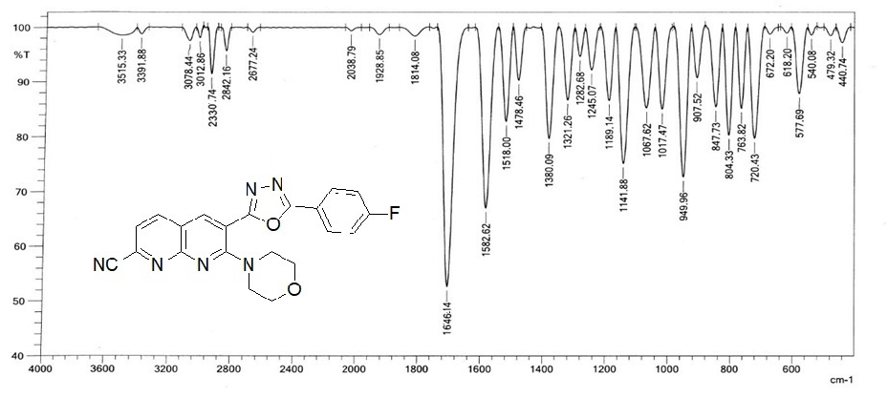
Fig. 13 IR spectrum of compound 6f
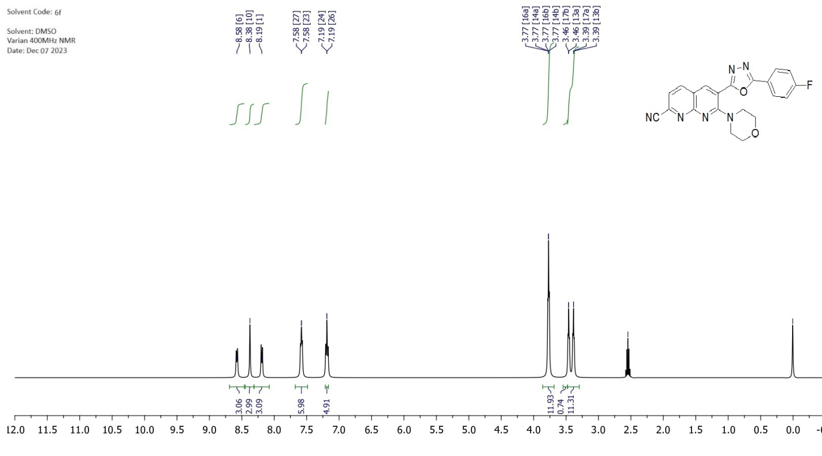
Fig. 14 ¹H NMR spectrum of compound 6f

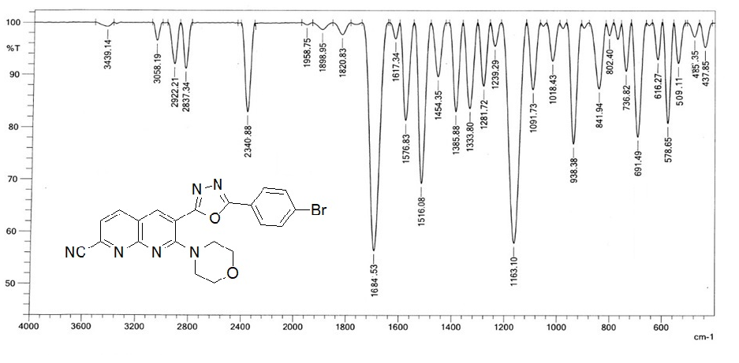
Fig. 15 IR spectrum of compound 6g

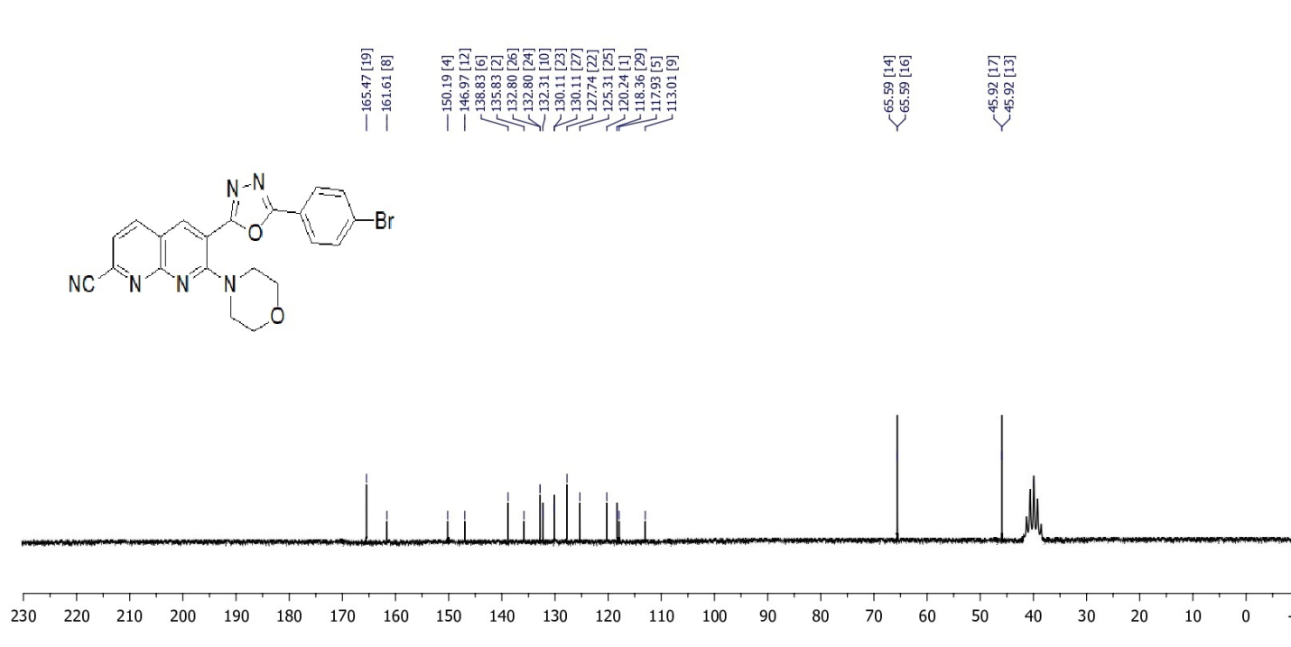
Fig. 16 ¹H NMR spectrum of compound 6g

