SUPPLEMENTARY INFORMATION
Table 1. One way repeated measures ANOVAs comparing purification steps (PI, dPI, wPI, cPI, fPI) for each type of measure (phage titre, x; particle concentration, y).
 | Degrees of freedom | Sum of squares | Mean square | F | P-value
Phage titre (x) measures
Total | 14 | 2.10²¹ | 1.10²⁰
Groups | 4 | 2.10²¹ | 4.10²⁰ | 71.12 | <0.0001
Replicates | 2 | 2.10¹⁹ | 8.10¹⁸ | 1.25 | 0.34
Error | 8 | 5.10¹⁹ | 6.10¹⁸
Particle concentration (y) measures
Total | 14 | 1.10²² | 9.10²⁰
Groups | 4 | 1.10²² | 3.10²¹ | 35.75 | <0.0001
Replicates | 2 | 2.10²⁰ | 1.10²⁰ | 1.31 | 0.32
Error | 8 | 7.10²⁰ | 8.10¹⁹
Homogeneity of variances demonstrated beforehand with Levene’s test (phage titre measures, p=0.29; particle concentration measures, p=0.26).

Table 2. In-process characterisation of purification replicate A by ILM and spot-test.
Particle  characterisation | Purification steps
Particle  characterisation | PI | dPI | wPI | cPI | fPI
ILM image | 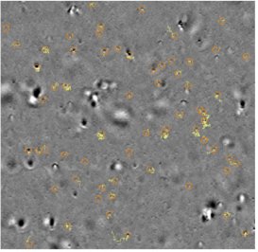 | 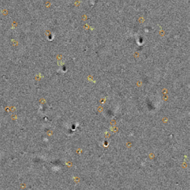 | 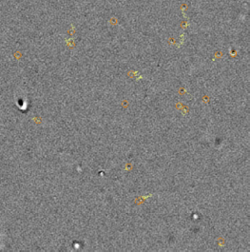 | 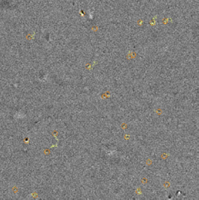 | 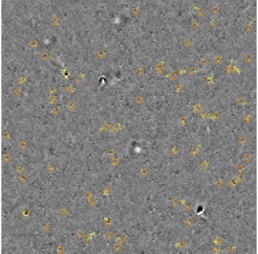
Phage titre^{ǂ}  (PFU/mL) | (2.7 ± 0.7) 10¹⁰ | (2.2 ± 0.3) 10⁹ | (9.3 ± 5.0) 10⁸ | (1.9 ± 0.8) 10⁹ | (1.5 ± 0.8) 10¹⁰
Particle concentration† (particles/mL) | (8.3 ± 0.1) 10¹⁰ | (5.4 ± 0.3) 10⁹ | (2.5 ± <0.1) 10⁹ | (3.4 ± <0.1) 10⁹ | (3.3 ± 0.2) 10¹⁰
Mean particle diameter† (nm) | (168 ± 4) | (169 ± 8) | (169 ± 1) | (169 ± 1) | (155 ± 1)
Size distribution diagram | 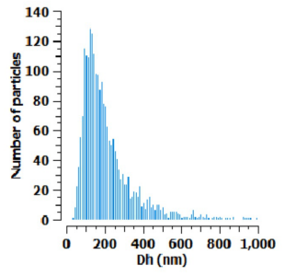 | 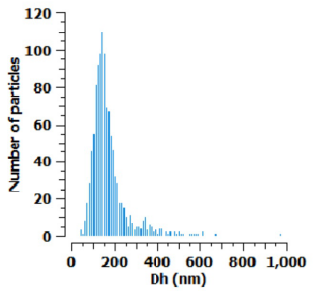 | 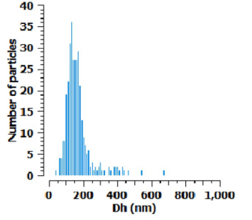 | 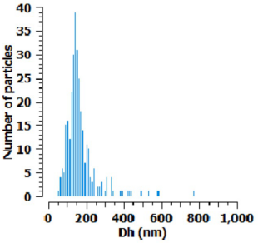 | 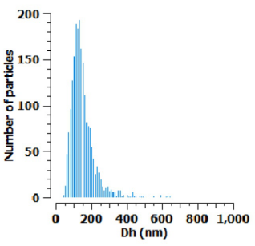
Each value is the (mean value ± sd) of 2 (†) to 3 (ǂ). ILM image and size distribution diagram were taken on undiluted samples while particle concentration and mean size were measured on samples diluted to fit the instrument specifications. The particle concentration displayed here is the detected value multiplied by the sample’s dilution factor. On the ILM images, the orange lines circle tracked particles and the yellow lines track the particle movement.

Table 3. In-process characterisation of purification replicate C by ILM and spot-test.
Particle  characterisation | Purification steps
Particle  characterisation | PI | dPI | wPI | cPI | fPI
ILM image | 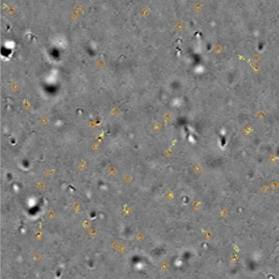 | 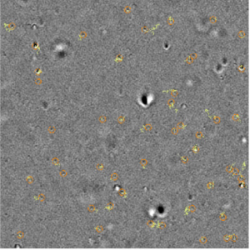 | 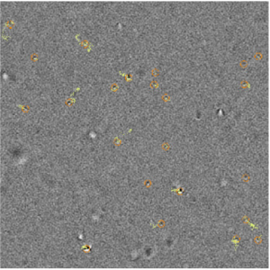 | 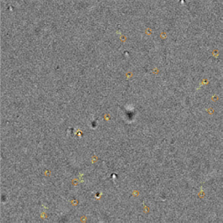 | 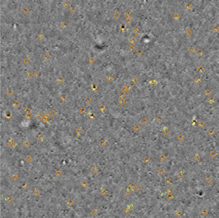
Phage titre^{ǂ}  (PFU/mL) | (3.0 ± 1.0) 10¹⁰ | (2.7 ± 0.4) 10⁹ | (1.5 ± 0.8) 10⁹ | (6.0 ± 2.0) 10⁸ | (2.3 ± 0.4) 10¹⁰
Particle concentration† (particles/mL) | (7.8 ± 0.8) 10¹⁰ | (1.0 ± <0.1) 10¹⁰ | (5.7 ± 0.2) 10⁹ | (4.9 ± 1.6) 10⁹ | (6.5 ± 1.1) 10¹⁰
Mean particle diameter† (nm) | (184 ± 1) | (174 ± 6) | (174 ± 11) | (157 ± 5) | (155 ± 4)
Size distribution diagram | 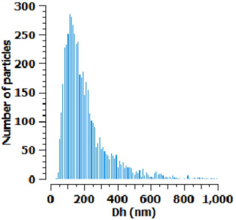 | 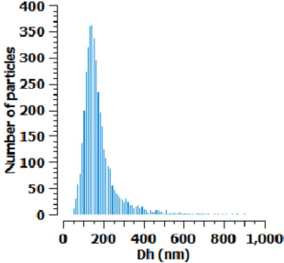 | 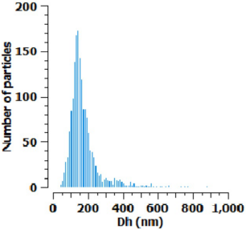 | 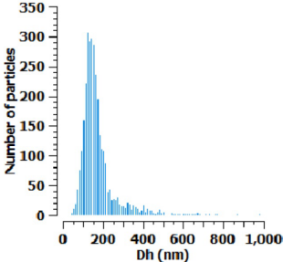 | 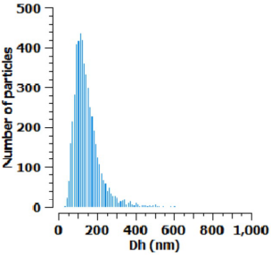
Each value is the (mean value ± sd) of 2 (†) to 3 (ǂ). ILM image and size distribution diagram were taken on undiluted samples while particle concentration and mean size were measured on samples diluted to fit the instrument specifications. The particle concentration displayed here is the detected value multiplied by the sample’s dilution factor. On the ILM images, the orange lines circle tracked particles and the yellow lines track the particle movement.

