Supplementary materials

Supplementary Table 1. MRI acquisition protocol
N (subjects) | 186
Scanners | 3T GE Signa PET/MR (GE Healthcare, Waukesha, Wisconsin, USA)
T1 sequence | SPGR
FOV | 256 × 256 mm²
Slice thickness | 1 mm, no gap
Slice number | 192
TR/TE/TI/FA | 6.9 ms/ 2.98 ms/ 450 ms/ 12°
Voxel size | 1 × 1 × 1 mm³
rs-fMRI sequence | EPI
FOV | 224 × 224 mm²
Slice thickness | 4 mm, gap = 1 mm
Slice number | 28
Slice order | Interleaved
TR/TE/FA | 2000 ms/ 30 ms/ 90°
GRAPPA | ----
Voxel size | 3.5 × 3.5 × 5 mm³
Volume number | 240
DTI sequence | DTI
FOV | 224 × 224 mm²
Data matrix | 112 × 112
Slice thickness | 2 mm, no gap
Slice number | 70
Slice order | interleaved
TR/TE | 16500 ms/ 95.6 ms
Gradient directions/b0 images | 30/ 5
Voxel size | 2 × 2 × 2 mm³
NOTE. SPGR, spoiled gradient-recalled echo; MP-RAGE, magnetization prepared - rapid gradient echo; FOV, field of view; TR, repetition time; TE, echo time; TI, inversion time; FA, flip angle; rs-fMRI, resting-state functional magnetic resonance imaging; EPI, Echo Planar Imaging; GRAPPA, GeneRalized Autocalibrating Partial Parallel Acquisition.

Supplementary Table 2. PET acquisition and reconstruction protocol

 | SILCODE
N (subjects) | 42 | 13
Scanner | GE Signa | GE Discovery PET/CT Elite
Tracer activity | 259-370 MBq | 5.55-7.4 MBq/ kg
Start emission [post injection] | 40 min | 50—70mins
Reconstruction algorithm | VPFXS | VPFXS
Iterations/ subsets | 8/32 | 5/18
Matrix | 192*192 | 192*192
In-plane pixel resolution | 1.82*1.82 mm | 1.56*1.56 mm
Slice number | 89 | 47
Slice thickness | 2.78 mm | 3.27 mm
Time frames | 1*35 min | 1*10 min

Supplementary Table 3. Regions of interest based on automated anatomical labeling (AAL) atlas

Regions | Abbreviations | Regions | Abbreviations
Precentral gyrus | PreCG | Cuneus | CUN
Superior frontal gyrus, dorsolateral | SFGdor | Lingual gyrus | LING
Superior frontal gyrus, orbital part | ORBsup | Superior occipital gyrus | SOG
Middle frontal gyrus | MFG | Middle occipital gyrus | MOG
Middle frontal gyrus, orbital part | ORBmid | Inferior occipital gyrus | IOG
Inferior frontal gyrus, triangular part | IFGoperc | Fusiform gyrus | FFG
Inferior frontal gyrus, triangular part | IFGtriang | Postcentral gyrus | PoCG
Inferior frontal gyrus, orbital part | ORBinf | Superior parietal gyrus | SPG
Rolandic operculum | ROL | Inferior parietal, but supramarginal and angular gyri | IPL
Supplementary motor area | SMA | Supramarginal gyrus | SMG
Olfactory cortex | OLF | Angular gyrus | ANG
Superior frontal gyrus, medial | SFGmed | Precuneus | PCUN
Superior frontal gyrus, medial orbital | ORBsupmed | Paracentral lobule | PCL
Gyrus rectus | REC | Heschl gyrus | HES
Insula | INS | Superior temporal gyrus | STG
Anterior cingulate and paracingulate gyri | ACG | Temporal pole: superior temporal gyrus | TPOsup
Median cingulate and paracingulate gyri | DCG | Middle temporal gyrus | MTG
Posterior cingulate gyrus | PCG | Temporal pole: middle temporal gyrus | TPOmid
Parahippocampal gyrus | PHG | Inferior temporal gyrus | ITG
Calcarine fissure and surrounding cortex | CAL

Supplementary Table 4. Differences in the network-level topological properties between NC and SCD based on different network-forming thresholds

 |  | Network-level Property
 |  | $$E_{glob}$$ | $$E_{local}$$ | Gamma | Lambda | Sigma
Functional networks | Pearson correlation threshold = 0.1 | 2.440 | 1.876 | -1.699 | -0.140 | -1.102
Functional networks | Pearson correlation threshold = 0.2 | 2.440 | 1.707 | -2.038 | -0.193 | -1.823
Functional networks | Pearson correlation threshold = 0.22 | 2.441 | 1.568 | -2.136 | -0.150 | -2.038
Functional networks | Pearson correlation threshold = 0.3 | 2.439 | 1.467 | -2.042 | 0.132 | -2.082
Functional networks | Pearson correlation threshold = 0.4 | 2.448 | 1.505 | -1.750 | 1.077 | -1.826
Structural networks | Fiber numbers threshold = 1 | -0.301 | -0.403 | -0.356 | -1.193 | -0.041
Structural networks | Fiber numbers threshold = 2 | -0.303 | -0.407 | -0.015 | -0.980 | -0.245
Structural networks | Fiber numbers threshold = 3 | -0.303 | -0.392 | 0.011 | -0.944 | 0.258
Structural networks | Fiber numbers threshold = 4 | -0.306 | -0.376 | 0.158 | -1.195 | 0.507
Structural networks | Fiber numbers threshold = 5 | -0.308 | -0.349 | 0.152 | -1.141 | 0.469

NOTE. The reproducibility of the network construction was examined using a range of network-forming thresholds. Network forming thresholds refer to the threshold for defining a significant weighted edge between a node pair. Comparisons between the NC and SCD groups were performed by using generalized linear regression models accounting for age, sex, years of education, and ApoE genotype. Results are presented as T values. None of the results exceeds the threshold of Bonferroni-corrected p < 0.05. Results in Bold are reported in the main text.
NC, normal controls; SCD, subjective cognitive decline; $E_{glob}$, global efficiency; $E_{gloc}$, local efficiency.

Supplementary Table 5. Differences in the node-level topological properties between NC and SCD based on different network-forming thresholds

 |  | Regional efficiency
 |  | OLF.L | INS.R |  | ACG.L | ACG.R |  | DCG.L
Functional networks | Pearson correlation threshold = 0.1 | 3.459(*) | 3.061(*) |  | 3.532(*) | 3.580(*) |  | /
Functional networks | Pearson correlation threshold = 0.2 | 3.456(*) | 3.069(*) |  | 3.553(*) | 3.599(*) |  | 3.013(*)
Functional networks | Pearson correlation threshold = 0.22 | 3.441(*) | 3.067(*) |  | 3.552(*) | 3.616(*) |  | 3.055(*)
Functional networks | Pearson correlation threshold = 0.3 | 3.401(*) | 3.044(*) |  | 3.682(*) | 3.707(*) |  | 3.201(*)
Functional networks | Pearson correlation threshold = 0.4 | 3.204(*) | 3.088(*) |  | 3.557(*) | 3.482(*) |  | 3.232(*)
 |  | Regional betweenness
 |  | SFGmed.R |  | ACG.L |  |  | DCG.L
Structural networks | Fiber numbers threshold = 1 | / |  | 3.366(*) |  |  | 3.510(*)
Structural networks | Fiber numbers threshold = 2 | / |  | 3.274(*) |  |  | 3.431(*)
Structural networks | Fiber numbers threshold = 3 | -3.161(*) |  | 3.202(*) |  |  | 3.384(*)
Structural networks | Fiber numbers threshold = 4 | -3.309(*) |  | / |  |  | 3.608(*)
Structural networks | Fiber numbers threshold = 5 | / |  | / |  |  | /

NOTE. The reproducibility of the network construction was examined using a range of network-forming thresholds. Network forming thresholds refer to the threshold for defining a significant weighted edge between a node pair. Comparisons between the NC and SCD groups were performed by using generalized linear regression models accounting for age, sex, years of education, and ApoE genotype. Results are presented as T values (* represents FDR-corrected p < 0.05). Results in Bold are reported in the main text.
NC, normal controls; SCD, subjective cognitive decline; L, Left; R, Right; OLF, Olfactory cortex; INS, Insula; ACG, anterior cingulate and paracingulate gyrus, DCG, Medial cingulate and paracingulate gyri; SFGmed, Superior frontal gyrus, medial.
Supplementary Table 6. Demographic and neuropsychological assessments

Characteristics |  | SCD (n = 55)
Age |  | 66.14 $±$ 4.33
Sex (M/F) |  | 16 / 40
Education |  | 12.61 $±$ 2.77
APOE $ε4$ (percentage) |  | 30.36%
A+ (percentage) |  | 7.3%
MMSE |  | 29.18$±$ 0.81
AVLT-N1-3 |  | 21.30$±$ 3.58
AVLT-N4 |  | 7.57$±$ 2.03
AVLT-N5 |  | 7.52$±$ 2.09
AVLT-reco |  | 22.34$±$ 1.69
NOTE. Data were presented as mean $±$ std. M, male; F, female; SCD, Subjective cognitive decline; MMSE, Mini-Mental State Examination; AVLT, Auditory Verbal Learning Test, which contains four subscores, including the sum of the first three learning trials (N1-3), the 5 min short-term recall (N4), the 20 min long-term recall (N5), and the recognition (reco).

Supplementary Table 7. Associations between node-level topological properties and behavioral scores in the combined sample with SCD and NC groups

 | Region | Behavioral scores
 | Region | AVLT-N1-3 | AVLT-N4 | AVLT-N5 | AVLT-reco | SCD-domain | SCD-plus
fNE | OLF.L | 0.028 | 0.060 | 0.042 | 0.008 | 0.070 | 0.185
fNE | INS.R | -0.017 | -0.003 | -0.030 | 0.015 | 0.104 | 0.132
fNE | ACG.L | 0.072 | 0.018 | 0.031 | 0.064 | 0.024 | 0.126
fNE | ACG.R | 0.111 | 0.052 | 0.078 | 0.105 | 0.033 | 0.120
fNE | DCG.L | 0.031 | -0.010 | 0.009 | 0.107 | 0.145 | 0.171
sNB | SFGmed.R | 0.024 | -0.053 | -0.105 | -0.104 | -0.010 | -0.102
sNB | ACG.L | -0.067 | 0.052 | 0.039 | 0.055 | 0.204 * | 0.227 *
sNB | DCG.L | -0.069 | 0.071 | 0.047 | -0.001 | 0.162 | 0.162

NOTE. Pearson correlation analysis was performed, and results were presented as correlation coefficient (* represents Bonferroni-corrected p < 0.05).
AVLT, Auditory Verbal Learning Test, which contains four subscores, including the sum of first three learning trials (N1-3), the 5 min short-term recall (N4), the 20 min long-term recall (N5), and the recognition (reco); NC, Normal control; SCD, Subjective cognitive decline; L, Left; R, Right; OLF, Olfactory cortex; INS, Insula; ACG, anterior cingulate and paracingulate gyrus, DCG, Medial cingulate and paracingulate gyri; SFGmed, Superior frontal gyrus, medial.

Supplementary Table 8. The rank of thirty-nine regions according to the proportion of participants with the ROI-level amyloid positivity (total n = 55)

Region | Amyloid-positive percentage | Anatomical  division |  | Region | Amyloid-positive percentage | Anatomical  division |  | Region | Amyloid-positive percentage | Anatomical  division
FFG | 83.6% | 1 |  | STG | 14.6% | 3 |  | CUN | 7.3% | 4
ITG | 61.8% | 1 |  | PCG | 12.7% | 3 |  | PoCG | 7.3% | 4
MTG | 50.9% | 1 |  | CAL | 12.7% | 3 |  | SPG | 7.3% | 4
LING | 47.3% | 2 |  | ROL | 10.9% | 3 |  | IPL | 7.3% | 4
MOG | 45.5% | 2 |  | INS | 10.9% | 3 |  | PreCG | 5.5% | 4
IOG | 40.0% | 2 |  | PCUN | 10.9% | 3 |  | ORBmid | 5.5% | 4
SMG | 20.0% | 3 |  | ORBinf | 9.1% | 4 |  | ORBsupmed | 5.5% | 4
REC | 20.0% | 3 |  | ORBsup | 7.3% | 4 |  | PCL | 5.5% | 4
PHG | 18.2% | 3 |  | MFG | 7.3% | 4 |  | HES | 5.5% | 4
ACG | 18.2% | 3 |  | IFGoperc | 7.3% | 4 |  | TPOsup | 5.5% | 4
DCG | 16.4% | 3 |  | IFGtriang | 7.3% | 4 |  | TPOmid | 5.5% | 4
SOG | 14.6% | 3 |  | SMA | 7.3% | 4 |  | SFGdor | 3.6% | 4
ANG | 14.6% | 3 |  | OLF | 7.3% | 4 |  | SFGmed | 3.6% | 4

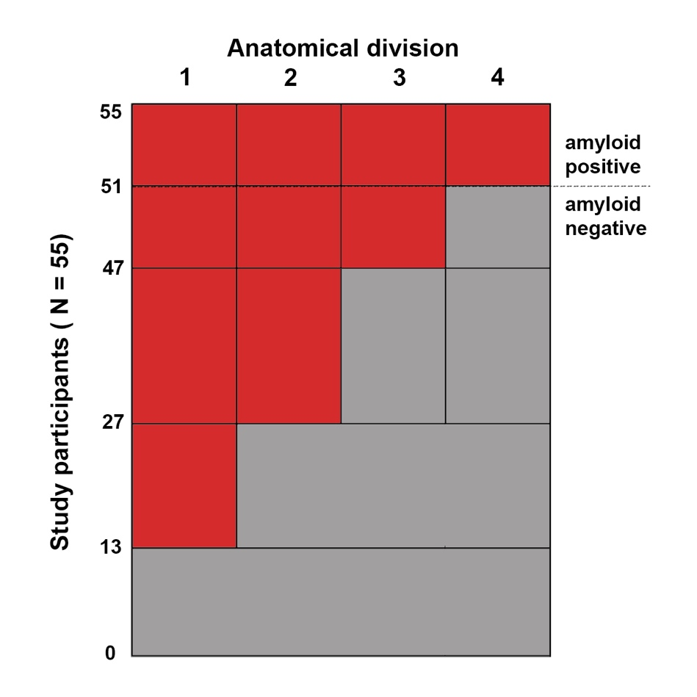
Figure S1. Each column corresponds to one of the four anatomic divisions (1–4), and each row corresponds to the number of participants in each stage. The absence or presence of amyloid is denoted by gray and red, respectively. Amyloid deposition in the four anatomic divisions shows a consistent hierarchical nesting across participants, allowing us to stage 100% of the participants with detectable regional amyloid deposits into one of the four amyloid stages predicted by the regional progression model.

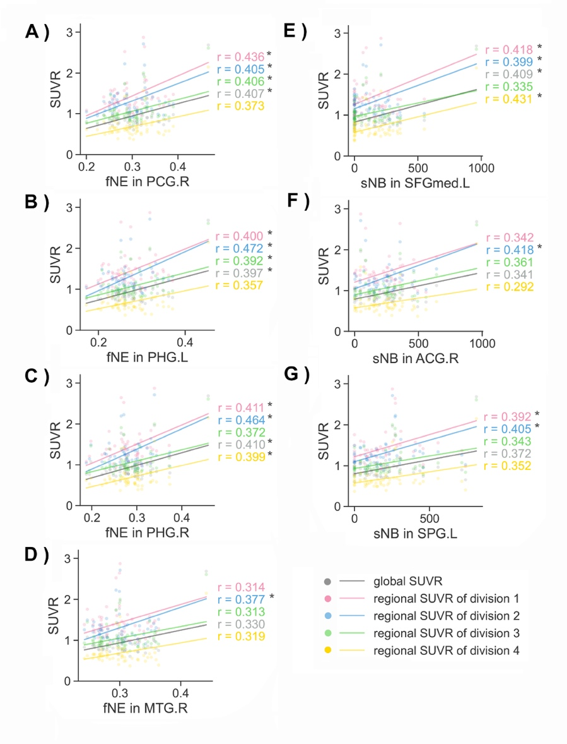
Figure S2. Pearson correlations between node-level topological properties and global SUVr and regional SUVr values of anatomical divisions 1-4. A-D: functional nodal efficiency (fNE); E-G: structural nodal betweenness (sNB). *: FDR-corrected p < 0.05. L, left; R, right; PCG, posterior cingulate gyrus; PHG, parahippocampal gyrus; SFGmed, superior medial frontal gyrus; ACG, anterior cingulate and paracingulate gyrus; SPG, superior parietal gyrus.

