SUPPLEMENTARY INFORMATION

Fully transparent flexible 2D molybdenum disulfide transistors
Yang Li^{1,2#}, Lejuan Cai^{1#}, Nan Cui^{1#}*, Xiaoru Li^{1,3#}, Tinghe Yun¹, Bohan Wei¹, Youchen Chen¹, Hua Yu¹, Zhenhe Zhao¹, Nianqing Fu⁴, Lede Xian¹, Qingqing Ke³, Wenlong Wang¹, Shusheng Pan²*, Guangyu Zhang¹* and Shenghuang Lin¹*
¹Songshan Lake Materials Laboratory, Dongguan, China.
²School of Physics and Materials Science, Guangzhou University, Guangzhou, China.
³School of Microelectronics Science and Technology, Sun Yat-sen University, Zhuhai, China.
⁴School of Materials Science and Engineering, South China University of Technology, Guangzhou, China.
#These authors contributed equally: Yang Li, Lejuan Cai, Nan Cui, Xiaoru Li.
*Corresponding author e-mail: cuinan@sslab.org.cn; sspan@gzhu.edu.cn; gyzhang@sslab.org.cn; linshenghuang@sslab.org.cn
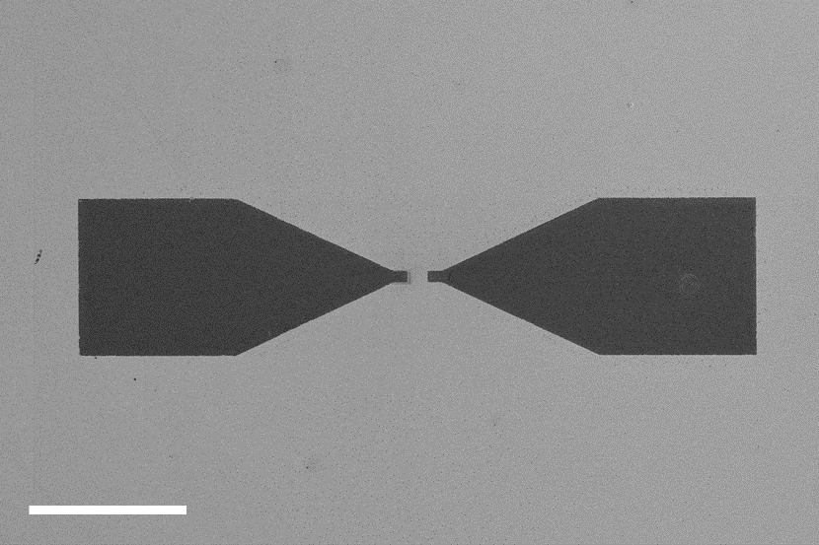
Supplementary Fig. S1 SEM image of PEDOT:PSS pattern fabricated by lithography. Scale bar, 200 µm.

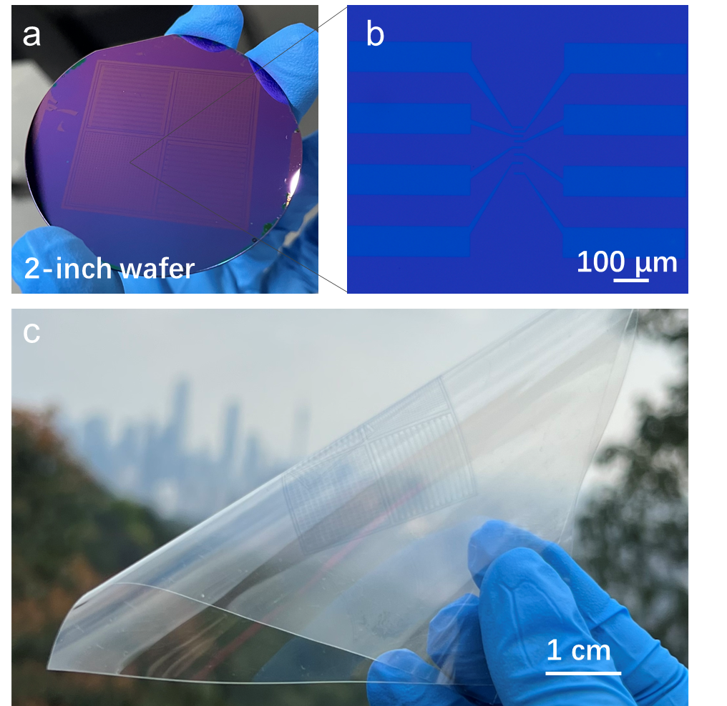
Supplementary Fig. S2 a, Optical image of PEDOT:PSS pattern on 2-inch SiO₂ wafer. b, Optical micrograph of PEDOT:PSS electrode on SiO₂. c, Optical image of PEDOT:PSS pattern transferred onto the flexible PET substrate.

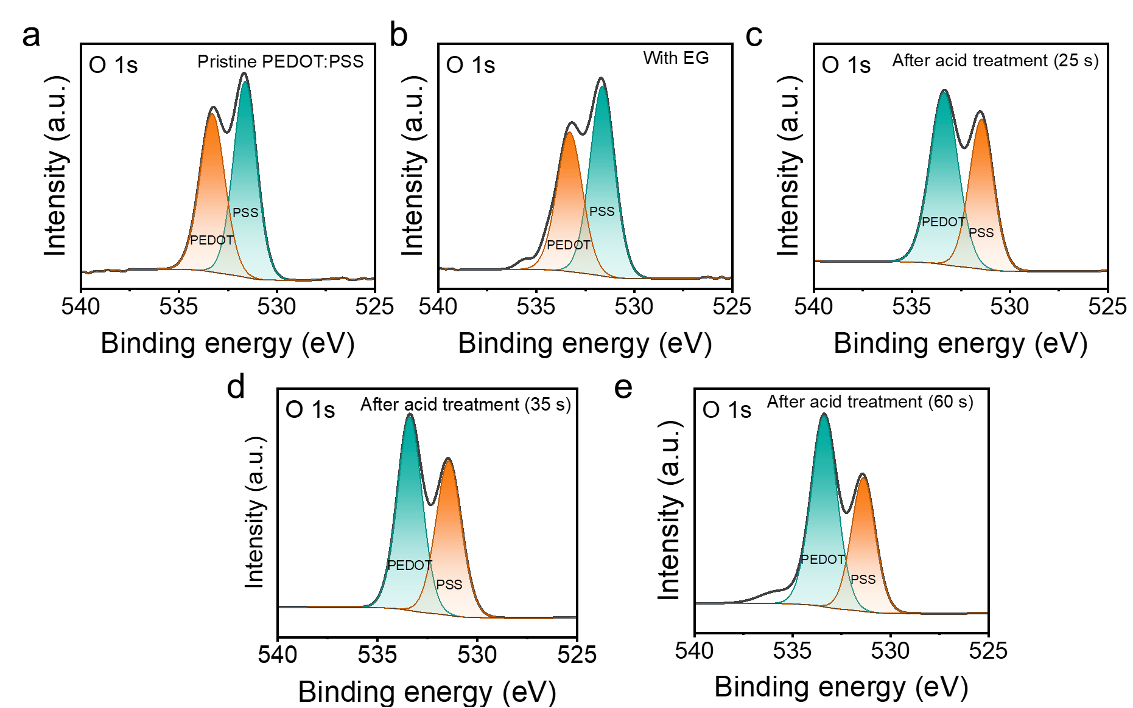
Supplementary Fig. S3 XPS for O 1s in PEDOT:PSS with different treatments. a, Pristine films. b, PEDOT:PS with the addition of EG. c-e, PEDOT:PS with acid treatments.

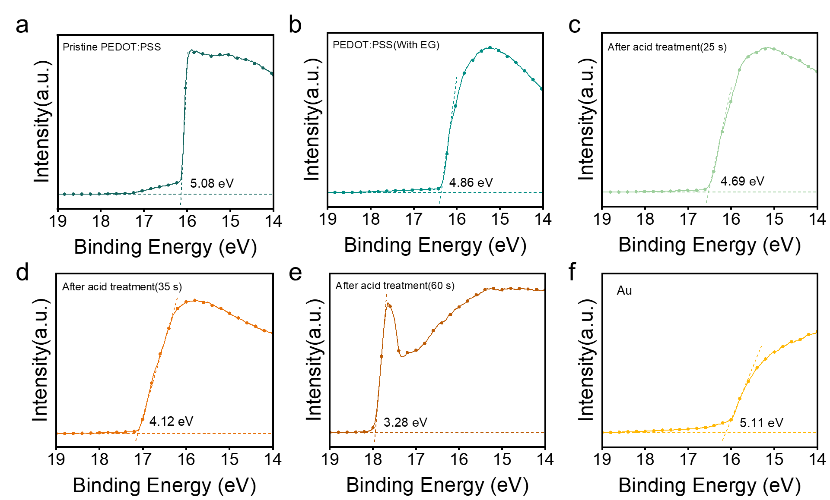
Supplementary Fig. S4 UPS analysis results. a-e, PEDOT:PSS with various treatments. f, Au electrode for calibration.

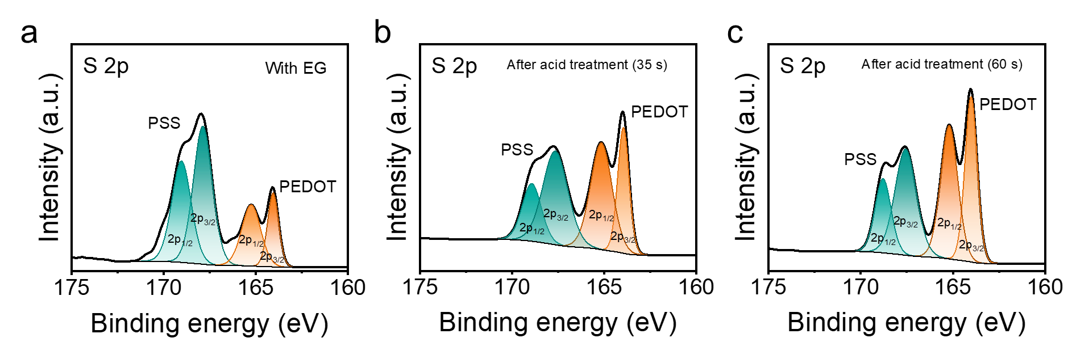
Supplementary Fig. S5 XPS for S 2P in PEDOT:PSS with different treatments. a, PEDOT:PSS with the addition of EG (Sample B). b,c, PEDOT:PSS with 35-s and 60-s acid treatments in in correspondence with Sample D and E.

The XPS in Fig. 1b and Fig. 1c correspond to Sample A and C.

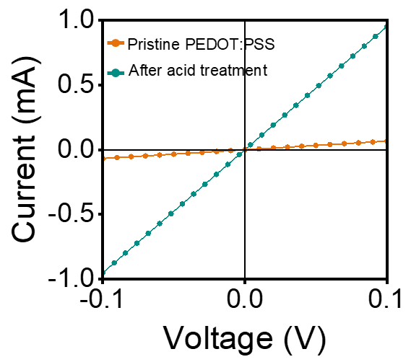
Supplementary Fig. S6 I-V curves of PEDOT:PSS w/o and with acid treatment.

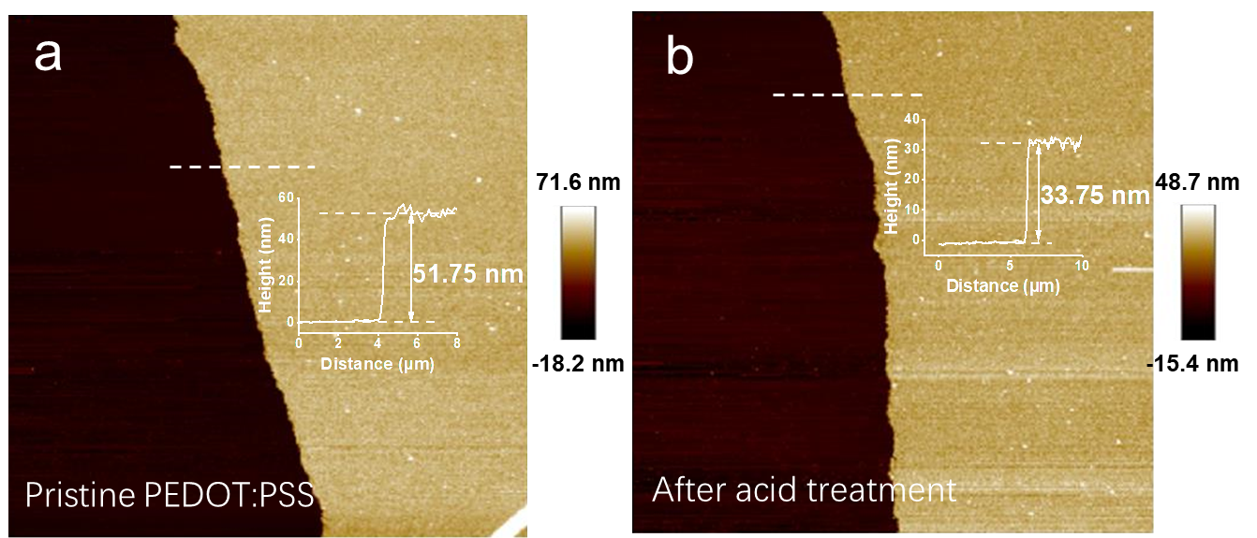
Supplementary Fig. S7 AFM images of the PEDOT:PSS. a, Pristine PEDOT:PSS. b, PEDOT:PSS with acid treatment. The insets show that the thickness of PEDOT:PSS w/o and with acid treatment are 51.75 nm and 33.75 nm, respectively.

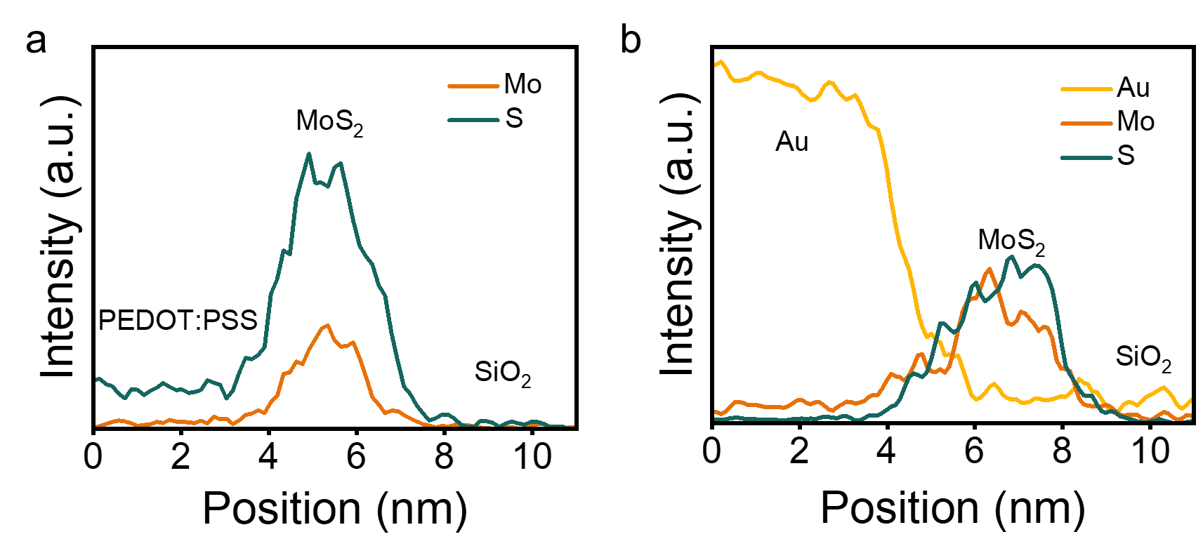
Supplementary Fig. S8 a, EDS line profiles for Mo and S signals in PEDOT:PSS/MoS₂, and b, Au, Mo, and S signals in Au/MoS₂ on SiO₂.

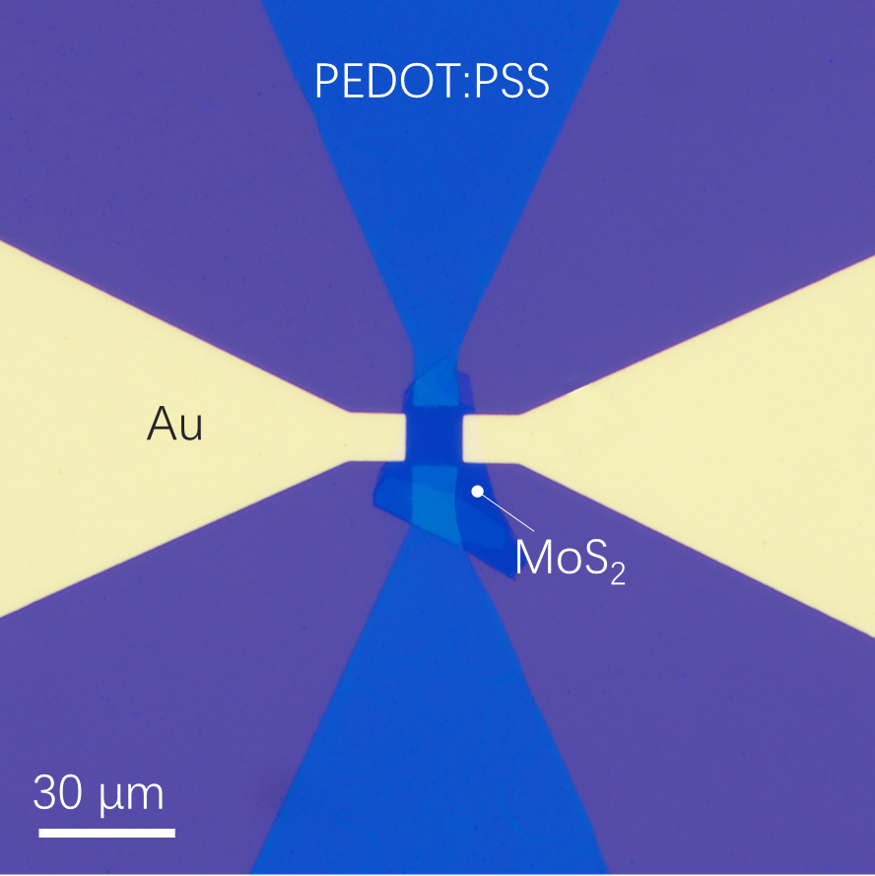
Supplementary Fig. S9 Optical micrograph of typical FETs with PEDOT:PSS and Au electrodes on identical MoS₂ flake.

Supplementary Table S1. Performance comparison of MoS₂ FETs based on PEDOT:PSS and Au electrode.
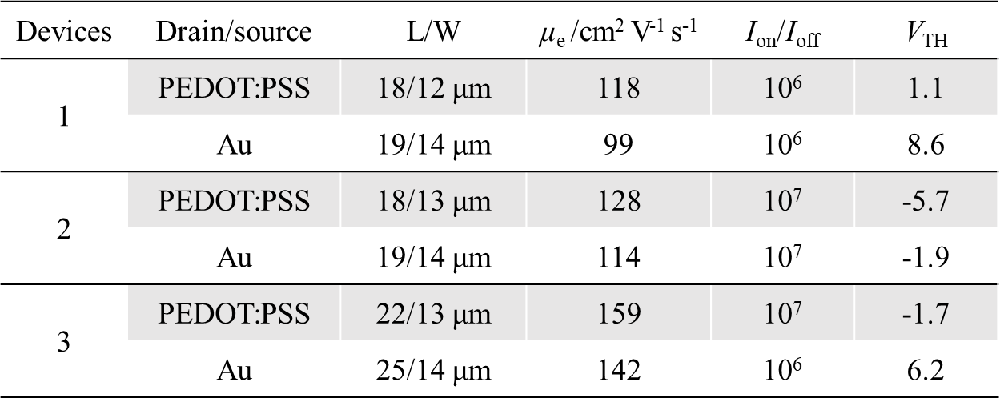
In MoS₂ transistors employing PEDOT:PSS as source/drain electrodes, the negative shift in threshold voltage (V_{TH}) primarily arises from the synergistic effects of optimized electrode-channel interfacial properties and electrode-induced n-type doping. First, acid treatment modulates the work function of PEDOT:PSS, reducing it from its intrinsic value to align closely with the conduction band minimum (CBM) of MoS₂. This significantly mitigates interfacial energy band misalignment, suppressing Fermi-level pinning effects and facilitating the transition from Schottky to Ohmic contacts. This process reduces electron injection barriers. However, interfacial band alignment alone cannot fully account for the V_{TH} shift, as it merely diminishes the gate voltage compensation required for barrier modulation. Even under near-ideal work function matching, chemical interactions between the electrode material and MoS₂ introduce additional doping effects. Second, acidic components in PEDOT:PSS (e.g., sulfonic acid groups) react with sulfur vacancies in MoS₂ at the interface, releasing protons (H⁺) to passivate defect states and inducing charge transfer. The sulfur vacancies capture H⁺ to form localized positive charge centers, whose electrostatic effects substantially increase the electron concentration in the MoS₂ conduction band. This is equivalent to a donor doping mechanism, shifting the Fermi level of MoS₂ toward its CBM and directly reducing the gate voltage required to activate the channel.^{[1-4]}

Supplementary S10. Mobility calculation.
The carrier mobility based on a three-terminal FET can be extracted from the transfer curve of the device. Based on the linear region of the transfer characteristic and device structure, the field-effect carrier mobility $μ_{e}$ can be calculated as:
$$μ_{e}=g_{m}×\frac{L}{W}×\frac{1}{C_{ox}}$$
Here L and W are the channel length and width, respectively. C_{ox} is the gate capacitance per unit area ($C_{ox}$= 11 nF/cm² for 300 nm-SiO₂), and $g_{m}$ is the transconductance, which can be extracted from the transfer curve as:
$$g_{m}=\frac{{dI}_{D}}{{dV}_{D}}$$

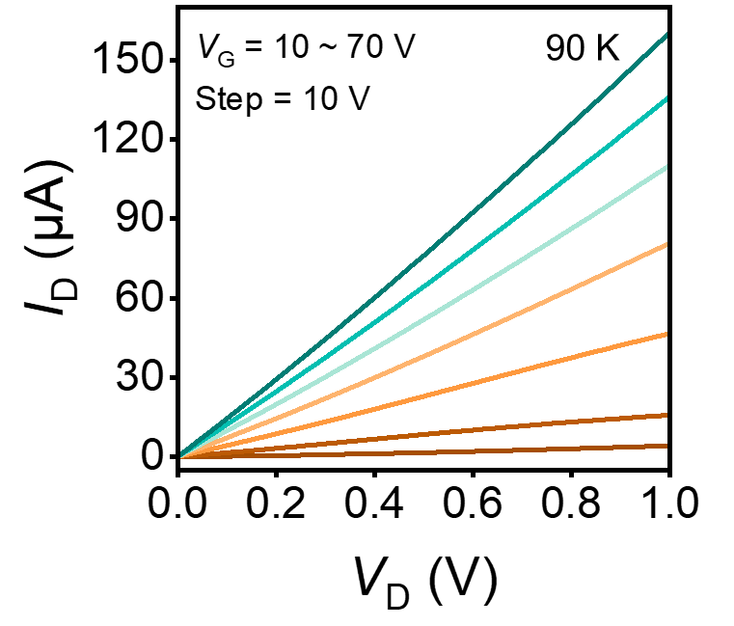
Supplementary Fig. S11 Output characteristics of the PEDOT:PSS/MoS₂ FET at the low temperature of 90 K.

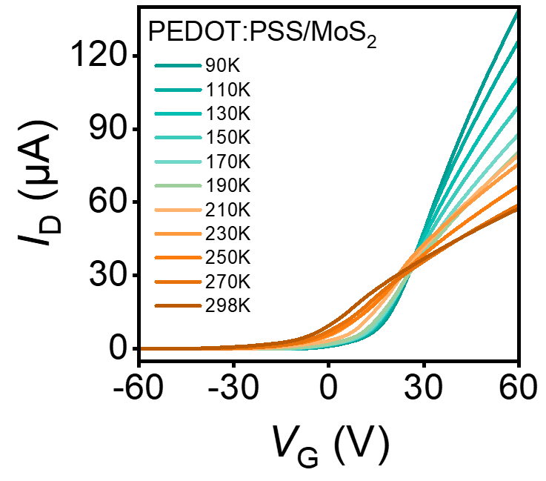
Supplementary Fig. S12 Transfer curves of MoS₂ FET based on PEDOT:PSS electrode at different temperatures.

In van der Waals transfer-fabricated PEDOT:PSS/MoS₂ field-effect transistors (FETs), although Ohmic characteristics with low contact resistance are achieved through interfacial energy-level alignment, the nonlinearity of I_{D}-V_{G} curves under high gate voltages remains predominantly governed by the carrier transport mechanisms within the channel. When the gate voltage increases substantially, the lateral electric field in the channel exceeds a critical threshold, triggering the carrier velocity saturation effect: under strong electric fields, the electron drift velocity becomes limited by intrinsic phonon scattering within the material, causing the drain current growth rate to transition from linear to sublinear. Concurrently, the enhanced vertical electric field confines carriers near the channel interface, intensifying interface roughness scattering and surface phonon scattering, which markedly reduces the effective mobility and further disrupts current-voltage linearity. ^{[5-7]}
Additionally, self-heating effects and carrier concentration modulation under high bias jointly exacerbate nonlinearity. Joule heating elevates the channel temperature, establishing a negative feedback loop through enhanced phonon scattering and temperature-dependent mobility degradation, thereby aggravating current saturation tendencies. As demonstrated in low-temperature measurements (T < 100 K), where phonon scattering is suppressed, the I_{D}-V_{G} linearity of MoS₂ FETs shows significant improvement, confirming the dominant role of thermal phonon scattering.^{[8]}

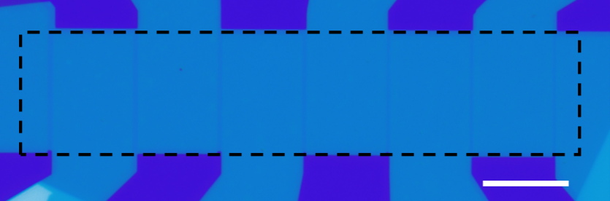
Supplementary Fig. S13 Optical microscope image of MoS₂ FETs based on PEDOT:PSS electrodes at various channel lengths (L). Scale bar, 20 µm.

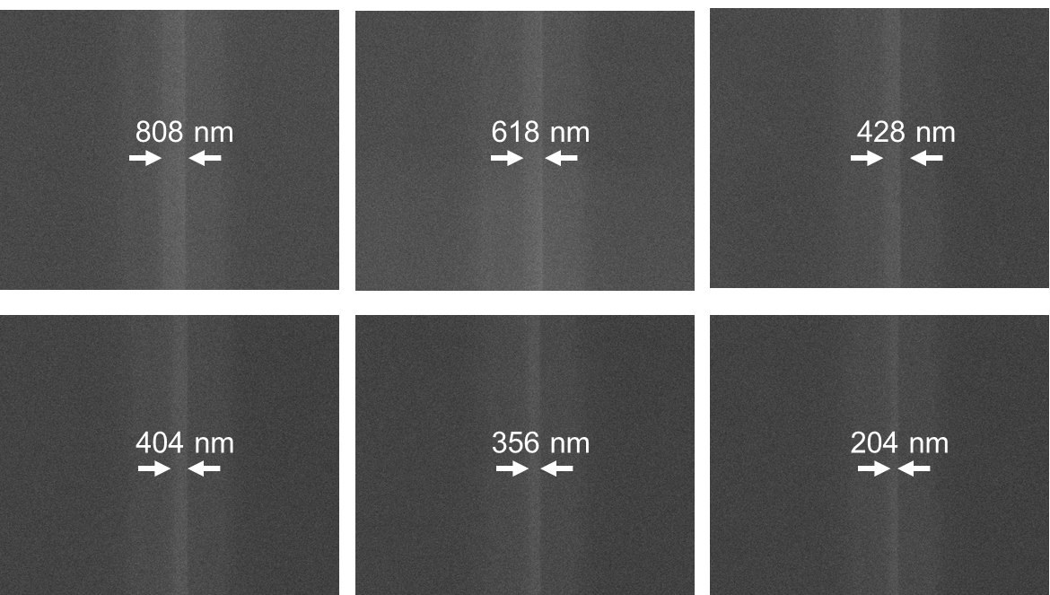
Supplementary Fig. S14 SEM images of the transferred PEDOT:PSS electrodes for TLM measurements.

Supplementary Fig. S15 Output characteristic curves for the PEDOT:PSS/MoS₂ device with channel length of 860 nm.

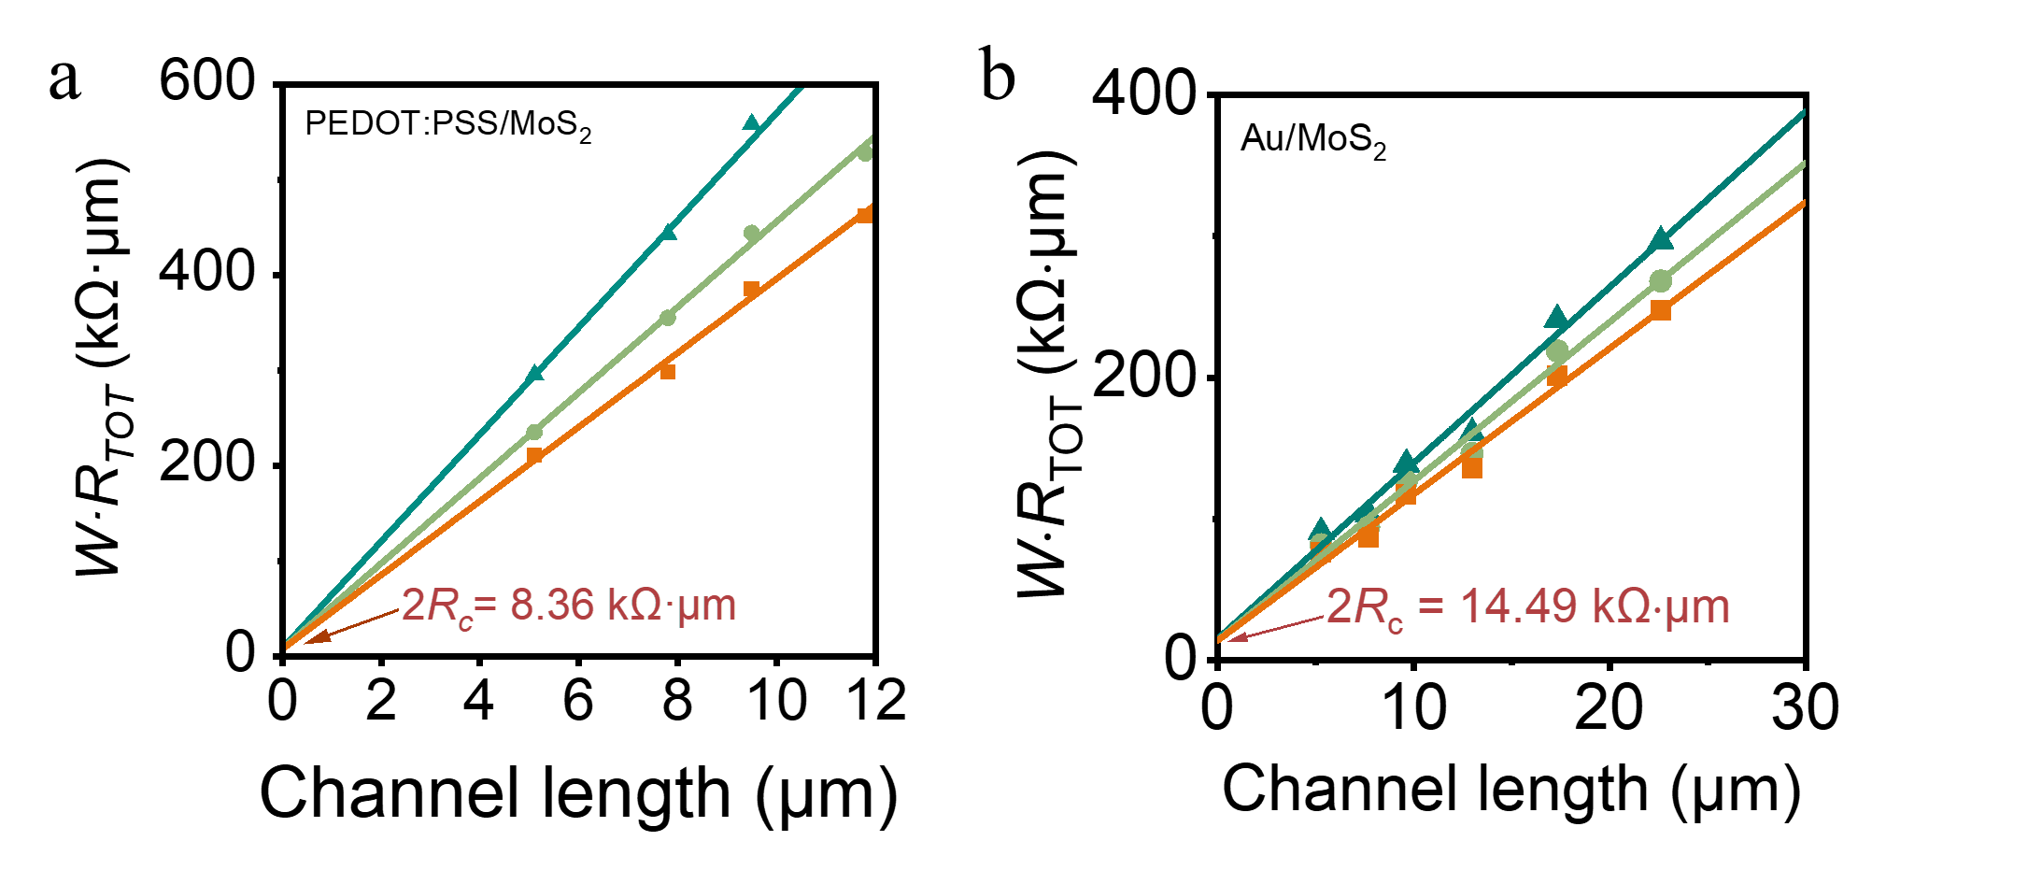
Supplementary Fig. S16 W×R_{TOT} versus channel lengths for MoS₂ devices with transferred (a) PEDOT:PSS and (b) Au contacts.

Supplementary Fig. S17 Histogram distributions of field-effect mobility (µ_{e}) of MoS₂ FETs with PEDOT:PSS electrodes.

Supplementary Table S2. Comparison of the typical characteristics in the reported MoS₂ FETs.^{[9-31]}
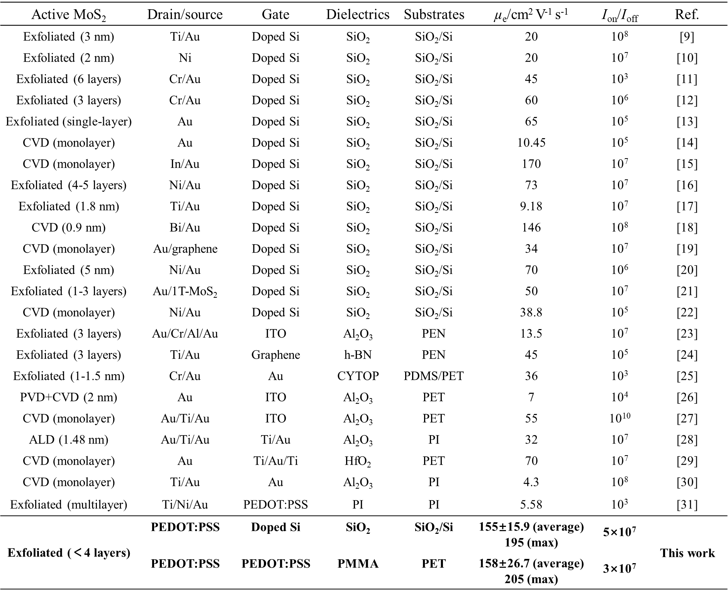

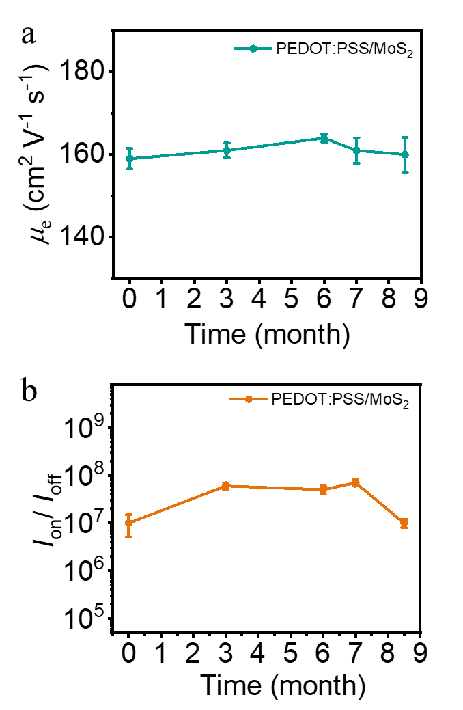
Supplementary Fig. S18 a,b, Mobility (µ_{e}) and current on-off ratio (I_{on}/I_{off}) in PEDOT:PSS/MoS₂ FETs as a function of storage time in the atmosphere.

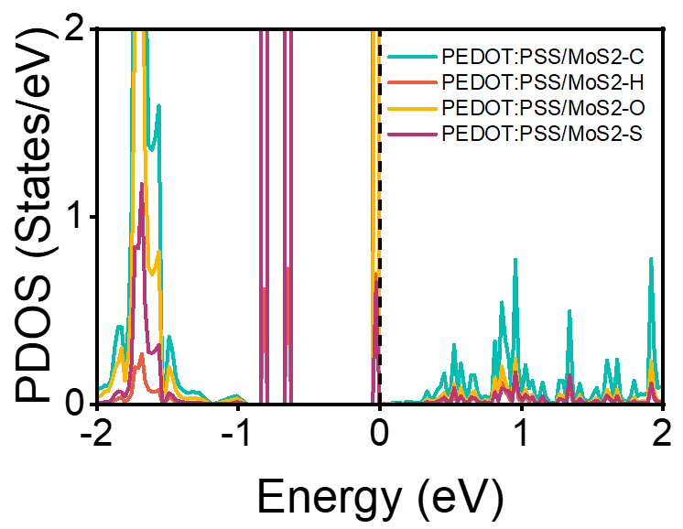
Supplementary Fig. S18 PDOS of PEDOT:PSS.

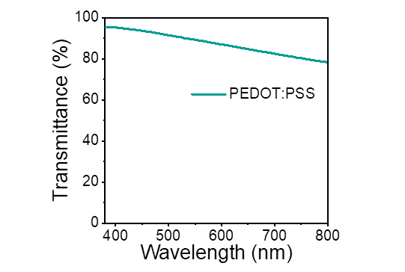
Supplementary Fig. S20 Transmittance spectra of PEDOT:PSS electrode with the average transmittance of 87.4%.

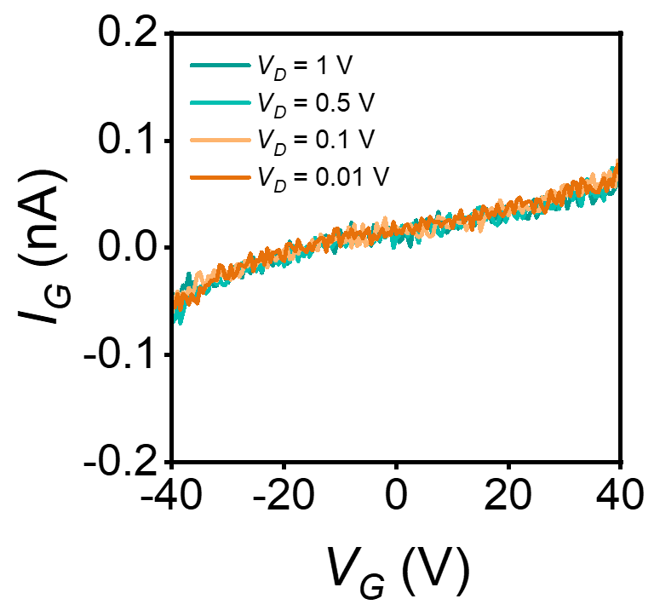
Supplementary Fig. S21 I_{G}-V_{G} curves for transparent flexible 2D FET at various V_{D}.

Supplementary Table S3. Performance statistics of the transparent flexible MoS₂ FETs based on PEDOT:PSS electrodes with the L/W of 20/13 μm.
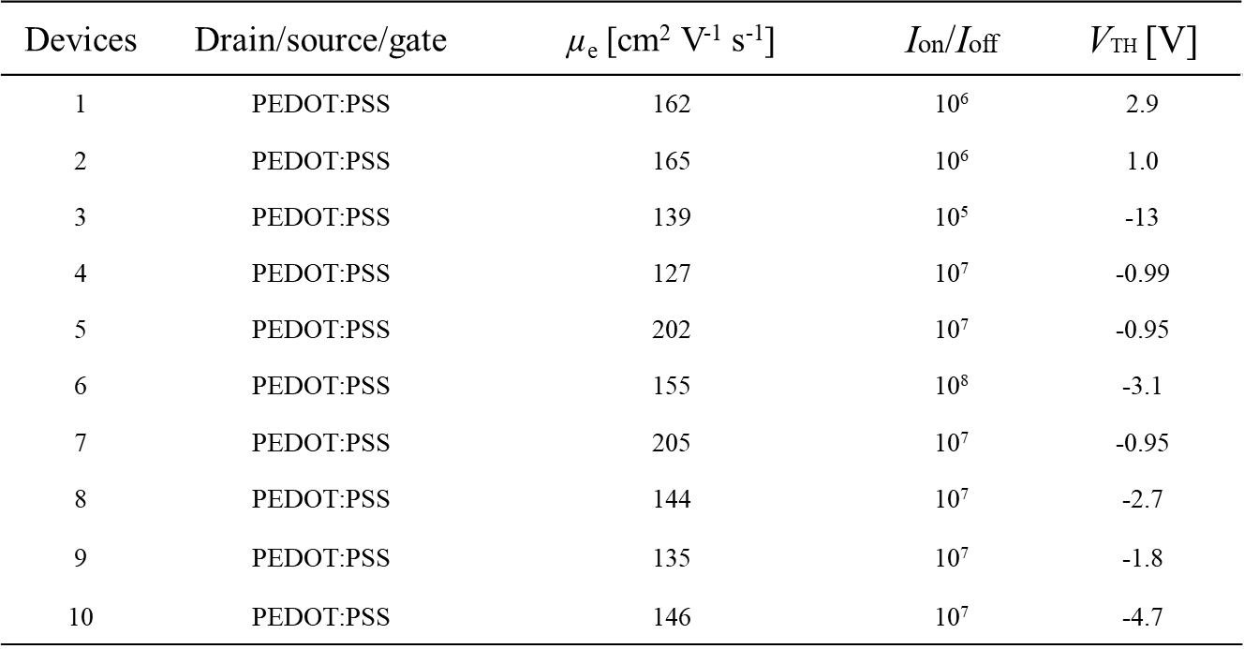

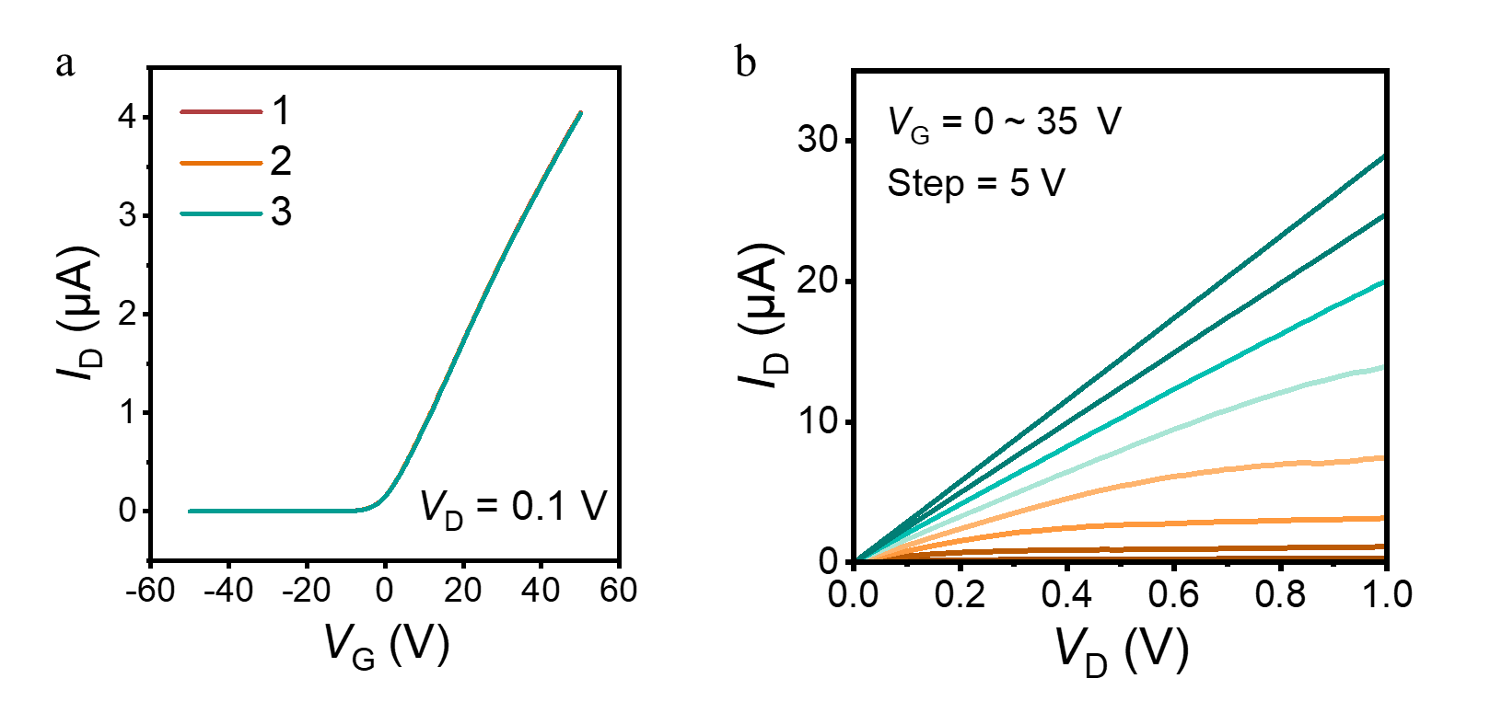
Supplementary Fig. S22 a, Multiple transfer curves at V_{D} = 0.1 V for the transparent flexible MoS₂ FET based on PEDOT:PSS electrodes with the maximum mobility value of 205 cm² V⁻¹ s⁻¹. L/W = 20/13 μm. b, Output characteristics of the MoS₂ FET with V_{G} from 0 to 35 V in 5 V steps.

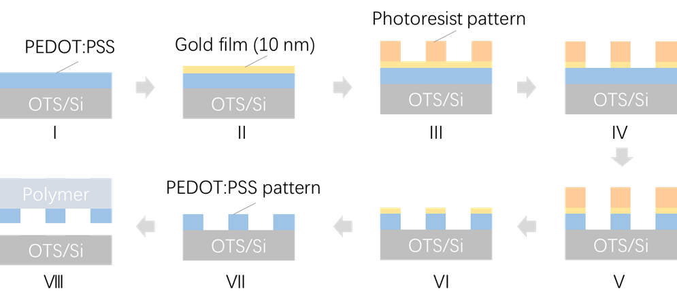
Supplementary Fig. S23 Fabrication process for lithographic PEDOT:PSS electrode.

Fabrication Details
Supplementary Fig. S23 illustrates the fabrication process of the lithographic PEDOT:PSS electrode. Initially, an aqueous solution of PEDOT:PSS (Clevios PH1000), mixed with ethylene glycol and a surfactant, is spin-coated onto a substrate modified with OTS (Step Ⅰ). Nitric acid is then used to selectively remove portions of the PSS component from the PEDOT:PSS film, with the extent of removal controlled by varying the immersion time. This acid treatment enhances both the stability in aqueous solution and the conductivity of the PEDOT:PSS film. Subsequently, a 10-nm-thick gold film is deposited on the PEDOT:PSS film to serve as a protective layer during the lithography process (Step Ⅱ). Traditional lithography is performed on the gold film, rather than directly on the PEDOT:PSS film, to obtain a photoresist pattern on the gold layer (Step Ⅲ). A metal etchant is employed to selectively etch away the gold film that is not covered by the photoresist pattern (Step Ⅳ). The PEDOT:PSS microelectrode pattern is defined using lithography, followed by etching the exposed areas with oxygen plasma (Step Ⅴ). The residual photoresist is then removed using acetone (Step Ⅵ). The gold film on the PEDOT:PSS pattern is subsequently etched away using a metal etchant, resulting in the final PEDOT:PSS electrode pattern on the OTS-modified substrate (Step Ⅶ). Finally, the transparent PEDOT:PSS electrode can be transferred onto the target substrate with the aid of an organic polymer (Step Ⅷ).
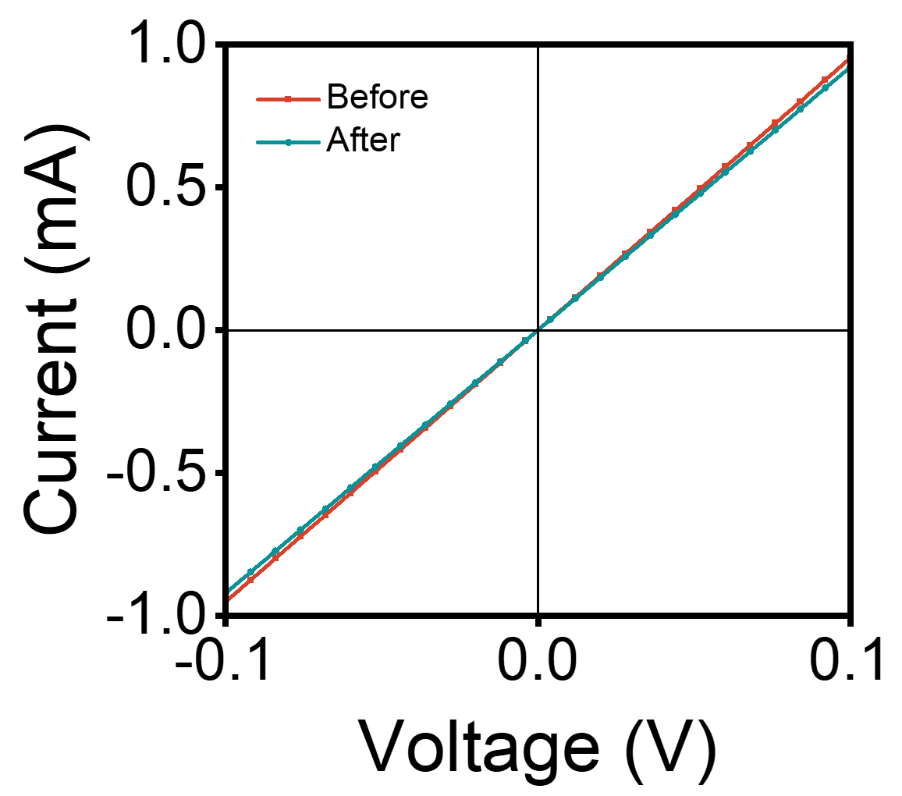
Supplementary Fig. S24 I-V curves for PEDOT:PSS electrode before and after lithography process.

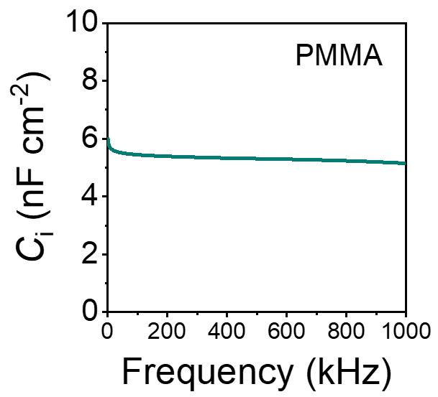
Supplementary Fig. S25 C_{i}-f curves for PMMA dielectric. The C_{i} measured at 1kHz is 6 nF cm⁻².

References
1. Kang, M. et al. Tunable Doping Strategy for Few-Layer MoS₂ Field-Effect Transistors via NH₃ Plasma Treatment. ACS Appl. Mater. Interfaces 16, 43849-43859 (2024).
2. Seo, D. et al. High-performance monolayer MoS₂ field-effect transistor with large-scale nitrogen-doped graphene electrodes for Ohmic contact. Appl. Phys. Lett. 115, 012104 (2019).
3. Singh, A. K. et al. Ultraviolet-light-induced reversible and stable carrier modulation in MoS₂ field-effect transistors. Adv. Funct. Mater. 24, 7125-7132 (2014).
4. Zhao, B. et al.18.9% efficiency binary organic solar cells enabled by regulating the intrinsic properties of PEDOT:PSS. Adv. Funct. Mater. 34, 2309832 (2023).
5. Cao, J. et al. A new surface-potential-based compact model for the MoS2 field effect transistors in active matrix display applications. J. Appl. Phys. 123, 064501 (2018)
6. Cao, J. et al. A new velocity saturation model of MoS₂ field effect transistors. IEEE Electron Device Lett. 39, 893-896 (2018).
7. Cao, W. et al. A compact current-voltage model for 2D semiconductor based field-effect transistors considering interface traps, mobility degradation, and inefficient doping effect. IEEE Trans. Electron Devices 61, 4282-4290 (2014).
8. Liu, Y. et al.Approaching the Schottky-Mott limit in van der Waals metal-semiconductor junctions. Nature 557, 696-700 (2018)
9. Guo, Y. et al. Charge trapping at the MoS₂-SiO₂ interface and its effects on the characteristics of MoS₂ metal-oxide-semiconductor field effect transistors. Appl. Phys. Lett. 106, 103109 (2015).
10. Arnold, AJ. et al. Mimicking neurotransmitter release in chemical synapses via hysteresis engineering in MoS₂ transistors. ACS Nano 11, 3110-3118 (2017).
11. Yang, H., Cai, S., Wu, D. & Fang, X. Humidity-dependent characteristics of few-layer MoS₂ field effect transistors. Adv. Electron. Mater. 6, 2000659 (2020).
12. Lee, D. et al. Remote modulation doping in van der Waals heterostructure transistors. Nat Electron. 4, 664-670 (2021).
13. Jariwala, D. et al. Band-like transport in high mobility unencapsulated single-layer MoS₂ transistors. Appl. Phys. Lett. 102, 173107 (2013).
14. Shen, Y.-C. et al. Design of versatile top-down transfer by thermal release tape/poly(methyl methacrylate) (TRT/PMMA) bi-supporting layers toward all-transfer transition metal dichalcogenide material based transistor arrays. Small Sci. 4, 2300144 (2024).
15. Wang, Y. et al. Van der Waals contacts between three-dimensional metals and two-dimensional semiconductors. Nature 568, 70-74 (2019).
16. Wang J. L. et al. High mobility MoS₂ transistor with low schottky barrier contact by using atomic thick h-BN as a tunneling layer. Adv. Mater. 28, 8302-8308 (2016).
17. Guo, S. Q. et al. Integrated contact lens sensor system based on multifunctional ultrathin MoS₂ transistors. Matter 4, 969-985 (2021).
18. Li, H. et al. Bridging synthesis and controllable doping of monolayer 4 in. length transition-metal dichalcogenides single crystals with high electron mobility. Adv. Mater. 35, 2211536 (2023).
19. Wu, Y. H. et al. All-transfer electrode interface engineering toward harsh-environment-resistant MoS₂ field-effect transistors. Adv. Mater. 35, 2210735 (2023).
20. Hemanjaneyulu, K., Kumar, J. & Shrivastava, M. MoS₂ doping using potassium iodide for reliable contacts and efficient FET operation. IEEE Trans. Electron Devices 66, 3224-3228 (2019).
21. Kappera, R. et al. Phase-engineered low-resistance contacts for ultrathin MoS₂ transistors. Nat. Mater. 13, 1128-1134 (2014).
22. Wang, C. L. et al. High-quality MoS₂ monolayers with largely enhanced electrical properties by plasma-treated SiO₂/Si substrates based chemical vapor deposition. Appl. Surf. Sci. 655, 159693 (2024).
23. Yang, H., Chen, X., Wu, D. & Fang, X. High-performance flexible MoS₂ transistors using Au/Cr/Al/Au as source/drain electrodes. Adv. Electron. Mater. 9, 2300277 (2023).
24. Lee, G.-H. et al. Flexible and transparent MoS₂ field-effect transistors on hexagonal boron nitride-graphene heterostructures. ACS Nano 7, 7931-7936 (2013).
25. Lee, H. et al. Highly efficient thin-film transistor via cross-linking of 1T edge functional 2H molybdenum disulfides. ACS Nano 11, 12832-12839 (2017).
26. Tsai, M.-Y. et al. Flexible MoS₂ field-effect transistors for gate-tunable piezoresistive strain sensors. ACS Appl. Mater. Interfaces 7, 12850-12855 (2015).
27. Li, N. et al. Large-scale flexible and transparent electronics based on monolayer molybdenum disulfide field-effect transistors. Nat. Electron. 3, 711-717 (2020).
28. Aspiotis, N. et al. Large-area synthesis of high electrical performance MoS₂ by a commercially scalable atomic layer deposition process. npj 2D Mater. Appl. 7, 18 (2023).
29. Tang, J. et al. Low power flexible monolayer MoS₂ integrated circuits. Nat. Commun. 14, 3633 (2023).
30. Amani, M., Burke, RA., Proie, RM. & Dubey, M. Flexible integrated circuits and multifunctional electronics based on single atomic layers of MoS₂ and graphene. Nanotechnology 26, 115202 (2015).
31. Shin, JM. et al. Induction heating effect on the performance of flexible MoS₂ field-effect transistors. Appl. Phys. Lett. 111, 153105 (2017).

