Table 1 Number of images used in soil moisture estimation models by classification and rating.
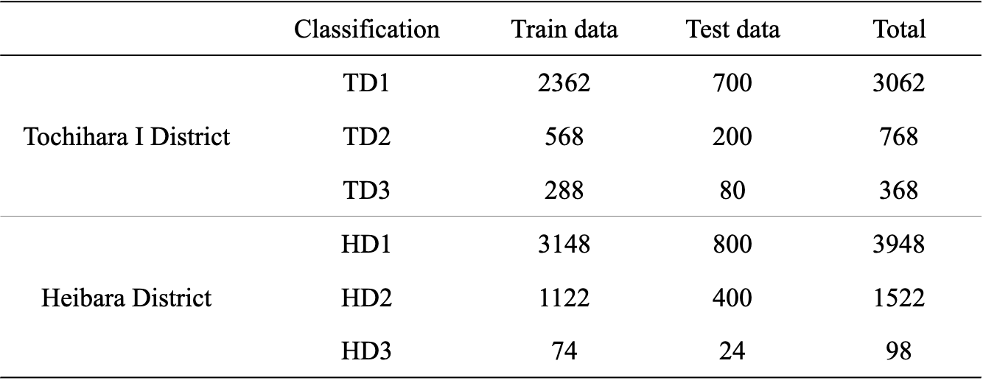

Table 2 Confusion matrix of the soil moisture estimation model
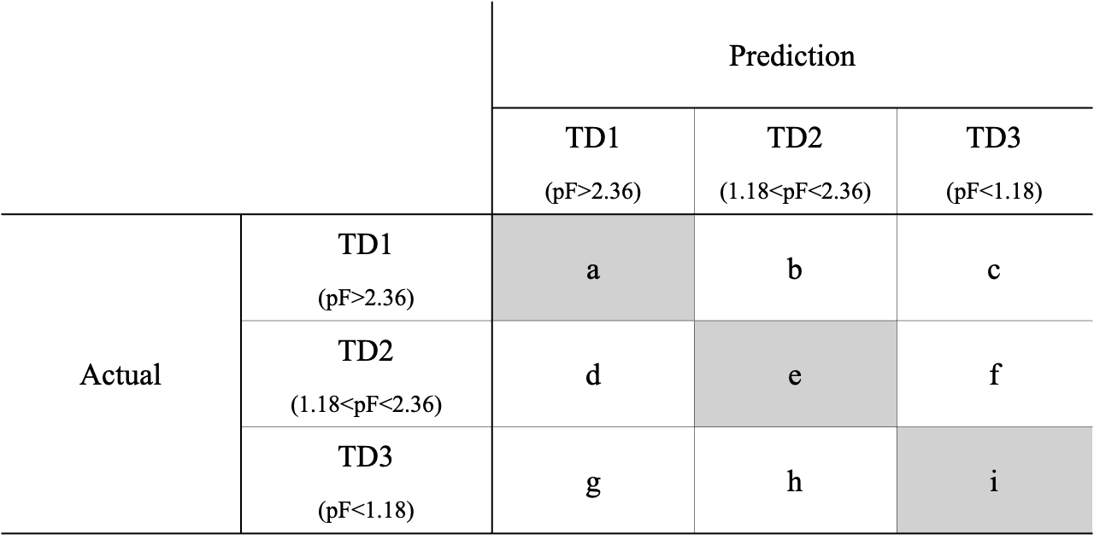

Table 3 Number of images used for irrigation decision models according to classification and rating.
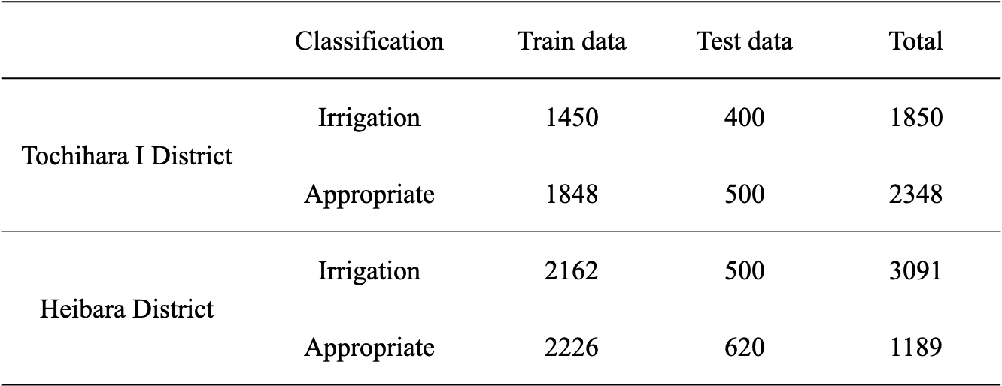

Table 4 Confusion matrix of the irrigation decision model

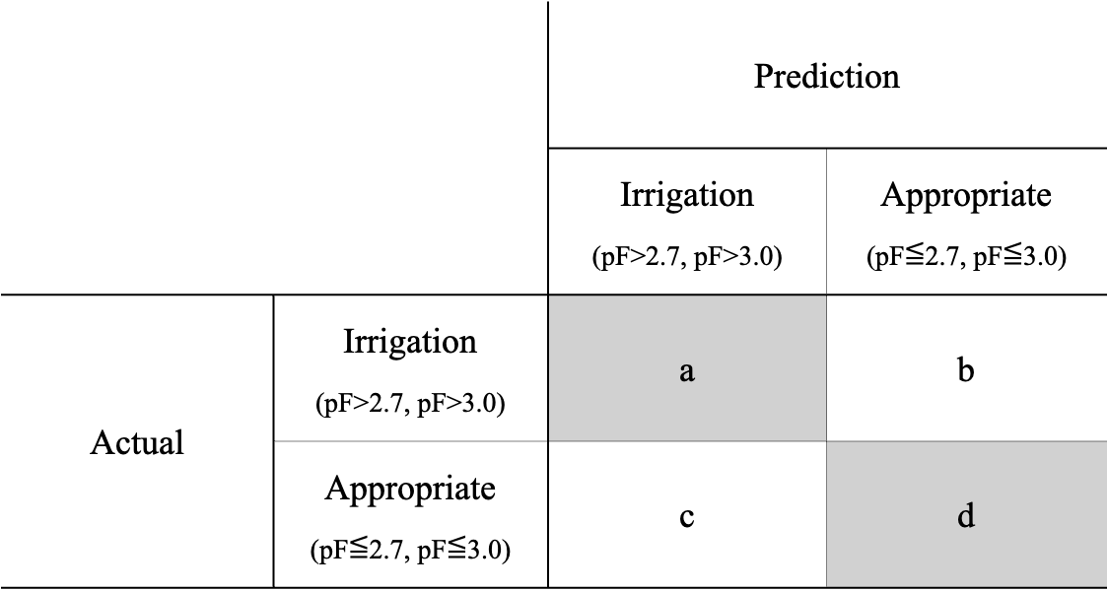

Table 5 TSm model evaluation results
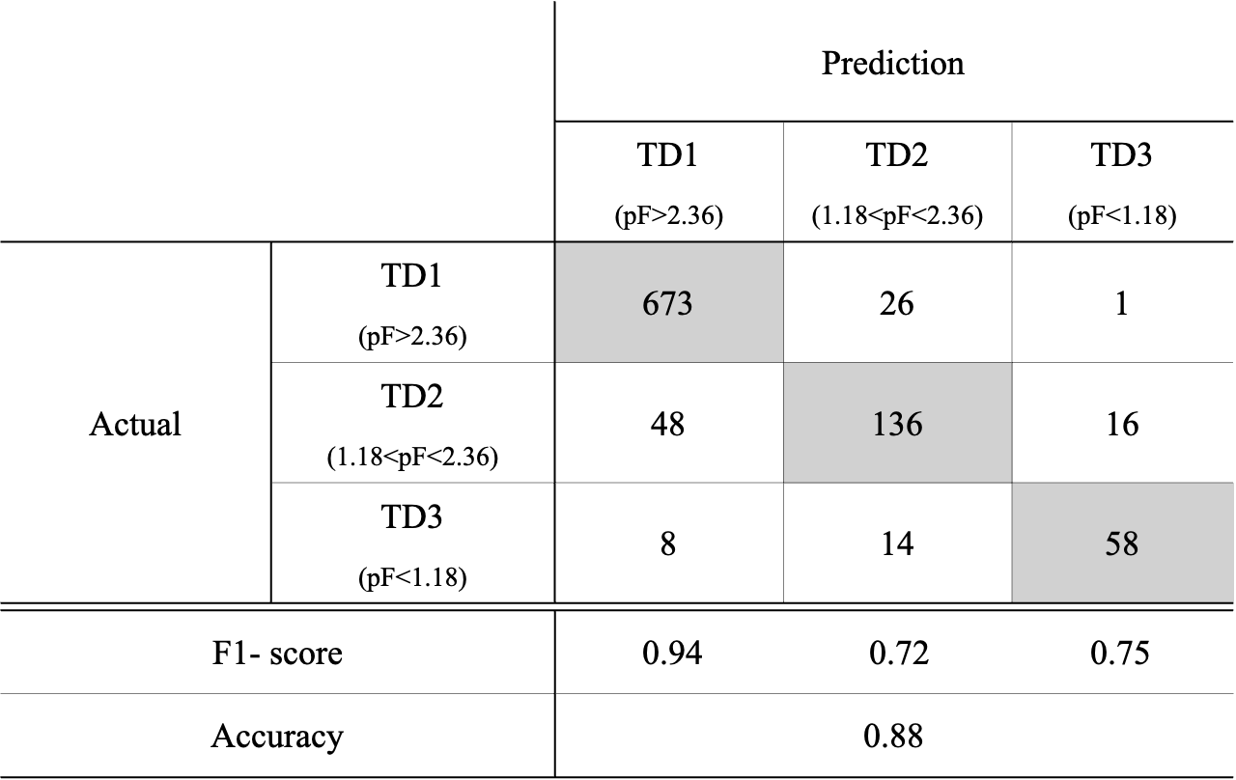

Table 6 HSm model evaluation results
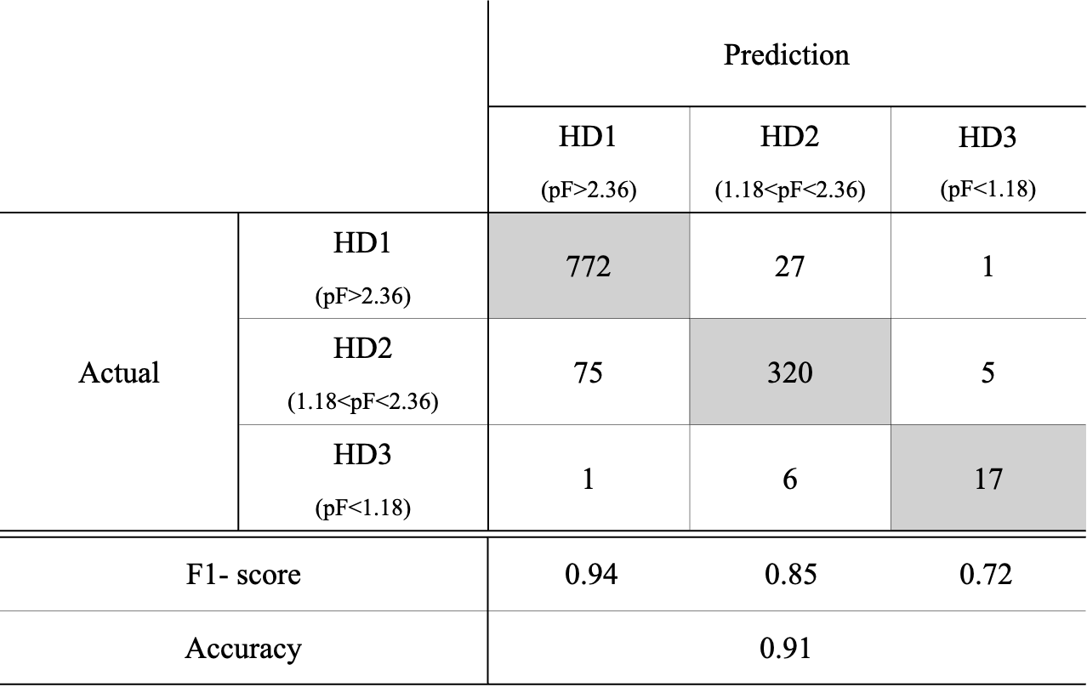

Table 7 TIr model evaluation results
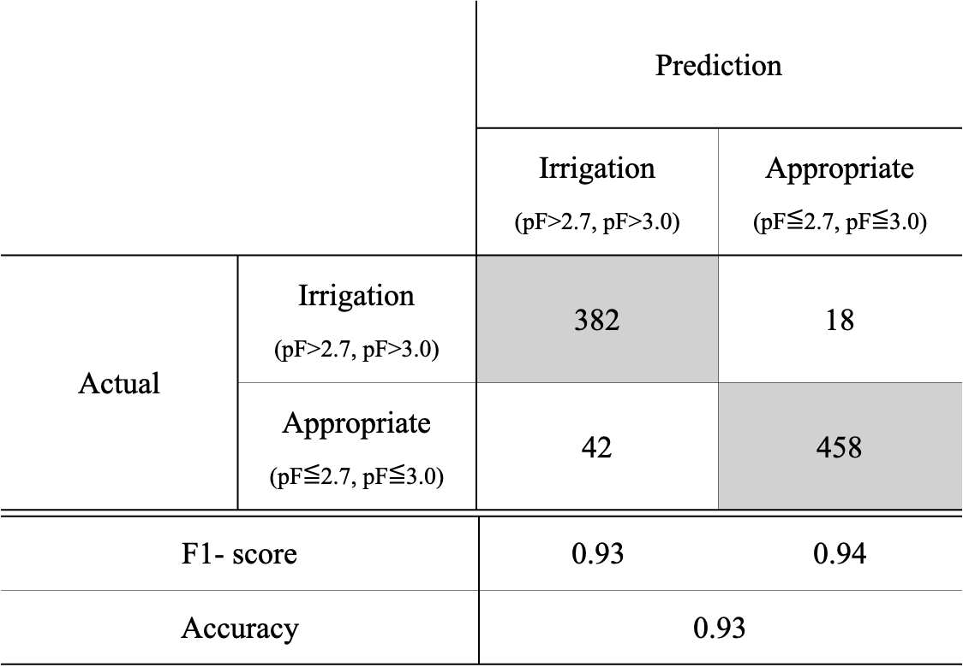

Table 8 HIr model evaluation results
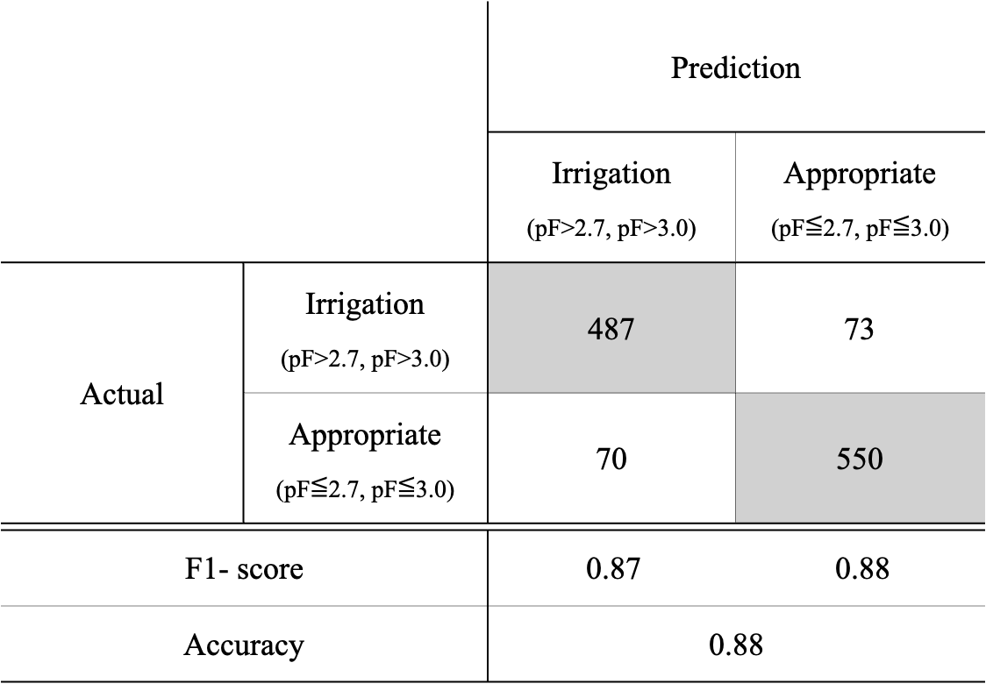

Table 9 CIr model evaluation results
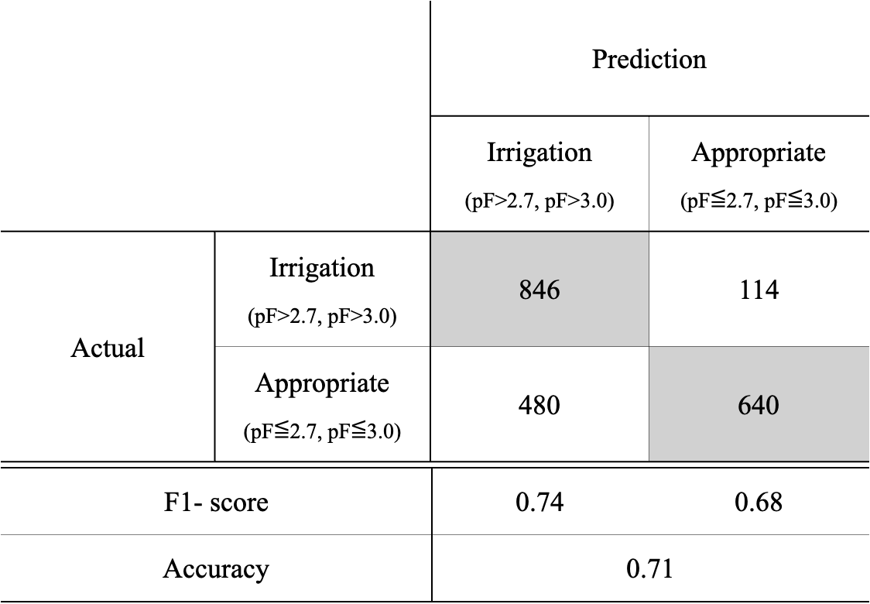

Table 10 Results of the TIr model assessment of Heibara Danchi.
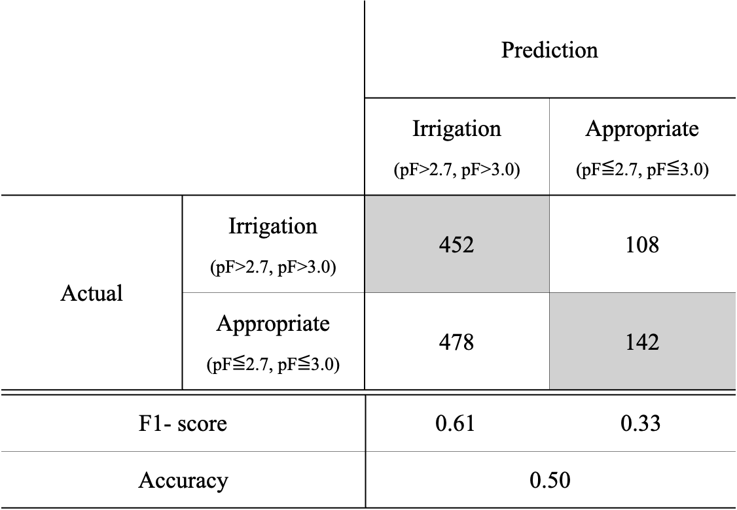

Table 11 Results of the HIr model assessment of Tochihara Ⅰ Danchi.
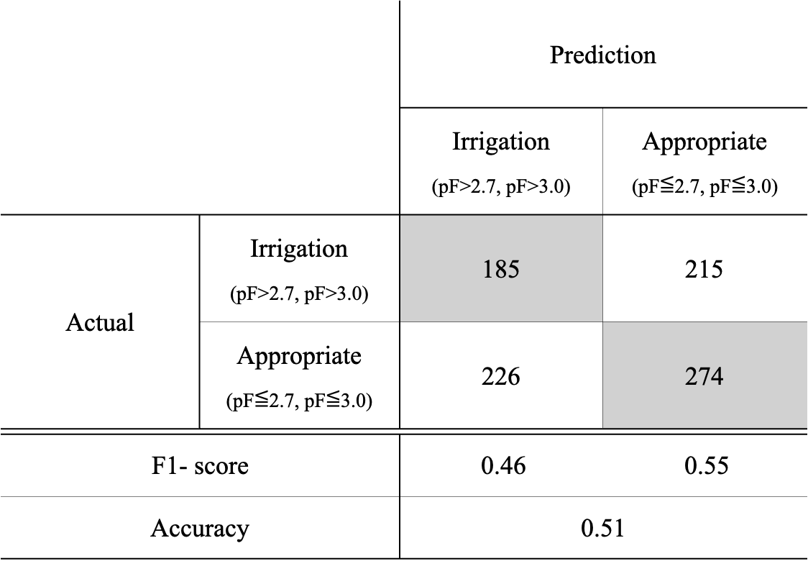

Table 12 Percentage of the number of misjudged items from each camera in the irrigation decision model.
