Appendix A Supplementary data

Preparation of a novel Ag₃PO₄/Bi-MOF heterojunction photocatalyst for the degradation of organic pollutants under visible light irradiation

Yufeng Ji^{ab}, Congyang Zou*^{ab}, Yong Wangª, Zhuyou Zhou^{ab},Menghe Liu^{ab}, Ying Xu^{ab}, Ruijie Liu^{ab}, Mingjie Yang^{ab}

a. School of Environmental Science and Engineering, Suzhou University of Science and Technology, Suzhou 215009, Jiangsu, China
b. Institute of Ecological Environment Carbon Neutrality, Suzhou University of Science and Technology, Suzhou 215009, Jiangsu, China

----------------------------------
* Corresponding authors. E-mails: ericcongyang @126.com (C. Zou).

- Characterization
The crystal structures of the synthesized catalysts were obtained by using combined techniques including X-ray diffraction (XRD; D8-Advance, Bruker, Germany),the scan range was 5°～ 70°.The morphology and size of the synthesized material were surveyed by field emission scanning electron microscopy (SEM, JSM-6460000LV, Japan) equipped with an energy dispersive X-ray spectrometer (EDX). The surface composition, chemical states and the valence band (VB) edges were tested by X-ray photoelectron spectroscopy (XPS; ESCALAB 250Xi, Thermo Scientific, USA).The optical properties of the synthesized photocatalysts were determined by spectrophotometer (UV-vis, UV-3600) in the spectral range was 400-800 nm.The photocurrent and the electrochemical impedance spectra (EIS) were obtained by an electrochemical workstation(CH Instruments, CHI 660D, China). The active species were detected by an electron spin resonance spectrometer(Bruker, EMXplus-10/12, Germany).The functional groups were analyzed by Fourier Transform Infrared (FT-IR, Nexus670, America).
Fig. S1 The XPS spectra of the samples Ag3PO4, Bi-MOF and APBM-1/1 composit.

Fig. S2 Valence band spectra of Bi-MOF and Ag₃PO₄.

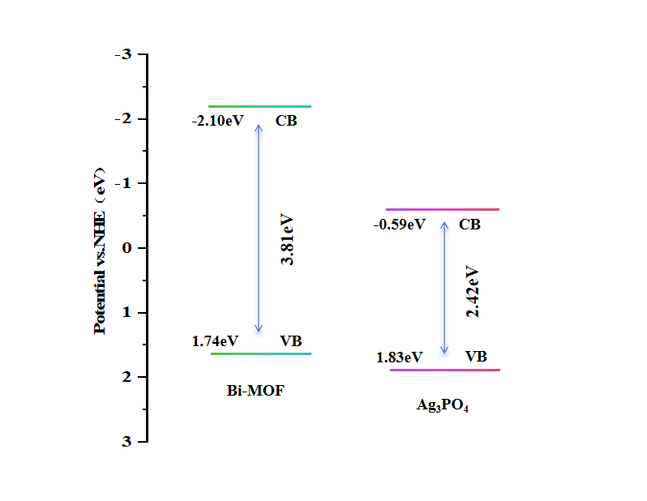
Fig. S3. Band structure of Bi-MOF and Ag₃PO₄ (VB is valence band, CB is conduction band).

Fig.S4 (a) Photocatalytic degradation of TCH with the as-prepared catalysts, (b) The first-order kinetic curves.

