11 Supplementary Material
Supplementary Figure 1. Incremental exhaustion test in C57BL/J6 mice. Adult male C57BL/J6 mice were submitted to the maximum incremental test to determine the animal's voluntary withdrawal from treadmill running physical exercise. (A) Incremental test, (B) Lactate concentrations. ANOVA for multiple comparisons followed by post hoc Tukey test for A. One tail Student’s t-test for B. * P ≤ 0.05 (n= 5 animals per group).

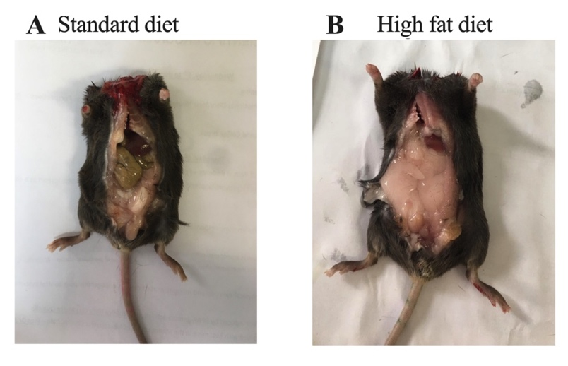
Supplementary Figure 2. Visceral white adipose tissue (WAT) accumulation in C57BL/J6 mice submitted to high fat diet (HFD). Adult male C57BL/J6 mice received HFD ad libitum for 8 consecutive weeks (20 kcal % protein, 35 kcal % carbohydrates and 45 kcal % lipids). Animals in the control group received a standard rodent diet for the same period (20 kcal % protein, 70 kcal % carbohydrates and 10 kcal % lipids). (A) Representative image of a mouse from the control group submitted to regular rodent diet that shows no WAT accumulation. (B) Representative image of a mouse from the group of animals submitted to HFD that shows increased WAT accumulation.

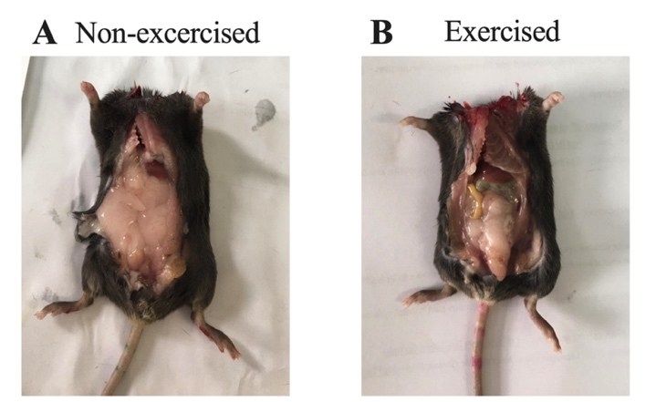
Supplementary Figure 3. Visceral white adipose tissue (WAT) accumulation in C57BL/J6 mice submitted to high fat diet (HFD) and physical exercise. Adult male C57BL/J6 mice received HFD ad libitum for 8 consecutive weeks (20 kcal % protein, 35 kcal % carbohydrates and 45 kcal % lipids). After 2 weeks of the dietary intervention, mice were also submitted to physical exercise 5 times per week for 6 weeks (for details see M&M). (A) Representative image of a mouse from the non-exercised group submitted to HFD that shows increased WAT accumulation. (B) Representative image of a mouse from the exercised group submitted to HFD that shows no WAT accumulation.

