Table1. Top 10 of enriched diseases affected of
drug target of Toujiequwen Granules in CTD analysis
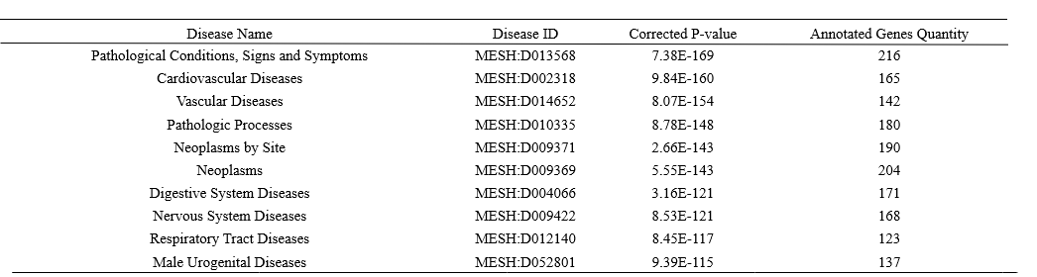

Table 2. The possible Main active components of Toujiequwen Granules against COVID-19
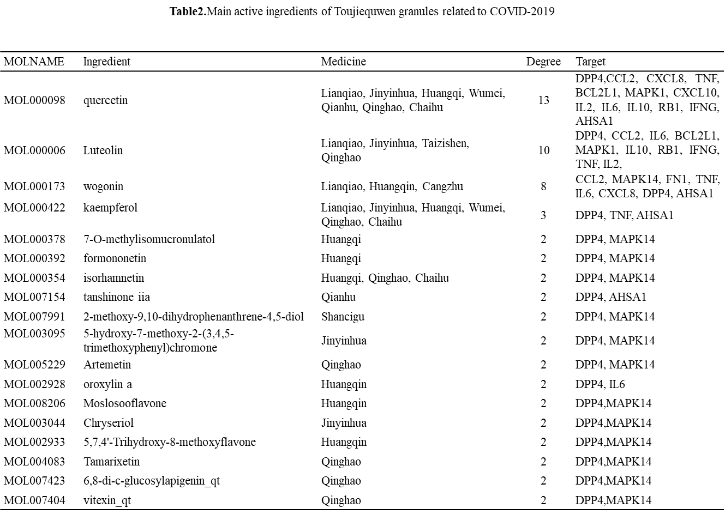

Table 3.The main possible disease target of COVID-19 affected by Toujiequwen Granules
