Appendix A

Table 1: UDVA trajectory over time post ICL placement
 | Coefficient | Std. Error | t | Sig.
(Intercept) | 0.081 | 0.020 | 4.113 | <0.001
Time since surgery | -0.001 | 0.000 | -2.674 | 0.008
(Time since surgery)² | 0.000 | 0.000 | 2.338 | 0.020
(Time since surgery)³ | 0.000 | 0.000 | -2.111 | 0.036

Regression equation:
UDVA = 1 + Time since surgery + (Time since surgery)² + (Time since surgery)³ + (1 | Patient ID) + (1 | Patient ID : Eye laterality)

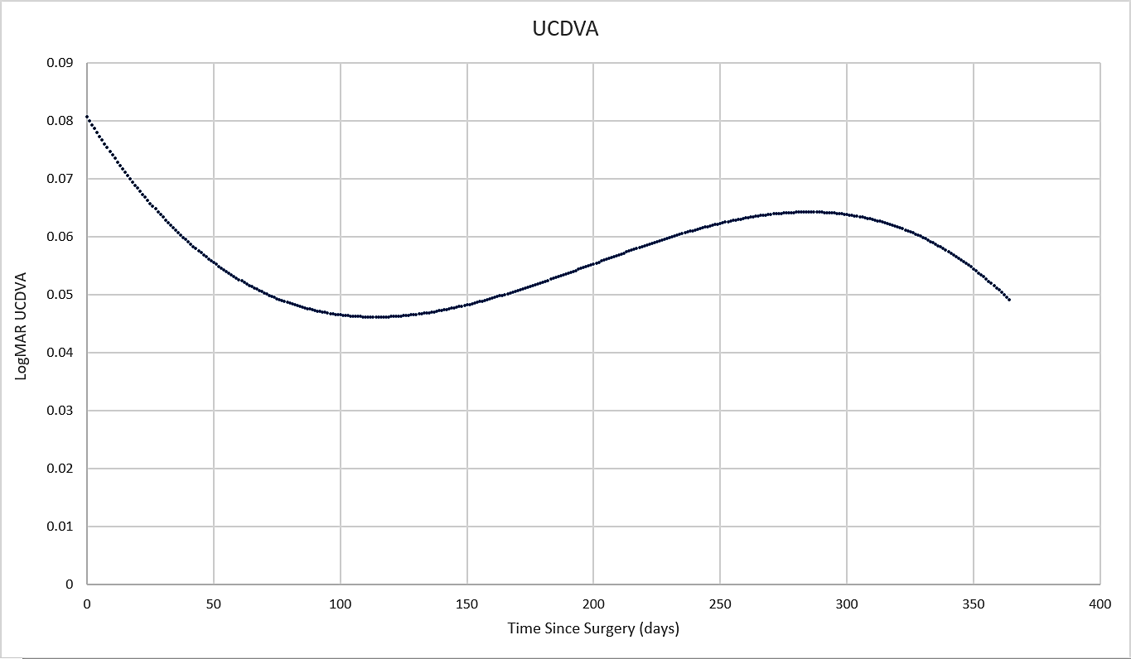

Table 2: IOP trajectory over time post ICL placement
 | Coefficient | Std. Error | t | Sig.
(Intercept) | 2.556 | 0.026 | 97.020 | 0.000
(Time since surgery)² | 0.000 | 0.000 | -1.908 | 0.057
(Time since surgery)³ | 0.000 | 0.000 | 1.937 | 0.053

Regression equation:
Log IOP = 1 + (Time since surgery)² + (Time since surgery)³ + (1 | Patient ID) + (1 | Patient ID: Eye laterality)

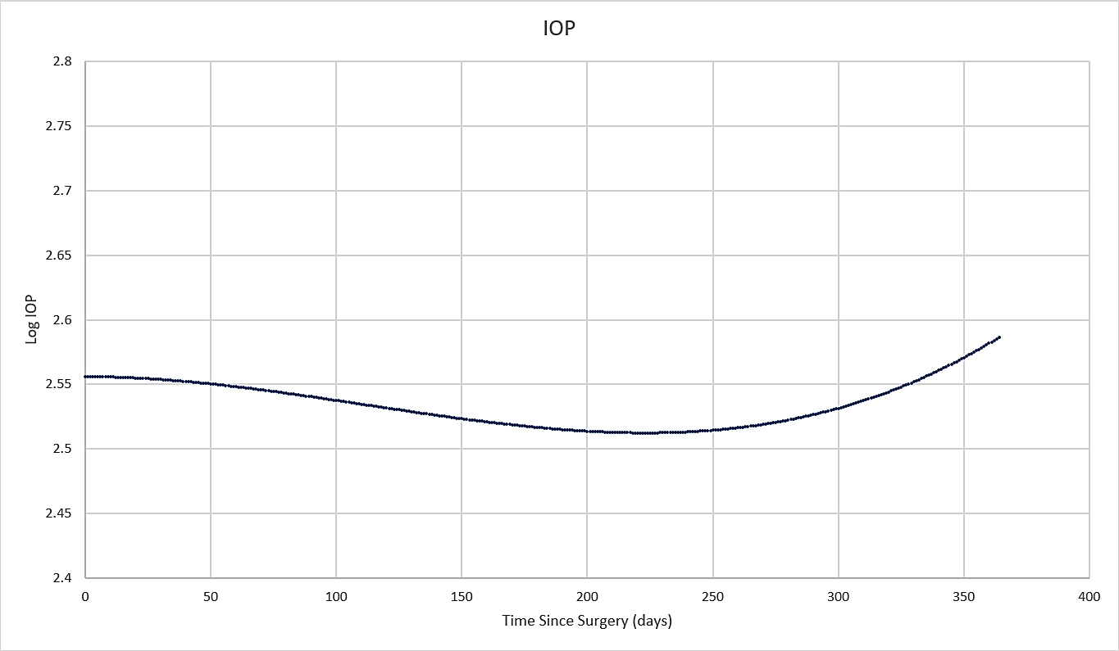

UDVA
Model 1:
UDVA = 1 + Time since surgery + (Time since surgery)² + (Time since surgery)³
+ (1 | Patient ID) + (1 | Patient ID: Eye laterality)
Model 2:
UDVA = 1 + Time since surgery + (Time since surgery)² + (Time since surgery)³ + CBC
+ Time since surgery * CBC + (Time since surgery)² * CBC + (Time since surgery)³ * CBC
+ (1 | Patient ID) + (1 | Patient ID: Eye laterality)

Likelihood Ratio Test examining the association between CBC and UDVA
 | Parameters | Log Likelihood | χ² | df | Sig
Model 1 | 7 | 298.109
Model 2 | 11 | 299.404 | 2.589 | 4 | 0.629

IOP
Model 1:
Log IOP = 1 + (Time since surgery)² + (Time since surgery)³
+ (1 | Patient ID) + (1 | Patient ID: Eye laterality)
Model 2:
Log IOP = 1 + (Time since surgery)² + (Time since surgery)³ + CBC
+ (Time since surgery)² * CBC + (Time since surgery)³ * CBC
+ (1 | Patient ID) + (1 | Patient ID:
Eye laterality)

Likelihood Ratio Test examining the association between CBC and IOP
 | Parameters | Log Likelihood | χ² | df | Sig
Model 1 | 6 | -0.821
Model 2 | 11 | 0.744 | 3.130 | 5 | 0.680

