Supplementary Information:

Marine megavertebrate migrations connect the global oceans

Lily K. Bentley, Dina Nisthar, Ei Fujioka, Corrie Curtice, Sarah E. DeLand, Ben Donnelly, Autumn-Lynn Harrison, Ellie I. Heywood, Connie Y. Kot, Guillermo Ortuño Crespo, Sarah Poulin, Patrick N. Halpin, Daniel C. Dunn

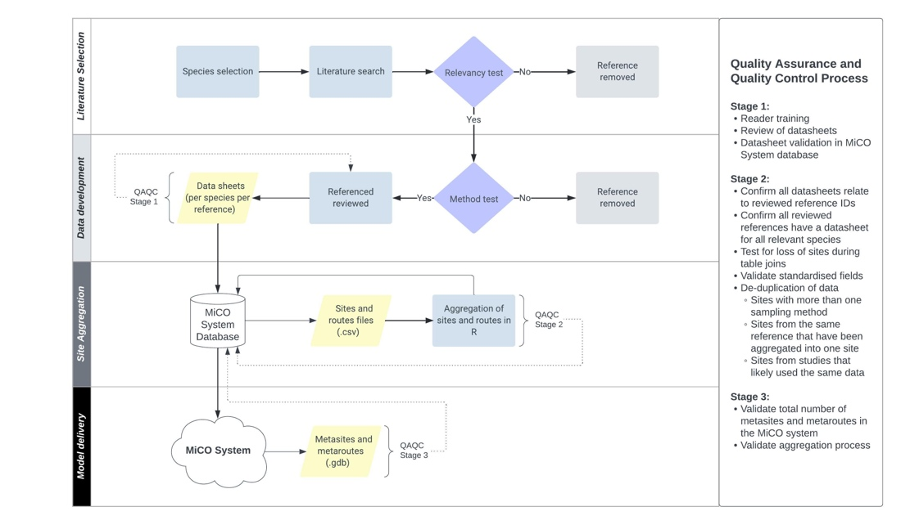

Fig. S1.
Quality assurance and quality control processes from literature selection to delivery of models within the MiCO database.

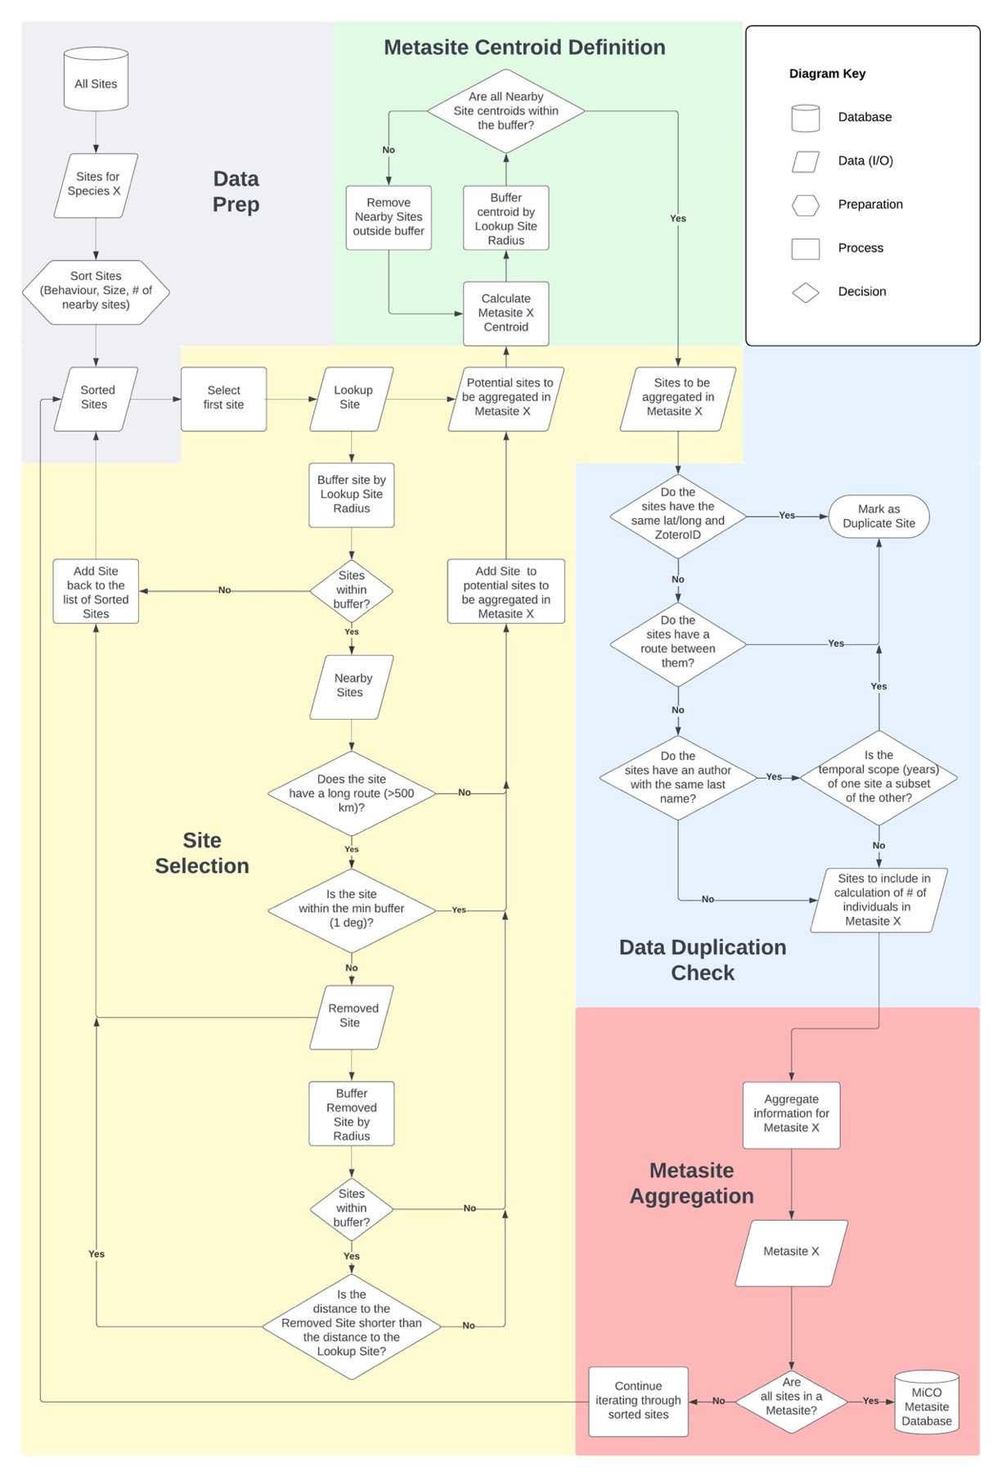
Fig. S2.
Flowchart illustrating the site aggregation process used to generate metasites.

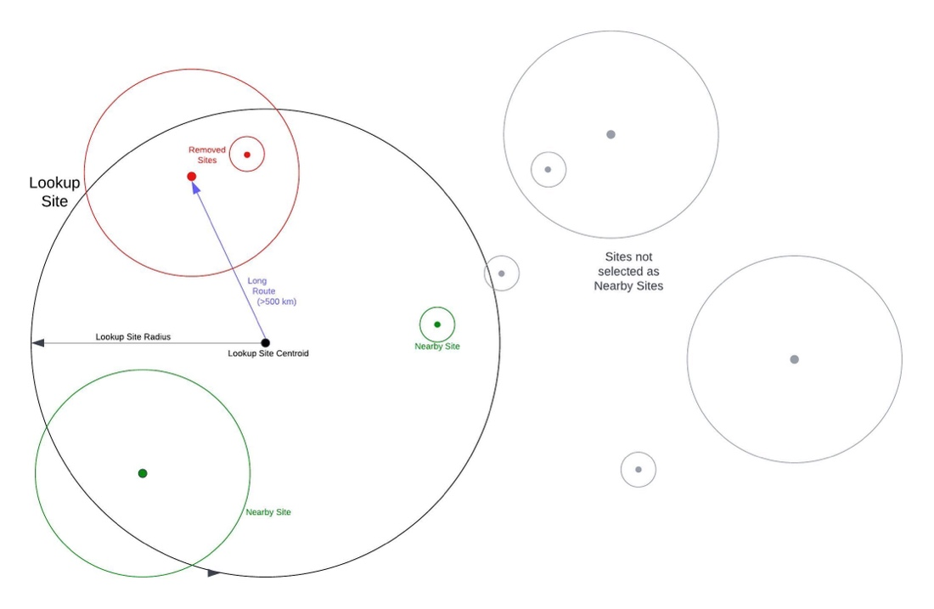

Fig. S3.
Diagram illustrating the process of iterative site-selection with reference to the lookup site, nearby sites, and long routes.

Table S1.
Taxon | species_code | Common Name
Fishes | ACSO | Wahoo
Fishes | ALSU | Bigeye Thresher Shark
Fishes | ALVU | Common Thresher Shark
Fishes | ANAN | European Eel
Fishes | CACA | Great White Shark
Fishes | CAFA | Silky Shark
Fishes | CEMA | Basking Shark
Fishes | COHI | Common Dolphinfish
Fishes | ISIN | Black Marlin
Fishes | ISOX | Shortfin Mako
Fishes | ISPA | Longfin Mako
Fishes | ISPL | Sailfish
Fishes | KAAL | White Marlin
Fishes | KAAU | Striped Marlin
Fishes | KAPE | Skipjack Tuna
Fishes | LANA | Porbeagle
Fishes | MAAL | Reef Manta Ray
Fishes | MANI | Blue Marlin
Fishes | MOBI | Giant Manta Ray
Fishes | MOJA | Spinetail Devil Ray
Fishes | MOTA | Chilean Devil Ray
Fishes | RHTY | Whale Shark
Fishes | SPLE | Scalloped Hammerhead
Fishes | SPMO | Great Hammerhead
Fishes | SQAC | Spiny Dogfish
Fishes | TEPF | Longbill Spearfish
Fishes | THAB | Yellowfin Tuna
Fishes | THAL | Albacore Tuna
Fishes | THAT | Blackfin Tuna
Fishes | THMAC | Southern Bluefin Tuna
Fishes | THOB | Bigeye Tuna
Fishes | THOR | Pacific Bluefin Tuna
Fishes | THTH | Atlantic Bluefin Tuna
Fishes | XIGL | Swordfish
Marine Mammals | ARAU | South American Fur Seal
Marine Mammals | BABR | Sei Whale
Marine Mammals | BAED | Bryde's Whale
Marine Mammals | BAMU | Blue Whale
Marine Mammals | BAMY | Bowhead Whale
Marine Mammals | BAPH | Fin Whale
Marine Mammals | CEHE | Heaviside's Dolphin
Marine Mammals | DEDE | Short-beaked Common Dolphin
Marine Mammals | DELE | Beluga
Marine Mammals | DUDU | Dugong
Marine Mammals | EUAU | Southern Right Whale
Marine Mammals | EUGL | North Atlantic Right Whale
Marine Mammals | EUJA | North Pacific Right Whale
Marine Mammals | GLME | Long-finned Pilot Whale
Marine Mammals | GRGR | Risso's Dolphin
Marine Mammals | HYAM | North Atlantic Bottlenose Whale
Marine Mammals | LAAC | Atlantic White-sided Dolphin
Marine Mammals | LAAL | White-beaked Dolphin
Marine Mammals | MENO | Humpback Whale
Marine Mammals | MOMO | Narwhal
Marine Mammals | OROR | Killer Whale
Marine Mammals | PHMA | Sperm Whale
Marine Mammals | STAT | Pantropical Spotted Dolphin
Marine Mammals | TRIN | South American Manatee
Marine Mammals | TRMA | American Manatee
Marine Mammals | ZICA | Cuvier's Beaked Whale
Sea Turtles | CACAR | Loggerhead
Sea Turtles | CHMY | Green
Sea Turtles | DECO | Leatherback
Sea Turtles | ERIM | Hawksbill
Sea Turtles | LEKE | Kemp's Ridley
Sea Turtles | LEOL | Olive Ridley
Sea Turtles | NADE | Flatback
Seabirds | CHNI | Black Tern
Seabirds | DIAM | Amsterdam Albatross
Seabirds | DIAN | Antipodean Albatross
Seabirds | DIDA | Tristan Albatross
Seabirds | DIEP | Southern Royal Albatross
Seabirds | DIEX | Wandering Albatross
Seabirds | DISA | Northern Royal Albatross
Seabirds | GAAD | Yellow-billed Loon
Seabirds | LAAT | Olrog's Gull
Seabirds | LAAU | Audouin's Gull
Seabirds | MAGI | Southern Giant Petrel
Seabirds | MAHA | Northern Giant Petrel
Seabirds | PHAL | Short-tailed Albatross
Seabirds | PHFU | Sooty Albatross
Seabirds | PHIM | Laysan Albatross
Seabirds | PHIR | Waved Albatross
Seabirds | PHNI | Black-footed Albatross
Seabirds | PHPA | Light-mantled Albatross
Seabirds | PRAE | White-chinned Petrel
Seabirds | PRCI | Grey Petrel
Seabirds | PRCO | Spectacled Petrel
Seabirds | PRPA | Black Petrel
Seabirds | PRWE | Westland Petrel
Seabirds | PTSA | Hawaiian Petrel
Seabirds | PUMA | Balearic Shearwater
Seabirds | STAL | Little Tern
Seabirds | STDO | Roseate Tern
Seabirds | STHI | Common Tern
Seabirds | STPA | Arctic Tern
Seabirds | SYWU | Japanese Murrelet
Seabirds | THBU | Buller's Albatross
Seabirds | THCA | Indian Yellow-nosed Albatross
Seabirds | THCH | Atlantic Yellow-nosed Albatross
Seabirds | THCR | Grey-headed Albatross
Seabirds | THCU | Shy Albatross
Seabirds | THER | Chatham Albatross
Seabirds | THME | Black-browed Albatross
Seabirds | THSA | Sandwich Tern
Seabirds | THST | White-capped Albatross

List of species (including codes) included in the summary Figure 4. Because their ecology (and therefore reporting of populations and movements in the literature) are distinct compared to the other marine mammals reviewed, polar bears Ursus maritimus and grey seals Halichoerus grypus are not included in Figure 4.

