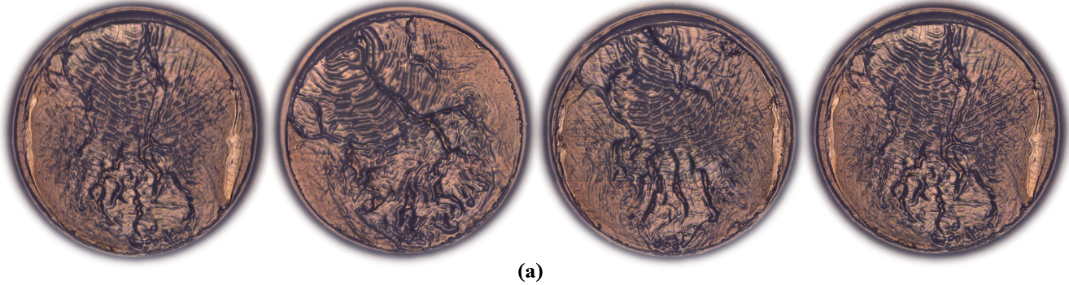
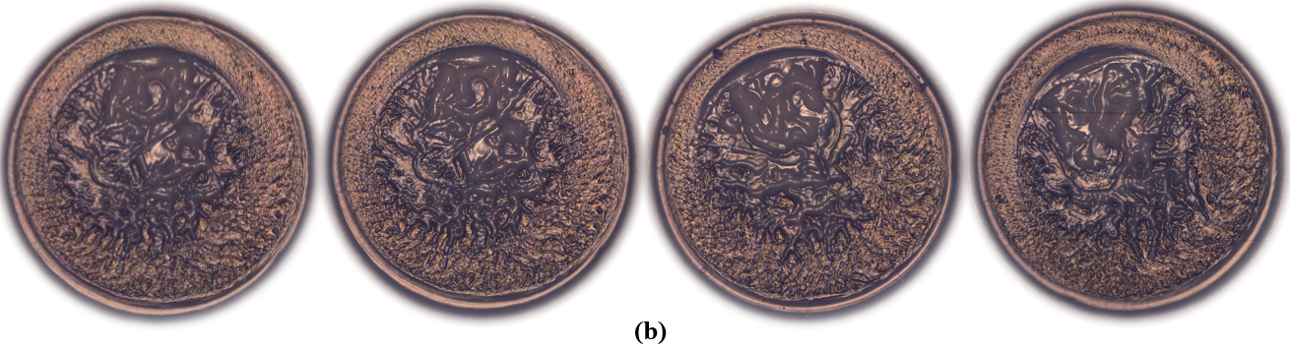
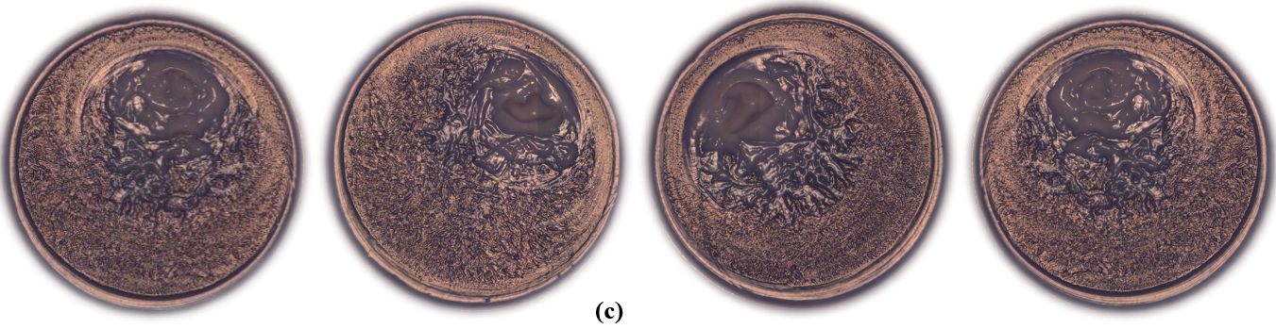

Fig. S1 The deposition pattern: a)Ts=30℃, 10nm, 1w%; b)Ts=45℃, 10nm, 1w%; c)Ts=62℃, 10nm, 1w%

