Supplementary figure legends
Fig. S1 Dissection of the malignant glioma cells.
- UMAP plots of malignant glioma cells identify in this study, with each cell color coded to indicate the associated dataset.
- UMAP plots of malignant glioma cells identify in this study, with each cell color coded to indicate the associated clusters.
Fig. S2 Dissection of the M1 polarization and M2 polarization in TAM cells.
- Dot plot showing the average expression of highlighted M1-like and M2-like genes in all TAM clusters.
- FeaturePlot displayed the M1 polarization scores in five TAM cell subtyps.
- FeaturePlot displayed the M2 polarization scores in five TAM cell subtyps.

Fig. S1
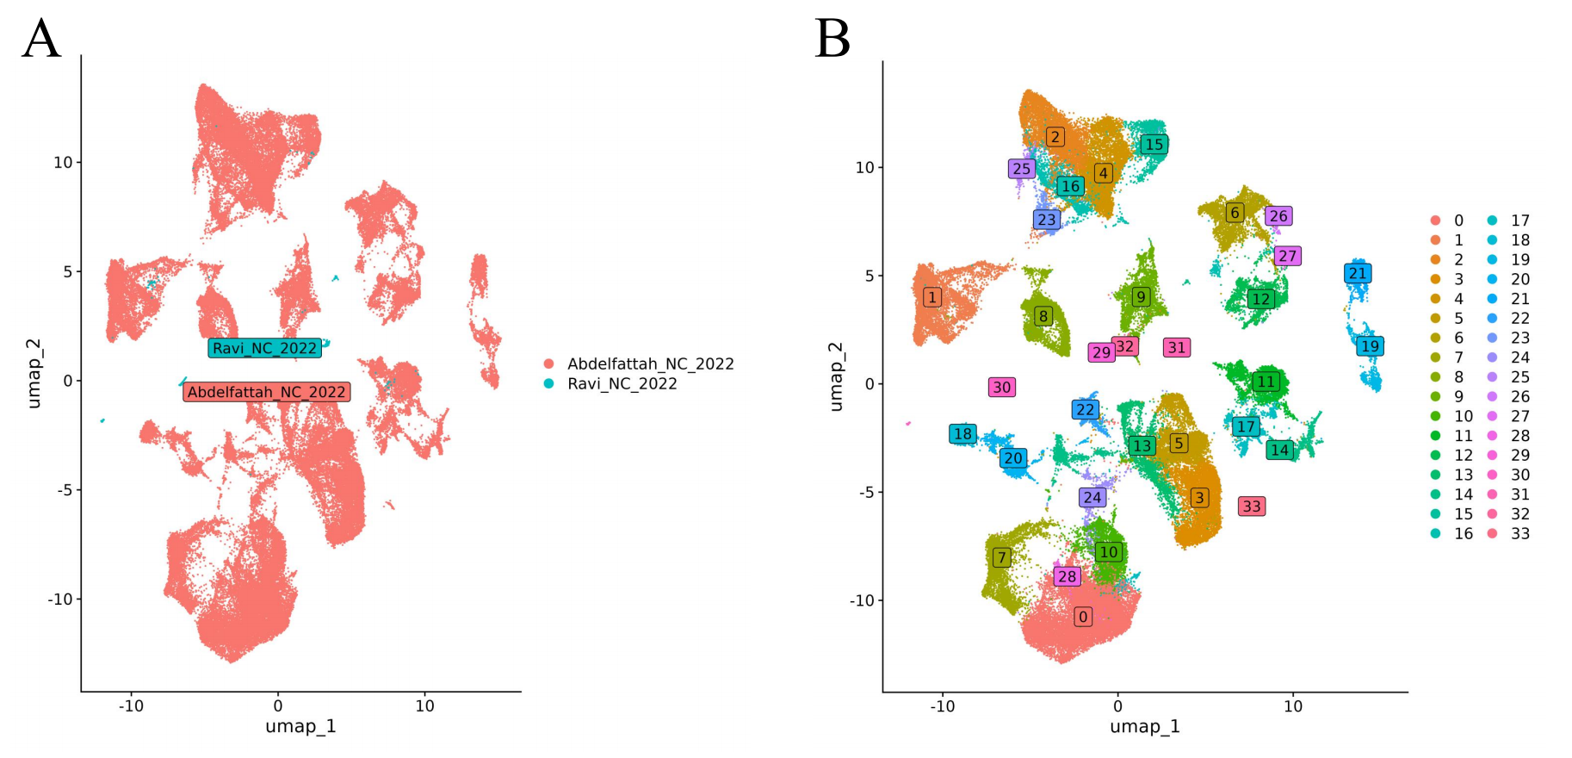

Fig. S2
