Supporting information

Effect of mechanochemically modified MoO₃-ZnO on Mo supply to plants when co-granulated with macronutrient fertilizers

Bo Zheng†*, Fien Degryse†, Ivan B. Andelkovic†, Roslyn Baird†, Mike John McLaughlin†
†Fertilizer Technology Research Centre, School of Agriculture, Food and Wine, The University of Adelaide, Waite Campus PMB 1, Glen Osmond, SA, 5064, Australia
*Corresponding author: Bo Zheng. E-mail: bo.zheng@adelaide.edu.au .
Table S1 Mechanochemical treatments of AMT and ZnO with different Zn: Mo ratios milled for 8h.
 | AMTª: ZnO treatments
Treatments | AMT (g) | ZnO (g) | Mo % | Zn% | Zn:Mo
33% Mo | 1.76 | 1.24 | 33 | 33 | 1.0
10% Mo | 0.53 | 2.47 | 10 | 66 | 6.6
8% Mo | 0.42 | 2.58 | 8 | 69 | 8.6
4% Mo | 0.21 | 2.79 | 4 | 75 | 18.7
2% Mo | 0.11 | 2.89 | 2 | 77 | 38.8
1% Mo | 0.05 | 2.95 | 1 | 79 | 78.9
ª AMT-(NH₄)₆Mo₇O₂₄·4H₂O
Table S2 Characteristics of the two soils for column leaching.

Characteristics | Value
Characteristics | Ngarkat | Streaky Bay
pH (H₂O: soil -5:1) | 6.8 | 8.6
pH (0.01 M CaCl₂:soil - 5:1) | 5.3 | 7.9
Organic carbon (%) | 0.7 | 1.5
Exchangeable K (cmol_{c} kg⁻¹) | <0.2 | 0.6
Exchangeable Ca (cmol_{c} kg⁻¹) | 2.2 | 6.3
Exchangeable Mg (cmol_{c} kg⁻¹) | 0.4 | 1.4
CEC-Cation Exchange Capacity (cmol_{c} kg⁻¹) | 3.1 | 5.8
Clay (g kg⁻¹) | 3 | 9
Silt (g kg⁻¹) | 1 | 4
Sand (g kg⁻¹) | 81 | 15
CaCO₃ (%) | <0.2 | 83

Table S3 Experimentally determined (recovered) and expected Mo and Zn concentrations in the mechanochemically synthesized Mo + ZnO treatments.
Treatments | MoO₃ + ZnO |  |  |  | AMTª + ZnO
Treatments | Recovered |  | Expected |  | Recovered |  | Expected
Treatments | Mo% | Zn% | Mo% | Zn% | Mo% | Zn% | Mo% | Zn%
36/33% | 36.3 ± 2 | 38.3 ± 2 | 36 | 36 | 30.0 ± 4 | 29.4 ± 4 | 33 | 33
10% Mo | 10.1 ± 1 | 70.1 ± 2 | 10 | 68 | 11.0 ± 1 | 64.7 ± 5 | 10 | 66
8% Mo | 8.6 ± 0 | 74.2 ± 2 | 8 | 71 | 9.0 ± 0 | 70.1 ± 2 | 8 | 69
4% Mo | 4.3 ± 0 | 77.5 ± 1 | 4 | 76 | 4.0 ± 0 | 74.4 ± 1 | 4 | 75
2% Mo | 2.1 ± 0 | 78.1 ± 4 | 2 | 78 | 2.5 ± 0 | 76.7 ± 5 | 2 | 77
1% Mo | 1.1 ± 0 | 77.3 ± 2 | 1 | 79 | 1.3 ± 0 | 75.8 ± 4 | 1 | 79
ª AMT-(NH₄)₆Mo₇O₂₄·4H₂O

Figure S1 Theoretical XRD peaks for the reactants and several reference zinc molybdate and zinc molybdenum oxides.
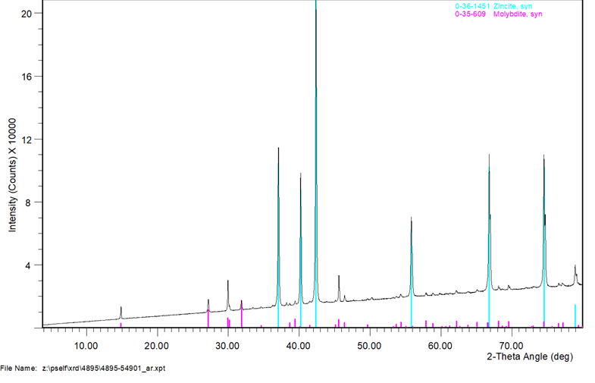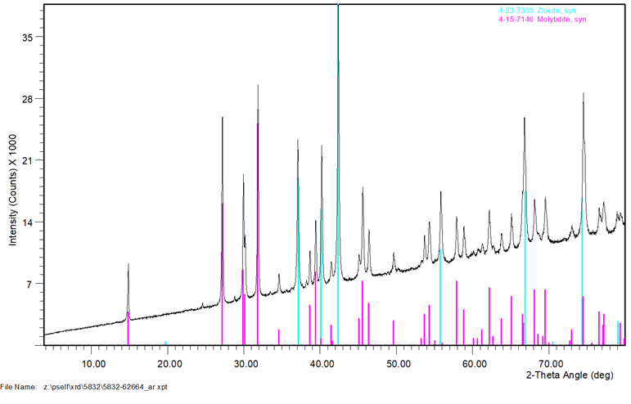
- 36% MoO₃- Control
- 4% MoO₃- Control
Figure S2 The XRD spectrum of ZnO with (a) 4% and (b) 36% of MoO₃ without mechanochemical treatment as controls.

Figure S3 The cumulative release over 72 h of (a, c) P and K (as % of added) and (b, d) pH of the percolation solution at each collection time from MAP, MOP and DAP, compacted with mechanochemically treated 4% and 36% Mo (MoO₃-ZnO) and 4% Mo. The Control was without mechanochemical treatment. Error bars represent standard errors of duplicate samples.
Figure S4 The percentage of total Zn recovered in the leachate from (a) MAP or (b) DAP alone N (no micronutrient source), or compacted with AMT ((NH₄)₆Mo₇O₂₄·4H₂O + ZnSO₄·7H₂O), C (4% MoO₃ + ZnO) or MC (Mechanochemically treated 4% MoO₃ + ZnO) collected after 4 consecutive 350 ml leaching events (L1 to L4) in the pot experiment. Error bars present the standard error of the mean (n = 4).

