Supplementary Materials for

Interferon upregulation as the origin of Alzheimer’s disease

Corresponding author: science@research.re.kr

Materials and Methods
The National Agency approved this study for the Management of Life-sustaining Treatment, which certified that the life-sustaining treatments were managed properly (Korea National Institute for Bioethics Policy (KoNIBP) approval number P01-202007-22-006). According to Korea's Official Information Disclosure Act, the Seoul study analyzed AD and anti-Alzheimer's disease drug (AAD) use in Hansen subjects. We searched all medical records of the National Health Insurance Service (NHIS) in Korea and the Sorokdo National Hospital from the time when the International Classification of Diseases (ICD)-10 code and Electronic Data Interchange (EDI) were computed. Sorokdo National Hospital was established in May 1916 to treat leprosy. We connected the data to the medical records database of the Sorokdo National Hospital and archived the data from January 2005 to June 2020. The ICD-10 codes were used to analyze medical data on the correlation between DDS, VRDs, COPD, and AD incidence. In the group of patients diagnosed with Alzheimer's disease, the average age at death while taking only drugs for dementia treatment was recorded (group 1), and the mean age at death was recorded after taking psychiatric drugs (group 1 and group 2). According to the Official Information Disclosure Act in Korea, we also requested and analyzed the entire ICD 10 code data of AD, VRDs, COPD, and AAD patients (from 2010 to 2021) from the Health Insurance Review & Assessment system. As a result, from 2010 to 2021, the number of diagnosed patients with MCI and AD in Korea increased dramatically.

Supplementary Text
When the diseases were classified and analyzed individually, it was confirmed that bronchitis, COPD, and pneumonia increased again around 2013. So, a correlation graph was drawn and analyzed. As we already know, Alzheimer's drugs reduce lung function, which can cause or make people vulnerable to related respiratory diseases. Since dapsone lowers inflammation levels, a separate study was conducted to see if viral respiratory diseases developed in the dapsone group. Surprisingly, the group taking dapsone had a very low incidence of respiratory disease, even if they had a viral respiratory disease, and the incidence of respiratory disease was very high in the dementia drug group. Dapsone has already been used in intensive care units as a treatment for Covid-19, and it has been proven that patients survive more than 40% more, and the cause and mechanism have been continuously announced.
Now, we counted the numbers of the group taking dapsone and the group taking dementia drugs each year, subtracted them, treated them as absolute values, drew a graph, and compared it with the graph of the number of patients with bronchitis, COPD, and pneumonia. Surprisingly, there was an inverse (reversing graph) agreement with the graph of bronchitis and COPD incidence at 95% confidence. But pneumonia did not match. Dapsone was not a drug to treat pneumonia, but the results were consistent with the pathology of bronchitis and COPD.

We formulated the factor to calculate the relationship between Acetylation and Acetylcholine.

[Acetylation-Acetylcholine (AA) equation]
The Dapsone IFN1 factor = ㅣDDS (+) – sum AD (+) ㅣ (1)

Fig. S1. Histogram of age in the Sorok Island study cohort
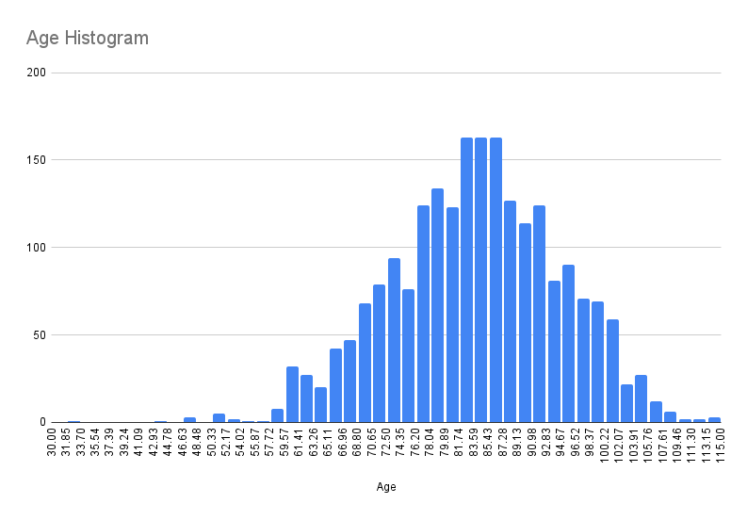
The mean age was 81.72 years, and the median age was 82.1 years. The average age was 83.7 years (median (M) 84, interquartile range (IQR) 76.8–91.2, standard deviation (SD) 10.8, 95% confidence interval (CI): 0.45, 83.6–84.5). The annual total number of participants was 4,064 male subjects and 3,539 female subjects. The known average residence period was 20.1 years. For this study, a total of leprosy patients who were able to study the relationship between AD and dapsone were identified through the use of ICD-9 and ICD-10 codes.

Fig. S2. T1:T3 on Sorok Island from 2005 to 2019.
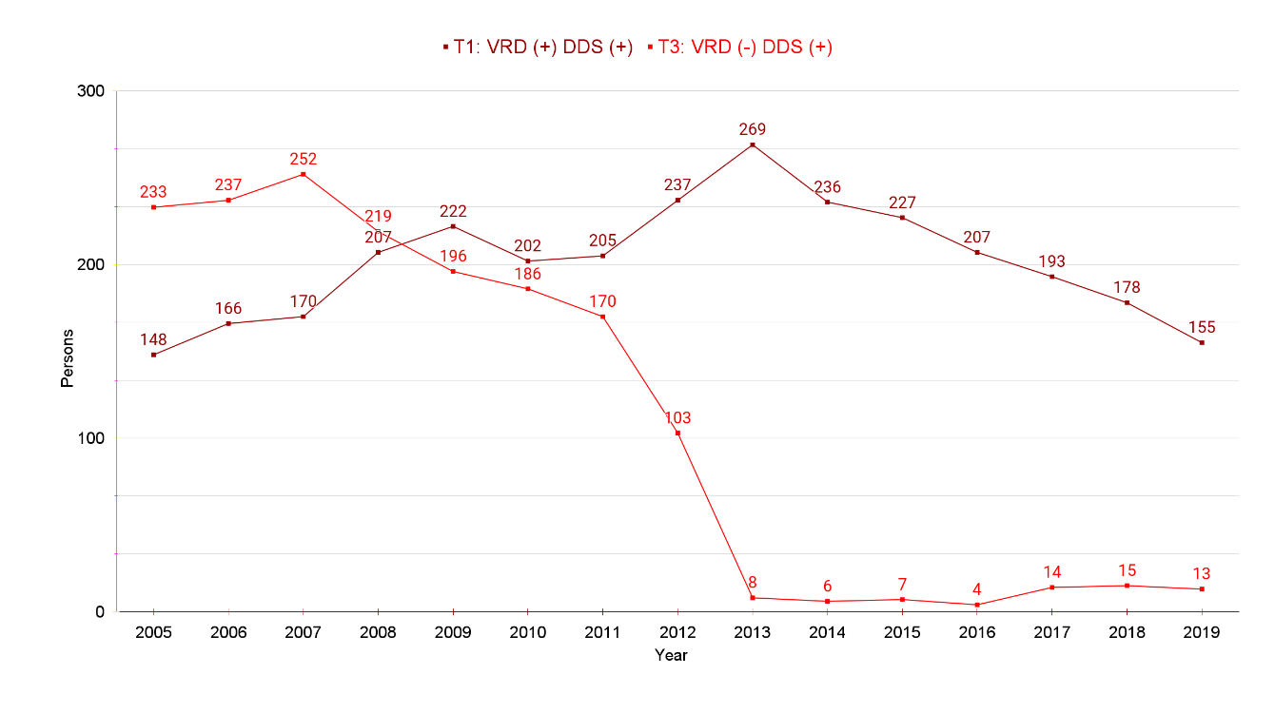

Fig. S3. T1:T4 on Sorok Island from 2005 to 2019.
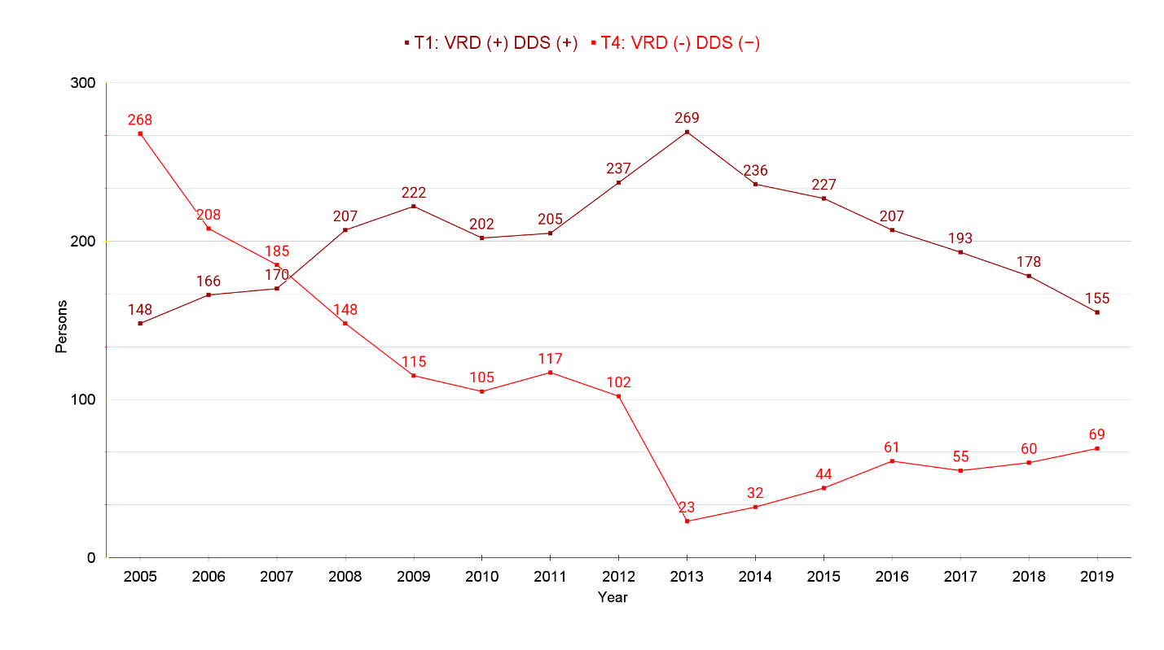

Fig. S4. T2:T4 on Sorok Island from 2005 to 2019.
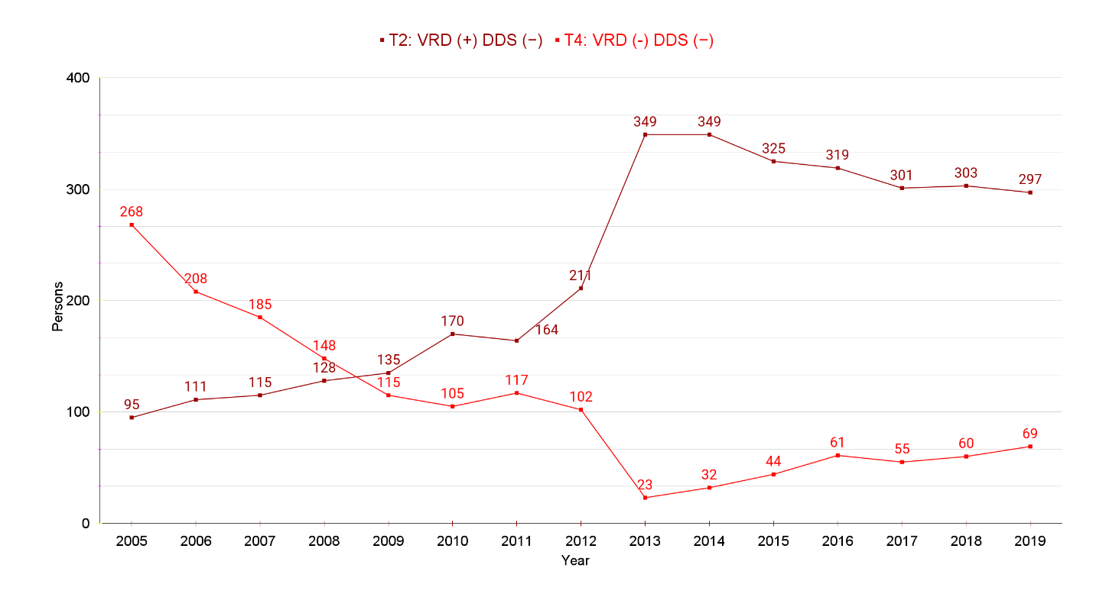

Fig. S5. T2:T3 on Sorok Island from 2005 to 2019.
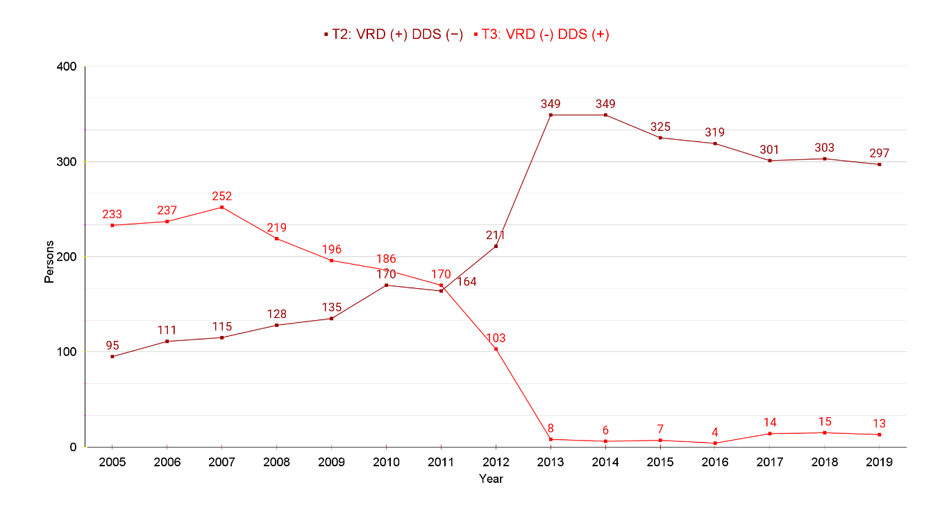

Fig. S6. Life expectancy and endemic status on Sorok Island
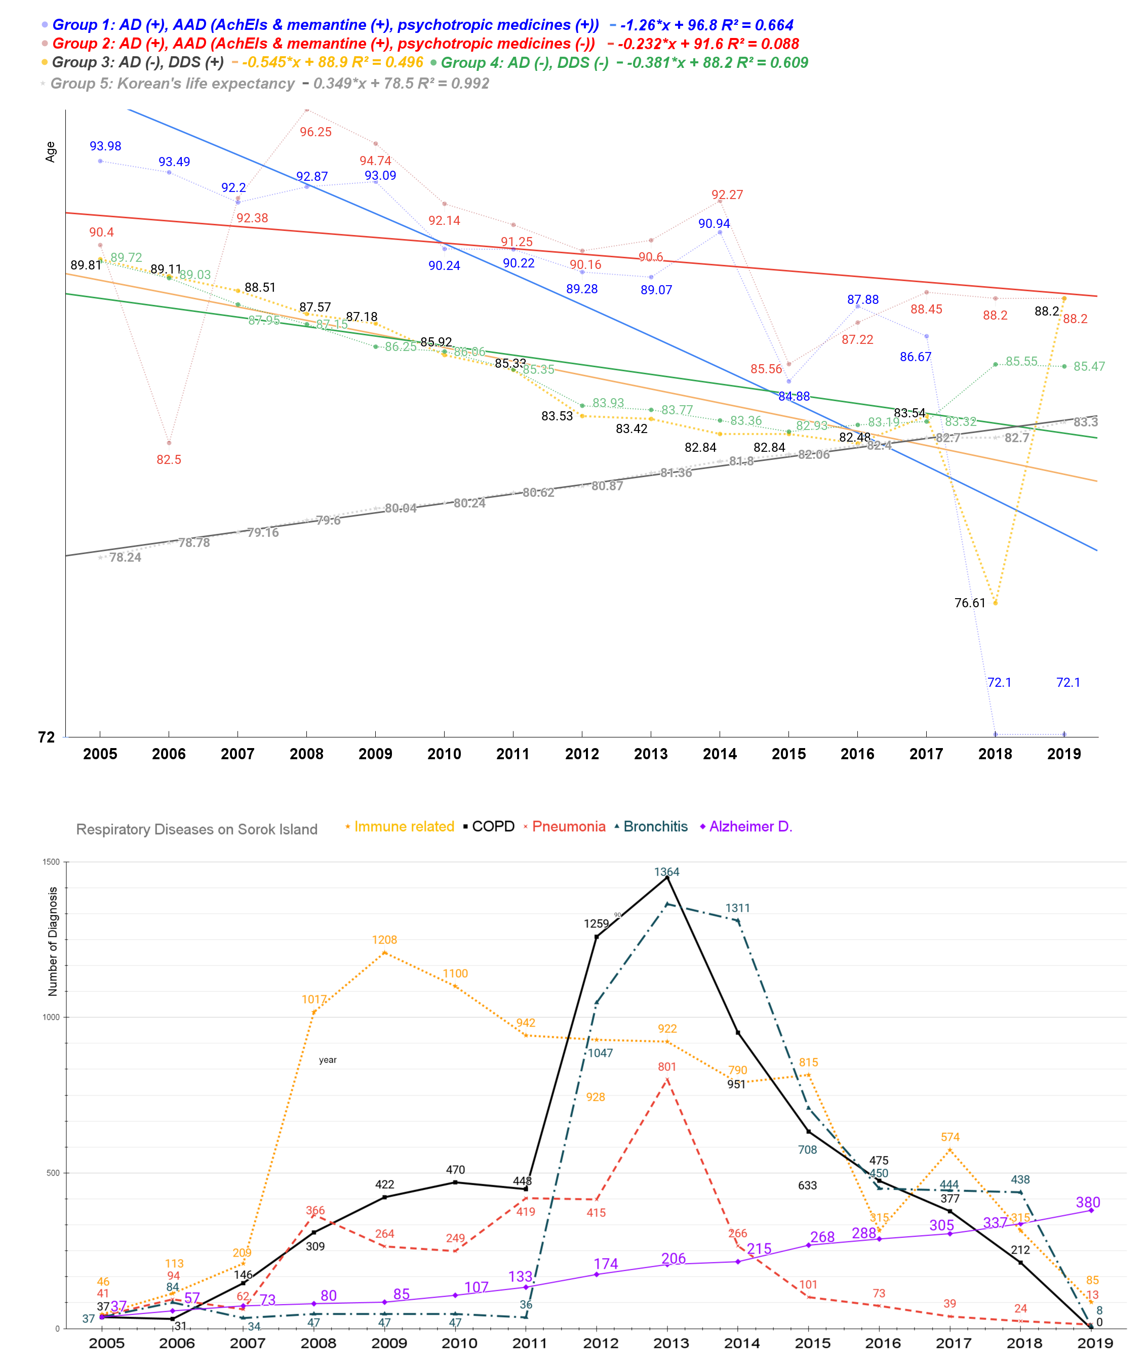
Patients in Group 1 and Group 2 were diagnosed with Alzheimer’s disease (+). Both are prescribed (+) acetylcholine esterase inhibitors (AchEIs) and memantine. In addition, group 1 was prescribed only psychotropic medicines. Patients in Group 3 and Group 4 were undiagnosed with Alzheimer’s disease. Group 3 was only dapsone prescribed (+), and group 4 was not dapsone prescribed (-). A gradual trend in life expectancy can be identified when observing a 15-year time series (2005-2019) (1). The group using AchEIs had a greater life expectancy than did those not using them. The life expectancy of the entire Korean population is gradually increasing (2).

Fig. S7. T1:T2 on Sorok Island from 2012 to 2019.
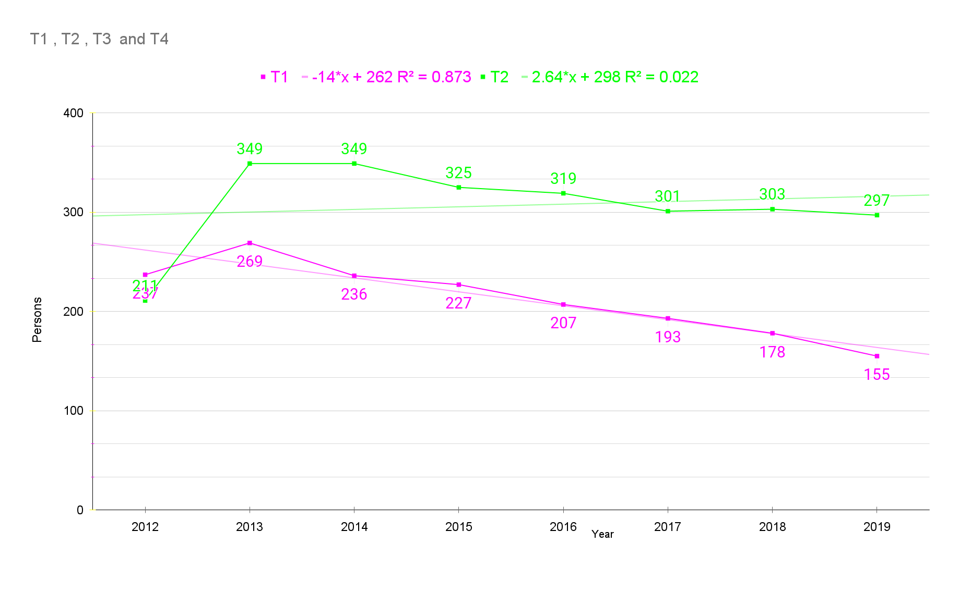

Fig. S8. T1:T3 on Sorok Island from 2012 to 2019.
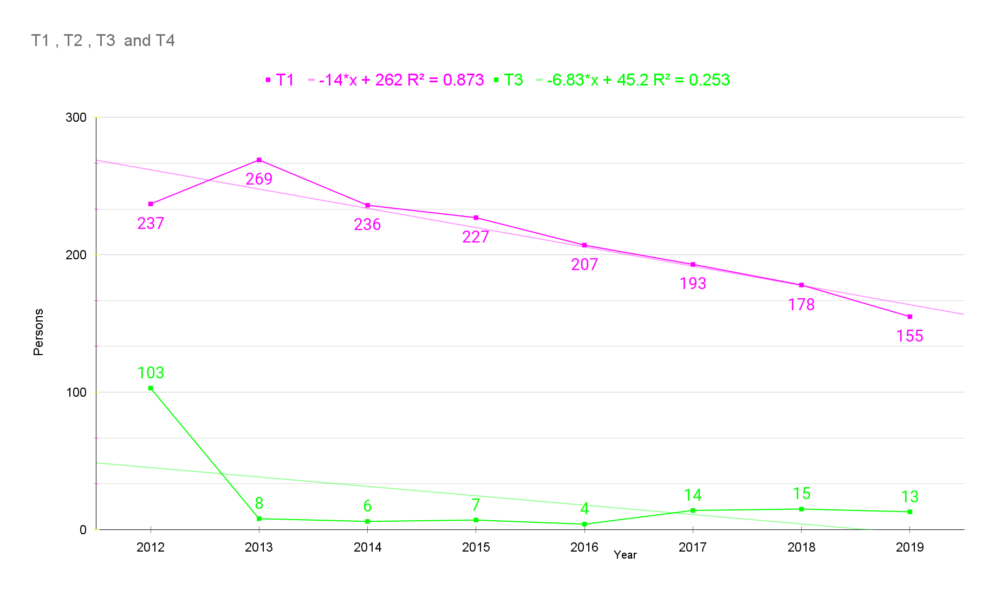

Fig. S9. T1:T4 on Sorok Island from 2012 to 2019.
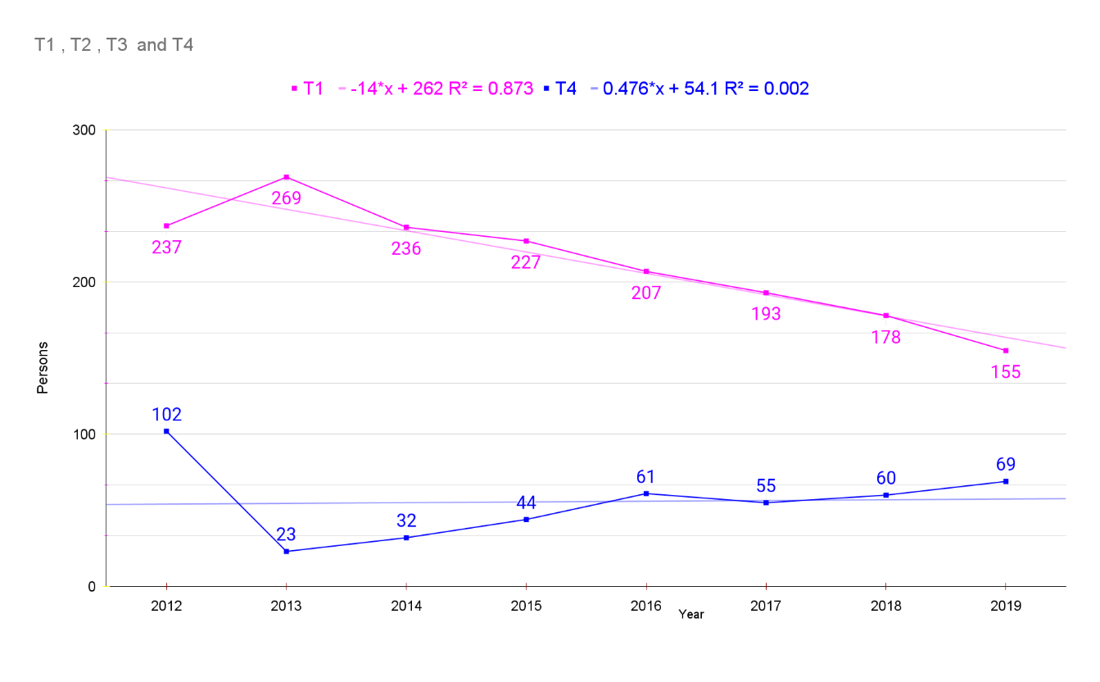

Fig. S10. T2:T3 on Sorok Island from 2012 to 2019.
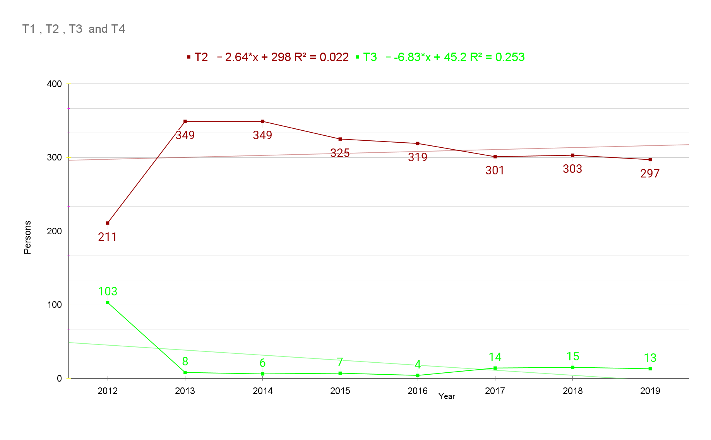

Fig. S11. T2:T4 on Sorok Island from 2012 to 2019.
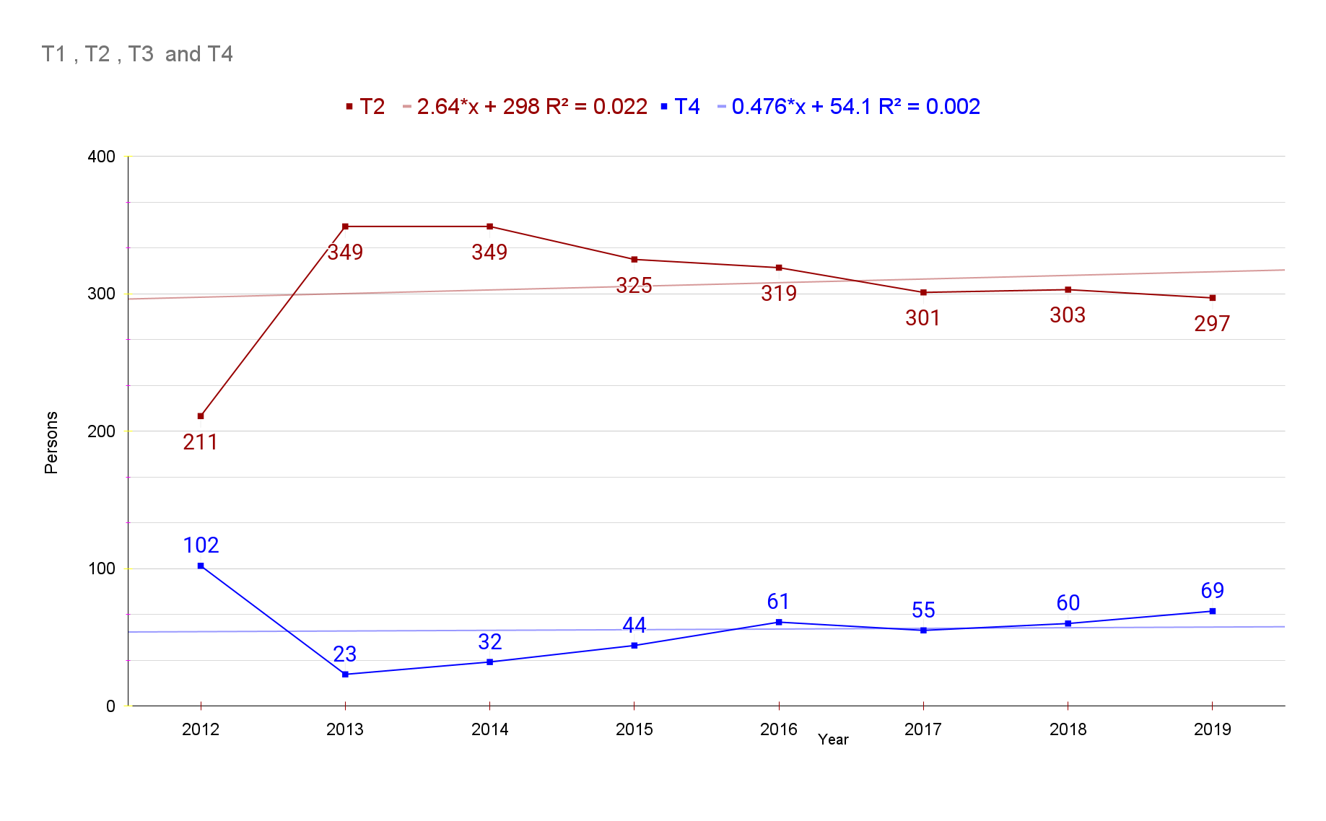

Fig. S12. AD patients without or with COPD.
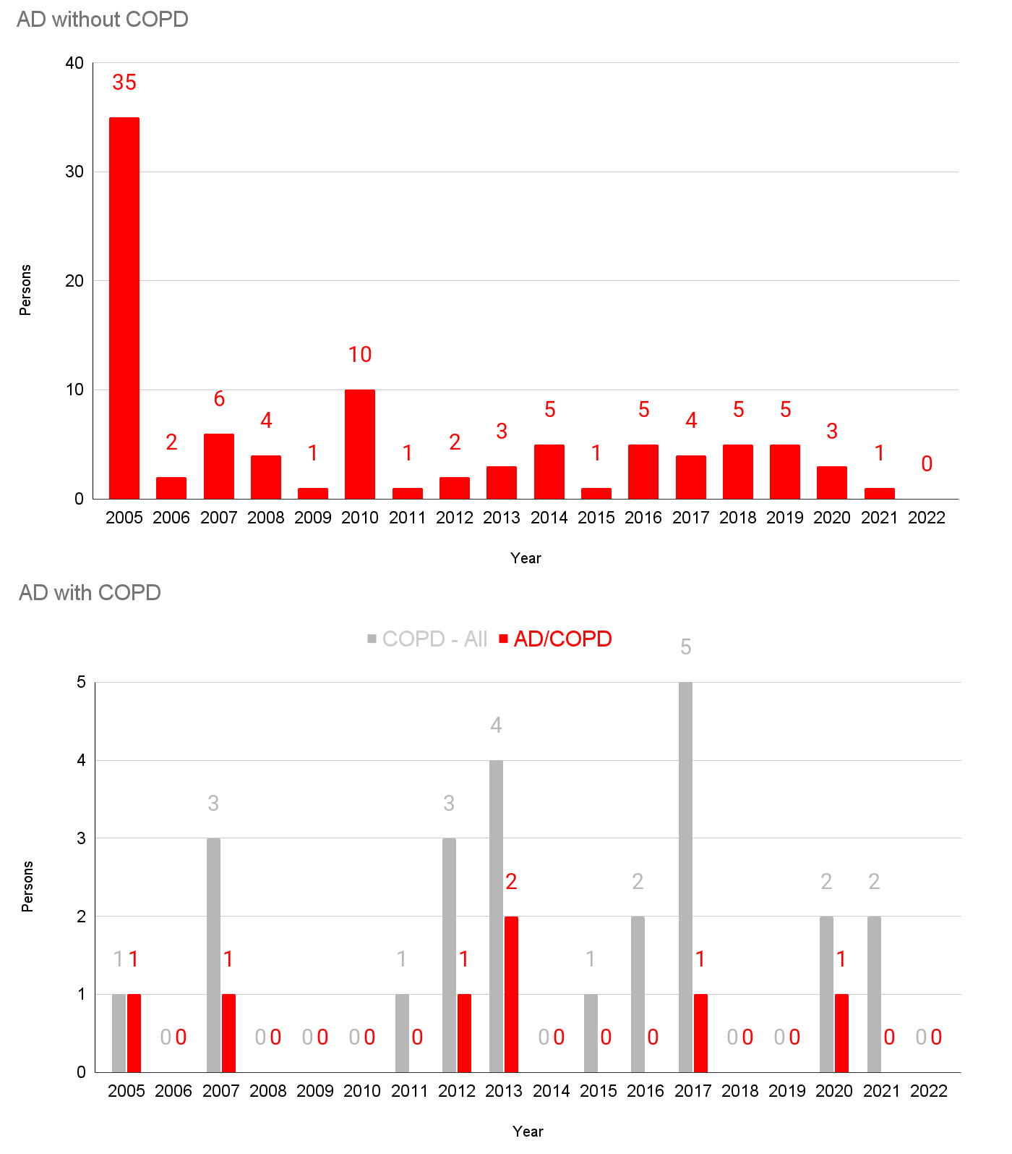

Table S1. Mental and Behavioral Disorders, F00-F09, G30
F00 code | Dementia in Alzheimer's disease (G30.-+)
F01 code | Vascular dementia
F02 code | Dementia in other diseases classified elsewhere
F03 code | Unspecified dementia
F04 code | Organic amnesic syndrome, not induced by alcohol and other psychoactive substances
F05 code | Delirium, not induced by alcohol and other psychoactive substances
F06 code | Other mental disorders due to brain damage and dysfunction and to physical disease
F07 code | Personality and behavioral disorders due to brain disease, damage and dysfunction
F09 code | Unspecified organic or symptomatic mental disorder
G30 code | Alzheimer's disease

Table S2. Symptomatic Relief of Alzheimer’s Disease
Donepezil  Rivastigmine  Galantamine  Memantine | 148603ATB 148602ATD 148602ATB 148601ATD 148601ATB 643401ATD 643402ATD
Donepezil  Rivastigmine  Galantamine  Memantine | 224501ACH 224503ACH 224504ACH 224505ACH 224506CPC 224507CPC 224508CPC
Donepezil  Rivastigmine  Galantamine  Memantine | 385203ACR 385203ATR 385204ACR 385204ATR 385205ACR 385205ATR
Donepezil  Rivastigmine  Galantamine  Memantine | 190031ALQ 190001ATB 190003ATD 190004ATB 190004ATD

Table S3. Psychologic Symptoms of Alzheimer’s Disease
Haloperidol  Risperidone  Quetiapine  Olanzapine  Aripiprazole  Oxcarbazepine  Fluvoxamine  Escitalopram  Trazodone  Sertraline  Fluoxetine | 167903ATB 167904ATB 167905ATB 167906ATB 167908ATB 167908ATB 168030BIJ
 | 224201ATB 224201ATD 224202ATB 224202ATD 224203ATB 224204ATB 224205BIJ 224206BIJ
 | 378601ATB 378602ATB 378603ATB 378604ATB 378605ATB 378605ATR 378606ATR 378607ATR 378608ATR 378608ATR 378610ATB
 | 204001ATB 204001ATD 204002ATB 204002ATD 204004ATB 204005ATB
 | 451501ATB 451501ATD 451502ATB 451502ATD 451503ATB 451504ATB 451505ATB 451506BIJ 451507BIJ
 | 206330ASS 206301ATB 206302ATB 206303ATB
 | 162501ATB 162502ATB
 | 474801ATB 474802ATB 474803ATB 474804ATB
 | 242901ACH 242901ATB 242902ATB 242903ATR
 | 227001ATB 227002ATB 227003ATB
 | 161501ACH 161501ATB 161502ACH 161502ATB 161502ATD

Table S4. AD (+) prevalence in the dapsone (+/-) subgroup*.
year | DDS (+) | DDS (-) | sum AD (+) | Mean | SD | 95% CI | [CI | CI]
2005 | 18 | 19 | 37 | 18.5 | 0.71 | 0.24 | 18.26 | 19.21
2006 | 20 | 37 | 57 | 28.5 | 12.02 | 3.19 | 25.31 | 40.52
2007 | 22 | 51 | 73 | 36.5 | 20.51 | 4.78 | 31.72 | 57.01
2008 | 22 | 58 | 80 | 40 | 25.46 | 5.66 | 34.34 | 65.46
2009 | 19 | 66 | 85 | 42.5 | 33.23 | 7.17 | 35.33 | 75.73
2010 | 25 | 82 | 107 | 53.5 | 40.31 | 7.73 | 45.77 | 93.81
2011 | 35 | 98 | 133 | 66.5 | 44.55 | 7.64 | 58.86 | 111.05
2012 | 39 | 135 | 174 | 87 | 67.88 | 10.16 | 76.84 | 154.88
2013 | 34 | 172 | 206 | 103 | 97.58 | 13.40 | 89.60 | 200.58
2014 | 25 | 190 | 215 | 107.5 | 116.67 | 15.68 | 91.82 | 224.17
2015 | 26 | 242 | 268 | 134 | 152.74 | 18.37 | 115.63 | 286.74
2016 | 33 | 255 | 288 | 144 | 156.98 | 18.21 | 125.79 | 300.98
2017 | 37 | 268 | 305 | 152.5 | 163.34 | 18.40 | 134.10 | 315.84
2018 | 45 | 292 | 337 | 168.5 | 174.66 | 18.71 | 149.79 | 343.16
2019 | 46 | 334 | 380 | 190 | 203.65 | 20.54 | 169.46 | 393.65
2020 | 32 | 352 | 384 | 192 | 226.27 | 22.70 | 169.30 | 418.27
Sum | 478 | 2651
Mean | 29.88 | 165.69
SD | 9.03 | 112.31
95% CI | 0.81 | 4.28 | 4.18
 | 29.06 | 161.41 | 191.39
 | 30.69 | 169.96 | 199.74
*Participants were randomized in a 2:1 ratio to DDS (+) or matching placebo DDS (-). Randomization was unrestricted (no blocking or stratification), and we analyzed the ICDs in the databases of Sorokdo National Hospital. A 2:1 allocation ratio was used because HD patients were taking dapsone for a lifetime. Therefore, this approach increases participants' probability of receiving the active study drug without compromising statistical power. Furthermore, the 2:1 allocation ratio led to a 10% increase in the overall sample size relative to the 1:1 allocation ratio (3).

Table S5. AD (-) prevalence in the dapsone (+/-) subgroup.
year | DDS (+) | DDS (-) | sum AD (-) | Mean | SD | 95% CI | [CI | CI]
2005 | 290 | 417 | 707 | 353.5 | 89.80 | 6.63 | 346.87 | 443.30
2006 | 302 | 363 | 665 | 332.5 | 43.13 | 3.28 | 329.22 | 375.63
2007 | 317 | 332 | 649 | 324.5 | 10.61 | 0.82 | 323.68 | 335.11
2008 | 310 | 312 | 622 | 311 | 1.41 | 0.11 | 310.89 | 312.41
2009 | 300 | 283 | 583 | 291.5 | 12.02 | 0.98 | 290.52 | 303.52
2010 | 270 | 286 | 556 | 278 | 11.31 | 0.94 | 277.06 | 289.31
2011 | 255 | 268 | 523 | 261.5 | 9.19 | 0.79 | 260.71 | 270.69
2012 | 238 | 241 | 479 | 239.5 | 2.12 | 0.19 | 239.31 | 241.62
2013 | 195 | 248 | 443 | 221.5 | 37.48 | 3.50 | 218.00 | 258.98
2014 | 172 | 236 | 408 | 204 | 45.25 | 4.40 | 199.60 | 249.25
2015 | 167 | 168 | 335 | 167.5 | 0.71 | 0.08 | 167.42 | 168.21
2016 | 154 | 149 | 303 | 151.5 | 3.54 | 0.40 | 151.10 | 155.04
2017 | 143 | 115 | 258 | 129 | 19.80 | 2.43 | 126.57 | 148.80
2018 | 132 | 87 | 219 | 109.5 | 31.82 | 4.24 | 105.26 | 141.32
2019 | 114 | 40 | 154 | 77 | 52.33 | 8.33 | 68.67 | 129.33
2020 | 109 | 4 | 113 | 56.5 | 74.25 | 13.84 | 42.66 | 130.75
Sum | 3468 | 3549
Mean | 216.75 | 221.81
SD | 76.04 | 117.71
95% CI | 2.53 | 3.87 | 4.45
 | 214.22 | 217.94 | 434.11
 | 219.28 | 225.69 | 443.01

Table S6. P value for the Dapsone (+/-) subgroup.
Year | DDS (+) | DDS (-) | AD (+) | Dapsone (+) | Dapsone (-) | AD (-) | P value* | chi-square | p value | 년도 | *AAD (+)
2005 | 18 | 19 | 37 | 290 | 417 | 707 | .3583 | 0.8438 | 0.358314 | 2005 | 79
2006 | 20 | 37 | 57 | 302 | 363 | 665 | .1324 | 2.2655 | 0.132282 | 2006 | 78
2007 | 22 | 51 | 73 | 317 | 332 | 649 | .0024** | 9.22 | 0.002394 | 2007 | 65
2008 | 22 | 58 | 80 | 310 | 312 | 622 | .00028** | 14.191 | 0.000165 | 2008 | 62
2009 | 19 | 66 | 85 | 300 | 283 | 583 | < .00001** | 25.1874 | 0.00001 | 2009 | 69
2010 | 25 | 82 | 107 | 270 | 286 | 556 | < .00001** | 23.0669 | 0.00001 | 2010 | 89
2011 | 35 | 98 | 133 | 255 | 268 | 523 | < .00001** | 21.651 | 0.00001 | 2011 | 102
2012 | 39 | 135 | 174 | 238 | 241 | 479 | < .00001** | 38.8685 | 0.00001 | 2012 | 116
2013 | 34 | 172 | 206 | 195 | 248 | 443 | < .00001** | 46.6137 | 0.00001 | 2013 | 115
2014 | 25 | 190 | 215 | 172 | 236 | 408 | < .00001** | 60.6925 | 0.00001 | 2014 | 61
2015 | 26 | 242 | 268 | 167 | 168 | 335 | < .00001** | 110.2835 | 0.00001 | 2015 | 35
2016 | 33 | 255 | 288 | 154 | 149 | 303 | < .00001** | 105.7934 | 0.00001 | 2016 | 22
2017 | 37 | 268 | 305 | 143 | 115 | 258 | < .00001** | 120.4582 | 0.00001 | 2017 | 17
2018 | 45 | 292 | 337 | 132 | 87 | 219 | < .00001** | 134.6692 | 0.00001 | 2018 | 13
2019 | 46 | 334 | 380 | 114 | 40 | 154 | < .00001** | 200.2285 | 0.00001 | 2019 | 13
2020 | 32 | 352 | 384 | 109 | 4 | 113 | < .00001** | 333.6671 | 0.00001 | 2020 | 9
 |  |  |  |  |  |  |  | 252.58 | < 0.00001
* Dats S4 disclosure 693119_DDS_AD_Related Table 4 Figure 6.xlsx from Lee, Jong Hoon (2022), “Data of Viral Respiratory Diseases on Sorok Island during the Pandemic”, Mendeley Data, V1, doi: 10.17632/cwxswnjnb2.1

Table S7 ICD-10 Major Codes for Viral Respiratory Diseases
Study Code | description
J00 | Acute nasopharyngitis [common cold]
J01 | Acute sinusitis
J01.8 | Other acute sinusitis. Acute sinusitis involving more than one sinus but not pansinusitis
J02 | Acute pharyngitis
J02.9 | Acute pharyngitis, unspecified pharyngitis (acute):  NOS  gangrenous  infective NOS  suppurative  ulcerative  Sore throat (acute) NOS
J03 | Acute tonsillitis
J03.9 | Acute tonsillitis, unspecified  Tonsillitis (acute):  NOS  follicular  gangrenous  infective  ulcerative
J04.0 | Acute laryngitis  Laryngitis (acute):  NOS  oedematous  subglottic  suppurative  ulcerative  Excl.: chronic laryngitis (J37.0)  influenzal laryngitis, influenza virus:  identified (J09, J10.1)  not identified (J11.1)
J06.0 | Acute laryngopharyngitis
J06.9 | Acute upper respiratory infection, unspecified  Upper respiratory:  disease, acute  infection NOS
J09 | Influenza due to identified zoonotic or pandemic influenza virus
J10.8 | Influenza with other manifestations, seasonal influenza virus identified. Encephalopathy due to influenza  Influenzal: seasonal influenza virus identified  gastroenteritis  myocarditis (acute)
J12.9 | Viral pneumonia, unspecified
J20.9 | Acute bronchitis, unspecified
(https://icd.who.int/browse10/2019/en#/J20-J22)
'J00', 'J01', 'J01.81', 'J02', 'J02.9', 'J03', 'J03.9', 'J04.0', 'J06.0', 'J06.9', 'J09', 'J10.8', 'J12.9', 'J20.9'

Table S8. ICD-10 Study Code for Respiratory Diseases and Prevalence on Sorok Island.
DISEASE NAME | year | 2005 | 2006 | 2007 | 2008 | 2009 | 2010 | 2011 | 2012 | 2013 | 2014 | 2015 | 2016 | 2017 | 2018 | 2019
Immune-related respiratory diseases |  | 46 | 113 | 209 | 1017 | 1208 | 1100 | 942 | 928 | 922 | 790 | 815 | 315 | 574 | 315 | 85
ASTHMA | J45 | 6 | 5 | 5 | 5 | 5 | 5 | 5 | 4 | 2 | 3 | 2 | 1 | 1 | 1
PREDOMINANTLY ALLERGIC ASTHMA | J45.0 |  |  | 40 | 40
NONALLERGIC ASTHMA | J45.1 |  |  | 36
ASTHMA, UNSPECIFIED | J45.9 |  |  |  |  |  |  |  |  | 5 | 6 | 7 | 6 | 5 | 3 | 2
STATUS ASTHMATICUS | J46 |  |  |  | 4 | 4 | 4
VASOMOTOR RHINITIS | J30.0 |  |  | 3 | 45 | 54 | 96 | 99 | 182 | 180 | 110 | 96 | 28 | 30 | 29 | 9
ALLERGIC RHINITIS, UNSPECIFIED | J30.4 | 11 | 11 | 60 | 189 | 205 | 197 | 151 | 142 | 178 | 129 | 102 | 71 | 47 | 40 | 21
CHRONIC RHINITIS | J31.0 | 10 | 40 | 40 | 16 | 95 | 91 | 64 | 19 | 15 | 18 | 19 | 16 | 14 | 11 | 1
CHRONIC SINUSITIS | J32 |  |  |  | 571 | 636 | 567 | 455 | 345 | 291 | 155 | 128 |  | 106 |  | 5
CHRONIC MAXILLARY SINUSITIS | J32.0 |  |  |  |  |  |  |  |  | 1 | 9 | 20 |  | 17 |  | 5
CHRONIC PANSINUSITIS | J32.4 |  |  |  |  |  |  |  |  |  |  | 2 | 2 | 4 | 4 | 4
OTHER CHRONIC SINUSITIS | J32.8 |  |  |  |  |  |  |  |  |  |  |  | 1 | 1 | 1 | 1
CHRONIC SINUSITIS, UNSPECIFIED | J32.9 | 11 | 19 | 18 | 16 | 15 | 15 | 44 | 41 | 42 | 33 | 32 | 32 | 29
CHRONIC LARYNGITIS | J37.0 | 6 | 6 | 6 |  | 7 | 6 | 6 | 6 | 5 | 7 | 12 | 15 | 11 | 8 | 3
CHRONIC NASOPHARYNGITIS | J31.1 |  |  |  |  |  |  |  |  | 2 | 17 | 33 | 49 | 38 | 30 | 8
CHRONIC PHARYNGITIS | J31.2 |  | 27 |  |  |  |  |  |  | 79 | 168 | 226 |  | 188 | 130
ABSCESS, FURUNCLE AND CARBUNCLE OF NOSE | J34.0 |  | 1 | 1 | 122 | 127 | 59 | 59 | 43 | 24 | 51 | 47 | 47 | 41 | 25 | 16
DEVIATED NASAL SEPTUM | J34.2 |  |  |  | 5 | 56 | 56 | 56 | 120 | 70 | 51 | 65 | 22 | 26 | 27 | 6
OTHER SPECIFIED DISORDERS OF NOSE AND NASAL SINUSES | J34.8 | 2 | 4 |  | 4 | 4 | 4 | 3 | 3 | 5 | 5 | 7 | 6 | 2 | 2 | 2
CHRONIC TONSILLITIS | J35.0 |  |  |  |  |  |  |  |  |  | 5 | 10 | 12 | 7 | 4 | 2
PERITONSILLAR ABSCESS | J36 |  |  |  |  |  |  |  | 7 | 7 | 7 | 7 | 7 | 7
RETROPHARYNGEAL AND PARAPHARYNGEAL ABSCESS | J39.0 |  |  |  |  |  |  |  | 16 | 16 | 16
Bronchitis |  | 37 | 84 | 34 | 47 | 47 | 47 | 36 | 1047 | 1364 | 1311 | 708 | 450 | 444 | 438 | 8
ACUTE BRONCHITIS, UNSPECIFIED | J20.9 | 11 | 11 | 1 | 1 | 1 | 1 | 1 | 515 | 675 | 655 | 354 | 225 | 222 | 219 | 4
BRONCHITIS, NOT SPECIFIED AS ACUTE OR CHRONIC | J40 | 4 | 4 | 4 | 4 | 4 | 4 | 4 | 4 | 1 | 1
UNSPECIFIED CHRONIC BRONCHITIS | J42 | 11 | 58 | 28 | 41 | 41 | 41 | 30 | 13 | 13
Pneumonia |  | 41 | 94 | 62 | 366 | 264 | 249 | 419 | 415 | 801 | 266 | 101 | 73 | 39 | 24 | 13
BACTERIAL PNEUMONIA, NEC | J15 |  |  | 1 | 18 | 24 | 18 | 143 | 17 | 6 | 2
OTHER BACTERIAL PNEUMONIA | J15.8 |  | 16 |  | 86 | 89 | 88 | 3 | 3 | 3 |  |  | 1 | 16 | 7 | 1
BACTERIAL PNEUMONIA, UNSPECIFIED | J15.9 | 5 | 5 | 5 | 95 | 5 | 6 | 136 | 258 | 638 | 218 | 68 | 32 | 5 | 4 | 4
PNEUMONIA IN BACTERIAL DISEASES CLASSIFIED ELSEWHERE | J17.0 |  | 20 | 20 | 20 | 20 | 20 | 20 | 20 | 20 | 20
OTHER PNEUMONIA, ORGANISM UNSPECIFIED | J18.8 |  | 17 |  | 111 | 111 | 110 | 110 | 110 | 127 | 17 | 17 | 17
PNEUMONIA, UNSPECIFIED | J18.9 | 36 | 36 | 36 | 36 | 15 | 7 | 7 | 7 | 7 | 9 | 16 | 23 | 18 | 13 | 8
COPD |  | 37 | 31 | 146 | 309 | 422 | 470 | 448 | 1259 | 1450 | 951 | 633 | 475 | 377 | 212 | 0
PNEUMONITIS DUE TO FOOD AND VOMIT | J69.0 |  | 5 | 5 | 6 | 6 | 1 | 9 | 61 | 89 | 34 | 39 | 36 | 35 | 34 | 1
OTHER CHRONIC OBSTRUCTIVE PULMONARY DISEASE | J44 |  |  |  | 65 | 64 | 64 | 64
CHRONIC OBSTRUCTIVE PULMONARY DISEASE, UNSPECIFIED | J44.9 | 35 | 29 | 144 | 242 | 356 | 404 | 382 | 1257 | 1447 | 948 | 631 | 473 | 375 | 212
BRONCHIECTASIS | J47 | 2 | 2 | 2 | 2 | 2 | 2 | 2 | 2 | 3 | 3 | 2 | 2 | 2
End stage |  | 1 | 10 | 6 | 26 | 1 | 1 | 1 | 1 | 1 | 3 | 9 | 4 | 11 | 4 | 2
PULMONARY OEDEMA | J81 |  |  |  |  |  |  |  |  |  |  | 3 | 2 | 2 | 2 | 1
ABSCESS OF LUNG WITH PNEUMONIA | J85.1 |  | 5 | 5 | 5
PLEURAL EFFUSION, NEC | J90 |  |  |  |  |  |  |  |  |  |  | 2 | 1 | 2
PNEUMOTHORAX | J93 | 1 | 5 | 1 | 1 | 1 | 1 | 1 | 1 | 1 | 1 | 1
HAEMOTHORAX | J94.2 |  |  |  |  |  |  |  |  |  | 2 | 1 | 1
CHRONIC PULMONARY INSUFFICIENCY FOLLOWING SURGERY | J95.3 |  |  |  |  |  |  |  |  |  |  | 1 |  | 1
ACUTE RESPIRATORY FAILURE | J96.0 |  |  |  | 20
PULMONARY COLLAPSE | J98.1 |  |  |  |  |  |  |  |  |  |  | 1
OTHER SPECIFIED RESPIRATORY DISORDERS | J98.8 |  |  |  |  |  |  |  |  |  |  |  |  | 1
RESPIRATORY DISORDER, UNSPECIFIED | J98.9 |  |  |  |  |  |  |  |  |  |  |  |  | 5 | 2 | 1
Sum |  | 634 | 1004 | 1254 | 3384 | 3971 | 3950 | 3985 | 6249 | 8359 | 6448 | 5229 | 3795 | 3314 | 2172 | 575

Table S9. Study of the prevalence of viral respiratory diseases (VRDs) on Sorok Island, South Korea. The primary T1:T2:T3:T4 study was a retrospective cohort study at Sorok Island.

year | T1 | T2 | T3 | T4 | Sum | Mean | SDf | 95% CI | [CI | CI] | χ2 | p value
2005 | 148 | 95 | 233 | 268 | 744 | 186 | 78.86 | 11.41 | 174.59 | 264.86 | 13.5772 | 0.000229
2006 | 166 | 111 | 237 | 208 | 722 | 180.5 | 54.74 | 8.05 | 172.45 | 235.24 | 3.0793 | 0.079295
2007 | 170 | 115 | 252 | 185 | 722 | 180.5 | 56.37 | 8.29 | 172.21 | 236.87 | 0.2794 | 0.597118
2008 | 207 | 128 | 219 | 148 | 702 | 175.5 | 44.34 | 6.61 | 168.89 | 219.84 | 0.3293 | 0.566073
2009 | 222 | 135 | 196 | 115 | 668 | 167 | 50.31 | 7.69 | 159.31 | 217.31 | 0.0498 | 0.823418
2010 | 202 | 170 | 186 | 105 | 663 | 165.75 | 42.55 | 6.54 | 159.21 | 208.30 | 6.2203 | 0.012629
2011 | 205 | 164 | 170 | 117 | 656 | 164 | 36.18 | 5.58 | 158.42 | 200.18 | 0.8918 | 0.344987
2012 | 237 | 211 | 103 | 102 | 653 | 163.25 | 70.95 | 10.97 | 152.28 | 234.20 | 0.3981 | 0.528071
2013 | 269 | 349 | 8 | 23 | 649 | 162.25 | 172.68 | 26.79 | 135.46 | 334.93 | 3.7892 | 0.051583
2014 | 236 | 349 | 6 | 32 | 623 | 155.75 | 164.85 | 26.16 | 129.59 | 320.60 | 9.0547 | 0.00262
2015 | 227 | 325 | 7 | 44 | 603 | 150.75 | 150.82 | 24.33 | 126.42 | 301.57 | 14.7575 | 0.000122
2016 | 207 | 319 | 4 | 61 | 591 | 147.75 | 142.63 | 23.25 | 124.50 | 290.38 | 27.7773 | < 0.00001e
2017 | 193 | 301 | 14 | 55 | 563 | 140.75 | 131.44 | 21.96 | 118.79 | 272.19 | 9.1835 | 0.002442
2018 | 178 | 303 | 15 | 60 | 556 | 139 | 129.14 | 21.66 | 117.34 | 268.14 | 8.2801 | 0.004008
2019 | 155 | 297 | 13 | 69 | 534 | 133.5 | 123.66 | 21.21 | 112.29 | 257.16 | 10.9433 | 0.000939
Sum | 3022 | 3372 | 1663 | 1592
Mean | 201.47 | 224.80 | 110.87 | 106.13
SD | 33.86 | 97.50 | 103.80 | 70.30
95% CI | 1.21 | 3.29 | 4.99 | 3.46
[ | 200.26 | 221.51 | 105.87 | 102.68
] | 202.67 | 228.09 | 115.86 | 109.59
The chi-square is 281.826.
The p value is < 0.00001. It is significant at p < .05.

Table S10 after DMA for the 2005-2019 T1:T2:T3:T4 study at Sorok Island

Summary of Data
 | Treatments
 | 1 |  | 2 | 3 | 4 | 5 |  | Total
N | 15 |  | 15 | 15 | 15 |  |  | 60
∑X | 3022 |  | 3372 | 1663 | 1592 |  |  | 9649
Mean | 201.4667 |  | 224.8 | 110.8667 | 106.1333 |  |  | 160.817
∑X² | 624884 |  | 891104 | 335199 | 238156 |  |  | 2089343
Std.Dev. | 33.8608 |  | 97.4967 | 103.795 | 70.3013 |  |  | 95.4581
Result Details
Source |  | SS |  | df | MS
Between-treatments |  | 168473.3833 |  | 3 | 56157.7944 |  | F = 8.51914
Within-treatments |  | 369149.6 |  | 56 | 6591.9571
Total |  | 537622.9833 |  | 59
The f-ratio is 8.51914. The p value is.000094. The result is significant at p <.05.

Post hoc Tukey HSD
Pairwise Comparisons |  | HSD_{.05} = 78.5016  HSD_{.01} = 96.6119 | Q_{.05} = 3.7447 Q_{.01} = 4.6086
T₁:T₂ | M₁ = 201.47  M₂ = 224.80 | 23.33 | Q = 1.11 (p = .86003)
T₁:T₃ | M₁ = 201.47  M₃ = 110.87 | 90.60 | Q = 4.32 (p = .01755)
T₁:T₄ | M₁ = 201.47  M₄ = 106.13 | 95.33 | Q = 4.55 (p = .01130)
T₂:T₃ | M₂ = 224.80  M₃ = 110.87 | 113.93 | Q = 5.43 (p = .00173)
T₂:T₄ | M₂ = 224.80  M₄ = 106.13 | 118.67 | Q = 5.66 (p = .00104)
T₃:T₄ | M₃ = 110.87  M₄ = 106.13 | 4.73 | Q = 0.23 (p = .99853)

Table S11. RCT Study - The primary T1:T2:T3:T4 study was a retrospective cohort study at Sorok Island.

year | T1* | T2* | T3* | T4* | Sum | Mean | SD^{f} | CI^{g} | [CI^{g} | CI^{g}] | χ2* | p value
Pre RCT Study
2005 | 148 | 95 | 233 | 268 | 744 | 186 | 78.86 | 11.41 | 174.59 | 264.86 | 13.5772 | 0.000229
2006 | 166 | 111 | 237 | 208 | 722 | 180.5 | 54.74 | 8.05 | 172.45 | 235.24 | 3.0793 | 0.079295
2007 | 170 | 115 | 252 | 185 | 722 | 180.5 | 56.37 | 8.29 | 172.21 | 236.87 | 0.2794 | 0.597118
2008 | 207 | 128 | 219 | 148 | 702 | 175.5 | 44.34 | 6.61 | 168.89 | 219.84 | 0.3293 | 0.566073
2009 | 222 | 135 | 196 | 115 | 668 | 167 | 50.31 | 7.69 | 159.31 | 217.31 | 0.0498 | 0.823418
2010 | 202 | 170 | 186 | 105 | 663 | 165.75 | 42.55 | 6.54 | 159.21 | 208.30 | 6.2203 | 0.012629
2011 | 205 | 164 | 170 | 117 | 656 | 164 | 36.18 | 5.58 | 158.42 | 200.18 | 0.8918 | 0.344987
RCT Study
2012 | 237 | 211 | 103 | 102 | 653 | 163.25 | 70.95 | 10.97 | 152.28 | 234.20 | 0.3981 | 0.528071
2013 | 269 | 349 | 8 | 23 | 649 | 162.25 | 172.68 | 26.79 | 135.46 | 334.93 | 3.7892 | 0.051583
2014 | 236 | 349 | 6 | 32 | 623 | 155.75 | 164.85 | 26.16 | 129.59 | 320.60 | 9.0547 | 0.00262
2015 | 227 | 325 | 7 | 44 | 603 | 150.75 | 150.82 | 24.33 | 126.42 | 301.57 | 14.7575 | 0.000122
2016 | 207 | 319 | 4 | 61 | 591 | 147.75 | 142.63 | 23.25 | 124.50 | 290.38 | 27.7773 | < 0.00001e
2017 | 193 | 301 | 14 | 55 | 563 | 140.75 | 131.44 | 21.96 | 118.79 | 272.19 | 9.1835 | 0.002442
2018 | 178 | 303 | 15 | 60 | 556 | 139 | 129.14 | 21.66 | 117.34 | 268.14 | 8.2801 | 0.004008
2019 | 155 | 297 | 13 | 69 | 534 | 133.5 | 123.66 | 21.21 | 112.29 | 257.16 | 10.9433 | 0.000939
Sum | 1702 | 2454 | 170 | 446
Mean | 212.75 | 306.75 | 21.25 | 55.75
SD | 36.7647 | 43.6929 | 33.277 | 24.3061
The chi-square is 281.826.
The p value is < 0.00001. I t is significant at p < .05.
The f-ratio value is 116.07984.

Post Hoc Tukey HSD
Pairwise Comparisons |  | HSD_{.05} = 48.0660 HSD_{.01} = 60.1211 | Q_{.05} = 3.8612 Q_{.01} = 4.8296
T₁:T₂ | M₁ = 212.75  M₂ = 306.75 | 94.00 | Q = 7.55 (p = .00006)
T₁:T₃ | M₁ = 212.75  M₃ = 21.25 | 191.50 | Q = 15.38 (p = .00000)
T₁:T₄ | M₁ = 212.75  M₄ = 55.75 | 157.00 | Q = 12.61 (p = .00000)
T₂:T₃ | M₂ = 306.75  M₃ = 21.25 | 285.50 | Q = 22.93 (p = .00000)
T₂:T₄ | M₂ = 306.75  M₄ = 55.75 | 251.00 | Q = 20.16 (p = .00000)
T₃:T₄ | M₃ = 21.25  M₄ = 55.75 | 34.50 | Q = 2.77 (p = .22720)

Table S12. Survivors of non-COPD with AD at Sorokdo National Hospital
'22.1.1.~'22.9.30. non-COPD patients Survivor
No | Sex | Age | Hypertension | Obesity | Cancer | Diabetes | DDS | AD | Leprosy activity
349 | Female | 81.7 | Y | N | N | Y | Y | Y | N
336 | Female | 72 | N | N | N | N | N | Y | N
375 | Female | 83.4 | Y | N | N | N | N | Y | N
112 | Male | 85 | Y | N | N | N | N | Y | N
114 | Male | 88.4 | Y | N | N | N | Y | Y | N
116 | Female | 88.8 | N | N | N | N | N | Y | N
117 | Female | 92.2 | Y | N | N | N | Y | Y | N
119 | Female | 80.2 | Y | N | N | N | Y | Y | N
123 | Female | 74.6 | Y | N | N | N | Y | Y | N
258 | Female | 75.9 | Y | N | N | Y | N | Y | N
126 | Male | 88.6 | Y | N | N | Y | N | Y | N
272 | Male | 83.5 | Y | N | N | N | N | Y | N
130 | Female | 84 | Y | N | N | N | N | Y | N
384 | Female | 87 | Y | N | N | Y | Y | Y | N
134 | Male | 73 | Y | N | N | N | N | Y | N
366 | Female | 85.5 | Y | N | N | N | N | Y | N
137 | Female | 89.1 | Y | N | N | N | Y | Y | N
403 | Female | 83.2 | N | N | N | N | N | Y | N
260 | Male | 73.9 | Y | N | N | Y | Y | Y | N
406 | Female | 95 | N | N | N | N | N | Y | N
376 | Female | 84 | Y | N | N | Y | N | Y | N
144 | Female | 88.1 | N | N | N | N | Y | Y | N
145 | Female | 92 | Y | N | N | N | Y | Y | N
252 | Female | 77.4 | Y | N | N | Y | Y | Y | N
147 | Male | 97.1 | N | N | N | N | N | Y | N
148 | Female | 93.4 | Y | N | N | N | N | Y | N
339 | Female | 79.3 | Y | N | N | N | Y | Y | N
328 | Male | 86.6 | Y | N | N | N | N | Y | N
155 | Female | 89.3 | N | N | N | N | N | Y | N
163 | Female | 79 | N | N | N | N | N | Y | N
274 | Female | 88.4 | Y | N | N | N | N | Y | N
385 | Female | 81 | Y | N | N | N | N | Y | N
295 | Male | 62 | N | N | N | N | Y | Y | N
168 | Female | 92.6 | Y | N | N | N | Y | Y | N
170 | Female | 77.3 | Y | N | N | Y | N | Y | N
171 | Female | 85 | Y | N | N | N | Y | Y | N
395 | Female | 94.8 | N | N | N | N | N | Y | N
173 | Male | 80.6 | Y | N | N | N | Y | Y | N
351 | Female | 79.5 | Y | N | N | Y | Y | Y | N
316 | Female | 93.5 | N | N | N | N | N | Y | N
368 | Female | 91.5 | Y | N | N | N | N | Y | N
176 | Female | 86 | N | N | N | N | Y | Y | N
396 | Female | 82.6 | Y | N | N | N | N | Y | N
377 | Male | 88.8 | Y | N | N | Y | Y | Y | N
263 | Female | 79.6 | Y | N | N | N | Y | Y | N
179 | Male | 80.5 | N | N | N | N | Y | Y | N
182 | Female | 67.2 | Y | N | N | N | Y | Y | N
378 | Female | 85.5 | Y | N | N | N | N | Y | N
352 | Male | 91.3 | N | N | N | Y | N | Y | N
369 | Female | 86.1 | N | N | N | N | N | Y | N
266 | Female | 98 | N | N | N | N | Y | Y | N
387 | Female | 83 | N | N | N | N | N | Y | N
297 | Female | 66.6 | Y | N | N | Y | Y | Y | N
298 | Female | 84 | Y | N | N | N | N | Y | N
300 | Male | 75.2 | N | N | N | Y | Y | Y | N
355 | Male | 69.2 | Y | N | N | N | N | Y | N
301 | Male | 80 | Y | N | N | Y | Y | Y | N
388 | Male | 83 | Y | N | N | N | N | Y | N
276 | Male | 77.8 | Y | N | N | N | N | Y | N
371 | Female | 78.4 | Y | N | N | N | N | Y | N
201 | Female | 90.5 | Y | N | N | N | N | Y | N
267 | Male | 76.9 | Y | N | N | Y | N | Y | N
302 | Male | 89 | Y | N | N | N | N | Y | N
207 | Female | 87.6 | N | N | N | N | N | Y | N
208 | Female | 92.6 | Y | N | N | N | Y | Y | N
210 | Female | 63.8 | N | N | N | Y | Y | Y | N
211 | Male | 89 | Y | N | N | N | Y | Y | N
255 | Female | 82.5 | N | N | N | N | N | Y | N
304 | Male | 75.4 | N | N | N | N | Y | Y | N
221 | Male | 81.4 | N | N | N | N | Y | Y | N
397 | Female | 94 | Y | N | N | N | N | Y | N
379 | Female | 84.8 | Y | N | N | N | Y | Y | N
357 | Female | 81.2 | Y | N | N | N | N | Y | N
226 | Female | 86.9 | N | N | N | N | N | Y | N
399 | Male | 83.7 | N | N | N | N | N | Y | N
280 | Male | 86.5 | Y | N | N | N | N | Y | N
305 | Female | 86.5 | Y | N | N | N | Y | Y | N
404 | Male | 76.6 | Y | N | N | N | N | Y | N
228 | Male | 86.1 | Y | N | N | Y | N | Y | N
405 | Female | 99.2 | Y | N | N | N | N | Y | N
231 | Female | 83.5 | Y | N | N | N | Y | Y | N
373 | Female | 78.8 | Y | N | N | N | N | Y | N
236 | Male | 85.6 | Y | N | N | N | Y | Y | N
307 | Female | 91 | Y | N | N | Y | N | Y | N
401 | Female | 77 | N | N | N | N | N | Y | N
382 | Female | 82.4 | Y | N | N | N | N | Y | N
270 | Female | 84.6 | Y | N | N | N | Y | Y | N
291 | Female | 82 | Y | N | N | N | N | Y | N
308 | Female | 88 | Y | N | N | N | N | Y | N
391 | Male | 74.9 | N | N | N | Y | N | Y | N
249 | Male | 80.3 | Y | N | N | Y | N | Y | N
364 | Female | 78 | N | N | N | Y | Y | Y | N
250 | Male | 90.8 | Y | N | N | N | N | Y | N
335 | Male | 79.5 | Y | N | N | N | Y | Y | N

Table S13. Onset year of patients with NON-COPD and AD (2022 survivors)

 | 2005 | 2006 | 2007 | 2008 | 2009 | 2010 | 2011 | 2012 | 2013 | 2014 | 2015 | 2016 | 2017 | 2018 | 2019 | 2020 | 2021 | 2022
1 |  |  |  |  |  |  |  |  |  | *1
2 |  |  |  |  |  |  |  |  | 1
3 |  |  |  |  |  |  |  |  | 1
4 | 1
5 | 1
6 | 1
7 | 1
8 | 1
9 | 1
10 |  |  | 1
11 | 1
12 |  |  |  | 1
13 | 1
14 |  |  |  |  |  |  |  |  |  |  |  |  |  | 1
15 | 1
16 |  |  |  |  |  |  |  |  |  |  |  | 1
17 | 1
18 |  |  |  |  |  |  |  |  |  |  |  |  |  |  |  | 1
19 |  |  | 1
20 |  |  |  |  |  |  |  |  |  |  |  |  |  |  |  |  | 1
21 |  |  |  |  |  |  |  |  |  |  |  |  | 1
22 | 1
23 | 1
24 |  | 1
25 | 1
26 | 1
27 |  |  |  |  |  |  |  |  | 1
28 |  |  |  |  |  |  |  | 1
29 | 1
30 | 1
31 |  |  |  | 1
32 |  |  |  |  |  |  |  |  |  |  |  |  |  | 1
33 |  |  |  |  |  | 1
34 | 1
35 | 1
36 | 1
37 |  |  |  |  |  |  |  |  |  |  |  |  |  |  | 1
38 | 1
39 |  |  |  |  |  |  |  |  |  | 1
40 |  |  |  |  |  |  | 1
41 |  |  |  |  |  |  |  |  |  |  |  | 1
42 | 1
43 |  |  |  |  |  |  |  |  |  |  |  |  |  |  | 1
44 |  |  |  |  |  |  |  |  |  |  |  |  | 1
45 |  |  | 1
46 | 1
47 | 1
48
49 |  |  |  |  |  |  |  |  |  | 1
50 |  |  |  |  |  |  |  |  |  |  |  | 1
51 |  |  | 1
52 |  |  |  |  |  |  |  |  |  |  |  |  |  | 1
53 |  |  |  |  |  | 1
54 |  |  |  |  |  | 1
55 |  |  |  |  |  | 1
56 |  |  |  |  |  |  |  |  |  | 1
57 |  |  |  |  |  | 1
58 |  |  |  |  |  |  |  |  |  |  |  |  |  | 1
59 |  |  |  | 1
60 |  |  |  |  |  |  |  |  |  |  |  | 1
61 | 1
62 |  |  | 1
63 |  |  |  |  |  | 1
64 | 1
65 | 1
66 | 1
67 | 1
68 |  | 1
69 |  |  |  |  |  | 1
70 | 1
71 |  |  |  |  |  |  |  |  |  |  |  |  |  |  | 1
72 |  |  |  |  |  |  |  |  |  |  |  |  | 1
73 |  |  |  |  |  |  |  |  |  | 1
74 | 1
75 |  |  |  |  |  |  |  |  |  |  |  |  |  |  | 1
76 |  |  |  | 1
77 |  |  |  |  |  | 1
78 |  |  |  |  |  |  |  |  |  |  |  |  |  |  |  | 1
79 | 1
80 |  |  |  |  |  |  |  |  |  |  |  |  |  |  |  | 1
81 | 1
82 |  |  |  |  |  |  |  |  |  |  |  | 1
83 | 1
84 |  |  |  |  |  | 1
85 |  |  |  |  |  |  |  |  |  |  |  |  |  |  | 1
86 |  |  |  |  |  |  |  |  |  |  |  |  | 1
87 |  |  | 1
88 |  |  |  |  | 1
89 |  |  |  |  |  | 1
90 |  |  |  |  |  |  |  |  |  |  |  |  |  | 1
91 | 1
92 |  |  |  |  |  |  |  |  |  |  | 1
93 | 1
94 |  |  |  |  |  |  |  | 1
Sum | 35 | 2 | 6 | 4 | 1 | 10 | 1 | 2 | 3 | 5 | 1 | 5 | 4 | 5 | 5 | 3 | 1 | 0
*1 The year of diagnosis of Alzheimer’s disease

Table S14. All COPD patients on Sorok Island from 2005 to 2021
Year |  | No. | ICD-10 | Diagnosis | Sex | Age | Hypertension | Obesity | Cancer | DM | Dapsone | AD
2005 |  | 1 | J44.9 | Chronic obstructive pulmonary disease, unspecified | Male | 96.3 | N | N | N | N | N | N
 |  | 2 | J44.9 | Chronic obstructive pulmonary disease, unspecified | Male | 101.7 | N | N | N | N | Y | N
 |  | 3 | J44.9 | Chronic obstructive pulmonary disease, unspecified | Male | 72.2 | N | N | N | N | N | N
 |  | 4 | J44.9 | Chronic obstructive pulmonary disease, unspecified | Male | 98 | N | N | N | N | N | N
 |  | 5 | J44.9 | Chronic obstructive pulmonary disease, unspecified | Female | 92.5 | N | N | N | N | N | N
 |  | 6 | J44.9 | Chronic obstructive pulmonary disease, unspecified | Male | 104.6 | N | N | N | N | N | N
 |  | 7 | J44.9 | Chronic obstructive pulmonary disease, unspecified | Male | 106.8 | N | N | N | N | N | N
 |  | 8 | J44.9 | Chronic obstructive pulmonary disease, unspecified | Female | 83.8 | Y | N | N | N | N | Y
 |  | 9 | J44.9 | Chronic obstructive pulmonary disease, unspecified | Male | 92.5 | N | N | N | N | Y | N
 |  | 10 | J44.9 | Chronic obstructive pulmonary disease, unspecified | Male | 90.7 | Y | N | Y | N | N | Y
 |  | 11 | J44.9 | Chronic obstructive pulmonary disease, unspecified | Male | 85.8 | N | N | N | N | N | N
 |  | 12 | J44.9 | Chronic obstructive pulmonary disease, unspecified | Male | 95.7 | N | N | N | N | N | Y
 |  | 13 | J44.9 | Chronic obstructive pulmonary disease, unspecified | Female | 99.6 | N | N | N | N | N | N
 |  | 14 | J44.8 | Other specified chronic obstructive pulmonary disease | Male | 89.5 | Y | N | N | N | N | Y
 |  | 15 | J44.9 | Chronic obstructive pulmonary disease, unspecified | Female | 95 | N | N | N | N | N | N
 |  | 16 | J44.9 | Chronic obstructive pulmonary disease, unspecified | Male | 97 | N | N | N | N | N | N
 |  | 17 | J44.9 | Chronic obstructive pulmonary disease, unspecified | Female | 93.8 | Y | N | N | N | Y | Y
2006
2007 |  | 18 | J44.9 | Chronic obstructive pulmonary disease, unspecified | Male | 92.9 | N | N | N | N | Y | N
2007 |  | 19 | J44.9 | Chronic obstructive pulmonary disease, unspecified | Female | 84.8 | N | N | N | N | N | Y
2007 |  | 20 | J44.9 | Chronic obstructive pulmonary disease, unspecified | Male | 94.8 | N | N | N | N | N | N
2007 |  | 21 | J44.9 | Chronic obstructive pulmonary disease, unspecified | Male | 72.3 | Y | N | N | N | Y | N
2007 |  | 22 | J44.9 | Chronic obstructive pulmonary disease, unspecified | Male | 81.7 | N | N | N | N | N | N
2007 |  | 23 | J44.9 | Chronic obstructive pulmonary disease, unspecified | Male | 92.2 | N | N | N | N | N | N
2008 |  | 24 | J44.9 | Chronic obstructive pulmonary disease, unspecified | Female | 79.6 | N | N | N | N | N | N
2008 |  | 25 | J44.8 | Other specified chronic obstructive pulmonary disease | Female | 92.4 | N | N | N | N | N | N
2008 |  | 26 | J44 | Other chronic obstructive pulmonary diseases | Male | 99.4 | N | N | N | N | N | N
2008 |  | 27 | J44.9 | Chronic obstructive pulmonary disease, unspecified | Male | 89.1 | N | N | N | N | N | N
2009 |  | 28 | J44.9 | Chronic obstructive pulmonary disease, unspecified | Male | 82.7 | N | N | N | N | N | N
 |  | 29 | J44.9 | Chronic obstructive pulmonary disease, unspecified | Male | 88 | Y | N | N | Y | N | Y
 |  | 30 | J44.9 | Chronic obstructive pulmonary disease, unspecified | Male | 92.7 | N | N | N | N | Y | N
 |  | 31 | J44.9 | Chronic obstructive pulmonary disease, unspecified | Male | 102.5 | N | N | N | N | N | Y
2010 |  | 32 | J44.9 | Chronic obstructive pulmonary disease, unspecified | Male | 85.8 | N | N | N | N | N | N
 |  | 33 | J44.9 | Chronic obstructive pulmonary disease, unspecified | Male | 86.3 | N | N | N | N | N | N
2011 |  | 34 | J44.9 | Chronic obstructive pulmonary disease, unspecified | Male | 102 | N | N | N | N | N | Y
 |  | 35 | J44.9 | Chronic obstructive pulmonary disease, unspecified | Male | 55.6 | N | N | N | N | N | N
 |  | 36 | J44.9 | Chronic obstructive pulmonary disease, unspecified | Female | 67.3 | N | N | N | N | N | N
 |  | 37 | J44.9 | Chronic obstructive pulmonary disease, unspecified | Female | 89.3 | N | N | N | N | N | N
 |  | 38 | J44.9 | Chronic obstructive pulmonary disease, unspecified | Female | 87.5 | N | N | N | N | N | N
 |  | 39 | J44.9 | Chronic obstructive pulmonary disease, unspecified | Male | 87.6 | N | N | N | N | N | N
 |  | 40 | J44.9 | Chronic obstructive pulmonary disease, unspecified | Female | 96.2 | Y | N | N | Y | N | N
 |  | 41 | J44.9 | Chronic obstructive pulmonary disease, unspecified | Female | 73 | N | N | N | N | N | N
 |  | 42 | J44.9 | Chronic obstructive pulmonary disease, unspecified | Male | 72.3 | Y | N | N | N | Y | N
 |  | 43 | J44.9 | Chronic obstructive pulmonary disease, unspecified | Female | 96.9 | N | N | N | N | N | Y
2012 |  | 44 | J44.9 | Chronic obstructive pulmonary disease, unspecified | Male | 91.7 | Y | N | N | N | N | N
 |  | 45 | J44.9 | Chronic obstructive pulmonary disease, unspecified | Male | 98.9 | Y | N | N | N | N | Y
 |  | 46 | J44.9 | Chronic obstructive pulmonary disease, unspecified | Female | 97.8 | Y | N | N | N | N | N
 |  | 47 | J44.9 | Chronic obstructive pulmonary disease, unspecified | Male | 93.6 | Y | N | N | N | N | N
 |  | 48 | J44.9 | Chronic obstructive pulmonary disease, unspecified | Female | 92.3 | Y | N | N | Y | N | N
 |  | 49 | J44.9 | Chronic obstructive pulmonary disease, unspecified | Female | 80 | N | N | N | N | N | N
 |  | 50 | J44.9 | Chronic obstructive pulmonary disease, unspecified | Female | 93.9 | Y | N | N | N | N | N
 |  | 51 | J44.9 | Chronic obstructive pulmonary disease, unspecified | Male | 99.2 | Y | N | N | N | N | Y
 |  | 52 | J44.9 | Chronic obstructive pulmonary disease, unspecified | Male | 74.8 | Y | N | N | N | N | Y
 |  | 53 | J44.9 | Chronic obstructive pulmonary disease, unspecified | Male | 74.7 | Y | N | N | N | N | Y
 |  | 54 | J44.9 | Chronic obstructive pulmonary disease, unspecified | Male | 90.6 | N | N | N | N | Y | N
 |  | 55 | J44.9 | Chronic obstructive pulmonary disease, unspecified | Male | 93.9 | N | N | N | N | N | N
 |  | 56 | J44.9 | Chronic obstructive pulmonary disease, unspecified | Female | 91.9 | N | N | N | N | N | N
 |  | 57 | J44.9 | Chronic obstructive pulmonary disease, unspecified | Male | 103.5 | N | N | N | N | N | Y
 |  | 58 | J44.9 | Chronic obstructive pulmonary disease, unspecified | Female | 76.6 | Y | N | N | Y | Y | Y
 |  | 59 | J44.9 | Chronic obstructive pulmonary disease, unspecified | Male | 80 | Y | N | N | N | N | Y
 |  | 60 | J44.9 | Chronic obstructive pulmonary disease, unspecified | Male | 85 | N | N | N | N | N | Y
 |  | 61 | J44.9 | Chronic obstructive pulmonary disease, unspecified | Male | 83.9 | N | N | N | N | N | N
 |  | 62 | J44.9 | Chronic obstructive pulmonary disease, unspecified | Female | 95 | N | N | N | N | Y | N
 |  | 63 | J44.9 | Chronic obstructive pulmonary disease, unspecified | Male | 75.2 | N | N | N | N | N | N
2013 |  | 64 | J44.9 | Chronic obstructive pulmonary disease, unspecified | Male | 77.8 | N | N | N | N | N | N
 |  | 65 | J44.9 | Chronic obstructive pulmonary disease, unspecified | Male | 95.5 | N | N | N | N | N | N
 |  | 66 | J44.9 | Chronic obstructive pulmonary disease, unspecified | Female | 85.6 | Y | N | N | N | Y | Y
 |  | 67 | J44.9 | Chronic obstructive pulmonary disease, unspecified | Male | 90.1 | Y | N | N | N | Y | N
 |  | 68 | J44.9 | Chronic obstructive pulmonary disease, unspecified | Male | 77.6 | Y | N | N | N | N | N
 |  | 69 | J44.9 | Chronic obstructive pulmonary disease, unspecified | Female | 76.6 | Y | N | N | Y | Y | Y
 |  | 70 | J44.9 | Chronic obstructive pulmonary disease, unspecified | Male | 92.8 | N | N | N | N | Y | N
 |  | 71 | J44.9 | Chronic obstructive pulmonary disease, unspecified | Female | 83.5 | Y | N | N | Y | Y | N
 |  | 72 | J44.9 | Chronic obstructive pulmonary disease, unspecified | Male | 106.6 | Y | N | N | Y | N | Y
 |  | 73 | J44.9 | Chronic obstructive pulmonary disease, unspecified | Male | 88.2 | Y | N | N | N | N | N
 |  | 74 | J44.9 | Chronic obstructive pulmonary disease, unspecified | Female | 100 | Y | N | N | N | N | N
 |  | 75 | J44.9 | Chronic obstructive pulmonary disease, unspecified | Male | 78.5 | N | N | N | N | N | N
 |  | 76 | J44.9 | Chronic obstructive pulmonary disease, unspecified | Male | 88 | Y | N | N | Y | N | Y
 |  | 77 | J44.9 | Chronic obstructive pulmonary disease, unspecified | Female | 83.2 | N | N | N | Y | N | Y
 |  | 78 | J44.9 | Chronic obstructive pulmonary disease, unspecified | Male | 79.5 | N | N | N | N | N | N
2014 |  | 79 | J44.1 | Chronic obstructive pulmonary disease with acute exacerbation, unspecified | Male | 78.4 | Y | N | N | Y | Y | N
 |  | 80 | J44.0 | Chronic obstructive pulmonary disease with acute lower respiratory tract infection | Male | 88 | N | N | N | N | N | N
 |  | 81 | J44.9 | Chronic obstructive pulmonary disease, unspecified | Male | 88.1 | N | N | Y | N | N | N
 |  | 82 | J44.0 | Chronic obstructive pulmonary disease with acute lower respiratory tract infection | Female | 92.5 | N | N | N | N | N | N
 |  | 83 | J44.1 | Chronic obstructive pulmonary disease with acute exacerbation, unspecified | Male | 92.8 | N | N | N | N | Y | N
 |  | 84 | J44.9 | Chronic obstructive pulmonary disease, unspecified | Male | 78.9 | N | N | N | N | N | N
 |  | 85 | J44.9 | Chronic obstructive pulmonary disease, unspecified | Male | 87.6 | N | N | N | N | Y | N
2015 |  | 86 | J44.1 | Chronic obstructive pulmonary disease with acute exacerbation, unspecified | Female | 97.1 | Y | N | N | Y | N | N
 |  | 87 | J44.9 | Chronic obstructive pulmonary disease, unspecified | Male | 85.5 | N | N | N | Y | Y | N
2016 |  | 88 | J44.9 | Chronic obstructive pulmonary disease, unspecified | Female | 85.5 | Y | N | N | N | Y | N
 |  | 89 | J44.9 | Chronic obstructive pulmonary disease, unspecified | Male | 89.2 | N | N | N | N | N | N
2017 |  | 90 | J44.90 | Chronic obstructive pulmonary disease, unspecified, 경도 | Female | 90.8 | Y | N | Y | N | N | Y
 |  | 91 | J44.99 | Chronic obstructive pulmonary disease, unspecified, Unspecified | Male | 64.8 | N | N | N | N | N | N
 |  | 92 | J44.92 | Chronic obstructive pulmonary disease, unspecified, Severe | Female | 78.8 | Y | N | N | N | N | N
 |  | 93 | J44.91 | Chronic obstructive pulmonary disease, unspecified, Moderate | Male | 91.9 | Y | N | N | Y | Y | N
 |  | 94 | J44.91 | Chronic obstructive pulmonary disease, unspecified, Moderate | Male | 99.2 | Y | N | N | N | N | Y
 |  | 95 | J44.91 | Chronic obstructive pulmonary disease, unspecified, Moderate | Female | 74.1 | N | N | N | N | Y | N
 |  | 96 | J44.92 | Chronic obstructive pulmonary disease, unspecified, Severe | Female | 83.2 | N | N | N | Y | N | Y
 |  | 97 | J44.91 | Chronic obstructive pulmonary disease, unspecified, Moderate | Male | 75.4 | Y | N | N | N | N | N
 |  | 98 | J44.92 | Chronic obstructive pulmonary disease, unspecified, Severe | Male | 89.5 | Y | N | N | N | N | Y
 |  | 99 | J44.91 | Chronic obstructive pulmonary disease, unspecified, Moderate | Male | 77.7 | Y | N | Y | Y | Y | N
 |  | 100 | J44.91 | Chronic obstructive pulmonary disease, unspecified, Moderate | Female | 83.3 | Y | N | N | Y | N | Y
 |  | 101 | J44.91 | Chronic obstructive pulmonary disease, unspecified, Moderate | Female | 99.1 | N | N | N | N | N | Y
 |  | 102 | J44.91 | Chronic obstructive pulmonary disease, unspecified, Moderate | Male | 87.8 | N | N | N | N | N | N
 |  | 103 | J44.92 | Chronic obstructive pulmonary disease, unspecified, Severe | Male | 78.2 | Y | N | N | N | Y | Y
2018 |  | -
2019 |  | -
2020 |  | 104 | J44.99 | Chronic obstructive pulmonary disease, unspecified, Unspecified | Male | 75 | Y | N | N | Y | Y | Y
 |  | 105 | J44.19 | Chronic obstructive pulmonary disease with acute exacerbation, unspecified, Unspecified | Male | 83.9 | Y | N | N | N | N | N
2021 |  | 106 | J44.89 | Other specified chronic obstructive pulmonary disease, Unspecified | Male | 76.4 | Y | N | N | N | N | N
 |  | 107 | J44.99 | Chronic obstructive pulmonary disease, unspecified, Unspecified | Female | 85.9 | Y | N | N | N | Y | N

Table S15. Survivors of COPD in 2022 at Sorokdo National Hospital

No | ICD | Dx | sex | age | hypertension | obesity | cancer | diabetes | DDS | AD | Leprosy
106 | J44.89 | Chronic obstructive pulmonary disease, other specified, unspecified | M | 76.3 | Y | N | N | N | Y | N | N
44 | J44.9 | COPD | M | 91.6 | Y | N | N | N | Y | N | N
107 | J44.99 | Chronic obstructive pulmonary disease, other specified, unspecified | F | 85.8 | Y | N | N | N | Y | N | N
104 | J44.99 | Chronic obstructive pulmonary disease, other specified, unspecified | M | 75 | Y | N | N | Y | Y | Y | N
88 | J44.9 | COPD | F | 85.5 | Y | N | N | N | Y | N | N
105 | J44.19 | Chronic obstructive pulmonary disease, other specified, unspecified | M | 83.8 | Y | N | N | N | N | N | N
105 | J44.99 | Chronic obstructive pulmonary disease, other specified, unspecified | M | 83.8 | Y | N | N | N | N | N | N
66 | J44.19 | Chronic obstructive pulmonary disease, other specified, unspecified | F | 85.5 | Y | N | N | N | Y | Y | N
66 | J44.9 | COPD | F | 85.5 | Y | N | N | N | Y | Y | N
66 | J44.91 | Chronic obstructive pulmonary disease, unspecified, moderate | F | 85.5 | Y | N | N | N | Y | Y | N
66 | J44.92 | Chronic obstructive pulmonary disease, unspecified, severe | F | 85.5 | Y | N | N | N | Y | Y | N
67 | J44.9 | COPD | M | 90 | Y | N | N | N | Y | N | N
92 | J44.92 | Chronic obstructive pulmonary disease, unspecified, severe | F | 78.7 | Y | N | N | N | Y | N | N
93 | J44.91 | Chronic obstructive pulmonary disease, unspecified, moderate | M | 91.8 | Y | N | N | Y | Y | N | N
50 | J44.9 | COPD | F | 93.8 | Y | N | N | N | Y | N | N
19 | J44.9 | COPD | F | 84.7 | N | N | N | N | N | Y | N
19 | J44.99 | Chronic obstructive pulmonary disease, other specified, unspecified | F | 84.7 | N | N | N | N | N | Y | N
19 | J44.99 | Chronic obstructive pulmonary disease, other specified, unspecified | F | 84.7 | N | N | N | N | N | Y | N
21 | J44.9 | COPD | M | 72.2 | Y | N | N | N | Y | N | N
58 | J44.9 | COPD | F | 76.5 | Y | N | N | Y | Y | Y | N
10 | J44.81 | Other specified chronic obstructive pulmonary disease, moderate | M | 90.6 | Y | N | N | N | Y | N | N
10 | J44.9 | COPD | M | 90.6 | Y | N | N | N | Y | N | N
10 | J44.91 | Chronic obstructive pulmonary disease, unspecified, moderate | M | 90.6 | Y | N | N | N | Y | N | N
10 | J44.99 | Chronic obstructive pulmonary disease, other specified, unspecified | M | 90.6 | Y | N | N | N | Y | N | N
75 | J44.9 | COPD | M | 78.4 | Y | N | N | N | Y | N | N
75 | J44.91 | Chronic obstructive pulmonary disease, unspecified, moderate | M | 78.4 | Y | N | N | N | Y | N | N
89 | J44.9 | COPD | M | 89.1 | N | N | N | N | Y | N | N
41 | J44.9 | COPD | F | 73 | N | N | N | N | Y | N | N
76 | J44.9 | COPD | M | 87.9 | Y | N | N | Y | Y | Y | N
76 | J44.91 | Chronic obstructive pulmonary disease, unspecified, moderate | M | 87.9 | Y | N | N | Y | Y | Y | N
76 | J44.91 | Chronic obstructive pulmonary disease, unspecified, moderate | M | 87.9 | Y | N | N | Y | Y | Y | N
76 | J44.91 | Chronic obstructive pulmonary disease, unspecified, moderate | M | 87.9 | Y | N | N | Y | Y | Y | N
76 | J44.91 | Chronic obstructive pulmonary disease, unspecified, moderate | M | 87.9 | Y | N | N | Y | Y | Y | N
14 | J44.8 | COPD | M | 89.5 | Y | N | N | N | N | Y | N
14 | J44.80 | Other specified chronic obstructive pulmonary disease, mild | M | 89.5 | Y | N | N | N | N | Y | N
14 | J44.9 | COPD | M | 89.5 | Y | N | N | N | N | Y | N
87 | J44.9 | COPD | M | 85.4 | N | N | N | Y | Y | N | N
97 | J44.91 | Chronic obstructive pulmonary disease, unspecified, moderate | M | 75.3 | Y | N | N | N | Y | N | N
98 | J44.89 | Chronic obstructive pulmonary disease, other specified, unspecified | M | 89.5 | Y | N | N | N | N | Y | N
98 | J44.92 | Chronic obstructive pulmonary disease, unspecified, severe | M | 89.5 | Y | N | N | N | N | Y | N
99 | J44.91 | Chronic obstructive pulmonary disease, unspecified, moderate | M | 77.6 | Y | N | N | Y | Y | N | N
'22.1.1.~'22.9.30. COPD Diagnosed Patients
*No: The number of survivors from COPD is different from the number of all COPD subjects

Dapsone-nontaking COPD patients were more likely to suffer from dementia than dapsone-taking COPD patients were (X² (1, n = 24) = 4.9, p =.027). There is a significant relationship between COPD and dementia, and COPD is next to the endemic disease. In 2008-2010, it was endemic to Sorok Island. Since 2012, the incidence of COPD has increased, as has that of bronchitis and pneumonia (4).

Table S16. The Fisher Tersts
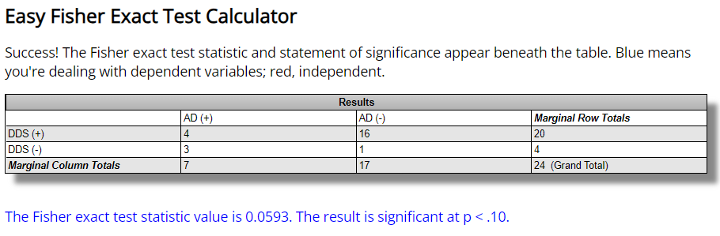
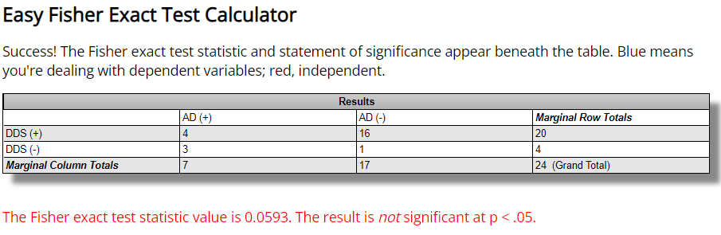

Table S16. Survivors suffering from COPD at Sorokdo National Hospital
AD
1: The onset of COPD
 | 2005 | 2006 | 2007 | 2008 | 2009 | 2010 | 2011 | 2012 | 2013 | 2014 | 2015 | 2016 | 2017 | 2018 | 2019 | 2020 | 2021 | 2022
106 |  |  |  |  |  |  |  |  |  |  |  |  |  |  |  |  | 1
44 |  |  |  |  |  |  |  | 1
107 |  |  |  |  |  |  |  |  |  |  |  |  |  |  |  |  | 1
104 |  |  |  |  |  |  |  |  |  |  |  |  |  |  |  | 1
88 |  |  |  |  |  |  |  |  |  |  |  | 1
105 |  |  |  |  |  |  |  |  |  |  |  |  |  |  |  | 1
66 |  |  |  |  |  |  |  |  | 1
67 |  |  |  |  |  |  |  |  | 1
92 |  |  |  |  |  |  |  |  |  |  |  |  | 1
93 |  |  |  |  |  |  |  |  |  |  |  |  | 1
50 |  |  |  |  |  |  |  | 1
19 |  |  | 1
21 |  |  | 1
58 |  |  |  |  |  |  |  | 1
10 |  |  | 1
75 |  |  |  |  |  |  |  |  | 1
89 |  |  |  |  |  |  |  |  |  |  |  | 1
41 |  |  |  |  |  |  | 1
76 |  |  |  |  |  |  |  |  | 1
14 | 1
87 |  |  |  |  |  |  |  |  |  |  | 1
97 |  |  |  |  |  |  |  |  |  |  |  |  | 1
98 |  |  |  |  |  |  |  |  |  |  |  |  | 1
99 |  |  |  |  |  |  |  |  |  |  |  |  | 1

Table S17. Study of the prevalence of viral respiratory diseases (VRDs) on Sorok Island, South Korea - Primary T1:T2:T3:T4 study for the retrospective cohort study at Sorok Island.

year | T1* | T2* | T3* | T4* | Sum | Mean | SD^{f} | CI^{g} | [CI^{g} | CI^{g}] | χ2* | p value
Pre RCT Study
2005 | 148 | 95 | 233 | 268 | 744 | 186 | 78.86 | 11.41 | 174.59 | 264.86 | 13.5772 | 0.000229
2006 | 166 | 111 | 237 | 208 | 722 | 180.5 | 54.74 | 8.05 | 172.45 | 235.24 | 3.0793 | 0.079295
2007 | 170 | 115 | 252 | 185 | 722 | 180.5 | 56.37 | 8.29 | 172.21 | 236.87 | 0.2794 | 0.597118
2008 | 207 | 128 | 219 | 148 | 702 | 175.5 | 44.34 | 6.61 | 168.89 | 219.84 | 0.3293 | 0.566073
2009 | 222 | 135 | 196 | 115 | 668 | 167 | 50.31 | 7.69 | 159.31 | 217.31 | 0.0498 | 0.823418
2010 | 202 | 170 | 186 | 105 | 663 | 165.75 | 42.55 | 6.54 | 159.21 | 208.30 | 6.2203 | 0.012629
2011 | 205 | 164 | 170 | 117 | 656 | 164 | 36.18 | 5.58 | 158.42 | 200.18 | 0.8918 | 0.344987
RCT Study
2012 | 237 | 211 | 103 | 102 | 653 | 163.25 | 70.95 | 10.97 | 152.28 | 234.20 | 0.3981 | 0.528071
2013 | 269 | 349 | 8 | 23 | 649 | 162.25 | 172.68 | 26.79 | 135.46 | 334.93 | 3.7892 | 0.051583
2014 | 236 | 349 | 6 | 32 | 623 | 155.75 | 164.85 | 26.16 | 129.59 | 320.60 | 9.0547 | 0.00262
2015 | 227 | 325 | 7 | 44 | 603 | 150.75 | 150.82 | 24.33 | 126.42 | 301.57 | 14.7575 | 0.000122
2016 | 207 | 319 | 4 | 61 | 591 | 147.75 | 142.63 | 23.25 | 124.50 | 290.38 | 27.7773 | < 0.00001e
2017 | 193 | 301 | 14 | 55 | 563 | 140.75 | 131.44 | 21.96 | 118.79 | 272.19 | 9.1835 | 0.002442
2018 | 178 | 303 | 15 | 60 | 556 | 139 | 129.14 | 21.66 | 117.34 | 268.14 | 8.2801 | 0.004008
2019 | 155 | 297 | 13 | 69 | 534 | 133.5 | 123.66 | 21.21 | 112.29 | 257.16 | 10.9433 | 0.000939
Sum | 3022 | 3372 | 1663 | 1592
Mean | 201.47 | 224.80 | 110.87 | 106.13
SD | 33.86 | 97.50 | 103.80 | 70.30
95% CI | 1.21 | 3.29 | 4.99 | 3.46
[ | 200.26 | 221.51 | 105.87 | 102.68
] | 202.67 | 228.09 | 115.86 | 109.59
The chi-square is 281.826.
The p value is < 0.00001. I t is significant at p < .05.
Blue means we are dealing with dependent variables; red, independent.

Table S18. General status and incidence rate of COVID-19 reinfection
Classification | Total^{b} | Reinfection casesª
 |  | sum | % | 45∼89 day | over 90 day
Sumª | 16,130,855 | 55,841 | 0.35 | 2,540 | 53,301
Reinfection and Diagnosis
- 2022. 3. 13. | 6,726,887 | 17,659 | 0.26 | 1,028 | 16,631
2022. 3. 14.~3. 19 | 9,403,968 | 38,182 | 0.41 | 1,512 | 36,670
Variants (dominant)
delta variant (~2021. 6.) | 133,502 | 8 | 0.01 | - | 8
Delta (2021. 7.~12.) | 425,883 | 545 | 0.13 | 94 | 451
Omicron BA1 (2022. 1.~ 3. 29.) | 8,664,294 | 25,629 | 0.30 | 1,092 | 24,537
Omicron BA2 (2022.3.20. ~) | 6,907,176 | 29,659 | 0.43 | 1,354 | 28,305
Gender
male | 7,588,561 | 26,660 | 0.35 | 1,201 | 25,459
female | 8,542,277 | 29,181 | 0.34 | 1,339 | 27,842
Age^{c}
0-17 years old | 3,808,039 | 17,926 | 0.47 | 1,397 | 16,529
18-29 years old | 2,683,865 | 10,641 | 0.40 | 294 | 10,347
30-39 years old | 2,387,983 | 8,209 | 0.34 | 242 | 7,967
40-49 years old | 2,481,334 | 7,149 | 0.29 | 190 | 6,959
50-59 years old | 1,969,973 | 4,742 | 0.24 | 117 | 4,625
60-74 years old | 2,052,693 | 5,072 | 0.25 | 185 | 4,887
75 years old More than | 746,949 | 2,102 | 0.28 | 115 | 1987
Immunity
Immune compromized patients | 409,697 | 1006 | 0.25 | 33 | 973
Nursing hospitals and home | 307,183 | 1,814 | 0.59 | 77 | 1,737
Etc | 15,413,975 | 53,021 | 0.34 | 2,430 | 50,591
Vaccination history
unvaccinated | 3,638,932 | 19,513 | 0.54 | 1,538 | 17,975
1st vaccination complete | 187,490 | 1,204 | 0.64 | 63 | 1,141
2nd vaccination complete | 4,565,171 | 18,549 | 0.41 | 493 | 18,056
3rd vaccination complete | 7,705,070 | 16,394 | 0.21 | 443 | 15,951
4th vaccination complete | 34,150 | 181 | 0.53 | 3 | 178
ª Subject to 55,841 presumed cases of reinfection (secondary infection) after 45 days of confirmation of primary infection
^{b} Exclusion of 65 patients with tertiary infection
^{c} Excluding 17 patients with missing sex data, 19 patients with missing age data, and 5,325 patients with foreign infection
(Reproduced from Go-woon Y, Eun-Jeong J, Seon-Joo L, Sungjin W, Young-jun P. Reinfection calculation current situation analysis. Weekly Health and Illness Vol. 15, No. 18 (2022. 5. 4.) Korea Disease Control and Prevention Agency.)

Table S18-1. There were 77 critical cases of COVID-19 reinfection in nursing hospitals and homes.
Classification | Total | Gender |  | Age
 |  | male | female | 40-49 | 50-59 | 60-74 | Over 75
*Total Exacerbated  (Critical + death) | 72  (100) | 42  (58.3) | 30  (41.7) | 2  (2.8) | 6  (8.3) | 28  (38.9) | 36  (50.0)
*Death | 52  (100) | 28  (53.8) | 24  (46.2) | - | 2  (3.8) | 20  (38.5) | 30  (57.7)

Vaccination status in nursing hospitals and homes: Registration number 9318128 (Supplement 2)

○ Reinfection rate among members of nursing hospital facilities is 1,814.

○ The number of severe cases: 67 among members of nursing hospital facilities,

*(Reproduced from Go-woon Y, Eun-Jeong J, Seon-Joo L, Sungjin W, Young-jun P. Reinfection calculation current situation analysis. Weekly Health and Illness Vol. 15, No. 18 (2022. 5. 4.) Korea Disease Control and Prevention Agency.) ¹⁴

Table S19. General status and cumulative incidence rates according to COVID-19 vaccination history of immunocompromised persons and residents of elderly care hospitals and facilities
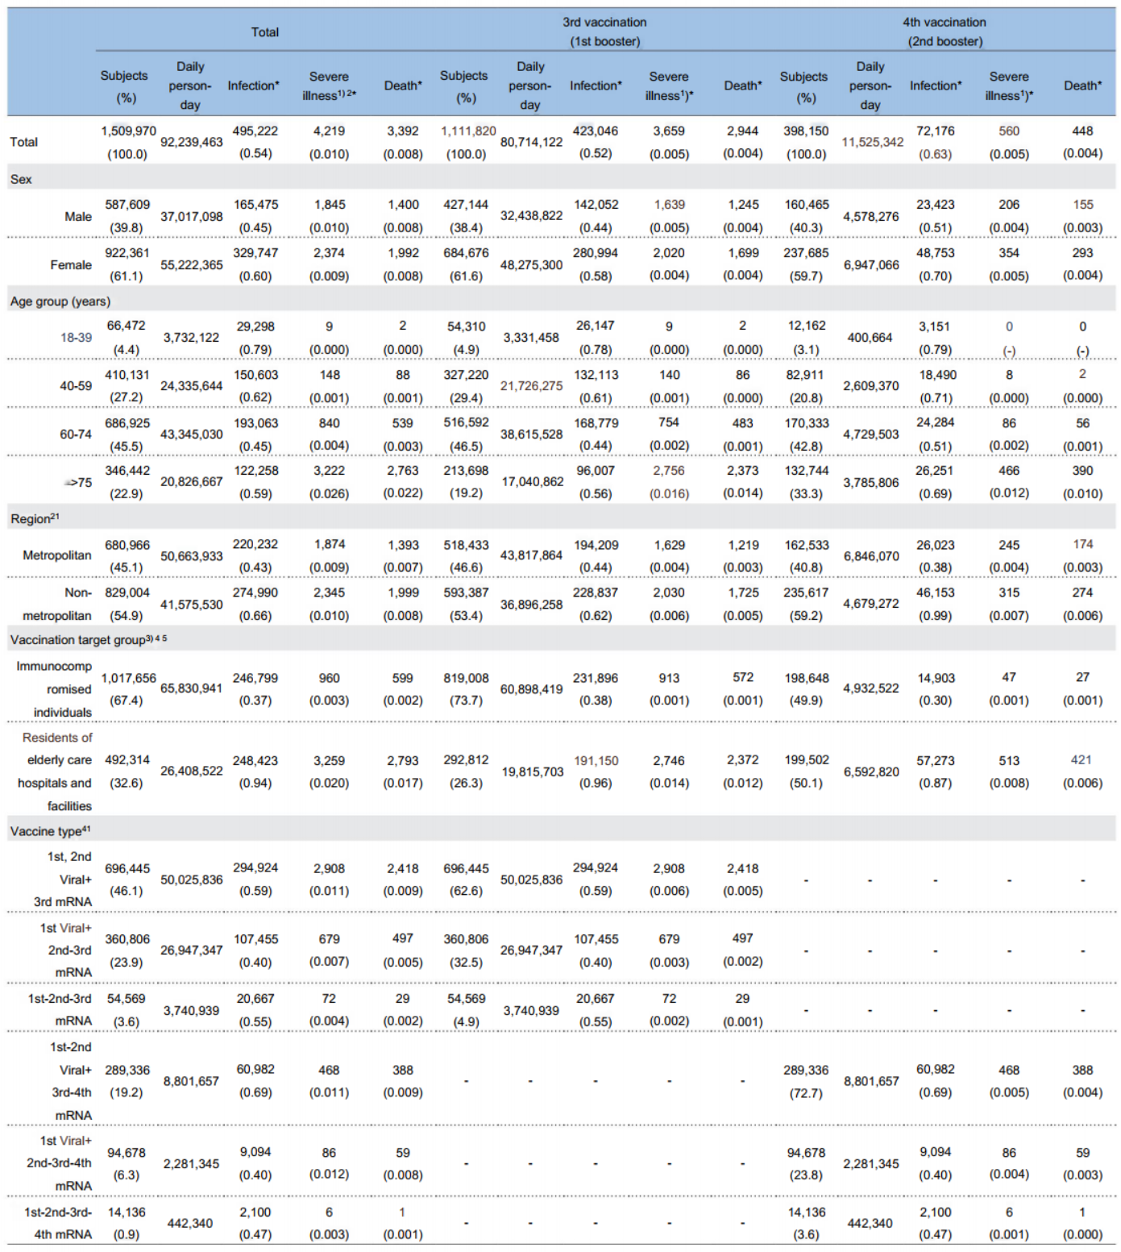
- Severe illness or death within 28 days after being diagnosed with COVID-19
- Place of residence, metropolitan area (Seoul, Gyeonggi, and Incheon) and nonmetropolitan area (cities and provinces outside the metropolitan area), based on vaccination registration information
- Immunocompromised persons and residents of elderly care hospitals and facilities who received the third vaccination
- Viral: AstraZeneca, mRNA: Pfizer or Moderna
- *: number of people per 100 per day

(Reproduced from Yoo-Yeon Kim, Eun Jung Jang, Ryu Kyung Kim, Seon Kyeong Park, Ju Hee Lee, Young Joon Park Epidemic Investigation Team, Epidemiological Investigation and Analysis Task Force, Korea Disease Control and Prevention Agency (KDCA) Geun-Yong Kwon, Jee Yeon Shin, Sang-Yoon Choi, Mi Jin Jeong COVID-19 Vaccination Task Forece, KDCA. Analysis of the preventive effect of the fourth coronavirus disease vaccine dose in immunocompromised individuals and residents of elderly care hospitals and facilities. Weekly Health and Illness Vol. 15, No. 28 (2022. 7. 14.) Korea Disease Control and Prevention Agency.)

Table 19-1. General status and cumulative incidence rates according to COVID-19 vaccination history of immunocompromised persons and residents of elderly care hospitals and facilities

 | Total (%) |  |  |  |  | 3rd vaccination  (1st booster) (%) |  |  |  |  | 4th vaccination  (2nd booster) (%)
 | Subjects | Daily  person- day | Infection* | Severe illness^{1*} | Death* | Subjects | Daily  person- day | Infection* | Severe illness^{1)*} | Death* | Subjects | Daily  person- day | Infection* | Severe illness^{1)*} | Death*
Total | 1,509,970 | 92,239,463 | 495,222 | 4,219 | 3,392 | 1,111,820 | 80,714,122 | 423,046 | 3,659 | 2,944 | 398,150 | 11,525,342 | 72,176 | 560 | 448
Residents of elderly care  hospitals and  facilities (E1) | 492,314  (32.6) | 26,408,522  (28.6) | 248,423  (50.2) | 3,259  (77.2) | 2,793  (82.3) | 292,812  (26.3) | 19,815,703 (24.6) | 191,150  (45.2) | 2,746  (75.4) | 2,372  (80.6) | 199,502  (50.1) | 6,592,820 (57.2) | 57,273  (79.3) | 513  (91.6) | 421  (94.0)
Immunocomp  romised  individuals (E2) | 1,017,656  (67.4) | 65,830,941  (71.4) | 246,799  (49.8) | 960  (22.8) | 599  (17.7) | 819,008  (73.7) | 60,898,419  (75.4) | 231,896  (54.8) | 913  (24.6) | 572  (20.4) | 198,648  (49.9) | 4,932,522  (42.8) | 14,903  (20.7) | 47  (8.4) | 27  (6.0)
^{**E}1 |  |  | ²⁾ 940.69 (71.5) | ³⁾ 662 (87.6) | ⁴⁾ 567 (90.6) |  |  | ²⁾ 964.64 (71.7) | ³⁾ 938 (89.4) | ⁴⁾ 810 (92.0) |  |  | ²⁾ 868.72 (74.2) | ³⁾ 257 (91.5) | ⁴⁾ 211 (93.8)
^{**E}2 |  |  | ²⁾ 375 (28.5) | ³⁾ 94 (12.4) | ⁴⁾ 59 (9.4) |  |  | ²⁾ 381 (28.3) | ³⁾ 111 (10.6) | ⁴⁾ 70 (8.0) |  |  | ²⁾ 302 (25.8) | ³⁾ 24 (8.5) | ⁴⁾ 14 (6.2)
* number of people per 100 per day, ¹⁾ severe illness or death within 28 days after being diagnosed with COVID-19, ²⁾ infection/daily person-day*100,000, ³⁾ severe illness/subjects*100,000, and 4) death/subjects*100,000
** This is the number of cases per 100,000 people. .
(Reproduced from Yoo-Yeon Kim, Eun Jung Jang, Ryu Kyung Kim, Seon Kyeong Park, Ju Hee Lee, Young Joon Park)
Epidemic Investigation Team, Epidemiological Investigation and Analysis Task Force, Korea Disease Control and
Prevention Agency (KDCA) Geun-Yong Kwon, Jee Yeon Shin, Sang-Yoon Choi, Mi Jin Jeong
COVID-19 Vaccination Task Forece, KDCA. Analysis of the preventive effect of the fourth coronavirus disease vaccine dose in
immunocompromised individuals and residents of elderly care hospitals and facilities. Weekly Health and Illness Vol. 15, No. 28 (2022. 7. 14.) Korea Disease Control and Prevention Agency.)

Calculator S1. One-way ANOVA Calculator, Including Tukey’s HSD: COPD Patients

Summary of Data
 | Treatments
 | 1 | 2 |  | 3 |  | 4 |  | 5 |  | Total
N | 17 | 17 |  | 17 |  | 17 |  | 17 |  | 85
∑X | 6 | 20 |  | 25 |  | 56 |  | 107 |  | 214
Mean | 0.3529 | 1.1765 |  | 1.4706 |  | 3.2941 |  | 6.2941 |  | 2.518
∑X² | 8 | 44 |  | 119 |  | 364 |  | 1347 |  | 1882
Std.Dev. | 0.6063 | 1.1311 |  | 2.2671 |  | 3.3497 |  | 6.4881 |  | 3.9988
Result Details
Source |  |  | SS |  | df |  | MS
Between-treatments |  |  | 381.5765 |  | 4 |  | 95.3941 |  | F = 7.93589
Within-treatments |  |  | 961.6471 |  | 80 |  | 12.0206
Total |  |  | 1343.2235 |  | 84
The f-ratio is 7.93589. The p value is.000019. The result is significant at p <.05.

Post hoc Tukey HSD test
Pairwise Comparisons |  | HSD_{.05} = 3.3190  HSD_{.01} = 4.0049 | Q_{.05} = 3.9470 Q_{.01} = 4.7627
T₁:T₂ | M₁ = 0.35  M₂ = 1.18 | 0.82 | Q = 0.98 (p = .95755)
T₁:T₃ | M₁ = 0.35  M₃ = 1.47 | 1.12 | Q = 1.33 (p = .88044)
T₁:T₄ | M₁ = 0.35  M₄ = 3.29 | 2.94 | Q = 3.50 (p = .10712)
T₁:T₅ | M₁ = 0.35  M₅ = 6.29 | 5.94 | Q = 7.07 (p = .00003)
T₂:T₃ | M₂ = 1.18  M₃ = 1.47 | 0.29 | Q = 0.35 (p = .99916)
T₂:T₄ | M₂ = 1.18  M₄ = 3.29 | 2.12 | Q = 2.52 (p = .39191)
T₂:T₅ | M₂ = 1.18  M₅ = 6.29 | 5.12 | Q = 6.09 (p = .00044)
T₃:T₄ | M₃ = 1.47  M₄ = 3.29 | 1.82 | Q = 2.17 (p = .54415)
T₃:T₅ | M₃ = 1.47  M₅ = 6.29 | 4.82 | Q = 5.74 (p = .00107)
T₄:T₅ | M₄ = 3.29  M₅ = 6.29 | 3.00 | Q = 3.57 (p = .09575)

Calculator S2 T1 and T5

Pearson correlation coefficient calculation

The value of R is 0.7187.

X Values  1  0  0  0  0  0  0  1  2  0  0  0  1  0  0  1  0 | Y Values  17  0  6  4  4  2  10  20  15  7  2  2  14  0  0  2  2 | 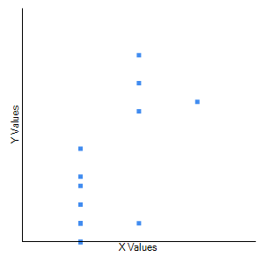

X - M_{x} | Y - M_{y} | (X - M_{x})² | (Y - M_{y})² | (X - M_{x})(Y - M_{y})
0.647  -0.353  -0.353  -0.353  -0.353  -0.353  -0.353  0.647  1.647  -0.353  -0.353  -0.353  0.647  -0.353  -0.353  0.647  -0.353  Mx: 0.353 | 10.706  -6.294  -0.294  -2.294  -2.294  -4.294  3.706  13.706  8.706  0.706  -4.294  -4.294  7.706  -6.294  -6.294  -4.294  -4.294  My: 6.294 | 0.419  0.125  0.125  0.125  0.125  0.125  0.125  0.419  2.713  0.125  0.125  0.125  0.419  0.125  0.125  0.419  0.125  Sum: 5.882 | 114.616  39.616  0.087  5.263  5.263  18.439  13.734  187.851  75.792  0.498  18.439  18.439  59.381  39.616  39.616  18.439  18.439  Sum: 673.529 | 6.927  2.221  0.104  0.810  0.810  1.516  -1.308  8.869  14.339  -0.249  1.516  1.516  4.986  2.221  2.221  -2.779  1.516  Sum: 45.235

Result Details & Calculation  X Values  ∑ = 6  Mean = 0.353  ∑(X - Mx)2 = SSx = 5.882  Y Values  ∑ = 107  Mean = 6.294  ∑(Y - My)2 = SSy = 673.529  X and Y Combined  N = 17  ∑(X - Mx)(Y - My) = 45.235  R Calculation  r = ∑((X - My)(Y - Mx))/√((SSx)(SSy))  r = 45.235/√((5.882)(673.529)) = 0.7187  Meta Numerics (cross-check)  r = 0.7187 | Key  X: X Values  Y: Y Values  M_{x}: Mean of X Values  M_{y}: Mean of Y Values  X - M_{x} & Y - M_{y}: Deviation scores  (X - M_{x})² & (Y - M_{y})²: Deviation Squared  (X - M_{x})(Y - M_{y}): Product of Deviation Scores

The value of R is 0.7187.
This correlation is moderate and positive, which means that there is a tendency for high X variable scores to accompany high Y variable scores (and vice versa).
The value of R2, the coefficient of determination, is 0.5165.

The P value is.001152. The result is significant at p <0.05.

Spearman's Rho Calculator

The value of r_{s} is 0.62057.

r_{s} = -0.83929, p (2-tailed) = 9E-05.
By normalization, the association between two variables was considered to be statistically significant.

X Values | Y Values | X_{Ra} | X_{Ra} - M_{x} | Y_{Ra} | Y_{Ra} - M_{y} | Sum Diffs
1  0  0  0  0  0  0  1  2  0  0  0  1  0  0  1  0 | 17  0  6  4  4  2  10  20  15  7  2  2  14  0  0  2  2 | 14.50  6.50  6.50  6.50  6.50  6.50  6.50  14.50  17.00  6.50  6.50  6.50  14.50  6.50  6.50  14.50  6.50 | 5.50  -2.50  -2.50  -2.50  -2.50  -2.50  -2.50  5.50  8.00  -2.50  -2.50  -2.50  5.50  -2.50  -2.50  5.50  -2.50 | 16.00  2.00  11.00  9.50  9.50  6.00  13.00  17.00  15.00  12.00  6.00  6.00  14.00  2.00  2.00  6.00  6.00 | 7.00  -7.00  2.00  0.50  0.50  -3.00  4.00  8.00  6.00  3.00  -3.00  -3.00  5.00  -7.00  -7.00  -3.00  -3.00 | 38.50  17.50  -5.00  -1.25  -1.25  7.50  -10.00  44.00  48.00  -7.50  7.50  7.50  27.50  17.50  17.50  -16.50  7.50

Calculation  R = CoVariance/(X_{Ra} St. Dev. * Y_{Ra} St. Dev.)  Key  X_{Ra} = Ranks of X Values; Y_{Ra} = Ranks of Y Values  X_{Ra} - M_{x} = X rank minus mean of X ranks  Y_{Ra} - M_{y} = Y rank minus mean of Y ranks  Sum Diffs = (X_{Ra} - M_{x}) * (Y_{Ra} - M_{y}) | Result Details  X Ranks  Mean: 9  Standard Dev: 4.03  Y Ranks  Mean: 9  Standard Dev: 4.97  Combined  Covariance = 199/16 = 12.44  R = 12.44/(4.03 * 4.97) = 0.621

r_{s} = 0.62057, p (2-tailed) = 0.00786.
By normalization, the association between two variables was considered to be statistically significant.

Calculator S3 T2 and T5

Pearson correlation coefficient calculation

The value of R is 0.7504.

X Values  37  31  146  309  422  470  448  1259  1450  951  633  475  377  212  0 | Y Values  271  265  266  252  234  188  157  103  23  18  75  101  125  160  220 | 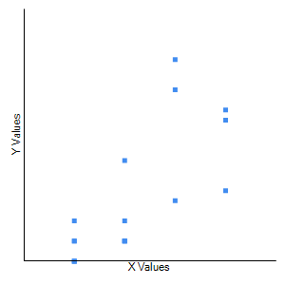

X - M_{x} | Y - M_{y} | (X - M_{x})² | (Y - M_{y})² | (X - M_{x})(Y - M_{y})
-444.333  -450.333  -335.333  -172.333  -59.333  -11.333  -33.333  777.667  968.667  469.667  151.667  -6.333  -104.333  -269.333  -481.333  Mx: 481.333 | 107.133  101.133  102.133  88.133  70.133  24.133  -6.867  -60.867  -140.867  -145.867  -88.867  -62.867  -38.867  -3.867  56.133  My: 163.867 | 197432.111  202800.111  112448.444  29698.778  3520.444  128.444  1111.111  604765.444  938315.111  220586.778  23002.778  40.111  10885.444  72540.444  231681.778  Sum: 2648957.33 | 11477.551  10227.951  10431.218  7767.484  4918.684  582.418  47.151  3704.751  19843.418  21277.084  7897.284  3952.218  1510.618  14.951  3150.951  Sum: 106803.733 | -47602.911  -45543.711  -34248.711  -15188.311  -4161.244  -273.511  228.889  -47333.978  -136452.844  -68508.711  -13478.111  398.156  4055.089  1041.422  -27018.844  Sum: -434087.333

Result Details & Calculation  X Values  ∑ = 7220  Mean = 481.333  ∑(X - M_{x})² = SS_{x} = 2648957.333  Y Values  ∑ = 2458  Mean = 163.867  ∑(Y - M_{y})² = SS_{y} = 106803.733  X and Y Combined  N = 15  ∑(X - M_{x})(Y - M_{y}) = -434087.333  R Calculation  r = ∑((X - M_{y})(Y - M_{x}))/√((SS_{x})(SS_{y}))  r = -434087.333/√((2648957.333)(106803.733)) = -0.8161  Meta Numerics (cross-check)  r = -0.8161 | Key  X: X Values  Y: Y Values  M_{x}: Mean of X Values  M_{y}: Mean of Y Values  X - M_{x} & Y - M_{y}: Deviation scores  (X - M_{x})² & (Y - M_{y})²: Deviation Squared  (X - M_{x})(Y - M_{y}): Product of Deviation Scores

The value of R is 0.7504.

This is a strong positive correlation, which means that high X variable scores are associated with high Y variable scores (and vice versa).
The value of R2, the coefficient of determination, is 0.5631.

The P value was.00052. The result is significant at p <0.05.

Spearman's Rho Calculator

The value of r_{s} is 0.80789.

r_{s} = -0.80789, p (2-tailed) = 9E-05.
By normalization, the association between two variables was considered to be statistically significant.

X Values | Y Values | X_{Ra} | X_{Ra} - M_{x} | Y_{Ra} | Y_{Ra} - M_{y} | Sum Diffs
2  0  2  0  1  0  1  2  3  3  1  1  3  0  0  0  1 | 17  0  6  4  4  2  10  20  15  7  2  2  14  0  0  2  2 | 13.00  3.50  13.00  3.50  9.00  3.50  9.00  13.00  16.00  16.00  9.00  9.00  16.00  3.50  3.50  3.50  9.00 | 4.00  -5.50  4.00  -5.50  0.00  -5.50  0.00  4.00  7.00  7.00  0.00  0.00  7.00  -5.50  -5.50  -5.50  0.00 | 16.00  2.00  11.00  9.50  9.50  6.00  13.00  17.00  15.00  12.00  6.00  6.00  14.00  2.00  2.00  6.00  6.00 | 7.00  -7.00  2.00  0.50  0.50  -3.00  4.00  8.00  6.00  3.00  -3.00  -3.00  5.00  -7.00  -7.00  -3.00  -3.00 | 28.00  38.50  8.00  -2.75  0.00  16.50  0.00  32.00  42.00  21.00  0.00  0.00  35.00  38.50  38.50  16.50  0.00

Calculation  R = CoVariance/(X_{Ra} St. Dev. * Y_{Ra} St. Dev.)  Key  X_{Ra} = Ranks of X Values; Y_{Ra} = Ranks of Y Values  X_{Ra} - M_{x} = X rank minus mean of X ranks  Y_{Ra} - M_{y} = Y rank minus mean of Y ranks  Sum Diffs = (X_{Ra} - M_{x}) * (Y_{Ra} - M_{y}) | Result Details  X Ranks  Mean: 9  Standard Dev: 4.85  Y Ranks  Mean: 9  Standard Dev: 4.97  Combined  Covariance = 311.75/16 = 19.48  R = 19.48/(4.85 * 4.97) = 0.808

rs = 0.80789, p (2-tailed) = 9E-05.
By normalization, the association between two variables was considered to be statistically significant.

Calculator S4 T3 and T5

Pearson correlation coefficient calculation

The value of R is 0.9078.

X Values  4  0  1  0  2  0  2  7  3  0  0  0  6  0  0  0  0 | Y Values  17  0  6  4  4  2  10  20  15  7  2  2  14  0  0  2  2 | 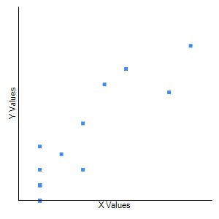

X - M_{x} | Y - M_{y} | (X - M_{x})² | (Y - M_{y})² | (X - M_{x})(Y - M_{y})
2.529  -1.471  -0.471  -1.471  0.529  -1.471  0.529  5.529  1.529  -1.471  -1.471  -1.471  4.529  -1.471  -1.471  -1.471  -1.471  Mx: 1.471 | 10.706  -6.294  -0.294  -2.294  -2.294  -4.294  3.706  13.706  8.706  0.706  -4.294  -4.294  7.706  -6.294  -6.294  -4.294  -4.294  My: 6.294 | 6.398  2.163  0.221  2.163  0.280  2.163  0.280  30.574  2.339  2.163  2.163  2.163  20.516  2.163  2.163  2.163  2.163  Sum: 82.235 | 114.616  39.616  0.087  5.263  5.263  18.439  13.734  187.851  75.792  0.498  18.439  18.439  59.381  39.616  39.616  18.439  18.439  Sum: 673.529 | 27.080  9.256  0.138  3.374  -1.215  6.315  1.962  75.785  13.315  -1.038  6.315  6.315  34.903  9.256  9.256  6.315  6.315  Sum: 213.647

Result Details & Calculation  X Values  ∑ = 25  Mean = 1.471  ∑(X - Mx)2 = SSx = 82.235  Y Values  ∑ = 107  Mean = 6.294  ∑(Y - My)2 = SSy = 673.529  X and Y Combined  N = 17  ∑(X - Mx)(Y - My) = 213.647  R Calculation  r = ∑((X - My)(Y - Mx))/√((SSx)(SSy))  r = 213.647/√((82.235)(673.529)) = 0.9078  Meta Numerics (cross-check)  r = 0.9078 | Key  X: X Values  Y: Y Values  M_{x}: Mean of X Values  M_{y}: Mean of Y Values  X - M_{x} & Y - M_{y}: Deviation scores  (X - M_{x})² & (Y - M_{y})²: Deviation Squared  (X - M_{x})(Y - M_{y}): Product of Deviation Scores

The value of R is 0.9078.

This is a strong positive correlation, which means that high X variable scores are associated with high Y variable scores (and vice versa).

The value of R2, the coefficient of determination, is 0.8241.

The P value was <0.00001. The result is significant at p <0.05.

Spearman's Rho Calculator

The value of r_{s} is 0.84932.

r_{s} = -0.84932, p (2-tailed) = 2E-05.
By normalization, the association between two variables was considered to be statistically significant.

X Values | Y Values | X_{Ra} | X_{Ra} - M_{x} | Y_{Ra} | Y_{Ra} - M_{y} | Sum Diffs
4  0  1  0  2  0  2  7  3  0  0  0  6  0  0  0  0 | 17  0  6  4  4  2  10  20  15  7  2  2  14  0  0  2  2 | 15.00  5.50  11.00  5.50  12.50  5.50  12.50  17.00  14.00  5.50  5.50  5.50  16.00  5.50  5.50  5.50  5.50 | 6.00  -3.50  2.00  -3.50  3.50  -3.50  3.50  8.00  5.00  -3.50  -3.50  -3.50  7.00  -3.50  -3.50  -3.50  -3.50 | 16.00  2.00  11.00  9.50  9.50  6.00  13.00  17.00  15.00  12.00  6.00  6.00  14.00  2.00  2.00  6.00  6.00 | 7.00  -7.00  2.00  0.50  0.50  -3.00  4.00  8.00  6.00  3.00  -3.00  -3.00  5.00  -7.00  -7.00  -3.00  -3.00 | 42.00  24.50  4.00  -1.75  1.75  10.50  14.00  64.00  30.00  -10.50  10.50  10.50  35.00  24.50  24.50  10.50  10.50

Calculation  R = CoVariance/(X_{Ra} St. Dev. * Y_{Ra} St. Dev.)  Key  X_{Ra} = Ranks of X Values; Y_{Ra} = Ranks of Y Values  X_{Ra} - M_{x} = X rank minus mean of X ranks  Y_{Ra} - M_{y} = Y rank minus mean of Y ranks  Sum Diffs = (X_{Ra} - M_{x}) * (Y_{Ra} - M_{y}) | Result Details  X Ranks  Mean: 9  Standard Dev: 4.51  Y Ranks  Mean: 9  Standard Dev: 4.97  Combined  Covariance = 304.5/16 = 19.03  R = 19.03/(4.51 * 4.97) = 0.849

r_{s} = -0.84932, p (2-tailed) = 2E-05.
By normalization, the association between two variables was considered to be statistically significant.

References

1. J. H. Lee, B. Kanwar, C. J. Lee, C. Sergi, M. D. Coleman, Dapsone is an anticatalysis for Alzheimer’s disease exacerbation. iScience, (2022).
2. J. H. Lee, The listed, delisted, and sustainability of therapeutic medicines for dementia patients: the study is specific to South Korea. Naunyn Schmiedebergs Arch Pharmacol 395, 535-546 (2022).
3. C. E. Oldenburg et al., Effect of Oral Azithromycin vs Placebo on COVID-19 Symptoms in Outpatients With SARS-CoV-2 Infection: A Randomized Clinical Trial. JAMA, (2021).
4. J. H. Lee et al., Bronchitis, COPD, and pneumonia after viral endemic of patients with leprosy on Sorok Island in South Korea. Naunyn-Schmiedeberg's Archives of Pharmacology, (2023).

