Supplementary Information

Periosteum-Bone Inspired Hierarchical Scaffold with Endogenous Piezoelectricity for Neuro-Vascularized Bone Regeneration

Yao Zhao¹, Yun-Fan Cai^{1,2}, Wen-Kai Wang^{1,3}, Yong-Kang Bai¹, Ming-Yi Liu¹, Yan Wang¹, Wen Niu¹, Zhi-Xiao Luo², Ling-Yun Xia², Juan-Fang Zhu³, Fei Zhao¹, Franklin R. Tay⁴, Li-Na Niu¹

¹ State Key Laboratory of Oral & Maxillofacial Reconstruction and Regeneration, National Clinical Research Center for Oral Diseases, Shaanxi Key Laboratory of Stomatology, Department of Prosthodontics, School of Stomatology, The Fourth Military Medical University, Xi’an, Shaanxi, 710032, P.R. China

² Department of Stomatology, Taihe Hospital, Hubei University of Medicine, Shiyan, Hubei 442000, P. R. China

³ Department of Stomatology, The First Affiliated Hospital of Zhengzhou University, Zhengzhou, Henan 450052, P. R. China

⁴ The Dental College of Georgia, Augusta University, Augusta, GA 30912, USA

Yao Zhao and Yun-Fan Cai contributed equally to this work.

Corresponding author: Li-Na Niu
niulina831013@126.com

Contents:
1. Supplementary Figures (Fig. S1-S13)
2. Supplementary Tables (Table S1 and S4)
3. Reference

- Supplementary Figures
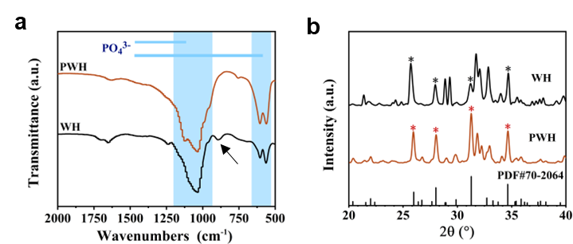
Fig. S1. a) FTIR and b) XRD patterns of WH and PWH nanoparticles.
FTIR analysis showed that WH and PWH peaked at 1030 cm⁻¹ and 608 cm⁻¹, which were mainly the tensile and bending vibration peaks of the O-P-O bond in the PO₄³⁻ functional group[4] (Fig. S1a). Compared with WH, the disappearance of the HPO₄²⁻ characteristic peak at 872 cm⁻¹ in PWH may be due to the decomposition of the unstable HPO₄²⁻ functional group into PO₄³⁻ after high-temperature sintering (As shown by black arrow).
XRD analysis showed that PWH and WH had similar diffraction peaks (Fig. S1b). Among them, the obvious peaks at 25.92°, 28.02°, 31.26° and 34.63° correspond to the (101), (214), (021) and (220) crystal planes of whitlockite nanoparticles (Standard card: PDF #70-2064), respectively[2].
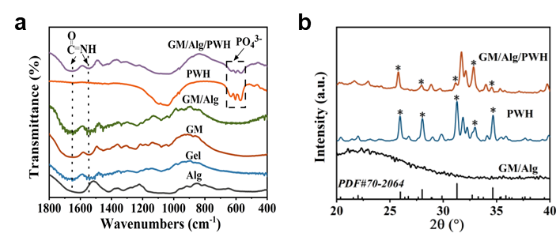
Fig. S2. a) FTIR and b) XRD patterns of GM/Alg/PWH hydrogel and its components.
Chemical structure of the GM/Alg/PWH hydrogel was analyzed by FTIR spectra (Fig. S2a). Due to the covalent crosslinking of the amino group in the methacrylic acid anhydride with the carboxyl group in the gelatin molecule, the characteristic peaks of amide I and amide Ⅱ were appeared in the GM at the wavenumbers of 1654 cm⁻¹ and 1542 cm⁻¹, respectively[3]. The characteristic peaks at 1613 cm⁻¹ and 1416 cm⁻¹ in Alg and GM/Alg/PWH were mainly derived from the carbonyl functional groups in the Alg molecule[1]. Besides, the O-P-O (608 cm⁻¹) vibration peak from PWH was also present in GM/Alg/PWH, indicating that PWH was also successfully recombined.
Compared with GM/Alg, there were obvious characteristic peaks in the GM/Alg/PWH patterns. Meanwhile, the diffraction peak at 25.92°, 28.02°, 31.26° and 34.63° were correspond to the (101), (214), (021) and (220) diffraction crystal planes of PWH (Standard card: PDF #70-2064), which was consistent with the characteristic peaks of PWH (Fig. S2b). As a result, all of the results demonstrated that the successful preparation of in situ in the GM/Alg/PWH hydrogel.
Fig. S3. Variation of loss modulus (G") and storage modulus (G') of GM/Alg/PWH hydrogel with times.
Fig. S4. Voltage stability test of GM/Alg/PWH piezoelectric hydrogel under constant force stimulation (2 N, 1 Hz).

Fig. S5. The stress-strain curves of the Bio-S, B-S and P-S materials.

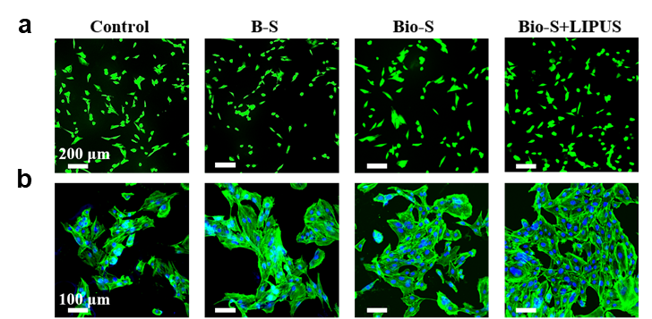
Fig. S6. Representative a) live/dead images and b) morphology images of BMSCs incubated with different scaffold for 2 days, green and red in Fig. (a) represent living cells and dead cells, respectively (scale bars = 200 µm, 100 µm). F-actin and nucleus of cells in Fig. (b) is stained in blue and green, respectively.

Fig. S7. The relative cell viabilities of BMSCs incubated with different groups for 1, 3, 5, and 7 day (s).
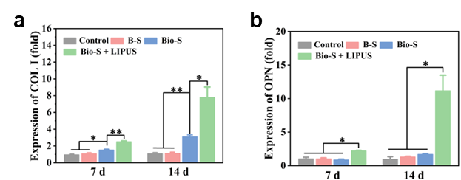
Fig. S8. a, b) The expressions of osteogenic genes in BMSCs after osteo-induction for 7 and 14 days (taking control group as reference). Error bars: mean ± SD (n = 5), *p< 0.05, **p< 0.01.

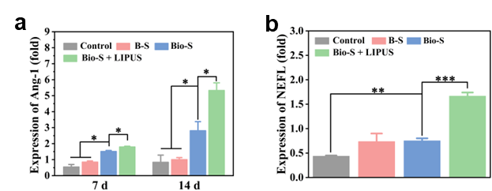
Fig. S9. The expression of a) angiogenic and b) neurogenic genes in BMSCs of each group (taking control group as reference). Error bars: mean ± SD (n = 5), *p< 0.05, **p< 0.01, ***p< 0.001.
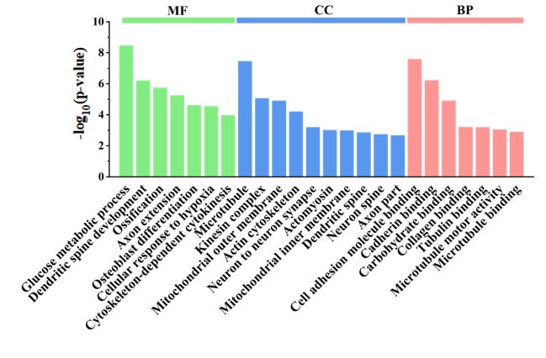
Fig. S10. The biological process (BP), cellular component (CC), and molecular function (MF) of Gene ontology (GO) enrichment analysis in the Bio-S + LIPUS group and B-S group.

Fig. S11. Relative mRNA expressions of OCN in BMSCs. Error bars: Mean ± SD (n=5). *P < 0.05.

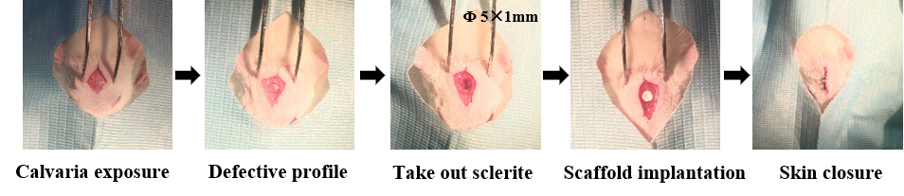

Fig. S12. In vivo surgical procedures for scaffold implantation into the calvaria defect sites.
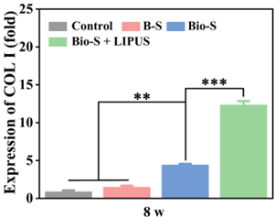
Fig. S13. The expression of COL I genes in newly formed tissue after 8 weeks of implantation in the calvarial bone defects site. Error bars: Mean ± SD (n=5). **P < 0.01, ***P < 0.001.

- Supplementary Tables

Table S1. Primer sequences utilizcd for real timc RT-qPCR in vitro study.
Target gene | Forward primer sequence | Reverse primer sequence
GAPDH | TGTGTCCGTCGTGGATCTGA | TTGCTGTTGAAGTCGCAGGAG
Runx2 | GACACTGCCACCTCTGACTT | ATTCGTGGGTTGGAGAAGCG
OCN | CAGAACAGACAAGTCCCACACAG | TCAGCAGAGTGAGCAGAAAGAT
COL I | GACATGTTCAGCTTTGTGGACCTC | GGGACCCTTAGGCCATTGTGTA
VEGF | CACCAAAGCCAGCACATAGGAG | GCTTTGTTCTGTCTTTCTTTGGTCT
Ang-1 | TTACACGGTGCCGATTTCAG | CCACTTTATCCCATTCAGTTTTCC

Table S2. Primer sequences utilizcd for real timc RT-qPCR in vitro study.
Target gene | Forward primer sequence | Reverse primer sequence
GAPDH | TGTGTCCGTCGTGGATCTGA | TTGCTGTTGAAGTCGCAGGAG
nestin | CCTTAGTCTGGAAGTGGCTACAT | AGGTGCTGGTCCTCTGGTATC
NEFL | CAGAATGCAGACATTAGCGCC | AAACTGAGCCTGGTCTCTTCG
TUBB3 | ACCATGGACAGTGTTCGGTC | ACACTCTTTCCGCACGACAT

Table S3. Primer sequences utilizcd for real timc RT-qPCR in vitro study.
Target gene | Forward primer sequence | Reverse primer sequence
GAPDH | TGTGTCCGTCGTGGATCTGA | TTGCTGTTGAAGTCGCAGGAG
HIF-1α | GGACGATGAACTGAAGTCAGCA | AGGAATGGGTTCACAAATCAGCA
P2X7 | AGGGTGGGGTGACGAAGTTAG | GTCTGCATTGGCCTTCTGAC
RSK | ACCATGGACAGTGTTCGGTC | ACACTCTTTCCGCACGACAT

Table S4. Primer sequences are used for true timc RT-qPCR in vivo studies.
Target gene | Forward primer sequence | Reverse primer sequence
GAPDH | CTGGAGAAACCTGCCAAGTATG | GGTGGAAGAATGGGAGTTGCT
Runx2 | GGACGATGAACTGAAGTCAGCA | AGGAATGGGTTCACAAATCAGCA
COL I | AGAGGCATAAAGGGTCATCGTG | AGACCGTTGAGTCCATCTTTGC
VEGF | GCACTGGACCCTGGCTTTACT | AACTTCACCACTTCATGGGCTTT
TUBB3 | CAACTATGTGGGGGACTCGG | TGGCTCTGGGCACATACTTG

References
1. Ji D, Park JM, Oh MS, Nguyen TL, Shin H, Kim JS, Kim D, Park HS, Kim J (2022) Superstrong, superstiff, and conductive alginate hydrogels. Nat. Commun. 13(1):3019
2. Kaliannagounder VK, Raj NPMJ, Unnithan AR, Park J, Park SS, Kim S-J, Park CH, Kim CS, Sasikala ARK (2021) Remotely controlled self-powering electrical stimulators for osteogenic differentiation using bone inspired bioactive piezoelectric whitlockite nanoparticles. Nano Energy 85(62):105901
3. Kurian AG, Singh RK, Patel KD, Lee J-H, Kim H-W (2022) Multifunctional GelMA platforms with nanomaterials for advanced tissue therapeutics. Bioact. Mater. 8:267-295
4. Zhao Y, Fan T, Chen J, Su J, Zhi X, Pan P, Zou L, Zhang Q (2019) Magnetic bioinspired micro/nanostructured composite scaffold for bone regeneration. Colloids Surf. B 174:70-79

